Headline Benefit Numbers at the end of March 2013

At the end of March 2013, 310,000 working age people were receiving main benefits. This compares with 256,000 in March 2008 and 332,000 in March 2011. The number of working age people receiving main benefits increased by 76,000 (30 percent)³ in the three years ended March 2011, then decreased by 21,000 (6 percent) between 2011 and 2013.

Trends in the number of working age recipients of main social security benefits
(quarterly series, March 2008 – March 2013)

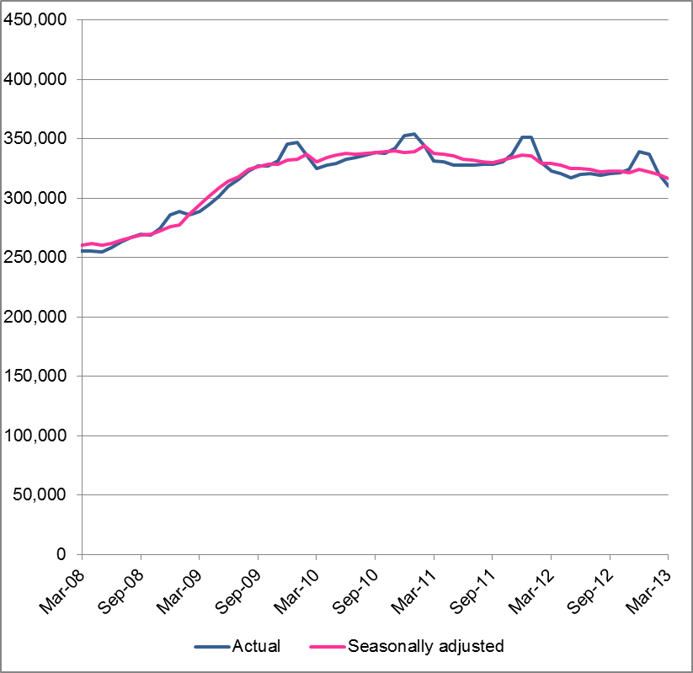
The actual numbers underlying this trend are provided in the table below.

Total numbers of working age recipients of main benefits
(quarterly series – March 2008 – March 2013)
March 2008 | 255,754
June 2008 | 258,317
September 2008 | 269,608
December 2008 | 286,176
March 2009 | 288,959
June 2009 | 310,296
September 2009 | 326,811
December 2009 | 345,476
March 2010 | 324,814
June 2010 | 332,924
September 2010 | 338,212
December 2010 | 352,707
March 2011 | 331,529
June 2011 | 327,817
September 2011 | 328,496
December 2011 | 350,932
March 2012 | 322,951
June 2012 | 320,041
September 2012 | 320,942
December 2012 | 339,095
March 2013 | 310,146
Movement Mar08 – Mar13 | 21.3%
Movement Mar12 – Mar13 | -4.0%

The above table includes unemployed students receiving an Unemployment Benefit – Student Hardship. Excluding these clients gives the numbers shown in the table below.

Net Numbers:
Working age recipients of main benefits
excluding Unemployment Benefits – Student Hardship
March 2008 | 255,695
March 2012 | 322,806
March 2013 | 309,966
Movement Mar08 – Mar13 | 21.2%
Movement Mar12 – Mar13 | -4.0%

This report defines “working age” clients as those aged 18-64 years. These ages are the normal age boundaries for receipt of mainstream social security benefits and for the age of eligibility for New Zealand Superannuation.
Comprises Unemployment Benefits, Unemployment Benefits – Hardship (includes Unemployment Benefits – Student Hardship), Unemployment Benefits Training, Unemployment Benefits – Hardship – Training, Independent Youth Benefits, Youth Payments, Young Parent Payments, Domestic Purposes Benefits – Sole Parent, Domestic Purposes Benefits – Care of Sick or Infirm, Domestic Purposes Benefits – Women Alone, Sickness Benefits, Sickness Benefits – Hardship, Emergency Maintenance Allowances, Invalid's Benefits, Widow’s Benefits and Emergency Benefits. Youth Payments and Young Parent Payments replaced Independent Youth Benefits from August 2012. 3 All changes given are calculated using the exact numbers presented on page 2 of this report.

