Supporting vulnerable children and young people

CONTENTS
Overview i
Executive Summary ii
- Supporting New Zealand’s Vulnerable Families
Most families are doing well, but some face multiple challenges 2
Most families don’t require statutory intervention if we can help early 3
Support during the early years and access to universal services are key 3
Making a difference means working in partnership 4
- The Role of Child, Youth and Family
For some families, Child, Youth and Family involvement is necessary 8
We have developed a better way to respond to some of our notifications 9
We don’t work in isolation 10
Child, Youth and Family is primarily a care organisation 12
Relevant legislation 12
The children we work with are diverse – and so are the reasons they need our help 13
Care and protection 13
Youth justice 13
Children and young people with disabilities 15
Adoptions 15
- Current Picture of Child, Youth and Family
Notifications are increasing, but those requiring intervention are reducing 18
Differential response will enable use to reduce repeat notifications 18
We have more children and young people in care than 10 years ago, but numbers are now reducing 19
We have more high needs children and young people 19
Meeting the needs of our children and young people means operating high quality facilities 20
Family homes 20
Residences 20
Contracted services 20
We are committed to increasing the qualifications of our staff 21
We want to strengthen our first response 22
- A Chance to Make a Difference
We have a set of priorities to guide our work 24
There are more opportunities to make a difference in the future 25
Responding to family violence notifications 25
Specialising foster care 25
Improving outcomes for children and young people who offend 26
Improving transitions for children and young people 27
Working with you 28
Endnotes 29

TABLE OF FIGURES
Figure 1. How social services work with families with children 3
Figure 2. Notifications, substantiations, and cases proceeding to investigations, 2003/2004–2007/2008 8
Figure 3. Role of Child, Youth and Family in social services for families 10
Figure 4. Child, Youth and Family 2008/2009 budgeted funding 11
Figure 5. Care and protection and youth justice services 14

Overview
This briefing, Supporting Vulnerable Children and Young People, focuses on the role of Child, Youth and Family. It discusses the challenges we currently face and some opportunities for future work. The briefing is divided into four sections:
- Part 1, Supporting New Zealand’s Vulnerable Families, discusses the wider context. It talks about how government can best prevent the need for statutory intervention by Child, Youth and Family by tilting the balance of investment towards prevention and early intervention.
- Part 2, The Role of Child, Youth and Family, sets out our role. It covers how Child, Youth and Family works with families who need our help, our primary role as a care organisation, and the reasons children and young people come to our attention and into our care.
- Part 3, Current Picture of Child, Youth and Family, talks about the pressures we face. It discusses the current trends faced by Child, Youth and Family and what these challenges mean for us.
- Part 4, A Chance to Make a Difference, provides some suggestions for future areas of work. It discusses our priorities for the next two years and signals four main opportunities to make even more of a difference in the lives of vulnerable children and young people in the future.

We would be happy to talk further with you about these, or any other ideas, for future work.
We look forward to working with you.

Peter Hughes
Chief Executive
Ministry of Social Development
i

Executive Summary

Supporting New Zealand’s vulnerable families
While the lives of most children and young people living in New Zealand have improved in recent years, some groups continue to face challenges. These challenges, including unemployment, inadequate housing, low education levels and financial deprivation, can put children at greater risk.
Tackling problems before they escalate is critical to making inroads into some of the more complex and difficult challenges facing our families and whānau. The first years of a child’s life are key – this is when intervention is cheapest and most successful. Over time, it becomes more difficult, complex and often more expensive to put the problem right.
Government and non-government organisations, alongside families, whānau and communities, all have a role in supporting children and young people. Government agencies acting in isolation will not manage to tackle the enduring challenges our children and young people face. We are most effective when acting together.

The role of Child, Youth and Family
Child, Youth and Family is part of the Ministry of Social Development’s service delivery cluster. Our vision is safe children and young people, in strong families, whānau and communities.
Our involvement generally begins when a concern is raised about the safety and wellbeing of a child or young person. In many cases, the family just needs some advice or access to services. In some cases, we work with the family to identify the issues and find solutions. Our role is to help:
- families and whānau get the support they need to care for their children
- children needing care to find secure, long-term homes with family, whānau, caregivers or adoptive parents
- young people who offend to take responsibility for their actions, and to make the changes they need to build an offending-free future
- communities to raise awareness, and to prevent child abuse and neglect.

Current picture of Child, Youth and Family
Child, Youth and Family is experiencing a number of challenges – both for the outcomes of the children and young people we work with and for the way we operate as an organisation. These challenges include an increasing number of notifications and high numbers of children and young people in care. We received 98,890 notifications in 2007/2008 alone.
There is a need to strengthen our response to the first notification for each child, particularly for children under five. At the moment, many of these children come to our attention again later on in their lives. We also have a growing number of children and young people with high needs.
ii
There is an ongoing need for quality residential facilities and innovative approaches to residential care. This is particularly important for children and young people who offend, and for those with high needs. We are making good progress in professionalising our social worker workforce, and are increasing our focus on recruiting and retaining qualified social workers.
A global shortage of social workers makes this area a particular challenge.

A chance to make a difference
With challenges come opportunities. We are already working to increase our responsiveness, to reduce abuse, neglect and youth offending, and to increase the number of permanent homes found for children and young people in care.
But there are opportunities to make an even greater difference in the lives of our vulnerable children and young people. There are four areas where we think government could make the biggest impact:
- We need to develop a sustainable approach for the way we respond to the family violence notifications from Police so we can cope with the increasing volume of notifications.
- We can be more strategic about how we use our foster carers, focusing on children and young people with high needs. We need to be able to better identify the interventions needed, to upskill our carers, and to ensure they have access to the right support.
- We face ongoing challenges in our work with children and young people who offend. Improving results for this group will mean examining how we accommodate them and ensuring we strike a balance between rehabilitation and containment.
- We also want to provide better support for young people leaving our care. To do this, we need to ensure our support provides young people with the life skills they need to make sound decisions after care.
Very real progress has been made in the last few years, and Child, Youth and Family is in a better position than it has been in for the last decade.
However, there are challenges and opportunities in front of us. Meeting these will ensure outcomes for the children, young people and families that we work with will improve.
We are committed to working hard to achieve these improvements.
iii
iii

Supporting New Zealand’s Vulnerable Families
While the lives of most New Zealand families have improved in recent years, some groups continue to face multiple disadvantages. These can have an impact on the children growing up within these families, and make it harder for them to reach their potential. Tackling problems before they escalate is critical because, over time, it becomes more difficult to put the problem right.

Most Families are Doing Well, but Some Face Multiple Challenges
Most children and young people are doing really well. New Zealand already has the building blocks of a comprehensive system of support for families and whānau with children. Services like health care, early childhood education and primary and secondary schools are available to everyone, irrespective of their circumstances. They are an important part of giving our kids the best possible start in life.
Some families and whānau, however, face multiple disadvantages. For many of our vulnerable families, hardship is due to a number of factors and disadvantage is transferred from generation to generation. Factors contributing to hardship include poor mental and physical health, educational underachievement, criminal offending and victimisation. The likelihood of children raised within these families reaching their full potential is severely diminished.
Family hardship creates a risk for children – the negative factors present in a parent’s life put children at a higher risk of maltreatment

Adverse life events and financial deprivation also put children at a greater risk of maltreatment. Poverty-related factors such as unemployment, inadequate housing and low education levels have a cumulative effect. The more negative factors present in a parent’s life, the more likely the parent is to maltreat their child. The presence of other types of family violence and abuse, such as intimate partner violence, further increases the likelihood parents will maltreat their children.
Conduct problems affect 5–10 per cent of New Zealand children and are the single most important predictor of poor mental and physical health, academic underachievement, early school leaving, teenage parenthood, delinquency, unemployment and substance abuse. For many affected young people, the pathway from early conduct problems typically leads to youth offending, family violence and, ultimately, serious adult crime.
Early intervention is crucial – the longer we wait, the more difficult and expensive the problem becomes
Tackling problems before they escalate and become entrenched is critical to making inroads into some of the more complex and difficult challenges facing our families. With every year, behavioural, health and skill deficits accumulate and become more entrenched. The first years of a child’s life are a critical time because this is when intervention is cheapest and most successful. Over time, it becomes more difficult, complex and often more expensive to put the problem right.

Most families Don’t Require Statutory Intervention if we can help Early
For most families, universal services and additional help through targeted services provide enough support to avoid the need for statutory intervention. Figure 1 below shows the progression from universal services (those services provided free-of-charge for everyone) towards targeted services, and on to statutory services.
Figure 1. How social services work with families with children
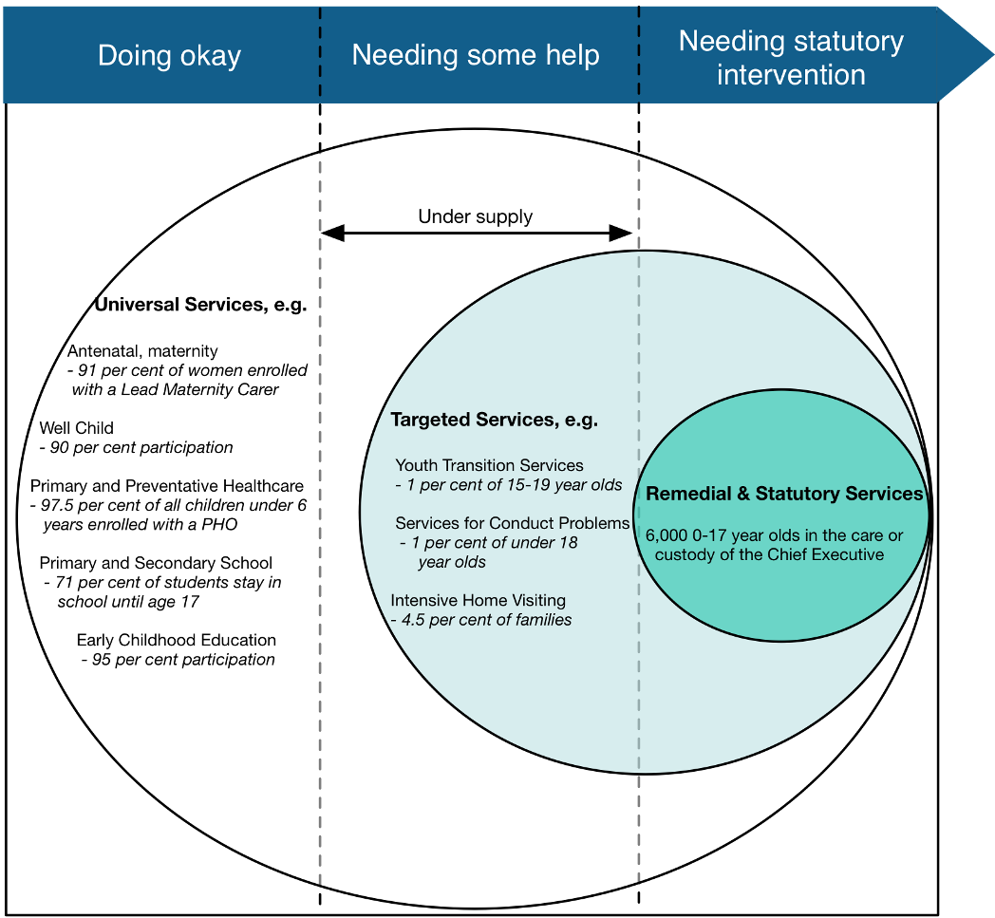
By placing a stronger emphasis on tackling problems early, we not only decrease the need for remedial and statutory services, but we can stop the cycle of disadvantage repeating itself in future generations. For example, having behavioural problems or mental health issues as a child, low educational achievement and becoming a parent at a young age can all be predictors of long periods of benefit receipt in later life.
Participation in universal services helps get children off to a good start…

Support during the early years and access to universal services are key
Experiences in early childhood lay the foundations for learning, health, safety and behaviour. Getting things right from the start, with a focus on high quality and accessible maternity care, primary health care and early childhood education, is critical for all children.
The early years are when it is most cost effective to invest in vulnerable young children and their families. We can do this by ensuring:
- we have the right mix of universal, targeted and statutory services
- all services are of a high quality
- participation in comprehensive assessments at birth and at school entry by using all government and community-provider contact points with vulnerable families to encourage them to participate
- more targeted and intensive services like parenting and home-visiting programmes are linked up to the assessment points.
Future problems are not a forgone conclusion. Getting in early to address problems can turn things around. The sooner we start, the lower the cost and the more likely we are to succeed. Child, Youth and Family has an opportunity when concerns are first raised about the wellbeing of a child. A notification of concern doesn’t always require statutory intervention in the first instance. In fact, early statutory intervention can sometimes do harm. Early notifications do, however, provide an opportunity to reduce the likelihood of future interventions.
…and when there are problems, getting in early is key to making the biggest impact
Government agencies (the Ministries of Education, Health, Social Development and Justice) have been working together to lift and strengthen services for children with behavioural problems. A key focal point of the plan is to increase the provision of effective services available to children aged 3–7 years.
Early prevention of youth offending means addressing the reasons behind it. Many children and young people who are already offending or who are at a high risk of offending have complex family circumstances and personal factors that increase their likelihood of offending or re-offending.

Making a Difference Means Working in Partnership
Government and non-government organisations, alongside families, whānau and communities, have different but complementary roles in supporting children and young people. We are most effective when acting together. One of government’s important responsibilities is working alongside families, whānau and communities to support them to do their jobs. In times of need, government provides a safety net to ensure a basic standard of living and quality of life for all.
When working with vulnerable families with children we are thinking, more and more, about the learning and health needs of the children. We are not just concerned with their immediate safety or the income and employment needs of their parents. Improving the living standards of families with children will increase their chances of achieving better health and learning outcomes.
We are also getting smarter about how, why and when we collaborate with others. We have been involved in a lot of collaboration and have learnt a lot about what makes it effective. It is essential we work together when we develop policy and deliver services that affect our communities.
A robust and sustainable social services sector is critical to improving results for children, young people and families and whānau. Community-based services are better positioned to reach out and engage with vulnerable families. They can access families and whānau in ways government agencies cannot. They can be more responsive to changing circumstances and can respond quickly to emerging social problems.
We have invested in the non-government sector to ensure families and whānau have access to high-quality services and early support

In 2007, Pathway to Partnership was introduced. This is a multi-year plan to build stronger, sustainable and more effective community-based social services for children, young people and families. It is about helping community groups to deliver high-quality services and early support. Pathway to Partnership will move towards results-based funding for providers and will focus more on collaboration between organisations. It will also encourage the development of more innovative approaches to community and family issues.

The Role of Child, Youth and Family

There will always be a small number of families and whānau who require support from Child, Youth and Family. We carry out most of the statutory functions in the Children, Young Persons, and Their Families Act 1989 and we work with a range of other agencies – almost one-third of our funding is budgeted for non-government providers who deliver services on our behalf. Our main role is to provide care. This can be for children or young people who are not safe at home, or it can be for children and young people who come to our attention due to offending.

For Some Families, Child, Youth and Family Involvement is Necessary
Some families and whānau need more than universal and targeted services can offer. Children and young people generally come into contact with Child, Youth and Family after a concern is raised about their safety and wellbeing. Notifications are primarily received from the Police, health professionals, teachers, community-based organisations, concerned family members or neighbours. They are often raised first with our call centre, and an initial assessment is made by the social workers there.
Universal and targeted services are not always enough – some families and whānau will still need statutory services

In the year ending 30 June 2008:
98,890 notifications were received – an increase of 31 per cent on last year’s volume (mainly due to increased family violence notifications from Police)
33,301 investigations were completed.
After the initial assessment is carried out, cases that require further action are referred to local offices, where social workers respond, taking into account anything they already know about the families. Not every case notified is referred for further action, nor would it be appropriate to do so. The figure below indicates the level of notifications, cases where further action is required (FARs) and cases where one or more types of abuse were substantiated over the past six years.
Figure 2. Notifications, substantiations, and cases proceeding to investigations, 2003/2004–2007/2008
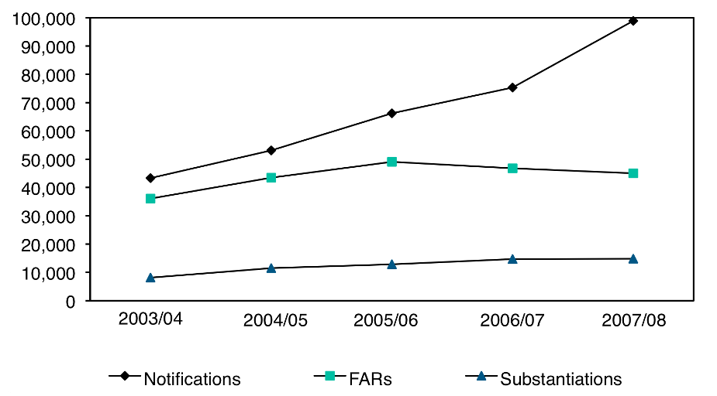

We have developed a better way to respond to some of our notifications
Differential response is about getting the right services to the right child, at the right time

Our differential response approach engages local non-government organisations to help us decide who is best placed to respond to new cases.
Differential response gives us more options for responding when we receive a report of concern about a child’s safety or wellbeing. It supports an earlier and more comprehensive response to a family’s needs, preventing more serious problems occurring further down the track.
We are implementing differential response in two phases – the internal and the external pathways:
- The internal pathway, introduced in 12 leader sites in July 2008, involves a ‘child and family assessment’. This approach is a more facilitative, less intrusive way of engaging families and identifying their needs. The majority of the families we work with will be assessed in this way. Cases involving serious abuse or violence will continue to be investigated as is current practice.
- The external pathway was introduced in the leader sites from the end of September 2008. It involves us working more closely with government and non- government agencies to respond to a family’s needs. By sharing our knowledge and expertise, we can ensure a co-ordinated and comprehensive response.
It offers a wider range of responses to meet the individual needs of each family
There will be a phased implementation across the country until differential response is implemented nationwide by 30 June 2009.

We Don’t Work in Isolation
Child, Youth and Family carries out most of the statutory functions specified in the Children, Young Persons, and Their Families Act 1989. We also work with the non-government sector and other government agencies to provide the services needed by our vulnerable children, young people and their families and whānau.
It is crucial we work effectively with other agencies and organisations for the benefit of vulnerable children and young people…
Our investment in the non-government sector through Pathway to Partnership will increase the capacity of our non-government providers. This will mean they have what they need to help us respond to families and whānau in need. In particular, it will mean they are able to support more of the families who are notified to us but for whom statutory intervention is not appropriate. This role will become even more crucial for our differential response approach.
Below is an adapted version of Figure 1 on page 3. It summarises the role of agencies (both government and non-government) in social services and highlights the role of Child, Youth and Family. It also gives examples of the range of services – from universal through to statutory. For most families, universal services and additional help through targeted services provide enough support to avoid the need for statutory intervention. For families who require it, statutory social services are most often delivered by Child, Youth and Family.
…no one agency can provide everything they need
Figure 3. Role of Child, Youth and Family in social services for families
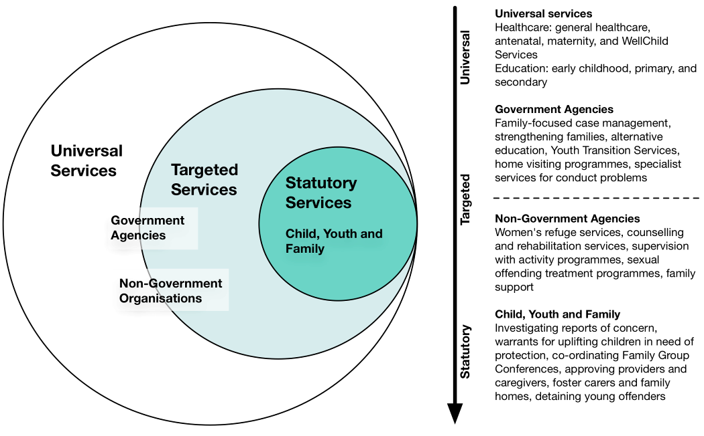
These roles are also reflected in our spending. Budgeted funding for Child, Youth and Family amounts to $407.028 million in 2008/2009. Of this, $122.587 million, or 31 per cent, is planned to be spent by providers who deliver services on behalf of Child, Youth and Family.
The most significant area of Child, Youth and Family expenditure relates to the care of children and young people in the custody of the Chief Executive. The non-discretionary care costs, of board, clothing, health and education, range from just under $10,000 per year for a child aged 0 to 4 years, to almost $13,000 per year for young people aged 14 to 16 years.
Figure 4. Child, Youth and Family 2008/2009 budgeted funding
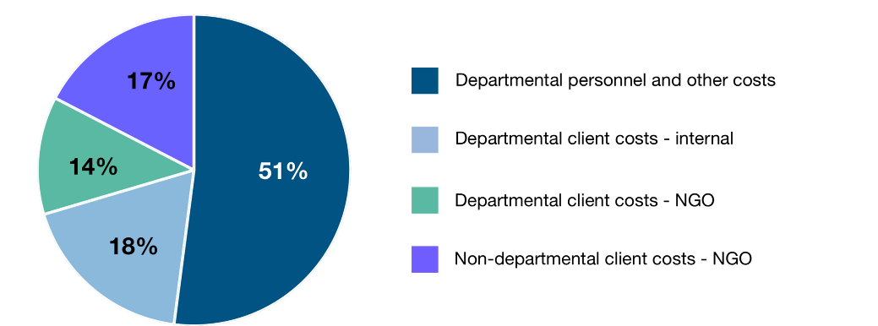
Our interaction with other government agencies can be challenging at times, mainly because we are often advocating for services on behalf of our children and young people. This is something government could be better at. To this end, a statement of collaboration was recently agreed for the Ministries of Social Development, Health and Education.
The statement covers how agencies will work together for the benefit of children and young people in care. It states that agencies will, individually and collectively, assess and meet the needs of these children and young people and make a particular effort to work together to provide timely co-ordinated services. Among other things, agencies will be expected to:
We are trying to improve the way we work with other government agencies – especially around children and young people in State care

- give special consideration to children and young people in care so they can access and receive timely, effective co-ordinated services
- have particular regard to working together at the critical transition points in the lives of children and young people
- encourage children and young people and families and caregivers to maintain relationships
- encourage families and whānau and caregivers to participate in decision-making with their children and young people in care.
We are now looking at how best to put the statement into action. This includes considering mechanisms for developing shared outcomes, undertaking joint services planning, and establishing formal monitoring and accountability mechanisms.

Child, Youth and Family is Primarily a Care Organisation
Children and young people come into our care when it is no longer possible for them to live with their parents because of serious concerns about their safety, neglect, offending, or uncontrolled and dangerous behaviour. As at 30 June 2008, 6,000 children and young people were in the custody of the Chief Executive – 4,470 were in out-of-home care and protection placements. The remaining children and young people were in other types of placement, including those living independently. About a third of our children and young people in out-of-home care and protection placements were placed with family members.
The number of children and young people in our custody is high – 6,000 children and young people

Given our focus on care, securing the safety of children and young people in a permanent home is a key function for the organisation. A delay in finding a permanent home can lead to further damage for a child or young person in care. It can contribute to placement breakdowns and the development of disruptive behaviour. The length of time spent in care can affect a child’s sense of self worth and identity. It can also impact on their ability to trust and form attachments.
If we focus our efforts on reducing a child’s duration in care, we will better support children and young people to overcome any trauma they have faced, develop positive relationships, and move on with their lives. There is also the potential to enhance the sustainability of Child, Youth and Family as a care organisation.
Reducing the time children and young people spend in care means better outcomes for all
Child, Youth and Family also plays an important role for children and young people who are transitioning from one life stage to another – most often when they are leaving care to live independently. It is important our young people have the skills they need to live successfully out of State care.

Relevant legislation
Our emphasis on care is enshrined in legislation through the Children, Young Persons, and Their Families Act 1989. The objective of the Act is to promote the wellbeing of children, young persons, and their families. In addition to this Act, we are also responsible for administrating other legislation, including the:
- Adoption Act 1955
- Adult Adoption Information Act 1985
- Adoption (Intercountry) Act 1997
- Care of Children Act 2004.
Amending the Children, Young Persons and their Families Act
In 2007, we reviewed the Children, Young Persons, and Their Families Act 1989 in consultation with key stakeholders. An amendment Bill was introduced to the House in December 2007. The Social Services Select Committee reported back to the House on 11 August 2008, and the Bill now awaits a second reading. The Bill will need to be reinstated by a resolution of the House for it to continue.
The Bill amends the Act to give better effect to its objectives and principles, mandating or directing best practice, and strengthening the effectiveness of family group conferences. The Bill covers care and protection, and offending by children and young persons.
A second phase of changes proposes to amend the language and structure of the Act, making it easier to follow and apply.

The Children we Work With are Diverse – and so are the Reasons They Need our Help
Child, Youth and Family cares for two main populations of children and young people – those who need care and protection, and those in the youth justice system.

Care and protection
Notifications can trigger positive change within families and whānau – sometimes just advice or access to services is needed

Children and young people in need of care and protection are suffering, or at-risk of suffering, harm, ill-treatment, abuse, neglect or deprivation.
Our job for these children and young people is to make sure they have the care and protection they need to be safe from harm. We also work with families to enable them to provide a safe home for their children. In many cases, the family just needs some advice or access to support services to achieve this. In other cases, we work with the family and whānau to identify the supports and services they need.
For more serious or complex cases, we hold a family group conference. This is where key people involved with the child agree on a plan to keep the child safe and identify the support they need to achieve this. Sometimes it’s not safe for a child or young person to live at home. For these children and young people, we work to ensure they have a permanent living arrangement with a family they can call their own.
Sometimes, we need to take things further – the next step is a family group conference to identify the problem and develop solutions

Youth justice
Young offenders aged 14–16 years who are referred to Child, Youth and Family make up our youth justice population.
We know that once a young person has a criminal record, they tend to carry on breaking the law and offences often get more serious. New Zealand’s youth justice system tries wherever possible to resolve offending and to hold a young offender to account without them receiving a criminal conviction. Only serious cases or those going through the Courts are referred to Child, Youth and Family.
Most of the young people who come to our attention for offending are involved with us for a short time and then move on with their lives. Through the family group conference process, we help to ensure these young people are held accountable and are encouraged to accept responsibility for their offending. We also use the conference to develop a plan to address the factors behind the offending. We may also need to provide secure residential care in some situations. We want to help these young people to learn from their mistakes and to develop in a responsible and socially acceptable way.
The services provided for these two main groups of children and young people are summarised in the table below.
Figure 5. Care and protection and youth justice services
Care and Protection Services |  | Youth Justice Services
- investigating and assessing reports of children and young people at risk due to abuse, neglect, self-harm, or behaviour  - managing cases where Child, Youth and Family intervenes to achieve care and protection outcomes  - co-ordinating family group conferences  - supporting families to meet their care, control, and support responsibilities  - providing care through foster carers and residential services  - providing resolution services to help achieve care and protection needs  - improving the life outcomes of the children, young people and families involved. |  | - providing services to manage and resolve offending behaviour by children and young people  - managing cases where Child, Youth and Family intervenes due to offending  - co-ordinating youth justice family group conferences  - supporting young people, families and providers to ensure young people achieve the activities in their individual plans  - co-ordinating community programmes that provide youth justice services  - managing residential facilities for young people on remand and serving supervision with residence orders  - assisting families to exercise their care and control responsibilities.
In the year ending 30 June 2008, 7,302 care and protection family group conferences were held.  As at 30 June 2008, 12,123 children and young people were in receipt of a care and protection social work service. |  | In the year ending 30 June 2008, 9,237 youth justice family group conferences were held.  As at 30 June 2008, 2,328 children and young people were in receipt of a youth justice social work service.

Children and young people with disabilities
Child, Youth and Family also has contact with children and young people who have disabilities. The majority of these children and young people come to us because of concerns about their abuse, neglect, or offending. A small number come to us because their parents are no longer able to cope with their disability needs. Some of these families come to us seeking out-of-home care for their child. In this situation, we work to support the family through the family group conference process.
Accessing services for our disabled children and young people can be challenging – but we are working to improve this

Some of the children and young people with disabilities in the custody of the Chief Executive have very complex needs. It can be a challenge ensuring this group of children and young people are able to access the health and education services they need. We are actively working to change this by bringing in additional disability expertise and by developing better relationships with the disability sector.

Adoptions
Adoption numbers are small, but we have opportunities for future work in this area
We also facilitate adoptions for children born in New Zealand and manage intercountry adoptions. Numbers have fallen for both types of adoption in recent years. This has provided an opportunity for some couples to provide permanent placements for children already in the care system.
The assessment of prospective parents is key. It helps us to provide the right family for each child by measuring the skills, abilities, flexibility and resilience of the applicants. As other countries have become better able to provide for their orphaned or abandoned children, those children in need of intercountry adoption are more likely to be children with special needs. This trend further reinforces the importance of the assessment process.
There are opportunities in this area of work. We want to work with the Ministry of Justice to simplify New Zealand’s adoption legislation, aligning it with best practice and our international obligations. We can then build on this by developing a policy direction for the future.

Current Picture of Child, Youth and Family

As an organisation, we face a number of challenges. The major driver of our business, and probably our biggest challenge, is the increasing number of notifications we receive. Alongside the increase in notifications are high numbers of children and young people in care and increasing numbers of children and young people with high needs. These challenges require new ways of thinking and operating.

Notifications are Increasing, but Those Requiring Intervention are Reducing
The volume of notifications continues to rise. In the year ending 30 June 2008, overall notifications increased by 31 per cent. This rise reflects a 27 per cent increase in family violence notifications from the Police. The Police are required to notify us when they are called to family violence incidents where children are present. Notification numbers are also influenced by public awareness and publicity around child abuse.
The rise in notifications is mainly due to an increase in family violence notifications received from the Police
Despite the general increase, we are intervening less than we used to. In the year ending 30 June 2008, 46 per cent of our notifications required further action (down from 62 per cent of notifications in 2006/2007). Again, this trend can be seen in the notifications coming from the Police. In the year ending 30 June 2008, 8,795 of the Police notifications required further action – 1,638 less than the year before.
Prioritising notifications according to how critical they are ensures resources are used in the best way possible. This said, the threshold for entry to services has been variable over the years and has reflected public expectations and resources. We need to reach a balance between a high threshold that presents risk for children, and a low threshold that results in unnecessary intervention and a strain on resources.

Differential response will enable use to reduce repeat notifications
The development of the differential response approach provides a significant opportunity to intervene earlier and reduce repeat notifications. Differential response is supported by our increased investment in the non-government sector through Pathway to Partnership. This investment will enhance the capacity of the non-government sector to provide targeted support for families who do not need statutory intervention.
Alongside this, family violence initiatives such as the Family Violence Interagency Response System and the Family Safety Teams provide new ways of working with families coping with violence. Both initiatives are designed to improve co-ordination and information-sharing among agencies working with these families and whānau. These initiatives are key for our response to the rise in family violence notifications.
We need to reduce the number of children and young people who require statutory intervention by Child, Youth and Family. Giving families the support they need in a community setting without the need for statutory intervention will ensure better outcomes for New Zealand’s children and young people, keep families together and ease the pressure on our business.

We Have More Children and Young People in Care Than 10 Years Ago, but Numbers are Now Reducing
Children enter our care where there are significant concerns for their safety and these numbers have grown dramatically in the past decade. Removing a child or children from a family involves us operating at the top end of our range of interventions. Sometimes it occurs with the agreement of the family and at other times, the decision is made by the Family Court. There are consequences, however, for family relationships that mean we need to be cautious about when we intervene.
Early is best – finding a permanent home for children in care becomes harder as they get older

The age of a child has a significant impact on their duration in care. Children who reach age five in care or who enter the care system after the age of five have a higher probability of staying longer or remaining in the care system. Securing a permanent home as soon as possible helps to achieve the best outcomes for our children.
The cost of children in care is the single largest economic driver for Child, Youth and Family. Children with serious conduct and behaviour problems cost twice and three times as much as those without. As well as achieving better outcomes for children and young people who come into care, finding permanent homes can also help us to manage the cost. It also presents less risk for the children who come to our attention than focusing purely on restricting the entry to care.
We need to push for permanent homes right from the start, ensuring children and young people in our care return to their families or have a family they can call their own as soon as possible. Achieving permanency means our children and young people can move on with their lives without the uncertainty of living in State care. Reducing duration in care and the use of multiple placements also saves Child, Youth and Family resources.

We Have More High Needs Children and Young People
We often knew our high needs young people when their problems were beginning…
Young people who display serious antisocial behaviour are a small but growing cohort of children in care. The young people in this group are unpredictable, sometimes dangerous, and almost always victims themselves of unthinkable crimes. They tend to attract public attention through their actions and are considered high risk by their communities.
High needs children and young people account for 20 per cent of the total cost of children in care. Their individual plans can cost up to $330,000 per year and involve multiple agencies. There are issues of capacity within the wider care system to accommodate these high needs, high risk individuals.
…later on, if problems have not been addressed, these children become some of our most expensive clients

Our challenge is to ensure that high-cost plans have a rehabilitative effect rather than purely a containment one. This ensures better long-term outcomes for the child or young person. It also enables our costs to reduce over time. There are also opportunities to use our family homes differently – with more of a therapeutic focus. The key to achieving this is access to health and mental health services. Unfortunately, the current provision of adolescent mental health services is inadequate to meet the need.
We often knew these children when their problems were just beginning. This first contact is the best opportunity for us to make a difference in the lives of these families and whānau. A delay in responding can allow the problem to escalate. As children get older and the problems become worse, they become more difficult to put right. It also becomes harder to find care placements for these children.
We need to find new ways of working with our high needs children and young people and we need to do more than just keep them safe. We also need to ensure children and young people in our care receive the services they require from other agencies at the earliest point possible. Only then will we be able to achieve the best outcomes possible for this group, with the best chance of rehabilitation.

Meeting the Needs of our Children and Young People Means Operating High Quality Facilities

Family homes
Child, Youth and Family owns 79 family homes that accommodate approximately 400 children. The way family homes have been used has largely been determined by local needs and this has resulted in their under-utilisation. We need to protect our investment in family homes and to prevent any further reduction in capacity.
There may also be opportunities to use our family homes as more effective ways of supporting our children and young people with high needs in a community-based setting. Work has begun to determine the future positioning of our family homes, as part of a review of our overall care strategy.

Residences
For those young people who cannot be cared for in a community-based setting, we also operate eight residential facilities (186 beds in total). Some of our residences are for young offenders, others are for children and young people in need of care and protection. These facilities are both capital and labour intensive. This is due to the need to ensure effective containment and to prevent the young people from harming themselves or absconding and harming others.
Rehabilitation is just as important as containment – it is what will make the difference after a young person leaves residential care

We would like our residences, particularly the youth justice ones, to be more therapeutic – to focus as much on rehabilitation as they do on containment. For this to occur, these environments need to have better access to the services we need from other agencies, such as adolescent mental health services. We also need to continue our work to address the factors behind the offending. With the better use of intensive social services, we can help prevent re-offending once young people leave the residence.

Contracted services
Aside from the facilities we own and operate, we purchase services from organisations that provide semi-residential or community-based supervised programmes. In addition, there are specialist group homes run by community-based treatment providers to care for sex offenders, and a network of providers who offer supervision with activity programmes for serious young offenders (programmes for young offenders subject to Court-ordered Supervision with Activity orders).
Child, Youth and Family has faced considerable pressure from these organisations over the years for funding to keep the programmes viable. The $446 million investment in the Pathway to Partnership programme provides a new way forward.
We need to continue thinking around how we can best use our family homes. We would like our residences to be focused as much on treatment as they are on containment. Getting this right will mean the best possible outcomes for the children and young people in residential care. It will also mean we are using our resources in the most efficient and effective way possible.

We are Committed to Increasing the Qualifications of our Staff
Child, Youth and Family employs 2,952 staff. We have supported 1,091 social workers to registration since September 2005 (260 of them have resigned since achieving registration). This means that we currently maintain a workforce of 831 registered social workers.
Our workforce is moving further into a professional era – but this places pressure on our ability to recruit the qualified social workers we need
Over the past four to six years there has been an increasing desire to have social work recognised as a profession. This reflects the developing nature of the role and the growing understanding that social workers are responsible for exercising judgement in critical situations.
There is a global shortage of social workers. Compounding this shortage is the increase in qualification levels required to achieve registration. Together, this poses a considerable challenge to, and cost for, our recruitment and remuneration. Although registration is not mandatory, there is a clear expectation social workers working in a statutory setting will seek registration. There is also an expectation Child, Youth and Family will support and advance registration among its workforce.
A significant downsizing of the National Office has occurred since the merger with the Ministry of Social Development. A number of positions were transferred into the Ministry’s corporate infrastructure. We reorganised the remaining Child, Youth and Family National Office function to achieve savings in personnel and programme administration costs. We have redirected $3.5 million of these savings to the frontline.
We need to work out the best way to attract and retain qualified social workers. To do this, we need to target our recruitment strategy to qualified social workers. To ensure they stay with us, we need to provide ongoing professional development. These areas of work will help to ensure we provide the best service possible by making the best use of our most precious resource – our staff.
Early, intense intervention has the best chance of making a genuine difference in the lives of vulnerable families

We Want to Strengthen our First Response
We want to ensure children and young people get the best possible results when they come to our attention. For many, a notification can be positive. It is often a trigger for positive change within the family.
The best window for our involvement is when children are young. The years between birth and five are crucial for attachment and brain development. This stage shapes children’s ongoing growth and future development. If disrupted, there can be profound, irreversible damage and vulnerability.
Early intense intervention creates opportunities to make a difference to the lives and outcomes of the families and whānau we come into contact with. This intervention can build safety, protection and resilience. Children under two are particularly vulnerable. They have very little ability to protect themselves from harm or to seek help. They are dependent on adults for all of their needs.
In the 2005/2006 financial year, Child, Youth and Family received notifications for 6,699 children under two years of age.
1,645 children (25 per cent of these cases) were determined at first assessment as requiring no further action (first assessment means no investigation was carried out)
1,018 children (62 per cent) assessed as requiring no further action, have been re-notified to us (as of 31 August 2008).
We could do a better job to prevent future involvement with these families if we changed the way we think about each case. We need to assess the child’s experiences over time. Each notification needs to be carefully integrated into the case history to determine harm over time and to enhance opportunities for positive change.
If we get our response right the first time, we will not only have achieved better outcomes for our families for the long term, but we will have reduced the need for future work with these families. If we can prevent the need to take children into care, this will also reduce our costs significantly. Our overall rate of repeat notifications is currently too high – 67 per cent.
Our current focus on immediate safety means we often do not see the bigger picture of the child’s life. We need to understand the cumulative harm they have experienced and to explore resilience and any protective factors. This can only be achieved by changing the way we approach each case and by ensuring the best response. Differential response, and the access it provides to non-statutory support, provides an opportunity to get families involved with services earlier.

A Chance to Make a Difference
With challenges come opportunities. Building on our current priorities, there are four focus areas where we think government could make the biggest impact. These are: developing a sustainable approach to responding to increasing notifications, being more strategic about how we use our foster carers, improving outcomes for children and young people who offend, and providing better support for young people leaving our care.

We Have a Set of Priorities to Guide our Work
In 2007, we set ourselves six priority areas in the document Leading for Outcomes. Through these priorities, we want to increase our responsiveness. We want to reduce abuse, neglect and youth offending, and to increase the number of permanent homes found for children and young people in care.
The six priorities are:
- Quality social work practice: We are entrusted with the safety, security and wellbeing of many children, young people and their families and whānau. We want to strengthen our performance and decision-making wherever possible. Meeting the highest standards of professional practice is essential, given the critical nature of the work we do.
- Addressing youth offending: Although most young people offend once and move on, there is a group of persistent offenders who cause harm to themselves and others. These young people typically come from challenging backgrounds and have multiple difficulties. Our youth justice services must meet this challenge and provide the support needed for young people to turn their lives around.
- Achieving permanency for children: Securing the safety of children who cannot live at home is core to our work as a care organisation. A sense of belonging comes with a permanent home and every young person should have that opportunity. This could be returning home, or living with their extended family or with a new family. It can take time to achieve, but this provides one of our greatest opportunities to influence long-term outcomes.
- Responding to community needs and expectations: When we work together with our communities, we shape local solutions that achieve lasting outcomes. A more developed non-government sector will allow us to access help for the many families where an early intervention may avoid the need for a statutory one.
- Outcome-focused residential facilities: Residential placements go to young people with the highest needs. The challenge they pose to the safety, security and wellbeing of themselves and others means we need an intensive and creative response. We need to ensure a young person’s time in a residence is not an isolated event in their rehabilitation path and they are well supported when they leave.
- Enhancing leadership: The leadership task at Child, Youth and Family is a significant one. We work with many of New Zealand’s most vulnerable children and young people and we need to operate with compassion and courage. We want to develop a culture that encourages and supports our staff, partners and communities to develop local initiatives that focus on breaking the cycle of child abuse, neglect, and offending in their communities.

There are More Opportunities to Make a Difference in the Future
There are a number of opportunities where government could make a difference. Four possible areas are set out below.

Responding to family violence notifications
Keeping families safe reduces the risk to children. The volume of family violence notifications we receive from the Police is higher than ever. We received 33,569 in 2007/2008, compared to 26,348 in 2006/2007. This is an increase of just over 27 per cent. If this number continues to rise, it will have an impact on our ability to cope.
The growing number of family violence notifications provides further opportunities for a more effective community response

Most of these cases are best responded to by family violence workers, not Child, Youth and Family social workers. There is a good opportunity for better community involvement through the organisations in the family violence network.
We need to work more effectively with the Police, Women’s Refuge and other non-government organisations. We also need to forge a stronger alliance with the 250 providers in the family violence network. We could make this a priority for future Pathway to Partnership funding. This would provide more capacity for responses to this type of notification.

Specialising foster care
Our foster carers are one of our most important resources. In August 2008 we had over 4,400 foster caregivers either caring, or available to care, for a child. Fifty-four per cent were approved as family caregivers and 46 per cent as non-kin caregivers. Ultimately, we would like to see our foster carers used as short-term transition care for children and young people on their journey to a permanent home. The earlier permanency can occur, the less need there will be for foster care. This will result in better outcomes for our children and young people. It will also allow scarce resources to be directed to more children in need of care and protection.
We want to focus more on children and young people with high needs…
…by upskilling our carers to provide the extra help needed by these children and young people

In particular, we want to focus on care for our children and young people with high needs. These children and young people need care, but they also need specialised help for the additional problems they face. We need to be able to better identify the interventions needed, to upskill our carers, and to ensure there is access to the right support. Basically, we want good skills in the home and quality support around the home.
We want to be able to give our foster carers the support they deserve. We can do this by providing better training and support. We also need to agree on clear expectations for all parties and to ensure carers have access to quality respite care.

Improving outcomes for children and young people who offend
One of our goals is to reduce the rate and severity of re-offending by children and young people. Basically, we want to achieve better results for children and young people who offend. To do this, we need to look for more effective ways of working with this group of children and young people. This is particularly true for the way we deal with those who have multiple, deep-seeded issues.

For children who offend
The number of children who offend has grown…
The number of children aged between 10 and 14 years who come to our attention because of their offending is growing. In 2002, we were involved with 126 children who offended. In 2007, we had 239 of these offenders. The question of how responsible children should be for crimes committed at this young age is not an easy one and these children face a great deal of public scrutiny. Like any group of people who offend, we need to strike a balance between rehabilitation that meets the needs of the child while protecting the safety of the community.
…we need to intervene earlier – when these children are still young – and before their offences become more serious

We need to consider the best accommodation arrangements for these children. Care and protection placements are not the complete answer. We want to be able to use more specialised, therapeutic placements for our child offenders in community-based settings. This would help us to achieve the best outcomes possible for this group of children.
Young children who offend provide a significant opportunity for early intervention. If we can make positive changes early on in the lives of children who offend, they have a better chance of not re-offending.

For young people who offend
A shift in focus means we are now working harder to address the factors behind the offending, as well as holding the young person to account. We work with local communities and the youth justice sector to look for opportunities for these young people. These opportunities, such as education, skill development and training allow young people to move on with their lives towards a future that is free from offending.
We are improving our capacity to accommodate offenders through the construction of an additional youth justice residence in Rotorua. We have also expanded our supervision with activity programmes for children and young people who offend.
We want to do even more to prevent re-offending, by better addressing the factors behind the offending behaviour
There are further opportunities for the way we use our supervision with activity programmes. For example, we don’t want young offenders who avoid attending their programme to view time in a residence as an easy way out of the programme. We need to be able to ensure they attend because these programmes are the best chance of making a change in their lives.

Improving transitions for children and young people
We want the young people who leave our care to be successful in everything they do. To allow this to happen, we need to ensure our young people have the skills they need to make sound decisions outside of care. This will enable them to make better transitions from State care to independent living.
Child, Youth and Family need to play a stronger role in the transitions of our young people. We would like to see every 15–17 year-old in our care have a transition plan in place. Planning shouldn’t be left until young people are aged 16 years and close to leaving our care. Our planning can only go so far. At 16 and 17 years, our young people need to be making their own choices. They need our help to make sure they make the right ones.
We need to strengthen the way we support our young people to transition from care to independence

Young people in care are less likely to have family support to fall back on as most young people leaving home do. We need to ensure these young people are able to access their entitlements, such as through StudyLink and Work and Income, and they know where to go for advice.
There is also an opportunity to make further use of the personal support provided to young people transitioning out of care. When it works well, personal advisors help young people establish their own support networks, and remain available when extra advice is needed. We want to ensure this kind of service is available to all the young people leaving care who need it.

Working with you
While the lives of most of our children and young people have improved in recent years, we continue to face challenges. Helping parents give their children the best start in life, and tackling problems before they escalate are key to making further progress.
We work alongside other government and non-government organisations, with families and whānau to get results.
We have challenges to address and opportunities to build on. We want the outcomes of the children and young people we come into contact with to be even better. We want them to reach their potential.
We will work with you to develop a work programme that delivers on your priorities as Minister.
We can provide further briefings as a basis for decisions you may wish to taken on the issues and actions we have raised.
We look forward to working with you.

Endnotes

Ministry of Social Development (2008) Preventing Physical and Psychological Maltreatment of Children in Families
Teen parents and their children have an especially high risk of long-term benefit receipt. A third of sole parents receiving benefits in 2005 had become a parent in their teens. In the same year, around 20 per cent of children were born into a family supported by a main benefit.

