Organisation briefing

CONTENTS
Overview i
Executive Summary ii
- About the Ministry of Social Development
We provide sector leadership and policy advice and deliver services 2
Social sector leadership 3
Policy advice and service delivery 5
Support for other agencies 6
Monitoring and advice in respect of Crown entities 6
MSD’s organisational structure 7
Responsibility for social services legislation 8
MSD administers $18 billion in government expenditure 8
- Where We Are Now
MSD manages by focusing on results 12
Partnering policy and delivery 12
Structured to focus on results 13
Taking a Value for Money approach 14
Governance of performance and risk 14
MSD’s capability 14
Our people 14
Working with integrity 17
Our national service network 17
We spend $18 billion on social services and entitlements 19
A national IT network and information technology systems 21
Knowledge and data about New Zealanders’ social outcomes 22
- How we work
We work across the social sector to address issues 26
Our service delivery strategy is focused on getting results for clients 26
Closer working arrangements with community organisations 27
Greater use of contact centres and on-line services 27
Integrated Service Response 28
Establishing Community Link Centres 29
Enhancing services for older New Zealanders 29
- Opportunities and Challenges
We are managing costs and getting Value for Money 32
Meeting cost pressures through this term of government 32
Implementing the Value for Money initiatives 33
We are improving our systems and developing our people 33
Implementing results-focused IT systems 34
Supporting leadership in service delivery 35
Achieving registration for Child, Youth and Family social workers 36
We work with three key pieces of legislation 36
Working with the Privacy Act 36
Rewriting the Social Security Act 36
Updating the Children, Young Persons, and Their Families Act 37
Our property portfolio supports our delivery strategy 37
We are reducing MSD’s environmental footprint 38
Working with you 39

TABLE OF FIGURES
Figure 1. MSD’s responsibilities 2
Figure 2. Government agencies across the social sector 3
Figure 3. MSD’s structure 7
Figure 4. MSD’s votes and appropriations 2008/2009 9
Figure 5. Roles added to MSD, June 2002–June 2008, by source of role 13
Figure 6. MSD’s diversity compared to the public service (June 2007) 15
Figure 7. The Ministry has a presence in most communities 18
Figure 8. We administer $16.6 billion in non-departmental spending 20
Figure 9. We are appropriated $1.156 billion for services and policy advice 21
Figure 10. Cost pressures met and remaining to be found 32

Overview
This briefing is the Ministry of Social Development’s Organisation Briefing. It contains four parts:
- Part 1, About the Ministry of Social Development, sets out MSD’s two roles, of providing social sector leadership, and policy advice and services; and sets out the funding, legislation and entities for which you are responsible
- Part 2, Where We Are Now, outlines the organisation’s capability
- Part 3, What We Are Trying to Achieve, sets out how we are working in our dual roles to get good results and to ensure our activities deliver good value for money
- Part 4, Opportunities and Challenges, is about the changes we are making to the organisation to manage costs and to make sure we are able to continue to deliver into the future.
We hope you find this briefing helpful.
We look forward to working with you to implement your priorities.

Peter Hughes
Chief Executive
Ministry of Social Development
i

Executive Summary

We deliver services, provide policy advice and help Government set priorities
The Ministry of Social Development (MSD) is the lead agency for the social sector. We help the Government to set priorities across the sector, co-ordinate the actions of other social sector agencies and track changes in the social wellbeing of New Zealanders. We also provide policy advice, and deliver social services and assistance to children and young people, working age people, older people, and families and communities.
These responsibilities involve a presence in most New Zealand communities and, in some, we are the only immediate face of government. This is reflected in the size of the organisation and the scope of your own responsibilities as Minister.
As Minister for Social Development you are responsible for some of New Zealand’s most important social services legislation, $18 billion in government funding for the delivery and administration of social services and entitlements, five Crown entities, and appointments to three statutory tribunals. You also have responsibility for the capability of four agencies that are part of MSD but work to other Ministers holding portfolio responsibilities for Youth Affairs, Senior Citizens, Disability Issues, and the Community and Voluntary Sector.
The Ministry itself is organised into 10 groups, each of which is led by a Deputy Chief Executive (DCE) and located within one of three functional clusters – service delivery, policy and corporate. We have taken advantage of having policy and delivery responsibilities located in a single organisation and we use the strengths of each to get effective frontline services and policy settings that make a difference.

We focus on both efficiency and effectiveness
We maintain a clear focus on operating efficiency, with a four-year forecast and plan for managing cost pressures. A “Value for Money” departmental baseline review has been completed this year, and its implementation is likely to enable MSD to meet wage, property and other operating cost increases from existing baselines through this term of government.
The Social Outcomes Briefing shows how, over time, agencies have had better information on where and how to work together on the root causes of problems.
We have established an Integrated Service Response case management approach which provides a key point of contact for understanding individuals’ and families’ needs and brings other agencies together around these. This is central to our Services Delivery Strategy. As part of this, Community Link Centres are being established to provide a base for the Integrated Service Response in local communities. One Community Link Centre is operating now and five others will be operating by the end of this year.

ii

We work closely with NGOs
We are working more closely with community and non-government organisation (NGO) agencies so we can make a difference earlier in the life of problems. Government’s investment in NGOs over the next four years is improving that sector’s capability. The NGO sector has a strong role to play. We are clearer now on the activities that NGOs are best placed to lead, and those where government agencies are the most effective. We get the best results where we work to our respective strengths and collaborate where that makes sense.
A further part of our Service Delivery Strategy is improving services for older people. We have piloted new services in six sites and we are working to set up a seniors’ service line to manage service delivery, work with interested groups, and look at future delivery opportunities such as telephone, internet and mobile services for seniors.

We are focused on supporting our frontline services
Changes are being made to our people and our systems to support these developments and the way of working needed for them to be effective. This includes implementing a new client management IT system to support more integrated delivery of services, and to provide on-line services for employers and clients. We are investing in our people to develop their skills and understanding so they get better results for our clients.
Action is also underway to ensure key pieces of legislation such as the Social Security Act and the Children, Young Persons, and Their Families Act keep pace with modern practice. We are also making sure our frontline locations are suited to providing the services government wants, and we are working to reduce the organisation’s carbon footprint.
iii

About the Ministry of Social Development
The Ministry of Social Development (MSD) is the lead agency for the social sector. We also provide policy advice and social services in relation to children and young people, working age people, older people, and families and whānau and communities. We do this by working with other government and non-government organisations, employers and industry, and private organisations. MSD’s services are important to every New Zealander at some point in their or their family’s lives.

WE PROVIDE SECTOR LEADERSHIP AND POLICY ADVICE AND DELIVER SERVICES
MSD has two principal roles. First, we are the lead agency for the social sector. We help the Government to set priorities across the sector, co-ordinate the actions of other social sector agencies and track changes in the social wellbeing of New Zealanders. Second, we provide policy advice, and deliver social services and assistance to children and young people, working age people, older people, and families and whānau and communities. We work directly with New Zealanders of all ages to improve their social wellbeing.
We provide assistance to more than 1.1 million individuals and 110,000 families
In both these roles, MSD has broad responsibilities for policy design, research and evaluation, and for collaboration with other government and non-government organisations.
Figure 1. MSD’s responsibilities
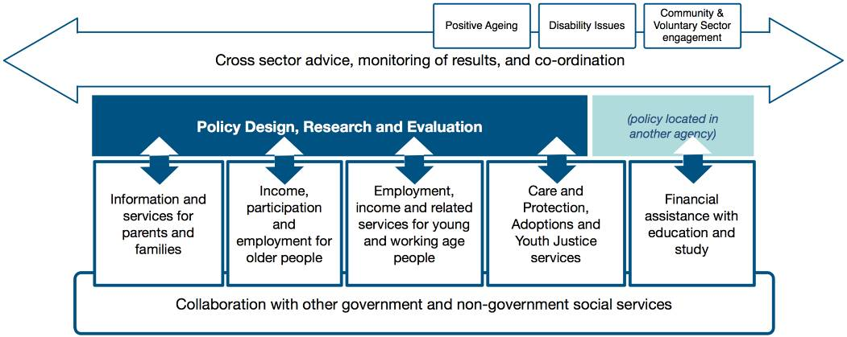
These responsibilities involve the Ministry maintaining a presence in most New Zealand communities and, in some, we are the only immediate face of government. In the service and assistance delivery role, we routinely serve more than 1.1 million individuals and 110,000 families. Last year we received 98,890 care and protection notifications, and at any time there are about 6,000 children and young people in the care or custody of the Chief Executive.
We also have a role supporting the Ministry of Youth Development and the Offices for Disability Issues, Senior Citizens, and the Community and Voluntary Sector. Each of these agencies operates as a part of MSD and is supported by our infrastructure and administrative systems.

Social sector leadership
MSD provides leadership and co-ordination among various government and non-government organisations to achieve better results. We help to identify priorities and to promote action where agencies can best achieve results by working together. The social sector encompasses the social services, education, justice and health sectors.
The lead agencies for the social sector make up the Social Sector Forum
Each of these four sectors has a lead Ministry, the Chief Executive of which is a member of the Social Sector Forum (SSF). The Chief Executive of MSD chairs the SSF which meets regularly with a focus on making sure cross-sectoral action is occurring where it is needed. The social sector also includes community, voluntary and private organisations which deliver many social services.
Figure 2. Government agencies across the social sector
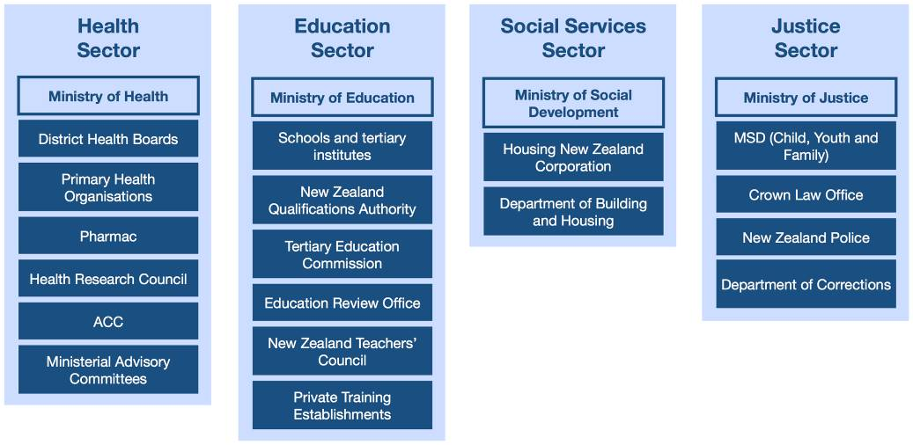
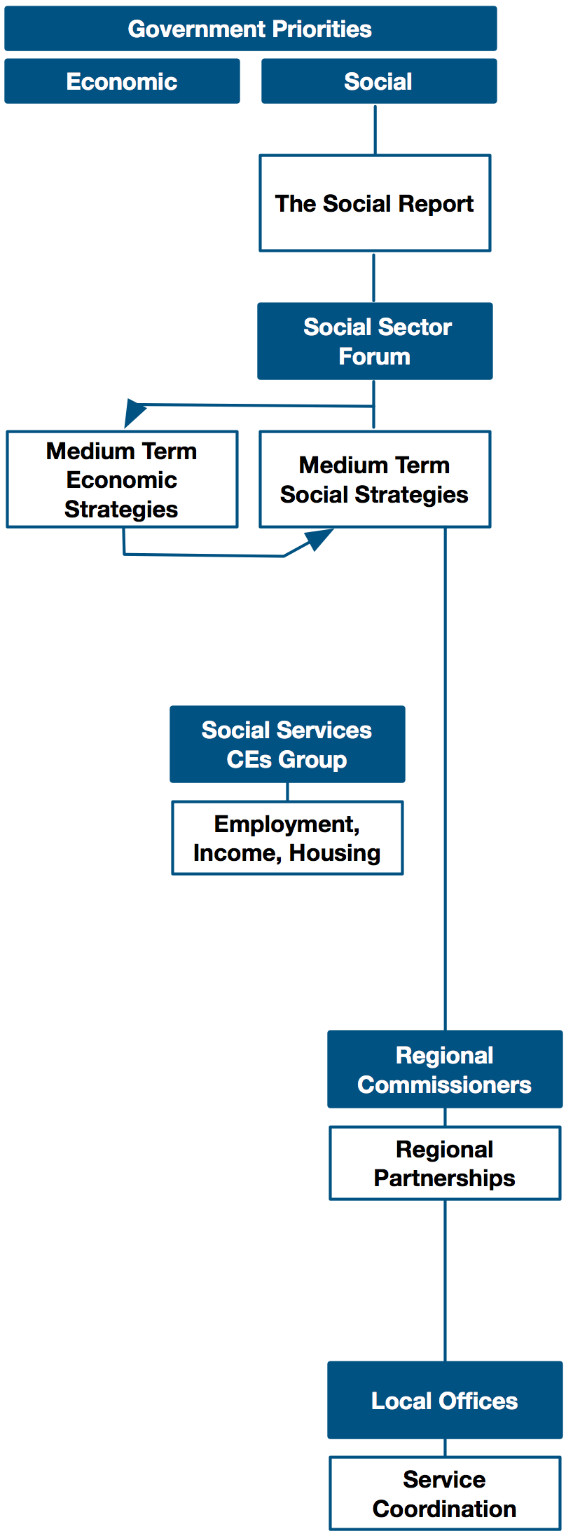
MSD leads work at the national, regional and local levels, and provides second-opinion advice on proposals of all kinds that have implications for social wellbeing. We also participate in cross-sector and cross-government work that is led by others.

MSD’s lead agency role includes responsibility for the annual Social Report. This document analyses and comments on New Zealand’s social progress, and helps the Government to set its priorities for action. The Social Report informs the SSF as it provides advice to the Government on sector-wide strategies, and agrees action in support of these strategies. The SSF’s work includes the co-ordination of social sector agencies in the development of the Budget. It also operates as a Chief Executives’ steering group and clearing house for initiatives such as Justice Sector Effective Interventions, Schools Plus, Pathway to Partnership (a package for non-government organisations), and Early Years (a framework for supporting the care and development of children aged 0–5 years).

The Chief Executive of MSD also leads the Social Services Chief Executives Group that includes the Chief Executives of the two housing agencies. The group has led welfare and housing initiatives such as the South Auckland 90 Day Action Plan, Youth Transitions Services and joint Housing and Work and Income Services across Auckland. It has also contributed to work on housing affordability.

MSD’s Regional Commissioners also work across the social sector. They work closely with local government, and with other government and non-government organisations and industry at a regional level. MSD staff and offices are used to support this form of cross-sector work. An example is the Youth Gangs in Counties Manukau initiative undertaken by MSD with the Police and other agencies.

MSD’s local staff are the only immediate face of government in many communities. These staff provide a point for co-ordinating and extending the delivery of various government services. An example is our Integrated Service Response approach to helping individuals and families with serious or multiple problems. This involves bringing together government and non-government organisations to help families address the root causes of their problems.

Policy advice and service delivery
MSD is the Government’s lead provider of policy advice and services in respect of children and young people, working age people, older people, and families and whānau and communities. As noted, our service lines provide services and assistance to more than 1.1 million individual New Zealanders and 110,000 families/whānau. We have seven principal service lines:
- Work and Income operates out of 142 service centres throughout New Zealand and 5 contact centres. It helps people to find work, and receives 1.6 million applications each year to provide income support for those who are unemployed or unable to work, and to provide income assistance to working families.
- Child, Youth and Family operates out of 55 local site offices, 79 Family Homes and one contact centre. It also has eight residential facilities, seven of which it operates itself. Child, Youth and Family provides statutory care and protection services, youth justice services, and adoption services. It received 98,890 care and protection notifications last year, of which 46 per cent required further action. At 30 June 2008, 6,000 children and young people were in the care or custody of the Chief Executive, of whom 4,470 were in out of home care and protection placements.
- Seniors’ Services pays New Zealand Superannuation and related entitlements to 530,000 older people and veterans, and administers New Zealand’s international welfare portability arrangements. Many of its services are provided through local Work and Income offices. It also administers the SuperGold Card, which subsidises goods and services for 525,000 seniors, and the Community Services Card which provides subsidised access to healthcare, of which there are nearly 1 million cards on issue.
- Family and Community Services (FACS) operates out of regional offices in, Auckland, Rotorua, Wellington and Christchurch. It contracts with community and non-government organisations to provide more than $80 million in family support services. FACS also leads cross-government services for families and whānau and communities. These include family violence intervention services, Strengthening Families and Family Start, Settling In services to help connect refugees and migrants to their communities, and local services mapping.
- StudyLink operates out of six permanent offices, 35 outreach services that operate as needed on campus sites and in Work and Income offices, a contact centre, and a central processing centre. It pays student loans and allowances to more than 235,000 students so they can undertake tertiary studies.
- Integrity Services operates out of 10 offices, one contact centre and a National Data-match Centre. It undertakes more than 25,000 investigations each year and carries out data-matches across more than 12 million records each year. It proactively visits more than 10,000 clients each year to help them understand and comply with their obligations.
- Debt Management offices operate in four locations around New Zealand, and manage the repayment of debts and recoverable grants owed by former clients. Debt Management is part of the Integrity Services Group.
Support for other agencies
MSD supports the Ministry of Youth Development and three Offices, which provide advice and services to their portfolio ministers:
- The Ministry of Youth Development supports the Minister of Youth Affairs and provides policy advice on issues for young people. It also administers some programmes specifically for young people.
- The Office for Senior Citizens supports the Minister for Senior Citizens and leads cross-sectoral work on the needs of older people. It provides advice and works with other departments to make sure government policies and programmes support strong outcomes for older people. It leads work on the New Zealand Positive Ageing Strategy.
- The Office for Disability Issues supports the Minister for Disability Issues. It provides advice and works with other departments to enhance the participation of people with disabilities in society and in work activities. The Office leads the New Zealand Disability Strategy.
- The Office for the Community and Voluntary Sector supports the Minister for the Community and Voluntary Sector. It provides advice on the work of the community and the voluntary sector, and it works with government, community and voluntary organisations to maintain and enhance the relationship between them.
Hosting smaller agencies on the MSD platform reduces operating costs and frees them up to focus on their core business tasks
Having these agencies on the MSD platform reduces their operating costs and enables them to focus on their core businesses. The Ministry of Youth Development and the Office for Senior Citizens are funded through their own Votes, while the Office for Disability Issues and the Office for the Community and Voluntary Sector are funded through Vote Social Development.

Monitoring and advice in respect of Crown entities
MSD supports you as Minister to carry out your responsibilities for five Crown entities:
- The Children’s Commissioner
- The Families Commission
- The New Zealand Artificial Limb Board
- The Retirement Commissioner
- The Social Workers Registration Board.
We work with you to set clear expectations and communicate these to the Crown entities, and to make statutory appointments. We also monitor the operation and performance of the entities.
We also provide you with advice on appointments to three statutory tribunals: the Social Security Appeal Authority, the Social Workers’ Complaints and Disciplinary Tribunal, and the Student Allowance Appeal Authority.

MSD’s organisational structure
The Ministry is organised around 10 groups and service lines, each is led by a Deputy Chief Executive (DCE) and located within one of three functional clusters – service delivery, policy and corporate:
- Service delivery is focused on providing services and assistance to clients through four separate service delivery lines: Child, Youth and Family; Family and Community Services; Seniors, Students and Integrity Services; and Work and Income.
- Policy comprises two groups: the Social Sector Strategy Group and the Social Services Policy Group. The former undertakes evaluation and research, and provides social sector-wide advice. The Social Services Policy Group provides advice on services for children and families, young people, working age New Zealanders and older people.
- Corporate comprises four groups that support the service delivery and policy clusters, and provide day to day services to Ministers. The support functions include human resources, financial management, and property services to all parts of the Ministry, along with internal audit and risk management services, legal services, planning, communications, and client reviews and appeals. Specific day-to-day services to Ministers include assistance with responding to Official Information Act requests, Parliamentary questions, correspondence from clients and constituents, and some Select Committee matters.
Figure 3. MSD’s structure
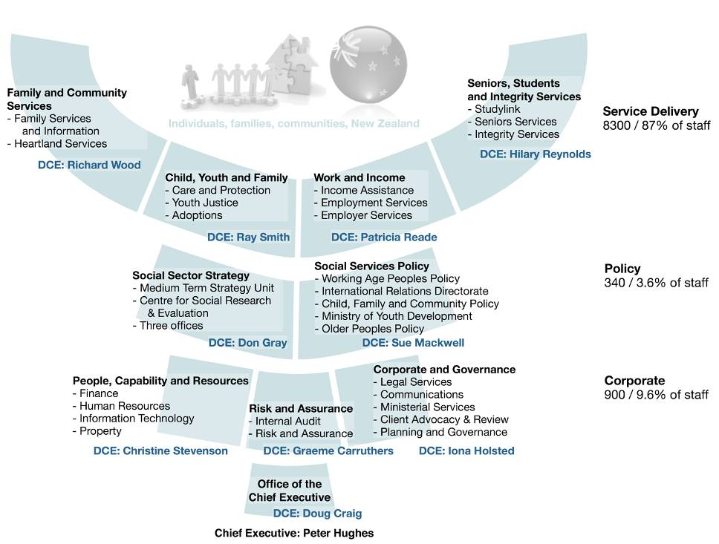

Responsibility for social services legislation
The Ministry of Social Development is responsible for the administration of a number of significant statutes including the:
- Children’s Commissioner Act 2003
- Children, Young Persons, and Their Families Act 1989
- Department of Child, Youth and Family Services Act 1999
- Disabled Persons Community Welfare Act 1975 (except Part 2A which relates to the rights to review of people in residential care)
- Education Act 1989 (Part 25 which sets out the administrative provisions for student loans and allowances)
- Employment Services and Income Support (Integrated Administration) Act 1998
- Families Commission Act 2003
- New Zealand Superannuation and Retirement Income Act 2001 (parts of it)
- Social Security Act 1964
- Social Workers Registration Act 2003.
Some of this legislation governs the administration of income support programmes delivered by the Ministry, such as the Social Security Act 1964. Other statutes apply to the delivery areas for which we are responsible, such as the Children, Young Persons, and Their Families Act 1989, or to the Crown entities we monitor, such as the Families Commission Act 2003.
Where we deliver services for which we do not hold the corresponding policy responsibility, we are governed by legislation administered by other departments.

MSD administers $18 billion in government expenditure
The Ministry administers four Votes that collectively total $18 billion
The Social Development portfolios together account for $18 billion in annual appropriations (2008/2009, GST excluded).
This funding is drawn from four votes:
- Vote Social Development (this includes the former Vote Child, Youth and Family)
- Vote Veterans’ Affairs – Social Development
- Vote Youth Development
- Vote Senior Citizens.
Vote funding is divided into two types: departmental, which funds government departments’ operations; and Crown (non-departmental), which largely funds benefit and allowance payments and services delivered in accordance with legislated entitlements.
MSD is appropriated $1.156 billion in ongoing departmental operational funding. Further detail on this is provided in Part 2 of this briefing.
Our Crown spending is divided into four categories: benefits and other unrequited expenses, which are benefit and social assistance payments; non-departmental output expenses, which are mainly for Crown entities and some services including Ministry of Youth Development programmes; capital expenses, which are largely made up of student loans and recoverable assistance; and other expenses, which are various costs incurred by the Crown (for example, provisioning for the management of debt and some employment-assistance programmes).
MSD provides income support to veterans through the payment of Veterans’ Pensions. On 1 July 2008 responsibility for disablement pensions transferred to the Ministry of Defence.
Figure 4. MSD’s Votes and appropriations 2008/2009
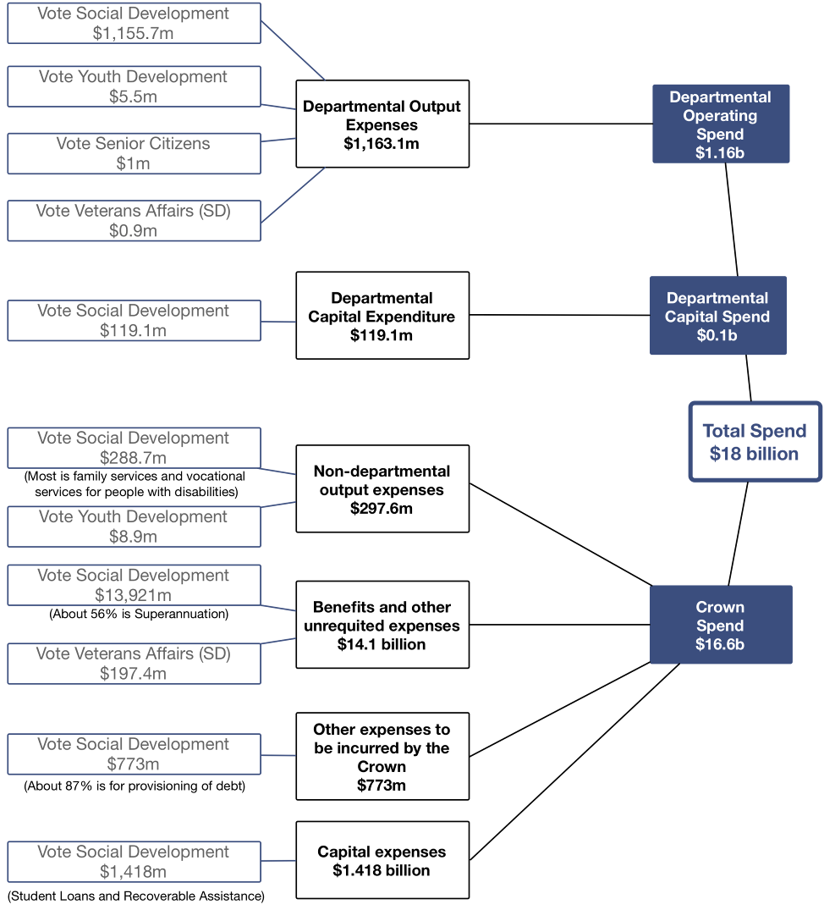

All figures GST exclusive (where applicable)

Where We Are Now
The Ministry of Social Development has effective structures, systems and processes for performing its roles and for managing its resources. Those resources include $18 billion in annual funding, 9,500 staff and a network of about 300 locations nationwide. MSD has developed substantial capability on behalf of government and an organisational focus on achieving the best results for New Zealanders. We have developed a Value for Money approach to planning and financial management, and governance structures that include external, expert review of our operations.

MSD MANAGES BY FOCUSING ON RESULTS

Partnering policy and delivery
MSD’s structures, systems and processes have been developed to support its policy and delivery strengths, and to promote efficiency in all areas. There is a particular emphasis on joining policy and delivery functions so that practical considerations are to the fore in policy advice, design and evaluation, and policy implementation is well planned. The Ministry’s formation in 2001 brought together a large delivery agency and a policy agency. These, and other functions that have subsequently been added to MSD, are now strong partners within the one Ministry.
Our processes for designing new policies and programmes take advantage of the respective strengths of policy and delivery functions.
We have delivery responsibilities without the matching policy responsibilities in three areas: Youth Justice and Adoption Services, and the provision of financial assistance with study.
Our position today reflects many organisational developments since 2001. Mergers and new functions have added responsibilities to MSD in respect of families/whānau, children, young people, people with disabilities, and the community and non-government sector. Key developments have included:
- in 2002 the Office for Disability Issues was established within MSD
- in 2003 the Office for the Community and Voluntary Sector was established within MSD, and the Ministry of Youth Affairs was moved onto the MSD platform and renamed the Ministry of Youth Development
Since 2001 the Ministry has been added to through mergers, new functions, and new programmes
- in 2004 Family and Community Services was established to lead and co-ordinate services for families/whānau, bringing together some existing services and taking on some services transferred from Child, Youth and Family
- in 2005 the functions of the Community Employment Group from the Department of Labour were moved to MSD and refocused on community labour market development
- in 2006 the Department of Child, Youth and Family Services (Child, Youth and Family) was merged with MSD.
There have also been significant new programmes such as Working for Families, other family-focused initiatives including family violence services, and new data-matching and benefit fraud programmes. MSD staff numbers grew by about one-quarter between 2001 and mid-2005. Since then, excluding the merger with Child, Youth and Family, staff numbers have trended down.
Figure 5. Roles added to MSD, June 2002–June 2008, by source of role
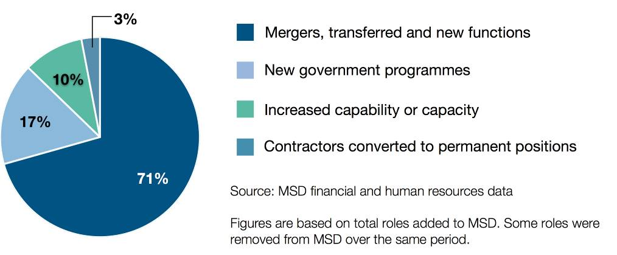

Structured to focus on results
The Ministry has been structured so it maintains a clear focus on operating efficiency and achieving results through its various service lines and groups. As each area has achieved consistent performance, it has then looked at what opportunities exist to make a greater contribution towards New Zealanders’ wellbeing. For example, StudyLink introduced its StudyWise service, which makes students aware of the practical implications of their borrowing, and helps them to make good financial decisions. Integrity Services has introduced Early Intervention Services where staff visit clients in their homes, and verify they are receiving their full entitlement and they are aware of their obligations and the consequences of benefit fraud.
Work and Income has focused on sustainable employment, where results are measured in terms of how long people are maintained in work once they have been helped to get a job. The approach has led to new services that include Job Partnerships with industry and employers, assistance with things such as transport and childcare, and the provision of specialised help for people who face barriers through sickness or disability.
As we have achieved consistent performance, we have sought improved results
In some cases MSD’s service lines have also been able to make a bigger difference by working together. For example, Work and Income’s Youth Transitions Services have been effective when used with Child, Youth and Family’s Youth Justice clients, and FACS has developed Family Violence Intervention Services that are delivered by Work and Income case managers.
Child, Youth and Family has achieved a stable and improving level of performance, is financially sustainable, and has a multi-year plan (Leading for Outcomes) that includes priorities and performance targets for improvement. In 2008, Child, Youth and Family is trialling results-based performance measures that focus not just on the number of interventions made but on recurrence, or the number of families that require its help on subsequent occasions beyond the initial contact.

Taking a Value for Money approach
We maintain a four-year forecast and plan for managing cost pressures across the organisation. Cost-saving initiatives are planned well in advance and, wherever possible, are managed through staff attrition so there is the least impact on organisational performance.
Our approaches to managing performance, risk and costs are well established and externally governed
Managers are expected to fund cost increases through increased efficiency and productivity and through reductions in overhead costs.
Part 4 of this briefing sets out how we have undertaken departmental baseline reviews in 2005 and 2008 to find ways of meeting future cost pressures. Our approach has been identified as providing opportunities across the public service.

Governance of performance and risk
We have well established, effective performance and risk management processes across the Ministry. A major feature of these is two governance committees that operate independently of the Leadership Team and include expert members who are external to MSD. These are an Audit Committee and a Value for Money Advisory Board, both of which are chaired independently by an individual with extensive private sector business experience. The Audit Committee also includes two other external members, and the Value for Money Advisory Board includes private sector experts and representatives from the Treasury. Both governance committees operate with a clear mandate from MSD’s Chief Executive.
The Ministry’s Leadership Team maintains a strong focus on performance and risk management. Some DCEs are members of the governance committees.

MSD’s Capability

Our people
The Ministry’s approximately 9,500 employees represent 22 per cent of the public service and 4 per cent of all people working in the State sector as a whole. It is important we reflect the population we serve and the diversity of New Zealand society. Half of all senior managers are female, and the proportion of staff who are Māori or Pacific is higher than for the population as a whole.
Figure 6. MSD’s diversity compared to the public service (June 2007)
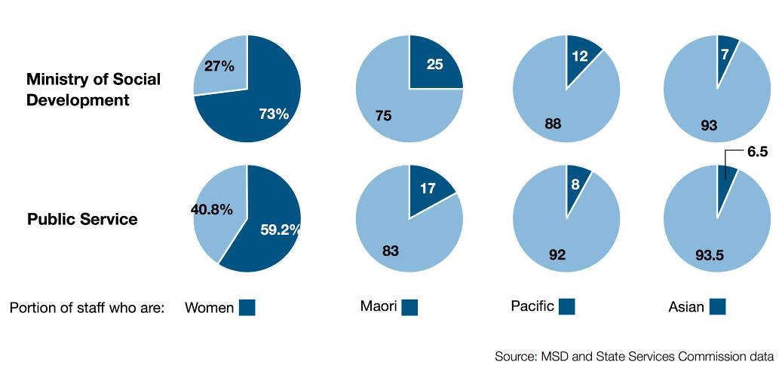
Staff turnover is in line with the public service average, while the incidence of personal grievances is below the average. We have 6,140 staff on six separate collective employment agreements. Changes in the remuneration and employment terms of our staff have been consistent with overall labour market trends. The Ministry’s managers are conscious of our ability to influence pay trends across the public service, and industry-standard systems are applied to maintain wages and salaries in line with market averages.
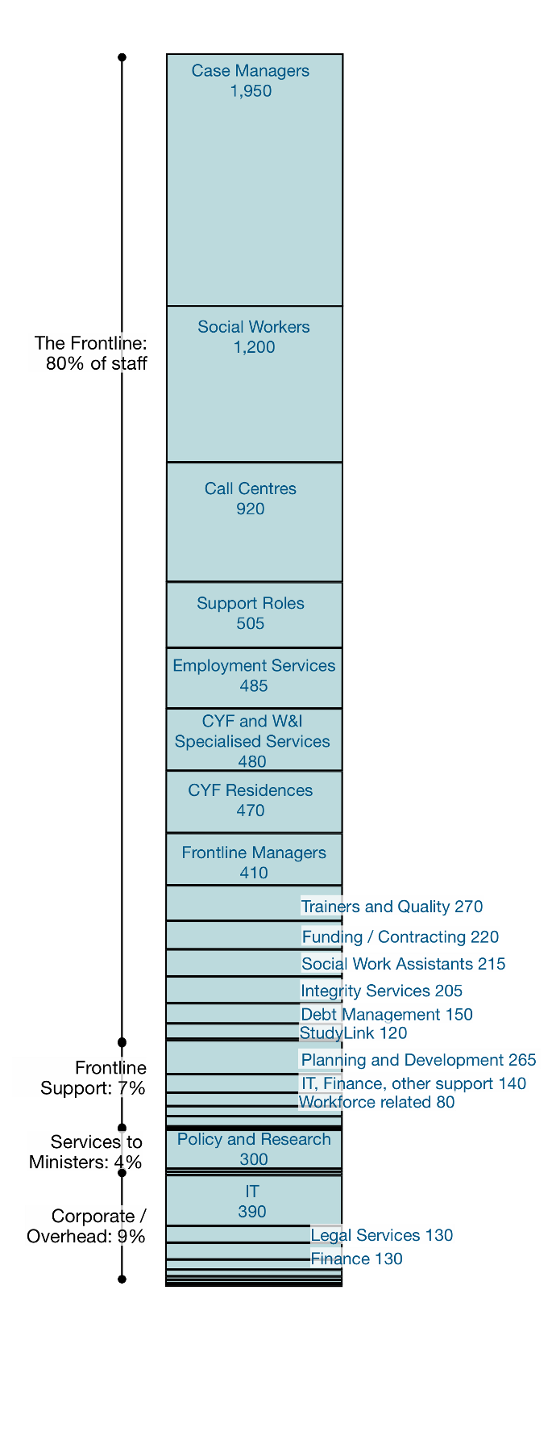
MSD’s staff work in a range of specialised professions.
80 per cent of all staff have frontline roles. They include:
- About 1,200 professional social workers whose registration requires a Bachelor’s degree in social work and a competency assessment.
- About 2,000 case managers who have NZQA-approved qualifications. These include about 290 specialist delivery staff working in areas such as childcare, health and disability.
- More than 900 people in call centres who, together, receive more than 150,000 calls each week in 12 different languages.
- Staff who manage Child, Youth and Family’s residences, or who have other frontline duties that include delivering loans and allowances to students, visiting approximately 15,000 clients each year to detect or minimise benefit fraud, data-matching 12 million records, managing client debt, and/or managing more than 2,500 social service contracts with a value of around $600 million.
About 7 per cent of MSD’s employees directly support frontline services. These roles are service development, administrative processing, workforce development, planning and monitoring, and certain information technology, communications, and finance roles that give direct support to frontline delivery.
About 4 per cent of staff provide advice and services to Ministers. They include 330 staff engaged in policy, research, and evaluation, cross-government consultation and co-ordination, and forecasting and modelling. A further 25 staff manage correspondence from clients and other New Zealanders, respond to Official Information Act requests, and provide advice on Parliamentary Questions and some Select Committee matters.
About 9 per cent of staff are in corporate roles. Nearly 390 staff operate MSD’s IT systems and 130 provide legal services. Many of the latter work with Child, Youth and Family social workers in relation to Courts’ administration of the Children, Young Persons, and Their Families Act. Corporate groups are benchmarked against the wider corporate sector to assess performance and productivity.

Working with integrity
As a core public sector organisation it is important the Ministry is seen to operate with integrity. We have an ‘own it, fix it, learn from it’ approach in relation to mistakes but, at the same time, we are active in defending ourselves if we are wrongly or unfairly criticised. In addition, we have a ‘zero tolerance’ policy in relation to staff benefit fraud, misuse of client personal information or misconduct in relation to young people in residences. Zero tolerance means summary dismissal, referral for prosecution and full restitution (where relevant) in every case.
Our Integrity Services function works across the organisation to detect and prevent benefit fraud, and to protect the integrity of the system. Last year we established a Fraud Intelligence Unit to deploy more sophisticated modelling and data-mining approaches, and to enable us to get ahead of emerging fraud trends. In June 2008, the Auditor General released a review of our benefit fraud related activities and this concluded that our approaches were sound.
We have client complaint, review and appeal processes for all of MSD’s frontline delivery responsibilities. These are administered and overseen independently of the service lines. This year we introduced a new Child, Youth and Family complaints process that is supported by a service charter.

Our national service network
We operate out of about 300 locations nationwide. Our network of offices means we can provide face-to-face delivery of a broad range of social services. About 80 per cent of our staff work in one of these locations and are involved in frontline delivery.
We operate out of 292 locations, in which many of our 8,300 frontline staff work
MSD has an ongoing programme of review of its locations and properties; where they are needed, and what communities’ future needs may be, including a multi-year property strategy for Auckland. Community Link Centres are part of our new approach to the delivery of services, and will replace other locations as they are progressively introduced.
The Crown owns, and we are responsible for, the eight Child, Youth and Family residential facilities and 79 family homes. One of the residential facilities, while owned by the Crown, is operated by Barnardos. We are currently managing the building of another $62 million residence and managing major upgrades to an existing residence.
Figure 7. The Ministry has a presence in most communities
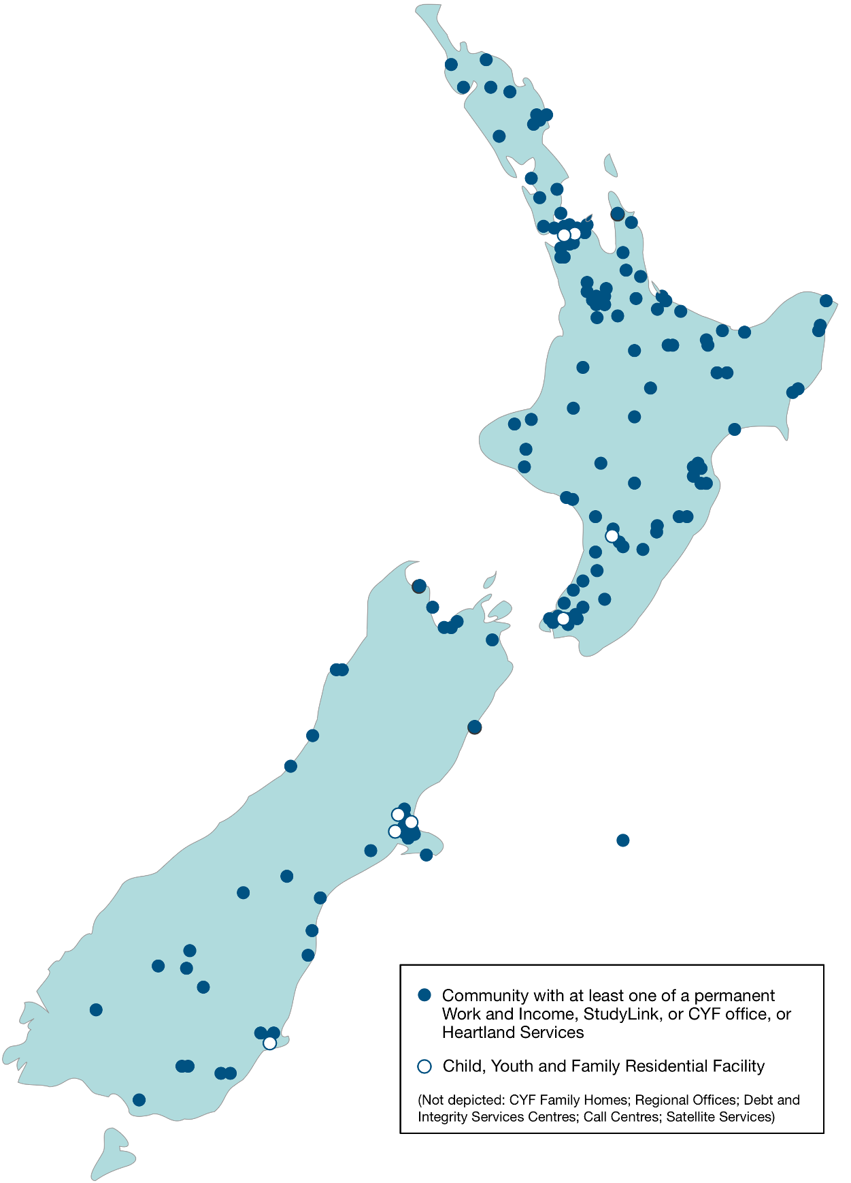

Staff safety
Our staff deal with some people who have difficult personal circumstances and may become threatening or violent. This may occur in a local office, a Youth Justice facility, or a private home being visited by Child, Youth and Family or Integrity Services staff. We have protocols with the Police for protecting staff working away from MSD sites, and all Work and Income service centres and StudyLink Outreach sites have security guards and closed circuit television surveillance. Child, Youth and Family offices have guards on call.
Each day we manage incidents of violent and threatening behaviour towards our staff
On average our staff experience approximately 5 incidents of violent, threatening or abusive behaviour each day, though only a small percentage of these involve some form of assault, theft, serious intimidation or wilful damage. Training and support is available for all MSD staff where this is needed.

We spend $18 billion on social services and entitlements
As noted in Part 1, MSD administers $16.6 billion in non-departmental expenditure largely comprising benefit and allowance payments. The annual appropriation for these is based on forecasts influenced by demographic shifts, economic and social trends, and changes in policy settings.
Approximately $350 million is spent on programmes where you as Minister have some discretion. These are generally Ministerial Welfare Programmes, the eligibility rules for which are set by you under delegation from legislation. Examples of these are Recoverable Assistance ($122 million) and Hardship Assistance ($170.4 million).
A large part of our spending is on legislated payments and entitlements
Figure 8. We administer $16.6 billion in non-departmental spending
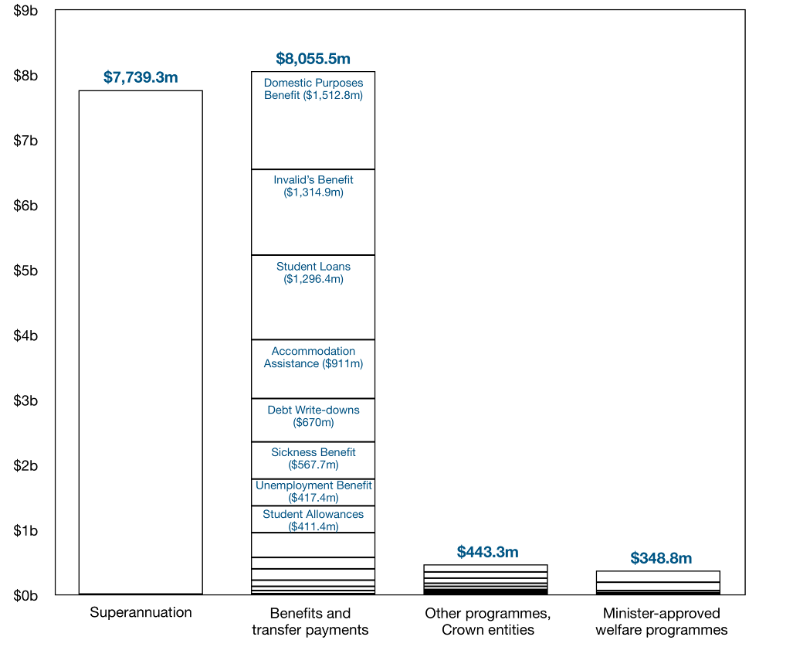
Of the total $1.16 billion that makes up MSD’s departmental baseline, $610.5 million (53 per cent) is spent on salaries and other personnel costs. A further $217.7 million (19 per cent) is spent on third party services for clients. Most of this is accounted for by the costs borne by Child, Youth and Family carers and funding for the Training Opportunities programmes delivered through the Tertiary Education Commission.
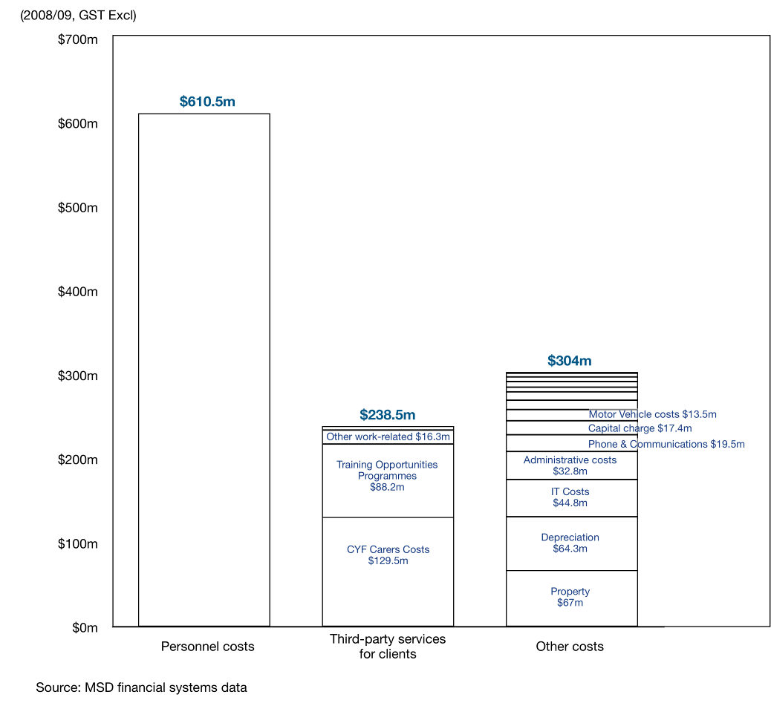
Figure 9. We are appropriated $1.16 billion for services and policy advice
Our service and processing requirements make us the 10th largest user of IT in New Zealand

A national IT network and information technology systems
The Ministry is the 10th largest user of information technology (IT) in New Zealand. We operate a nationwide, networked IT infrastructure that involves the provision of payments and services to clients through mainframe systems similar in scale to those used by the major trading banks.
The main systems include:
- SWIFTT, the Ministry’s main benefit payment system, which reports 1.2 million transactions per day
- CYRAS, Child, Youth and Family’s case management system, holds information to support the work of social workers
- TRACE, the Ministry’s system for managing debt, recoverable assistance, and fraud, which reports more than 200,000 daily transactions
- SOLO, a case management system, which holds employment-related client information and supports activity such as work tests
- SAL, which enables students applying for a Student Allowance to be assessed and paid.
We outsource the management of our key mainframe systems, which are housed in Wellington and Auckland, to EDS who provide the specialised housing the hardware requires. We are presently moving our mainframe-based systems to a platform that requires less specialised housing and is more broadly supported, to give us more options to maintain them and reduce costs.
We have been early adopters of technology that enables us to deal with clients away from the office setting, where this leads to improved results. In 2007/2008, 90 per cent of student loan and allowance applications were lodged on-line.
We have introduced on-line job-matching systems to free up case managers to spend more time working with clients, and over the next four years we are introducing a range of on-line services for students, working age, and older clients. These will enable many transactions to be moved on-line, let clients assess their eligibility over the internet, and enable employers and jobseekers to list and apply for vacancies on-line. We are also introducing some new on-line channels to support the work of NGOs and other third-party service providers.
We have been early adopters of electronic delivery and are expanding this
Our office network is supported by contact centres that can help clients with basic transactions such as reporting changes in their income. Our contact centres deal with nearly 22,000 calls per day, freeing up case managers and social workers to spend more time with clients. In addition, our Family and Community Services service line has established an on-line searchable directory to provide information about local family and community service providers.

Knowledge and data about New Zealanders’ social outcomes
Our knowledge of New Zealanders’ social outcomes and of what works to improve these outcomes is a huge asset for MSD. Much of this knowledge resides with the Centre for Social Research and Evaluation (CSRE), provider of the Ministry’s research and evaluation needs, and increasingly those of the broader social sector. CSRE’s Living Standards research is world-leading, and has led to the development of a scale for measuring standards of living (ELSI scale). CSRE also undertakes evaluations of services delivered on the ground. It has developed methodologies to undertake real-time evaluations of services while they are being delivered so we can make improvements as we go.
As part of our social sector leadership, we provide knowledge to various other agencies. We host the Social Policy Evaluation and Research Committee (SPEaR). SPEaR was set up to co-ordinate social policy research across government. It is headed by an independent chairperson and works across public, private and tertiary sector providers and users of information, to foster the capability of the sector to provide advice that is informed by good evidence. It reports to the relevant portfolio Ministers for Social Development; Statistics; and Research, Science and Technology through the Ministry’s Chief Executive.
The Information Analysis Platform (IAP) is MSD’s data warehouse. The IAP provides one centralised platform for all data analysis and management reporting and contains data from Ministry of Social Development and Child, Youth and Family Services systems dating back to 1992. The data is used by staff in a number of social sector departments.
Data from the IAP allows us to understand what assistance people are receiving and how parts of their circumstances change. This helps us to target assistance to where it is effective and to look at improvements. The IAP also provides data for frontline systems that give managers, social workers and case managers reliable and up-to-date information about their cases, caseloads and the local labour market.
By linking policy and delivery functions, we have improved our ability to gather and use information about service effectiveness and local needs and to feed it into our national policy work. We actively seek and apply the knowledge held by frontline staff who are often well placed to see what is needed and what will work with clients. Some of our policy staff are based in the regions to help with this.

How We Work
MSD is leading collaboration across the social sector where agencies need to work together to get better results. MSD is also moving forward with practical approaches to helping people address their problems earlier and at a more fundamental level. Our Service Delivery Strategy is forming new links between government agencies, and non-government and community-based organisations to deliver integrated assistance to families and individuals, with a special focus on children and seniors.

WE WORK ACROSS THE SOCIAL SECTOR TO ADDRESS ISSUES

Strengthening our Social Sector Leadership
MSD was set up in 2001 with a brief to lead collaboration across the social sector to get better results. Early on we established the Social Sector Forum of Chief Executives (SSF). This is now a mature and effective team, which is providing strong leadership across social sector agencies. We also consolidated MSD’s social research, evaluation and monitoring activities in the Centre for Social Research and Evaluation and now have much better information on social issues and trends. We also know much more about which policies and interventions will make a difference and get results.
More recently we have consolidated all of MSD’s social sector focused policy resources into a Medium Term Strategy Unit (MTSU). The new unit is leaner, more agile and will draw on skills, experience and perspectives from across all social sector agencies, initially by way of seconded staff.
The MTSU will support the SSF Chief Executives to advise the Government on medium term (3−6 years) strategies for the social sector and lead the implementation of these. These strategies will focus on areas where agencies need to act together to get better results. Some of them are outlined in the SSF’s Social Outcomes briefing.
The MTSU will provide advice that is relevant to both frontline services as well as policies and programmes. About half of the MTSU’s staff are located outside Wellington in the regions.
MSD’s social sector leadership role carries through to the regions with our Regional Commissioners for Social Development often being called upon to lead change in their communities. This is particularly the case where government agencies, local government and non-government organisations need to be brought together to drive improvement.

OUR SERVICE DELIVERY STRATEGY IS FOCUSED ON GETTING RESULTS FOR CLIENTS
We recognise that our clients have different levels of need and that our response needs to be tailored to that need. Many people who come to MSD have simple short-term needs which can be met quickly and simply. Others have multiple, complex and long-term issues. They are also likely to be the clients of other government and non-government agencies. This latter group requires greater help over a longer period of time.
Our service delivery strategy involves:
Investments in community-based providers will enable us to work more closely with them

- strengthening our working arrangements with community and non-government agencies
- greater use of on-line services to deal with simple transactions, in order to free-up resources to deal with more complex client needs
- making the Integrated Service Response a core part of how we work with individuals and families with complex needs
- bringing the functions of MSD and other government and non-government organisations together in Community Link Centres where we can, and co-locating MSD functions wherever possible
- enhancing our delivery of services to older people so that we provide greater support to those who have more complex needs.

Closer working arrangements with community organisations
Government social services work primarily at the statutory and remedial end of the service spectrum, while non-government services tend to work at the preventative end. It is essential that both have the capacity and capability to work effectively. Effective early intervention by non-government community based organisations will reduce the need to take expensive remedial action in the future. We therefore need to build the capability of the non-government sector.
MSD is working closely with community providers to implement the Pathway to Partnership programme. This programme is intended to fully fund essential social services provided by non-government organisations. Extra funding to the order of $52 million is being made available in 2008/2009. The programme rolls-out to provide an additional $192.8 million in 2011/2012.
Over the last few years we have worked hard to build a much stronger and more effective relationship with the non-government sector. Pathway to Partnership is providing us with an opportunity to take this relationship to the next level. The roll-out of the Pathway programme is being overseen by a joint MSD−non-government sector steering group and the end of the roll-out will see a whole new funding regime and model put in place.
To support this, across MSD, we are bringing our funding arms together in a single, frame-worked approach which will reduce double handling and ensure a ‘single face of MSD’ to the providers we fund.

Greater use of contact centres and on-line services
Our delivery strategy includes increased use of on-line services and contact centres for our straightforward and simple transactions. On-line services can also help people get better access to general information. MSD, through Studylink, has been providing many of its services to students through on-line services. Students are able to apply for study assistance and update their records through this service.
There is scope for greater use of on-line services for a wider range of our simple transactions, especially within Work and Income. By doing this we are able to free up staff so that they can work face to face with people who have more complex issues.

Integrated Service Response
The Integrated Service Response is our case management approach for supporting the individuals, families and whānau who have complex and multiple needs. The Integrated Service Response approach works across MSD’s service lines and also involves other government and community agencies already working with the client.
The key to the Integrated Service Response is identifying an individual or family’s underlying needs, rather than addressing the presenting problem. The approach involves working closely with other social service agencies – both government and non-government – to provide more intensive support at an earlier stage. A Work and Income case manager acts as a key contact for the family or whānau to understand their needs and to bring other agencies together around these. These agencies can include Housing New Zealand Corporation, the New Zealand Police, Accident Compensation Corporation, Department of Corrections and Workbridge, but may also involve a range of community-based social service providers, and the local District Health Board.
The Integrated Service Response looks at individuals’ and families’ circumstances as a whole and how to address root causes

By working proactively with families at an earlier stage, and by providing a more intensive level of support, we are able to help them lead more successful lives.
Since 2006, we have monitored the results of the Integrated Service Response. There are already indications of positive outcomes for the individuals and families we work with in this way, including improved accommodation, increased participation in education, increased enrolments with health providers, improved financial management skills and increased participation in employment and training.
The Integrated Service Response operates in 53 communities across the country. As at 31 October 2008, there were a total of 590 families enrolled with the Integrated Service Response, comprised of 870 adults and 1,806 children.
We are planning to roll-out the Integrated Service Response to all Work and Income sites within two years. The next stage commences in early 2009. In deciding the locations for the next phase we are giving priority to locations with higher numbers of people on benefit with children aged 0-2 years and households with low incomes, higher rates of teenage pregnancy and parenthood, and other indicators of social and economic deprivation.

Establishing Community Link Centres
The Integrated Service Response works best where government and non-government providers or services have a place where they can work together.
Community Link Centres will support the Integrated Service Response in local communities
Work and Income sites provide the widest coverage of government services across the country, reaching into communities where the only other government service might be the Police. This service network infrastructure provides a place in the community where agencies can work together.
We are therefore reconfiguring our Work and Income sites over time into Community Link Centres. The first of these was opened in Linwood in Christchurch in February 2008. The Linwood Community Link Centre has provided some agencies with a presence they would not otherwise have had in Linwood.
Our plan is to place a presence from most of MSD’s service lines in the Community Link Centres. Over time we will also co-locate most MSD services within the Link Centres. There will also be provision for other government agencies to operate out of the Centres, and for non-government services to share the facilities. This might range from being able to use meeting facilities, through to actual services being located on-site.
Five further Community Link Centres are being established around New Zealand by the end of 2008: Work and Income Service Centres in Huntly, Ashburton, Naenae and Flaxmere will be reconfiqured to operate as Community Link Centres by the end of 2008 followed by another centre in Glen Innes. New centres will be established in Kamo and Rotorua in early 2009.
We are planning to have Community Link Centres operating nationwide within two years. The roll-out of further sites will take place as part of the standard refurbishment of sites, prioritised on a set of criteria including socio-economic and client data and staff and partner agency support.
We will have a further 50 Community Link Centres operational by the end of next year.

Enhancing Services for Older New Zealanders
In 2008 we began designing a new service line for seniors which:
- ensures they receive their full and correct entitlement, in particular additional special assistance
- supports them to live, and age in the place they choose
- provides easy access to other information and services they require, including from government agencies, local government and non-government organisations
- provides tailored employment assistance if they choose to work.
In 2008 we piloted new approaches at six Work and Income Service Centres in Whangarei, Tauranga, Hamilton, Stoke, Papanui and Dunedin. Each pilot involves a dedicated seniors case manager working across a range of agencies to bring services to more vulnerable clients. For example, a Falls Prevention initiative with the Accident Compensation Corporation involves referring people to exercise programmes to reduce the injury risk from falling. An evaluation of the pilots is now underway.
We established working forums with a range of government and non-government organisations to look at how we can better join up services around seniors and brought together separate services across MSD, focused on seniors so that our own service delivery is more seamless.
Mobile services for seniors were trialled as part of preparing for the new Ashburton Community Link. We commenced work on an MSD employment strategy for seniors and began to engage with seniors around how they wish to access services from us.
In 2009 we will complete our consultation with seniors, finalise the design of a new seniors employment service and review our communications to seniors, including introducing a new seniors-focused web site.
Many seniors will only require information from us. This will be provided either face to face or through virtual channels – whichever the client prefers. Seniors with more complex needs will be supported by have case managers. They will, where the client prefers, meet with seniors in their own homes or in a residential facility.
Over the next two years, this service will be rolled out to areas with high concentrations of seniors clients.

Opportunities and Challenges
MSD sees significant opportunities and challenges in its roles, its management of resources, and its achievement of sustained results for New Zealanders. We have rigorous processes for planning expenditure with a special focus on expected cost pressures and our value for money approach to budgeting. At the same time, we are taking major steps to improve our information systems and to upskill our people – steps to enable cost savings and integrated services delivery. Significant work is also underway to improve the legislation the Ministry works with, to improve our work locations, and to reduce our carbon footprint.

WE ARE Managing Costs and Getting Value for Money
We spend about $610 million annually on salaries and wages and $67 million on property rentals. MSD has seen average wage and salary growth of 3.5 per cent per year over the past three years, consistent with the wider market trend of 3–5 per cent.
Cost pressures in staff remuneration, property and other areas of core operations are expected to grow in each of the years ahead, with this growth reaching about $100 million in the 2011/2012 year (8.6 per cent of the 2008/2009 departmental baseline expenditure).
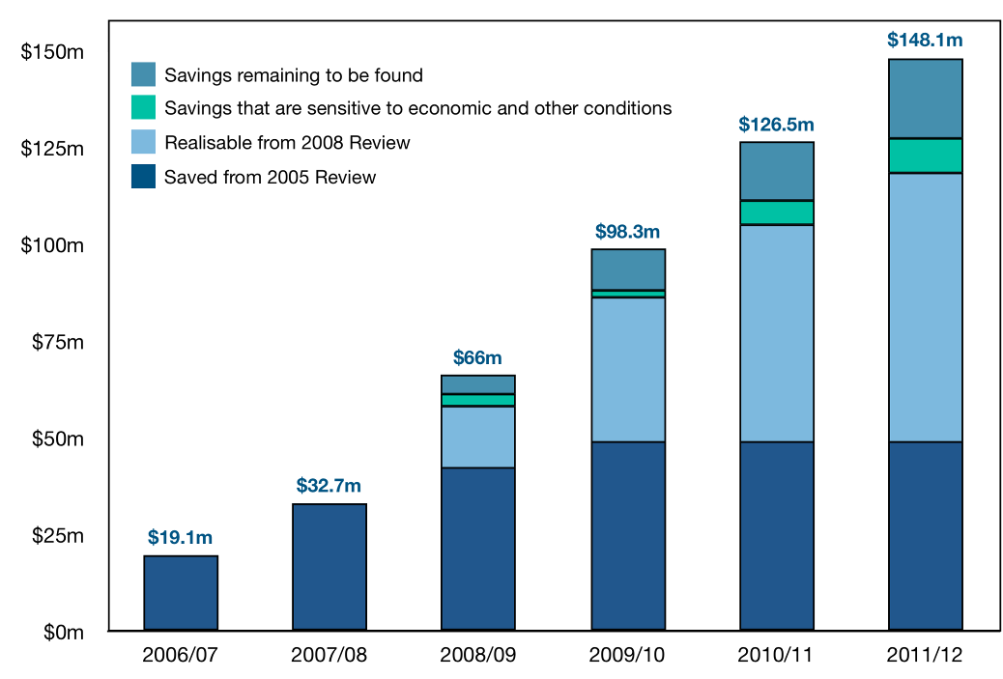
Figure 10. Cost pressures met and remaining to be found

Meeting cost pressures through this term of government
Our current plan will enable MSD to meet forecast cost increases in 2008/2009, 2009/2010 and in most of 2010/2011. We will do this by increasing our operating efficiency and productivity and by reducing our overhead costs. We are identifying further solutions for predicted cost pressures in the remainder of 2010/2011 and for all of 2011/2012. Our plans rely on the demand for our services remaining within current forecasts.
The savings in our current plan arise from a 2008 Value for Money departmental review, and are in addition to the $145 million savings over a four-year period that were identified as part of a 2005 departmental Value for Money review. The 2008 review was led by MSD’s Chief Executive and Leadership Team, and reported to a steering group that included private sector expertise and central agency representation.
Savings proposals include expanding the use of internet services, upgrading some legacy IT systems, streamlining business processes, and reducing corporate overhead costs. The proposals do not compromise our ongoing effectiveness, and we will maintain all aspects of service quality.
Our approach has been identified as providing opportunities for other public service agencies.

Implementing the Value for Money initiatives
Implementing the savings initiatives will be challenging, and it will involve, among other things, reducing the number of staff we employ by upwards of 5 per cent over the next four years. We will need to dedicate significant resources, leadership and capability to ensure projects are successfully completed and the gains are fully realised. The Chief Executive has put in place arrangements to make sure plans are fully implemented and savings are captured, and to take further opportunities over time.
Making these savings will require a significant commitment of resources and strong leadership
As noted earlier, MSD has a Value for Money Advisory Board, and a Value for Money Programme Unit has been established as part of the Chief Executive’s Office. The unit will help the Chief Executive to make sure savings plans are implemented, to identify further opportunities, and to identify incentives for improved cost performance.
We will report on progress to you as Minister and to the Minister of Finance through the normal Budget process, and on any baseline adjustments that may need to be made to manage savings initiatives across the years.

WE ARE IMPROVING OUR SYSTEMS AND DEVELOPING OUR PEOPLE
We have a multi-year capability strategy for making sure our systems and people are able to deliver as we enhance our frontline delivery and implement new priorities. Key components of the strategy include:
- a programme to replace our legacy IT systems with modern systems to better support the way we now work and to improve efficiency
- supporting our staff to develop the leadership skills they need to deliver integrated service responses
- helping our social worker workforce to meet new professional requirements and expectations, and working to retain skilled social workers.

Implementing results-focused IT systems
MSD’s primary IT system is transaction and payment based. This was appropriate to the 1990s social security system, but is not appropriate to tracking of clients’ progress, holding information about their overall situation, needs and skills, and supporting various agencies that work together.
Improvements to date have enabled Work and Income and Child, Youth and Family frontline staff to access information on their own cases, and the total picture of jobs, caseloads and other information in their own office or locality. We have also automated parts of the job-matching process using an off-the-shelf package that enables clients’ skills to be matched with available jobs.
We are also implementing a new client management system that will provide the functionality our legacy systems lack. We have purchased Cúram, an Irish-made product that has been used to deliver social security services in the United Kingdom, Australia and elsewhere, as the platform for these systems.
Our new client management system will support wraparound services, and co-operation between agencies
The first two phases of functionality have been implemented, with the next step being to consolidate core client information from a range of existing MSD systems. It will also provide enhanced case management functionality to help staff to provide integrated services to clients.
We anticipate we will continue to use the payment engine from SWIFTT to support the new client management system, as it is a proven and reliable system. We are currently transitioning this system off two mainframes housed and maintained by EDS.
Our staff need new skills to work differently with our clients, their families, and other agencies

Improving frontline services and better supporting frontline staff
Over the next four years we intend to introduce a range of on-line services to improve MSD service levels to students, income support and seniors clients. We will also move a lot of transactional activity on-line so our frontline staff are freed up to work more intensively with clients and their families:
- clients will be able to update personal details, declare income, and view payments and debt balances on-line
- on-line tools will provide information about how to get assistance and enable clients to self-assess their eligibility
- clients will be able to apply for some types of assistance over the internet, and to receive correspondence electronically
- employers will be able to list vacancies on-line and jobseekers will be able to apply for jobs on-line.
We will also improve the systems that support the work of case managers. This includes facilities to digitise client records which will reduce the time spent dealing with and searching through paper-based files.

Supporting leadership in service delivery
The Ministry’s staff need a broad skillset for working with individuals and families, and with other organisations in an integrated manner. We have introduced NZQA-recognised qualifications for case managers and a qualifications programme that gives all staff access to a broad range of knowledge which is increasingly important as we work through complex situations with clients and their families. We also encourage our staff to gain a broad understanding of the organisation’s roles and responsibilities. At any given time, up to 10 per cent of our staff are working in a role other than their own.
In the last year we introduced the following set of principles to guide the work of all staff:
We have introduced eight principles that support our way of working
“MSD People:
Put people first
Team up to make a bigger difference
Act with courage and respect
Empower others to act
Create new solutions
Are ‘can do’ and deliver
Honour achievement
Above all we do the right thing for New Zealanders”
We have launched a range of initiatives designed to promote and reinforce these principles. These include principle-centred leadership training for managers, the incorporation of the principles in job descriptions and the performance appraisal process, and the implementation of a MSD-wide awards system. We have introduced an Emerging Leaders programme to take identified staff through a
9–12 month programme of workshops and change projects that will develop their skills and knowledge.
We have been committed for some years to the development of Māori and Pacific staff for leadership roles. We provide two successful leadership programmes – the Te Aka Matua and Te Aratiatia programmes. Last year five individuals from the first Te Aka Matua programme graduated with Masters degrees. A further seven staff involved in the second Te Aka Matua programme are expected to complete their degrees within the next year.
Te Aratiatia is an Emerging Leaders programme which is conducted annually. Our last two intakes numbered 24 staff. From this group 30 per cent of participants have achieved either manager roles or are now engaged in project secondments and stretch activities.

Achieving registration for Child, Youth and Family social workers
We support the professionalisation of our social worker workforce through education and registration. This reflects the complexity and sensitivity of situations social workers must deal with and the impact of their work on peoples’ lives.
Our social workers are in demand internationally
Registration is not mandatory but there is a clear expectation social workers who work in a statutory setting will seek registration. Social worker registration requires as a minimum a competency assessment and a NZQA recognised level 7 qualification such as a Bachelor’s degree in social work.
An international shortage of qualified social workers will continue to make it challenging to recruit staff to these roles, and will place pressures on remuneration. We have aligned the salaries of social workers with comparable health sector roles and we have budgeted to meet the further costs of maintaining this parity.

WE WORK WITH THREE KEY PIECES OF LEGISLATION
There are three pieces of legislation that govern the way we deliver many of our services: the Privacy Act 1993, the Social Security Act 1964, and the Children, Young Persons, and Their Families Act 1989.

Working with the Privacy Act
Government agencies often need to work together to achieve the results the government is seeking. This is recognised in the State Services Commissioner’s Development Goals for the State Sector which emphasise the importance of networked state services, co-ordinated state agencies and accessible state services.
There are a number of things social services agencies can do better if we could share client information more easily. These include:
- prevent the creation or exacerbation of debt
- provide more tailored services to joint clients
- better manage ex-offenders in the community.
We have training in place to ensure our staff understand the Privacy Act, and are able to comply with it. We are also working across agencies to seek practical, non-legislative solutions to barriers wherever we can. We are working with the Privacy Commissioner to investigate ways to make complying with the Act easier. This may involve the Commissioner using her powers under the Act to issue a special code.
The Law Commission has a review of the Privacy Act underway. We have put our views to the Law Commission and understand it is likely to publish an Issues Paper in early 2009.
We have a plain english rewrite of the Social Security Act ready for introduction

Rewriting the Social Security Act
The legislation that governs the social security system needs modernising. The current Social Security Act was passed in 1964 and is largely based on the 1938 Act it replaced.
The Social Security Act has been amended many, many times since it was passed. It is now o obscure it is not possible for citizens to understand their entitlements under the legislation. This has led to criticism from the Supreme Court and the Law Commission.
Last year Government directed us to review the Act and to identify a legislative approach that would provide a plain english Act that is comprehensible and accessible for citizens.
We have worked with Parliamentary Counsel and prepared a draft Bill that is ready to introduce to Parliament.

Updating the Children, Young Persons, and Their Families Act
We are part way through updating the Children, Young Persons, and Their Families Act. The current Act is overly prescriptive and has not kept pace with developments in the provision of Child, Youth and Family’s services.
The focus of the first stage of the update is to align the Act with best practice today, to strengthen the application of its principles and the family decision-making model that underpins it. The redrafted legislation also increases the upper age of the youth justice system to include 17 year-olds. The Bill to implement this first stage was reported back to the House on 11 August 2008 with a recommendation that the Bill proceed.
A second phase would implement further practical changes, and improve the overall language and structure of the Act. This Bill is yet to be drafted and could provide a vehicle for new priorities for more wide-ranging reforms of the law relating to care and protection or youth justice.

OUR Property Portfolio SUPPORTS OUR DELIVERY STRATEGY
Over the next few years we are looking to turn an increasing number of Work and Income locations into Community Link Centres and to co-locate MSD and other agency services within them. We will do this as leases enable us to look at where we are located. We will also locate frontline offices next door to each other where they do not need to be located together in a Community Link Centre.
Setting up a Community Link Centre requires more work than establishing a typical Work and Income office. Consultation is required with the local community and other agencies, and we need to tailor the fit-out to local needs.
We are also currently implementing a programme to upgrade Child, Youth and Family’s frontline office accommodation. This recognises that some sites do not provide adequate facilities for clients or for our staff. We are about a third of the way through this programme which will be completed by the end of 2009.
We are also looking at whether Child, Youth and Family’s residential facilities are able to meet placement demands. An additional youth justice residence to accommodate 30 young people is being built in the Rotorua region. This will cost $62.4 million and come into operation in late-2010. We are also upgrading the Lower North Island Youth Justice facility at a cost of $12 million. We have put good governance and project management around these projects, including independent quality assurance.
We are in the process of taking decisions on the Ministry’s Head Office accommodation. This was looked at as part of our regular process of reviewing whether our office space represents good value for money and enables us to work effectively.
AMP Capital Properties has proposed the redevelopment of the Bowen Campus (Wellington) which accommodates the majority of our National Office staff. Resource consent has been granted for the development and AMP Capital is reviewing the necessary commercial arrangements.
Our current accommodation is among the oldest office accommodation in Wellington and it does not meet minimum earthquake, fire, health and safety and other requirements. Its age and layout is such that more appropriate accommodation is likely to enable savings over the medium term, including through reductions in National Office staff numbers and operating efficiencies.

WE ARE Reducing MSD’s Environmental Footprint
We will meet our 2012 Government Carbon Neutral Public Service requirements
In February 2007 we became part of the Government’s Carbon Neutral Public Service (CNPS) programme. CNPS counts the core public service’s emissions connected with energy use, domestic and international work-related travel, and waste.
The CNPS involves six lead government agencies that are required to be carbon neutral by 2012 and 28 stage-2 core public service agencies that will be on the path to carbon neutrality by the year 2012. MSD is a stage-2 agency.
We have made good progress and we are targeting a range of emission reduction activities in the areas of energy, transport and waste. We have implemented energy efficiency measures with cost savings of more than $600,000 per year. We are continuing to enhance our standard building and fit-out specifications so that our buildings are as sustainable as possible.
We are implementing fuller recycling across all MSD sites, and we have introduced ‘smart diesel’ cars to our vehicle fleet (27 per cent of the fleet has an engine size of 1.5L or less). The Ministry’s carbon footprint is currently being independently verified, and we anticipate meeting the 2012 requirements for stage-2 agencies.

WORKING WITH YOU
This briefing has described the roles and responsibilities of MSD, and set out the capability and resources you have at your disposal as Minister.
MSD delivers services and provides advice to help Government set its priorities. We work closely with other government and non-government agencies where this is the best way to get results. This is particularly the case with complex issues and our most vulnerable clients.
We maintain a clear focus on operating efficiently and have a plan for managing our cost pressures.
Our service delivery strategy is based on what works. We have established an Integrated Service Response Case Management approach and are establishing Community Link Centres which provide a location for services from different agencies to come together. We are also working more closely with community and non-government organisations who play a vital role in delivering early intervention services.
We will work with you to develop a work programme that delivers on your priorities as Minister.
We can provide further briefings as a basis for decisions you may wish to take on the issues and actions we have raised.
We look forward to working with you.

