New Zealanders: getting older, doing more

CONTENTS
Overview i
Executive Summary ii
- Overview – The Situation Today
Older people will make up a growing share of the population 2
Today’s older people are different from previous generations 3
Changing relationships among older people 4
Some grandparents raise their grandchildren 5
- Current Challenges
Planning for retirement is Essential 8
The majority of older people are able to manage on New Zealand Superannuation 9
Expectations for health care and support are high 11
Elder abuse and neglect has wide ranging effects 12
- Opportunities for Action
Ageing in the community has personal, social and economic impacts 14
Improved needs assessment leads to better health outcomes 15
Promoting suitable housing options 16
Working with local councils to promote positive ageing initiatives 16
Recognising older people’s contributions to their communities 17
Supporting older people to stay in the workforce longer 18
Maintaining strong relationships with older people 19
- How the Office Works
Our role 22
Our responsibilities 23
Our structure 23
Working with you 25
Endnotes 26
TABLE OF FIGURES
Figure 1. Projected population ageing in New Zealand 2
Figure 2. Ethnicity of older New Zealanders 3
Figure 3. Employment rate for people aged 65 years and over 4
Figure 4. Uptake of KiwiSaver at August 2008 8
Figure 5. Percentage of New Zealand Superannuation and Veterans Pension recipients receiving additional support 10
Figure 6. Older population in New Zealand aged 85+, 1951–2006 11
Figure 7. MSD – Services to Seniors Model 15
Figure 8. New Zealand Positive Ageing Strategy Goals 16
Figure 9. People aged 60+ in employment, 1996–2006 18
Figure 10. Vote: Senior Citizens 23
Figure 11. MSD’s organisational structure 24

Overview
New Zealand, like most OECD countries, has an ageing population. The older population is predicted to double by the year 2028 and the population aged over 85 years will almost treble during this same period. Older people will make up approximately a quarter of New Zealand’s total population by 2051.
Today’s older New Zealanders are healthier than past older generations and they have high expectations of being in the best possible health well into their older age. They are much more active and positive about approaching their later years and increasing numbers are continuing to work to maintain their active lifestyles.
We know older people want to live in the community for as long as possible and they are keen to continue to contribute to their families, whānau and communities. People who save for their retirement and have good support services available when they need them will be more independent and will have a more satisfying life in old age.
The Office for Senior Citizens is committed to helping make New Zealand a place where all citizens have a positive attitude to ageing and where older people are valued for their wisdom and life experience.
As Minister for Senior Citizens, your portfolio is a broad one. It incorporates positive ageing, retirement income, health, housing, employment, transport and security. The Office for Senior Citizens will provide you with advice across these policy areas and support you in your advocacy role to promote positive ageing and the interests of older people.
We look forward to working with you.

Natalie Lavery
Director
Office for Senior Citizens

Executive Summary
In this briefing we give you an overview of older people today and of how their lives differ from those of their parents and grandparents. We look at the challenges and opportunities of an ageing population and consider what these mean for older people, for economic growth and for New Zealand.
An increasing number of New Zealanders aged 65 years and over are contributing to the economy by remaining in the workforce longer and paying taxes. Statistics show that in the year ending March 2007, 13.2 per cent of older people aged 65+ were in paid work, double the percentage of 15 years ago. For this trend to continue we will need flexible workplace conditions and flexible retirement options.
Flexibility in the workplace and for those people embarking on retirement will also help to address recruitment problems as a result of an ageing workforce. New Zealand’s workforce is getting older due to population ageing and declining birth rates. At the time of the 2006 Census, 52 per cent of the labour force was aged 40 years and over. Older people remaining in the workforce have the potential to help address New Zealand’s shortage of skilled labour.
For those who retire at age 65 years or over, New Zealand Superannuation provides a level of retirement income that meets the needs of most people, but some older people will require extra support. Saving behaviour will need to be encouraged so people can meet their high expectations of retirement and enjoy the lifestyle they envisage.
Good health is fundamental to the wellbeing of older people and they expect the best possible health care well into old age. Primary health interventions that address the early symptoms of illness will improve health in older age and will have social and economic gains for older people and for the country.
Legislation protecting the rights and interests of older people contributes to their wellbeing and helps them to live longer at home and protect them when they are no longer able to make decisions for themselves.
Older people are a valuable part of our society and contribute to our communities in many ways. They keep volunteer organisations afloat and many combine this with caring for their older parents or, for some, raising their grandchildren. Policies and programmes that recognise and value older people help them to undertake this important work.
The New Zealand Positive Ageing Strategy has been used to encourage central and local governments to develop creative policies to keep older people as well as possible and connected with their families, whānau and communities. Local government initiatives that support safe and well-integrated communities give older people the best chance of achieving a satisfying old age.

Overview – The Situation Today
As in other countries, New Zealand’s population is ageing and today’s older people differ from previous generations. Older New Zealanders are living longer, working longer and enjoying better heath.

Older people will make up a growing share of the population
The older population is growing faster than ever before resulting in a major shift in the population structure. This change in the composition of New Zealand’s population brings new challenges and future implications for the government to consider. Projection scenarios developed by Statistics New Zealand show the number of New Zealanders aged 65 years and over will exceed one million by the late 2020s, compared with half a million people aged 65 years and over in 2006. New Zealanders aged 65 years and over are also projected to outnumber the population aged under 15 years by the mid-2020s.
Figure 1. Projected population ageing in New Zealand
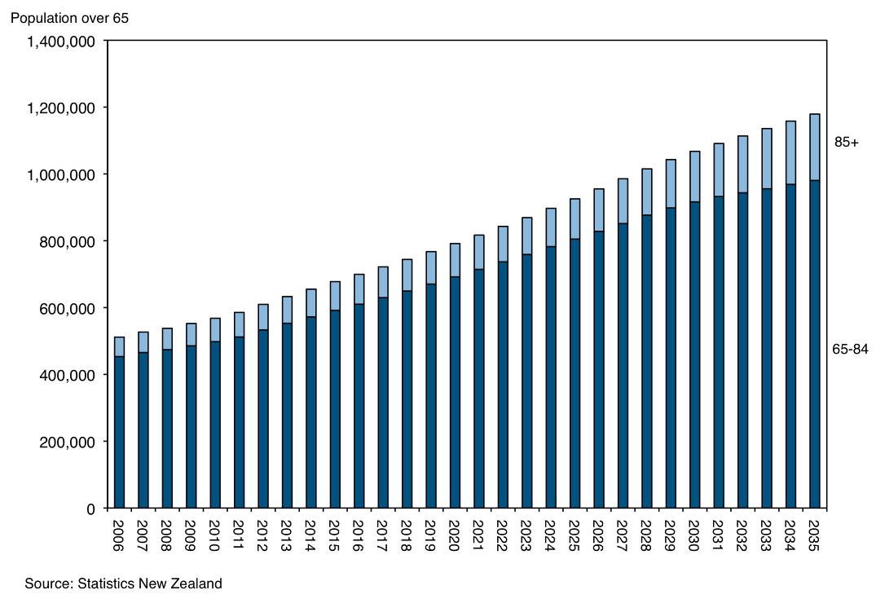
New Zealanders aged 65 years and over will outnumber the population aged 15 years and under by the mid-2020s
Within the older population, the group aged 85 years and over is growing fastest. In 2006, one in nine older people were aged 85 or over; by 2061, this proportion is projected to change to one in four. This rise in the very old age group will have the most dramatic impact on health and social services.
Women have a longer life expectancy than men, and make up a greater proportion of the older population. In the group aged 85 years and over, women outnumber men by two to one. In the population aged 65 years and over, women are less likely to be living with a spouse or partner and more likely than men to be living in residential care.
Increasing ethnic diversity is reflected in New Zealand’s older population. Older Mäori made up 4.1 per cent of all Mäori in 2006, up from 3.4 per cent in 2001. The number of Mäori aged 65 years and over is projected to reach 71,000 by 2026, almost three times the 2006 population of 26,000. Older Pacific people in 2006 accounted for 4 per cent of the total Pacific peoples population. The greatest growth was in the Asian ethnic group, where the proportion of older people reporting Asian ethnicity trebled from 1 per cent in 1996 to 3 per cent in 2006.
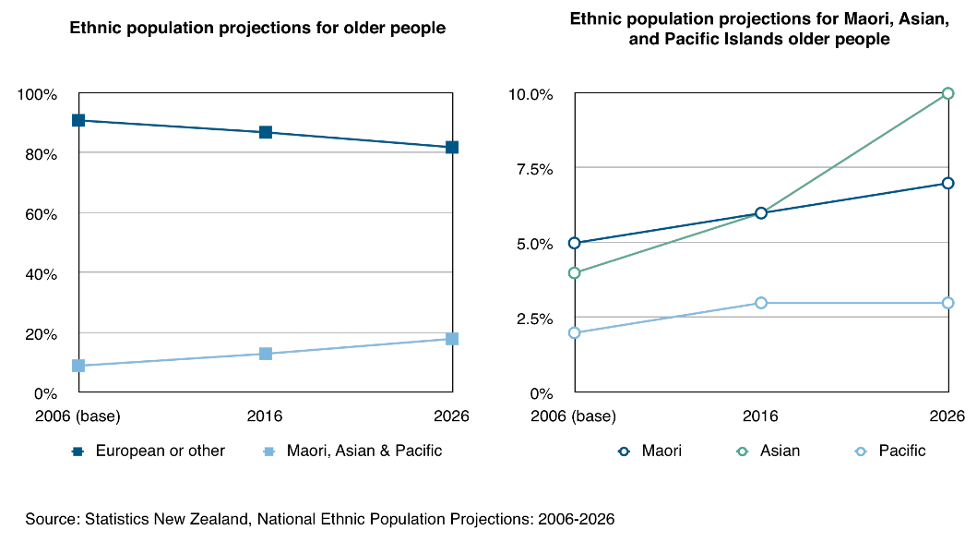
Figure 2. Ethnicity of older New Zealanders

Today’s older people are different from previous generations
The proportion of older New Zealanders is growing and they are doing more
New Zealanders are growing older and doing more. Longer life expectancies and falling fertility rates are causing our population to age but, more than ever before, older people are enjoying good health. They are assertive, have a strong political voice and hold high expectations of living active, healthy lifestyles well into old age.
Older people want to travel and to keep connected with their families, who are often in other parts of the world; and they want to use and get the best from modern technology to keep in touch. Engagement and familiarisation with new technologies is growing, particularly in the 65 to 69 years age group.
Older people want to use and get the best out of modern technology
People expect to age in the community for as long as possible. Unlike previous generations, more New Zealanders are choosing to take advantage of the benefits and security of retirement villages. We know that more than 30,000 people are living in around 375 retirement villages throughout the country.
The Office for Senior Citizens was instrumental in the development of legislation leading to the Retirement Villages Act 2003. The legislation protects the interests of residents and intending residents of retirement villages. Retirement villages must be registered and a code of practice is in place. There is now a complaints and disputes resolution process for residents.
Protections are in place to control the advertising of retirement villages, and the form and content of agreements that confer occupation rights on residents have been greatly improved. Intending residents will benefit from the requirement for full disclosure of the terms and conditions of their contract with a retirement village, and from having received legal advice before signing a contract.
Many older people are choosing to stay longer in work and are contributing skills to the workforce, boosting the economy and paying income taxes. If barriers to employment are reduced, older people will have the potential to help address New Zealand’s shortage of skilled labour.
Many older people are choosing to stay in the workforce
Workforce participation among older New Zealanders has risen significantly. Between 1991 and 2001, the number of older people in the workforce doubled, and it continues to grow. A large number of the working population aged 65 years and over are in part-time jobs. Full-time employment rates for people aged 60 years and over have increased since the age of eligibility for New Zealand Superannuation began rising in 1992.
New Zealand’s universal superannuation policy, whereby payments are not reduced by extra income, is a significant incentive for people to remain in the workforce longer.
Figure 3. Employment rate for people aged 65 years and over
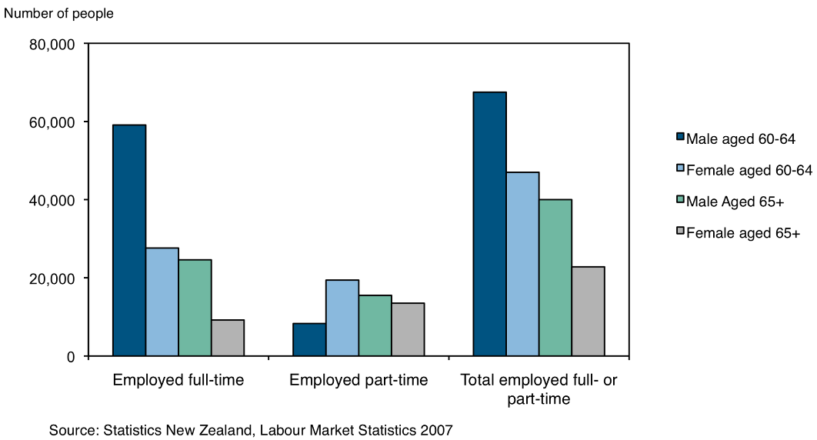

Changing relationships among older people
De facto relationships, same-sex relationships and divorce are becoming more common and these trends will be reflected in older age groups in the future.
Older people can be caring for their children and their parents at the same time
Some older people are supporting their children’s families by providing care for grandchildren, older people are caring for their partners and, with the ageing of the population, more of them are supporting their own very old parents. Difficulties combining caring responsibilities with paid work are affecting some. The Employment Relations Amendment Act 2007 gives employees with caring responsibilities the right to ask their employers for flexible working arrangements. These new provisions are aimed at improving the lives of many New Zealanders who need to balance their work with caring for other people.
As many women are choosing to have children later in life, people in middle age may face increasing problems caring for both their children and their own parents at the same time.

Some grandparents raise their grandchildren
A growing number of grandparents are caring for their grandchildren, either full-time or while the children’s parents are at work. Providing primary day-to-day care for grandchildren can cause older people financial, emotional and social stress.
The intergenerational gap between grandparents and grandchildren can span many decades. The ageing population will affect intergenerational relationships, and the roles and practices of grandparents will change across generations.
As relationship patterns change across society and are affected by the ageing population, helping older people with diverse caring responsibilities will be one of the challenges for government.

Current Challenges
New Zealand's growing and changing older population is producing challenges for policy development. The ageing population is increasing the demand for health care, support services and housing, and making personal financial planning more important.

Planning for retirement is Essential
You are never too young or too old to save
The increase in our older population will create social, financial and economic challenges for New Zealand.
Saving initiatives, such as KiwiSaver, have encouraged large numbers of younger people in the workforce to start financial preparation for their retirement. Twenty-nine percent of KiwiSaver members are under 25 years of age. Incentives that originate in schools will encourage young people to develop good savings behaviour and will improve financial literacy. The Retirement Commission has a plan to take the challenge of ‘you are never too young or too old to save’ into New Zealand schools.
This kind of forward planning will be essential if people are to enjoy the lifestyle of their choice in older age. Financial planning for future retirement will also ensure older people are more resilient to economic changes and are less vulnerable during times of economic downturn.
Figure 4. Uptake of KiwiSaver at August 2008
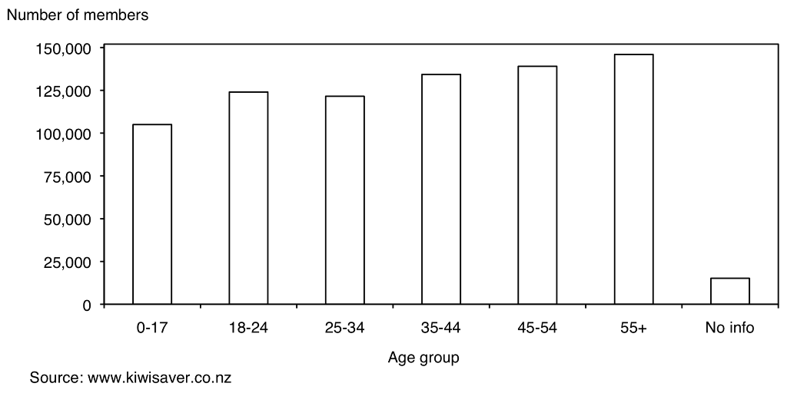
People’s ability to plan for retirement can be affected by life events, like ill health, divorce, child-rearing or job loss. Basics such as food, clothing and housing are fundamental to the wellbeing of older people. The report: New Zealand Living Standards 2004 found that 8 per cent of older New Zealanders were living in hardship and that older single people were more likely to be in some degree of hardship than older couples. To meet the challenge of the ageing population and to better meet the individual needs of older people, the Ministry of Social Development is transforming its services for seniors. This new service delivery approach aims to ensure older people receive a secure and adequate income and they have improved access to the services and information they require.

The majority of older people are able to manage on New Zealand Superannuation
A high proportion of today’s older people own their homes but have few available savings; they are often referred to as asset rich and income poor. This means some older people may require extra help with one-off costs. Maintaining the real value of New Zealand Superannuation through regular adjustments, taking into account price inflation, remains critical in protecting living standards.
Home ownership is one of the most important factors in maintaining good living standards in old age. Encouraging home ownership among younger people is important because it helps them to secure their future financial wellbeing. Potential home buyers need access to affordable housing and confidence in the market, so they will save and invest for retirement.
It is vital younger people make financial provision for their retirement. Whether they will do this in the future through home ownership or other methods of saving is yet to be determined, although we can say New Zealanders are still wedded to home ownership. Whatever retirement planning they select, people will need to be confident their savings and investments are safe. Work being done by the Ministry of Economic Development to protect consumers in the wider financial sector will be fundamental in keeping investments as safe as possible.
Home ownership is one of the most important factors in maintaining good living standards in old age
Longer life expectancy and retirement years have led people to challenge traditional inheritance ideologies. New initiatives to supplement fixed incomes by using the equity in their homes are increasingly being considered by older New Zealanders. For some older homeowners, releasing the equity in their homes will be an option for maintaining their homes and lifestyle choices.
Home equity release schemes enable older people to take out a loan drawing on the equity in their home as security. The loan principal and compound interest are taken as a charge over the property to be repaid on sale or death. In New Zealand, the home equity release market is currently dominated by one provider. There are several other providers in the market and numbers of home equity release providers are expected to rise when the economy improves.
The Office for Senior Citizens has led a project to establish a Code of Practice for Home Equity Release Schemes so older people can access these schemes with the confidence that appropriate checks and protections are in place.
Home equity release scheme providers can adopt the Code voluntarily, but it is proposed that the Code will be set in regulations by 2010, if you agree. Safe and secure home equity release schemes will give this and future older generations the confidence to take advantage of this option to supplement their income in retirement.

Extra help is available
The Ministry of Social Development, through its Work and Income service line, provides a range of financial supports in addition to New Zealand Superannuation. The Living Alone Payment recognises that single superannuitants may face similar costs to couples, but have only one income. Other income-tested support available to older people includes the Disability Allowance, the Accommodation Supplement, Temporary Additional Support, Special Needs Grants and Advance Payment of Superannuation.
It is going to be even more important with an increasing ageing population that barriers to older people accessing information and assistance are identified early and addressed promptly. This is especially so in regard to supplementary assistance, where the up-take among superannuitants has been consistently low over the past five years.
The eligibility criteria for extra assistance may affect the uptake among superannuitants. Older people, due to privacy and generational attitudes, may also be reluctant to go into a Work and Income service centre to ask for help.
Up-take of supplementary assistance among superannuitants has been consistently low over the past five years
Ministry of Social Development initiatives to address the possible barriers to older people accessing extra help have included:
- outbound calling to check full and correct entitlement
- upskilling superannuation case managers
- developing fact sheets on individual extra help and reviewing information in the extra help booklet
- increasing the distribution channels through non-government organisations.
Figure 5. Percentage of New Zealand Superannuation and Veterans Pension recipients receiving additional support
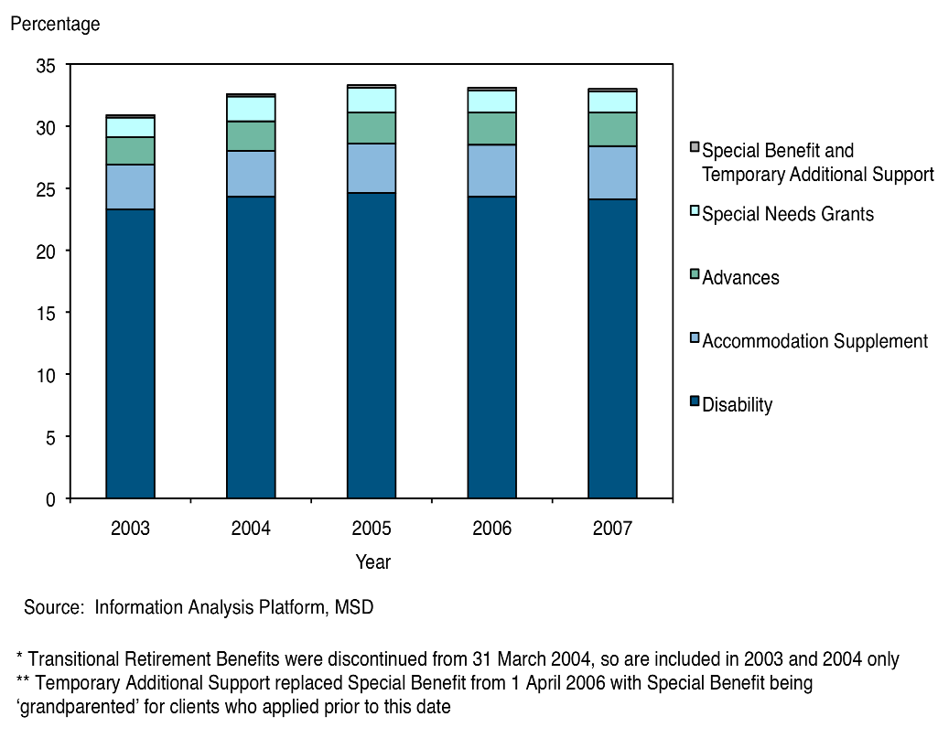

Expectations for health care and support are High
Medical technology and pharmaceutical advances along with improved health care services help today’s older New Zealanders to be more confident, assertive and active than previous older generations.
Older people expect to enjoy good health well into old age, and to receive the health and support services they need. Preventative and primary health care are important to help them enjoy good health for as long as possible. Initiatives such as the Accident Compensation Corporation’s Otago Exercise and Tai Chi programmes are playing an important role in reducing injuries caused by falls and other avoidable accidents. Improvements in health reducing the incidence of disability could offset around a third of the extra health costs of an ageing population.
Improvements in health that reduce the incidence of disability, could offset around a third of the extra health costs of an ageing population
As the population ages so does the number of older people in the community who require support services. For these services to be sustainable into the future, the best possible use of resources is critical.
The population aged over 85 years has potentially higher needs for health care due to a greater incidence of disability. This support will be costly to meet. As this group of older-olds grows, its proportion of required health expenditure is expected to increase.
It is not only the ageing of the population that will put pressure on health expenditure but also the expectation of people of all ages that they will receive treatment based on the most advanced medical and surgical technology. This factor will continue to have a bigger effect on health expenditure than demographic factors such as population ageing.
Figure 6. Older population in New Zealand aged 85+, 1951–2006
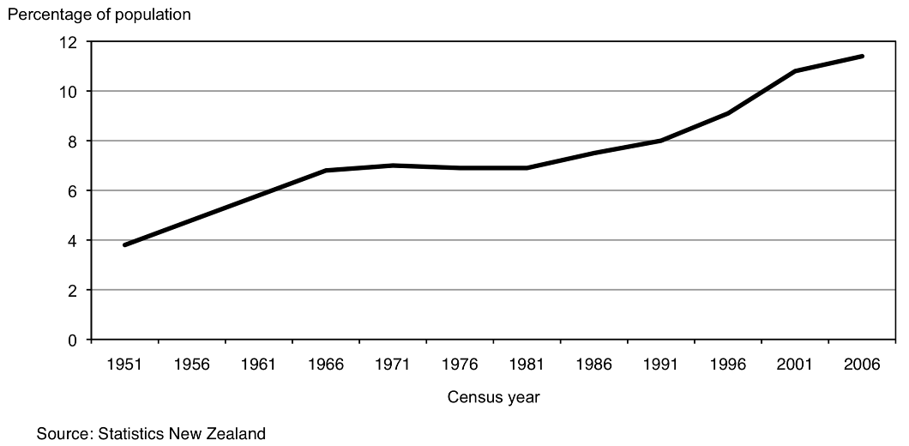
The need for high-level formal care grows for people over the age of 80 years. There are approximately 28,000 people in aged residential care around the country and the majority of these are in rest homes. There are approximately 750 aged residential care facilities throughout New Zealand.
Older people and their relatives have the right to expect residential care facilities will provide a safe and caring environment. As more older people receive support services at home, staff training and standards for the home-based care industry will be just as important as those required for the residential care facilities. More robust independent auditing measures for residential care would be welcomed, with a stronger focus on consumer and patient satisfaction as a measure of quality.

Elder abuse and neglect has wide ranging effects
Elder abuse and neglect is a complex issue, requiring a range of responses to keep older people safe. Research suggests that, when elder abuse occurs, 79 per cent of the time those responsible for the abuse are family members.
Elder abuse and neglect can have wide-ranging and long-term effects on a person’s physical and mental health as well as on their finances, living arrangements, relationships and support networks.
Recent changes to the Protection of Personal and Property Rights Amendment Act 2007 give older people, who have enduring powers of attorney in place, confidence their interests and assets will be protected if they can no longer make their own decisions.
Elder abuse and neglect is a complex issue, requiring a range of responses to keep older people safe
The Ministry of Social Development, through its Family and Community Services service line, funds a nationwide network of 24 elder abuse and neglect prevention services, co-ordinated by Age Concern New Zealand. Elder abuse and neglect prevention services work with about 500 older people each year. Half of all abuse and neglect cases are referred to the Police, but some older people are reluctant to report family members who are responsible for the abuse or neglect.
Age Concern New Zealand and the Ministry of Social Development have been working together with key agencies to identify priority areas for further action on elder abuse and neglect prevention. This work has highlighted the need for improving the social services and health sectors’ responses to elder abuse and neglect, for preventing financial abuse, and for strengthening the accountability of perpetrators of elder abuse and neglect.
These are some of the key current challenges for government. In Part 3 we offer suggestions on how you can use some of these challenges as opportunities to make a difference.

Opportunities for Action
New Zealand’s older people have valuable skills, experiences and knowledge. There are a number of ways to support them to age positively and to continue to contribute to their families, communities and the economy.

Ageing in the community has personal, social and economic impacts
Most older people want to stay in their own homes for as long as possible. At the 2006 Census, 90 per cent of the older population aged 65 years and over lived in private dwellings. Fifty-six per cent of this group were living with a spouse or a partner, 31 per cent were living alone, and 5 per cent were living with others.
To age at home in the community older people have to feel safe and confident
People feel more socially connected when their housing is close to community amenities. Older people in rural areas face different housing issues to those in urban areas. Older rural residents live further from community amenities, have particular transport and support needs, and can be more vulnerable to social isolation.
Having access to transport is critical to the participation of older people in society. Barriers that prevent older people using public transport include distance from bus stops, railway stations and ferry terminals; difficulty getting on and off public transport; and the reliability and timing of services. Smaller towns and rural areas may have limited or no public transport available to them.
Feeling safe and secure is important to the wellbeing of older people, and to their ability to age in the community. To achieve a high quality of life, older people must not only be safe, but feel safe. Anxiety about crime often prevents them from participating in and enjoying life fully. Community organisations like Neighbourhood Support and local community patrol groups involve many older people as volunteers and help to reduce the fear of perceived crime in the community.
Over the next few decades, the number of people aged 65 years and over will increase significantly, and the needs of the older population are expected to become more diverse. In response to this, the Ministry of Social Development is changing the way it delivers its services to older people.
MSD will establish partnerships with other government agencies and community organisations to deliver services
The transformation of the Ministry’s services for seniors will aim to ensure older people receive a secure and adequate income, are supported to age in the community if they choose, and are easily able to access the services and information they need. The Ministry will maintain and enhance partnerships with other government agencies and community organisations to deliver services as effectively as possible. It will seek older people’s feedback to make services easy to use, and will invest in older people’s skills and support their employment aspirations.
Figure 7. MSD – Services to Seniors Model
Intensity of client needs
& organisational response

Low level engagement
Income assistance administration
Self service

Not getting in your way

Moderate engagement
Single & multi-agency information & service brokerage
Here when you need us

Wrapping our services around your needs
Complexity of need

Independence
(most clients)
Resilience
(some clients)
Support
(few clients)
Transitioning
Working Age People
CLIENT SITUATION

Source: Ministry of Social Development
Having access to responsive services will allow people to age in the community. Your support for the introduction of wraparound service delivery initiatives in every corner of New Zealand will give older people the best chance to live at home.

Improved needs assessment leads to better health outcomes
Achieving and maintaining good health is key to reducing the numbers of older people who need residential care. This has many personal benefits for older people, as well as economic benefits for New Zealand. Responsive home-based support services as well as better needs assessment are effective in delaying premature admission to residential care. The new InterRAI geriatric assessment tool implemented throughout all district health boards will provide consistency and accuracy when assessing the needs of older people requiring support and will lead to better outcomes for them.
Responsive home-based support can delay premature admission to residential care
Vulnerability generally accompanies extreme old age and often leads to the need for residential services. Supporting your colleague, the Minister of Health, to better fund client assessment and residential and home-based support services, and to train the health sector’s workforce, will mean older people have a better quality of life.

Promoting suitable housing options
As New Zealand’s population ages and the overall number of older people grows, we will need more affordable and diverse housing options. The concept of designing and developing buildings and environments that can adapt to people’s changing age and mobility needs is gaining popularity worldwide. Suitable housing is crucial if ageing in the community is to be successful.
Housing designed to enhance mobility and decrease the risk of accidental injury can extend the time older people can live in their own home
People who own their homes are less likely to experience hardship and will be in a better position to adapt their houses as they age and their needs change. Housing that is designed to enhance mobility and to decrease the risk of accidental injury can extend the time older people can live on their own.
Well insulated homes are healthy homes. Energy-efficient homes that can be heated effectively and economically will reduce the incidence of respiratory and other health problems.
There are many government-driven initiatives being undertaken to make New Zealand homes healthy homes. Working with your ministerial colleagues and fostering these schemes will increase the energy-efficiency of New Zealand homes and make them better places for older people to live in.

Working with local councils to promote positive ageing initiatives
Local government plays a key role in driving initiatives to support positive ageing. The New Zealand Positive Ageing Strategy puts into action the Government’s commitment to promoting the value of older people and affirms their importance in the community.
The New Zealand Positive Ageing Strategy (NZPAS) was launched in April 2001 by the Minister for Senior Citizens and provides a framework for developing and understanding policy with implications for older people. The following 10 goals guide policies and programmes across the central, regional and local government sectors.
Figure 8. New Zealand Positive Ageing Strategy Goals
Leading, promoting and monitoring implementation of the New Zealand Positive Ageing Strategy
Goal 1:  Secure and adequate income for older people | Goal 2:  Equitable, timely, affordable and accessible health services for older people | Goal 3:  Affordable and appropriate housing options for older people | Goal 4:  Affordable and accessible transport options for older people | Goal 5:  Older people feel safe and secure and can “age in the community”
Goal 6:  A range of culturally appropriate services allows choices for older people | Goal 7:  Older people living in rural communities are not disadvantaged when accessing services | Goal 8:  People of all ages have positive attitudes to ageing and older people | Goal 9:  Elimination of ageism and the promotion of flexible work options | Goal 10:  Increasing opportunities for personal growth and community participation
The report Positive Ageing Indicators 2007 found that significant progress is being made across the 10 goals set out in the NZPAS.
Thirty-six local councils contribute to the NZPAS, and are committed to promoting positive ageing in their communities. Other local councils not yet in the plan are also running programmes that benefit their older citizens.
Local councils are increasingly developing their own positive ageing strategies
Local councils provide key supports to older people through accessible public transport and good access to parks, leisure and social opportunities, information and community amenities. Local councils are increasingly developing their own positive ageing strategies and taking a more holistic approach when planning and implementing policies.
The World Health Organisation released a guide on age-friendly cities aimed primarily at town planners, in October 2007. The guide provides a checklist of features to accommodate the changing needs and abilities of people as they grow older.
Supporting local councils to promote positive ageing is particularly important. Establishing more collaborative relationships between central and local government will extend the benefits to more older New Zealanders.
Older people have a better quality of life when their local council recognises community needs in planning policy. We will continue to work with local councils, if you agree, to encourage and support them with their positive ageing plans.

Recognising older people’s contributions to their communities
As workers, volunteers, unpaid caregivers and grandparents, older people are contributing to their communities and the economy.
We support schools around the country to organise activities involving pupils and their grandparents
Older people have abilities, knowledge and experiences that are valuable to the workforce, communities and families. The SAGES programme is a New Zealand-wide volunteer initiative funded by the Ministry of Social Development that connects older people with younger people. The programme helps younger people learn the skills they need to care for their families and run their homes.
Each October the Office for Senior Citizens promotes Greats and Grands month. This is to recognise the importance of grandparents, aunts and uncles, and older family friends in the lives of young New Zealanders. We support schools around the country to organise intergenerational activities involving pupils and their grandparents, so they can share stories, experiences and skills, from crafts to text messaging.
Older people make up a large proportion of the country’s volunteers, including supporting younger people’s sporting activities as coaches, referees and team administrators. They often do this while caring for their grandchildren, enabling their own children to go to work. Valuing older people for the wide range of unpaid work they do will ensure they continue to contribute to their families and communities in these ways.
Women are having children later in life. This means future generations of older people may be faced with the pressures of caring for children as well as their own, old parents. To make sure older people can contribute to their communities, it will be important to continue to support them in their caring work. Carers need choices and opportunities to combine caring with other facets of living such as family life, social activities and employment.
Older people are fitter and more active than previous generations and they enjoy helping their families and communities. We have a programme to help you to encourage schools around New Zealand to tap into this valuable resource.

Supporting older people to stay in the workforce longer
Greater numbers of older people are opting to stay longer in the workforce, and there are many benefits when they choose to do so. Older people who keep working have more opportunities for social connectedness and often experience greater wellbeing. Generating extra income can help older people achieve their lifestyle aspirations in retirement. Misconceptions about older people’s ability to continue in the workforce can restrict their options for participation.
Figure 9. People aged 60+ in employment, 1996–2006
Older people who keep working are often more socially active and experience greater wellbeing
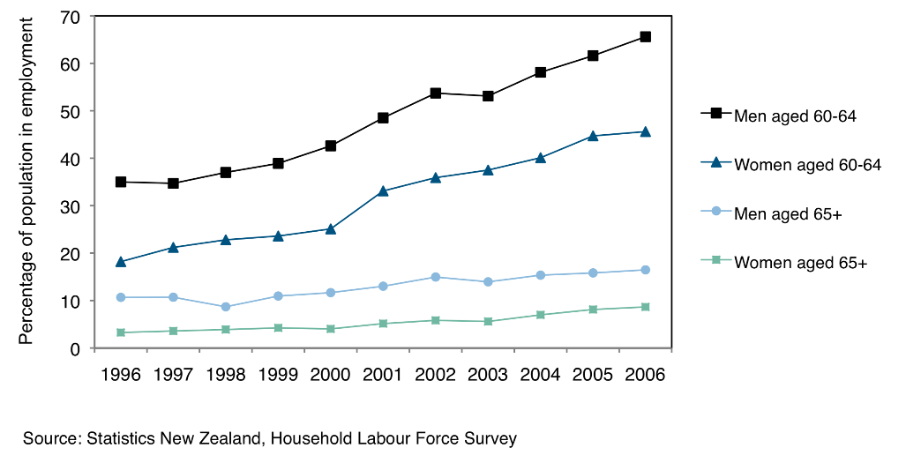
New Zealand’s workforce is ageing, and it is becoming more important to recruit and retain skilled workers. Supporting older workers to continue in employment has benefits for the New Zealand economy, as older workers can help to meet the skill shortage.
An important step towards supporting older workers is reducing negative stereotyping and promoting positive ageing
Some employers are actively seeking to attract older workers. Other employers have misconceptions about older workers and see them as less productive in the workforce than younger people. An important step towards supporting older workers is reducing the negative stereotyping of older workers and promoting positive ageing.
Employers can support their older workers by offering flexible work arrangements. Consulting employees considering retirement, offering meaningful part-time employment and providing them with opportunities to enhance their skills are ways to keep older workers in the workplace longer.
Partnerships with local government and the business community are the best way to keep older people in the workforce. Supporting these partnerships and encouraging the roll-out of programmes that retain older workers will ensure the numbers of older people in the workforce continue to increase.

Maintaining strong relationships with older people
The two major national organisations representing older people are Age Concern
New Zealand and the Grey Power Federation
There are hundreds of organisations within New Zealand working to promote the interests of older people. Many of these organisations meet together and support each other locally.
The two major national organisations representing older people are Age Concern New Zealand and the Grey Power Federation. Both organisations have a strong presence within central and local government where they are highly regarded for their advocacy work. Representatives of Age Concern New Zealand and Grey Power like to meet you, the Minister, on a regular basis to raise and discuss issues.
As the Minister for Senior Citizens, you are fortunate to have a unique and direct relationship with a group of older people around New Zealand who do not represent national organisations but who offer advice and information from their local communities. These are the Volunteer Community Co-ordinators (VCCs) for the Office for Senior Citizens.
The VCC programme is a national network of approximately 50 volunteers. The volunteers are nominated by local older people’s organisations, but do not represent specific organisations. VCCs consult older people in their local communities, and gather feedback on older people’s issues through meetings, hui and fono. This process offers older people, including Mäori and Pacific peoples, input into policy development and the opportunity to share information with their communities. They maintain links with key community groups, church groups, ethnic groups and neighbourhood support groups.
Some of the VCCs’ work over recent times has included a significant input into the development of the New Zealand Positive Ageing Strategy, the changes to the Enduring Powers of Attorney, and the Code of Practice for Home Equity Release schemes.
Volunteer Community Co-ordinators for the Office for Senior Citizens can take much of the credit for the success of the New Zealand Positive Ageing Strategy. They have been at the forefront of the work from the beginning, and they continue to work with their local councils, encouraging them to plan for an ageing population.
In the next section we tell you about our role, about the Office itself and where it sits within the Ministry of Social Development.

How the Office Works

The Office for Senior Citizens works across government agencies and with non government organisations that work with older New Zealanders. We work on priorities identified by you as Minister.

Our Role
The Office for Senior Citizens was established in 1990 to act as a focal point for older people’s issues within government. New Zealand’s ageing population means the profile and significance of our portfolio has increased. Government agencies, community organisations and the public are taking a greater interest in ageing issues. Organisations representing the interests of older people are also becoming more forthright in presenting their views.
Older people have an expectation the Minister for Senior Citizens will reflect their views and interests at government policy and decision-making forums
Older people have an expectation the Minister for Senior Citizens will reflect their views and interests at government policy and decision-making forums, and that these will be represented and explained clearly and sensitively.
While the Minister for Senior Citizens represents the needs and expectations of older people, these must be balanced against the interests of other age groups, and of future generations of older people. The focus of the Office for Senior Citizens is to enhance the wellbeing of today’s older people and of older people in the future.
It is our goal to ensure that older people are valued as important members of society, they have the right to dignity and security in their senior years, and they have opportunities to use their skills, knowledge and experiences to contribute to society.
We have the following key roles:
- supporting you as Minister for Senior Citizens in representing the rights and interests of older people in the Government’s policy making process
- overseeing and implementing the New Zealand Positive Ageing Strategy
The New Zealand Ageing Strategy underpins all our work
- promoting positive ageing to government departments and local communities
- protecting the rights and interests of older people
- participating in a wide range of programmes, policies and services that have an impact on the lives and wellbeing of older people
- keeping a watching brief on other changes that affect older people and acting in an advisory capacity to other departments on older people’s issues.
The New Zealand Positive Ageing Strategy (NZPAS) underpins all our work. To achieve the goals of the NZPAS, we work across central, regional and local government, and with older people and their communities, supporting the development and achievement of action plans.

Our responsibilities
A primary function of the Office is to support and advise you. We will ensure you are well informed about key issues and trends affecting older people, and we will provide you with advice on opportunities for leadership.
A weekly issues update and regular briefings ensure you are well informed about current issues for
older people
As portfolio Minister, you are responsible for the priorities and work programme of the Office. There is a direct working relationship between the Director of the Office for Senior Citizens and yourself.
The effective management of ministerial correspondence is critical to maintaining credibility with the sector and the public. We prioritise our support, including drafting replies to ministerial correspondence, parliamentary questions, notes for speeches and requests made under the Official Information Act 1982, and any other briefing you may require.
A weekly issues update and regular briefings ensure you are well informed about current issues for older people, in particular those that might arise in Cabinet discussions.
Figure 10. Vote: Senior Citizens
Vote: Senior Citizens | $000 | $000 | $000
 | 2008/2009 | 2009/2010 | 2010/2011
Output expenses | 1,035 | 1,035 | 1,035

An annual performance agreement is signed between you as Minister for Senior Citizens and the Chief Executive of the Ministry of Social Development on behalf of the Office. The agreement outlines the parameters of the work of the Office for Senior Citizens, and sets performance measures for policy advice and ministerial services.
Every six months we provide a draft work programme for your consideration, and we provide a progress report on the work programme at the end of each six-month period. We will work with you to review our work programme, to ensure it delivers your priorities as Minister.

Our structure
The Office has a staff of seven, the Director, an executive assistant, three senior analysts and two analysts.
The Office is located within the Social Sector Strategy Group of the Ministry of Social Development, along with several other units with a whole-of-government brief.
Figure 11. MSD’s organisational structure
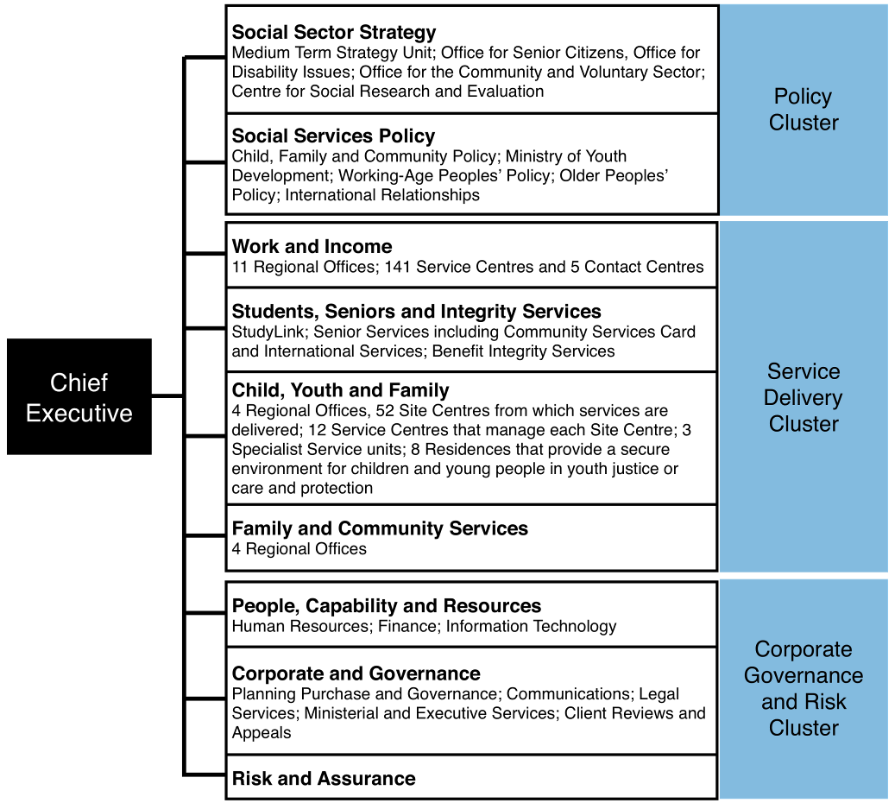
We aim to bring a broad whole-of-government perspective to our work
Our location within the Ministry of Social Development enables us to access the corporate support provided by the Ministry, including expertise in financial and human resource management, evaluation and research, and communications. Our administration and overhead costs are minimised through the economies of scale available to us by being part of the larger Ministry.

Working WITH you
The Office for Senior Citizens strives to provide you with quality advice, promotes the New Zealand Positive Ageing Strategy, maintains excellent working relationships with older people’s organisations and represents the needs and expectations of older people. We aim to bring a broad, whole-of-government perspective to our work, recognising the need to balance older people’s interests with those of other members of the community.
We will work with you to develop a work programme that delivers on your priorities as Minister.
We can provide you with further briefings as a basis for decisions you may wish to take on issues and actions we have raised.
We look forward to working with you.

EndNotes

Department of Labour, Labour Market Report 2007
Statistics New Zealand 2006 www.stats.govt.nz
Statistics New Zealand, National Population Projections 2006(base)–2061
Statistics New Zealand, National Population Projections 2006(base)–2061
Statistics New Zealand, National Population Projections 2006(base)–2061
Statistics New Zealand, National Population Projections 2006(base)–2061
Ministry of Social Development, Positive Ageing Indicators 2007, MSD 2007, p 20
www.stats.govt.nz/census/census-outputs/quickstats [accessed June 2008]
www.stats.govt.nz/datasets/population/population-projections [accessed May 2008]
www.stats.govt.nz/datasets/population/population-projections [accessed May 2008]
Ministry of Social Development, Positive Ageing Indicators 2007, MSD 2007, p 18
MSD/Family Centre, Implication of Population Ageing for New Zealand
Statistics New Zealand, Census 2001
www.dbh.govt.nz [accessed 17 September 2008]
MSD/Family Centre, Implication of Population Ageing for New Zealand
Statistics New Zealand, Labour Market Statistics 2007
The raising of the age of entitlement for New Zealand Superannuation from 60 years of age to 65 years began in 1992 and continued progressively through to 2001. The need to make New Zealand Superannuation more sustainable was one of the main reasons the age of eligibility was increased, but it was not the only one. Back in the 1990s many people were remaining in employment beyond age 60 and the qualifying age was increasingly becoming out of step with peoples’ retirement practices
MSD, CSRE, A Place to Call My Own
Ministry of Social Development, Positive Ageing Indicators 2007, MSD 2007, p 27
www.treasury.govt.nz [accessed 23 September 2008]
www.treasury.govt.nz [accessed 23 September 2008]
Age Concern New Zealand, Elder Abuse and Neglect Prevention – Challenges for the Future, 2007, Age Concern New Zealand Inc, p 37
Age Concern New Zealand, Elder Abuse and Neglect Prevention – Challenges for the Future, 2007, Age Concern New Zealand Inc, p 21
Ministry of Social Development, Positive Ageing Indicators 2007, MSD 2007, p 18
www.stats.govt.nz Older People’s Access to Motor Vehicles 2006, p 9
www.sparc.org.nz/filedownload [accessed 24 September 2008 ]
The Senior Citizens Unit was established in 1990 as a small team to support the Minister for Senior Citizens in carrying out the function of the Senior Citizens portfolio. In July 2002, in recognition of the challenges being faced from an ageing population, the Unit was upgraded to an Office for Senior Citizens

