Social outcomes briefing

CONTENTS
Overview i
Executive Summary ii
- Social Outcomes and the Social Sector: 1994–2008
Social outcomes have improved 2
We compare well with other OECD countries in a number of areas 2
Government plays a strong role in shaping social outcomes 3
Social sector spending 1994–2008 3
How our social spending compares with other OECD countries 5
- Looking Ahead: Critical Social Challenges for New Zealand
Complex and inter-related challenges remain 8
Educational underachievement and post-school disengagement have serious consequences 8
Criminal offending has a high cost 8
Housing costs have increased 9
Low incomes remain a problem for some 10
Factors undermining the health of the nation 10
Some families are caught in a cycle of social deprivation 11
There is growing pressure on social sector spending 12
- Working Together to Meet These Challenges
We can achieve more in some areas by working together 16
Some promising initiatives threaten to slip through the cracks 17
There are promising areas of common interest 18
Antenatal, infancy and early childhood 18
Promoting good behaviour among our children and young people 19
Tackling problematic alcohol use 20
Redeveloping our more deprived communities 21
Effective engagement with our vulnerable families with children 22
We can make faster progress in these areas 23
Unified social sector leadership 23
Commitment to high value-for-money social spending 24
Contributing to New Zealand’s economic success 25
Working with you 26
Endnotes 27

Table of Figures
Figure 1. Real social sector spending per capita and social sector spending as a percentage of GDP, 1994–2008 4
Figure 2. Real social sector spending, by area of expenditure, 1994, 2000, 2008 5
Figure 3. New Zealand social sector expenditure relative to the OECD, 2005 6
Figure 4. Pathway to recidivist criminal offending 19

Overview
The Social Outcomes Briefing has been prepared on behalf of the Social Sector Forum of Chief Executives of the Ministries of Health, Education, Social Development and Justice. It presents an analysis of issues across the whole social sector. This is the first time the major social sector agencies have come together to provide joint advice for incoming Ministers.
This briefing contains three parts:
- Part 1, Social Outcomes and the Social Sector: 1994–2008, summarises how social outcomes and social sector spending have changed over the past 15 years, and how New Zealand performs compared to other OECD countries.
- Part 2, Looking Ahead: Critical Social Challenges for New Zealand, outlines some enduring and inter-connected social policy issues.
- Part 3, Working Together to Meet These Challenges, sets out some promising areas which have the potential to lift outcomes across the social sector.
We hope you find this briefing helpful.
We look forward to working with you to implement your priorities.

Peter Hughes
Chair
Social Sector Forum

Executive Summary

Social Outcomes and the Social Sector: 1994–2008
Over the past 15 years, we have seen significant improvements in the health, knowledge and skills, standard of living and employment of many New Zealanders. Employment growth, higher wages, a strong focus on the quality, affordability and supply of social services, and greater financial support for low and middle income families have brought an improved quality of life for many people. These gains will, in turn, support better health, educational attainment, living standards, labour market participation and productivity in the future.

Looking Ahead: Critical Social Challenges for New Zealand
Government now has the opportunity to focus on some of the more enduring and inter-connected social policy challenges that are holding back social and economic development in New Zealand. At the heart of this are the vulnerable families and whānau caught in a cycle of social deprivation where multiple challenges – including poverty, family violence, mental and physical ill-health and unemployment – both reflect and are compounded by each other. The quality of life for children raised in these vulnerable families is often poor. Many will struggle to fulfil their potential into adulthood. This is particularly so where the parents lack the skills, experiences and social supports necessary to underpin their children’s development.
The consequences can be seen in early school leaving and underachievement, persistent and increasingly violent offending, substandard and unstable living conditions, long-term health conditions, and poor job prospects. These poor outcomes represent a real lost opportunity for the individuals themselves, their families and whānau and their communities. They also create successive and avoidable costs to government and act as a drag on economic growth.

Working Together to Meet These Challenges
We believe that our growing understanding of such complex challenges means we can now capitalise on this opportunity and gain some real traction in these areas. These are difficult problems to solve, but not insurmountable ones.
Most importantly we need to strengthen our focus on tackling problems before they escalate and become entrenched. Too much government expenditure is currently directed towards ameliorative programmes which primarily serve to contain a problem at a point where the possibility for change is largely lost. The cost of maintaining the current level of remedial provision is set to grow in the coming years. Gearing our system more strongly towards resilience-building, prevention and early intervention is critical to containing these spending pressures and to improving medium to long-term fiscal sustainability for government.
Also fundamental to success is taking measures to enable parents, families/whānau and communities to take a stronger lead in supporting all of us, but especially our most vulnerable citizens, to gain the skills, knowledge and self-belief to live independent and fulfilling lives. A critical step towards progress in many of these areas is people deciding to make changes in their own lives.
There are a number of initiatives underway within individual agencies which are likely to make significant inroads into these challenges. There are also some highly promising initiatives, however, which have the potential to improve results across the social sector but which struggle to get the prominence they merit because no agency has a clear leadership role. Making further progress in these areas requires concerted and aligned action across all social sector agencies.
The promising areas of common interest are: antenatal, infancy and early childhood; supporting good behaviour and respect for others among our children and young people; tackling problematic alcohol use; redeveloping our more deprived communities; and working effectively with our highly vulnerable families with children.
The Social Sector Chief Executives’ Forum has already begun to work together to lift the profile of joined-up working in these areas. We could make quicker progress by making some changes to the way social sector agencies work together. We propose a set of shared targets in each of the areas of common interest, underpinned by strong and unified leadership from Ministers and Chief Executives. Ministers have a particularly important role to play in communicating to colleagues and the public that investments in resilience-building, prevention and early intervention will pay dividends in the medium to long term.
We also outline funding options that will allow us to invest more in these areas of common interest during a time of fiscal constraint.
In the long term, investing in children, reducing inter-generational disadvantage and early intervention in these enduring challenges will help to build a skilled, flexible and resilient workforce. An ageing population and an ongoing domestic and international shortage of skilled workers will make progress on these fronts critical to New Zealand’s continued wealth and economic success.

Social Outcomes and the Social Sector: 1994–2008
Statistics show that progress has been made on social outcomes in recent years. New Zealand performs well on many indicators when compared to other OECD countries. However, in some areas results are mixed.

social outcomes have improved
Over the past 15 years there have been significant improvements in the health, knowledge and skills, standard of living and employment of many New Zealanders:
- Life expectancy continues to improve, smoking is at its lowest recorded level and suicide death rates have dropped since the late 1990s. However, there has been an increase in obesity and no improvement in drinking patterns.
The health, knowledge and skills, standard of living and employment of many New Zealanders have improved over the past 15 years…
- More students are leaving school with upper secondary qualifications and we have had a sharp growth in tertiary participation and attainment.
- The unemployment rate is low by international standards and our overall employment rate is higher than the rate recorded in 1986.
- There have been significant increases in the real household incomes of most New Zealanders, and the number of households with low incomes has dropped significantly. However, the proportion is still higher than in the 1980s. Housing affordability is also significantly worse than it was in 1980s.
- Overall offending has been declining. However, violent offending is increasing.
Lives have improved across the population. For example, in recent years Māori have had greater improvements than the rest of the population in life expectancy, employment and unemployment, and participation in early childhood and tertiary education. Similarly, since 2004, income growth has been particularly strong for low to middle income households, and the reduction in poverty over that period has benefited children in particular. Significant disparities, however, remain.

We compare well with other OECD countries in a number of areas
New Zealand performs strongly in a number of areas compared to other OECD countries. We do very well on both the employment and unemployment fronts. We have relatively high rates of tertiary participation and attainment. We also do well for smoking, voter turnout, and trust in others.
However, our living standards tend to be lower than those in many OECD countries and we have relatively high levels of inequality between high and low income households. We also have relatively high levels of obesity, suicide deaths and criminal victimisation.
…and, by and large, we perform well compared to other OECD countries
Outcomes for children and young people compared to other OECD countries are mixed:
- New Zealand has relatively high rates of infant mortality and relatively low rates of child immunisation. We had a relatively high rate of child maltreatment deaths in the 1990s, although there is some variation in recording practices across countries.
- Overall, secondary school students perform strongly overall, but we have a relatively high proportion of young people not faring well within the schooling system. Our teenage birth rates are high relative to other OECD countries and, in 2004, the proportion of our children living in low income households was higher than the OECD median.

Government plays a strong role in shaping Social Outcomes
Families and whānau, communities, the economy and government play different, but complementary, roles in helping people to achieve a good quality of life and in supporting them to reach their potential. These institutions are inter-dependent and, consequently, most effective when acting in concert.
Parents are central to children’s wellbeing and have the primary responsibility for raising them in a safe, healthy, secure and loving environment. Parents’ skills, knowledge and expectations are important, and so too are household resources. The wider family and whānau can also play an influential role, helping to establish expectations about how children should be brought up, and helping with the care and support of children. As children age, parents and the wider family remain important, but the influence of peers and the wider community grows.
Families and whānau, communities, the economy and government play different, but complementary, roles in helping people achieve a good quality of life
The economy plays a critical role too. Employment and wage growth over recent years have meant an improved quality of life for many New Zealanders. A larger economy has also supported higher levels of spending on social services and income support for low to middle income families. The increased cost of housing, food and energy has clawed back some of these gains in recent years. People on low incomes which have not increased over this period have been hit the hardest.
Government also influences our wellbeing over our lifetimes (for good or for bad) through legislation and its enforcement, the provision or funding of services, regulation, income assistance and public education. Many social policies, particularly for children and young people, will falter without family and whānau support. Government can help to foster an environment in which families and communities function effectively, and provide targeted support for those families that need help.

Social sector spending 1994–2008
Expenditure through the social sector accounts for 75 per cent of total government spending.
Total government expenditure on the social sector in 2008 was just under $43 billion. This includes spending on health, education, law and order, housing, superannuation, benefits and financial assistance for families.
Social sector spending accounts for 75 per cent of total government spending
Figure 1 below shows real social sector spending per capita and social sector spending as a percentage of Gross Domestic Product (GDP) from 1994 to 2008. Key points to note are:
- Real social sector per capita spending grew by around 24 per cent in the 15 years to 2008.
- Social sector spending as a percentage of GDP averaged around 23 per cent between 1994 and 2008, ranging from a low of 21 per cent in 1994, to a peak of almost 25 per cent in 1999.

Figure 1. Real social sector spending per capita and social sector spending as a percentage of GDP, 1994–2008
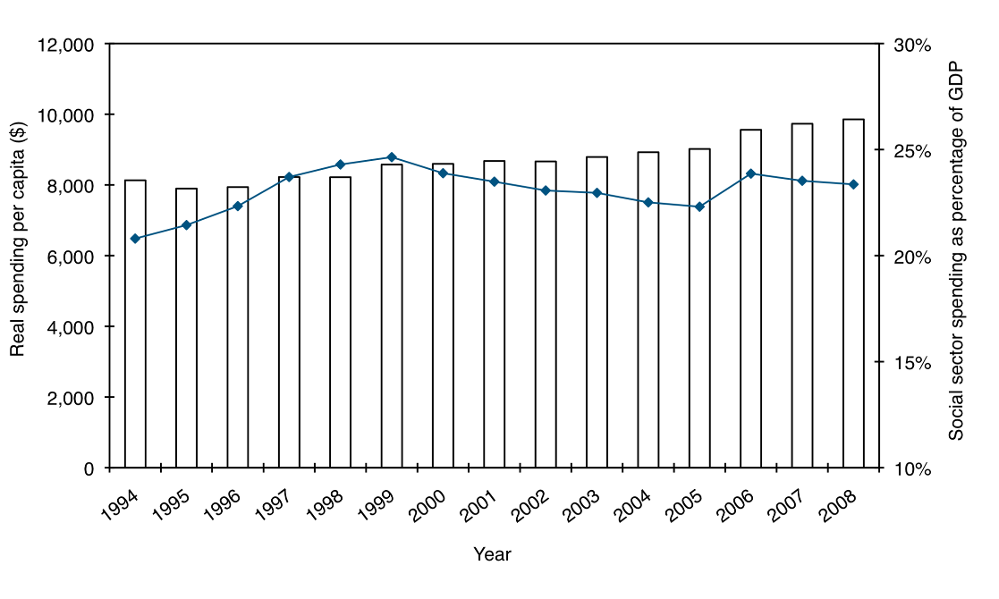
Since 1994, real social sector spending per capita has increased by 24 per cent.

Spending has increased across all of the main spending areas, except benefits
Figure 2 below shows real social sector spending in 1994, 2000 and 2008. Key points to note are:
- Spending increased across all areas of the social sector, except benefit expenditure where benefit numbers have dropped.
- The greatest dollar increases have been in health, primary, secondary and tertiary education, financial assistance for families, and law and order. Increases have been driven by population growth, wage and other cost growth, and increased spending on the quality, affordability and supply of social services.
Figure 2. Real social sector spending, by area of expenditure, 1994, 2000, 2008

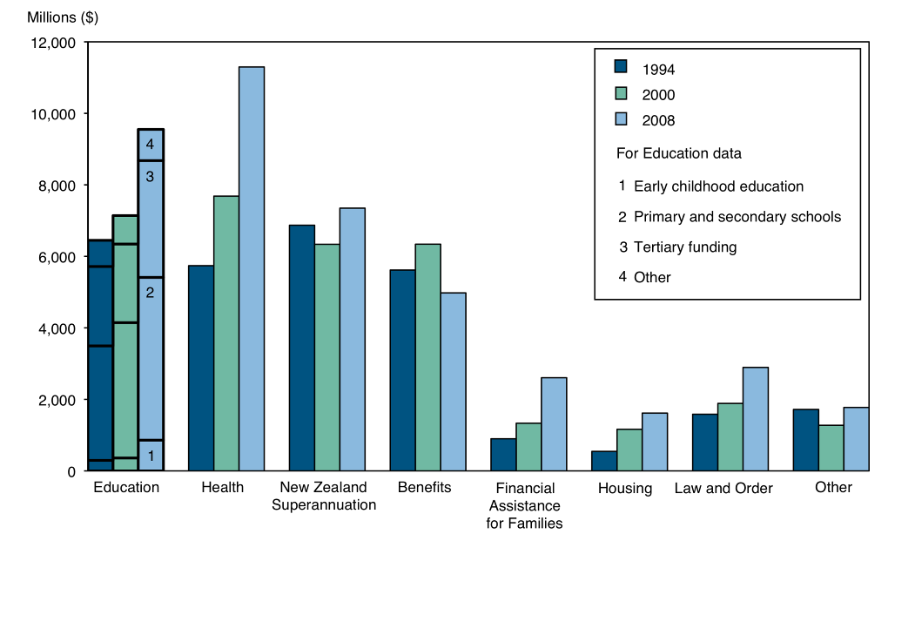
Spending as a percentage of GDP is projected to increase in the areas of health and New Zealand Superannuation (see Part 2 for more details).

How our social spending compares with other OECD countries
Figure 3 below compares government social sector spending in New Zealand with other OECD countries. Key points to note are:
- Overall social sector spending as a percentage of GDP is lower in New Zealand than the OECD average. In particular, our expenditure on pensions and benefits is significantly lower and has declined in recent years as the number of working age beneficiaries has declined. However, our spending on education and law and order is relatively high.
- New Zealand also spends significantly less per capita than the OECD average across all areas, except law and order.
Social sector spending is relatively low in New Zealand compared to other OECD countries…
Figure 3. New Zealand social sector expenditure relative to the OECD, 2005
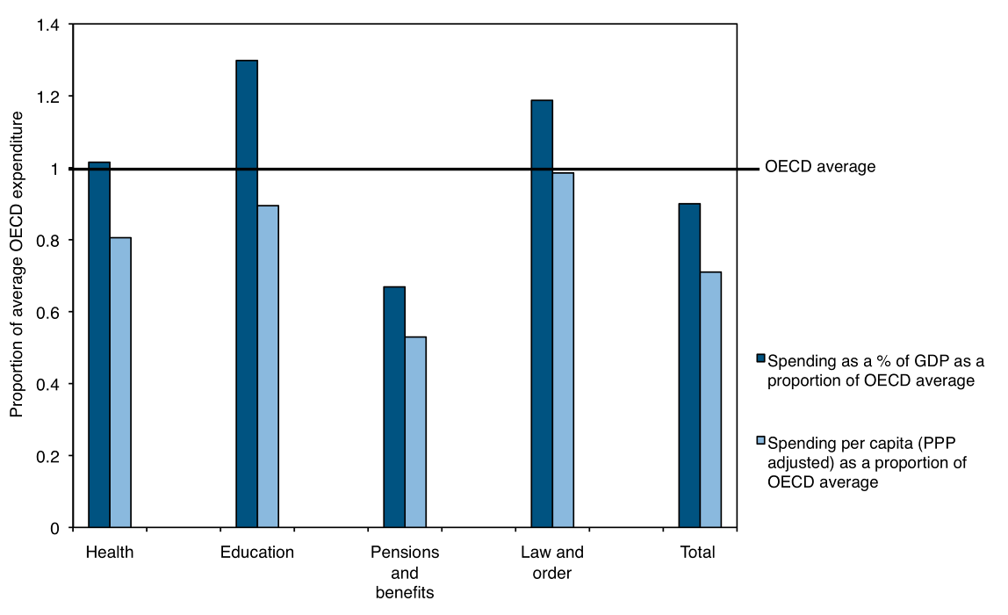New Zealand, by and large, achieves relatively good outcomes compared to other countries based on what we spend:
- New Zealand is the fifth highest performer out of 30 OECD countries for our 15 year-olds’ science results, but we have the second lowest education expenditure on 6–15 year-olds out of the top 10 countries.
…and we achieve relatively good social outcomes compared to other countries based on what we spend
- New Zealanders are living longer than would be predicted from our GDP when compared with other OECD countries. Life expectancy in New Zealand is similar to that in Sweden, Australia, Italy and Iceland – all of which have a higher GDP per capita and invest more in their health systems.
We have relatively high rates of criminal victimisation, however, despite our average to above-average spending on law and order.

Looking Ahead: Critical Social Challenges for New Zealand
In New Zealand we face a number of complex social issues which have long-term costs and consequences. Social spending to address the impacts of these issues will continue to grow unless we can get ahead of them.

Complex and Inter-related Challenges Remain
Despite the good progress made over the past 15 years, a number of complex and inter-related challenges across the social sector remain:
Despite the gains many New Zealanders have made, some complex and inter-related challenges remain

- These issues have the potential to act as a brake on social and economic development in New Zealand.
- Evidence suggests New Zealand can do better in these areas.
- Economic and demographic changes are likely to make these issues even more pressing over the short to medium term.

Educational underachievement and post-school disengagement have serious consequences
While New Zealand secondary students have a very high achievement rate on average, a relatively high proportion of students continue to do poorly compared to other OECD countries.
In 2007, almost 19 per cent of students left school without achieving NCEA Level 1. Although this is an improvement on recent years, it is still a relatively high rate of underachievement.
A relatively high proportion of students are still not faring well within the schooling system. Changing demographics make this challenge even more pressing

The consequences of educational underachievement are significant and they have an impact throughout our lives. Wider society also pays a cost through lower productivity and higher social spending.
Māori and Pacific students and students with disabilities are over-represented among those students who are not faring well within the schooling system – in 2007 35 per cent of Māori students and 26 per cent of Pacific students left school with less than a NCEA Level 1 qualification.
Changing demographics make this challenge even more pressing. As the ‘baby boomers’ retire, young New Zealanders will play an increasingly important role in the economy both as the major source of labour and as contributors to the revenue base of future governments. Different population structures among ethnic groups mean the share of the youth population who are Māori and Pacific peoples is expected to be higher in 2021 than it is now, and the share of Pakeha New Zealanders is projected to fall by 10 per cent.
Overall recorded crime is dropping, although recorded violent crime is on the increase. Despite the overall decline, the sentenced prison population has grown significantly resulting in a sharp growth in expenditure

Criminal offending has a high cost
Overall recorded crime has dropped by 9 per cent since 1993. However, there has been an increase in recorded property damage, offences involving violence, drugs, antisocial behaviour and, to a lesser degree, sexual offences.
Māori continue to be significantly over-represented in criminal justice statistics compared to the overall population.
Despite the overall decline in the level of recorded crime, the sentenced prison population has grown by 41 per cent since 1993. New Zealand now has the fourth highest incarceration rate in the OECD, behind the United States, Poland and Mexico.
This creates high fiscal and social costs for New Zealand. Since 1993, real expenditure on Corrections has grown by approximately 135 per cent – an increase of around $550 million.
While there are a number of opportunities for improving the efficiency of the justice system that will help reduce the pressure on prison capacity in the short term, the most promising avenue in the long term lies in tackling the underlying drivers of criminal offending and reoffending. To do this, the justice sector relies on interventions in the health, education and social development fields.

Housing costs have increased
The cost of housing has increased significantly since the late 1980s. It is estimated than in 2007, one in three low-income households were struggling to purchase the basic necessities of life after paying for housing costs, and this figure had doubled since 1988.
Some people are already struggling to meet their housing costs and the price of low-cost rental housing is likely to increase sharply over the next few years

Although housing affordability for some people may improve with dropping mortgage costs and the predicted drop in house prices, the price of low-cost, private rental housing is predicted to increase, as more people enter the rental market, landlords seek to increase their return on rental properties, and house building slows. The forecast economic slowdown may also lead to a drop in incomes, which in turn may lead to a higher demand for government support to help people meet their housing costs. People in state houses paying income-related rents will be shielded from these price increases.
Currently, the Accommodation Supplement (AS) is the government’s main tool for helping to combat affordability issues in the private rental market. The maximum amount government pays for people eligible for the AS has not been adjusted since 2005, despite rising rentals in some regions.
To reduce the amount of money spent on accommodation, some people are compromising on the quality, space and location of their housing. This in turn further contributes to the poor outcomes some families already experience:
- Living in inappropriate and poor quality housing leads to poorer health. New Zealand has an old housing stock that is damp and difficult to heat. This includes some Housing New Zealand Corporation houses. Living in damp and poorly insulated housing is resulting in unnecessarily high energy costs and rates of respiratory disease.
Substandard housing conditions are contributing to stress, poor health and high energy costs
- Household crowding makes the transmission of infectious diseases more likely, increases family stress and can adversely impact on educational outcomes.
- Housing in close proximity to jobs, public transport, schools and amenities attracts a price premium that many low-income people cannot afford.

Low incomes remain a problem for some
Job growth, higher wages, greater financial support from government for low to middle income working families, and active employment services over the past 15 years have meant that:
- an unprecedented number of people are now in work
- people who are in work are better placed to provide themselves and their families with a decent standard of living. In 1994, 14 per cent of households whose main source of income came from work lived in poverty. By 2007, that figure had dropped to 8 per cent.
Living standards in some households, however, remain poor. Although child poverty has dropped significantly since 1994, households with children continue to make up a large proportion of those experiencing poverty. Poverty, particularly when it is experienced over a number of years and in the early years of a child’s life, can mean a poor quality of life, doing less well at school and the prospect of lower paid jobs in adulthood.
Although the incomes of many New Zealanders have increased, a small proportion of families and whānau still experience substandard living conditions
Although the risk of poverty for people in work has dropped in recent years, people in low-paid, low-skilled and sometimes unstable work over a number of years remain vulnerable to substandard living conditions.
People who spend long periods of time on benefits are also at a high risk of poverty. An estimated 17 per cent of children born in 2001 spent more than four of their first five years in a family receiving a benefit. As many as one in five children turning 15 years in 2008 are estimated to have been supported by benefits for a total of seven or more of their first 13 years of life.
For some people on benefits, caring responsibilities, ill health or disability make a quick return to work difficult.

Factors undermining the health of the nation
At the most basic level, the health of a population depends on:
- the presence of things that promote health – regular exercise, a diet high in fruit and vegetables, choice and a degree of control in life and work
- minimising things that harm health – family dysfunction, abuse, tobacco, harmful drinking and drug use
- ready access to primary health care.
New Zealand has made a significant improvement in access to primary health care. However, further improvements are needed, particularly for Māori and people in our poorest communities.
Some people continue to struggle to maintain a healthy lifestyle and this is creating high health-care costs
The most significant challenge for our future health is for New Zealanders to build back into their lives basic health-promoting actions, and to reduce activities that harm or undermine their health.
Exercise and good nutrition have been eroded by changing lifestyles and patterns of employment, transport, food distribution and living conditions. Obesity, a major predictor of future diabetes and other chronic diseases, has been rising over recent decades (from 19 per cent to 24 per cent in adults between 1997 and 2006). Childhood obesity is of particular concern, with over one in five Pacific children, and one in seven children in the poorest fifth of neighbourhoods, being obese in 2006. The future impacts of obesity on health care, disability, employment and participation in community life are major concerns for New Zealand.
New Zealanders’ drinking patterns are also of considerable concern. Although our overall consumption is around the OECD median, binge drinking (a high number of drinks per drinking occasion) is prevalent and has been increasing in teenagers and young people (from 29 per cent in 1995 to 40 per cent in 2004). Drinking to excess has become the norm in some social situations, and the level of harm that results is a significant drag on social and economic success.

Some Families and whānau are Caught in a Cycle of Social Deprivation
The gains experienced by many New Zealanders over the past 15 years have not reached a small number of highly vulnerable families. What has worked for many families over this period does not appear to be working for our most vulnerable citizens.
These families and whānau remain caught in a cycle of social deprivation where multiple challenges – including poverty, family violence, child neglect, mental and physical ill-health, unemployment – both reflect and are compounded by each other.
The quality of life for children raised in these families and whānau is often poor.
A small number of families and whānau remain caught in a cycle of social deprivation
Many will struggle to fulfil their potential into adulthood. This is particularly so where the parents lack the skills, experiences and social supports necessary to underpin their children’s development.
The consequences can be seen in early school leaving and underachievement, persistent and increasingly violent offending, substandard and unstable living conditions, and poor job prospects.
These poor outcomes represent a real lost opportunity for the individuals themselves, their families and whānau and their communities. They also create successive and avoidable costs to society and act as a drag on economic growth.
It is difficult to estimate the percentage of highly vulnerable families and how this has changed over time. Analysis in the United Kingdom suggests around 2 per cent of families experience multiple and complex challenges. Data from the Christchurch Health and Development Study showed that 22 per cent of children from the 5 per cent of the most disadvantaged families went on to experience multiple problems in their teenage years. This compared with only 0.2 per cent of children from the least disadvantaged families (54 per cent of the sample).

there is Growing Pressure on Social Sector Spending
Government social sector spending can be characterised as either:
- future-focused spending to improve economic and social outcomes in the medium to long term. This includes much of the current spending within the education system, and primary and preventative spending within the health system, or
75 per cent of government’s $43 billion social sector spending is on helping people during difficult circumstances…
- social protection spending to look after people during potentially difficult circumstances. This includes some of the current spending on health care, income support, housing assistance and law and order.
Around 75 per cent of the $43 billion dollars government spends on the social sector can be characterised as ‘social protection’ spending.
…and some of this could have been avoided by greater investment in future-focused forms of spending
Some of this spending could have been avoided if more had been invested in high-quality, future-focused forms of spending to build resilience and prevent problems escalating and becoming entrenched. This includes:
- the direct health-care costs of obesity ($400–500 million in 2004)
- the rising prison population ($894 million in 2008)
- expenditure on child and youth care and protection ($380 million in 2008)
- expenditure on long-term benefit receipt.
The cost of sustaining the current level of social protection has grown in recent years and will continue to grow into the short to medium term:
- New Zealand Superannuation payments are projected to increase from 3.3 per cent of GDP in 2008 to 4.4 per cent in 2020.
- Health spending is projected to increase from 6 per cent of GDP in 2005 to just under 9 per cent in 2020. This will be driven by both the increased cost of maintaining the current level of services (reflecting growing workforce costs) and an increased demand for services. The increased demand will be driven by the growth in long-term conditions associated with lifestyle and environmental factors, and our ability to better treat disease and preserve life. Population ageing will also affect service demand.
Social protection spending is projected to grow
in the short to medium term
- While New Zealand is better placed than many countries to mitigate some of the impact of the recession on benefit numbers, a growing number of people will find themselves without work over the next few years. Unemployment benefit numbers are currently projected to increase from around 23,000 to 35,000 by 2010.
- Corrections spending is projected to continue to increase with the expected ongoing growth in prison numbers.
The increased demand for spending on social protection will be difficult to sustain fiscally. This is particularly so given the potential for tax revenue to contract:
- An ageing population will result in the ‘working’ age population shrinking as a proportion of the total population. This will bring labour and skills shortages, which can be expected to constrain the rate of economic growth with flow-on implications for tax revenue.
Increased social protection spending has the potential to crowd-out more future-focused forms of spending
- Māori and Pacific people are currently over-represented among low-paid workers and will progressively make up a higher proportion of our working age population. Unless Māori and Pacific people move into higher paid jobs, this presents another significant risk to tax revenue.
Increased spending on social protection also has the potential to further crowd-out more future-focused forms of social spending to improve outcomes in the medium to long term.
This could create an even higher demand for social protection spending in the future.

Working Together to Meet These Challenges
An increasing number of the social issues we face cannot be addressed by one agency alone – we need to work together. We also need to work with our non government colleagues. But we don’t need to work together on everything. The Social Sector Chief Executives Forum has identified a number of areas where joint effort will get the best results.

We Can Achieve More in Some Areas by Working Together
These are difficult, but not intractable, challenges for Government
We believe that our growing understanding of these complex challenges means that government can get some real traction in each of these areas. These are difficult, but not impossible, problems to solve.
There are a number of major policy initiatives underway within social sector agencies that have the potential to make a significant contribution.
Significant Initiatives Underway Within Agencies
Effective teaching for all students: increasing the proportion of qualified teachers in early childhood education; providing quality professional development for teachers in literacy and numeracy teaching; and the development of quality assessment tools to support better monitoring of student learning in schools.
Reform of senior secondary schools and support for effective transitions to further education and training: better support for students to plan their education pathways; more flexible and innovative practice in secondary schools; more youth apprenticeships; and more effective engagement of youth at risk.
Initiatives within the justice system to manage pressure on prison capacity: including a wider and more effective range of sanctions; more efficient prosecution and court processes; better alcohol and drug programmes for offenders; and the expansion of prisoner employment programmes.
Health and disability system performance: health targets that focus on improving performance and reducing performance variation between District Health Boards; integrated planning and networking of local, regional and national services to improve quality and efficiency; and new preventive and early detection programmes to allow effective, early-stage care so people can continue to be productive.
Health protection and promotion for resilience: encouraging individuals and families to build protective activities, like regular physical exercise, good eating, self-respect and respect for others, that not only prevent future illness but also contribute to their own and their communities’ social and economic health.
Increased investment in community-based family violence and early intervention services: to support high-quality services for some of our most vulnerable children, young people and their families and whānau.
Integrated Service Response to address underlying needs: Work and Income case managers working alongside clients to support them to identify their own, and their family's underlying needs (broader than income and employment), and bringing other agencies together around these.
Agencies already work together on these and other initiatives to consider the best way to improve outcomes in their own areas and also contribute to improved outcomes in other portfolio areas. For example, the Ministry of Health is prioritising alcohol and drug services for prisoners to help reduce re-offending, and prioritising health services in teen parents units, alternative education and deciles 1–3 schools to improve school retention and attainment as well as health.
There are other highly promising areas where leadership responsibility is less clear and which are vulnerable to slipping through the cracks between agencies. We need to continue to work together in these areas to ensure they get the level of prominence and joined-up effort research suggests they deserve.
Continuing to work together on areas which threaten to slip through the cracks between agencies will be critical to making progress

Some promising initiatives threaten to slip through the cracks
Many of the promising areas where there is no clear agency leadership are areas where we can get in early before a problem escalates and becomes entrenched.
For example, although parents are critical to their children’s immediate and long-term wellbeing, no agency has a clear leadership role in working alongside parents to promote their understanding of their children’s educational, physical and emotional needs and to help prevent child neglect, serious behavioural problems and educational disengagement. Conversely, once those poor outcomes are clearly manifested – in the shape of unemployment, youth offending and child maltreatment – there is clear agency leadership. By this stage, however, changing the path of the problem is both more difficult and more costly.
Current budget and accountability practices can make it difficult to secure funding for initiatives in these areas:
- Often the costs and levers sit in one portfolio but the benefits are spread across several portfolios. Not enough emphasis is given to weighing up the relative cost-effectiveness of initiatives across the whole of the social sector during the budget process to overcome this.
Budget and accountability practices can impede progress in these areas…
- Many of these initiatives do not pay clear dividends until the medium to long term. Consequently, investing in these services effectively represents a double spend in the short to medium term.
- Usually, public demand for such initiatives is not as strong as for services that have immediate, tangible, but often less cost-effective, benefits. For example, although research suggests tackling conduct problems in young children is one of the most cost-effective ways to reduce offending in the medium to long term, there is little call from the public for such initiatives. Similarly, New Zealanders in general tend to be more outspoken about the availability of health services, especially hospital and life-saving services such as cancer treatments, than about basic, effective measures that promote or improve health.
…resulting in a long-term under-investment in resilience building, prevention and early intervention
The combined effect of this has been a long-term under-investment in resilience building, prevention and early intervention initiatives which are some of the most cost-effective investment opportunities for government. This means we are spending more on remedial interventions than is ultimately necessary.

there are Promising Areas of Common Interest
The Social Sector Chief Executives’ Forum has identified some areas:
- where there is a lack of clarity about agency leadership and which, as a consequence, can struggle to get sufficient prioritisation through ordinary policy and budget processes
- which research suggests have the potential to improve results across the social sector
- where we know we can do more and be more effective
We have identified some promising areas of common interest. Making progress in these areas will help to combat social sector spending pressures
- which require concerted, joined-up action between agencies for us to be successful.
At a minimum this means an aligned policy process at a national level. This could include the greater use of joint budget bids for joint work-programmes, and co-located cross-agency teams brought together to work on an area of common interest.
In some instances, this will need to be supported by a combined planning process at a regional/local level and joined-up services for the most vulnerable families.
We have already begun to make progress in some of these areas.
Doing more and working more effectively in these areas will help to combat social sector spending pressures in the medium to long term.

Antenatal, infancy and early childhood
Good maternal nutrition and physical and mental health during pregnancy, nurturing, responsive and stimulating care and play from birth, and good access to primary health care is critical for all children. Poor experiences during the early stages of a child’s life can cast a shadow that remains throughout their life.
New Zealand already has the fundamental building blocks of a comprehensive early years support system, and there has been significant investment in a number of these areas. Agencies have been working together closely to give a high profile to the early years and to ensure effective joined-up work. More, however, could be done:
We can do more to ensure every child gets the best possible start in life
- We could improve the linkages between agencies and community providers to increase the participation of vulnerable parents and children in the core early years services. Vulnerable parents and children are less likely to take part in services available to all families, including antenatal care, WellChild services and early childhood education. Missing out on these services also means not accessing the specialist services attached to those early years services.
- We could put more effort into promoting quality parent and child attachment from birth. A lack of quality attachment, particularly in the very early stages, can leave a child with life-long difficulties in controlling their behaviour, communicating with others, developing healthy relationships, and can put them at a greater risk of addiction. Many of the children who are notified to Child, Youth and Family in their infant years but who are not assessed as facing an immediate risk to their safety return to the attention of Child, Youth and Family in their later years. By this stage, it is more difficult to work with parents to improve the child’s care and to undo the impact of harm the child has already experienced.

Promoting good behaviour among our children and young people
The earlier parents, teachers and the wider community start to promote children’s emotional and social skills, good behaviour and respect for others, the greater our chances are of preventing offending in teenage years and into adulthood. If we are successful in building these skills, we will also improve other outcomes, including educational attainment, mental health and long-term employment outcomes.
It is estimated that 5 per cent of people commit around 50 per cent of all crime. Many of these serious and violent offenders will have shown a pattern of antisocial behaviours dating back to their childhood and teenage years. Figure 4 below shows the pathway to recidivist criminal offending.
The earlier we start to promote good behaviour and respect for others, the greater our chances are of preventing offending and improving educational attainment, mental health and job prospects
Figure 4. Pathway to recidivist criminal offending
Severe behavioural problems in a child’s early years are a strong predictor of future offending. It is estimated that between 5 and 10 per cent of children are affected. However, no agency has clear accountability in this area and the consequence has been a significant shortage of behavioural services. This is despite good evidence that high-quality programmes can make an enduring difference. In the past, agencies that do have some responsibilities have got involved at a point where the child’s behaviour is very difficult to control. At this stage, our chances of changing those patterns of behaviour are considerably diminished.
Joining-up to Tackle Offending and Re-offending
Central, social sector and population agencies have joined-up to tackle offending and reoffending by: reducing the underlying causes of crime, including effective early interventions for at-risk children and their families; reducing opportunities for offending and reoffending; and enhancing victims' satisfaction with the criminal justice system in the medium term. Work is also underway to alleviate pressures on prison capacity in the short term.
This work has strengthened connections between agencies and brought to the table a wide range of perspectives and fresh understanding of both the workings of the New Zealand criminal justice system and of current thinking on crime and punishment.
Agencies are joining together at both a national and regional planning level to combat offending and re-offending
Getting mainstream, national programmes right is critical to making further progress on the offending front. However, the challenges take different shapes in different communities and neighbourhoods. Community co-ordination and innovation draws on the knowledge people on the ground have about what networks and services are needed in their communities. It can also lead to more effective problem and solution identification.
Youth Gangs and the Auckland Youth Support Network (AYSN)
The Youth Gangs plan, implemented through the Auckland Youth Support Network provides systematic, integrated and targeted services and supports to the children, young people, families and communities of Counties Manukau and Otahuhu. The AYSN has senior representatives from all key central government agencies. These representatives are Auckland-based and are able to provide an on-the-ground view and on-the-ground decision making. Local government is also represented on the network. Each agency is committed to a collaborative approach in response to youth gang activity and siloed operational activities no longer occur. This is a whole-of-government response to improve outcomes for young people and to respond to youth offending.

Tackling problematic alcohol use
Harm from drinking is a significant undertow on New Zealand's social and economic success and has an impact on results across all social sector agencies:
- alcohol is a factor in 90 per cent of all police callouts between 10pm and 6am. Many of these are family-violence related
Strong cross-government leadership to combat the significant cost of alcohol-related harm could have a significant positive impact
- seventy to 80 per cent of hard core youth offenders have a diagnosable alcohol or drug problem
- alcohol contributes to over a third of the deaths of 15–29 year-olds and, across all age groups, cost 33,500 disability-adjusted life years in 2002
- alcohol dependence is a barrier to work for a significant proportion of our long-term unemployed.
In the medium to long term, the most cost-effective way to reduce alcohol-related damage is for government to take the lead in limiting harmful drinking. We need to recognise the particular vulnerability of the young, but also to moderate the drinking (and acceptability of excessive drinking) of everyone. Leadership can be both social (opinion and acceptability) and regulatory (legislated and code-based).
Strong and sustained leadership by government here could have a significant and positive impact across a broad range of social and economic outcomes – our experience with drink driving and cigarette smoking provides strong evidence of the effectiveness of such leadership.

Redeveloping our more deprived communities
People facing multiple disadvantages live throughout the country. However, in many of the major cities and towns in New Zealand there are geographic concentrations of low-income households living in low-cost housing which is often of a poor quality. This is most apparent in areas that have high concentrations of state housing. The overall level of individual disadvantage within these communities is high and the infrastructure in some of them is poor – people live far from work, with inadequate public transport, few shops, and no quality social services.
The key to redeveloping deprived communities is a joined-up approach between central government, local government, businesses and communities with a focus on improving outcomes for existing residents and on using higher density housing to encourage the growth of more mixed communities – a mix of housing of varied sizes, prices, and tenures, and catering for single people, couples and families.
We need to continue to work together to improve outcomes for residents in our more deprived communities and to encourage the growth of more mixed communities
Research shows that encouraging the growth of more mixed communities usually reduces geographic concentrations of disadvantage. Other potential benefits include: communities being able to attract and support a high level of local services, leisure activities, shops and related facilities. Higher average levels of disposable income may create more employment opportunities for local residents; improve educational attainment; reduce low-level crime; and bring greater social cohesion.
Tamaki Transformation Programme
This programme aims to take advantage of the significant opportunities in Tamaki (East Auckland) to make the area a better place to work and live.
The multi-agency nature of the programme provides a significant opportunity to change the life course of a community by improving education, employment, health and housing and by reducing crime in the area. It requires new ways of working between central government agencies, local government, the community and non-government sectors to co-ordinate and commit resources.
The transformation of Tamaki to a more mixed and sustainable community has a
20-year time horizon. The initial redevelopment of selected sites is scheduled to
take place over the next five years, integrated with community, social and economic initiatives.
Deteriorating housing affordability, changing demographics and climate change will become more important as New Zealand’s population grows. To make our cities more sustainable, new developments and the redevelopment of suburbs and town centres must focus on using land, infrastructure and assets more effectively. Intensifying land use in strategic areas, in particular, could provide New Zealanders with more housing types, viable public transport and thriving town centres.
An interagency team (the Sustainable Urban Development Unit), hosted by the Department of Internal Affairs, has been set up to explore options for place-based approaches to sustainable urban development. The team has identified some barriers and implementation difficulties that can prevent the delivery of large-scale urban development projects. They have also suggested new tools to overcome these challenges.

Effective engagement with our vulnerable families with children
Enduring challenges like disengagement from school, family violence, and long-term unemployment typically have complex and inter-related causes. Dealing with the presenting issue in isolation does not work.
Whenever government agencies engage with vulnerable families, we need to think about the needs of the whole family – both the parents and the children – and, where necessary, joining-up services for the family.
We need a strong emphasis on joining-up our services for the most vulnerable families and whānau. This includes thinking about the needs of the whole family – both parents and children
We also need to get better at attracting and retaining vulnerable people in our services. This includes ensuring agencies and providers have the right incentives for working with vulnerable families.
Integrated Service Response for Vulnerable Individuals and Families
The Integrated Service Response is a case management approach for vulnerable people who have complex and multiple needs.
The approach is led by Work and Income and has a strong focus on interagency collaboration, particularly working with Housing New Zealand Corporation and the Police as well as other government and non-government agencies. A Work and Income case manager acts as a key contact for the individual or family to understand their needs and bring other agencies together around these.
By working proactively with these families earlier and by providing a more intensive level of support we are able to help them to get on with and be successful in their lives.
We could also do more to support good parenting – for many families and whānau, but particularly the most vulnerable. While parenting is sometimes a stressful and challenging job for everyone, some people lack the experiences, social supports, and living conditions to respond successfully to these challenges. A growing body of evidence suggests high-quality and evidence-based parenting programmes can make an enduring difference to children’s education, health, safety and behaviour.
Providing better mental health and addiction services to parents, reducing family violence, and helping parents find decent and affordable housing and sustainable employment also places them in a position where they can begin to take greater responsibility for and better care of their children.

We Can Make Faster Progress in These Areas

Unified social sector leadership
The Social Sector Chief Executives’ Forum has begun to take a leadership role in promoting a cross-agency effort in each of these areas but more can be done to strengthen our leadership.
We can make faster progress in these areas by strengthening social sector leadership
Establishing clear government goals and developing measurable and public targets in each of these areas which are the joint responsibility of the social sector agencies would help to create a stronger focus on the areas of common interest we have identified. It would also help to energise staff at all levels.
Publishing a document that sets out the progress being made towards achieving those targets would establish strong incentives to align and motivate efforts towards success. The document could clearly set out how the activity of each agency contributes to achieving those targets and how agencies could do things differently to make faster progress.
Developing community ownership of these targets, for example among local authorities and Māori and Pacific leaders, would also be critical to success.
Joint social sector and community targets would help align our efforts
The timeframe for meeting the targets should be sufficiently long to allow for sustainable change to be achieved, while maintaining pace and urgency.
Some examples of the types of high-level targets that could be agreed across and outside of government are provided below.
Possible joint targets through to 2015
– decrease the percentage of low birth-weight full-term babies
– increase the percentage of full and exclusive breast-fed infants
– increase the percentage of 2-year-olds who are fully immunised
– increase participation in quality early childhood education in our more deprived
neighbourhoods
– reduce the rates of re-notification of child maltreatment to Child, Youth and Family
– reduce the percentage of students who leave school without NCEA Level 2
– reduce the percentage of children and young people who are apprehended for
serious offences
– reduce the percentage of people who engage in binge drinking

Commitment to high value-for-money social spending
Achieving the best value-for-money for government’s social spending requires ongoing review with a long-term perspective. It requires us to identify both those very high value activities where investment will result in high returns in the long term, and also those lower value activities and services. We need to have a willingness to pull out of those lower value areas of expenditure.
High value for money is especially necessary in a time of fiscal constraint. Re-prioritisation within baselines and across Votes, and careful investment for high future returns, will increase value and give the flexibility and stability required for programmes with long-term returns.

Re-prioritisation of funding within and across social sector agencies
If the social sector is to make a significant difference in the medium to long term in the areas we have discussed, there needs to be an ongoing effort to re-prioritise effort and expenditure to focus on effective early interventions. To achieve this kind of re-prioritisation we need to ensure there is leadership focused on results, characterised by:
- a shared understanding of the results being sought from re-prioritisation
- timely monitoring of these results and a commitment to reconsider priorities if these results are not achieved
In an environment of fiscal constraint, we need to get better leverage from both existing and future spending
- clarity about, and commitment to, the consequences of reducing expenditure or activity in lower priority areas.

‘Spending to save’ approach
There are areas of activity where we know that increased investment in prevention and early intervention, such as primary and preventative health care for young children, and parenting programmes, not only improve immediate outcomes but also save money in the long term. They do that by reducing the development of downstream problems such as school disengagement and youth offending.
Society is already concerned about the growing costs of obesity, crime and educational underachievement. Those costs are reflected in forecasts of future government spending. If we move to using a portion of that forecast spending growth to fund early intervention programmes, we could get ahead of some of the problems and avoid some of their growth.
By identifying the future investment propositions and capitalising on future funding to enable us to fund those initiatives, we can achieve improvements in social outcomes and reduce spending over time.

Contributing to New Zealand’s Economic Success
In the medium to long-term, investing in children and tackling the inter-generational transfer of disadvantage will help build a skilled, flexible workforce. An ageing population and an ongoing domestic and international shortage of skilled workers will make progress on these fronts critical to New Zealand’s continued wealth and economic success.
Of particular importance is improved attainment and retention within school, and then good transitions out of school into further education, work or training. What happens over the short to medium-term within the schooling sector will be vital. Other parts of the social sector will also have a role to play, particularly in supporting children and young people from our more vulnerable families and whānau. A joint effort to promote uptake of quality early childhood education, to address behavioural issues as soon as they arise, and to provide comprehensive support for vulnerable young people in transition all have the potential to make a significant contribution.

Working with you
Over the past 15 years there have been improvements in results across the social sector. However, a number of complex and inter-related challenges remain which have the potential to act as a break on social and economic progress.
We now have the opportunity to get some real traction on these enduring and complex challenges.
Social sector agencies can achieve more on these fronts by continuing to work closely together.
The Social Sector Chief Executives’ Forum would welcome the opportunity to discuss with Ministers how we can strengthen social sector leadership to achieve better social and economic outcomes for all New Zealanders.
We can provide further briefings on the issues and actions we have raised.
We look forward to working with you.

Endnotes

Dijk, Jan van et al (2007) Criminal victimisation in international perspective; key findings from the 2004–2005 ICVS and EU ICS http://rechten.uvt.nl/icvs/pdffiles/ICVS2004_05.pdf
The ‘other’ category includes funding for care and protection and youth justice work undertaken by Child, Youth and Family
In 2006, 33 per cent of the bottom income quintile of households spent more than 30 per cent of their income on housing, compared with 16 per cent in 1988. See Ministry of Social Development (2008) The Social Report 2008 Ministry of Social Development: Wellington
Wilson M and Soughtton D, Children In Families Supported By Main Benefits: An Update, Social Policy Journal Of New Zealand, Issue 34, Nov 2008 (forthcoming)
Cabinet Office Social Exclusion Taskforce (2007) Reaching Out: Think Family Cabinet Office: United Kingdom http://www.cabinetoffice.gov.uk/~/media/assets/www.cabinetoffice.gov.uk/social_exclusion_task_force/think_families/think_families%20pdf.ashx
Fergusson D M, Horwood L J and Lynskey M (1996) The Childhoods of Multiple Problem Adolescents: A 15-year Longitudinal Study Journal of Child Psychology and Psychiatry 1994 Sep 35(6):1123–1140javascript:PopUpMenu2_Set(Menu7995847);
This figure is net of tax, but does not include payments into or dividends from the New Zealand Superannuation Fund
This includes universal, free maternity care, regular free WellChild health checks for 0–5 year-olds, free primary health care for all children under-5, and 20 hours free early childhood education for 3 and 4 year-olds. Government also supports parents to take time out from work to care for their young children through parental leave provisions, paid parental leave, and work-life balance legislation. Targeted financial support is provided to parents who have no other source of income to support them while they care for their young children or to enable them to re-train. Financial assistance is also available to families whose earned income is inadequate
Based on material in H M Treasury and Department for Education and Skills (2007) Policy Review of Children and Young People: A Discussion Paper http://www.hm-treasury.gov.uk/media/B/B/cyp_policyreview090107.pdf
Chartered Institute of Housing (2006) Creating and Sustaining Mixed Income Communities: A Good Practice Guide, Joseph Rowntree Foundation: United Kingdom

