Coversheet |  | 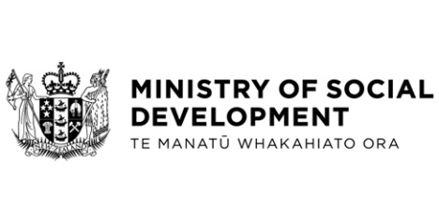

FamilyBoost Tax Credit Exemption Regulations 2024
Hon Louise Upston, Minister for Social Development and Employment
These documents have been proactively released.
8 August 2024, Cabinet paper - FamilyBoost Tax Credit Exemption Regulations 2024
8 August 2024, Cabinet Legislation Committee Minute LEG-24-MIN-0154, Cabinet Office.

Amendments to the Social Security Regulations 2018, the Residential Care and Disability Support Services Regulations 2018, and the Student Allowances Regulations 1998, are required to ensure FamilyBoost tax credit payments are not considered as income or a cash asset for assistance administered by the Ministry for Social Development, for 12 months from receipt of each FamilyBoost payment.
© Crown Copyright, Creative Commons Attribution 4.0 International (CC BY 4.0)
Search Tags: FamilyBoost, income and cash asset exemption

