the fall and rise (??) of household incomes

Mary Mowbray and Neela Dayal
Researcher Analysts
Social Policy Agency

introduction

New Zealand has undergone significant changes in its economic and social policy environments over the past 15 years. In an attempt to bring New Zealand out of recession a new economic philosophy has been adopted. This has led to an overturning of state intervention and a complete remodelling of the economy. These changes have included: the introduction of the wage/price freeze lasting more than two years, to November 1984; currency devaluation and the freeing up of the foreign exchange market; a short lived upturn in economic activity from 1985 to 1987; major changes in the income tax structure, and the introduction of the Goods and Services Tax late in 1986; increasing unemployment and growth in the number of people reliant on benefit income throughout this period, but particularly after 1987; changes in the process of adjusting benefits in line with the Consumer Price Index until the late 1980s which meant that benefits maintained their real value while the real value of wages and superannuation declined because of inflation; the introduction of Family Support in the mid 1980s which helped prop up the incomes of low income families with children; tax restructuring in the late 1980s which significantly reduced the marginal tax rate for higher income earners; substantial restructuring of both the public and private sectors; significant changes in the area of income maintenance; the introduction of the Employment Contracts Act designed to free up the labour market, resulting in reductions in wage protection; the overall effects of the recession during the late 1980s and early 1990s; and the more recent upturn in economic performance.

These changes, have to varying degrees, impacted on the level of household income. In the year to March 1993, pre-tax mean household income was on average 15 per cent lower than it was in the March 1982 year. Disposable mean household income fell ten per cent over the same period. Median household income fell at twice the rate of mean household income. This suggests low income households have experienced greater falls in real incomes when compared to high income households.

Among household types, households with single adults receiving superannuation and lone parents of dependent children were consistently lowest in income, while those with three or more adults without children were the highest.

On an equivalent basis, households where one of the residents was a beneficiary, a superannuitant, a Pacific Island or Māori adult, were at considerable disadvantage when compared to households in general.

In December 1993 the Social Policy published the Incomes Monitoring Report 1981-1991 (Mowbray 1993). This report found household incomes had fallen in real terms over the ten year period. This paper updates a portion of this study for the 1992 and 1993 March years while providing a summary of its finding.

Explanatory Notes

The data were drawn from the ASSET database derived from Statistics New Zealand's Household Expenditure and Income Survey (HEIS) for the March years 1982, 1984, 1986 and 1988 to 1993.

Household income is the reported income of all persons aged 15 years and over, i.e. all adults in the household. Pre-tax income is total income from all sources including social welfare benefits. After tax or disposable income takes into account tax liability and tax credit such as Family Support and Guaranteed Minimum Family Income (GMFI) regardless of whether tax is paid or credit is received. All incomes are inflation adjusted to December 1993 dollar values using the Consumer Price Index, to reflect their updated purchasing power. In the final section of the paper equivalent disposable income is adjusted using the Revised Jensen Scale (1988) to allow comparison to be made across all households. The scale adjusts for the number and ages of children, to the standard of two adult households. Where the study refers to households with different residents, superannuitants and beneficiaries are people who receive more than half their income from National Superannuation or a social welfare benefit respectively.

Mean and Median Incomes of Households

Throughout the eighties, mean household incomes across all households became lower. More recently there has been a slight upturn in household income, although it is too early to suggest a reversal of the downward trend.

Both the pre-tax and the disposable mean income levels have fallen over the 1981 to 1993 period. The pre-tax mean fell 15 per cent to $41,489 per annum while the disposable mean fell ten per cent to $31,893 per annum (see Figure 1).

The median household income fell at twice the rate of mean household income. Over the 1981 to 1993 period the pre-tax median fell 28 per cent to $31,015 per annum while the disposable median fell 24 per cent to $24,789 per annum (see Figure 1).

Figure 1 CHANGES IN PRE-TAX AND DISPOSABLE INCOME 1981 to 1993
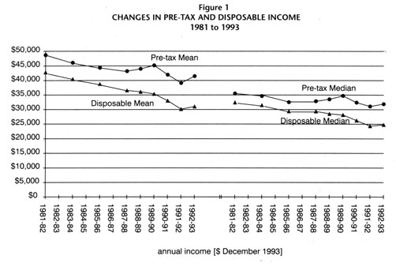

The reduction in household income in part reflects the fall in the average number of people per household. In the March 1982 year there were on average 3.0 people per household, compared to 2.6 in the year to March 1993. Also reflected in the falling mean household income level is the overall decline in employment. Over the 1981 to 1993 period, the number of households in which no paid work as undertaken increased significantly. In 1981, less than a quarter of all households recorded zero hours of paid work per week. By 1993, this proportion had increased to 35 per cent.

The degree of inequality between household incomes appears to have increased. In 1981, the household at the upper quartile boundary had a pre-tax income which was 2.7 times that of the household at the lower quartile. By 1993 this had risen to three times that of the lower quartile. The redistributive effects on taxation are observed to a degree in that disposable household income is only marginally more equally distributed than total household income. Households at the upper quartile boundary had a disposable household income which was 2.6 times that of the lower quartile in 1993.

Low income households have experienced greater falls in income than high income households. Between 1981 and 1993 pre-tax household income fell 26 per cent at the lower quartile boundary compared to an 18 per cent fall at the upper quartile. Over the same period, disposable household income fell 23 per cent and 14 per cent at the lower and upper quartile boundaries respectively.

Mean Disposable Income in Households of Different Composition

While overall household incomes have fallen, there were substantial differences in household income trends and in the nature of extent of the fall, depending on household composition.

Over the 1981 to 1993 period, households comprising single adults receiving National Superannuation, one adult plus children, other single adults and two adult households in which at least one received National Superannuation, all had disposable household income levels below that of households in general (see Figure 2).

By contrast households in which two or more non-superannuitant adults were present had disposable income levels above the overall mean (see Figure 2).

In general, all household types experienced a fall in disposable income over the eighties. The largest fall in disposable mean income was experienced in households comprising three or more adults with children (where incomes fell by 17 per cent between 1981 and 1992).

One adult with children households and single non-superannuitant adults without children also experienced large declines in income. Mean disposable income for both types of households fell 14 per cent over the decade to 1992.

While overall comparisons of household income levels in the decade to 1992 reveal disturbing downward trends in income levels, the year to March 1993 has seen a slight upturn in the mean income level of most household types.

There was an increase in the mean household incomes for all one and (with the exception of those in receipt of National Superannuation), two adult households in the year to March 1993. Single adults receiving National Superannuation and one adult plus children households experienced the largest increases of 7 per cent and 6 per cent respectively (see Table 1).

Not all households have shared in this increase. Three adult households and two adult households receiving National Superannuation, continued to experience a decline of disposable income in the 1993 year. The largest fall in disposable income was recorded by households comprising two superannuitant adults without children (down two per cent over the year).

While one and two adult households recorded increases in disposable income over the 1993 year, this did not redress the losses made in earlier years for the majority. In particular, one adult plus children households had disposable income eight per cent lower than they had in 1981, despite the large percentage increase in the year to March 1993. Single adults receiving National Superannuation had, on average, higher incomes than they did in 1981, while all other households had lower incomes.

Figure 2 Mean Disposable Household Income for households of different
composition 1981 to 1993
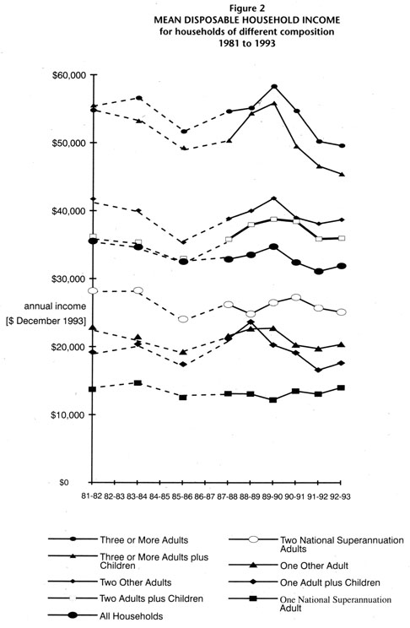

Table 1 | Changes in Mean Disposable Income for Households with Different Compositions 1981-82, 1991-92 and 1992-93
 |  |  | Annual Income |  | percentage  change
 |  |  | ($ December 1993) |  | percentage  change
Household Type |  | 1981-82 | 1991-92 | 1992-93 | 1981-82 to 1992-93
One National Superannuation Adult |  | $13,730 | $13,054 | $13,995 | 2%
One Adult plus Children |  | $19,202 | $16,603 | $17,633 | -8%
One Other Adult |  | $22,881 | $19,731 | $20,358 | -11%
Two National  Superannuation Adults |  | $28,202 | $25,704 | $25,109 | -11%
Two Adults plus Children |  | $36,236 | $35,820 | $35,940 | -1%
Two Other Adults |  | $41,722 | $38,120 | $38,694 | -7%
Three or More Adults  Plus Children |  | $55,507 | $45,798 | $45,407 | -18%
Three or More Adults |  | $54,802 | $50,204 | $49,591 | -10%
All Households |  | $35,534 | $31,102 | $31,914 | -10%

This is likely to be due to the introduction of the single living alone allowance in October 1990.

Households with children appear to have been particularly disadvantaged. For all years, a lower level of disposable income was recorded for both one adult and multi-adult households where children were present.

In general, a higher proportion of households received their main source of income from market sources in the March 1993 year than in the previous year. Conversely, there was a reduction in the proportion of households reliant on a social welfare benefit or National Superannuation.

Mean Equivalent Income for Households with Different Residents

Households income in its unadjusted form is of limited value when examining the living standard of households because households of different size and composition will need different incomes to attain a similar standard of living. Equivalent income allows a more realistic comparison of households with different residents.

Table 2 | Changes in Mean Equivalent Disposable Income for Households1 with  Different Residents2 1989-90 TO 1992-9
Resident |  | 1989-90 | % | 1990-91 | % | 1991-92 | % | 1992-92 | %
Beneficiary |  | $22,014 | 72 | $18,976 | 65 | $16,331 | 59 | $16,606 | 58
Superannuitant |  | $21,447 | 70 | $21,076 | 73 | $21,098 | 76 | $19,818 | 70
Pacific Island Adult |  | $24,524 | 80 | $23,459 | 81 | $21,609 | 78 | $21,252 | 75
Māori Adult |  | $24,931 | 81 | $23,652 | 81 | $21,8985 | 79 | $22,327 | 78
Children |  | $28,012 | 91 | $26,288 | 90 | $24,196 | 87 | $24,475 | 86
All Households |  | $30,764 | 100 | $29,049 | 100 | $27,850 | 100 | $28,458 | 100

The December 1990 benefit cuts appear to have had a significant impact on the equivalent disposable incomes of beneficiary households. The lowest mean equivalent disposable income levels were experienced in households in which a beneficiary was present. As Table 2 indicates, beneficiary households on average had a disposable income equivalent to only 58 per cent of that for all households in the March 1993 year. This compares with 72 per cent prior to the announcement of welfare cuts of December 1990 (see Table 2).

Households in which a superannuitant was present had the next lowest equivalent disposable income, equal to 70 per cent of that for households in general for the March 1993 year.

Households in which a Māori or Pacific Island adult was resident, along with households with children, also had below average equivalent disposable household income.

When compared with households in general, those with a beneficiary, Pacific Island adult or Māori adult, and those with children, have experienced substantial falls in equivalent income over the 1981 to 1993 period. This in turn is likely to have had a negative impact on standard of living.

conclusion

There have been considerable reductions in real household income over the 1981 to 1993 period. Real pre-tax and disposable mean income levels have fallen 15 and ten per cent respectively, while median household income has fallen twice as fast. This has led to an increased level of income inequality amongst households. Examination of disposable household incomes at the quartile boundaries has shown an income level at the upper quartile boundary 2.6 times that at the lower quartile. Low and middle income households experienced greater falls in real incomes when compared to high income households. This is evident when comparing changes in some levels at different percentiles. The real household median income fell 24 per cent, while the fall at the upper quartile boundary was significantly lower at 14 per cent.

High unemployment has increased the number of beneficiary households, while the 1991 benefit cuts have further contributed to falling household income at the lower end of the distribution. The overall effect is likely to have been a much reduced standard of living for many New Zealand households. In the March 1993 year beneficiary households had a mean disposable income equivalent to only 58 per cent of households in general. This suggests that beneficiary households may be becoming economically marginalised in society. Superannuitant households had the next lowest level of equivalent income followed by households in which a Māori adult was resident and households in which a Pacific Island adult was resident.

Although there is evidence of a return to economic growth in New Zealand, the examination of household income shows that this is yet to be experienced by all. The trends observed over the 1981 to 1993 period give some weight to the notion that the gap between the rich and the poor is getting wider.

While the above analysis informs us of changes in income distribution, it does not tell us much about the adequacy of different income levels in terms of the standard of living they will support. Reported increases in demand for services such as food banks suggests there is an increasing number of individuals, families and households with income less than is required to meet basic needs. There is an urgent need for further research on the situations of those using these "safety net" services, and on the actual standard of living associated with different income levels, to make explicit the social and economic implications of the fall in household incomes which has been documented.

references

Jensen. J. (1988) Income Equivalences and the Estimation of Family Expenditures on Children, Department of Social Welfare, Wellington.

Mowbray, M. (1993) Incomes Monitoring 1981-1991, Social Policy Agency, Department of Social Welfare, Wellington.

1 Household incomes have been adjusted using the Revised Jensen Equivalence Scale.
2 Percentages express mean equivalent disposable income for the different households as a percentage of the mean for all households.

