what does employment change have in store for the
unemployed in the 1990s?

Vasantha Krishnan
Researcher/Analyst
Social Policy Agency

introduction

New Zealand has experienced major changes in employment trends and the labour market in recent years. Studies across the Tasman have also identified significant changes in the Australian labour market which have challenged the structure and rationale of Australian labour market and income support policies. In response to these changes, the Australian White Paper on Employment and Growth has reported on Government policy initiatives for the reform of Australian labour market and social security systems to make it appropriate to fit them to the current and prospective labour market, rather than the labour market of the past. New Zealand's social security system has been based on some of the key assumptions of the present Australian system, namely, that the normal pattern of work is full-time participation in the labour market until retirement and that unemployment is a finite period of short duration. This report examines whether the trends impacting on New Zealand's labour market and social security systems are similar to those experienced in Australia, and poses the question as to whether responses similar to those carried out in Australia my be appropriate for New Zealand.

auStralian labour market trends and policy responses

The Australian labour market has undergone dramatic change, particularly over the past decade. Key components of this change include:
- Increases in the duration of unemployment:
- Decreases in full-time labour force participation by men at all ages, but particularly men aged over 55 years;
- Increased labour force participation by married women;
- An increase in two earner families to more than half of married couple families;
- Increased earnings by women in the labour market and the increased contribution of wives' income to household earnings;
- Increasing part-time and casual employment opportunities;
- A reduced likelihood for men and women of leaving unemployment for full-time work and an increased probability of leaving unemployment for part-time work; and
- Growth in low paid jobs and reductions in real wages for low-paid jobs, resulting in income support relatively problems for some groups (Department of Social Security 1993).

The Australian economy was in recession during 1990-91 and since 1991-92 has experienced slow growth. Recent forecasts of economic growth in Australia suggest that unemployment will slowly reduce, but not significantly for some time. In addressing the issue of how best to equitably share the benefits of economic growth in Australia, the Australian White Paper on Employment and Growth (1994), suggests that unemployment will have to be substantially reduced. While economic growth is seen as a key to achieving this objective, it is not considered to be sufficient in addressing unemployment. This is because growth tends to delivery jobs to new entrants to the labour market and the short-term unemployed. The White Paper has concluded that new labour market and social security programmes are required to address long-term unemployment and improve the circumstances of the economically marginalized.

The "Job Compact" is a central feature of Australia's unemployment policy to assist the long-term unemployed. Through this scheme, the Government will offer a job to those unemployed for 18 months or more. The unemployed in turn must take up the offer or lose their benefits. Specific steps are also to be taken to identify people at risk of becoming long-term unemployed for prompt assistance. Those "at risk" as well as those unemployed for 12 months would receive individual case management to overcome barriers and be given access to relevant labour market programmes (Australian Government Publishing Service 1994).

In Australia, the youth labour market has also changed. Policy development in Australia has recognised that there are no longer large numbers of full-time jobs for unskilled young workers. In response to this change the Australian Government has abolished the Job Search Allowance for people under 18 years of age and replaced it with a Youth Training Allowance. The Youth Training Allowance is part of the new Youth Training Initiative which aims to intervene at early stages of the unemployment cycle. A central philosophy in Australia's multi-faceted initiative for youth is that all young people should be involved in some form of education and training, including work-based training.

Low employment rates for the partners of unemployed men in Australia had prompted the Department of Social Security to conclude that the treatment of married couples as a joint income unit created a disincentive to work, i.e. "once one partner has earned income, any income earned by the other partner is largely offset by reductions in Social Security payments" (Australian Government Publishing Service 1994). The restructuring of the Australian income support scheme has been geared towards removing this disincentive, by giving individual income support to each partner of an unemployed couple. In cases where both partners are entitled to unemployment allowances, each would also have an entitlement to labour market assistance. Along with individual entitlement comes an obligation for both partners to search for work.

Part-time employment growth is also a feature of the Australian labour market, with almost a quarter of all jobs in Australia being part-time. This transition has provided an impetus for reforming the Australian social security system. Under the traditional Australian social security system, the income test on benefits was a major disincentive for unemployed people to take on part-time work. Where income exceeded even a modest level, the unemployment benefit was withdrawn on a dollar for every dollar earned basis (i.e. 100 per cent abatement). Under this system, beneficiaries with earned income had an earnings "free-zone" of $45 for single people, $55 if only one partner of a couple had earnings and $80 if both partners had earnings. In order to encourage unemployed people to take up part-time work, the White Paper on Employment and Growth (1994) has proposed that the abatement be reduced to 70 per cent, so that unemployed people would gain financially from taking up work. The changes included a simplification of the earning "free-zone" for beneficiaries, to $30 for a single person and $30 for each partner of a couple.

In summary, key components of the initiatives to reform the Australian labour market and social security systems include: reforms to labour market assistance; active case management for those at risk of long-term unemployment; an emphasis on making the unemployed "job ready", even if work is not immediately available; youth training initiatives to encourage movement into education and training; individual unit of entitlement for unemployed and low income families to encourage both partners of a couple to enter paid work; reduced benefit abatement to foster the take-up of part-time work by beneficiaries; and significant re-structuring of the social security system to remove disincentives to work.

new zealand labour market trends

Employment Outlook

New Zealand has experienced record levels of unemployment over the past ten years and its economy has undergone significant structural change. Economic recession has affected New Zealand throughout much of the late 1980s and early 1990s, notwithstanding a short lived upturn in economic activity from 1985-1987. More recently, there has been another upturn in economic performance, but there are still large numbers of people unemployed and reliant on benefit income.

Recent forecasts by the New Zealand Institute for Economic Research (NZIER) suggest that the New Zealand economy is expected to grow by 3.6 per cent in the year to March 1994. It is anticipated that this growth is sustainable in the medium term, although at slightly lower rates of growth than those currently being recorded (NZIER 1994).

Comparable forecasts by a number of monitoring agencies suggest that employment will continue to grow over the next few years, although at a slower rate than the past few years. Reserve Bank estimates show that employment will increase by 2.7 per cent by March 1995 and further by 1.6 per cent by March 1996 (see Figure 1).

Figure 1 Trends in Employment Growth and Unemployment, 1989-1997
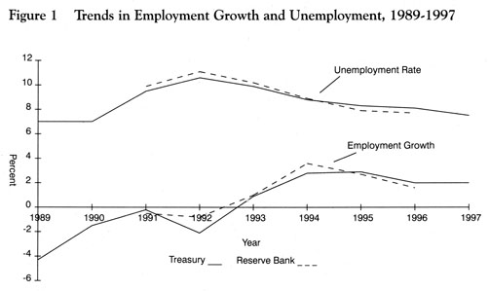
Sources: | Reserve Bank Bulletin, Vol. 55, No. 4, Reserve Bank, Wellington, 1992.  Reserve Bank Bulletin, Vol. 56, No. 3, Reserve Bank, Wellington, 1993.  Reserve Bank, (1994), March Forecasts, Wellington, (Unpublished).  Treasury, (1994), March Forecasts, Wellington, (Unpublished).

Similarly, the Reserve Bank forecast has predicted that unemployment will fall to 7.9 per cent in the March 1995 quarter and further to 7.7 per cent by the March 1996 quarter. However, NZIER forecasts suggest that while unemployment will fall, it will respond more slowly to increases in economic activity. This is due to factors such as natural increases in the labour force, a substantial reversal in the net outward migration of the late 1980s, and an increase in labour force participation. There is a risk that participation increases in response to an improving labour market may be stronger than expected, providing upward pressure on unemployment (NZIER 1993).

Long-Term Unemployment - A Growth Area

Since the 1980s, both the numbers of long-term unemployed (i.e. those unemployed for 27 weeks or more) and the median duration of unemployment have risen, the latter from eight weeks in 1986 to 28 weeks in 1994. According to the March 1986 New Zealand Household Labour Force survey, 7,200 people (11 per cent of the unemployed) had been unemployed for more than 6 months. The corresponding figure for March 1993 was 78,500 (47 per cent of the total unemployed). By March 1994, there had been a slight improvement in unemployment with 74,600 persons being long-term unemployed (see Figure 2).

Figure 2 Unemployed by Duration of Unemployment, 1986-1994
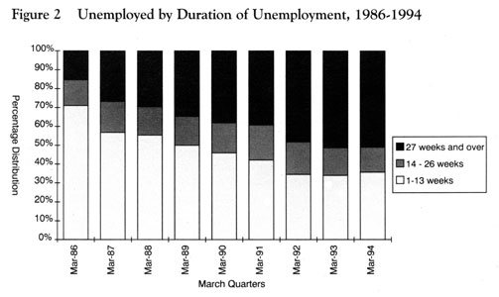
Source: | New Zealand Household Labour Force Survey, March Quarters 1986-1994, Statistics New Zealand, Wellington

Furthermore, amongst the long-term unemployed, there has, until 1993, been an increased incidence of being unemployed for more than a year. In 1986, under half (44 per cent) of those who had been unemployed for more than six months had been out of work for more than a year. By 1993, this group of unemployed represented almost two-thirds (68 per cent) of those who had been out of work for more than six months. By 1994, this proportion had fallen slightly to 65 per cent.

In line with increases in the duration of unemployment, the past few years have seen an increase in the average duration of people on the unemployment benefit from 66 weeks in 1990 to 95 weeks in 1994. The fact that a person can, on average, spend almost 2 years on the Unemployment benefit, contradicts the very assumptions on which this benefit was developed, primarily that it was there to fill a short-term income gap, while a person was in between jobs. Today, the unemployment benefit may be the only source of income for unemployed individuals, for a considerable length of time.

Who Are The Long-Term Unemployed?

The composition of the long-term unemployed is of increasing concern. The risk of long-term unemployment is greater amongst men than women. Amongst males who were unemployed in 1994, half (51 per cent) were long-term unemployed. In comparison 40 per cent of unemployed women were long-term unemployed. The lower likelihood of women being long-term unemployed may be due to the fact that women are more likely to leave the labour force and become "discouraged unemployed" i.e. those who are not actively seeking work and are therefore excluded from official unemployment statistics (Department of Statistics 1993). In 1993, almost two-thirds (64 per cent) of all discouraged unemployed were women.

The official unemployed are therefore not the complete measure of "labour market slack" which also includes discouraged unemployed and those who are involuntarily employed on a part-time, casual or temporary basis, but want full-time secure employment (i.e. the under-employed). Furthermore, large proportions of the beneficiary population e.g. those receiving domestic purposes benefits, sickness or invalids benefits, who are not cited as "officially unemployed", may actually move into paid work, if it were available.

While the incidence of unemployment declines with age, amongst those who are unemployed, the incidence of long-term unemployment increases with age. For example, while those aged 55 plus had the lowest likelihood of being unemployed in 1993, those in this age group who were unemployed had a higher likelihood of being long-term unemployed. In 1993, 65 per cent of those aged 55 plus who were unemployed were long-term unemployed, compared with 47 per cent of those aged 20-24 years. In contrast, the total unemployment rate for the 55 plus and 20-24 age groups were five per cent and 16 per cent respectively (see Figures 3a and 3b). What this suggests is that while unemployment is still predominantly a youth phenomenon, where it does affect older people, it is more likely to be long-term with subsequent long-term implications. Furthermore, older people are also more likely to withdraw from the labour market. This will depress the unemployment rate amongst this age group. Within this context, it is important to note that between 1989 and 1993, numbers of persons receiving the Aged 55+ unemployment benefit more than doubled from 3,909 to 8,585. Increases since 1992 are partly related to the rise in the age of eligibility for New Zealand Superannuation.

Figure 3a Total Unemployment Rates by Age, 1993
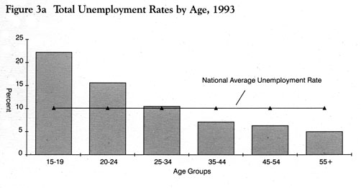
Source: | Labour Market 1993, Statistics New Zealand, Wellington, 1994.

Figure 3b Incidence of Long-Term Unemployment Amongst the Unemployed by Age, 1993
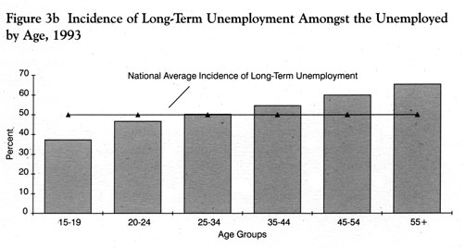
Source: | Labour Market 1993, Statistics New Zealand, Wellington, 1994.
Parallel patterns are apparent in average duration of receipt of unemployment benefit. Social Welfare statistics on current benefits show that in 1994, the average duration on the unemployment benefit for those aged 50-54 years was 136 weeks. This compares with 73 weeks for those aged 20-24 years and 95 weeks for all ages (see Figure 4).

Figure 4 Average Duration on Unemployment Benefit by Age, 1994
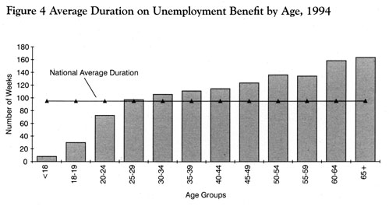
Source: | Unpublished operational statistics relating to current benefits, extracted from Social Welfare systems

The population most disadvantaged by long-term unemployment appears to be unemployed Pacific Island people, for whom the incidence of long-term unemployment is higher than for any other group. Amongst Pacific Island people who were unemployed in 1993, just over two-thirds (68 per cent) were long-term unemployed (see Figure 5a and 5b). The higher incidence of long-term unemployment amongst Pacific Island people may reflect the circumstances of an older unskilled Pacific Island work force who lost jobs in the manufacturing sector during the re-structuring of the 1980s. Substantial numbers of jobs were lost from this sector at that time. However, when the risk of being long-term unemployed is measured as a proportion of the total labour force, 17 per cent of Pacific Island people are likely to be long-term unemployed, compared with 13 per cent of New Zealand Māori and four per cent of European.

Figure 5a Unemployment Rates by Ethnic Group, 1993
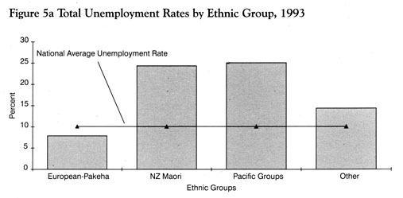
Source: | Labour Market 1993, Statistics New Zealand, Wellington, 1994.

Figure 5b Incidence of Long-Term Unemployment Amongst the Unemployed
by Ethnic Groups, 1993
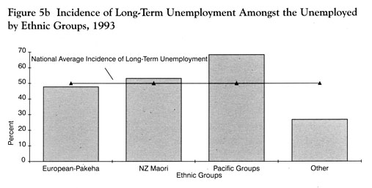

Source: | Labour Market 1993, Statistics New Zealand, Wellington, 1994.

The Prime Ministerial Task Force on Employment (1994) has identified a number of factors which can lead to long-term unemployment becoming self-reinforcing. These include: losing contact with the labour market and informal networks which are a common source of information about vacancies; missing out on formal and informal on-the-job training; and the loss in self-confidence as a result of repeated rejections experienced by the long-term unemployed. This in turn leads to less frequent and/or less effective job searching.

Changes in the Youth Labour Market

Changes in labour force participation rates in the past 40 years have varied markedly for different groups in the population. The longest established trends have been the steadily increasing involvement of women in the labour force and the gradual decline in male labour force participation. However, these trends have not been consistent across all age groups.

Between 1986 and 1994, overall male labour force participation continued to fall from 79 per cent to 74 per cent. This fall in participation occurred across all age groups, but was greatest among younger men. Amongst men aged 15-19 years, 72 per cent were in the labour force in 1986. By 1994, only 55 per cent were participating in the labour force. This decline in participation has also been recorded for young women. Reduced employment opportunities may have meant that many young people are delaying entering, or have withdrawn from, the labour force. The increased numbers and proportions of youth remaining at school or entering tertiary institutions is consistent with this suggestion (Department of Statistics 1993). Between 1986 and 1993, the participation of 15-19 year olds in post-compulsory education increased from 54 per cent to 69 per cent. While the raising of the school leaving age was effective from 1993, Ministry of Education sources suggest that because increases in educational participation were already under way, the law change has had a marginal impact on overall educational participation amongst this age group.

While New Zealand's labour force participation rate for 15-19 year olds has fallen considerably, it is still higher than many OECD countries which have lower rates of labour force participation amongst this age group.

There has been a strong association between levels of youth unemployment and levels of participation in post-compulsory education in recent years. Up until recently, New Zealand had very low rates of participation in post-compulsory education, at levels which were well below other similar countries. The low levels of participation were carried over from an era of low unemployment, when many young school leavers were absorbed into employment in highly protected industries. With the lifting of protection and the opening up the economy to global competition, youth unemployment soared as did demands for skilled labour. One of the outcomes of this has been increased participation of youth in education and training at the post-compulsory ages.

Reversal of Historical Trends in Labour Force Participation

The historical trend has been for the labour force participation of older males to decline. This pattern was still evident between 1986 and 1989, when for example, participation for 55-59 year old fell from 87 per cent to 78 per cent. Since then, this trend has stalled for this age group with participation fluctuating around 80 per cent. In contrast this trend has reversed for 60-64 year olds with participation initially having declined from 46 per cent in 1986 to 33 per cent in 1992 and then increasing to 43 per cent by 1994. This is probably associated with the recent rise in the age of eligibility for New Zealand Superannuation (see Figure 6). Other contributing factors could include improved health of older people and a greater desire amongst older workers to continue their participation in the labour force.

Figure 6 Labour Force Participation Rates of Persons Aged 60+ Years,
1986-1994
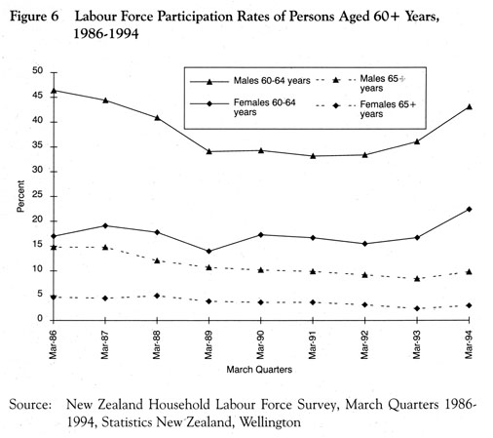

Source: | New Zealand Household Labour Force Survey, March Quarters 1986-1994, Statistics New Zealand, Wellington

In contrast to male participation, the historical trend for female labour force participation through to 1986 was one of increasing participation. However, since 1986, female labour force participation has also stalled and oscillated between 53 and 55 per cent. While overall female participation has remained relatively stable since 1986, this pattern has not been consistent across all age groups. Like younger males, participation for women aged 15-19 years has fallen substantially from 63 per cent to 53 per cent. For women aged 25-29 years, participation has increased from 62 per cent in 1986 to 67 per cent in 1994. Similar large increases in participation have been experienced by women aged 45 years and over.

Labour Market Circumstances of Partnered Women and Sole Parents

The overall increase in female labour force participation which has occurred since 1951 is largely the result of increased labour force participation by partnered women.

While there has been overall growth in the employment rates of partnered women, the employment rate for partners of unemployed men remains low. At the time of the 1991 Population Census, two-thirds 66 per cent) of female partners of unemployed men were not in employment. For couple-only families (i.e. those without children), where the male partner was unemployed, half (51 per cent) of the female partners were also not in employment. The likelihood of female partners not being in paid jobs was lower in families where the male partner was employed. For example, just under a third (31 per cent) of female partners in these families were not in employment. Amongst couple-only families were the male partner was employed, 23 per cent of female partners were not in employment. Factors influencing the lower employment rates of women with unemployed partners could include the values regarding work roles within a couple, and the correspondence between the labour market characteristics such as skills of partners.

At the time of the 1991 Population Census, 66 per cent of sole parents were not in paid employment. This proportion was much higher for female sole parents (69 per cent) than male sole parents (50 per cent). Part-time employment rates were low amongst sole parents, accounting for only 9 per cent of all sole parents. However, one in four sole parents (24 per cent) was in full-time employment. This rate was again much higher for male sole parents (44 per cent) than for female sole parents (19 per cent). These results are also reflected in Social Welfare statistics which show that DPB recipients have very low levels of earned income. In March 1994, only 16 per cent of DPB recipients reported receiving earned income.

Mothers who are partnered are more likely to be employed than sole mothers. In 1991, over half (57 per cent) of partnered mothers were employed, up from 39 per cent in 1976. Similarly in 1991, partnered fathers were almost twice as likely as sole fathers to be employed (83 per cent compared with 49 per cent).

The likelihood of employment for mothers is strongly influenced by the age of their youngest child, the likelihood of employment increasing as the age of their youngest child increases. Furthermore, as might be expected, there is an inverse relationship between being employed full-time or part-time depending on the age of the youngest child. For women whose youngest child is aged 1-7 years, there is a higher likelihood of being employed part-time as opposed to full-time. The reverse is true for women whose youngest child is older than seven years (see Figure 7).

Figure 7 Mothers Employed by Age of Youngest Child, 1991
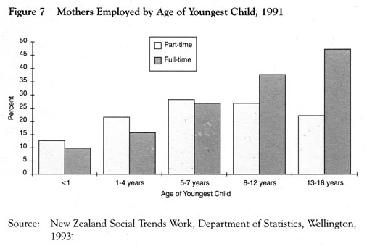
Source: | New Zealand Social Trends Work, Department of Statistics, Wellington, 1993.

Earned Income of Beneficiaries

In recent years, the proportion of beneficiaries declaring earned income has increased. For example, in 1992, 15 per cent of unemployment beneficiaries reported receiving earned income. This proportion had increased to 20 per cent by 1994. This increase is likely to be a function of two factors. Firstly, an increased rate of reporting due to publicity about benefit fraud. Secondly beneficiaries are seeking part-time or casual paid employment to supplement benefit earnings.

The amount of earned incomes declared by different beneficiary groups tends to be around the existing abatement levels, with numbers in each category tailing off as the income categories rise. Figure 8 shows that the shape of distributions of declared earnings is broadly similar across benefit groups. Each peaks around the abatement level, with a rapid fall-off in numbers over the income categories spanning $60-$100 per week, to a more gently reducing tail for categories over $120 per week. The median income values tend to fall close to the abatement level. However, it is important to note that beneficiaries with earned incomes are in a minority, and that the majority of those with additional incomes are receiving amounts at or below the abatement levels. For example, in March 1994, 80 per cent of unemployment beneficiaries had no earned income. This compares with 84 per cent of Domestic Purposes Benefit (DPB) recipients, 88 per cent of sickness beneficiaries and 83 per cent of all beneficiaries.

Figure 8 Earned Weekly Income of Beneficiaries, 1994
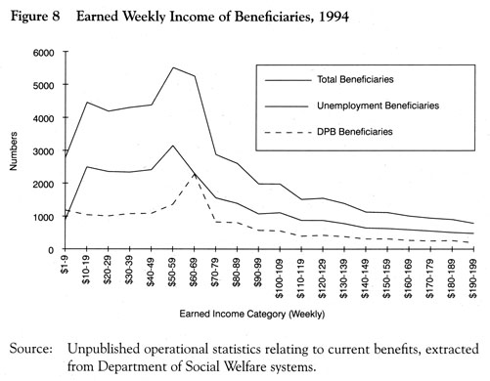

Source: | Unpublished operational statistics relating to current benefits, extracted from Department of Social Welfare systems.

Effects of Paid Employment on Family Income

Paid employment plays a vital part in improving the longer term economic circumstances of families. For example, amongst low income couple families, increases in family income from a second earner would exceed any increase in income possible from pay rises, promotions or tax cuts, even under favourable economic conditions. The position of families with no earners offers a sharp contrast to the improved income circumstances of two-earner families. The OECD has estimated that poverty rate amongst couples in which both partners are in employment are generally half those in which only one partner is in employment (Department of Social Security 1993). The New Zealand Household Expenditure and Income Survey for the 1992-93 year shows that employment has a significant impact on total family income for sole parent and partnered families. As Table 1 demonstrates, families with two earners will be significantly better off financially than other families.

Table 1 Median Equivalent Family Income¹ by Family Type and
Employment Circumstances, 1992-1993 Year
Family Circumstances | Median Equivalent Income
Sole Parent (Not Employed) | $12,369
Sole Parent (Employed) | $19,632
Two Parents (Neither Employed) | $12,194
Two Parents (One Employed) | $24,167
Two Parents (Two Employed) | $35,266
Couple Only (Neither Employed) | $19,549
Couple Only (One Employed) | $36,225
Couple Only (Two Employed) | $52,418
- Gross income from all sources

Source: | New Zealand Household Expenditure and Income Survey, 1992-93 Year,  Social Policy Agency, Wellington

Employment Growth – Who Has Benefited?

Overall employment has steadily increased by five per cent or 72,300 between the March 1992 and March 1994 quarters of the Household Labour Force Survey. While most age groups have benefited from this growth, employment growth for those aged 15-19 years has not been so steady. Between the March 1992 and March 1993 quarters of the Household Labour Force Survey, employment for 15-19 year olds fell by 10,900 from 116,700 to 105,800. However, between the March 1993 and March 1994 quarters, employment for this age group had increased slightly to 109,200.

In contrast, those aged 45-49 years accounted for 29 per cent of the total growth in employment between the March 1992 and March 1994 quarters, with an increase of 21,300 jobs amongst this age group. They were followed by people aged 20-24 and 30-34 years, for whom employment increased by 15,400 and 10,100 respectively over this period.

The 60-64 age group also experienced significant employment growth of 9,200 jobs over the March 1992 to March 1994 period. This is possibly indicative of people in this age group remaining in employment following the raising of the age of eligibility for New Zealand Superannuation.

All the major ethnic groups have shared in the employment growth experienced since 1992. Employment amongst New Zealand Māori grew by nine per cent or 9,400 between the March 1992 and March 1994 quarters. Over this same period, Pacific Island employment increased by 13 per cent or 6,100 extra jobs. Other smaller ethnic groups experienced employment growth of 3,900 or nine per cent, while Europeans accounted for the balance of 52,600 (an increase of four per cent) between 1992 and 1994.

While New Zealand Māori and Pacific Island people have also shared in the recent employment growth, the unemployment rate for these groups remains double the national unemployment rate of nine per cent.

Part-time Employment Growth

The total number of part-time jobs has grown by a third from 241,500 in 1986 to 321,500 in 1994. In contrast, the number of full-time jobs has fallen by seven per cent from 1,302,600 in 1986 to 1,210,700 in 1994. Furthermore, the proportion of all employment which is part-time has increased from 16 per cent in 1986 to 21 per cent in 1994.

Part-time work has significantly increased in all industry groups, most notably in service industries which tend to employ more women. However, part-time employment has increased for both men and women over the 1986-1994 period. Whereas full-time male employment fell by 81,900 over the 1986-1994 period, part-time male employment increased by 29,100. The proportion of all men employed part-time has almost doubled from five per cent in 1986 to nine per cent in 1994.

Female part-time employment has also grown by 26 per cent from 191,100 in 1986 to 241,900 in 1994. In 1994, over a third (36 per cent) of all employed women worked part-time. This proportion has grown from 30 per cent in 1986.

Part-time employment has also benefited in the recent employment growth experience in New Zealand. Of the 57,200 employment growth experienced between 1993 and 1994, 19,700 (34 per cent) have been part-time employment growth. While males and females shared equally in the growth in total employment, much of the female employment growth was part-time. In contrast, males benefited from the recent full-time employment growth. Overall, 92 per cent of the growth in part-time work experienced between 1993 and 1994 was female employment. In contrast, female employment accounted for only 28 per cent of the increase in full-time employment over the past two years.

Mobility in the Labour Market

Changes in the labour market can also be measured by examining the incidence of labour monthly mobility between different labour force status. Such mobility is affected by many factors including employment growth or decline, completion of education, new entrants to the labour market, childbearing, retirement or changes in employment prospects. Analysis of gross flow data from the New Zealand Household Labour Force survey shows a substantial decline in the probability of leaving unemployment for full-time employment. Exit rates from unemployment to full-time employment fell sharply from a third (34 per cent) between the December 1985 and March 1986 quarters to 16 per cent between the December 1993 and March 1994 quarters. Exit from unemployment to part-time employment has stayed relatively stable at around ten per cent over this period.

Paralleling the fall in overall employment levels over this period, exit from unemployment into any form of employment has halved from 45 per cent between the December 1985 and March 1986 quarters to 23 per cent between the December 1990 and March 1991 quarters. Since March 1991, exit rates into employment have improved slightly to 26 per cent. This possibly reflects an improvement in employment opportunity as a result of recent employment growth. However it remains to be seen whether this trend will continue.

The likelihood of moving from unemployment out of the labour force altogether remains high at around 30 per cent. It is possible that many of these people become disillusioned job-seekers and join the "discouraged unemployed". Between the December 1985 and March 1986 quarters, there was a higher likelihood of exiting from unemployment into employment (45 per cent) than out of the labour force altogether (29 per cent). However, by the December 1993 and March 1994 quarters, there was a higher probability of the unemployed leaving the labour force altogether (30 per cent) than going into employment (26 per cent). Some people who leave the labour force may transfer from social welfare benefits such as the unemployment benefit to the sickness, invalids or domestic purposes benefit. Social welfare statistics show that there is a considerable amount of movement between these benefits. This suggests that the labour market potential of persons receiving benefits such as the sickness, invalids or domestic purposes benefit must not be ignored.

While the analysis of gross flows shows that part-time employment may act as a bridge to full-time employment, the majority (66 per cent) of part-time workers remained part-time employed between the December 1993 and March 1994 quarters. However, one in six (16 per cent) of part-time workers did move into full-time work between the December 1993 and March 1994 quarters. The remaining 18 per cent of part-time workers had either become unemployed or left the labour force altogether.

Self-Employment On The Increase

The growth in self-employment is another aspect of employment change witnessed in recent years. Technological change, structural changes in the economy, social change and the economic recession of the 1980s have all contributed to the growth in self-employment.

Since 1987, the number of self-employed persons has increased by 16 per cent from 270,900 to 314,900 in 1994 (see Figure 9). In comparison, the number of wage and salary earners has fallen by five per cent. The proportion of the employed labour force who are self-employed has increased slightly from 17 per cent in 1987 to 20 per cent in 1994. Over the same period, the representation of wage and salary earners amongst the employed labour force has fallen from 81 per cent in 1987 to 78 per cent in 1994.

Figure 9 Changes in Numbers Employed by Type of Employment, 1987-1994
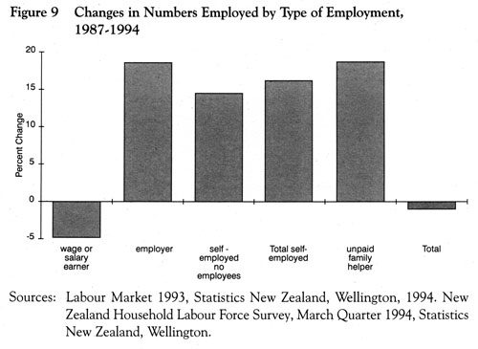
Source: | Labour Market 1993, Statistics New Zealand, Wellington, 1994. New Zealand Household Labour Force Survey, March Quarter 1994, Statistics New Zealand, Wellington

While self-employment has traditionally been the domain of the agricultural sector, industries such as manufacturing, construction and transport have experienced growth in the numbers of self-employed. This growth has been associated with the increased use of "multi-tiered" sub-contracting (that is, where people previously employed as wage and salary earners become self-employed as private contractors and consultants), the growth in service sector employment and the increased importance of small businesses in these industries (Department of Statistics 1993).

Although self-employment has been looked at as a means of job creation, the recent Prime Ministerial Task Force on Employment (1994), concluded that the movement of unemployed workers into self-employment has not been a significant contributor to the growth in self-employment. However, economic recovery could encourage some unemployed (particularly older unemployed with skills, work experience and capital) into self-employment as a viable employment option.

Of the 61,800 employment growth experienced between 1993 and 1994, 44,500 (72 per cent) was wage and salary employment while 18,900 (30 per cent) was self-employment. While there has been significant growth in wage and salary employment over the past two years, continued growth is required before employment levels achieved in 1987 can again be reached. In contrast, barring a small decline in the numbers of self-employed experienced between 1990 and 1991, for most of the period since 1987, self-employment has continued to grow.

conclusion

Clearly there have been many changes in New Zealand's labour market and economy over the past decade. Many of these changes have been similar to those experienced in the Australian context, which prompted the Australian Social Security Reform package. These similarities include:
- An overall growth in unemployment;
- Significant and continued growth in long-term unemployment;
- Increases in youth unemployment;
- Growth in part-time work;
- Increased female participation in the labour market; and
- Declining male labour force participation.

However, there may also be key differences between the New Zealand and Australian experiences. These include:
- Ethnic differences in New Zealand's unemployment rates;
- Current high levels of employment growth experienced in New Zealand;
- Recent increases in the labour force participation rates of those aged over 60 in New Zealand, resulting in a reversal of a historical trend;
- High levels of immigration experienced in Australia; and
- New Zealand's severe economic recession over the 1989-1991 period which resulted in unemployed rates which were higher than that experienced in Australia over this period.

In response to labour market changes experienced across the Tasman, the Australian Government has introduced proposals to reform their labour market and social security systems. These proposals are based on a comprehensive analysis of the broad problem, drawing links between the labour market, education and training and social assistance.

Before this article is published, the Employment Taskforce will have reported. It will be interesting to see the extent to which proposals similar to those adopted by the Australians may be considered appropriate for New Zealand.

references

Australian Government Publishing Service (1994) Working Nation Policies and Programs. Presented by The Prime Minister The Honourable P.J. Keating, M.P. House of Representatives, 4 May 1994, Canberra.

Australian Government Publishing Service (1994) Working Nation: The White Paper on Employment and Growth. Presented by The Prime Minister The Honourable P.J. Keating, MP House of Representatives 4 May 1994, Canberra.

Department of Social Security (1993) Meeting The Challenge: Labour Market Trends And The Income Support System. Policy Discussion Paper No 3, Australian Government Publishing Service, Canberra.

Department of Social Welfare (1993) Statistical Information Report. Wellington.

Department of Statistics (1994) Labour Market 1993. Wellington.

Department of Statistics (1993) New Zealand Social Trends: Work. Wellington.

New Zealand Institute for Economic Research (1994) Quarterly Predictions March 1994. NZIER, Wellington.

Organisation for Economic Co-operation and Development (1994) Employment Outlook July 1994. OECD, Paris.

Organisation for Economic Co-operation and Development (1993) OECD Economic Outlook, 54, December 1993. OECD, Paris.

Prime Ministerial Task Force on Employment (1994) Employment: The Issues. Wellington.

Reserve Bank (1994) March Forecasts. Unpublished, Wellington.
Reserve Bank (1992) Reserve Bank Bulletin, Vol. 55, No. 4, Wellington.

Reserve Bank (1993) Reserve Bank Bulletin, Vol, 56, No. 3, Wellington.

Social Policy Agency, New Zealand Household Expenditure and Income Survey, 1992-1993 Year, Unpublished, Wellington.

Statistics New Zealand (1994) New Zealand Census of Population and Dwellings 1991. Wellington.

Statistics New Zealand, New Zealand Household Labour Force Survey, Wellington, (Unpublished).

Treasury (1994) March Forecasts. Unpublished, Wellington.

Long-Term unemployment is defined as being unemployed for 27 weeks for more.
Transitional Probabilities measure the likelihood of moving from one labour force status to another, between two quarters of the Household Labour Force Survey.
OECD Economic Outlook, 54, December 1993, Paris.

