MĀORI DEMOGRAPHIC TRENDS

Whetu Wereta
Ngāi Te Rangi, Ngāti Ranginui
Consultant

INTRODUCTION

The Māori population at the end of the 20th century is in a state of transition. The level of growth is falling. Under pressure from the falling rate of growth, the age composition of the population is changing. In terms of distribution, Māori are more highly concentrated in the northern regions of the country than in others and the urban-rural make-up of the population appears to have stabilised. However, there are signs of the possible emergence of a new trend in the movement of the population. Māori families, it seems, are now leaving the main urban centres for less urbanised regions.

Massive changes in the age structure of the population are expected over the next forty years. These will affect every aspect of Māori social, economic and cultural life. Policy-makers and planners at national and local government level, and at the iwi level, need to be conscious of the likely changes and their implications for social policy and Māori development. This paper identifies and describes the major movements in the population over the past four decades and looks forward to likely future trends. It is a descriptive paper intended to create a greater awareness of the issues with which government and Māori leadership alike will have to come to grips as the population progresses through the early part of the 21st century.

Two notes of caution must be sounded. First, longitudinal studies of the Māori population are fraught with definitional problems. The census definition of Māori has changed several times over the last 100 years. Most of those changes have occurred within the last 20 years. At the last census, three different counts of the population were taken. With the exception of the iwi statistics, all of the data presented in this paper refer to the Māori ethnic group population. Second, statistics about the future of the Māori population are derived from the latest official population projections. Projection methodology employs assumptions about future demographic behaviour. These assumptions are based on past and current trends. They cannot be said to predict the future with certainty because they do not allow for non-demographic factors. Projections provide indications of the future. They are not an exact forecast.

SIZE AND GROWTH

Between 1981 and 1991, the Māori population increased in size from 385,200 to 434,800 – a rise of about 13 per cent. Over the decade prior to that, the increase was in the order of 33 per cent. As these figures confirm, the level of growth has fallen markedly over recent years. Nevertheless, Māori numbers have continued to grow at a faster rate than non-Māori numbers and as a result the proportion of Māori in the total population rose during the period under review, from 12 to 13 per cent.

Figure 1 Number and proportion of Māori in the total population, 1966–2031
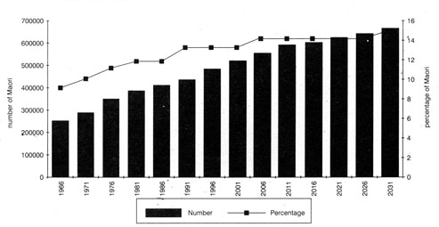
Projections based on middle set of assumptions, series 6, 1991 base for Māori and series 8 1991 base for
total population.

The downward trend in the rate of Māori population growth is expected to continue well into the 21st century. Over the next forty years, the rate of growth is expected to drop by more than half, the projected average being 1.1 per cent per annum. At this rate, the number of Māori at the end of the period should be 54 per cent higher than it was in 1991. This means that the population should number 672,000 in 2031, making up 15 per cent of the total New Zealand population.

FACTORS INFLUENCING THE CHANGING LEVELS OF GROWTH

A combination of demographic and social factors underlie the changing levels of growth in the Māori population. Principal among these are: a downward trend in fertility, a falling death rate and corresponding improvement in life expectancy and net losses to the population through external migration and inter-ethnic mobility.

Fertility

Between 1963 and 1993, the total fertility rate fell from 6.3 to 2,3 and is now only fractionally higher than the non-Māori rate. The sharpest drop occurred between 1970 and 1980, when the rate fell from 5.2 to 2.4. This is one of the fastest fertility declines recorded in the world and it was brought about largely through widespread adoption of contraception, abortion and sterilisation.

The total fertility rate is a measure of the average number of children a woman can expect to bear in her lifetime at current fertility levels and it is often used as an indicator of average family size. What the figures just mentioned tell us is that, over the decade prior to the one under review, the average size of a Māori family fell by more than half.

Figure 2 Fertility Rates, Māori and Non-Māori, 1963–1993
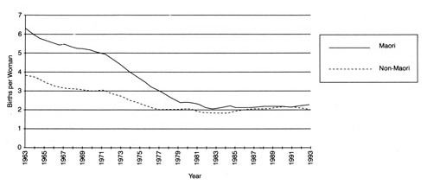
Although there have been the occasional fluctuations, Māori fertility has continued to decline, albeit at a much reduced pace. Over the next forty years, the total fertility rate is projected to fall more gently than it has in the past to a level of 2.1 children per woman in 2031. By that time, Māori families should be similar to non-Māori families.

The level of fertility has more bearing on Māori growth than any of the other factors under consideration. Māori population growth derives solely from natural increase, i.e. from an excess of births over deaths. It does not have the luxury of being supplemented by net external migration gains.

Life Expectancy

Life expectancy has improved steadily over the last four decides. Between 1951 and 1981, the number of years a new male child could expect to live rose from 54 to 65 years, whilst the number of years a new-born female child could expect to live rose from 56 to 69 years. The last ten years have added a further 3 years to male life expectancy and a further 5 year to that of females. In 1991, the average life expectancy for males was 68 years and for females, 72 years.

Figure 3 Life Expectancy at Birth, 1951–2031
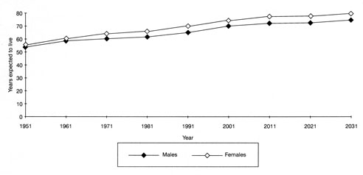
Underlying the increase in life expectancy is a continuing downward movement in mortality. Much of the recent improvement can be accounted for by a decline in the rate of infant mortality. The situation is likely to continue to improve. For population projection purposes, Statistics NZ has assumed that male and female life expectancy will rise to 75 years and 80 years by 2031.

External Migration

The Māori population has sustained losses through external migration for many years. Although the losses have been small, their cumulative effect on the population has been significant. For example, between 1980 and 1986 (when the recording of travellers' ethnicity was done away with by Customs, thereby putting a stop to the production of Māori migration statistics) the total net loss to the Māori population through migration overseas was in the order of 8,000.

Losses through external migration have both an immediate and long-term effect on population growth. The immediate effect is obvious. The longer-term effect is a consequence of the age structure of the migrant group. In the Māori case, emigrants are most likely to be in their 20s and early 30s. Those who are married will tend to be either childless or to have very young children. By going overseas, they diminish the reproductive capacity of the Māori population and thereby affect its future fertility levels.

Over the next forty years, losses through net migration are assumed for projection purposes to be on the order of 500 per year. If the assumptions hold over the period, by 2031 the resident Māori population would have sustained a loss of 20,000 members.

Inter-Ethnic Mobility

The term inter-ethnic mobility refers to the tendency on the part of some people to identify as Māori in some situations and as non-Māori in others. Overall, this process results in a loss to the population, between censuses, of between 3000 and 4000. Losses are projected to increase to a level of 6000 by the year 2031.

AGE STRUCTURE

As a direct consequence of the downward trend in the rate of population growth and as an indirect consequence of the factors that are influencing this movement, the Māori population is ageing. In 1961, 50 per cent of all Māori were under 15 years of age. By 1991, the proportion had fallen back to 37 per cent and the median age had risen to 20.5 years.

Over the next forty years, ageing is expected to accelerate as the large cohorts born in the aftermath of World War II retire to the ranks of the elderly. A four-fold increase in the size of the elderly population is projected. The number of Māori aged 65 years and over rising to 59,000 in 2031. In 2031, the elderly should make up 8.7 per cent of the total Māori population compared with 2.5 per cent in 1991. By that time, the median age should have risen to 28 years.

Over the same period, the proportion of children and young adults should decline; the proportion of adults aged 25-44 years is expected to fluctuate; and the proportion of those aged 45-59 should increase rapidly until 2011 and then stabilise. By that time, those born during the 1950s and 1960s will be moving out of this age group into old age.

Figure 4 Age distribution of Māori population 1981–2031
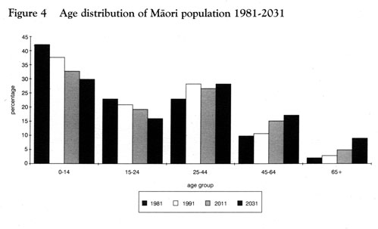

Whilst the age structure of a population is affected by the rate of population growth, and in particular by the fertility component, the age structure in turn affects fertility. By way of example, the Māori population has a larger proportion of women in the reproductive age group than the non-Māori population and this is one of the reasons why the Māori population can be expected to grow at a faster rate than the non-Māori population.

IWI DISTRIBUTION

The 1991 Census was the first since 1901 to attempt to collect information about iwi. Due to ambiguities in the phrasing of the question and to ignorance on the part of many respondents about their tribal affiliations, there are doubts about the quality of the data. Nevertheless, they do provide some interesting insights into the state of Māori tribal identity.

The question was addressed to persons of Māori ancestry. That population numbered 511,278, of whom 133,000 said they did not know to which iwi they were affiliated, 19,000 said they were not affiliated to any iwi and 12,000 failed to respond at all; giving a total of 144,000 (28 per cent of the Māori ancestry population) who failed to state an affiliation.

An analysis of this group by ethnic identification suggests that the majority did not think of themselves as Māori. Nearly 50 per cent identified solely as European. However, this does not account for the relatively large proportions of those identifying as Māori and Māori/European.

Table 1 Ethnicity of persons failing to state an affiliation, 1991
Ethnic Group | Per cent of persons failing  To state affiliation
European | 49.3
Māori | 28.4
Pacific Island | 1.8
Other | 0.3
Māori/European | 16.8
Māori/European Other | 1.2
Māori/Other | 1.4
European/Other | 0.4
Not specified | 0.3
Total | 100.0

The age of respondents seems to have been a more critical factor in the failure to state an iwi. In general, it could be said that the younger the respondents were, the less likely they were to identify with a tribe.

Table 2 Ages of person failing to state an affiliation, 1991
Age group  (in years) | Per cent of population  in each age group
0-4 | 31.0
5-14 | 30.1
15-19 | 21.0
20-29 | 24.4
30-39 | 22.6
40-49 | 17.7
50-59 | 14.4
60 + | 15.4
Total | 28.0

Until another census is taken, it will not be possible to draw any firm conclusions about the reliability and validity of the data. Moreover, at least two further censuses will have to be taken before firm trends become evident.

GEOGRAPHIC DISTRIBUTION

There has been little change in the geographic distribution of the Māori population over the past decade. A quarter of all Māori live in the Auckland region and another quarter live in the Waikato and Bay of Plenty regions. There is, however, significant variation in the degree to which Māori are represented within the total population of each region.

Gisborne and Northland have the highest concentration of Māori. Forty per cent of the people living in Gisborne and 28 per cent of those living in Northland are Māori. The Bay of Plenty, Waikato, Hawkes Bay and Manawatu-Wanganui also have higher than average concentration of Māori in their respective populations.

Figure 5 Māori proportion of population in Regional Council areas, 1991
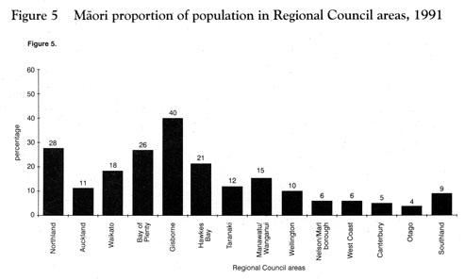

The degree of concentration also varies by age. Māori children (aged 0–14 years) make up nearly half of all the children in Gisborne and bout 40 per cent of the children in both Northland and the Bay of Plenty. The elderly are also over-represented in these and other regions where Māori make up a high proportion of their populations.

Table 3 Māori as a proportion of all children in Regional Council areas, 1991
Region | Per cent of total population region
Northland | 40
Auckland | 18
Waikato | 27
Bay of Plenty | 39
Gisborne | 48
Hawkes Bay | 31
Taranaki | 19
Manawatu/Wanganui | 25
Wellington | 17
Nelson/Marlborough | 10
West Coast | 11
Canterbury | 9
Otago | 7
Southland | 15

Urban-Rural Distribution

Very little change occurred in the urban-rural distribution of the population between 1981 and 1991. Eighty-two per cent of the Māori population now live in urban areas compared with 81 per cent in 1981, and there has been no change in the way in which the Māori urban population is distributed. Of those Māori living in urban areas, 74 per cent live in major urban areas, seven per cent in secondary urban areas and 14 per cent in minor urban areas.

Geographic Mobility

A change in the direction of Māori population movement appears to have occurred during the 1980s. Māori families, it seems, are leaving major urban areas for smaller cities, towns and rural localities in the less urbanised regions of the country. Just how much of this movement can be described as "return migration" is not known, but recent work by Statistics NZ demographers suggests that some of the families on the move are indeed returning to their tribal areas.

Between 1986 and 1991, Northland had the highest influx of Māori. Most of them came from the Auckland region. Auckland, in turn, suffered the highest outflow and was closely followed by Wellington. Although its inflow as not as high as the inflow into Northland, the Bay of Plenty emerged as a major destination for Māori migrants. Moreover, unlike Northland which derived most of its migrants from the one source (Auckland), the Bay of Plenty drew people from nearly every other region.

Table 4 Regional movement – net gains and losses 1981–86 and 1986–91
 | Year
Region | 1981-86 | 1986-91
Northland | 1518 | 1668
Auckland | 225 | –1620
Waikato | –684 | 534
Bay of Plenty | –195 | 1524
Gisborne | –393 | –495
Hawkes Bay | –471 | –549
Taranaki | 54 | –228
Manawatu- Wanganui | 561 | –30
Wellington | –861 | –936
Nelson-Marlborough | 102 | 240
West Coast | 12 | –90
Canterbury | –114 | 261
Otago | 300 | 93
Southland | –54 | –345

The direction of movement differs according to age. Young adults tend to move to Auckland, Wellington, Canterbury and Otago – the main centres for tertiary education, training and jobs. Families and the elderly tend to move in the opposite direction.

CONCLUSION

As the current realities and future trends highlighted in this paper indicate, the challenge to Māori development in the future is going to come not from growth in the overall size of the Māori population but from growth in numbers of Māori at different stages of the life cycle. Growth will be most rapid in the 65 years and over age group and the increasing numbers of elderly in the population can be expected to have profound and far-reaching consequences for Māori social, economic, political and cultural life.

In a policy environment which increasingly favours private over public provision of social services, Māori reaching the age of 65 years will be at a disadvantage. As few can be expected to have accumulated the savings and assets needed to sustain them in retirement, most will be forced to fall back on their families for support, families that will continue to be hard-pressed by economic adversity for some years to come. Under these circumstances, Māori authorities charged with the task of managing and administering land and other Māori interests could face increasing demand for service provision from elderly beneficial owners and their families. What effect might pressures of this kind have on economic development? How well will Māori rural communities cope with "return migrants"? What cultural values are at risk? What effect will the burgeoning numbers of elderly have on Māori socio-political arrangements at the local and national levels? What kind of services will the elderly need?

An appreciation of future population changes and understanding of their implications for Māori society are critical to the formulation of realistic development objectives. Data produced by Statistics NZ goes some way towards satisfying the first requirement, but the kind of information Māori decision-makers need to help in the identification and clarification of related social, cultural, political and economic issues is practically non-existent. The socio-cultural dislocation which Māori have suffered over the past thirty to forty years is, in part, an outcome of the lack of information about the social effects of rapid demographic changes.

There is, quite clearly, a pressing need for research in this field. Unless the information gap is filled, Māori authorities and central and local government agencies are in danger of repeating the policy mistakes of the past.

