development of the disability regulations in the netherlands

Joke de Vroom
Michel Rovers
Department of Social Affairs and Employment
The Netherlands

introduction

Disability regulations have dominated political debate and the political climate in the Netherlands in recent years. No other field of policy has exerted so much political and social influence, nor proved such a sensitive issue as the measures proposed and introduced in the field of disability support. Politically speaking, the measures cost a large political party almost half of its members and half of its supporters, while in society the measures met with widespread resistance which led to large-scale demonstrations.

Nevertheless, the new measures were introduced and, for the first time since disability regulations have been in existence in the Netherlands, there has been a drop in the number of people classified as disabled. This article looks at the origins of disability regulations in the Netherlands and the developments which have taken place since their inception – developments which proved to be very different from the expectations held at the time that the regulations were introduced. As a result, intervention was felt to be necessary. Initially this intervention also failed to bring about the expected result, and only after the most recent set of changes has there been the desired reduction in the number of persons claiming disability benefits.

the origins of the disability regulations: the 1960s

The disability regulations implemented in the Netherlands in recent decades were originally designed in the 1960s. The incomes policy being pursued by the governments of this period meant that favourable economic growth could not be translated into wage increases. Thus, partly for this reason, growing economic prosperity was passed on in the form of improvements in the social security system.

Disability regulations in the Netherlands make a distinction between short-term and long-term disability. During the first year of disability an employee is entitled to assistance under the terms of the Sickness Benefits Act. Though it origins date back to 1913, the Sickness Benefits Act came into effect only in 1930. In the 1960s, sickness benefit was 80% of the last-earned salary. During this period it was general practice for employers to increase sickness benefit to 100% of the last-earned salary.

Already in the 1950s and 1960s the number of people claiming sickness benefit under the terms of the Sickness Benefits Act was increasing. Figure 1 shows the number of people claiming sickness benefit expressed as a percentage of the working population. As can be seen from the graph, the number of people claiming sickness benefit in relation to the working population rose from 3.4% in 1954 to 6.2% in 1970.

Figure 1 The Number of People Claiming Sickness Benefit Expressed as a Percentage of the Working Population, 1954-1970
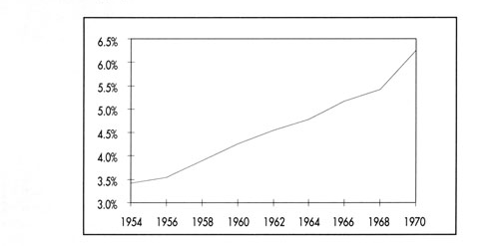

Until 1967 long-term disability was provided for by two laws, the Industrial Injuries Act and the Invalidity Act. Under the terms of the Industrial Injuries Act, an employee disabled as a result of an industrial accident was entitled to claim disability benefit. The Invalidity Act covered all other invalidity benefits. In other words, until 1967 the Netherlands – like all other European countries – made a distinction between professional risk and social risk.

In 1967 the Industrial Injuries Act and the Invalidity Act were replaced by one set of regulations for disability in the form of the Disablement Benefits Act (WAO). With this Act the distinction between professional risk and social risk was dispensed with – a distinction was no longer made regarding the cause of disability. Benefit was set at 80% of the last-earned salary. This was a high level of benefit, yet given the economic situation and expectations regarding the number of people likely to claim benefit under the terms of the act, it was considered to be feasible. The Act applied solely to employees. There was no fundamental reason for this restriction, yet out of practical considerations it was decided that the WAO should provisionally be limited to employees. At the time that the Act was introduced it was expected that no more than 150,000 employees would claim benefit under the terms of the WAO.

The goal of the WAO was twofold. In the first place, the Act was intended to provide security of income in the event that an employee became disabled. Secondly, the Act also had a clear rehabilitation function; in fact, its provisions show this to be the primary objective of the WAO. To this end, the Act included a number of conditions which were intended to help reintegrate people into the work process. One of these conditions was the so-called "assessment article" which specified that, in establishing the degree of disability, the position of the disabled person within the labour market (i.e. the possibility of the disabled employee finding work) could be taken into account. This article in particular had a considerable influence on the growth in the number of persons on disability benefit.

In 1970, in terms of "benefit-years", the number of people receiving disability benefit was approximately 195,000. In other words, the figure was already well above the expectations held at the time that the WAO was introduced. In terms of the working population, in 1970 the number of persons on disability benefit was 5.2%.

the political and social developments: the 1970s

The economic developments of the 1970s were of a very different order than those of the 1960s. The incomes policy which had been pursued up until that time was abandoned and employers and employees were free to negotiate regarding the level of salary. At the same time, the economy entered a deep, worldwide recession. In fact, the whole decade was characterised by the term "stagnation". There was a dramatic increase in unemployment and, given the rapid increase in the number of people entitled to benefit and the stagnating economy, the need for some form of intervention was increasingly felt. Employee insurance schemes proposed a number of interventions, but they would have to wait until the 1980s for real changes to be introduced.

Despite the growing realisation that cuts appeared to be unavoidable, the disability regulations were actually considerably extended in the 1970s with the introduction of the General Disablement Pensions Act (AAW) in 1976. This gave all residents the right to basic disability benefit. Thus the WAO, from 1976, provided insurance for the loss of income for employees above the level of the minimum wage. With the introduction of the AAW, the social security system in the Netherlands was finally complete.

The number of disability benefit payments grew spectacularly in the 1970s, reaching a level which was far higher than the number of unemployment benefit payments. This development is illustrated in Figure 2, which shows separately disability benefit paid to employees and the total number of disability benefit payments.

Figure 2 The Number of People Claiming Disability Benefit in the Period 1970-1980 (x 1,000 Benefit-Years)
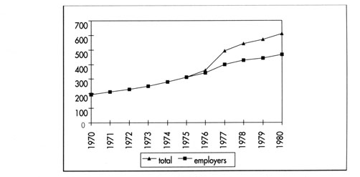

As the graph shows, the volume increased from 195,000 benefit-years in 1970 to 610,000 benefit-years in 1980. As mentioned above, this increase was partly due to the introduction of the AAW. The number of employees drawing invalids benefit under the WAO increased by approximately 240% during this period.

Also in terms of the working population, an increasing percentage of those working were classified as disabled. In 1970 the number of disabled persons was 5.2%, while ten years later the figure had grown to 11.5%.

There were two main reasons for the dramatic increase in the number of persons on a disability benefit. Firstly, the economic recession led to considerable reorganisation within the business community, and since the conditions for benefit were far more favourable under the WAO than under the Unemployment Benefits Act (WW), surplus personnel were shepherded to the WAO on a large scale. Wide use was made of the possibility of applying the assessment article. Also, in retrospect, there is some doubt as to whether the large number of employees declared disabled actually were disabled.

Secondly, the reintegration function of the WAO failed entirely. There were a number of reasons for this.
- The number of jobs available was so small that people who were disabled or partially disabled were rarely able to find paid employment.
- The executive institutions working in the field of reintegration were inefficient – far more attention was paid to correctly establishing the level of benefit than to reintegrating those entitled to benefit.
- The cause of disability lay far more in psychological factors than had originally been expected.

The fact that the increase in the number of disabled persons had to be accounted for by factors other than the deteriorating health of the population can be seen from the growth in benefits paid under the terms of the Sickness Benefits Act. Though there was indeed an increase in the number of people claiming benefit under the Sickness Benefits Act, in terms of the working population, the increase in sickness benefit was far smaller than the increase in disability benefit. Figure 3 shows the growth in sickness benefits and disability benefits paid to employees, both expressed in terms of percentage of the working population.

Figure 3 The Number of People Claiming Sickness Benefit and Disability Benefit Expressed as a Percentage of the Working Population, 1970-1980 (1970=100%)
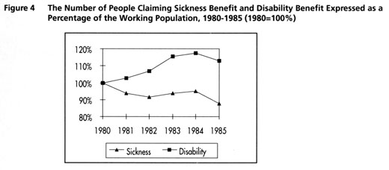

cuts and measures: the 1980s

The Period 1980 – 1985

The beginning of the 1980s saw a shift in the volume of the employees insurance schemes. The number of persons on a disability benefit continued to grow, though far less rapidly than it had done in the 1970s. However, as a result of a deep economic crisis, unemployment rose dramatically, particularly at the beginning of the 1980s. The number of companies going bankrupt increased from month to month, employees were directed to the unemployment schemes en masse, the financing deficit approached 10%, while total social security contributions rose to more than 20% of the national income. The rapid rise in unemployment was a far more serious source of concern for the various Cabinets than the increase in the volume of industrial disability benefits.

As a result of the rapidly worsening economic situation, the 1980s were characterised by a stream of proposals for cutbacks. The most important objective was to reduce both the financing deficit and the collective burden. The system of employees insurance schemes was clearly due for an overhaul. In view of the fact that the effects of such an overhaul would only result in a lower collective burden in the long term, at the beginning of the 1980s the main emphasis was placed on measures which would lead to cutbacks in the short term. The level of benefit was reduced a number of times, the indexing of benefit was dispensed with on several occasions and finally, in 1984, benefit percentages were reduced to 70% of the last-earned salary.

At the beginning of the 1980s, as a percentage of the working population, there was a reverse trend in the number of sickness benefits and invalids benefits paid out. This is illustrated in Figure 4.

Figure 4 The Number of People Claiming Sickness Benefit and Disability Benefit Expressed as a Percentage of the Working Population, 1980-1985 (1980=100%)

In the period from 1980 to 1985 the number of sickness benefit payments dropped, both in an absolute sense and in a relative sense. On the other hand, the number of invalids benefit payments continued to rise, though the increase was far less steep than it had been in the 1970s. In 1985 the volume of industrial disability was more than 700,000 benefit years; the number of industrially disabled employees was a high as 13% of the working population.

The Period 1985 – 1990

The developments in the first half of the 1980s clearly revealed that the system of employees insurance schemes was unable to withstand an economic setback. Thus those responsible worked assiduously to revise the system. In addition to changes in the unemployment legislation, disability insurance was also adjusted. The most important change was the abolition of the assessment clause. Henceforth, the situation in the labour market and the possibility of the disabled employee finding work were no longer to be taken into account in establishing the level of disability.

The revision of the system was expected to have a considerable influence on the volume of disability benefits. It was estimated that unemployment accounted for at least 50% of the disability benefit payments. Thus the abolition of the assessment clause was expected to lead to a sharp drop in the number of disabled persons in terms of benefit-years.

However, nothing could have been further from the truth. The volume of disability benefits continued to increase. This was caused, to a very considerable extent, by the fact that the old practice was maintained. Employers regarded the WAO as a convenient and inexpensive method of laying off excess – and, above all, elderly – personnel, while employees considered the WAO a safe and socially accepted regulation. Executive institutions and medical examiners continued to grant benefits and to declare people fully disabled on a large scale, without taking the element of unemployment into account.

Figure 5 illustrates the rise in the number of persons on disability benefits in the period 1985-1990.

Figure 5 The Number of People Claiming Disability Benefit, 1980-1990 (x 1,000 Benefit-Years)
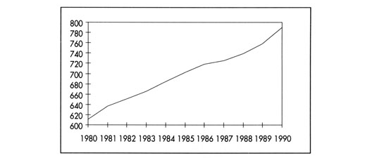

Despite the increase in the number of people entitled to benefit, in terms of the working population, the number dropped. On the other hand, in terms of the working population, the number of sickness benefit payments again showed an increase, as illustrated in Figure 6.

Figure 6 The Number of People Claiming Sickness Benefit and Disability Benefit Expressed as a Percentage of The Working Population, 1985-1990 (1980=100%)
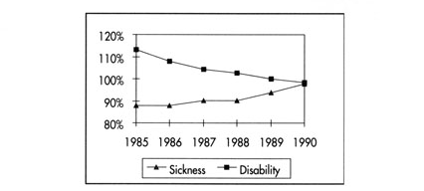

the reversal: the beginning of the 1990s

Public Support

Up to the beginning of the 1990s the measures which had been introduced had borne little fruit. The number of persons on a disability benefit continued to grow, though in terms of the working population, the percentage dropped slightly. At the end of 1992, 912,000 people were drawing disability benefit. In terms of benefit-years, the volume covered by the AAW/WAO was 805,000 while the volume covered by the Sickness Benefits Act was 338,000 benefit-years. From an international point of view, the Netherlands was spending far more on disability than any other European country. Figure 7 shows the total expenditure on disability benefits in terms of percentage of the Gross Domestic Product for a number of European countries.

Figure 7 Expenditure on Invalidity Benefit Expressed as a Percentage of GDP for 1992
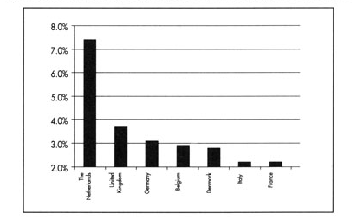

The graph shows that expenditure on disability benefit in the Netherlands was twice to three times higher than in neighbouring European countries. The fact that this was not due to poorer health on the part of the Dutch population is demonstrated by several indicators of general health: life expectancy in the Netherlands is higher than in most other European countries, while the infant mortality rate is the lowest in Europe. Also, the use of medication in the Netherlands is generally far lower than in the surrounding countries. Thus none of these indicators would suggest that the Dutch are less healthy than other Europeans. Therefore, the explanation for the exceptionally high number of disabled persons must be sought in the relatively favourable conditions of benefit set by the disability regulations in comparison with other regulations and the lenient conditions of access of the disability regulations.

In 1991 the Netherlands was veering dangerously in the direction of one million disabled persons. This was considered to be unacceptable both politically and socially. Politically, the country was finally ready to introduce measures which were more rigorous than those implemented previously. Premier Lubbers married his political fate to the number of disabled persons. All of the political parties, the Social Democrats included, saw the need for a radical change to be made to the system of sickness benefit and industrial disability regulations. In 1991 a Parliamentary Committee of Enquiry – the most powerful investigative instrument in the Netherlands – was set up to investigate what had gone awry in the implementation of the regulations.

By now there was also wide support within the business community for the need for change. Convinced of the necessity for intervention, employers' organisations and the unions were willing to co-operate and to offer their own suggestions for the kind of changes that might be introduced. A large committee made up of representatives of employers' organisations, unions and the Government had already been set up in 1989 to provide an initiative for the changes.

Even the Dutch population was finally convinced that things could no longer continue in the same way. In 1991, 79% of the population felt that employees were far too ready to stay at home ill; 68% felt that people were far too readily declared unfit. A huge 87% was of the opinion that the number of disabled persons needed to be reduced by stricter conditions with regard to benefit. And finally, 52% felt that many people were abusing the system of disability regulations. In other words, all parts of society agreed that radical changes to the regulations were absolutely necessary.

The Measures

In the period from 1992-1994 three legislative proposals were adopted. On 1 March 1992 the TAV Act ("Reduction of the Number of Disablement Benefits Claimants") came into effect. Key elements of this act consisted of the introduction of premium differentiation in the Sickness Benefits Act and the introduction of the bonus/penalty system within the disability regulations. As from 1 January 1993 the premium of the sickness Benefits Act was determined by the employer's rate of staff absenteeism due to illness. Depending on the branch of industry, there were three or five different levels of premium, from high to low.

The bonus/penalty-system meant that an employer was rewarded for employing a disabled person. This bonus amounted to half of a year's salary. If an employee was classified as disabled the employer was obliged to pay a penalty, which was initially equal to half a year's salary but later increased to a full annual salary. The employer could avoid having to pay the fine by continuing to employ the employee in question.

On 1 August 1993 the TBA Act ("Restriction of Claims on the Disablement Benefits Regulations") came into effect. The two most important features of this act were the tightening up of the assessments and the reduction in the level of benefit payments.

In the Netherlands disability is a wage-related concept rather than a medical concept. This means that the establishment of whether someone should be classified as disabled is based on what the person in question is capable of earning in relation to what he or she was formerly earning rather than on medical indications.

Up until 1 August 1993 the degree of industrial disability was established on the basis of the concept of "suitable work". This meant that the assessment took into account what someone was still capable of earning, given his or her level of education and previous level of function. From 1 August 1993, however, the assessment was based on the concept of "acceptable work" – education and previous occupation were no longer taken into account. In establishing the degree of disability, the assessment now considered the maximum income someone was still capable of earning regardless of the former work or level of education. If someone with a scientific background was still able to carry out simple administrative work, the degree of disability was determined on the basis of the maximum salary he or she was capable of earning in the said function. Those persons already entitled to benefit under the age of fifty were to be reassessed according to this new criterion.

In addition to the changes made to the criteria for assessment, the level of benefit was also adjusted. Previously benefit had always been 70% of the last-earned salary up to the age of 65 years. As from 1 August 1993, the level of benefit also depended on the age of the person in question. For a certain period, which was determined by the age of the person at the onset of disability, the person in question was entitled to 70% of his or her last-earned salary. Thereafter, subsequent benefit dropped to a lower level. The wage-related period was based on the following calculation:

- below 33 years: immediate subsequent benefit
- 33 to 37 years: six months wage-related benefit;
- 38 to 42 years 1 year wag-related benefit;
- 43 to 47 years: 1+ years wage-related benefit;
- 48 to 52 years: 2 years wage-related benefit;
- 53 to 57 years: 3 years wage-related benefit;
- over 57 years: 7 years wage-related benefit.

The level of subsequent benefit was also affected by the age of the person in question. In this case the level was calculated on the basis of the following formula:

level of benefit =
70% * (minimum wage + (age –15)* 2% *(last-earned salary – minimum wage)).

Finally, on 1 January 1994 the TZ Act ("Reduction of Absenteeism due to Sickness") was introduced. The most important measure of this act was the obligation on the part of the employer to continue paying the employee's salary for the first six weeks that an employee was absent from work on account of illness. For smaller companies (up to 15 employees) the employer was obliged to continue to pay the employee's salary for a lesser period of two weeks.

Parliamentary Discussion and Public Reaction

The legislative proposal for the TZ Act gave rise to very little discussion. All parties and all parts of society were able to agree to the form of the proposed measures. The same applied in the first instance to the legislative proposal for the TAV Act.

However, the preparation and subsequent discussion of the legislative proposal for the TBA Act met with a very different response. The introduction of the new assessment criterion was generally agreed to and accepted. The lowering of the level of benefit, on the other hand, met with massive opposition and almost led to a political crisis and the resignation of the Cabinet. Only at the very last moment were the parties in office able to reach a political compromise.

It was initially intended that the benefit payments of all those already entitled to benefit should also be reduced to the new level. This aspect in particular cost the Social Democratic Party almost half of its members and led to the resignation of the leader of the party. Finally it was decided that the benefit payments of those already entitled to benefit would remain the same at the expense of a greater reduction in the level of benefit paid to persons newly entitled to benefit.

The Results

The results of the TAV Act, and, above all, the results of the bonus/penalty-system, proved disastrous. Although the proposal initially originated from the employers' organisations, it immediately met with massive resistance on the part of the employers. The main objection raised by the employers was that they felt it to be extremely unfair that they should be penalised for something which was entirely beyond their control. For, even if an employee was disabled by circumstances occurring outside the workplace, the employer was still obliged to pay the penalty. The possibility for the employer to avoid paying the penalty by continuing to employ the person in question proved in many cases to be illusory as the majority of employees were still classified as fully disabled.

An attempt as made to remove the grounds for these objections by softening the act to some extent while the proposed increase in the penalty, from half a year's salary to a full annual salary, was not introduced. Yet these moderations failed to remove the opposition. The opposition on the part of the employers led to a situation in which the measure was completely counterproductive, with the result that on 1 July 1995 the measure was withdrawn.

In 1993 the introduction of premium differentiation in the Sickness Benefits Act had little effect on the rate of absence from work on account of illness. In the ensuing years it was no longer possible to assess the effect of premium differentiation as a separate measure in view of the fact that, as from 1994, the obligation to continue paying the salary was introduced.

In contrast to the TAV Act, the TZ Act did bring about the desired effect. The introduction of the obligation to continue paying the salary for the first six weeks or two weeks of illness as the case applied, led to a considerable drop in the rate of absenteeism on account of illness. In 1993 the volume of the Sickness Benefits Act was still 342,000 benefit-years, in 1994 this figure dropped to 290,000 benefit-years. The rate of absenteeism on account of illness dropped from 6.7% in 1993 to 5.5% in 1994. The drop in absenteeism differed considerably according to the size of the company. This is illustrated in Figure 8.

Figure 8 The Change in the Rate of Absenteeism on Account of Illness in Relation to the Size of the Company (Number of Employees) in 1994 as Compared with 1993.
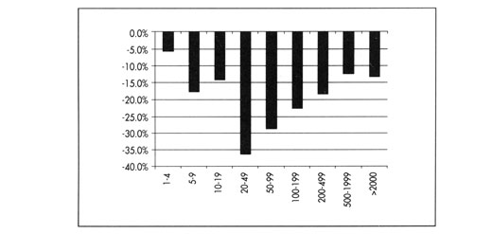

The drop in the rate of absenteeism due to illness was most noticeable in medium-sized companies (companies employing 20 to 50 people). It was least noticeable in very small companies and very large companies.

It also became apparent that 65% of all companies had introduced further measures in an attempt to reduce the rate of absenteeism on account of illness. Measures varied from better control and better supervision of employees who were ill, to the introduction of a system of financial rewards or penalties for employees. In the companies which introduced such measures approximately 90% of all employees were at work.

Of the three acts, the results of the TBA Act were most spectacular. As mentioned above, the introduction of the new criterion for disability was generally accepted. It was primarily the reduction in the level of the benefit which met with public resistance. It was only after the TBA Act had been introduced that the consequences of the new criterion became clearly visible. There was a dramatic drop in the number of people entering the WAO. The numbers leaving the WAO also increased enormously – mainly as a result of the reassessments. In retrospect, the fiercely fought compromise that the level of existing benefit payments should not be reduced proved to be purely a formality for many of these entitled to benefit, since the reassessment meant that a substantial number of those already entitled to benefit lost their benefit altogether.

The following figures and tables show the results of the TBA Act. As mentioned, firstly there was a spectacular drop in the numbers entering the WAO as well as an increase in the numbers leaving the WAO. Both of these developments are illustrated in Figure 9.

Figure 9 The Development in the Intake and Out-Flow of the AAW/WAO in the Period 1993-1995
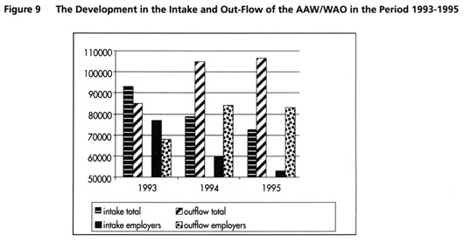

In 1993 the intake of the WAO was greater than the out-flow. This had been a consistent pattern since the introduction of the WAO in 1967. In 1994, for the first time since the Act was introduced, there was a reversal in this trend: the out-flow was greater than the intake: the number of benefit payments which were terminated exceeded the number of those which were granted by 26,000. This trend continued in 1995 as the intake dropped still further while the out-flow continued to increase: on balance the number of disabled persons benefits fell by more than 33,000 in 1995. The development in the volume of disability benefits is represented in Figure 10.

Figure 10 The Development in the Volume of Disability in the Period 1990-1995 (x 1,000 Benefit-Years)
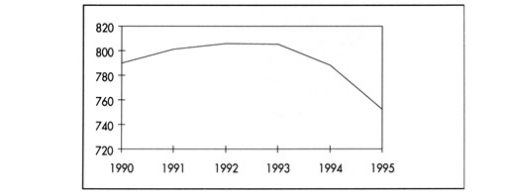

The drop in the volume of disability benefits was mainly accounted for by the introduction of the new criterion. This caused fewer new benefit payments to be granted and more existing benefit payments to be terminated. Yet the new legislation had both a direct and indirect effect on the decrease in intake. While the new criterion meant that fewer benefit payments were allocated (the direct effect), it was also clear that fewer people were now applying for benefit (the indirect effect). This can be seen from Table 1.

Table 1 Applications and Rejections in the Period 1993-1995 (Excluding Civil Servants)
 | 1993 | 1994 | 1995
Applications | 106,000 | 97,000 | 93,000
Adjudications | 88,000 (83%) | 69,000 (71%) | 63,000 (68%)
Rejections | 18,000 (17%) | 28,000 (29%) | 30,000 (32%)

The new legislation also had both direct and indirect effects on the increase in the outflow. The direct effect was the result of the reassessment of those already entitled to benefit. The indirect effect was in the number of spontaneous reports of recovery. In other words, more than in previous years, those entitled to benefit considered themselves fit to recommence work.

Table 2 shows the outflow in the period 1993-1995 presented in terms of the reasons for the termination of the benefit.

Table 2 Out-Flow from the AAW/WAO Together with the Reason in the Period 1993-1995
Cause | 1993 | 1994 | 1995
Recovery | 39,000 | 58,100 | 58,600
Pension | 33,000 | 33,500 | 34,700
Death | 10,400 | 10,000 | 9.700
Other | 2,400 | 3,100 | 3,500
Total | 84,800 | 104,800 | 106,500

The out-flow as a result of recovery can be subdivided as shown in Table 3

Table 3 Termination as a Result of Recovery in the Period 1993-1995
Recovery | 1993 | 1994 | 1995
Normal recovery | 34,000 | 40,400 | 32,500
Reassessment | - | 10,500 | 16,300
Total | 34,000 | 50,900 | 48,800

The results of reassessment were higher in 1995 than in 1994. This is accounted for by the fact that the reassessment operation was only started in 1994 and had to contend with teething troubles in the initial phase. In other words, in 1995 there was a knock-on effect from 1994.

In comparison with 1994, the number of spontaneous terminations decreased in 1995. There are two reasons for this. Firstly, there was a considerable drop in intake in the years 1993-1995, and it is precisely those persons whose benefit is of shorter duration that are most likely to leave the scheme. Secondly, the reassessments had an effect on the spontaneous outflow in 1995. Those persons who would have recovered had the reassessment operation not been introduced, lost their benefit at an earlier stage as a result of the reassessment.

In fact, the effects of the reassessment operation were far greater than had originally been expected. Prior to the introduction of the TBA Act it was anticipated that 21% of those entitled to benefit would receive a lower benefit. In other words, the reassessment would not affect 79% of those entitled to benefit. Of those who would experience the effects of the reassessment, it was assumed that those drawing full benefit would lose part of the benefit, while some of those drawing partial benefit would lose their benefit altogether. However, as it turned out, the results of the reassessments were entirely different from the expectations. This can be seen in Table 4.

Table 4 Reassessment Results 1994-1995
Reassessment result | 1994 | 1995
Withdrawal of benefit | 37% | 18%
Reduction of benefit | 15% | 17%
Maintenance of benefit | 46% | 61%
Raising of benefit | 2% | 4%
Total | 100% | 100%

In 1994 a total of 53,000 persons receiving disability benefit were reassessed. The new criterion affected the level of the benefit for as many as 52% of all those reassessed. As a result of the reassessment, 37% lost their benefit payments entirely, while 15% received reduced benefit. In 1995 the results were less dramatic: "only" 18% of those entitled to benefit lost their benefit altogether, while 17% received reduced benefit. A total of 38,500 persons were reassessed.

At this stage it is still difficult to offer a possible explanation for the drop in the statistics for 1995. A possible reason is that in 1995 those entitled to benefit being reassessed were older than those reassessed in 1994 and had also been receiving benefit for longer. Another reason could be that the reassessments carried out in 1995 were less severe than those carried out in the early stage of the operation.

Thus in 1994, 27,500 persons had their benefits withdrawn or reduced (52% of 53,000). In 1995, a survey was carried out to assess the position of these people one year after the reassessment. Figure 11 shows the results of this survey.

Figure 11 The Situation of Those Declared Fit or Partially Fit for Work One Year After The Reassessment
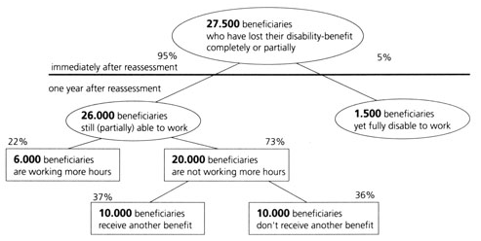

The objective of the TBA was, on the one hand, to reduce the number of disability benefits, and, on the other hand, to promote participation in the work process. At the time that the TBA Act was introduced it was assumed that, in due course, 50% of those who had lost or partially lost their benefit would once again find work. Figure 11 shows that one year after the reassessment only 22% of those who had lost all or part of their benefit were working for more hours. Thus, from the point of view of reintegration, the measure proved to be less successful – at least that was the case one year after the reassessment. From the point of view of volume control the policy can certainly be said to have been a success: 58% of those declared fit or partially fit for work were making lesmns) were already at work (again) at the time of the reassessment. Of these 12,000, 15% were working more hours one year later, 54% were working the same number of hours and 31% were working fewer hours or not at all.

Finally, as can be seen from the above, a percentage of the persons who lost all or part of their benefit did not start working for more hours, yet neither did they receive any other form of benefit. Thus this group suffered most in terms of loss of income. However, close analysis shows that 63% of this group are (still) working; 63% have a partner who is working and at least 90% report that they are able to get by well or moderately well with the total family income. Thus the cautious conclusion can be drawn that this group is satisfied with the situation, even after having lost all or a part of their disability benefit.

the prospects

The dramatic drop in absenteeism on account of illness in 1994 did not continue in 1995. One the contrary, absenteeism on account of illness increased slightly, particularly in the case of long-term absenteeism. Partly for this reason, the present Cabinet decided to extend the employer's obligation to continue paying the salary – which already applied for the first six weeks (or the first two weeks in the case of smaller companies) – to the entire year of sickness benefit. Therefore, as from 1 March 1996, all employers, both large and small, were obliged to pay for up to a full year's salary of any of their employees who fall ill. From that point onward, the Sickness Benefits Act applied only to employees on temporary contracts of employment. With this measure the Cabinet hoped to effect a further reduction in the rate of absenteeism due to illness.

Figures for the volume of disability benefits also showed a less positive trend in 1996. At the end of 1993 there were still 921,000 persons in the Netherlands drawing disability benefit. By the end of 1995 this figure had dropped to 860,000 – a drop of more than 60,000 persons in just two years. In 1996, however, there was an end to this rapid drop. The intake gradually began to increase again, while the outflow also decreased. For the first time since 1994, in September of 1996 the intake was greater than the outflow. Figure 12 shows the number of disability benefit payments over the course of 1996.

Figure 12 The Development in the Volume of Industrial Disability Over the Course of 1996 (x1,000 Benefit Payments)
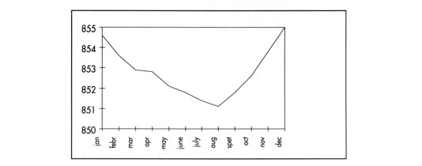

Thus despite the measures introduced in 1993 the volume of disability benefits is once again showing an upward trend, which is partly caused by the increase in the working population. The current expectations are that, without additional policy, the combined effect of increased participation in the work process and the ageing of the working population will cause the number of persons on disability benefits in the Netherlands to rise to more than one million following the year 2000.

Thus the cabinet has also proposed additional measures - the so-called "Pemba" proposals – with regard to disability regulations. In contrast to the measures introduced in 1993, the new measures will not address the level and duration of benefit payments. The new proposals will introduce changes in the financing structure of the disability regulations. Financial incentives will be introduced to encourage employers to adopt and pursue a more effective policy with regard to prevention and reintegration. In order to bring this about, a system of premium differentiation will be introduced in the WAO. Employers will also be given the possibility of taking out their own risk cover for part of the WAO contribution. In order to realise these proposals, the AAW and the WAO will be integrated to form one Act. Henceforth, the premium for this disability insurance scheme will be an employers' premium. The proposals were passed by the Dutch Lower Chamber in November of 1996 and are expected to be discussed by the Dutch Upper Chamber in the spring of 1997. The date of introduction is 1 January 1998.

Yet again, the new proposals are intended to reduce the number of persons on disability benefits. Figure 13 presents a prognosis of the expected number with and without the new proposals. As can be seen from this graph, even with the additional measures, the number of persons on disability benefits in the Netherlands is expected to continue to rise in the long term. This is accounted for by the increasing working population and, more especially, the ageing of the working population.

Figure 13 The Expected Development in the Number of Disabled Persons Without Additional Measure and With Additional Measures (x 1,000 Benefit-Years)
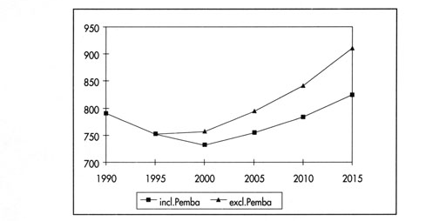

On the other hand, in terms of the working population, the number of persons on a disability benefit is expected to continue to drop until the year 2000, even though the figure is still extremely high when seen from an international point of view. From the year 2000 the number is expected to stabilise in relation to the working population. This is illustrated in Figure 14.

Figure 14 The Expected Development in the Number of Disabled Persons Without Additional Measures and With Additional Measures Expressed as a Percentage of the Working Population.
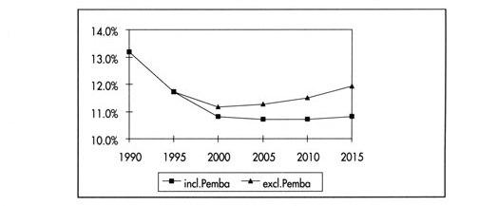

Thus it would appear that, despite considerable and rigorous changes to the system of disability regulations, the Netherlands will have to cope with an appreciable number of persons on a disability benefit for the foreseeable future.

