CHANGING EXPECTATIONS: SOLE PARENTS AND EMPLOYMENT
IN NEW ZEALAND

Kay Goodger
Peter Larose
Social Policy Agency

INTRODUCTION

This paper examines a range of factors that might explain trends in the employment rates of sole mothers in New Zealand since the 1970s. These factors include changes in the economy and the labour market, changes in family structure and the characteristics of sole mothers, and changes in the benefit system and other areas of government policy. We find that the level of economic activity and underlying demographic trends are important in explaining the employment rate of sole mothers. Examining government policy in isolation from economic and demographic factors can produce misleading conclusions.

BACKGROUND

In February 1996, the New Zealand Government announced a Tax Reduction and Social Policy Programme which included three significant changes affecting sole parents receiving social security benefits:

- The benefit abatement schedule was changed so that a greater share of earnings could be kept before benefits were reduced (effective 1 July 1996);
- A new tax credit (Independent Family Tax Credit) was introduced for employed parents not receiving benefits (effective 1 July 1996);
- A work test was introduced for the first time since sole parent benefits were established on a statutory basis (1912 for widows; 1973 for other sole parents).

The work test came into effect on 1 April 1997. Since then, sole parents whose youngest child is aged 14 or over have been required to meet part-time work or training requirements (for at least 15 hours per week) as a condition of receiving a domestic purposes or widows benefit.

In the 1998 Budget, the Government announced that from February 1999, the part-time work test will be extended to sole parent benefit recipients with a youngest child aged 6—13 years, and those with children aged 14 and over will be required to look for full-time work (for at least 30 hours per week). The Childcare Subsidy will be extended to include children in after-school care.

These measures represent a change in the Government’s work expectations of sole mothers. They have been motivated by long-standing concerns about the rising numbers of sole parents and children dependent on the domestic purposes benefit (DPB); the rising fiscal burden of benefit provision; and the incentive effects of the benefit system on sole parents’ levels of employment. They are part of a programme of welfare reform initiated by the Government in 1991 to reduce welfare dependency.

RESEARCH ON SOLE MOTHERS’ EMPLOYMENT IN NEW ZEALAND

The development of the statutory DPB took place at a time when the employment of mothers generally was undergoing change, although evidence of this change was not readily accessible from official statistics. The limited evidence available suggests that sole mothers were more likely to be employed than partnered mothers in the early 1970s. For example, divorced and separated women had far higher labour force participation rates than married women. In the 1971 Census, 64% of divorced women and 56% of separated women were in the labour force, compared with 28% of married women (Hyman 1978:160).

A survey of 319 sole mothers undertaken in Christchurch by the Society for Research on Women in 1971/72 showed that the majority (56%) were employed (35% for 20 or more hours, 21% for under 20 hours). Even among the 34% with children aged under five years, over a third (35%) were employed (SROW 1975:54). In many cases, however, these mothers of very young children lived with their parents, who cared for the children while they worked. Among all sole mothers not working, the most common reason given was the age of the children and their need for care at home. The second most common reason, cited by 19% of those not employed, was the state of their own or their children’s health (SROW 1975:60).

The 1976 Census was the first from which information on families with dependent children could be extracted. Using a 10% sample of 1976 Census data, Carmichael (1983) found little difference in the labour force participation rates of sole and partnered mothers, except that between the ages of 20 and 49, sole mothers were more likely to work full-time (defined as 30 or more hours per week). After standardising the rates of sole mothers to those of husband-present mothers (to equalise the distribution by number of children and age of youngest child), he found that the labour force participation rates of sole mothers were lower overall, but that full-time participation rates were generally higher. Carmichael explained this as the effect of disincentives in the benefit structure, which discouraged part-time employment.
In 1980 the Department of Social Welfare commissioned a small (n=82), qualitative survey to identify the factors affecting sole mothers’ employment (Wylie 1980). Wylie found that sole mothers in paid employment were better educated and more highly skilled than those not in employment. This study was instrumental in the establishment of the Training Incentive Allowance in 1983.

A decade later, a similar study (n=95) was conducted by researchers within the department (Levine et al. 1993). One of the aims of this study was to determine whether aspects of social welfare benefits and the tax structure affect the employment of sole parents. The researchers found that respondents regarded the income test and abatement regime as significant disincentives to their preferred option of part-time employment and a common response was to earn only up to the threshold of $60 per week. The tax structure also contained disincentives to gradual movement into paid work since earnings were taxed at a higher rate and Family Support debts could result if income rose in the course of the tax year.

The Department of Social Welfare has also published three census-based studies of sole parents that examine trends in their employment (Dominick et al. 1988, Rochford et al. 1992, Rochford 1993). Each of these studies identified educational qualifications and age of youngest child as the two factors most strongly associated with sole mothers’ employment.

The first study, based on a 10% sample from the 1981 Census, identified a number of factors associated with the employment rates of sole parents but was unable to explain the declining employment rate of sole parents between 1976 and 1981 from census data (p.34). It was argued that more general reasons, such as fewer employment opportunities, or increased difficulty obtaining childcare, would not explain why mothers in two parent families increased their rate of employment over the same period (p.27). Changes in the relationship between average female wages and benefit levels could not explain the downward trend as the gap had widened, rather than narrowed.

The second DSW study was based on the 1986 Census and was the first to include ethnicity as a possible factor. It found that European sole mothers were far more likely to be employed than Pacific Islands or Māori sole mothers. However, when age of youngest child and education were also taken into account, ethnic differences in employment rates were reduced (p.47).

This study noted that declines in rates of employment for both sole mothers and sole fathers needed to be considered in the context of a more general trend of rising unemployment between 1976 and 1986. It also observed that while the proportion of sole parents employed full-time had declined, the number had grown over the period. Another finding was that there was a large increase in the number of sole parents receiving benefits other than DPB or widows benefit between 1986 and 1991, mostly unemployment benefits.

Thus, by the early 1990s, trends in DPB numbers had become a less accurate guide to the employment levels of sole parents.

The profile of sole parents from the 1991 Census echoed the conclusions of the previous report. It also documented a further decline in the employment of sole mothers and an even sharper drop among sole fathers. The study suggested that this indicated an increasing tendency for both mothers and fathers to reduce their paid labour force participation upon becoming sole parents.

Recent comparative research found that the employment rate of sole mothers in New Zealand was very low and that the gap between sole and partnered mothers was the widest of any country. Bradshaw et al. (1996) examined a wide range of factors in an attempt to explain variation in the employment of lone parents in 20 countries. They rated New Zealand "low" on availability of public and private or subsidised childcare and "high" on child care costs. Whiteford (1997) analysed the structure of benefit systems in four countries — Australia, New Zealand, the United Kingdom and the United States — and their potential incentive effects on family structure and lone parents’ labour market participation. He found that the relationship between benefit levels and behaviour was not straightforward and identified the labour market disadvantages of Māori as a possible explanation for the continuing rise in benefit receipt after the benefit rate reductions in 1991.

Another relevant study is that of Maloney (1997), who modelled the effects of the 1991 benefit reforms. He estimates that between 40—80% of the growth in total employment after 1990 can be attributed to the reforms and that the effect was stronger for women than for men. While he did not study the labour supply of sole mothers directly, it could be inferred from the results of his analysis that the benefit cuts increased their employment rates.

EMPLOYMENT TRENDS OF PARENTS

Part of the rationale for introducing a work test is that the proportion of sole mothers employed had declined between 1976—1991 and was very low by international standards, while over the same period, the proportion of partnered mothers employed had increased.

At the time of the 1976 Census, sole and partnered mothers were almost equally likely to be employed: four in 10 had a paid job (Figure 1). Employment rates of sole fathers were twice as high as those of mothers, but lower than those of partnered fathers, Over the decade to 1986, employment rates increased for partnered mothers but declined for other parents, particularly sole parents. In the late 1980s, the upward trend for partnered mothers virtually stalled, and the employment rates of other parents declined further. By 1991, the employment rate of sole mothers had dropped to 27%, while that of partnered mothers had reached 58%. Thus, the disparity in the employment rates of sole and partnered mothers had grown from 13 to 31 percentage points between 1981 and 1991. Most of the increase in disparity was in full-time work, but it remained wider for part-time work.

Figure 1 Proportion of Parents Employed 1976 to 1996

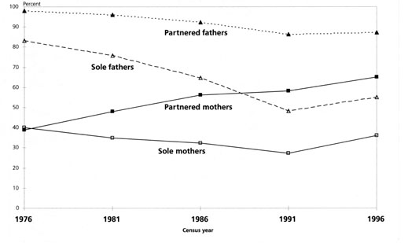
Source: Dominick et a1. (1988), Rochford (1993), Statistics NZ unpublished census data.

The 1996 Census showed that there had been a recovery in the employment rates of all categories of parents. Sole mothers’ employment rate increased to 36%, while that of partnered mothers rose to 65%. Faster growth in the employment rates of sole mothers, particularly in part-time work, reduced the employment rate gap slightly, but it remained large at 29 percentage points.

When the employment trends of all parents are viewed together in this way, it is clear that there were underlying factors that were not unique to sole mothers. To understand these trends, we need to look at the state of the economy and the labour market over this period.

ECONOMIC GROWTH AND EMPLOYMENT CHANGE

The New Zealand economy has undergone marked changes over the last 15 years. Output growth virtually stagnated between 1987 and 1992 as a result of structural reforms and an international recession, but subsequently showed a strong recovery (Figure 2). Full-time employment followed a similar path, declining between 1987 and 1992, then recovering and resuming an upward trend before levelling off in 1996. This pattern was more pronounced for men. For women, a long—term upward trend in employment levels was interrupted during this period.

It was under the difficult labour market conditions of the late 1980s that the employment rates of sole parents fell to record low levels. The economic downturn affected Māori and Pacific Islands people more than other ethnic groups, and its regional impact was uneven.

These employment and output trends are also reflected in benefit trends. The number of domestic purposes benefit recipients increased rapidly in the late 1980s, particularly among men: between 1986 and 1991, the number of sole fathers receiving the DPB almost doubled; as a proportion of DPB recipients, they increased from 6% to l0%.

Figure 2 Output and Full-time Employments Levels 1978 to 1998
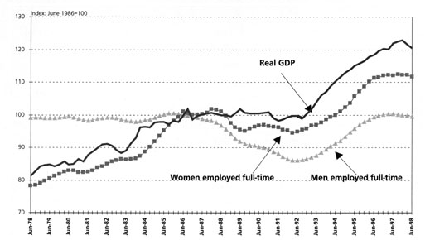

Sources: Statistics NZ, Quarterly seasonally-adjusted GDP (production—based) at constant 1991—92 prices; Household Labour Force Survey (unadjusted employment data averaged over four quarters). Backdated HLFS-consistent series prepared by S. Chapple, NZIER. Both series have been converted to indices, with June 1986 set to 100. Adapted from Mare, D. (1996).

The evidence indicates that employment rates are influenced by economic activity.

CHANGES IN FAMILY STRUCTURE AND EMPLOYMENT RATES

A second important factor which influences the trend in sole mothers’ employment rates is the growth of sole parenthood. Despite the steady decline in the employment rate of sole mothers, the actual number employed increased significantly in comparison with partnered mothers. For example, the number of sole mothers employed rose by 62% between 1976 and 1991, whereas the number of partnered mothers employed grew by only 28%. Even when the economy contracted, the number of sole mothers employed continued to rise, against the general downward trend in employment. Thus, the main reason for the falling employment rate of sole mothers was not a decline in employment but a rapid increase in the number of sole mothers in the population. The number of sole mothers increased by 135% between 1976 and 1991, more than twice as fast as the number of sole mothers employed (Figure 3). Given that many sole mothers had been out of the workforce prior to becoming sole parents, it is understandable that employment rates fell during a period when numbers of sole mothers were rapidly increasing.

After 1991, the situation was reversed. The number of sole mothers employed grew by 53%, while growth in the number of sole mothers slowed to 17%, about half the growth experienced in the three previous intercensal periods. Thus, their employment rate increased. The impact of the changing number of families on sole mothers’ employment rates is often omitted in studies of this nature.

Figure 3 Change in the Number of Families With Dependent Children by
Family Type 1967 to 1996
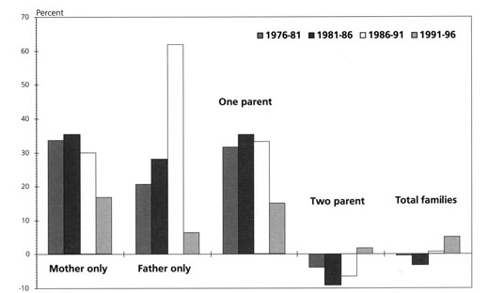

Source: Rochford (1993) A Profile of Sole Parents from the 1991 Census; Statistics NZ, published and unpublished tables.

Figures 4 and 5 illustrate trends in the number of mothers employed compared to trends in the rate of employment between 1976 and 1996.

Faster growth in the number of sole mothers employed has increased their representation among mothers in paid work. In 1996, sole mothers accounted for 15% of employed mothers, up from 10% in 1986.

CHANGES IN THE CHARACTERISTICS OF SOLE MOTHERS

Research has identified certain personal characteristics that are strongly associated with levels of employment among mothers, particularly qualifications and age of youngest child. Employment rates also vary widely by ethnic group and mothers’ age. We now consider changes in these characteristics over time that might explain the diverging employment trends of sole and partnered mothers up to 1991 and the continuing employment gap.

Figure 4 Sole Mothers Employed 1976 to 1996
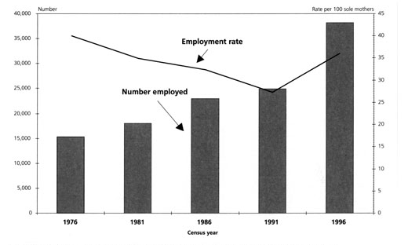

Source: Dominick et al. (1988), Rochford (1993), Statistics NZ unpublished census data.

Figure 5 Partnered Mothers Employed 1976 to 1996
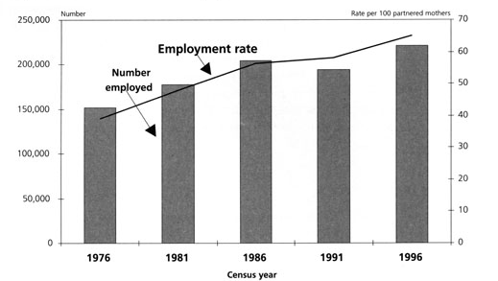
Source: Dominick et al. (1988), Rochford (1993), Statistics NZ unpublished census data.

Table 1 Proportion of Families with Characteristics Associated With Low Employment Rates
 | One parent families |  |  |  |  | Two parent families
 | 1976 | 1981 | 1986 | 1991 | 1996 | 1986 | 1991 | 1996
 | % | % | % | % | % | % | % | %
No qualifications (mothers) | .. | 62 | 51 | 49 | 43 | 38 | 31 | 26
Youngest child 0-4 years | 33 | 32 | 35 | 42 | 41 | 41 | 45 | 43
More than one child | 55 | 52 | 48 | 46 | 49 | 68 | 66 | 66
Mother under 30 years | 41 | 33 | 37 | 37 | 34 | 24 | 20 | 17
Never married parent (1) | 10 | 15 | 26 | 36 | 44 | .. | .. | 9
Mäori parent (2) | 19 | 20 | 26 | 29 | 31 | .. | 11 | 13
Outside main urban area
(mothers) | .. | 23 | 25 | 27 | 28 | 36 | 34 | 32
Rented housing | 44 | 45 | 44 | 44 | 51 | 17 | 16 | 20
No motor vehicle | .. | 27 | .. | .. | 21 | .. | .. | 3
No telephone | .. | 15 | .. | .. | 12 | .. | .. | 3
1. For sole parents, this includes those who were previously cohabiting. Cohabitation has increased markedly since 1981.
2. For two-parent families, the data refers to mothers only.
Sources: Carmichael (1983); Dominick et al. (1988); DSW; Rochford (1993); unpublished tables from the 1986, 1991 and 1996 censuses; Statistics NZ, 1996 Census — Families and Households, Table 16; 1996 Census — Regional Summary, Table 29.

Qualifications

One of the outcomes of the changes in the New Zealand economy over the past 15 years is that people with low skills have become increasingly disadvantaged in the labour market. Sole mothers are far less likely than partnered mothers to hold qualifications and the disparity has increased since 1986 (Table 1). The difference between the proportion of sole and partnered mothers with no qualifications grew from 13 to 18 percentage points between 1986 and 1991, then fell slightly, to 17 percentage points, in 1996. Thus, the qualifications gap has contributed to the employment gap between sole and partnered mothers.

Ethnicity

Another important difference between sole and partnered mothers in New Zealand is their ethnic composition. In 1996, 31% of sole mothers were Māori, compared with 13% of partnered mothers. Māori mothers are less likely than European mothers to have qualifications; they are more likely to be young, to have young children, to have several children, and to live outside a main urban area. These characteristics place them at a disadvantage in the labour market.

Māori account for a growing proportion of sole parents: between 1976 and 1996, their representation grew from 19 to 31%. Given that the loss of jobs during the economic downturn affected Māori more than non-Māori, this growing proportion of Māori among sole parents is likely to have contributed to the decline in sole parents’ employment rates in the 1980s. Between the March quarters of 1986 and 1991, the employment rate of Māori women declined by 23 percentage points, while the rate for non-Māori women declined by only 2 points.

However, Māori were also disproportionately affected by the recovery in employment. Between March 1991 and 1996, Māori women’s employment rate increased by 11 percentage points, compared with an increase of 8 points for non-Māori women. Putting all of this together, we can say that the impact of economic change on Māori is likely to have affected the employment rate of sole mothers more than that of partnered mothers. Figure 6 shows the trends in Māori and non-Māori women’s employment rates from 1986 to 1998. The pattern is very similar to that for sole and partnered mothers: growing disparity between 1987 and 1992, followed by a rise in the employment rates of both groups, but a continuing gap. Addressing the employment rate disparity between Māori and non-Māori may do much to narrow the disparity between sole and partnered mothers.

Figure 6 Proportion of Women Employed, Māori, non-Māori 1986 to 1998

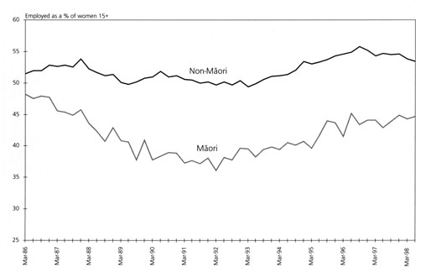

Source: Statistics NZ, Household Labour Force Survey.

The "Ageing" of Children and Mothers

Two other characteristics associated with low employment rates among women with children may help explain the employment trends of sole mothers over the past twenty years. These are: changes in the age of their youngest child and changes in the age profile of the mothers.

Between 1981 and 1991, when employment rates were declining, the proportion of sole mothers with a child under five years of age increased from 32% to 42%; by 1996, it had declined slightly to 41%. This reflects the increase in births between 1987 and 1991 and the subsequent ageing of these birth cohorts. The proportion can be expected to continue to decline as these children grow older and are followed by smaller birth cohorts. A similar proportion of partnered mothers have young children. However, with two parents to share the care of these children (or the cost of substitute care), the presence of young children is less of a constraint on their employment.

The proportion of sole mothers aged under 30 years increased from 33% in 1981 to 37% in 1986 and had declined to 34% by 1996. As employment rates are higher among older sole mothers, this change in the age composition of sole mothers since 1981 may have contributed to the pattern of employment decline and recovery. The proportion of sole mothers under 30 will also continue to decline over the next decade, given the ageing of the baby-boomers and their replacement by a smaller generation.

THE INFLUENCE OF GOVERNMENT POLICY AND CHANGING EXPECTATIONS

Thus far we have shown the economic and demographic factors that influence the employment rates of sole mothers. Now we turn to the factor that is often assumed to have the strongest influence on the employment behaviour of sole mothers: government policy.

There are several policy approaches that can influence the labour market behaviour of sole parents. Different approaches have been used at different times, reflecting the changing expectations of sole parents and policy-makers’ knowledge of ‘what works’, These include policies to: ensure adequate incomes; reduce financial disincentives to work; enhance employability; provide in-work benefits; and require reciprocal obligations.

Adequate Incomes

Sole parents can access any of the main income-tested benefits in New Zealand for which they meet eligibility criteria but most of those reliant on benefit receive the Domestic Purposes Benefit (DPB), introduced on a statutory basis in 1973. The DPB was established so that sole parents did not have to go out to work. It reflected a contemporary belief that full-time care by mothers was best for children and that sole mothers should have the same right as partnered mothers to provide this care. It also represented a pragmatic response to the lack of income security faced by sole mothers dependent on maintenance and the low wages typically paid to women. While the employment of sole mothers was not actively discouraged when the DPB was introduced, the policy aim of ensuring income adequacy took preference over maintaining or creating work incentives (Goodger 1998: 143). Clearly the introduction of the DPB contributed to the emergence of the employment rate gap between sole mothers and partnered mothers which began in the late 1970s.

Financial Disincentives

Government policies of the early 1980s may have contributed to the rise in women’s full- time employment in that period. As Figure 7 shows, real wages declined during the wage- price freeze of 1982 to 1984. In addition, mortgage interest rates rose steeply after 1984 following the deregulation of the finance sector. Both factors are likely to have pushed many partnered women into more hours of paid work in order to maintain family incomes. The same factors would have made it less attractive for sole parents to enter employment: declining real wages narrowed the difference between wage and benefit income; mortgage interest rate concessions and housing supplements were only available to people on benefits at that time. These factors may have contributed to the diverging employment trends of sole and partnered mothers in the early 1980s. Although mortgage interest rates subsequently declined from the extreme levels they reached in the mid-1980s, they remained relatively high as a result of tight monetary policy. Given that partnered mothers are more likely to live in mortgaged housing than sole mothers, they have a greater incentive to maintain and increase their levels of employment.

Undoubtedly, however, the most significant government policy change of this period was the reduction in benefit rates in 1991, which widened the gap between benefits and wages. The ratio of the real benefit rate to the real average weekly wage for females fell from 59 to 50% between 1990 and 1991. For a sole parent with one child, the benefit rate, plus family assistance, was worth 15% less ($45 a week) in real terms in April 1991 than it was the previous year. This led some sole parents to move off benefit or to make up the shortfall with part-time employment.

Figure 7 Real Benefit Rates and Real Average Female Weekly Wage 1974 to 1998
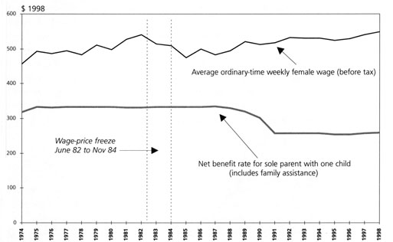

Sources: Department of Statistics, New Zealand Official Yearbook (various years); DSW benefit rate tables; Department of Labour, Quarterly Employment Survey; Statistics NZ, Quarterly Employment Survey, Consumers Price Index.

Employability Programmes

By the late 1980s, policy makers began to recognise that women were increasingly likely to combine paid work with raising a family. Consequently, they began to think about policies to facilitate and encourage sole mothers’ participation in the work force. However, in the poor labour market conditions of the late 1980s, it was unlikely that any initiatives in this direction would succeed. A pilot programme to enhance the employment prospects of long-term benefit recipients (Stepping Out) was launched in March 1987 but an evaluation survey showed that very few had gained employment. The Compass programme — introduced in 1994 — has been more successful in helping sole parents into employment, largely because of the more favourable labour market situation in the 1990s. This, too, may have contributed to the rise in employment among sole parents. The benefit reforms of 1991 included plans to work test sole parents, but the government recognised that it was futile to implement them while there were high levels of unemployment.

Childcare Assistance

The growing numbers of employed women led to changes in childcare policies. The availability and affordability of quality childcare is also a critical factor in the employment of sole parents. Two significant changes in childcare funding have occurred in the last decade, one affecting the funding of services; the other affecting the fee subsidies available to parents. Administrative reforms of the education sector in 1989 introduced a universal funding formula that gave parents greater choice over the early childhood education service they used. In 1993, an existing Child Care Subsidy programme administered by the Department of Social Welfare was refocused to give greater assistance to parents on low incomes who were in employment, training or education. Growth in the number of childcare services and enrolments has been faster than for other services, doubling between 1990 and 1997. Childcare services are now the largest providers of early childhood education in New Zealand. This increase in access to childcare is likely to have facilitated the movement of sole parents into employment.

Policy Changes Since 1996

In 1996, the Government announced two policy changes of particular importance to sole parents. First, the Government changed the abatement schedule for DPBs to allow them to keep a greater share of earnings without a reduction in benefits. Secondly, a part-time work-test for DPBs whose youngest child is 14 years or older was announced, to take effect on 1 April 1997. These changes were designed to increase the reward from working part- time by making part-time work more attractive than benefit receipt and to balance an individual’s rights with their responsibilities. Although it may be too early to determine the impact of these changes on the employment rate of sole parents, an increase in the proportion of DPBs with earnings has been observed.

By 1998 the Government was prepared to use several approaches to raise the employment prospects of sole mothers: in-work benefits; employment programmes to enhance employability; and work tests. In the May 1998 Budget, the Government announced several new policy measures under the heading "Benefit Reform" to come into effect 1 February 1999. Concerns about the rising numbers and length of stay on benefit by DPBs prompted the Government to put together a package of measures to encourage work and reduce barriers to employment and reciprocal obligations that require DPBs to seek work.

The key action announced by the Government was to introduce a full-time work-test for sole parents whose youngest child is aged 14 or over and to introduce a part-time work- test for those whose youngest child is between the ages of 6—13. This change reinforces the message that "taking part in paid work underpins economic independence" and that "work expectations and income support obligations should be linked to a person’s capacity and ability to work."

A second important policy change is the expansion of the Childcare Subsidy for those with children in Out-of-School Care (OSCAR) services and new operating funding for the establishment of OSCAR services in low-income communities.

It can be expected a priori that these changes will have a positive effect on the employment rates of sole parents all else being equal. However, the effect is not likely to be pronounced, as the impact that will be observed will be influenced by many factors including the state of the economy, demographic factors and other government policies.

At present most DPBs have a positive incentive to take-up part- or full-time employment. However, for those who face childcare costs, the incentives to work are mixed. The incentive to work part-time is reasonably strong, particularly if the work is within school hours. However, if the work falls outside school hours, this incentive can be quite modest or even disappear (depending upon actual costs). The introduction of an OSCAR subsidy will help address this disincentive, but only for those who can access OSCAR services, and whose rate of pay is high enough to cover the unsubsidised portion of the OSCAR costs. The provision of start-up funding for OSCAR Services in low-income communities is designed to address the supply concern. For those wishing to work full-time the financial incentive is negative if they face significant childcare costs and their earnings are below average. Given that two-thirds of sole mothers have a child under the age of five, further improvements in childcare assistance are likely to have some effect on employment rates.

CONCLUSION

This paper has highlighted the importance of the overall level of economic activity and demographic change in explaining trends in sole mother’s employment. Demographic factors such as the rate of growth of sole parenthood and the changing age profile of sole mothers and their children have contributed to the pattern of employment decline and recovery over the last decade. Slower growth in sole parenthood and the ageing of sole parent families means that the outlook is for further improvements in sole parents’ employment rates, assuming economic activity continues to rise.

We have also shown that the impact of economic change on Māori, given their over- representation among sole parents, is an important factor in explaining the low employment rates of New Zealand sole mothers and the wide employment gap between sole and partnered mothers. Similarly, the negative impact of labour market changes on the low-skilled, by increasing the qualifications gap, has contributed to this disparity. Failure to address these issues will reduce the prospect of further improvements.

Government policy has clearly had an important influence on the employment rates of sole parents over time, but we find it implausible that policy alone could have had as big an effect as that found by Maloney. What are the implications of these findings for future policy to increase the employment rates of sole parents?

We know that economic activity and demographic change will continue to have a strong influence on the levels of employment of sole mothers. With respect to policy, three approaches are likely to increase sole mothers’ employment rates:
- initiatives to address the disparities between Māori and non-Māori;
- further improvements in childcare assistance;
- measures to reduce the financial disincentives to work full-time.

REFERENCES

Bradshaw, J., et al. (1996) The Employment of Lone Parents: A comparison of policy in 20 countries, Family Policy Studies Centre, London.

Brosnan, P., M. Wilson and D. Wong (1989) "Welfare Benefits and Labour Supply: A review of the empirical evidence" New Zealand Journal of Industrial Relations, OECE 14:17—35.

Carmichael, G. (1983) "Solo Parent Families in New Zealand: Historical perspective and a 1976 Census profile" New Zealand Population Review, April.

Chapple, S. (1994) HLFS-Consistent Labour Market Data, New Zealand Institute of Economic Research, Wellington.

Department of Social Welfare (1987) "Rationales for Income Support: A paper prepared for the Royal Commission on Social Policy" mimeo.

Department of Social Welfare (1996) "Strategic Directions, Post-election Briefing Paper" DSW Corporate Communications Unit, Wellington.

Dominick, C.H., M.W. Rochford and M.J. Robb (1988) Solo Parents, Benefits and Employment. Department of Social Welfare, Research Section, Research Series 5, Wellington.

Goodger, K. (1998) "Maintaining Sole Parent Families in New Zealand: An historical review" Social Policy Journal of New Zealand, Issue 10:122—153, June.

Hyman, P. (1978) "Trends in Female Labour Force Participation in New Zealand Since 1945" New Zealand Economic Papers, 12:156—167.

Levine, M., H. Wyn and L. Asiasiga (1993) Lone Parents and Paid Work: A Study of Employment Patterns and Barriers, and Options for Change, Social Policy Agency, Evaluation Unit Wellington.

Maloney, T. (1997) Benefit Reform and Labour Market Behaviour in New Zealand, Institute of Policy Studies, Wellington.

Mare, D. (1996) "Labour Market Trends, Cycles and Outlook" Proceedings of the Seventh Conference on Labour, Employment and Work, Victoria University of Wellington, 28—29 November.

Ministry of Education (1997) "Early Children Education Statistics in 1997" Education Statistics News Sheet, 7(11) December.

Ministry of Education (1998) "Better Beginnings: Early Childhood Education in New Zealand" from internet site, www.minedu.govt.nz.

OECD (1998) OECD Economic Surveys: New Zealand, OECD, Paris.

Raymond, J. (1987) "Bringing Up Children Alone: Policies for Sole Parents" Issues Paper No.3, Social Security Review, Department of Social Security, Australian Government Publishing Service, Canberra.

Rochford, M., and N. Pawakapan (1990) An Evaluation of the Stepping Out Programme, Research Series 12, Research Section, Department of Social Welfare, Wellington.

Rochford, M., N. Pawakapan, S. Martin and M. Norris (1992) A Profile of Sole Parents from the 1986 Census, Research Series 13, Research Section, Department of Social Welfare, Wellington.

Rochford, M. (1993) A Profile of Sole Parents from the 1991 Census, Research Report Series No.15, Research Unit, Social Policy Agency, Wellington.

Royal Commission on Social Security (1972) Report, Government Printer, Wellington.

Shipley, J., S. Upton, L. Smith, and J. Luxton (1991) "Social Assistance: Welfare That Works: A Statement of Government Policy on Social Assistance" Department of Social Welfare, Wellington.

Society for Research on Women, Christchurch Branch (1975) Solo Mothers, Argosy Press, Christchurch.

Statistics New Zealand (1993) Social Trends: Work, Wellington.

Statistics New Zealand (1997) 1996 Census: Regional Summary.

Statistics New Zealand (1998) 1996 Census: Families and Households.

Whiteford, P. and J. Bradshaw (1994) "Benefits and Incentives for Lone Parents: A comparative analysis" International Social Security Review, 47(3—4):69—89.

Whiteford, P. (1997) "Patterns of Benefit Receipt Among Lone Parent Families: A Comparison of Australia, New Zealand, the United Kingdom and the United States." Conference Proceedings, Beyond Dependency Conference, Auckland, 16—19 March, pp426—46l.

Wylie, C.R. (1980) Factors Affecting the Participation in the Workforce of Female Heads of One Parent Families. Wellington Department of Social Welfare.

This paper is based on one delivered to the 6th Australian Institute of Family Studies Conference, Melbourne, Australia, 27 November 1998. The authors would like to thank Silvia Dixon for her comments on an earlier version of this paper.
The severe job losses among men between 1987 and 1992 may have contributed to the growth of sole parenthood as families were placed under financial stress.
The situation for women is complicated by the fact that there was a rise in fertility in the late 1980s and early 1990s. For some women, the opportunity costs of having children may have reduced in the declining labour market conditions; for others, employment may have been constrained by increased family responsibilities that would have been undertaken regardless of the state of the labour market.
However, the increase may be partly explained by the fact that men separated from a de facto spouse became eligible for the DPB in 1987. After the 1991 benefit reforms, the number of sole fathers on DPB fell by 6% (compared to a 1% decline for sole mothers). Some parents may have moved onto unemployment benefits, A change in eligibility conditions meant that from October 1991, it was no longer possible for parents to divide their children between them and each receive a domestic purposes benefit.
This pattern is stronger for men and does much to explain the sharp decline in their employment rates between 1986 and 1991, when the number of sole fathers grew nearly three times as fast as the number of sole fathers employed.
An exception is the Australian Social Security Review of 1987, which noted a similar situation in the period 1974 to 1985 (Raymond 1987:65—66)
As Whiteford (1997:457) has noted, the severe loss of employment among Maori men (down 29% between 1986 and 1991, compared to a 7% decline for non-Maori men) may also have contributed to the growth of sole parenthood among Maori.
Census data for 1981 and 1986 showed a 23% increase in the number of women employed for 30 or more hours per week (Statistics NZ 1993:86).
Shipley, et al. (1991) Social Assistance: Welfare That Works. A Statement of Government Policy of Social
The proportion of DPB recipients declaring earnings over the level of the income exemption ($80 per week after 1 July 1996) almost doubled between mid-1996 and November 1998, from 7% to 13%.

