the policy response to the employment task force and
changing patterns of domestic purposes benefit
receipt: a cohort analysis

Moira Wilson
Ministry of Social Policy

introduction

Policy affecting recipients of the Domestic Purposes Benefit (DPB) has undergone a series of radical changes since the announcement of the policy response to the Employment Task Force (ETF) in 1995. These changes have been accompanied by significant shifts in patterns of DPB receipt. Numbers in receipt have taken their most sustained fall since the introduction of the statutory DPB in 1973, and recipients' likelihood of declaring private income in addition to benefit, while still relatively modest, has grown substantially.

This paper uses benefit dynamics data to provide an in-depth picture of what has happened to successive cohorts of DPB recipients as they moved through the period of the ETF and subsequent reforms. A "multiple cohort analysis" of this nature has some advantages over time series analysis as a means of exploring the possible effects of policy reforms. One of the uncertainties when considering time series data is the extent to which changes in the composition of the population, rather than changes in policy settings, account for any changes observed. By following a cohort of individuals through a period of policy reform, we can be sure that any change in the experiences of the cohort is not the result of changes in its composition, other than those that result from the ageing of its members.

In addition, by following several cohorts we can tentatively assess the possible impact of a reform by comparing the change in experiences for a cohort that has passed the date at which a reform was introduced with that for an earlier cohort that reached the same "age" (or, in the case of this analysis, the same duration from entry) prior to the reform. Any "difference in differences" observed might reflect the impact of the reform. Such an assessment can only be tentative, however, because the contrasting experiences of successive cohorts might also reflect:
- differences in their composition (later cohorts, for example, might have a greater representation of those with older children and may be morel likely to have moved into employment by a given duration from entry);
- differences in the rate at which they "mature" (later cohorts might be more likely to enter benefit having worked in the past and may as a result move into employment when their children are younger); or
- differences in the economic or social environment faced by the cohorts at a given duration from entry (later cohorts might have greater opportunities to work, or face a stronger social expectation that work is appropriate).

That said, the ETF reforms had a particular feature that allows us to be less tentative about the relationship between some cohort-on-cohort-differences and policy impacts. Specifically, the reciprocal obligations that were introduced as part of the response to the ETF applied only to sub-groups of the DPB recipient population. This means that when we compare the contrasting experiences of successive cohorts of the sub-groups affected by reciprocal obligations with those of sub-groups unaffected by the change, any differences that we observe are less likely to be the result of changes in the economic or social environment, as these might be expected to affect all sub-groups.

Statistical analysis to estimate the existence and size of policy impacts, controlling for other possible effects, is an area for further work. The task of this paper is to provide a preliminary, descriptive analysis that identifies changes that are consistent with policy impacts and warrant further investigation.

The paper opens with an overview of the policy reforms and other changes that may have influenced patterns of benefit use since the announcement of the ETF reforms. Successive cohorts of entrants to DPB that are the subject of the analysis are then examined, before turning to an assessment of shifts in patterns of declared earnings and benefit receipt experienced by these cohorts that might be consistent with the effects of the ETF reforms.

policy, delivery, economic and demographic change, 1995 – 1999

The policy response to the ETF, announced in 1995, made a number of changes to the DPB. (Box 1 gives a chronology of these events.) A new abatement regime introduced on 1 July 1996 offered greatly improved financial incentives to combine DPB receipt with part-time employment (Box 2): the income threshold beyond which the main benefit began to abate was increased for all benefit recipients; and for DPB recipients, together with Widows and Invalids Benefit recipients, the abatement rate applying for the first $100 weekly income above this threshold was substantially reduced.

From 1 April 1997, these improved financial incentives were matched by the introduction of reciprocal obligations for some groups of DPB recipients (Focus on Employment, 1995):
- Those with a youngest child aged 14 or over and women alone receiving DPB became subject to a part-time work or training test. This work test applied to new applicants from 1 April 1997, and began to be rolled out to existing recipients as they came up for annual renewal from that date, with provision for exemption in cases where work testing was not considered appropriate.
- Those with a youngest child aged 7-13 (and some receiving the Caring for Sick or Infirm class of DPB) who had received DPB continuously for at least a year were required to attend a mandatory annual planning interview aimed at encouraging voluntary participation in part-time employment, education or training in preparation for the work-or-training test. From 1 April 1997, this requirement began to be rolled out to existing recipients as they came up for annual renewal, or as their child turned 7, whichever was the sooner, with provision for exemption.

Box 1: Policy, Delivery and Other Events Affecting DPB Recipients
Date | Change
Oct 1995 | Policy response to the ETF is announced
Oct 1995 | Compass programme is extended nationwide
Apr 1996 | National roll-out of customised service and activity agreements begins
May 1996 | Government's response to the ETF is passed into law
Jul 1996 | New part-time abatement regime takes effect
 | Independent Family Tax Credit is introduced
 | Rates of Family Support are increased
 | First round of tax cuts take effect
 | Secondary tax rate applying to earnings on top of benefit is reduced
Apr 1997 | ETF reciprocal obligations begin to be rolled out
Jul 1997 | The level of Independent Family Tax Credit is increased
 | Further increases to rates of Family Support take effect
Aug 1997 | The Compass programme is in place nationally and the number of places available begins to be increased to 16,000
Jan 1998 | Rates of Family Support for dependent children aged 16-18 are increased
Apr 1998 | The roll-out of ETF reciprocal obligations is completed
Apr-Jun 1998 | Income Support runs an advertising campaign targeting benefit fraud
May 1998 | DPB Review changes are announced as part of the Budget and passed into law soon after
Jul 1998 | Further tax cuts take effect
Oct 1998 | Work and Income New Zealand is formed
Oct 1998 | Changes to the Training Incentive Allowance are announced
Jan 1999 | Changes to the Training Incentive Allowance come into effect
Feb 1999 | DPB Review changes take effect. Further changes to reciprocal obligations begin to be rolled out.
Feb + Jun 1999 | The Inland Revenue Department runs an advertising campaign to raise awareness of Independent Family Tax Credit and Family Support among low working families

Box 2: Abatement Rates Applying to DPB
 | Abatement rate applying to DPB
Income level ($ per week) | Before 1 July 1996 | From 1 July 1996
$0-60* | 0% | 0%
$61-80 | 30% | 0%
$81-80 | 70% | 30%
$181 or over | 70% | 70%
* Before 1 July 1996 the lower income threshold for DPB and other benefit recipients without children was $50 per week.
The aim of the changes was to increase DPB recipients' participation in part-time employment and raise awareness of opportunities for education and training as a means of improving their chances of full-time employment and independence from benefit income in the longer term.

These benefit reforms were not made in isolation. The broader ETF package made changes to education and labour market policy and practices, extended the Compass programme nation-wide to all but four control sites, and made changes to the forms of job search assistance available to work-tested beneficiaries. The Tax Reduction and Social Policy Programme through which the ETF benefit changes were enacted cut rates of personal income taxes, including the secondary tax rate applying to earnings received while on benefit, increased rates of Family Support, and introduced a new Independent Family Tax Credit for families not in receipt of significant state support (Birch, 1996).

The reforms also came into effect at the same time as customised service in the delivery of benefits was being extended nation-wide. A key element of customised service was engaging benefit recipients, where appropriate, in a process of planning for independence from benefit through regularly reviewed "activity agreements". This welfare-to-work oriented case management continued with the formation of Work and Income New Zealand in October 1998.

The ETF reforms were not long in place before further extension of work testing and other reforms flowing from the Review of DPB were announced as part of the 1998 Budget. From 1 February 1999:
- The work test applying to those with no children or a youngest child aged 14 or over, and women alone, was to be strengthened to require participation in or search for full-time work.
- Those subject to this new full-time work test were to become subject to the abatement regime that encouraged full-time rather than part-time work.
- Those with a youngest child aged 6 to 13 were to become subject to a part-time work test.
- Participation in training or study would no longer automatically satisfy the work test requirements facing DPB recipients: access to training as a route to employment became the subject of more active case management and case-worker discretion.
- Those with younger children on benefit for more than 12 months were to become subject to annual mandatory planning interviews. Within this group, those with a youngest child aged 5 could be required to undertake activities in preparation for the work test, which would apply when that child turned 6.
- Those with children aged 5 to 13 were to gain access to a subsidy for after school and school holiday care (the OSCAR subsidy).

These changes were accompanied by a host of facilitative measures aimed at smoothing the path from benefit to full-time work. Changes to reciprocal obligations were rolled out to existing recipients as they came up for annual renewal, with provision for deferral in special cases.

- At the beginning of 1999, new roles refocusing eligibility for the Training Incentive Allowance in line with the new work expectations, introducing more work-focused case management to determine eligibility to the payment, and increasing the contribution to costs required of some course participants also came into effect.
- Interspersed with the more recent changes to benefit policy were a number of advertising campaigns aimed at those on benefits or low incomes. The announcement of the DPB Review reforms coincided with an advertising campaign that targeted benefit fraud. The introduction of the DPB Review changes coincided with a campaign seeking to raise awareness of family assistance available to low-income working families through the tax system.
- All of these events, including the announcements, passing of legislation, advertising campaigns and changes in delivery, as well as the policy changes themselves, could have influenced the behaviour of people receiving DPB. Their rapid pace presents particular challenges in distinguishing the immediate impacts of the ETF reforms from those of other changes that coincided with them, and in distinguishing the longer-term effects of the ETF reforms from the effects of the changes that followed.
- Further complicating the task of identifying policy impacts are the social, demographic and economic changes that occurred over the period. Goodger and Larose (1999) highlight the role that demographic changes and changing economic conditions played in explaining trends in sole parents' employment over the last two decades. The pace of economic growth, which had been rapid in the early part of the post-1992 recovery, slowed after June 1994. The economy contracted slightly in the middle of 1998 but had recovered to 1997 levels by December 1998. With these changes, the proportion of the working-age population employed full-time recovered and then fell, while part-time employment propensities generally increased or remained stable (Figure 1). These economic changes, together with the "ageing" of the sole-parent population over the period as smaller birth cohorts moved into the peak ages for childbearing, are likely to partly explain the recent changes in earnings and dependence on benefit income.

Figure 1 Annual Average Percentage Point Change in the Proportion of the Working-Age Population Employed, 1990 1999
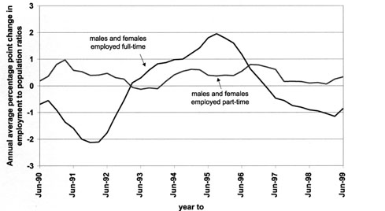
Source: Household Labour Force Survey

six entry cohorts, 1993-1998

Using benefit dynamics data, we are able to look at what happened to successive cohorts of DPB recipients as they moved through the period of the ETF policy reforms. One of the advantages of using benefit dynamics is that it allows us to analyse the entire population of individuals in a cohort rather than a sample. This permits examination of the experiences of narrowly defined sub-groups while avoiding the usual problems arising from sampling error. Table 1 shows the size and composition of the six cohorts of DPB entrants that are the subject of the present analysis.

The cohorts include all people granted DPB in a given calendar year and are not confined to "first ever" entries into the benefit system. A person can therefore appear in more than one cohort if they had grants in more than one calendar year. Data for years prior to 1993 are not sufficiently robust to be included in the benefit dynamics data set, and for this reason it is not possible to examine the experiences of earlier entry cohorts. Members of the six entry cohorts that can b studied made up 44% of all people in receipt of DPB on 31 December 1994, 65% of those in receipt on 31 December 1996, and 76% of those in receipt on 31 December 1998. Those who received benefit at these dates but are excluded from the analysis are earlier entrants who received DPB continuously throughout the study period (very long-term DPB recipients) or ceased receiving DPB within the study period and did not return.

Table 1 Size and Composition of DPB Entry Cohorts, 1993 - 1998
 |  | 1993 | 1994 | 1995 | 1996 | 1997 | 1998
Number in entry cohort |  | 31889 | 33835 | 36048 | 36092 | 33264 | 31693
Sex |  | Percentage of entry cohort
Female |  | 88 | 88 | 87 | 87 | 87 | 87
Male |  | 12 | 12 | 13 | 13 | 13 | 13
Ethnicity
Unknown |  | 20 | 17 | 10 | 5 | 5 | 6
Ethnic composition of those for whom known
NZ Maori |  | 35 | 35 | 35 | 34 | 34 | 33
NZ and Other European |  | 54 | 54 | 53 | 53 | 53 | 54
Pacific People |  | 9 | 9 | 9 | 10 | 9 | 9
Other |  | 2 | 3 | 3 | 3 | 3 | 4
Benefit type at entry
DPB/EMA – Sole Parent |  | 96 | 95 | 95 | 95 | 94 | 94
DPB – Woman Alone |  | 2 | 2 | 2 | 2 | 2 | 2
DPB – Caring for Sick or Infirm |  | 2 | 2 | 3 | 3 | 4 | 4
Age at entry
Under 20 |  | 10 | 10 | 10 | 10 | 10 | 9
20-29 |  | 45 | 44 | 43 | 41 | 40 | 39
30-39 |  | 33 | 33 | 33 | 34 | 34 | 35
40-49 |  | 9 | 9 | 10 | 11 | 11 | 13
50 or over |  | 3 | 4 | 4 | 4 | 4 | 4
Previously partnered?
No |  | 31 | 28 | 28 | 29 | 30 | 29
Yes |  | 69 | 72 | 72 | 71 | 70 | 71
Number of children at entry
No children |  | 4 | 4 | 5 | 5 | 5 | 5
1 |  | 54 | 53 | 53 | 53 | 54 | 53
2 |  | 26 | 26 | 25 | 25 | 25 | 25
3+ |  | 16 | 16 | 17 | 16 | 16 | 17
Age of youngest child at entry, of those with children
Under 7 |  | 79 | 79 | 78 | 77 | 76 | 75
7-13 |  | 16 | 16 | 17 | 18 | 19 | 20
14 or over |  | 5 | 5 | 5 | 5 | 5 | 5
Received DPB in year prior to entry?
No |  | - | 75 | 75 | 76 | 76 | 74
Yes |  | - | 25 | 25 | 25 | 24 | 26
Received any benefit in year prior to entry?
No |  | - | 32 | 33 | 34 | 35 | 35
Yes |  | - | 68 | 67 | 66 | 65 | 65
Received any benefit as primary in year prior to entry?
No |  | - | 44 | 43 | 43 | 44 | 44
Yes |  | - | 56 | 57 | 57 | 56 | 56
Received any benefit as partner in year prior to entry?
No |  | - | 77 | 79 | 80 | 82 | 80
Yes |  | - | 23 | 21 | 20 | 18 | 20
All (per cent) |  | 100 | 100 | 100 | 100 | 100 | 100

The annual number of entrants increased from 31,900 in 1993 to 36,000 in 1995, remained stabled between 1995 and 1996, and then fell to 31,700 in 1997. While the focus on this paper is on changing experiences once granted benefit, an interesting question is what has been driving the rise and fall in inflows to the benefit. Changes in the likelihood of multiple spells, or in the rate of "churning" within the recipient population, do not appear to have played a significant role. The proportion of entrants who had received benefit in the previous year fell from 68% for 1994 entrants to 65% for 1997 and 1998 entrants. Up until the arrival of the 1998 cohort, this was associated with a reduction in the likelihood of receiving benefit as a partner in the year prior, perhaps as a result of the improvement in male full-time employment propensities between 1993 and 1996. The likelihood of having received benefit as a primary recipient in the year prior and, within this category, the likelihood of having received DPB in the year prior, remained fairly constant.

Consistent with the wider demographic shift in the sole-parent population highlighted by Goodger and Larose (1999), there were shifts in the age composition of successive cohorts. While the percentage aged under 20 remained relatively constant, the percentage aged 20-29 fell steadily from 45% of the 1993 cohort to 39% of the 1998 cohort. The ageing of the entrants was accompanied by a shift in the age structure of their children. The percentage of entrants with children who had a youngest child under seven years of age at entry fell from 79% to 75%. There was no marked shift in the proportions with one and two or more children included in benefit at entry, however, and no clear trend in the proportion entering benefit having been previously partnered.

The rate of recording of ethnicity improved from 80% for the 1993 cohort to around 95% for the most recent cohorts. It is notable that the proportions of cohort members with ethnicity recorded who fell into each ethnic grouping remained fairly constant, with a slight fall in the percentage Māori and a slight increase in the percentage in the "other" ethnic group. It is not clear whether non-recording disguises an even greater or smaller shift in the ethnic composition of the cohorts than appears to be the case.

The remainder of this paper discusses the expected impacts of the ETF reforms and examines differences in the benefit experiences of the six entry cohorts that might be consistent with these.

etf reforms and changes in participation in
part-time employment

The ETF changes were expected to increase DPB recipients' rates of participation in part-time employment and, for those already in part-time employment, were expected to increase hours of work. In the absence of more direct measures, such as dates of employment and hours of work, data on the earnings declared by benefit recipients provide the best proxy for identifying any changes that followed the reforms. These data require some caution in interpretation however.
- DPB recipients can have their income assessed on either an annual or a weekly basis. Where income is assessed annually, anticipated income for the year is recorded until the actual income received is established at the annual renewal of benefit. Towards the end of the study period, therefore, earnings data for those reporting income annually are affected by a lag in recording.
- In converting income reported annually into weekly amounts, it is assumed that income falls evenly over the year for which it is declared. In cases where income declared as an annual amount was received over only the part of the year, this will overstate the number of weeks that income was received, and understate weekly income for the periods during which income was actually received. Prior to 1996, annual income declaration was the norm, although recipients could elect to have their benefit adjusted for changes in income more frequently. Since 1996, DPB recipients have been actively encouraged to declare changes in income as they happen. The resulting increase in the incidence of weekly declarations of income may have the effect of reducing the numbers appearing to be earning at any point in time, and increasing the average earnings of those earning.
- The quality of the data depends heavily on the accuracy of income reporting by benefit recipients, and on the degree of adherence to income assessment and recording procedures by District Office staff.

Bearing these limitations in mind, we examine the possible impacts on declared earnings of the new part-time abatement regime and reciprocal obligations in turn.

The Part-time Abatement Regime

Earnings changes observed following the 1 July 1996 introduction of the part-time abatement regime appear consistent with the expected policy impacts.

Figure 2 shows the proportion of members of the six entry cohorts in receipt of DPB who had declared earnings at quarterly intervals from 31 December 1993 to 30 June 1999. A strong seasonal pattern, with lower earnings propensities at 31 December, is apparent from 1995 onwards. This is likely to reflect the effect of childcare responsibilities on recipients' participation in employment over the summer school holidays.

A clear change can be observed following the 1 July 1996 policy change. The 1993, 1994 and 1995 cohorts, which can be tracked both before and after the change, each had sharp increases in earnings propensities between 30 June and 30 September 1996.

Figure 3 presents the same data in a way that allows the contrasting experiences of cohorts to be more easily distinguished. Comparing the first three cohorts at the same number of quarters from 31 December of the year of their entry (quarter 0), it is clear that up to 30 June 1996 (quarter 10 for 1993 entrants, quarter 6 for 1994 entrants, and quarter 2 for 1995 entrants) they tracked one another closely. After 30 June 1996, each had a much higher earnings propensity than the cohort that preceded it had at the same number of quarters from entry. Cohort-on-cohort differences peaked at around three percentage points at 30 June 1997 (an increase of just under 20%). At this point each cohort had faced the new abatement for a full year while the preceding cohort, at the same number of quarters from entry, was yet to become subject to the new regime. Towards the end of the study period, the three cohorts again tracked one another more closely.

Figure 2 Percentage of Cohort Members on DPB Declaring Earned Income at Quarterly Intervals (calendar time), 1993-1998 entry cohorts
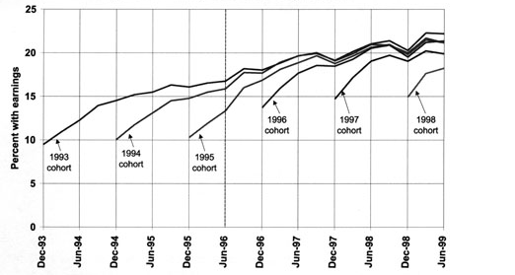

Figure 3 Percentage of Cohort Members on DPB Declaring Earned Income at Quarterly Intervals (relative to 31 December of entry year), 1993-1998 entry cohorts
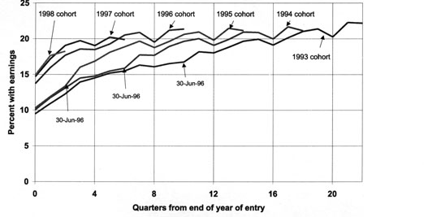

The 1996, 1997 and 1998 cohorts entered the follow-up window after the introduction of the part-time abatement regime. At quarter 0 (31 December of their year of entry), these cohorts had earnings propensities averaging 14.4%, 4.5 percentage points higher than those for the 1993, 1994 and 1995 cohorts at the same duration (an increase of 45%).

A useful summary measure of the possible impact of the policy change is the difference between the average change in earnings propensities for cohorts as they passed the date of the policy change and the average change in earnings propensities for earlier cohorts as they passed the same duration from entry.

Table 2 provides such a measure of "difference in differences'. It shows:
- the annual percentage change in earnings propensities in the year to 30 June 1997 (4 quarters after the policy change), averaged over the three entry cohorts that we can observe before and after the change (A);
- the annual percentage change in earnings propensities at the same duration from entry for each cohort's predecessor, averaged over the number of preceding cohorts for which this change can be observed (in this case two) (B); and
- the ratio of these two measures (A/B).

Table 2 Average Annual Percentage Change in Earnings Propensities at 30 June 1997 for Cohorts Observed Passing Through the 1 July 1996 Abatement Change (A) and for Preceding Cohorts at the Same Durations from Entry (B)
 | A* | B** | Ratio (A/B)
All | 27.6 | 14.7 | 1.9
Sole parents with youngest aged 0-6 at entry | 30.9 | 19.6 | 1.6
Sole parents with youngest aged 7-13 at entry | 23.5 | 7.0 | 3.4
Sole parents with youngest aged 14+ at entry | 19.6 | 7.3 | 2.7
Women alone | 23.8 | 13.8 | 1.7
Carers | 31.8 | 4.2 | 7.6
Māori | 32.7 | 24.9 | 1.3
Non-Māori | 26.3 | 12.4 | 2.1
*Average annual % change in earnings propensities at 30 June 1997 for cohorts observed passing through 1 July 1996 policy change
** Average annual % change in earnings propensities for preceding cohorts at the same durations from entry

A year after the policy change, cohorts observed passing through the 1 July 1996 policy change had, on average, experienced an annual rate of growth in earnings propensities 1.9 times that experienced by the cohorts that preceded them at the same durations from entry.

Comparing the size of this difference in differences between sub-groups shows a greater change in earnings propensities for sole parent entrants with a youngest child aged 7 or over at entry than for those with younger children. This may reflect the limiting effect of childcare costs and availability on the responsiveness of parents of younger children to the changed incentives. It may also partly reflect the first-quarter impact of the new reciprocal obligations, which began their roll-out on 1 April 1997, and would be expected to be associated with a larger change in behaviour for those with older children (see below).

While carers displayed the largest difference of the sub-groups, this reflects great quarter-to-quarter variability in their earnings propensities resulting from their small numbers. Small numbers also cause some instability in earnings propensities for women alone. Note, however, that no concerns about representativeness attach to the figures, because they relate to all benefit recipients who were members of the sub-groups and not a sample.

The table also shows a much more modest change for Māori than for non-Māori. This partly reflects the greater representation of Māori among cohort members with younger children at entry. Māori recipients of DPB are also less likely than non-Māori to have formal qualifications (Statistics New Zealand unpublished Census tables) and more likely to live in areas with high rates of unemployment which may have affected their ability to find jobs or increase their hours of work in response to the policy change. Further analysis would be needed to establish, where possible, the independent effects of these factors in explaining differences between Māori and non-Māori.

Also consistent with the changed incentives offered by the abatement change, there were pronounced increases in the proportions of cohort members on DPB who declared real ($March 1999) earnings of "$81 to $180 per week" and "$181 or over per week" following 30 June 1996 (Figures 4 and 5). At five quarters from the end of the year of their entry, for example, members of the 1995 entry cohort in receipt of DPB were almost twice as likely as members of the 1994 cohort at the same duration to declare real earnings of $81-180 per week (6.3% compared with 3.5%).

The shifts in earnings propensities and in the levels of real earnings declared are consistent with the expected effects of the changed incentives and their magnitude and timing strongly suggests that the new part-time abatement regime changed participation in part-time employment by recipients of DPB.

Other factors may have contributed to the changes that are observed. It is possible that part of the increase in earnings propensities is more apparent than real. The abatement change lowered the financial penalty attached to declaring income and this may have increased the proportion of benefit recipients making truthful earnings declarations.

In addition, changes in the economy and in the administration of benefits that coincided with the abatement change may have played a role. The growth in part-time employment propensities may be partly explained by a general expansion in part-time employment. The annual rate of growth in the proportion of the female working-age population employed part-time did increase over that period, averaging just under one percentage point (or 4%) in the four quarters to June 1997. The introduction of customised service, by increasing the frequency of contact with benefit recipients, may have increased the likelihood of income being declared. Data matching with IRD was carried out for all of the study period, however, which suggests that any such "declaration" effects would mainly occur for those employed in the informal sector. It is not clear whether this could account for changes of the magnitude observed.

The changes are unlikely to be explained by demographic changes, however. While differences in the age structure of the parents and children in successive cohorts are likely to partly account for the small cohort-on-cohort increases in earnings propensities observed over the study period as a whole (see Figure 3), by their nature, we would not expect these differences to result in a large change in behaviour affecting all cohorts at the same point in calendar time.

Figure 4 Percentage of Cohort Members on DPB Declaring Real Earnings of $81-180 pw ($March 1999) at Quarterly Intervals, 1993-1998 entry cohorts
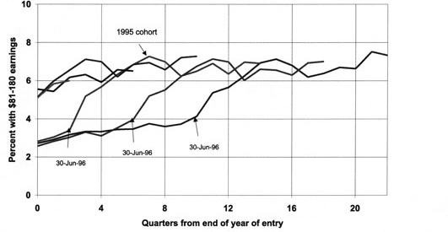

Figure 5 Percentage of Cohort Members on DPB Declaring Real Earnings of $181+ pw ($March 1999) at Quarterly Intervals, 1993-1998 entry cohorts
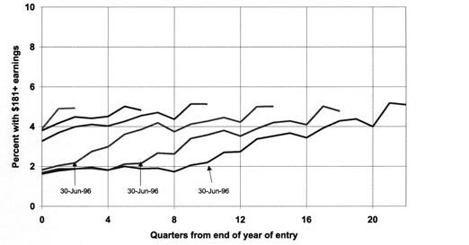

ETF Reciprocal Obligations

The new reciprocal obligations introduced as part of the Government's response to the ETF were expected to result in a stronger impact on part-time employment than could be achieved by financial incentives alone. As the reciprocal obligations rolled out from 1 April 1997, a further increase in the likelihood of having declared earnings was expected for those with a youngest child aged 14 or over (subject to the part-time work test) and those with a youngest child aged 7 to 13 (subject to the mandatory planning interview requirement), but not for those with younger children (subject to no new reciprocal obligations). Further increases were also expected for women alone (subject to the part-time work test), but little or no change was expected for carers (subject to no reciprocal obligations or, in a minority of cases, to the mandatory planning interview requirement).

Figures 6 to 8 show changes in the likelihood of declaring earnings for these sub-groups, defined by their status as they entered the cohorts.

Those with a youngest child aged 0-6 at entry (Figure 6) show a similar pattern to that observed for all entrants (see Figure 3): marked cohort-on-cohort departures in earnings propensities began at 1 July 1996 and peaked at 1 July 1997 before narrowing. Indeed, because this group made up more than 70% of entrants to each of the cohorts, the overall pattern shown in Figure 3 is largely shaped by their experiences.

The patterns for other sub-groups are less regular. However, in making comparisons between 1994 entrants and 1995 entrants, and between 1995 and 1996 entrants with a youngest child aged 7-13 (Figure 6), it is apparent that the departure in earnings propensities following 30 June 1996 is sustained for a much longer period than for entrants with a youngest child aged 0-6. Sustained differences between cohorts can also be observed for those with a youngest child aged 14 or over at entry (Figure 7) and woman alone entrants (Figure 8). Comparisons between the 1993 and 1994 women alone entrants, and between the 1994 and 1995 woman alone entrants, for example, show a marked gap in earnings propensities that is still apparent at the end of the study. In contrast, no clear pattern of cohort-on-cohort change is evident for carers.

These sustained cohort-on-cohort differences are consistent with the expected effects of the roll-out of reciprocal obligations. As each cohort approached the number of quarters from entry at which its predecessor became subject to the new abatement regime, it began to be affected by the roll-out of the new reciprocal obligations. It would take another year to reach the duration at which its predecessor had faced the same combination of policy settings.

As with the abatement changes, it is possible that these changes partly reflect changes in the propensity to declare earnings rather than changes in participation in part-time employment. Reciprocal obligations, by placing work expectations on DPB recipients and increasing the frequency of their contact with case managers, may have resulted in previously undeclared earnings being reported.

The bedding down of customised service and further expansion of Compass over the period may also have had this effect, although this would have been expected to affect all recipients, and is unlikely to account for the differences in patterns observed for the different reciprocal obligations sub-groups. A general expansion in part-time employment does not appear to have been a factor: the proportion of the female working-aged population employed pat-time fell on average by 0.3 percentage points (or 1.2%) over the four quarters to March 1998.

Figure 6 Percentage of Cohort Members on DPB Declaring Earned Income at Quarterly Intervals, 1993-1998 entry cohorts, sole parents with a youngest child aged
0-6 and 7-13 at entry compared
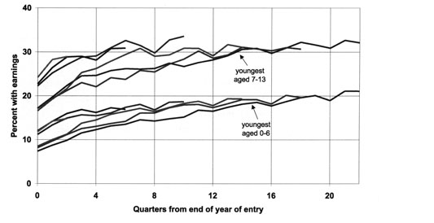

Figure 7 Percentage of Cohort Members on DPB Declaring Earned Income at Quarterly Intervals, 1993-1998 entry cohorts with a youngest child aged
14 or over at entry
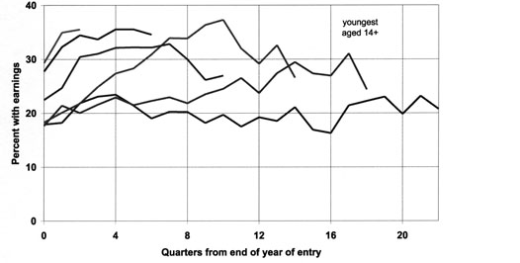

Figure 8 Percentage of Cohort Members on DPB Declaring Earned Income at Quarterly Intervals, 1993-1998 entry cohorts, those who were women alone and carers at entry compared
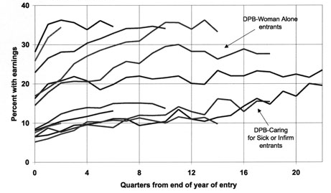

Figure 9 Percentage of Cohort Remaining on or Back on DPB at Quarterly Intervals, 1993-1998 entry cohorts
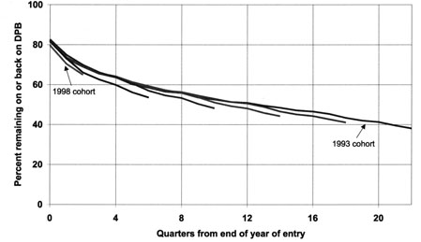

Figure 10 Percentage of Cohort Remaining on and Back on DPB at Quarterly Intervals,
1993-1998 entry cohorts
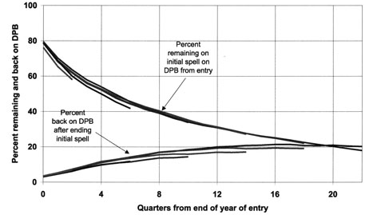

etf reforms and changes in participation in full-time
employment

Benefit dynamics data do not permit a precise examination of changes in full-time employment. Although information on destinations at the end of spells on benefit and events that led to their commencement is collected, the rate of non-recording is high, and it is likely that neither measure accurately reflects the real extent of full-time employment between spells on benefit. In addition, information on hours of work, which would be needed to assess the extent of full-time employment while in receipt of DPB, is not collected.

The best proxy for full-time employment available from the benefit dynamics data is non-receipt of benefit income. Two measures are examined:
- cohort members' probability of receipt (or non-receipt) of DPB with increasing time from entry; and
- cohort members' probability of receipt (or non-receipt) of any benefit income, either as a primary recipient or as a partner, with increasing time from entry.

Neither provides an ideal measure of the full-time employment outcomes of policy changes. For example:
- a reduction in the probability of DPB receipt will overstate policy impacts on full-time employment if one of the effects of the policy change is to increase transfers to other benefits, or to increase chances of partnering (perhaps as a result of the increased social contacts that part-time employment might provide); and
- a reduction in the probability of receipt of any benefit income will understate policy impacts if the policy change happens at the same time as male full-time employment is falling, increasing the likelihood that those who leave DPB to the ETF and subsequent reforms.

Figure 11 Percentage of Cohort on any Benefit as Primary or Partner at Quarterly Intervals, 1993-1998 entry cohorts
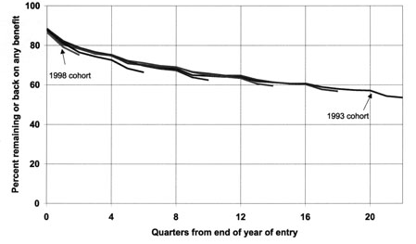

Figure 12 Percentage of Cohort on a Benefit Other than DPB at Quarterly Intervals,
1993-1998 entry cohorts
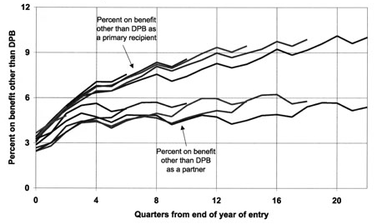

Compared with the changes in declared earnings, the differences in benefit receipt observed around the time the ETF reforms were implemented are less marked. Sizeable differences between successive cohorts to not emerge until June 1998 (quarter 14 for the 1994 cohort, quarter 10 for the 1995 cohort, quarter 6 for the 1996 cohort, and quarter 2 for the 1997 cohort), after the completion of ETF implementation. The following sections discuss the extent to which the changes observed might be consistent with the immediate and longer-term impacts of the ETF reforms.

The Part-Time Abatement Regime

The central objective of the abatement changes for DPB recipients was to increase their likelihood of full-time employment and independence from benefit income in the longer term. However, it was expected that in the short term the increased financial attractiveness of combining benefit and part-time earnings might hold people back from or draw people out of full-time employment at a greater rate than in the past.

The likelihood of being independent of benefit income might fall in the short term. An increase in benefit receipt could also result from the purely mechanical effects of raising the income level at which benefit fully abated away. Over the income range beyond the old cut-out point for benefit some people would newly retain or gain entitlement to benefit income.

At 30 June 1997, 12 months after the introduction of the abatement changes, members of each cohort that had passed through the change were indeed more likely to be in receipt of DPB than members of the preceding cohort at the same duration of entry. The change was slight, and is difficult to read off Figure 9 given the scale. Of the 1996 cohort, for example, 69.9% were receiving DPB at 30 June 1997 compared with 69.2% of the 1995 cohort at the same duration. The difference was the result of an increased likelihood of cohort members remaining on their initial spell on DPB, partly offset by a reduction in their likelihood of being back on DPB after ending their initial spell. It is consistent with the slowing of movement off DPB that was expected, but not with increased movement back onto that benefit.

Table 3 provides a summary measure of the changes in receipt observed, and compares this measure for different sub-groups within the cohorts. It compares the average annual percentage decline in the probability of receiving DPB for cohorts observed passing through the 1 July 1996 abatement change with the average annual percentage decline in the probability of receipt for preceding cohorts at the same durations from entry.

If the fall in the annual percentage decline in probabilities of benefit receipt that followed the abatement change were the result of that policy reform, we might expect the relative scale of these decreases for different sub-groups to mirror the relative scale of the increases in probability of earnings apparent in Table 2. This is not the case. Māori entrants, for example, experienced much small shifts in earnings propensities than non-Māori following the abatement change, but had the larger shift in the probability of DPB receipt of the two groups. This suggests that other factors must also have caused the changes in receipt observed. In particular, a general fall in full-time employment propensities coincided with the abatement change, and is likely to partly explain the increased probability of remaining on DPB over the period (see Figure 1).

Table 3 Average Annual Percentage Change in Probability of DPB Receipt at 30 June 1997 for Cohorts Observed Passing Through the 1 July 1996 Abatement Change (A) and for Preceding Cohorts at the Same Durations from Entry (B)
 | A* | B** | Ratio (A/B)
All | -10.5 | -12.6 | 0.8
Sole parents with youngest aged 0-6 at entry | -8.6 | -10.4 | 0.8
Sole parents with youngest aged 7-13 at entry | -15.8 | -17.2 | 0.9
Sole parents with youngest aged 14+ at entry | -42.2 | -43.2 | 1.0
Women alone | -9.9 | -12.9 | 0.8
Carers | -18.4 | -25.1 | 0.7
Māori | -8.3 | -10.1 | 0.8
Non-Māori | -11.0 | -11.9 | 0.9
* Average annual % change in probability of DPB receipt at 30 June 1997 for cohorts observed passing through July 1996 policy change.
** Average annual % change in probability of DPB receipt for preceding cohorts at the same durations from entry.

ETF Reciprocal Obligations

The ETF reciprocal obligations did not aim to increase movement into full-time employment and off benefit in the short term. However, the associated case management may have had this effect (Department of Social Welfare 1998:35). Newly work-tested DPB recipients gained access to job search assistance and services, and may have been assisted into full-time work as a result. Those who attended mandatory annual planning interviews may have been assisted into full-time work by the guidance, information and referrals that these interviews provided. In addition, the increased contact that the new obligations required, particularly of those subject to the part-time work test, may have increased the likelihood that those no longer entitled to DPB would be identified as such.

The possible extent of a short-term impact of this nature can be assessed by comparing changes in the probability of receipt of benefit for the sub-groups affected in different ways by the reciprocal obligations. Table 4 compares the average annual decline in the proportion of cohort members receiving any benefit income, either as a primary or as a partner, for cohorts observed passing through the 1 April 1997 – 1 April 1988 roll-out of reciprocal obligations with the same measure for preceding cohorts at the same duration from entry.

The results are mixed. At 31 March 1998, the average annual percentage decline in the probability of receiving benefit for woman alone entrants observed passing through the roll-out was 1.6 times greater than that for preceding cohorts at the same duration from entry. This contrasts with cohorts of carer entrants passing through the period of the roll-out, who had a smaller average annual decline in the probability of receipt than their predecessors, and is consistent with the employment effects hypothesised.

However, the average annual percentage decline in the probability of receipt for those with a youngest child aged 14 or over observed passing through the roll-out was in fact slightly smaller than that experienced by earlier cohorts at the same duration from entry. In contrast, those with a youngest child aged under 7 (who were not subject to any new reciprocal obligations), and those with a youngest child aged 7 to 13 (who were subject to less demanding reciprocal obligations) did show an increased rate of decline in receipt. Consistent with their greater representation among those with younger children, Māori showed a greater increase in their rate of decline in receipt than non-Māori.

Table 4 Average Annual Percentage Change in Probability of Benefit Receipt at 31 March 1998 for Cohorts Observed Passing Through the 1 April 1997 Reciprocal Obligations Change and for Preceding Cohorts at the Same Durations from Entry
 | A* | B** | Ratio (A/B)
All | -7.8 | -7.1 | 1.1
Sole parents with youngest aged 0-6 at entry | -7.0 | -6.4 | 1.1
Sole parents with youngest aged 7-13 at entry | -10.7 | -8.9 | 1.2
Sole parents with youngest aged 14+ at entry | -13.1 | -15.3 | 0.9
Women alone | -6.8 | -4.2 | 1.6
Carers | -6.3 | -9.2 | 0.7
Māori | -5.5 | -4.2 | 1.3
Non-Māori | -8.8 | -7.6 | 1.1
* Average annual % change in probability of benefit receipt at 31 March 1998 for cohorts observed passing through April 1997 policy change.
** Average annual % change in probability of benefit receipt for preceding cohorts at the same durations from entry.

The changes observed for sole parents are not consistent with the short-term employment effects hypothesised.

However, by 31 March 1998, some cohort members would only just have become subject to the new obligations. The reciprocal obligations may have taken longer to have their short-term impacts on full-time employment than Table 6 allows. Could the effects of the ETF reciprocal obligations, with a longer lead time, explain the marked cohort-on-cohort reductions in receipt observed from June 1998 onwards that are apparent in Figure 9?

Figures 13 and 14 compare the experiences of the sole parent sub-groups over a longer period. It is clear that even after the roll-out of reciprocal obligations was completed at the end of March 1988 (quarter 13 for the 1994 entrants and quarter 9 for the 1995 entrants) the changes for sole parent entrants cannot be explained by the impacts of the ETF reciprocal obligations. Sole parents with a youngest child aged under 7 (subject to no reciprocal obligations) had the largest cohort-on-cohort reductions in the probability of receiving DPB (Figure 13). For cohorts with a child aged 14 or over at entry, the average decline in the probability of receiving DPB over the year from 31 March 1998 was no greater than that experienced by earlier cohorts at the same duration from entry. It was not until after the introduction of full-time work testing for this group from February 1999 that marked changes began to be observed for this group.

If the marked cohort-on-cohort reductions in receipt from June 1998 onwards cannot be explained by the immediate impact of the case management associated with ETF reciprocal obligations on full-time employment propensities, then what can explain the shifts?

Figure 13 Percentage of Cohort Remaining on or Back on DPB at Quarterly Intervals,
1993-1997 entry cohorts, sole parents by age of youngest child at entry
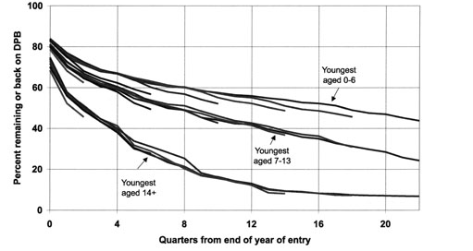

Figure 14 Percentage of Cohort on any Benefit at Quarterly Intervals,
1993-1997 entry cohorts, sole parents by age of youngest child at entry
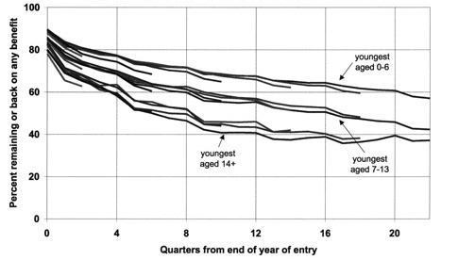

The benefit fraud advertising campaign, which ran between April and June 1998, emphasised non-declaration of de-facto relationships. The changes in patterns of receipt that followed June 1998 appear consistent with increased declaration of partnerships and cancellation of benefit as a result of the campaign. The changes were most pronounced for sole parents with a youngest child aged under 7 at entry, the group most likely to cease benefit as a result of partnering. In addition, the fall in likelihood of DPB receipt was accompanied by a sudden jump in the likelihood of being in receipt of a benefit other than DPB as a partner at the 30 June 1998 quarter (Figure 12). When receipt of any benefit income is examined, the reduction is much less marked (Figure 14).

However, that the cohort-on-cohort reductions in the likelihood of being in receipt of benefit have been sustained suggests that the benefit fraud campaign cannot account for all the change observed. If the reductions were solely the result of the benefit fraud campaign we might expect the gap between cohorts to have closed at 30 June 1999 as each reached the number of quarters from entry at which its predecessor experienced the campaign. (This is the pattern that can be observed in the probability of being on benefit as a partner shown in Figure 12, which suggests that these changes were largely the result of the benefit fraud campaign.

One possibility is that, by late 1998 and 1999, the longer-term effects on full-time employment propensities sought by the ETF changes were beginning to become apparent. The part-time abatement regime and the ETF reciprocal obligations, through their impact on rates of participation in part-time employment, may have begun to increase full-time earnings propensities. This, together with the tax cuts, increases in rates of Family Support and the introduction of the Independent Family Tax Credit, may have raised the in-work incomes of sole parents leaving benefit for work and/or a relationship with a low-income partner, and led to more sustained exits.

There are other possible explanations, however, including:
- the announcement of strengthened and extended reciprocal obligations in the May 1998 Budget which, by signalling a change in Government expectations, may have had an immediate impact on the behaviour of some DPB recipients, regardless of the ages of their children;
- changes in case management and the expansion of the number of places on the Compass programme which, by 1998, may have begun to affect full-time employment outcomes;
- the January 1999 changes to TIA which appear to have reduced DPB recipients' participation in education and training and may have increased availability for employment;
- the implementation of the DPB Review reform on 1 February 1999, in particular the roll-out of extended and strengthened reciprocal obligations from that date and the introduction of the OSCAR subsidy; and
- the Inland Revenue Department advertising campaign promoting Family Support and the Independent Family Tax Credit, which may have raised the income level that sole parents in receipt of benefit perceived they would receive on moving into full-time work.

Given the number and proximity of changes in the later part of the study period, it is not likely to be possible to isolate the longer-term effects of the ETF reforms.

conclusion

This paper uses benefit dynamics data to examine patterns of benefit use by successive cohorts of entrants to the DPB as they passed through the period of the ETF reforms.

It finds large changes in the propensity to declare earnings and in the level of earnings declared: changes that are consistent with the expected impacts on participation in part-time employment of the changed abatement regime and the ETF reciprocal obligations. The magnitude and timing of the changes, and he contrasting experiences of sub-groups affected in different ways by the ETF reciprocal obligations, strongly suggests that these changes were largely the result of the policy changes rather than the economic, administrative and demographic changes that coincided with them.

The relationship between the ETF reforms and changes in the probability of benefit receipt appears less clear. During the period when the immediate effects of these reforms might have been expected to be felt, changes in the probability of benefit receipt were less marked than the above-mentioned changes in propensity to declare income. The probability of remaining on DPB increased slightly following the introduction of the abatement changes, but it is possible that the change can be explained as much by falling rates of female full-time employment over the period as by the expected short-term effects of the abatement change. While there is some support for the hypothesis that the introduction of the ETF reciprocal obligations resulted in an immediate increase in full-time employment propensities for women alone, changes for sole parents are not consistent with such an effect.

Longer-term improvements in earnings capacities and chances of independence from benefit income sought by the ETF reforms may partly explain the more marked cohort-on-cohort reductions in benefit receipt that have occurred since mid-1998. However, it appears likely that one of the main drivers of this change was the benefit fraud campaign, and, given the number and proximity of changes in policy and administration that have occurred since the fraud campaign, it appears unlikely that it will be possible to distinguish the longer-term impacts of the ETF changes from other effects.

The paper demonstrates the richness of a multiple cohort analysis using benefit dynamics data as a tool for exploring possible policy impacts and for identifying changes that warrant further statistical analysis to estimate the size of policy impacts. It highlights the contrasting earnings experiences of successive cohorts of DPB recipients and their relationship with the ETF reforms as a strong candidate for further statistical investigation.

references

Birch, Rt Hon B. (1996) Tax Reduction and Social Policy Program – Details, 19 February.

Department of Social Welfare (1998) Statistics Report for the Year Ending 30 June 1998, Wellington.

Focus on Employment: The Government's response to the Employment Task Force and the Multi-Party Group Memorandum of Understanding, 19 October 1995.

Goodger, K. and P. Larose (1999) "Changing Expectations: Sole parents and employment in New Zealand" Social Policy Journal of New Zealand, Issue 12:53-70.

Wilson, M. (1999) "The duration of benefit receipt: New findings from the benefit dynamics data set" Social Policy Journal of New Zealand, Issue 13:59-82.

I am grateful to Malcolm Chambers, Raewyn Good, Kay Goodger, Roger Hurnard, Marlene Levine, Ron Lovell, Dave Maré, and Alex McKenzie, for their helpful comments on earlier drafts. Any errors or omissions are my own. The views expressed are not necessarily those of the Ministry of Social Policy.
The Domestic Purposes Benefit is an income-tested benefit payable to sole parents, those providing full-time care for a sick or infirm person ("carers") and other single women without dependent children ("women alone").
Numbers in receipt fell from around 115,400 in March 1998 to around 110,400 in March 2000, a period in which the real value of DPB remained constant.
See Wilson (1999) for a description of the benefit dynamics data.
This entailed an increase in the abatement rate applying to additional income between $81 and $180 per week from 30% to 70%.
The cohorts are defined in the manner described in Wilson (1999) except that a person is included as a member of the DPB entry cohort even if they were granted another benefit prior to their grant of DPB in the entry year.
Note that because of the assumptions made in defining spells on benefit in the benefit dynamics data, these inflows depart in scale from the number of applications granted shown in the Department of Social Welfare Annual Statistical Reports. For example, the Annual Statistical Reports treat transfers from two weekly to weekly forms of DPB which occurred from November 1996 onwards as new grants. In the benefit dynamics data set such transfers are treated as a continuation of the original spell.
The current version of the benefit dynamics data set was extracted at 30 August 1999. We can therefore expect that earnings data from September 1998 onwards are affected by this lag in recording.
It is not possible to accurately distinguish those who have their income assessed weekly from those who have their income assessed annually. However, one indicator of the possible scale of the bias resulting from the shift towards weekly declarations can be obtained by examining changes in the average number of changes in declared income recorded in a year. Whereas 1993 entrants who received DPB continuously for at least a year from entry had, on average, 1.3 changes in declared income recorded in that year, the equivalent figures for 1994, 1995, 1996 and 1997 entrants were 1.3, 1.4, 1.7 and 2.1 respectively. Note that this increase may partly reflect increased likelihood of having income, as well as changes in the frequency of declaration.
There were fewer than 700 woman alone and carer entrants in the 1993 entry cohort for example, each category making up about 2% of the cohort.
Adjusting for inflation avoids overstating the differences between cohorts. Note, however, that earnings thresholds did not change in normal terms over the period so that the income bands shown do not exactly match earnings thresholds.
Because we have no information on the earnings levels attained by people who moved off benefit before and after the policy change, it is not possible to accurately distinguish the behavioural and mechanical effects of the policy change over this income range.
One of the effects of the new reciprocal obligations on time series data was to increase the number of DPBs that are suspended for non-compliance at any point in time. A large proportion of such benefits are resumed once the requirements of the reciprocal obligations are met, with no break in payment. Unadjusted time series data on benefits in force therefore overstate the impact of reciprocal obligations on the caseload. This problem of overstatement does not apply to benefit dynamics data as retrospective action to resume benefit without interruption after a period of suspension is taken into account (see Wilson (1999)).

