WORKING FOR FAMILIES: THE IMPACT ON CHILD POVERTY

Bryan Perry
Ministry of Social Development

Abstract
The Working for Families (WFF) benefit reform package was the centrepiece of the 2004 Budget announcements of the Labour-led coalition government in New Zealand. The package is targeted at low-to-middle-income families with dependent children. One of its core goals is to improve income adequacy for these families as one of the key means of reducing child poverty over the next three years. In this regard, it is an example of the government implementing many of the poverty alleviation strategies outlined in the 2002 Agenda for Children, which committed to eliminating child poverty.

This paper gives an account of a modelling and analysis exercise that provides estimates of the likely impact of the WFF reforms on income poverty through to 2007, with a major focus on the impact of the Family Income Assistance (FIA) component of the WFF on child poverty. It uses two internationally recognised poverty thresholds of 50% and 60% of the median equivalised income of households. The impact analysis finds that, when the WFF reforms are fully implemented in 2007, child poverty can be expected to have been reduced by the FIA by around 70% and 30% respectively at these two thresholds. A distinctive feature of the paper is the extensive sensitivity testing regarding the possible effect on the impact estimates of different assumptions and parameter settings that go into the construction of the poverty measures.

Introduction

Child poverty is back on centre stage in the economically developed nations. The renewed focus is driven in part by the mounting evidence that childhood disadvantage increases the chances of poor outcomes later in life. One of the most common aspects of childhood disadvantage is low family income and there is good evidence of the negative impact on future outcomes of low family income during childhood, even when other related influences are accounted for. This makes child poverty an issue for all citizens as “many of the most serious problems facing today’s advanced industrialised nations have roots in the denial and deprivation that mark the childhoods of so many of their future citizens” (UNICEF 2000:3).

However, concern about child poverty does not depend only on the impact of childhood poverty on later life. Child poverty is also about suffering, deprivation and limited opportunity for poor children in the present.

The pledge by Tony Blair in 1999 to eradicate child poverty in the United Kingdom within a generation has focused public and political attention on the matter both within the United Kingdom and further afield. The United Kingdom has followed through on the pledge with a specific commitment to halve child poverty by 2010 and has put in place an official measurement regime to support the commitment (Department for Work and Pensions 2003).

In June 2002, the New Zealand Government made a commitment to eliminate child poverty, articulated in the Agenda for Children public report (Ministry of Social Development 2002). The Working for Families (WFF) benefit reform package, which was the centrepiece of the 2004 Budget, represents the Government’s implementation of many of the poverty alleviation strategies outlined in the Agenda for Children.

The WFF package is targeted at low-to-middle-income families with dependent children and will build to $1.1 billion of new money in 2007. Its key goals are: to “make work pay”; to improve income adequacy for families with dependent children, especially as a means of tackling child poverty; and to improve take-up rates of social assistance. The package has several elements, including measures to better assist with accommodation and childcare costs. However, the bulk of the new money is applied to the Family Income Assistance (FIA) element through increases to Family Support (FS) and more substantial tax credits for working families through an In-Work Payment (IWP). The package will be phased in over the next three years with the IWP becoming available in 2006 and the final FS increases in April 2007.

This paper has two purposes. Its first is to give an account of a modelling and analysis exercise that gives estimates of the likely impact of the WFF reforms on income poverty through to 2007, with a major focus on the impact on child poverty.

The paper’s second purpose is to promote a wider understanding of some of the key issues involved in poverty measurement in a practical setting, so that users of the results from this paper and similar studies are better informed and better able to discuss and assess the issues for themselves, whatever their background.

It is also important to note what the paper does not aim to do. The paper’s focus is on the proportional change in poverty rates after full implementation, and while this requires estimating the rates before and after, the focus is not usually on the poverty rates per se. A range of rates is reported, depending on the specific assumptions in the poverty measure that is used. Nor does the paper attempt to make an assessment of the various measures or recommend a preferred measure or set of measures, although the analysis reported here may assist in reaching a view on these questions.

A distinctive feature of the study is its extensive sensitivity testing regarding the possible effect on the impact estimates of the different assumptions and parameter settings that go into the construction of the poverty measures.

The data for the analysis are drawn in the main from a policy simulation using TAXMOD, a tax–benefit micro-simulation model constructed and maintained by the New Zealand Treasury and based on Statistics New Zealand’s Household Economic Survey (HES). TAXMOD models only the FIA components of the WFF package so, technically, the impact analysis in this paper is only about those aspects of the package. However, as the new FIA money accounts for 90% of the new expenditure at full implementation, this is not a serious limitation of TAXMOD for the purposes of this study, and the paper will speak more colloquially of the impact of the WFF package.

The body of the paper has four main sections.

It starts with a background section that outlines some key concepts and definitions and gives a graph-based description of the impact of the reforms on the income distribution for families with dependent children. This section is particularly for those who use income poverty statistics but do not have great familiarity with the area.

The second section outlines and discusses the analytical approach adopted by the paper.

The third section reports the estimated impact of the reforms on measured poverty, especially child poverty, relative to what could have been expected without any policy change. It compares the expected post-reform rates with those of the last 15 years in New Zealand and with recent measures among the richer nations.

A fourth section reports sensitivity analysis regarding the choice of income sharing unit for the analysis. In New Zealand, both the household and the benefit eligibility unit (also known as the economic family unit) are used for reporting on poverty. The two approaches give different estimates of poverty rates, which raises the question of whether the impact findings are also dependent on which approach is adopted.

Background

This section outlines some key concepts and definitions that are used in the subsequent analysis (“poverty”, income sharing unit and equivalised income), and gives a graph-based description of the impact of the reforms on the income distribution for families with dependent children.

Poverty?

In the economically developed nations, poverty is now almost universally conceptualised in relative rather than “absolute” or subsistence terms. It is defined and assessed vis-à-vis the living standards of the society in question. Poverty is understood as exclusion from the minimum acceptable way of life in one’s own society because of inadequate resources. The definition is explicitly relative, and includes both input and outcome elements.

Poverty is not just any limited social functioning, but specifically isolation that stems from the lack of economic resources. (Kangas and Ritakallio 1998:175)

The most common approach to measuring poverty on the “input” dimension is to limit resources to economic or financial resources and often to current income. As the aim of the modelling and analysis is to estimate the expected impact of the WFF reforms on “measured income poverty”, the income approach is what is required for this paper.

The majority of income poverty studies use one of two main approaches in establishing a poverty line or low-income threshold. A very common method is the proportion-of-median approach, which typically uses 50% or 60% of the median of an equivalised household or family income distribution. Alternatively a minimum reasonable budget can be determined by using experts to produce “budget standards” or by using focus groups of ordinary citizens, especially those who are in the low-income group and so have a practical expertise. This dollar value can be used in its own right or converted to a proportion of the median and used for other times and places. Both approaches are consistent with the relative conceptualisation of poverty in that anything less in income terms means that there is a very high chance of exclusion – the inability to participate in one’s own society in a reasonable way. This paper uses the proportion-of-median approach for establishing the poverty line(s).

Taking an outcome or more direct living standards approach can also identify a group “in poverty” (Krishnan et al. 2002). However this group is usually not the same group identified as poor on an income basis. It is well established that the overlap between the groups identified as “poor” by the two approaches is often only around 50–60% (Nolan and Whelan 1995, Bradshaw and Finch 2002, Perry 2002). In other words, a sizeable portion of people below income poverty lines are not experiencing significant restrictions regarding basic consumption presumably because they have other resources that are not fully captured in surveys like the HES (for example, a good stock of assets, accessible savings, gifts from outside the household, unreported income). Similarly, some of those above income poverty lines are struggling because they have special needs that place above-average demands on their budgets.

From one perspective, therefore, current income is a relatively blunt instrument to use to assess the material wellbeing of the population. Nevertheless there is a strong rationale for using an income approach at least as a key component in a measurement regime: current income is a reasonable indicator of the consumption opportunities available to a citizen; and income support is one of the most powerful instruments that a government has at its disposal for its poverty alleviation and resource redistribution goals.

Income Sharing Unit (ISU)

Estimates of income poverty for individuals typically use the income of the household or of some version of the co-resident “family” as the indicator of the individual’s resources and living standards. This assumes that all members of the income unit share equitably in the resources and experience a similar standard of living. The assumption clearly does not hold in all circumstances but is defensible as an approximation to the very complex reality of intra-ISU and inter-ISU patterns of sharing (cf. Bradbury 2003:25).

In broad terms, there are three ISUs in use in poverty measurement: the household, the “family unit”, and the more narrowly defined economic family unit or EFU.

• The household is either one person usually living alone or two or more people usually living together and sharing facilities (e.g., eating facilities, cooking facilities, bathroom and toilet facilities, a living area).

• The (Census) “family unit” is a slightly narrower grouping. A multi-person family unit is a group of two or more persons who live in the same dwelling and are related to each other by blood, registered marriage, common-law or adoption. Children in these units include both dependent and adult children. A single-person (family) unit or “unattached individual” is a person living either alone or with others to whom he or she is unrelated, such as roommates or a boarder.

• The economic family unit (EFU) is a narrower concept again. An EFU consists of an adult, a partner (if any) and/or dependent children (if any). Children are dependent while under 15, or while under 18 and neither employed full-time nor on a benefit. Thus children aged 15+ and in full-time employment or on a benefit, or those aged 18+ irrespective of employment or benefit status, are split off into separate EFUs in their own right even if their personal income is zero or very low. In practice, an EFU is a couple-only family unit, a two-parent family with dependent children, a sole-parent family with dependent children, or a single adult (someone who is not a dependent child as per the definition). A household may contain more than one EFU.

Internationally the household is the ISU most commonly chosen for establishing the income distribution that is used to rank the population and/or calculate the median for the purposes of assessing and reporting income poverty. Some researchers and countries (e.g., Australia, Canada and the United States) use the “family unit” as the ISU. As both the household and EFU approaches are used in New Zealand, the paper reports on the sensitivity of the impact results to the choice of the sharing unit. It is not the purpose of this paper to provide an assessment of the relative merits of the two approaches.

Equivalised Income

The income concept used for the analysis in this paper is equivalised disposable income. This is net income after taxes and government transfers, adjusted for family or household size and composition to enable a more sensible comparison of the purchasing power of a given income for different families and households. Equivalisation typically reflects the observation that, while larger households cost more to run than smaller ones, there are economies of scale as household size increases. Most also assume that children cost less than adults. The equivalence scale used in the TAXMOD model is the 1988 Revised Jensen Scale, which goes even further and makes adjustments based on the age of the children, with older children assumed to cost more than younger children.

There are other differences between families or households that it would be useful for equivalence scales to take into account (e.g., differing costs due to disability or unusual debt) but in general they cannot. Equivalising should therefore be seen as a rough and ready, albeit important, tool for adjusting income for selected differing needs.

Table 1 provides a look-up chart to convert equivalised to actual income and vice versa for selected low-income ISUs. The first row defines the family or household type: (1,2) is a one-adult, two-child household, and so on. The second row gives the values of the equivalence ratios used. The body of the table indicates, for example, that a (2,2) household needs around $28,000 to have the same purchasing power as a (1,1) household on around $18,000. Each has an equivalised income of $13,000.

Table 1: Conversion of Equivalised Dollars to Actual Dollars for Selected
Low-Income ISUs

Equivalised Income | Actual net income for families and households of various types
 | (1,0)ª | (1,1) | (1,2) | (1,3) | (2,0) | (2,1) | (2,2) | (2,3) | (2,4)
 | 1.00^{b} | 1.40 | 1.75 | 2.06 | 1.54 | 1.86 | 2.17 | 2.43 | 2.69
$10,000 | 10,000 | 14,000 | 17,500 | 20,600 | 15,400 | 18,600 | 21,700 | 24,300 | 26,900
$11,000 | 11,000 | 15,400 | 19,292 | 22,677 | 16,923 | 20,477 | 23,862 | 26,738 | 29,615
$12,000 | 12,000 | 16,800 | 21,046 | 24,738 | 18,462 | 22,338 | 26,031 | 29,169 | 32,308
$13,000 | 13,000 | 18,200 | 22,800 | 26,800 | 20,000 | 24,200 | 28,200 | 31,600 | 35,000
$14,000 | 14,000 | 19,600 | 24,500 | 28,840 | 21,560 | 26,040 | 30,380 | 34,020 | 37,660
$20,000 | 20,000 | 28,000 | 35,000 | 41,200 | 30,800 | 37,200 | 43,400 | 48,600 | 53,800

(a) This row defines the ISU type: (1,0) is a single ISU, (2,3) is a couple ISU with three children, and so on.
(b) This row gives the value of the equivalence ratio for a given ISU type.

Graphical Representation

Assessing the impact of the reforms on measured income poverty is largely about reporting succinctly on the way the income distribution changes at its lower end as a result of the reforms. This subsection gives a graph-based account of where the new money goes and the impact the reforms have on the income distribution. It underlines three themes that are relevant to the central purpose of the paper:

• The choice of poverty threshold matters. Different thresholds produce quite different poverty rates and, as will be shown in the results section, can also produce quite different assessments of the size of the impact of the reforms.

• Even a small movement of the threshold can have a large effect on measured poverty. This is because so many families or households (especially those in receipt of a benefit) cluster around the $9,000 to $14,000 (equivalised) zone where the most commonly used poverty lines are found.

• It is important to examine the proportional impact for a range of thresholds, rather than simply adopting a binary approach that divides the population into “poor” and “non-poor” based on one threshold.

Figure 1 shows the pre-reform income distributions for EFUs with dependent children and for all EFUs. The focus of the reforms is on the low-to-middle-income range, so the graph is truncated at $30,000 (equivalised). Note that in a full graph there would be a very long right-hand tail, with around 25% of families having incomes greater than $30,000 (equivalised).

The two main low-income thresholds or poverty lines used in this paper are shown for reference in Figure 1 and subsequent graphs. The rationale for the choice of these thresholds is given in the next section.

Figure 1: Projected Pre-Reform 2005 EFU Income Distribution (TAXMOD)

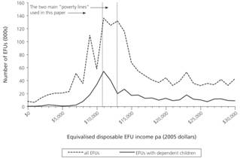

The vertical bars in Figure 2 show where the new money is being targeted in the first year for EFUs with dependent children. For example, those with equivalised incomes between $13,500 and $14,500 per annum (i.e., the bar at $14,000) receive on average an extra $1,900 (actual dollars per annum) as a result of the first phase of the reforms. For a couple with three children, an equivalised income of $14,000 is around $34,000 in actual dollars. For a sole parent with one child, it is around $19,600 in actual dollars. The effect of the additional assistance is to shift the income distribution to the right as in Figure 3. The distribution at the lower end gets pushed up towards the median, although the median itself changes very little as there is very little new money above the median and very few just below the median get moved across it.

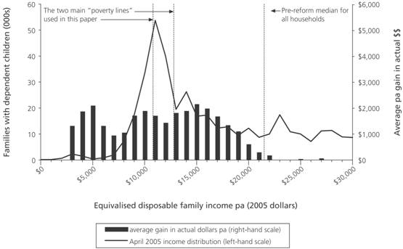
Figure 2: Average Annual Net Gain in Actual Dollars for Families with Dependent Children Phase 1 (2005/06)

Figure 3: Income Distribution for Families with Dependent Children Before and Immediately After Phase 1 of the Reforms

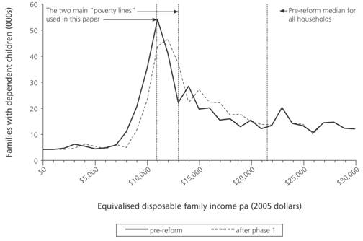

Figure 4 show where the new FIA money is being targeted in the second year (2006/07). It is mainly the new IWP and its impact is an average further up the income distribution than in year one (2005/06).

Figure 4: Average Annual Net Gain in Actual Dollars for Families with Dependent Children (2006/07)

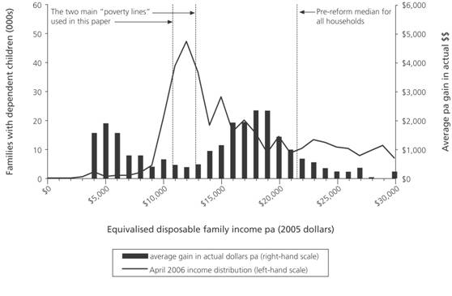

Figure 5 shows the overall change in the income distribution for families with dependent children once the reforms are fully implemented in 2007. The post-reform incomes have been converted to 2005 dollars using the forecast Consumer Price Index (CPI) to enable a more satisfactory before and after comparison.

Figure 5: Income Distribution for Families with Dependent Children Before and After Full Implementation of the Reforms

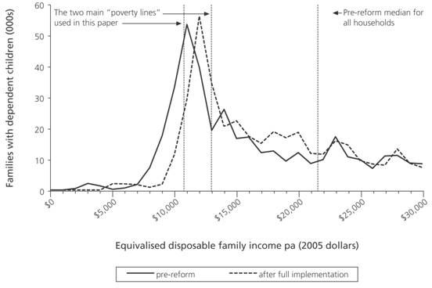

The task for the analysis in this paper is to report succinctly on the change in the numbers below a given threshold after the impact of the reforms has been factored in.

Outline Of Analytical Approach

In order to arrive at robust estimates of the expected impact of a policy change on measured income poverty, we need:

• a measure of income poverty to divide the population into “poor” and “not poor” at a given time
• a way to update the thresholds over time, especially where implementation is phased over several years
• a poverty index or indices to summarise the situation of those identified as poor
• a baseline income distribution or “counterfactual” against which to measure the modelled changes
• sensitivity analysis to test whether the results are robust to the adoption of different technical assumptions and parameter settings in the poverty measures.

This section outlines the paper’s approach on each of these issues.

Choosing a Measure of Income Poverty

All measures of income poverty are built on a range of assumptions and decisions that, though often appearing merely “technical” in nature, can each have a marked effect on the figures produced. The main ones are:

• the choice of weighting regime to give population estimates from the survey sample
• what, if anything, to do about “noise” at the lower end of the income distribution
• what income concept to use, the most common being gross or disposable ISU income
• whether or not to make an adjustment to income for housing costs and, if so, which adjustment to use
• which, if any, equivalence scale to use for adjusting for differences in need arising from differences in the size and composition of families/households, and sometimes other factors
• where to set the poverty line itself
• how to update the poverty line over time
• which unit of analysis to apply at various stages of the measuring and reporting process, especially the choice of ISU for establishing the income distribution.

One way of dealing with the issue of poverty estimates being dependent on the assumptions and choices around such issues is for a country (or researcher) to adopt an official (or preferred) poverty measure and to then carry out sensitivity analysis based on different settings of the key assumptions.

In the absence of an official poverty measure in New Zealand, this study uses two measures with international and New Zealand credentials and provides sensitivity analysis across key assumptions. The two measures are based on the equivalised disposable income of households, with thresholds set at 50% and 60% of the median. These are the measures used in The Social Report (Ministry of Social Development 2003) for international comparisons.

The 50% measure is used in many research reports based on the Luxembourg Income Study (LIS) database, in OECD poverty trends reports and in the league table for child poverty in rich nations produced by UNICEF’s Innocenti Research Centre (UNICEF 2000). The 60% measure has been officially adopted in the European Union and forms the basis for two of the three indicators that make up the official child poverty measure recently adopted by the British government. It is also the measure used by the New Zealand Poverty Measurement Project (PMP).

Two other measures were considered, both of which involved an EFU-based analysis rather than the household-based one as above. One option was to adopt the measure used in The Social Report for reporting New Zealand trends. This measure is based on the after-housing-costs disposable income of EFUs using thresholds of 40%, 50% and 60% of the median. As the TAXMOD model does not include either housing costs or the Accommodation Supplement, a measure involving adjustments for housing costs was not available for this paper.

Another option was to base the analysis on the before-housing-costs disposable income of EFUs. There were no obvious advantages in using this approach and it had the disadvantage of precluding international comparisons, which are almost always household based.

Updating Thresholds Over Time

There are two common approaches to updating thresholds over time. One is to adjust the thresholds on a year-by-year basis in accordance with changes in the contemporary median. The other is to maintain the real value of the thresholds over time by updating them using the CPI, starting from a chosen base year and threshold. The two approaches have a different conceptual basis and generally lead to different estimates of poverty rates. Both approaches have their place in a comprehensive poverty measurement regime. Fortunately, their relative merits do not have to be assessed in this study, as their values remain very close in the years after the reference year (2005).

In this paper the two poverty measures are applied over time using a constant-value approach in line with the updating approach adopted in The Social Report. The base thresholds are set at the dollar value of 50% and 60% of the 1998 HES median or the 2005 TAXMOD median. The 50% and 60% 1998 HES-based thresholds are $10,750 and $12,900 respectively in 2005 dollars. (The 2005 TAXMOD medians are very close to the HES ones, so the base year does not matter in practice.) Table 2 converts these equivalised dollar thresholds to actual dollars for selected ISU types.

Table 2: Conversion of Two Low-Income Thresholds to Actual Dollars for Selected Family Types

Equivalised Income | Annual net income for families and households of various types in 2005 dollars
 | (1,0) | (1,1) | (1,2) | (1,3) | (2,0) | (2,1) | (2,2) | (2,3) | (2,4)
$10,750 | 10,750 | 15,050 | 18,850 | 22,150 | 16,550 | 20,000 | 23,300 | 26,150 | 28,950
$12,900 | 12,900 | 18,050 | 22,600 | 26,600 | 19,850 | 24,000 | 28,000 | 31,350 | 34,750
Note: (1,2) is a one-adult, two-child ISU, and so on.

Two Poverty Indices: Headcount and Depth

Once the income poor have been identified (using the 50% and 60% household-based measures above), a poverty index has to be constructed to describe the situation.

The simplest and most common index is the headcount ratio – the proportion below the chosen threshold. The headcount is useful but cannot alone tell the full story for the impact analysis in this paper. For example, when using the higher threshold, the change in the number in income poverty may be relatively small (few cross the line), but those below the line are better off as their incomes have improved, sometimes quite significantly.

A second index (poverty depth) is therefore sometimes used. It reports the average distance that the poor are from the chosen poverty line. Although this index can be helpful it is not quite as useful in practice as it sounds as those a long way from the threshold have a large influence on the average distance.

For the purposes of this paper, it is often just as useful, if not more so, to assess the average poverty depth by looking at the dispersion of incomes at the lower end of the distribution by means of analyses that show how the poverty rate changes when using a wide range of (proportion-of-median) thresholds. This paper follows the latter course.

Baseline

The baseline or counterfactual is taken to be the 2005 pre-reform income distribution as modelled by TAXMOD. The impact is measured as the proportional reduction in poverty compared to the baseline after year one and then after full implementation.

Factors other than the WFF policy changes have an effect on the income distribution over time (e.g., wage rates, population composition, numbers in receipt of parent benefits and so on). The estimates of the impact for year one are the result of WFF policy effects only, but those for impact after full implementation include the effect of the other factors in the intervening two to three years. The influence of these factors is relatively small compared to the large effect of the reforms over the period, so the results of the analysis are not compromised by small variations from the model’s assumptions about these factors.

Sensitivity Analysis

At the beginning of this section, eight assumptions or technical decisions that can have an effect on income poverty results were identified. To give some assurance that the key results are robust to the different choices, it is important to carry out sensitivity testing.

For the purposes of this paper, three of the eight do not need further consideration:

• income poverty measurement in New Zealand is almost always based on disposable income and that approach is followed in this analysis
• using income adjusted for accommodation costs is not possible for this paper as the relevant data are not available
• although the choice of equivalence scale does have an effect on the levels and structure of income poverty, the proportional effect would be very similar for the before and after poverty estimates and therefore would not affect the estimates of the impact (proportional reduction).

Sensitivity analysis has already been reported above for the choice of method of updating the poverty line over time, and, in the next section, the effect of the choices of weighting regime and of the level at which the poverty line is set are examined. The matter of “noise” at the lower end of the income distribution is discussed separately at the end of the next section.

The final sensitivity testing required is about the effect on the impact analysis of the choice of ISU that is used for establishing the income distribution (and hence the median income). Two different approaches are used by leading producers of income poverty reports in New Zealand and they give significantly different estimates of poverty levels when using a proportion-of-median threshold. The question arises as to what effect the difference has on the estimated impact of the reform package on income poverty. The question is significant enough to warrant a more extended discussion. This is provided in a special section after the main results section.

Estimated Impact On Measured Child Poverty

The estimated impact on measured poverty is reported in the tables and graphs below. The main focus is on child poverty. The poverty rates are for individuals.

As noted earlier, the paper’s focus is on the proportional reduction in poverty rates, not on the levels per se. Nevertheless, poverty levels are of necessity reported in the text, tables and graphs which follow, and it can be disconcerting to have different figures given from table to table especially when the same shorthand (e.g., “the 60% measure”) is used to describe approaches which have slightly different parameter settings.
In the spirit of “forewarned is forearmed”, here is an example of the changes that different assumptions can have. Based on a “60% measure” and using TAXMOD weights, the 2005 pre-reform child poverty rate is 29%. When, instead, the HES weights are applied to the TAXMOD output, this rate drops to 24%, which is the same as the rate based on the 2001 HES itself. For one of the international comparisons, the rate is further lowered to 22% mainly as a result of the need to use a different equivalence scale to allow valid comparisons.

Table 3 shows the impact of the reforms on the headcount poverty rates for children and for the whole population using the two thresholds chosen for the paper. The bottom line in the table is the focal point of the analysis.

Table 3: Estimated Impact of the WFF Reform on Income Poverty (TAXMOD Weights)

 | Children |  | Whole Population
Threshold  (1998 base) | 50% household median | 60% household median | 50% household median | 60% household median
Threshold in equivalised $$ per annum (June 2005 dollars) | $10,750 | $12,900 | $10,750 | $12,900
Estimated pre-reform rate for 31 March 2005 | 14.7% | 29.0% | 9.3% | 17.8%
After Phase 1 | 9.3% | 24.2% | 7.3% | 15.8%
After full implementation | 4.3% | 20.5% | 5.5% | 13.9%
Reduction in measured poverty after full implementation (proportional decrease) | 71.0% | 29.0% | 41.0% | 22.0%

Measured Child Poverty – Before and After the Reforms

The reforms can be expected to lower the child poverty rate by around 70% using the lower threshold and by around 30% using the higher one. The different size of the impact at the two thresholds reflects the targeting of the reforms at those most in need. The size of the reduction at the lower threshold is very significant by any standard and although the impact at the upper threshold is not as great, it is still enough to put a very noticeable drop in a poverty trend graph (as shown in Figures 8 and 9).

The analysis for Table 3 uses the TAXMOD weights to bring the sample up to a population estimate. If the Statistics New Zealand weights used in the 2001 HES are applied instead (as in Figures 8 and 9), the estimated poverty rates are all lower by around 15–20%. However, the bottom line (i.e., the proportional decrease) is not noticeably different and the same high-level storyline is therefore supported (see Appendix B for the detail).

Figure 6 shows the child poverty rates before and after the reforms using a wide range of thresholds, from 40% to 80% of the household median.

Figure 7 extends the impact analysis in Table 3 across a wide range of thresholds from 40% to 80% of the median, but calibrated in equivalised dollar terms.

Figure 6: Income Poverty Rate for Children Over a Range of Thresholds: Impact of Full Implementation
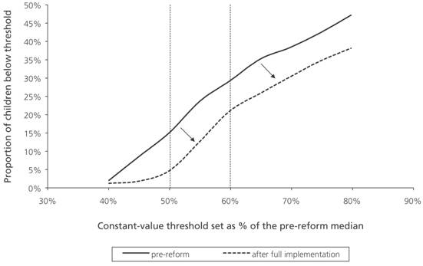

Figure 7: Proportional Reduction in Income Poverty Rate for Children After Full Implementation of the Reforms
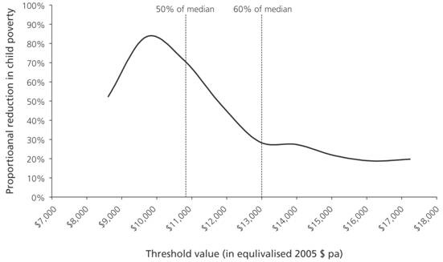

Measured Child Poverty – Impact in the Context of Rates over the Last 15 Years

Figures 8 and 9 set the impact on child poverty in the context of income poverty trends since 1988. Statistics New Zealand’s HES weights were applied to the TAXMOD output to facilitate comparability with the 1988–2001 trends. The time trend analysis supports the main finding that the reforms can be expected to have a very significant effect on measured child poverty, whether using a constant-value or relative-to-contemporary-median approach. On all measures, by 2008, we can expect child poverty measured on an income basis to be lower than at any time in the previous 20 years.

Figure 8: Headcount Poverty Rates for Children: Based on HES and TAXMOD Data Using Constant-Value Thresholds
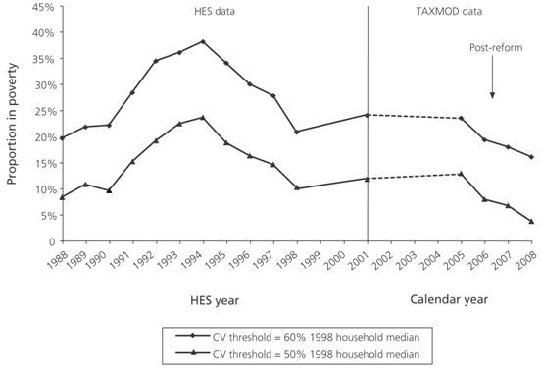

Note: The estimated rates for 2005 and later are from TAXMOD with Statistics New Zealand weights applied to enable more reasonable comparison with the HES-based poverty rates for 2001 and earlier.

Figure 9: Headcount Poverty Rates for Children: Based on HES and TAXMOD Data Using Relative Thresholds

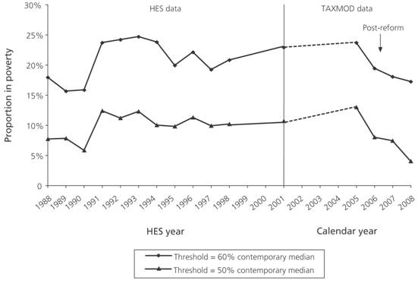

Note: The estimated rates for 2005 and later are from TAXMOD with Statistics New Zealand weights applied to enable more reasonable comparison with the HES-based poverty rates for 2001 and earlier.

International Comparisons of Child Poverty

From time to time, international league tables are produced that rank richer nations by their child poverty rates. The next two tables set the impact of the reforms in an international context using thresholds set at 50% and 60% of the contemporary median.

A widely reported international comparison was published by UNICEF’s Innocenti Research Centre (UNICEF 2000) using a threshold set at 50% of the household-based median and drawing in the main on the Luxembourg Income Study (LIS) database. The LIS methodology gives poverty rates slightly higher than those reported in Figure 8. Table 4 locates New Zealand’s pre-reform and post-reform child poverty rates on a shortened version of the table (left-hand columns) using a methodology that closely approximates the LIS assumptions. This section of the table shows that (if others in the table have no significant changes) the reforms move New Zealand from mid-table to the lower end. The right-hand columns give updates of the figures and confirm the relative change shown for earlier years. All this supports the headline result that the impact on measured child poverty using the lower threshold can be expected to be very significant.

Table 4 Comparison with Recent International Estimates of Child Poverty: 50% household-based threshold, contemporary median

 | UNICEF (2000) |  | Mainly from LIS
 | Year | Rate | Year | Rate
United States | 1997 | 22% | 2000 | 22%
Italy | 1995 | 21% | 2000 | 17%
United Kingdom | 1995 | 20% | 1999 | 15%
Ireland | 1997 | 17% | 2001 | 14%
Canada | 1994 | 16% | 2000 | 15%
New Zealand | 1994–98 | 11–14% | 2001 | 14% | Pre-reform
Australia | 1996–97 | 13% | 1997–98 | 12% | Pre-reform
Spain | 1990 | 12% | not available |  | Pre-reform
Germany | 1994 | 11% | 2000 | 9% | Pre-reform
Hungary | 1994 | 10% | 1999 | 9% | Pre-reform
France | 1994 | 8% | not available |  | Pre-reform
Netherlands | 1994 | 8% | 1999 | 10% | Pre-reform
Denmark | 1992 | 5% | 1997 | 9% | Pre-reform
New Zealand (estimated) | 2008 | 4–5% | 2008 | 4–5% | Post-reform
Belgium | 1992 | 4% | 1997 | 8% | Post-reform
Finland | 1995 | 4% | 2000 | 3% | Post-reform
Norway | 1995 | 4% | 2000 | 3% | Post-reform
Sweden | 1995 | 3% | 2000 | 4% | Post-reform

Sources: (a) The figures in the left-hand columns are drawn from the UNICEF league table of child poverty in rich nations (UNICEF 2000). (b) The figures in the right-hand columns are drawn in the main from the LIS Key Figures database at www.lisproject.org/keyfigures.htm accessed on 25 May 2004. The figure for Ireland was provided by Brian Nolan and uses an equivalence scale that gives slightly lower rates than the LIS approach (i.e., Ireland’s 14% is likely to be 15–16% on an LIS basis). The figure for Australia is from Bradbury (2003), Figure 3.2. (c) New Zealand figures are based on HES data using an analysis that closely approximates the LIS methodology by top and bottom coding as the LIS does, using the square root equivalence scale, and calculating the median weighted by individuals rather than households. (Ballantyne et al. (2004) report 13% for the late 1990s, using the Household Labour Force Survey and a similar methodology.)

International comparison using the 60% household threshold is reported in Table 5. The analysis is based mainly on data from the 2001 wave of the European Community Household Panel (ECHP), supplemented by LIS-based analysis for the United States and Canada. The figures for New Zealand are calculated using a method very close to that used for the ECHP analysis. This results in a slight lowering of the rate to 22% compared to the 24% in Figure 7. The impact of the reforms is not as great at the higher threshold but they still move New Zealand down to below the current European Union average.

Table 5 Comparison with Recent (2000/01) International Estimates of Child Poverty: 60% threshold, contemporary median

United Statesª | 30%
Portugal | 27%
Spain | 26%
Ireland | 26%
Italy | 25%
United Kingdom | 24%
Canadaª | 23%
New Zealand 2001 | 22% | Pre-reform  Post-reform
European Union average | 19% | Pre-reform  Post-reform
Greece | 18% | Pre-reform  Post-reform
France | 18% | Pre-reform  Post-reform
New Zealand 2008 (estimated) | 16% | Pre-reform  Post-reform
Netherlands | 16%
Germany | 14%
Belgium | 13%
Sweden | 10%
Finland | 6%
Denmark^{b} | 5%

a For comparison purposes, the figures for the United States and Canada (from the LIS database) should be reduced by one or two percentage points as the equivalence scale used in the LIS analysis gives child poverty rates around that much higher than the one used in the ECHP-based analysis. The New Zealand figures are based on an analysis of 2001 HES data, which uses the same equivalence scale as the ECHP analysis.

b The rate for Denmark using the 60% threshold based on the ECHP is considerably lower than that for a 50% threshold three years earlier from the LIS. The authors at Department of Work and Pensions and their informants from Denmark are investigating the apparent discrepancy but to date there is no clarification.

Sources: Most of the poverty rates are based on ECHP data as reported in Figure 2 of the Department of Work and Pensions (2004) paper “Measuring Child Poverty”. The rates for the United States and Canada are drawn from the LIS Key Figures database at www.lisproject.org/keyfigures.htm accessed on 1 April 2004.

Some care is needed in interpreting the results in Tables 4 and 5. The comparisons are valid for what they are intended to show but it is tempting to go further and conclude from the tables that the children in the countries that have low income poverty are better off in terms of a common notion of material wellbeing or actual living standards – the things and money-dependent experiences they have or have access to. This conclusion is not warranted from the evidence. It is possible that many of the income-poor children in a very rich economically developed nation could be better off materially than some of the non-poor children in a relatively “poor” developed nation when using an internationally comparable material deprivation index.

The comparisons reported in the tables are in effect only about the relative shapes of the lower part of the income distributions of the respective countries without regard to how they actually rank on a Purchasing Power Parity basis. Nevertheless, these relative shapes are not unimportant and the rates inform us about the proportions of children below a given “dollar distance” from their peers in the “average” household for each country. This is at the heart of a relative notion of poverty as described in the Background section and is a legitimate comparison.

“Eliminating Child Poverty” and Data Noise

The analysis indicates that, after full implementation of the reforms, it is estimated that there will still be some 4–5% of children “in poverty” even when using the lower (50%) threshold. This raises the question as to what it would take to eliminate child poverty using an income measure of poverty. The “obvious” response from a purely analytical perspective would seem to be either to use a lower poverty threshold or to further raise the level of social assistance to families with dependent children at the low end of the distribution. However, the matter is not that simple.

Whether or not a lower threshold is used, raising the level of social assistance would not necessarily lead to a “zero child poverty” result. For a survey-based income measure of poverty, there will always be “noise” at the lower end of the income distribution that would thwart the achievement of the goal.

In broad terms, there are two types of “noise” that are relevant. First, there can be measurement error in the income data. Some respondents may deliberately under-report income for a variety of reasons. Others may under-report accidentally. For example, there may be some sole parents who have ended up without a partner during the HES income year and who had no personal income while partnered. When they report their income, they may therefore give only the part-year DPB (and even Family Support), thus giving the family a low reported annual income.

The second type of noise arises when families and households (accurately) report low incomes that do not reasonably reflect the resources available. For example, some of the children still identified as poor will be in families that report income from self-employment. The reported income may be below the threshold, but may not accurately reflect the financial resources available to the household.

Further work is needed to obtain a more comprehensive understanding of the very bottom end of the income distribution in New Zealand. The implications of the noise issue discussed above need to be recognised and understood especially in the context of a commitment to “eliminate child poverty”, as the presence of the noise will make it look as if the target is never achieved, whatever threshold is used.

Measured Poverty for the Whole Population

For the whole population, the impact of the reforms is not so pronounced but is still significant – around 20% at the higher threshold and 40% at the lower threshold. The impact for the whole population is smaller than that for children, as a much smaller proportion of the whole population is affected by the reforms.

Figure 10 extends the impact analysis in Table 3 and shows the estimated reduction in measured poverty for the whole population across a wide range of thresholds, from 40% to 80% of the household median.

Figure 10: Proportional Reduction in Income Poverty Rate for Whole Population After Full Implementation of the Reforms

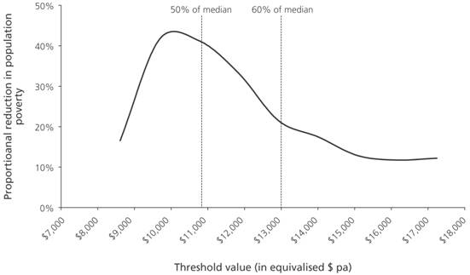
Figure 11 sets the impacts on population poverty in the context of trends since 1988. Poverty rates in 2008 for the whole of the population can be expected to be reduced to levels lower than at any time in the previous 20 years, just as for child poverty rates.

Figure 11: Headcount Poverty Rates for Whole Population: Based on HES and TAXMOD Data Using Constant-Value Thresholds
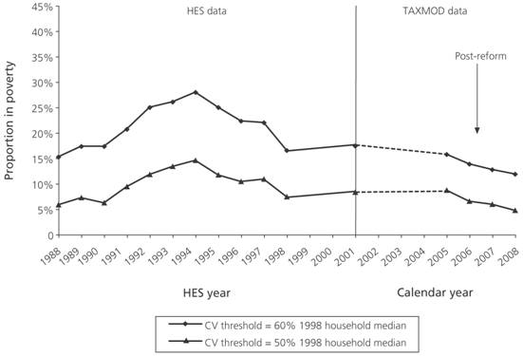

Note: The estimated rates for 2005 and later are from TAXMOD with Statistics New Zealand weights applied to enable more reasonable comparison with the HES-based poverty rates for 2001 and earlier.

Sensitivity Of Estimated Poverty Impact
To Choice Of Income Sharing Unit (ISU)

As noted earlier, estimates of income poverty for individuals typically use the income of the household or of some version of the co-resident “family” as the indicator of the individual’s resources and living standards. This assumes that all members of the income unit share equitably in the resources and experience a similar standard of living. The assumption clearly does not hold in all circumstances but is defensible as an approximation to the very complex reality of intra-ISU and inter-ISU patterns of sharing (cf. Bradbury 2003:25).

In a New Zealand setting, two ISUs (the household and the EFU) are used by the main producers of income poverty reports. The PMP, Statistics New Zealand, Brian Easton and others use a household-based analysis, while the Ministry of Social Development uses an EFU-based analysis for its primary measures. The different approaches give different estimates of poverty levels, especially when using a proportion-of-median threshold. In addition, the extent of the difference between the two approaches is much greater for child poverty estimates than for total population estimates. For example, using a constant-value threshold (1998 base) of 60% of the respective medians, a household-based approach gives a 24% child poverty rate in 2001 whereas an EFU-based approach gives 14%. For the total population, the estimates are closer at 17% and 14% respectively.

The question therefore arises of what effect the choice of ISU has on the estimated impact of the reform package on income poverty, as measured by the proportional reductions in poverty rates. This section briefly outlines why the choice of ISU makes a difference to estimated poverty levels and why the difference is less for the whole population than for children. It then provides a sensitivity analysis regarding the effect of the choice of ISU on the impact results.

Effect of the choice of ISU on the income distribution

Many households contain more than one EFU, so when EFUs are created out of households, there is a net gain in the number of ISUs. The process can be seen in the following examples:

• a household comprising a sole parent and her child living with her parents is split into two EFUs, a sole-parent EFU and a couple-only EFU
• a couple with a 14-year-old son and a 20-year-old daughter who is a full-time student living at home splits into two EFUs, with the daughter considered a single-person EFU in her own right
• a couple without children who have a boarder are split into two EFUs
• a flatting household of three adults (no partners in the household) splits into three single-person EFUs.

Based on the 2001 HES, the 1.4 million households become 1.8 million EFUs.

The greatest change between a household-based and an EFU-based categorisation of ISUs is the 500,000 (1500%) increase in single ISUs, 70% of whom have incomes below the household median. The majority of these are income-poor 18–25 year olds who reside in households with a much higher equivalised income. This disproportionate re-allocation bulks up the distribution more at the lower end and a different distribution with a significantly lower median is produced. The overall effect on the income distribution of moving from a household-based approach to an EFU-based approach is shown in Figure 12 for HES 2001 data. The EFU median is some 16% lower then the household-based median (i.e., the household median is around 19% higher).

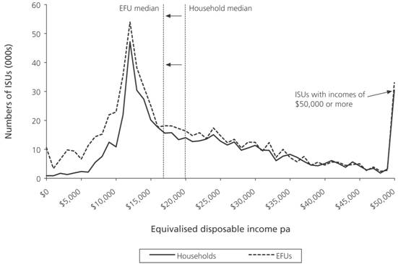
Figure 12 Income Distribution for All Households and EFUs (HES 2001)

The major consequence of interest for this paper is that a given proportion-of-median poverty threshold is quite different in dollar terms for an EFU-based distribution than for one based on households. As a rule of thumb, for HES-based analysis, a 50% of median threshold using a household income distribution is close to a 60% EFU-based threshold, and a 60% household-based threshold is close to a 70% EFU-based one. This is demonstrated in Table 6 for the 2001 HES.

Table 6: Comparison of the Dollar Value of EFU-Based and Household-Based Proportion-of-Median Low-Income Thresholds (HES 2001)

 | Median | 40%  of median | 50%  of median | 60%  of median | 70%  of median
EFU-based | $16,640 | 6,660 | 8,320 | 9,980 | 11,650
Household-based | $19,720 | 7,890 | 9,860 | 11,830 | 13,800
Note: The medians and thresholds are given in equivalised dollars, i.e., dollars per equivalent adult.

In the introduction to this section, it was noted that child poverty rates are much lower on an EFU basis than on a household basis when using a proportion-of-median threshold (14% and 24% respectively, using a 60% threshold). This is what we would expect, given that the EFU threshold is around a sixth (16%) lower in dollar terms.

For poverty rates for the whole population, the situation is different. The poverty rates are closer together at 14% and 17% respectively. This is consistent with the bulking up of the income distribution at the lower end mainly with new single ISUs and especially with income-poor 18–25 year olds. This to some degree counters the effect of the lower median for EFU-based analysis, thus keeping the estimated poverty rates for a given proportion-of-median threshold closer together for the two approaches.

Given the significant differences between the household-based and EFU-based income distributions, the question arises of whether the estimated impact on measured income poverty as reported in the previous section using a household-based income distribution holds for an EFU-based distribution. This question is addressed below.

Sensitivity of Poverty Impact Estimates to the Choice of ISU

A comparison of columns A and C (the 60% of median columns) in each of Tables 7 and 8 shows that both the actual levels of measured income poverty and also the proportional reductions differ greatly depending on whether household or EFUs are used as the basis for establishing the median.

In contrast, columns A and B show that, when using thresholds set at the same dollar value, the proportional reductions in poverty are similar for both ISUs (especially for child poverty), even though the respective reported poverty levels are different.

Table 7 Estimated Poverty Rates Before and After FIA Reform (TAXMOD Weights): Children

Measure | A | B | C
Threshold type (1998 base) | 60% of  EFU median | 50% of household  median | 60% of household  median
Threshold in equivalised  $$ per annum for base 2005 year | $10,746 | $10,751 | $12,901
Estimated rate for April 2005 | 20.1% | 14.7% | 29.0%
After Phase 1 | 11.8% | 9.3% | 24.2%
After full implementation | 4.8% | 4.3% | 20.5%
Reduction in measured poverty after full implementation (proportional decrease) | 76% | 71% | 29%

Table 8 Estimated Poverty Rates Before and After FIA Reform (TAXMOD Weights): Whole Population

Measure | A | B | C
Threshold type (1998 base) | 60% of  EFU median | 50% of household  median | 60% of household  median
Threshold in equivalised  $$ per annum for base 2005 year | $10,746 | $10,751 | $12,901
Estimated rate for April 2005 | 16.5% | 9.3% | 17.8%
After Phase 1 | 13.3% | 7.3% | 15.8%
After full implementation | 10.7% | 5.5% | 13.9%
Reduction in measured poverty after full implementation (proportional decrease) | 35% | 1% | 22%

Figure 13 extends the above analysis across a range of dollar thresholds and shows again that the household-based and EFU-based estimates of the reduction in measured child poverty are very close when using the same dollar threshold.

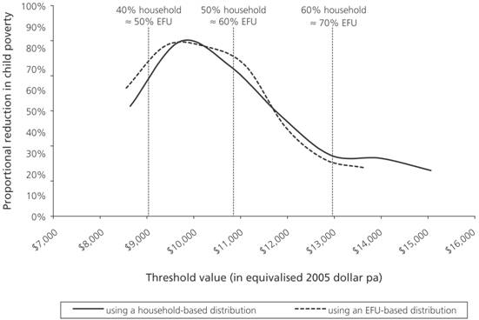
Figure 13 Proportional Reduction in Income Poverty Rate for Children After Full Implementation

For the population as a whole, the household-based and EFU-based analysis is not as close as for child poverty (Figure 14). This is mainly because of the disproportionately high number of extra single ISUs created at the lower end of the income distribution
by the shift to an EFU approach. Nevertheless, the headline story is still clear: at the lower threshold, the reduction is around 35–40% compared with about 15–20% at the higher threshold.

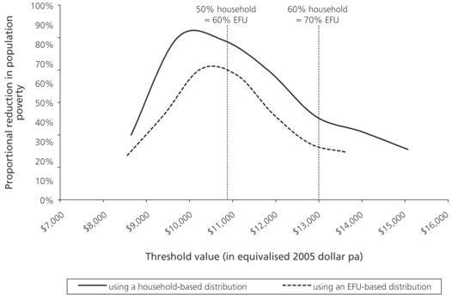
Figure 14 Proportional Reduction in Income Poverty Rate for Whole Population After Full Implementation

SUMMARY

Income support is one of the most effective and practicable policy instruments for poverty alleviation and for achieving improved living standards. Given the significant investment proposed in the WFF reforms, it is reasonable to expect a significant impact on measured income poverty, especially child poverty.

The measurement of income poverty depends on a range of assumptions and technical decisions, most of which are open to debate or difference of view. Different constructions of poverty measures give different estimates of the number of people below the line and of the rates for different subgroups.

There are, however, some commonly used measures and this paper has applied two that have international and New Zealand credentials: 50% and 60% of the median of the equivalised household income distribution. The lower threshold is $10,750 (equivalised) in 2005 dollars. For a family comprising two parents plus one dependent child, this is $20,000 per annum or $385 per week in actual (i.e., non-equivalised) 2005 dollars, and, for a family comprising one adult and two dependent children, it is $18,850 per annum or $360 per week.

The analysis shows that the reduction in measured child poverty after full implementation is likely to be close to 70% using the relatively tight threshold of 50% of the median. This is a very significant reduction by any standard and we could expect a measured poverty rate of around 4–5% on this measure after full implementation.

Using a higher threshold of 60% of the median (as in the United Kingdom, the European Union, and in the New Zealand Poverty Measurement Project), the reduction in measured child poverty after full implementation is estimated to be around 30%. This in itself is significant, albeit not as great as when using a lower threshold. The reforms can therefore be said to be very significantly helping those most in need and, to a lesser though still significant extent, those a little better off.

For the population as a whole, the reduction is also substantial: around 40% at the lower threshold and 20% at the higher one. This is consistent with the focus of the WFF package on families with children. The majority of the population is not directly affected by the reforms so the impact on poverty overall is less than for children.

Sensitivity testing across a range of measures shows that the estimated impact on measured income poverty is not compromised by the adoption of the different assumptions that are likely to be used or advocated in a New Zealand context.

The two main caveats to note are as follows:

• The estimated reductions are estimates only, based on the best modelling we have for the next four to five years of the economy, demographics and benefit numbers. The modelling assumes 100% take-up, which is likely to lead to an overstatement of the impact. On the other hand, the modelling covers only the FIA component of the reforms and does not build in any response to the employment incentives. These factors lead to an understatement of impact. The estimates of the net impact will have to be tested against future survey data. The next HES data collection is scheduled for 2006/07. This will pick up some of the changes but it will not be until the 2007/08 HES that the full impact will be measurable.

• The analysis is based on repeated snapshots of samples of the population for 1988–2001 and uses a static model for 2005–2007. A repeated snapshot approach both overstates and understates the extent of income poverty. It overstates it as some of those classified as “poor” in one year may have moved out of poverty the next. It understates it in that, over a few years, many more experience a spell of poverty than are reported poor at any given time.

Appendix A: Brief Description of TAXMOD

TAXMOD is the New Zealand Treasury’s direct tax and benefit microsimulation model. Its modelling is based on data from Statistics New Zealand’s Household Economic Survey (HES). TAXMOD enables modelling of the interaction between various tax and benefit policies, and allows new policies to be modelled. When projecting the population forward, market incomes are inflated and the appropriate benefit and New Zealand Superannuation rates for the year being modelled are applied.

TAXMOD reads in one economic family unit (EFU) at a time, calculates market income, adds income from government programmes according to eligibility, and calculates tax liability. It can output figures at the individual, EFU and household level and can accumulate some figures for the entire population.

For the purposes of the analysis in this paper, it is important to be aware of some of the features of TAXMOD.

• TAXMOD uses different weights than the HES in order to (among other things) bring the estimated population number of beneficiaries into line with actual numbers. The HES weights lead to an underestimate of beneficiary numbers, though they are appropriate on other criteria such as lining up with Census benchmarks on household type, age, gender and ethnicity breakdown. (Creedy and Tuckwell 2003)

• TAXMOD models only the FIA aspects of the reforms (not Childcare and the Accommodation Supplement). However, the FIA elements make up 90% of the new spending at full implementation so the bulk of the reform impact is modelled.

• TAXMOD does not include the Accommodation Supplement in its modelling mainly because the HES data on which TAXMOD builds greatly underestimate Accommodation Supplement receipt when compared with Ministry of Social Development records of what clients receive.

• TAXMOD is a static model in that it assumes that each individual’s labour supply remains fixed when the tax and benefit system changes.

• TAXMOD computes benefit expenditures on the assumption that all those who are eligible actually claim their full entitlement

• The 2001 HES is the latest available for the TAXMOD modelling, which means that for the 2007/08 modelling the database is seven years old. The risks inherent in this feature have been mitigated as well as possible by using the latest forecasts of population growth, benefit numbers, income growth and so on.

Appendix B: Sensitivity Analysis For Choice Of Weightings Regime

The TAXMOD weights are different from the Statistics New Zealand weights used for HES. The TAXMOD weights are chosen in order to (among other things) bring the estimated population number of beneficiaries into line with actual numbers. The HES weights lead to an underestimate of beneficiary numbers though they are appropriate on other criteria such as lining up with Census benchmarks on household type, age, gender and ethnicity breakdown. Poverty rates are 15–20% lower using HES weights, which is to be expected given the under-weighting of beneficiaries when using the Statistics New Zealand HES weights.

Tables B1 and B2 report the poverty impact assessment using both sets of weights. The analysis shows that the results reported in the main text are not compromised by the choice of weights (see last row in each table).

Table B1 Comparison of Poverty Impact Using TAXMOD and HES Weights: Children

Threshold |  | 50% household median |  | 60% household median
Weighting regime |  | TAXMOD | HES | TAXMOD | HES
Estimate pre-reform rate for  31 March 2005 |  | 14.7% | 12.8% | 29.0% | 23.5%
After Phase 1 |  | 9.3% | 7.8% | 24.2% | 19.3%
After full implementation |  | 4.3% | 3.6% | 20.5% | 16.0%
Reduction in measured poverty after  full implementation (proportional decrease) |  | 71% | 72% | 29% | 32%

Table B2 Comparison of Poverty Impact Using TAXMOD and HES Weights: Whole Population

Threshold |  | 50% household median |  | 60% household median
Weighting regime |  | TAXMOD | HES | TAXMOD | HES
Estimate pre-reform rate for  31 March 2005 |  | 9.3% | 8.6% | 17.8% | 15.7%
After Phase 1 |  | 7.3% | 6.4% | 15.8% | 13.8%
After full implementation |  | 5.5% | 4.6% | 13.9% | 11.8%
Reduction in measured poverty after full implementation (proportional decrease) |  | 41% | 47% | 22% | 25%

References

Ballantyne, S., S. Chapple, D. Maré and J. Timmins (2004) “Triggering movements into and out of child poverty: A comparative study of New Zealand, Britain and West Germany” Social Policy Journal of New Zealand, (23):83–96.
Bradbury, B. (2003) “Child poverty: A review” Report 3/03, Social Policy Research Centre, University of New South Wales.
Bradbury, B., S. Jenkins and J. Micklewright (2001) The Dynamics of Child Poverty in Industrialised Countries, Cambridge University Press, Cambridge.
Bradshaw, J. and N. Finch (2003) “Overlaps in dimensions of poverty” Journal Social Policy, 32(4):513-525.
Brewer, M., T. Clark and A. Goodman (2002) “The Government’s child poverty target: How much progress has been made?” Commentary 88, Institute for Fiscal Studies, London.
Citro, C.F. and R.T. Michael (1995) Measuring Poverty: A New Approach, National Academy Press, Washington, DC.
Creedy, J. and I. Tuckwell (2003) “Reweighting the New Zealand Household Economic Survey for Tax Microsimulation Modelling” New Zealand Treasury Working paper 03/33.
Department for Work and Pensions (2004) Measuring Child Poverty, Department for Work and Pensions, London.
Easton, B. (1995) “Properly assessing income adequacy in New Zealand” New Zealand Economic Papers, 29(1):89-102.
Easton, B. (1996) “Income Distribution” in B. Silverstone, A. Bollard and R. Lattimore (eds.) A Study of Economic Reform: The Case of New Zealand, Elsevier, Amsterdam.
Kangas, O. and V. Ritakallio (1998) “Different methods – different results? Approaches to multidimensional poverty” in H. Andress (ed.) Empirical Poverty Research in a Comparative Perspective, Ashgate, Aldershot.
Krishnan, V., J. Jensen and S. Ballantyne (2002) New Zealand Living Standards 2000, Ministry of Social Development, Wellington.
Ministry of Social Development (2002) Agenda for Children, Ministry of Social Development, Wellington.
Ministry of Social Development (2003) The Social Report, Ministry of Social Development, Wellington.
Nolan, B. and C.T. Whelan (1996) Resources, Deprivation and Poverty, Clarendon Press, Oxford.
Perry, B. (2002) “The mismatch between income measures and direct outcome measures of poverty” Social Policy Journal of New Zealand, (19):101-127.
Perry, B. (forthcoming) “Future Directions: expected impact on measured poverty” Ministry of Social Development Working Paper, Wellington.
Statistics New Zealand (1999) New Zealand Now – Incomes, Statistics New Zealand, Wellington.
Stephens, R., C. Waldegrave and P. Frater (1995) “Measuring poverty in New Zealand” Social Policy Journal of New Zealand, 5:88-112.
Stephens, R. and C. Waldegrave (2001) “The effectiveness of the transfer and tax system in reducing poverty in 1998” Social Policy Journal of New Zealand, 16:77-108.
Sutherland, H., T. Sefton and D. Piachaud (2003) “Poverty in Britain: The impact of government policy since 1997” Joseph Rowntree Foundation, York.
UNICEF (2000) A League Table of Child Poverty in Rich Nations, UNICEF, Florence.
Waldegrave, C., R. Stephens and P. King (2003) “Assessing the progress on poverty reduction” Social Policy Journal of New Zealand, 20:197-223.
Waldegrave, C., S. Stuart and R. Stephens (1996) “Participation in poverty research: drawing on knowledge of low-income householders to monitor social policy impacts” Social Policy Journal of New Zealand, 7:191-206.

Acknowledgements I wish to acknowledge the very helpful comments and suggestions on previous drafts from colleagues in the Ministry of Social Development and from four anonymous referees. Correspondence Email: bryan.perry001@msd.govt.nz
In a speech to the AGM of the Save the Children Fund on 14 June 2002 (the day after the launch of the Agenda), the Minister of Social Services and Employment, Steve Maharey, reiterated the Government’s commitment, noting that ending child poverty “will not be an easy task and we suspect it may take a long time to achieve … [but] it is one of the most critical challenges we face as a society”. He noted that at present New Zealand is about mid-table among western nations as far as child poverty goes, and said that “we need to significantly improve our ranking so that we sit alongside countries such as Norway and Denmark”. Speech downloaded on 3 May 2004 from www.beehive.govt.nz
Details of the package are available at www.msd.govt.nz
In addition to the use TAXMOD makes of the HES, this paper also presents analysis based more directly on HES data. Access to the HES data was provided by Statistics New Zealand under conditions designed to give effect to the confidentiality provisions of the Statistics Act 1975. The results presented in this paper are the work of the author.
Appendix A gives a brief description of TAXMOD and an outline of some of its key features that are relevant to this paper.
A fuller version of this paper will be available as a Working Paper on the Ministry of Social Development’s website at www.msd.govt.nz (Perry forthcoming).
Although income poverty is the focus for this paper, it is recognised that income poverty is only one aspect of disadvantage that needs addressing to improve the wellbeing of children.
“Poverty line”, “poverty threshold” and “low-income threshold” are used interchangeably in this paper.
This latter approach is adopted by the New Zealand Poverty Measurement Project, although with new focus group estimates of necessary expenditure and changes in the median their 60% proportion may change (Stephens, Waldegrave and Frater 1995, Waldegrave, Stuart and Stephens 1996, Waldegrave, Stephens and King 2003).
An income approach generally assumes that each household or family has standard needs once size and composition are adjusted for with equivalence scales and, perhaps, adjustments made for housing costs. Special demands on the budget are not and cannot easily be taken into account. This means, for example, that an income approach rates a family receiving the Invalids Benefit as better off than one of the same size and composition that receives an Unemployment Benefit simply because their income is higher. It does not take the higher-than-normal health-related expenses into account. Similarly, those in receipt of Special Benefit assistance would be rated better off than others with incomes otherwise the same, as their reported total income is higher.
Longitudinal data, which enable investigation of the dynamics of poverty, are needed to give a more complete picture (cf. Bradbury et al. 2001). Ballantyne et al. (2004) use the Income Supplement of New Zealand’s Household Labour Force Survey to examine transitions from one year to the next. Multi-year national data are not yet available in New Zealand, but are being collected by Statistics New Zealand in their Survey of Family, Income and Employment (SoFIE). Wave 2 is currently in the field.
Statistics New Zealand’s definition for the Household Economic Survey (HES) and the Census.
In the United States, official poverty statistics are based on the family unit. Cohabiting couples do not fall within the definition of family unit, so are not recognised as ISUs in official poverty statistics. For official poverty statistics, each partner of a de facto relationship is considered to be an “unattached individual” (Citro and Michael 1995).
EFUs are also known as Core Economic Units (CEUs) or Benefit Assessment Units (BAUs).
The scale used in the table is referenced to a single adult unit, i.e., a (1,0) unit is rated as 1.0. A scale value of 2.17 for a two-adult, two-child household means that it is rated as having 2.17 equivalent adults whereas a one-adult, one-child household is rated at only 1.40 equivalent adults. In other words, this equivalence scale rates a one-adult, one-child household as needing 40% more income than a single-adult household to achieve comparable purchasing power.
The 60% measure is on the European Union’s primary indicator list, with 40%, 50% and 70% measures on the secondary list to throw light on the dispersion around the 60% threshold.
The United Kingdom has adopted a tiered approach using: a constant-value measure based on 60% of the 1998–1999 household median; a relative measure of 60% of the contemporary household median; and a combination measure using both income and material deprivation (Department of Work and Pensions 2004).
There is an inherent arbitrariness in the choice of the 50% and 60% proportions. Why not 40% or 47% or 72%? In a New Zealand setting, the PMP focus groups in 1993 identified a low-income budget that came close to 60% of the median for the household type used. This is accepted by many as an endorsement of 60% or something close to it. It is useful to see how some other external reference levels compare. Using the 2001 HES household median: New Zealand Superannuation in 2001 was at 62%; Brian Easton’s Benefit Datum Line plus Family Support puts two-parent families with dependent children at close to 50%; and the Independent Family Tax Credit plus FIA assistance is just under 50% for a range of two-parent families.
This arises in part because the bulk of the new money goes to families with dependent children who are below the median, and very few out of the whole population are pushed above it (see Figures 2, 3 and 4). Any rise in the median is driven by other factors such as assumed wage rates and so on. In addition, it is the same HES sample that is the basis of the modelling for each year, so there is no variation in the median from sampling variations from survey to survey. See Sutherland et al. (2003) and Brewer et al. (2002) for a discussion of the challenges of using a relative-to-contemporary-median threshold as the poverty measure for assessing progress to poverty-level targets in the United Kingdom.
It is often asserted that “one in three children in New Zealand live in poverty”. Support for this claim comes from three sources: the PMP, which reports 35% for 2001 on a 60% household-based after-housing-costs measure (Waldegrave, Stephens and King 2003); The Social Report, which reports 29% for 2001 using a 60% EFU-based after-housing-costs measure (Ministry of Social Development 2003); and the Ministry of Social Development’s Living Standards research, which reports 29% experiencing “restricted living standards” in 2000 (Krishnan et al. 2002). The 60% before-housing-costs figure in this paper for 2001 and for 2005 pre-reform is 24% (using HES weights). After full implementation, this drops to 16% (Table B1, Appendix B). In other words, a one-in-four rate drops to one in six. Because the modelling did not allow an after-housing-costs measure, it is not clear what will happen to the “one in three” figure beyond saying it will definitely drop significantly over 2005–2007 for the income poverty measures. The rate based on the living standards measure is likely to take longer to reduce.
See Sutherland et al. (2001) for estimates for the United Kingdom in 2003/04 based on microsimulation modelling.
Purchasing Power Parities (PPPs) are currency conversion rates that both convert to a common currency and equalise the purchasing power of different currencies. They show the ratio of prices in national currencies of the same good or service in different countries. A well-known example of a one-product comparison is The Economist’s BigMacCurrency index.
According to 1996 HES data, households in the bottom equivalised income decile on average spent some $12,000 more than their reported income (Statistics New Zealand 1999). This is consistent with findings from other similar surveys worldwide and is due in part to the effect of there being a good number of self-employed in the bottom decile.
The PMP has sought to address the noise issue by excluding from the data set those households declaring self-employment losses or with an expenditure three or more times greater than their income. This reduces the poverty levels reported by a few percentage points (Stephens and Waldegrave 2001).
The same findings hold for the 1998 HES, which is used as the base by the Ministry of Social Development for calculating constant-value thresholds for The Social Report and other income poverty monitoring. The difference between household and EFU distributions is even more pronounced when using TAXMOD output, as the TAXMOD weighting regime is different from that used for HES. For TAXMOD output, the EFU median is around 20% lower than that using a household approach.

