“TRUST ME, I’M FROM THE GOVERNMENT”:
THE COMPLEX RELATIONSHIP BETWEEN TRUST IN GOVERNMENT
AND QUALITY OF GOVERNANCE

Paul Killerby
Senior Policy Analyst, Hamilton City Council
PhD student, University of Otago

Abstract
A comparative analysis of data for a sample of 45 countries illustrates that trust in government does not have a statistically significant correlation with any of a variety of other key policy objectives. The evidence suggests that trust in government is a poor indicator of the level of social trust in each country, its contribution to overall life satisfaction is at best indirect, and it is a poor indicator of quality of governance. Further research is recommended to clarify the value of trust in government and its relationship to other key policy objectives. This paper reinforces Wansbrough’s (2002) advice that trust in government is a complex concept. In particular, it observes that trust in government is a form of fiduciary trust between society and government (i.e. a principal–agent relationship), which is inherently different from mutual trust between people. The evidence illustrates that measured levels of trust in government are not the same as, or even necessarily indicative of, quality of governance.

INTRODUCTION

Trust in government measurably declined throughout the developed world during the second half of the 20th century (Crozier et al. 1975, Pharr and Putnam 2000). According to Wansbrough (2002:2):

Political scientists are concerned that the decline in trust in government may represent a decline in social capital, an impediment to the ability of government to function, or even a fundamental crisis in democracy.

In the words of Ryan (2000):

If governments and the institutions associated with government lose popular legitimacy, the capacity of systems of government to command authority, especially through voluntary compliance, may be under threat.

The restoration of trust in government has recently been elevated to the status of key government objective in several developed nations, including the United Kingdom (Mulgan 2003), Canada (Treasury Board of Canada Secretariat 2002, Zussman 2003) and New Zealand (Department of Prime Minister and Cabinet 2003). According to Annex One of New Zealand’s strategic framework, the Sustainable Development Programme of Action 2003, the New Zealand Government aims to maintain trust in government by:
• working in partnerships with communities
• providing strong social services for all, building safe communities and promoting community development
• keeping faith with the electorate
• working constructively in Parliament
• promoting a strong and effective public service (p.30).

In simple terms, the New Zealand Government aims to promote trust in government by providing good governance. This goal was recently reinforced by a State Services development target that by June 2010 there will be a measurable improvement in New Zealanders’ trust in government agencies (State Services Commission 2005).

This paper explores the hypothesis that trust in government is related to quality of governance and a selection of other key policy goals. Evidence is presented that trust in government is not statistically correlated with other selected goals, using cross-country data from the World Values Survey. The paper concludes with a discussion on the complex relationship between trust in government and quality of governance.

METHODOLOGY

In order to test the relationship between trust in government and a range of key indicators of public value – defined simply as “what the public values” (Mulgan 2003) – the following variables are compiled from cross-country data sets as summarised in Table 1 and described overleaf.

Table 1 Key Indicators
Indicator name | Description
GOVTRUST | Trust in government – index compiled from seven items in the 1995–1997 wave of the World Values Survey
TRUST | Social trust score – percentage of people who report they can generally trust other people (World Values Survey)
LIFESAT | Life satisfaction score – percentage of people who have a high level of reported life satisfaction (World Values Survey)
GOVQUAL | Quality of governance – index compiled from subjective assessments of country-level investment risk, from Kaufmann et al.’s (2004) Worldwide Governance Research Indicators Dataset (1996 data)

Measuring Trust in Government

Trust in government is an abstract concept that underlies a complex array of relationships, including trust in the police, members of parliament, the regulatory environment, legal system, civil servants, government-provided services etc. The method used to quantify trust in government should therefore account for this abstract nature. This paper estimates country-level scores for trust in government using the factor analysis method, thus explicitly assuming that trust in government is a latent variable. Factor analysis is a commonly used method in the fields of sociology and psychology, for example, to measure intelligence quotient (IQ) scores from test results.

Indicators of confidence (trust) in various dimensions of the institutional environment are compiled from results of the 1995-1997 wave of the World Values Survey (Inglehart et al. 2000). Following Knack and Keefer (1997) data are derived for the question: “I am going to name a number of organisations. For each one, could you tell me how much confidence you have in them: is it a great deal of confidence, quite a lot of confidence, not very much confidence or none at all?” Indicators compiled for this paper relate to the percentage of respondents with either a great deal or quite a lot of confidence in the armed forces, the legal system, the police, the government, political parties, parliament and the civil service. Data are compiled from the worldvaluessurvey.org website (see Appendix One for the list of countries covered).

A variable called GOVTRUST is calculated from factor analysis of the seven items above, using the principal component method. This assumes the existence of an underlying latent variable (GOVTRUST), which is imperfectly approximated by each of the indicators of trust in government. In other words, GOVTRUST is an estimate of the level of abstract trust in government for each country in the sample. The variable GOVTRUST has a range from approximately 2.5 to –2.5. The highest values of GOVTRUST are in Bangladesh (2.1), Bosnia-Herzegovina (1.8) and Norway (1.6), while the lowest are in the Dominican Republic (–2.4), Argentina (–1.9) and Peru (–1.8).

FINDINGS REGARDING TRUST IN GOVERNMENT AND SOCIAL TRUST

In parallel with the recent rise of academic and policy interest in trust in government, there has been an increased focus on such concepts as good governance (e.g. Petrie 2002, Kaufmann et al. 2004), governmental social capital (e.g. Knack 1999, Ahn and Hemming 2000), linking social capital (e.g. Woolcock 2001, Harper 2002) and social capital infrastructure (e.g. Warner 2001). This interest arises from a growing consensus amongst World Bank and OECD economists that quality of governance and social capital are each crucial and interrelated for achieving a path towards economic growth and sustainable development (e.g. Collier 1998).

Social capital is defined as “… networks together with shared norms, values and understandings that facilitate co-operation within or among groups" (Cote and Healy 2001:41). Social capital is a latent form of collective action, an intangible stock of norms and networks that defines the limits of cooperation in a society, community or group. Many policy makers view social capital as a fundamental tool for promoting community wellbeing and sustainable development. Considerable research has taken place in the past few years to understand the value of social capital and its implications for policy. It has been studied in the context of a range of issues including public health (e.g. Kawachi et al. 1997), political participation (e.g. DiPasquale and Glaeser 1999) and economic development (e.g. Woolcock 1998). Social capital “theory” underpins the recent upsurge of interest in network governance, social partnerships and common accountability frameworks (e.g. Craig 2004).

Following the tradition of Putnam (1993), this paper assumes that social capital exists in the form of a measurable stock of networks and norms. On this basis, a proxy for social capital is the level of perceived abstract trust (Newton 1997), otherwise known as trust in strangers, generalised trust or social trust. Social trust is linked in the literature with “bridging social capital”, which enables communication and cooperation between disparate groups (e.g. Gittell and Vidal 1998, Woolcock and Narayan 2000, Woolcock 2001). It allows people to move beyond familiar relationships, making cooperation portable and encouraging new forms of civic engagement (Rosenfeld et al. 2001). It is analogous to the “weak ties” described in Granovetter’s (1973) seminal work on social structure. Temple (2000) argues (validly or not) that focusing on measures of social trust is a way of collapsing the various aspects of social capital into one key variable.

A social trust variable (TRUST) is compiled as the percentage of World Values Survey respondents who reply in the affirmative to the question, “Generally speaking, do you feel you can trust people or you can’t be too careful?” This is a standard cross-country proxy for social trust (e.g. Almond and Verba 1963, Knack and Keefer 1997, Zak and Knack 2001) which has been subjected to extensive psychometric testing (e.g. Rosenberg 1957).

The relationship between trust in government (GOVTRUST) and social trust (TRUST) in this sample of countries is illustrated in Figure 1. A positive linear correlation would be signalled by a diagonal line running upward from left to right. However the relationship is more complex. It may be positive but it is certainly not linear. The correlation between TRUST and GOVTRUST is not statistically significant, with a Pearson’s correlation coefficient of just 0.222. This suggests that trust in government is a poor indicator of the level of social trust in a given country.

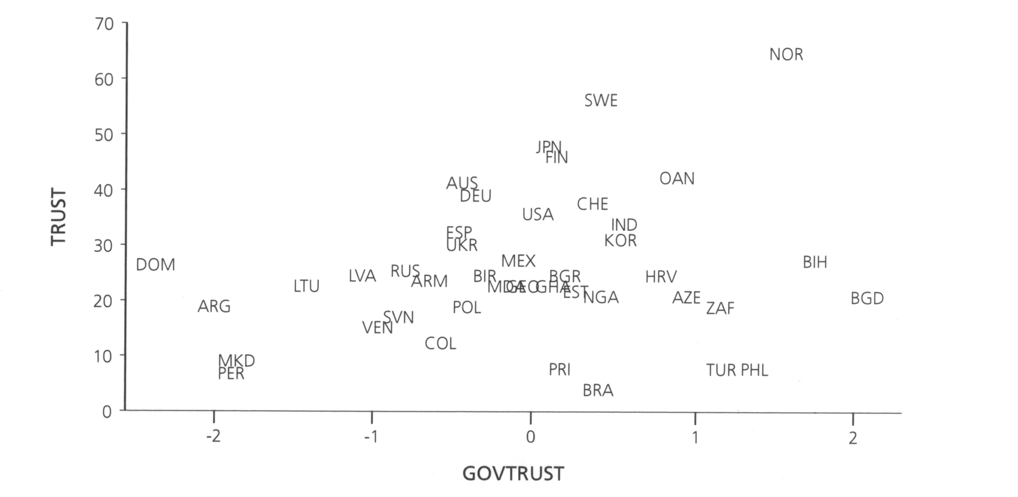
Figure 1 Trust in Government and Social Trust

Refer to the Appendix for a list of the country codes.

Trust in Government and Life Satisfaction

Subjective life satisfaction is increasingly seen as a key variable for assessing the public value of policy goals (e.g. Sumner 1996, Donovan and Halpern 2002, Duffy 2004). Life satisfaction is synonymous with personal utility, human welfare and overall sense of happiness. A measure of subjective life satisfaction (LIFESAT) is compiled from the World Values Survey question, “All things considered, how satisfied are you with your life as a whole these days?” The item is measured on a scale from one (dissatisfied) to 10 (satisfied), with LIFESAT calculated as the percentage of respondents with a score of six or higher.

An absence of association between trust in government (GOVTRUST) and life satisfaction (LIFESAT) for this sample is illustrated in Figure 2. The correlation coefficient between the two variables is not statistically significant, at just 0.093. This suggests that life satisfaction is more strongly influenced by factors other than trust in government.

Figure 2 Trust in Government and Life Satisfaction
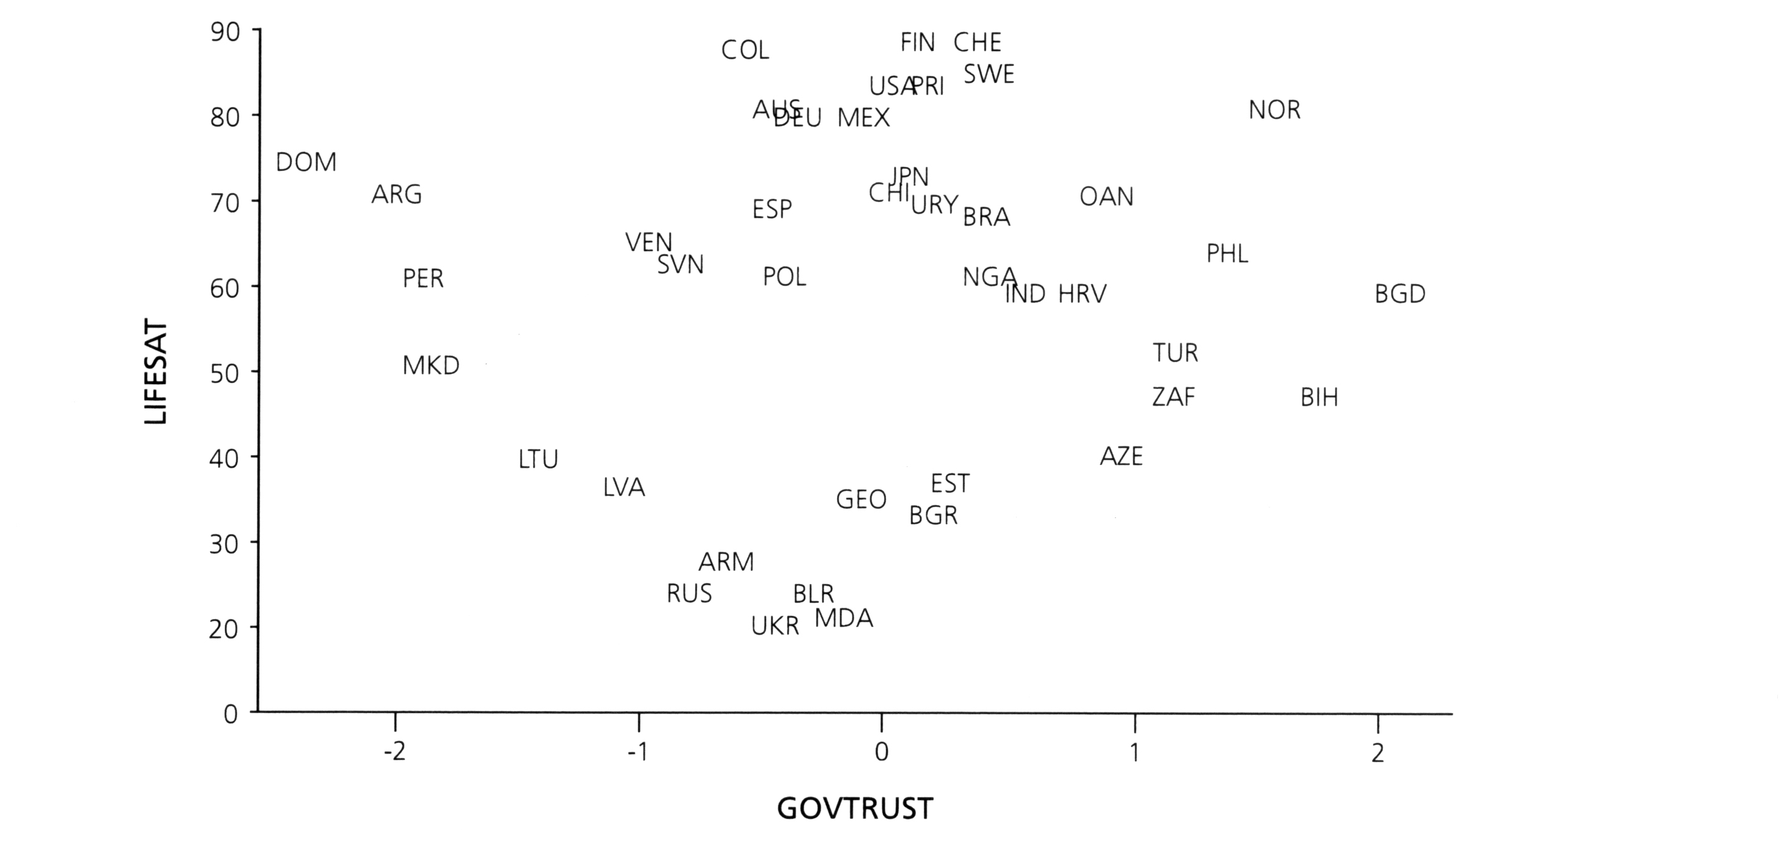
Refer to the Appendix for a list of the country codes.

Trust in Government and Quality of Governance

Finally, data on quality of governance are compiled from Kaufmann et al.’s (2004) Worldwide Governance Research Indicators Dataset via the World Bank website. Kaufmann et al. draw on an extensive range of subjective data sources, particularly international investment risk agencies, to compile six indicators of quality of governance using an unobservable components model. For the purpose of this paper, these are labeled:
• voice and accountability
• political instability and violence
• government effectiveness
• regulatory burden
• rule of law
• corruption.

Kaufmann et al. orient each indicator so that higher values correspond to better governance, and standardise them to have a mean of zero and a range from approximately 2.5 to –2.5. Indicators from 1996 are used in this paper to correspond with the time period for the 1995–1997 wave of the World Values Survey. A variable called GOVQUAL is calculated using factor analysis.

A lack of relationship between trust in government (GOVTRUST) and quality of governance (GOVQUAL) in this sample is illustrated in Figure 3. Again, the key point is that there is no discernible pattern. For example, most OECD countries tend to have only a moderate level of trust in government despite having above-average levels of quality of governance. The highest level of trust in government in this sample is in Bangladesh despite a below-average rating on quality of governance. The correlation coefficient between the two variables GOVQUAL and GOVTRUST is insignificant at 0.111.

Figure 3 Trust in Government and Quality of Governance
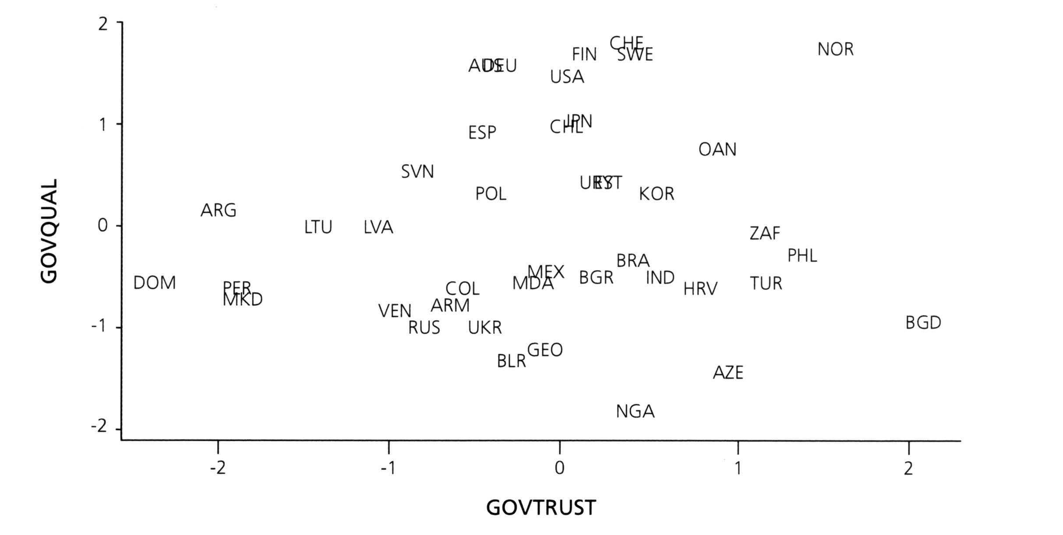
Refer to the Appendix for a list of the country codes.

To further highlight this point, Table 2 shows a breakdown of the correlation coefficients between trust in government and each of Kaufmann et al.’s six governance indicators. The variable GOVTRUST is not significantly associated with any of the indicators, whereas the individual governance indicators – expectedly, and by construction – all have a strong positive correlation with each other.

Table 2 Correlations of GOVTRUST and Individual Governance Indicators
 | GOVTRUST | Voice and accountability | Political stability | Government effectiveness | Regulatory burden | Rule of law | Corruption
GOVTRUST | 1 | –.029 | –.020 | .149 | –.090 | .154 | .200
Voice and accountability |  | 1 | .835** | .922** | .878** | .907** | .903**
Political stability |  |  | 1 | .813** | .705** | .827** | .791**
Government effectiveness |  |  |  | 1 | .902** | .972** | .951**
Regulatory burden |  |  |  |  | 1 | .833** | .866**
Rule of law |  |  |  |  |  | 1 | .965**
Corruption |  |  |  |  |  |  | 1
** Correlation is significant at the 0.01 level (2-tailed).
* Correlation is significant at the 0.05 level (2-tailed).

Table 3 summarises the correlations between trust in government (GOVTRUST), social trust (TRUST), life satisfaction (LIFESAT) and quality of governance (GOVQUAL). Using data from the mid-1990s for a sample of more than 40 countries, there is no significant correlation between trust in government and the other key policy goals.

Table 3 Correlations of GOVTRUST, LIFESAT and Other Variables
 | GOVTRUST | LIFESAT | GOVQUAL | TRUST
GOVTRUST | 1 | .093 | .111 | .222
LIFESAT |  | 1 | .633** | .311*
GOVQUAL |  |  | 1 | .670**
TRUST |  |  |  | 1
** Correlation is significant at the 0.01 level (2-tailed).
* Correlation is significant at the 0.05 level (2-tailed).

DISCUSSION

The evidence above suggests that further research should be undertaken to better understand the relationship between trust in government and quality of governance. Bouckaert and Van de Walle (2003:4) summarise the issue:

Though intuitively appealing, a relation between the quality and performance of public services and trust in government is not so obvious. Of course no one will deny that low quality of public services gives rise to a lot of discontent about these services and perhaps about government as well. But this does not mean that an increase in service quality will lead to a linear and direct increase in the public’s trust in government. Nor can we say that this relation is a clear causal relation.

This highlights the complicated nature of causality. Trust is easier to lose than to build up. Over any given period, trustworthiness and competence of government will not necessarily guarantee trust in government (or vice versa). Trust in government is likely to be influenced by a range of other factors, including socio-political fragmentation, cultural norms, education rates, cognitive competence and public expectations (e.g. Listhaug 1995). The widespread decline of trust in government may simply be a symptom of globalisation and the spread of neo-liberalism. Trust in government may also have a relative dimension, for example, compared to trust in private service providers.

Moreover, trust in government should not be conflated with trust between people. Thomas (1998) classifies trust into three different types:
• mutual trust, which exists in specific relationships (e.g. within family groups, sports clubs)
• social trust, which exists between strangers and underlies the broader social order
• fiduciary trust, in which the trustee undertakes to act in the capacity of the constituent and be accountable to that constituent.

Unlike mutual trust and social trust, the value of fiduciary trust is unequal between the principal and agent. Such is the nature of community–government relations, particularly regarding the regulatory and enforcement functions of government.

According to Hart:

Distrust [in government] is democratic and thoughtful, not an anti-democratic outburst of emotion, and is potentially constructive, threatening only to vested political interests. (1978:xii)

In other words, a certain level of distrust in government may indicate a healthy democracy with an educated and informed constituency.

The pursuit of trust in government appears to stem from a desire by policy makers to promote increased social trust. There is substantial empirical and case study evidence that social trust has public value in the form of improved economic performance, health outcomes, life satisfaction and other benefits to human welfare (e.g. Feldman and Assaf 1999, Donovan and Halpern 2002, Duffy 2004). However, evidence presented in this paper suggests that further research is required to better understand the complex relationship between social trust and trust in government.

CONCLUSION

This paper identifies a need for further research on the desirability of pursuing trust in government as a key government goal. A standard argument of social capital advocates (which may or may not be valid) is that individuals who have little trust in government may be less willing to support public services. In addition, distrust in government may be a barrier to people seeking out or accepting services such as social assistance, health or education, which clearly has negative implications for individuals, families, communities and wider society. In order for government to be effective there must be some basic level of trust or respect in government. However, the results presented in this paper suggest that trust in government may be only indirectly related to other key policy goals, bringing into question its status as a key government objective. This evidence reinforces Wansbrough’s (2002) advice that the factors that influence trust in government are complex, and official responses that oversimplify the concept may actually be alienating. In particular, it emphasises that measured levels of trust in government are not necessarily indicative of quality of governance.

REFERENCES

Ahn, S. and P. Hemming (2000) “Policy influences on economic growth in OECD countries: An evaluation of the evidence” OECD Economics Department Working Paper No. 246, Paris.
Almond, G.A. and S. Verba (1963) The Civic Culture: Political Attitudes and Democracy in Five Nations, Princeton University Press, Princeton, New Jersey.
Bouckaert, G. and S. Van de Walle (2003) “Quality of public service delivery and trust in government” in Ari Salminen (ed.) Governing Networks: AGPE Yearbook, IOS Press, Amsterdam, Netherlands.
Brehm, J. and W. Rahn (1997) “Individual-level evidence for the causes and consequences of social capital” American Journal of Political Science, 41(3):999-1023.
Collier, P. (1998) “Social capital and poverty” World Bank Social Capital Initiative Working Paper No. 4, World Bank, Washington, D.C.
Cote, S. and T. Healy (2001) The Well-Being of Nations: The Role of Human and Social Capital, OECD, Paris, France.
Craig, D. (2004) “Building better contexts for partnership and sustainable local collaboration: A review of core issues, with lessons from the ‘Waitakere Way’” Social Policy Journal of New Zealand, 23:45-64.
Crozier, M., S.P. Huntington and J. Watanuki (1975) The Crisis of Democracy: Report on the Governability of Democracies to the Trilateral Commission, New York University Press, New York.
Department of Prime Minister and Cabinet (2003) “Sustainable development for New Zealand: Programme of action” Department of Prime Minister and Cabinet, Wellington.
DiPasquale, D. and E.L. Glaeser (1999) “Incentives and social capital: Do homeowners make better citizens?” Journal of Urban Economics, 45:354-384.
Donovan, N. and D. Halpern, with R. Sargeant (2002) “Life satisfaction: The state of knowledge and implications for government” discussion paper, Strategy Unit of the Cabinet Office, London.
Duffy, B. (2004) “Life satisfaction and trust in other people” MORI Social Research Institute, London.
Feldman, T.R. and S. Assaf (1999) “Social capital: Conceptual frameworks and empirical evidence – An annotated bibliography” World Bank Social Capital Initiative Working Paper No. 5, World Bank, Washington, D.C.
Gittell, R. and Vidal, A. (1998) Community Organizing: Building Social Capital as a Development Strategy, Sage Publications, Thousand Oaks, California.
Granovetter, M. (1973) “The strength of weak ties” American Journal of Sociology, 78(3):1360-1380.
Hair, J.F. Jr., R.E. Anderson and R.L. Tatham (1987) Multivariate Data Analysis, Macmillan, New York.
Harper, R. (2002) “The measurement of social capital in the United Kingdom” Office for National Statistics, London.
Hart, V. (1978) Distrust and Democracy: Political Distrust in Britain and America, Cambridge University Press, Cambridge.
Inglehart, R. et al. (2000) “World Values Surveys and European Values Surveys, 1981–1984, 1990–1993, and 1995–1997” (Computer File) ICPSR Version, Institute for Social Research (producer), Inter-university Consortium for Political and Social Research (distributor), Ann Arbor, Michigan.
James, H.S. (2002) “The trust paradox: A survey of economic inquiries into the nature of trust and trustworthiness” Journal of Economic Behavior and Organization, 47:291-307.
Kaufmann, D., A. Kraay and M. Mastruzzi (2004) “Governance matters III: Governance indicators for 1996, 1998, 2000, and 2002” World Bank Economic Review, 18(2):253-287.
Kawachi, I., B. Kennedy and K. Lochner (1997) “Long live community: Social capital as public health” The American Prospect, 35:56-59.
Knack, S. (1999) “Social capital, growth and poverty: A survey of cross-country evidence” World Bank Social Capital Initiative Working Paper No. 7, World Bank, Washington, D.C.
Knack, S. and P. Keefer (1997) “Does social capital have an economic payoff? A cross-country investigation” Quarterly Journal of Economics, 112:1252-1288.
Listhaug, O. (1995) “The dynamics of trust in politicians” in H.-D. Klingemann and D. Fuchs (eds.) Citizens and the State: A Relationship Transformed, Oxford University Press, New York.
Manly, B.F.J. (1994) Multivariate Statistical Methods (2nd ed.), Chapman and Hall, London.
Molm, L.D., N. Takahashi and G. Peterson (2000) “Risk and trust in social exchange: An experimental test of a classical proposition” American Journal of Sociology, 105(5):1396-1427.
Mulgan, G. (2003) “Evidence and strategy: UK lessons”, paper presented at Social Policy, Research and Evaluation Conference, 29-30 April, Wellington.
Newton, K. (1997) “Social capital and democracy” American Behavioral Scientist, 40(5):575-587.
Petrie, M. (2002) “Institutions, social norms and well-being” Working Paper 02/12, Treasury, Wellington.
Pharr, S.J. and R.D. Putnam (2000) Disaffected Democracies: What’s Troubling the Trilateral Countries? Princeton University Press, Princeton, New Jersey.
Putnam, R.D., with R. Leonardi and R.Y. Nanetti (1993) Making Democracy Work: Civic Traditions in Modern Italy, Princeton University Press, Princeton, New Jersey.
Robinson, J.P., P.R. Shaver and L.S. Wrightsman (1991) Measures of Personality and Social Psychological Attitudes, Academic Press, San Diego, California.
Rosenberg, M. (1957) Occupations and Values, Free Press, Glencoe, Illinois.
Rosenfeld, R., S.F. Messner and E.P. Baumer (2001) “Social capital and homicide” Social Forces, 80(1):283-309.
Ryan, N. (2000) “Public confidence in the public sector”, Discussion Paper, Office of the Auditor General of Western Australia, West Perth, Australia.
Smith, T.W. (1979) “Happiness: Time trends, seasonal variations, intersurvey differences and other mysteries” Social Psychology Quarterly, 42:18-30.
State Services Commission (2005) “Development goals for the state services” State Services Commission, Wellington.
Sumner, L.W. (1996) Welfare, Happiness and Ethics, Oxford University Press, Oxford.
Temple, J. (2000) “Growth effects of education and social capital in the OECD” paper presented at the HRDC-OECD International Symposium on the Contribution of Human and Social Capital to Sustained Economic Growth and Wellbeing, 19-21 March, Quebec, Canada.
Thomas, C. (1998) “Maintaining and restoring public trust in government agencies and their employees” Administration and Society, 30(2):166-193.
Treasury Board of Canada Secretariat (2002) “Results for Canadians: A management framework for the Government of Canada” Treasury Board of Canada Secretariat, Ottawa, Canada.
Wansbrough, D. (2002) “Waiter, there’s a government in my soup! Public trust and confidence in food regulators” Australian National University, Canberra, Australia.
Wansbrough, D. (2004) “Trust me, I’m from the government!” presentation to the Institute of Public Administration New Zealand, Wellington.
Warner, M. (2001) “Building social capital: The role of local government” Journal of Socio-Economics, 30:187-192.
Woolcock, M. (1998) “Social capital and economic development: Toward a theoretical synthesis and policy framework” Theory and Society, 27:151-208.
Woolcock, M. (2001) “The place of social capital in understanding social and economic outcomes” ISUMA Canadian Journal of Policy Research, 2(1):11-17.
Woolcock, M. and D. Narayan (2000) “Social capital: Implications for development theory, research, and policy” The World Bank Research Observer, 15(2):225-249.
Zak, P.J. and S. Knack (2001) “Trust and growth” The Economic Journal, 111:295-321.
Zussman, D. (2003) “Evidence-based policy making: Some observations based on recent Canadian experience” Social Policy Journal of New Zealand, 20:64-71.
APPENDIX: COUNTRY COVERAGE

Country Codes and Country/Year Identifiers of World Values Survey Sample

NATWAVE Country CODE NATWAVE Country CODE
223 Argentina ARG 613 Moldova MDA
633 Armenia ARM 293 Nigeria NGA
173 Australia AUS 183 Norway NOR
643 Azerbaijan AZE 383 Pakistan PAK
693 Bangladesh BGD 513 Peru PER
313 Belarus BLR 583 Philippines PHL
933 Bosnia-Herzegovina BIH 253 Poland POL
283 Brazil BRA 273 Puerto Rico PRI
363 Bulgaria BGR 503 Russia RUS
303 Chile CHL 153 South Africa ZAF
733 Colombia COL 243 Korea, South KOR
843 Croatia HRV 353 Slovenia SVN
683 Dominican Republic DOM 083 Spain ESP
483 Estonia EST 193 Sweden SWE
233 Finland FIN 263 Switzerland CHE
623 Georgia GEO 403 Taiwan OAN
563 Ghana GHA 443 Turkey TUR
323 India IND 493 Ukraine UKR
133 Japan JPN 543 Uruguay URY
473 Latvia LVA 113 United States USA
463 Lithuania LTU 533 Venezuela VEN
833 Macedonia MKD 033 Germany DEU
143 Mexico MEX
Note: NATWAVE is the country/year identifier in the World Values Survey data set.

Acknowledgements The views expressed in this paper are those of the author and do no necessarily reflect the views of any organisation with which the author is affiliated. Their intention is to stimulate wider debate. The title of this paper was inspired by a December 2004 presentation by David Wansbrough to the Institute of Public Administration New Zealand. Feedback was received on earlier drafts from Stephen Knowles, Barbara MacLennan, Dorion Owen, Gavin Thomas, David Wansbrough and two anonymous referees. Correspondence Email address: paulkillerby@gmail.com
The topic of Paul Kilerby's PhD research is Social capital, economic performance and human welfare".
Correlation is an important prerequisite to the establishment of a casual relationship. There is a possibility that partial correlations between trust in government and other variables of interest could be significant if control variables were taken into account, but the consistency of non-significant pair-wise correlations suggests this is unlikely.
Data and results are available from the author. All raw data are feely available at www/worldvaluessurvey.org and www.worldbank.org/wbi/governance/govdata/
A latent variable is the quantitative equivalent of an abstract concept. The relationship between an observed variable and its "true" or latent counterpart is: observed = true + measurement error. In matrix notation, X = aS + e, where X is a vector of observable indicators, S is a matrix of factor constructs corresponding to the underlying latent variables, a is a vector of the measurement errors. The equation is estimated by calculating the eigenvalues of the covariance matrix of X. Refer to Hair et al. (1987) or Manly (1994) for further information on calculating factor scores.
Cote and Healy's (2001) is the "official" United Kingdom and OECD definition of social capital.
Molm et al. (2000) and James (2002) explore the economic meaning of trust and trustworthiness using prisoners' dilemmas and other experiments.
Responses of "not sure" or "it depends" are treated as a negative response. An alternative treatment by Brehm and Rahn (1997) is to code these as 0.5 of a positive response. Another approach would be to exclude these responses from both the numerator and the denominator (i.e. treat them as invalid responses).
Pearson's correlation coefficient is a measure of linear association. It has a maximum value of 1 (perfect positive association) and a minimum of -1 (perfect negative association). A value close to zero, as in this case, indicates there is no significant statistical association for this sample.
Evidence from the field of social psychology cautions that minor variations in the wording of subjective wellbeing items can have systematic effects on responses (Smith 1979, cited in Robinson et al. 1991:70). However, in its favour, LIFESAT is one of the most standard cross-country measures of subjective wellbeing currently in use.
For a review of key determinants of life satisfaction refer to Donovan and Halpern (2002).
A correlation matrix shows the strength of pair-wise correlations (refer to footnote 9) between the distributions of variables listed in the rows and columns. The diagonal down from left to right is all ones, showing that the correlation of each variable with itself is a perfect match. (The missing information below the diagonal is a reflection of information in the top right).
Similar results are obtained from initial analysis of data from the 1999-2001 wave of the World Values Survey, covering a larger sample of countries. An exception is that the correlation between trust in government and social trust becomes significant, though only at the 0.05 level (with a value of 0.269). Data and results are available from the author.
Related to this, survey results of self-reported trust in government are likely to be higher in underdeveloped countries as a result of greater acquiescence by survey respondents (refer to Robinson et al. 1991:47 for a discussion of acquiescence bias).

