WHAT INFLUENCES RETIREMENT DECISIONS?

Judith Davey
Senior Research Associate
Institute of Policy Studies
Victoria University of Wellington

Abstract
Workforce ageing is likely to lead to labour and skills shortages. Many governments are seeking to increase workforce participation by older workers and to discourage early retirement. Thus factors that influence retirement decisions are important in both personal and policy terms. Information on a range of factors, including health and financial circumstances, is reviewed in this paper, with particular reference to New Zealand sources, especially the Health, Work and Retirement Study. The findings of the qualitative interviews that were part of this study illustrate how the influences interact, and highlight the importance of life-course factors, both personal and contextual, which underlie decisions about workforce participation in mid- and later life.

THE CONTEXT – WORKFORCE AGEING

New Zealand’s workforce is ageing. Its median age is projected to reach 42 in 2012 (Statistics New Zealand 2006:8). Projections indicate that labour-force growth will slow down due to population ageing and declining birth rates, and it is expected to become negative by the 2020s as large numbers of baby boomers exit the workforce, leading to labour and skills shortages (Stephenson and Scobie 2002). In a paper for the Employment of Older Workers Summit in September 2006, Judy McGregor, Human Rights Commissioner, highlighted the increase in employment rates required to maintain the labour force, even without an allowance for growth (Table 1) (McGregor 2006). By 2026, she suggests, New Zealand will need an extra 95,000 people in employment.

Table 1 Older Workers: Required Increases in Workforce Participation

Age group | % currently in work | % needed in work by 2026
55–59 | 78 | 85
60–64 | 60 | 71
65+ | 12 | 16

POLICY RESPONSES

As they face the challenges of population ageing, governments in many developed countries are considering how to increase labour-force participation by older workers and discourage early retirement (OECD 2006). Their concerns are expressed in policy documents such as the National Strategy for an Ageing Australia, which argues that workforce participation in later life will be necessary to sustain economic growth (Andrews 2001). In the UK, Opportunity Age: Meeting the Challenges of Ageing in the 21st Century also emphasises the economic benefits of workforce participation in later life (HM Government 2005). Positive ageing policies in New Zealand seek to support “productive lives in the economy and society” (Dalziel 2001:11) and the New Zealand Positive Ageing Strategy further states that “The choice to work later in life is important in meeting the challenge of positive ageing” (Dalziel 2001:10).

There is a widespread belief that initiatives to enhance workforce participation by older workers will have advantages for the workers themselves, their employers and society as a whole. If older workers contribute less than their full economic potential due to unemployment, underemployment or premature retirement, then this will have a negative effect on economic growth. They will be contributing less as taxpayers and may be dependent on welfare benefits. At the personal level, they will be less able to set themselves up financially through saving for their old age, and they may lack the sense of social inclusion and contribution that can be derived from high-quality work.

WORK-ENDING

In an article entitled “Second adolescence? The transition from paid employment”, Schuller (1987) discussed the increasingly complex transition between work and retirement. He argued that just as there is no longer a simple transition from education to work, there is now another heterogeneous and ambiguous stage at the end of working life. He called this “work-ending” and emphasised the need for more research on this neglected life stage. How do individuals, as they move through their 50s and 60s, make choices about labour-force participation? What incentives and disincentives operate, and how are attitudes surrounding retirement changing? How do family circumstances and caring responsibilities impinge on working lives, productivity, career aspirations, incomes and ability to plan for retirement? Little work has been done on these questions in New Zealand, yet the answers are crucial as our population ages.

WHAT INFLUENCES RETIREMENT DECISIONS?

A range of personal and contextual factors are cited in the international literature in reply to this question, including:
- health status
- financial circumstances
- attachment to and conditions at work
- work–life balance
- caring and unpaid work responsibilities
- policy context
- labour market demand (Haider and Loughran 2001, Williamson and McNamara 2001, Hirsch 2003).

New Zealand evidence is available from a limited range of sources. These include the findings of the Health, Work and Retirement (HWR) study and the EEO Trust’s Work and Age survey. The HWR postal questionnaire asked all respondents (working, retired or partially retired) to indicate how important various reasons for retirement were, or could be, for them. The differences between these three groups are minor (Figure 1). The results show that the most important influences according to the proportion of respondents considering them very or moderately important, are personal or “pull” factors, such as health and wanting to do other things.

The gender differences in responses are greater than those between the retired and non-retired groups (Figure 2). Women are more likely than men to give importance to the health of family members and whether their partner is about to retire. Women are more likely to consider that not being able to find work would be an influence, as well as employers’ policy on older workers. Apart from this there are no significant differences in the ranking of influences by gender.

Figure 1 Influences on the Retirement Decision – Percentage of Respondents Indicating Very or Moderately Important, by Retirement Status
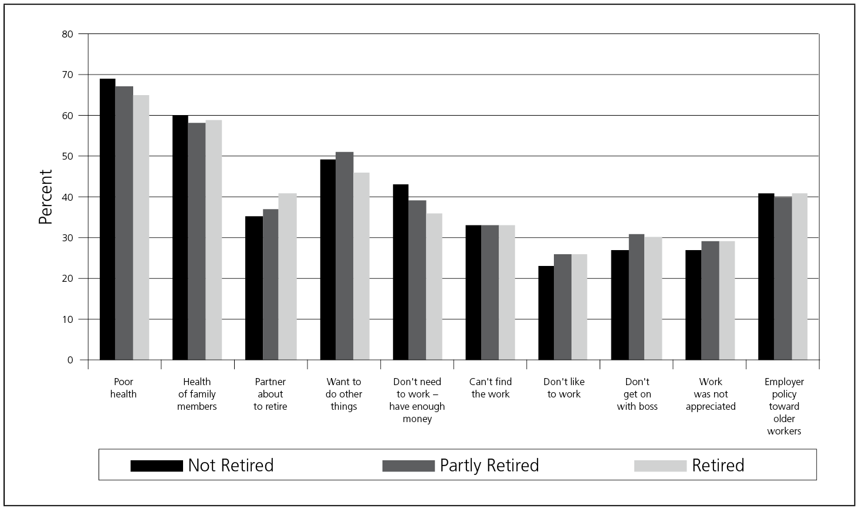
Source: HWR database

Figure 2 Influences on the Retirement Decision – Percentage of Respondents Indicating Very or Moderately Important, by Gender
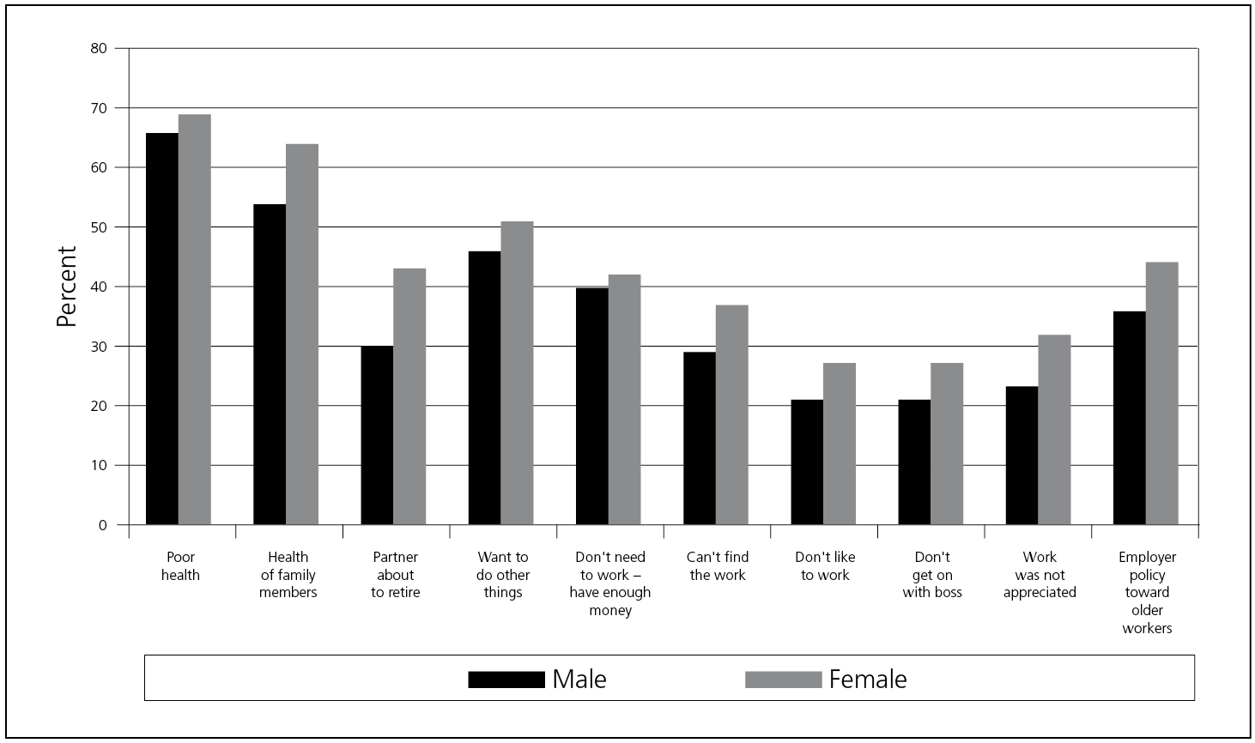
Source: HWR database

The following sections look at each of the influences listed above individually, drawing on international and New Zealand evidence.

Health Status

New Zealanders are enjoying better health status in old age and growing life expectancy. Even so, health status is an important influence on the retirement decision and was ranked first in the HWR study by both the retired and non-retired groups. One viewpoint on health came from McGregor and Gray’s (2003) interviews with industrial workers. A quarter of the sample indicated that they would work past age 65 provided their health allowed them to continue in physical labour. Many indicated that they were “conserving their physical wellbeing” to continue in employment, that they would be able to recognise when they began to “drag the chain” and would then make the appropriate decision to exit the workforce.

The importance of health factors also emerged from the EEO Trust Survey. Of those still working, 75% mentioned health as a factor that would influence their retirement decision, with a higher percentage of women than men. Health ranked second after finances for people still working, but was the dominant factor for people who had already retired.

Financial Situation

Whether an individual has an economic necessity to work depends on alternative sources of income, such as pensions or superannuation, and also on their income requirements. The availability of New Zealand Superannuation (NZS) as a non-contributory universal payment provides greater certainty about retirement income than is the case in many countries. It provides a high replacement income for low-income earners and beneficiaries and a moderate replacement income for average-wage earners (Periodic Report Group 2003).

Even so, a high proportion of EEO Trust respondents who were still working mentioned financial considerations as a major factor affecting retirement decisions. “Don’t need to work – have enough money” ranked fourth among influences on the retirement decision in the HWR study, again being more important for those still working than those retired. People who have a more advantaged financial position clearly have greater choices about whether to work and when to retire. For others, decisions about workforce participation are strongly motivated by the need for an income. In their segmentation of older workers, McNair et al. (2004) labelled this group “survivors”. They have little control over their working lives, often have job changes forced on them, and may leave work through sickness and redundancy but not from choice.

Donald Hirsch (2003) brought together the findings of several studies on retirement decisions and concluded that financial considerations are important but often not the driving factors. They are a constraint on whether or not people can afford to leave the labour market at a time when they would like to do so for reasons unrelated to money. McGregor and Gray (2003) also found that financial security, while important, is not the only determinant in the retirement decision: 30% of their sample indicated that winning the Lotto would not stop them from continuing to work.

Attachment to Work and Conditions of Work

Job-related influences ranked lower in the HWR study than external or personal factors (Figure 1). “Employer’s policy towards older workers” was cited as an important influence on retirement decisions by 41% of respondents, ranking fifth. Not being appreciated and not getting on with the boss were considered important by between a quarter and a half of respondents, but not liking the work was ranked last by all groups. This suggests there is scope for improvement in relationships between older workers and their employers and a need to know more about employers’ attitudes to these groups.

Research in the UK has also highlighted work-related factors in retirement decisions. Smeaton and McKay (2005) showed that feeling valued by employers and colleagues, having a sense of control, “agency” and autonomy, and a positive social environment in the workplace are positive factors (see also Hirsch 2003). People in jobs that entail a personal sense of purpose or concern about professional reputation may remain longer in paid work. Another of McNair et al.’s (2004) categories of older workers were labelled “choosers”. These are well-qualified people in professional and managerial jobs who have significant control over their job situations and describe their workforce choices in terms of challenge and opportunity. If work is interesting they are likely to stay (sometimes into their 70s), but they have the option and the resources to retire (or often to continue on a flexible basis).

Work–Life Balance

Pull factors may attract workers into retirement, such as having a partner who is retired, wanting to spend more time with family, travelling or pursuing hobbies. These factors may apply especially to high-income employees who can afford to retire. “Want to do other things”, which ranked third as an influence on retirement decisions offered in the HWR study, encapsulates some of these aspirations.

Women often leave the workforce early, following the retirement of their older male partners. “Partner about to retire” was ranked higher by retired HWR respondents than those still in work (Figure 1) and more highly for women than for men (Figure 2). US studies have also highlighted differences based on gender and partnership status. Pienta and Hayward (2002) saw retirement decisions as family-based, reinforced by earnings history and pension provision, and found that husbands have a stronger influence on their wives’ retirement expectations than vice versa. Smith and Moen (2004) believe that retirement transition adjustment and satisfaction are qualitatively different for men and women, based on gender ideology acquired over a life course. In analysing retirement decisions, the experiences of both partners need to be examined, and with increased female labour-force participation baby-boomer couples will have two retirements to make decisions about.

Caring Responsibilities

Workers in mid-life may have responsibilities to older parents/relatives, ranging from social contact to very intensive personal care (Davey and Keeling 2004, Phillips et al. 2002). An increasing proportion care for their grandchildren, often allowing the parents to be in paid work and sometimes taking over full parental responsibility (Worrall 2005). In the UK, McNair et al. (2004) identified a group of older workers labelled the “jugglers”, almost all of them women, who are balancing domestic and caring roles with paid work and are most likely to be working part-time in intermediate occupations.

In the New Zealand EEO study, “caring responsibilities” ranked third among factors affecting the decision when to retire for current workers (but well behind health and finances), but second for people already retired (after health). This influence on retirement was not listed among the choices specified in the HWR questionnaire.

Labour Market Demand

Not being able to find any work was listed as an influence on retirement in the HWR questionnaire. A third of respondents considered it very or moderately important, but it ranked only seventh among the influences suggested. Although age discrimination persists, despite human rights legislation and illustrated in the EEO study, the demographic imperatives cited earlier suggest that demand for the labour of older workers will increase as populations age. This was clearly demonstrated in the OECD report Live Longer, Work Longer (2006). The challenge is to tackle the barriers to prolonged participation, which may include employers’ attitudes towards older workers.

Policy Influences

The abolition of compulsory retirement under the Human Rights Act 1993 and changes in NZS provided policy-based incentives for workforce participation. Hurnard (2005) examined the effect of the latter on the labour-force participation of older people, suggesting that the rapid shift in eligibility from age 60 to 65 in the 1990s encouraged people to keep working. In New Zealand, retirement before the age of NZS eligibility is financially unattractive without a private source of income (Hurnard 2005:8). On the other hand, NZS conditions do not penalise people who choose to work. The New Zealand policy environment allows greater timing choice and flexibility in the transition to retirement than is the case in many other OECD countries.

INFORMATION FROM QUALITATIVE INTERVIEWS

More detailed qualitative information about influences on retirement decisions is available from the HWR follow-up interviews. An examination of the factors related to workforce choices and how retirement is approached and conceptualised by the interviewees confirms the importance of several of the factors discussed above, including health and financial considerations. However, this analysis also highlights influences that are harder to capture in a quantitative approach. These include the interaction of influences, and the importance of life-course experiences and their cumulative effects. The interview data, which incorporate a life-course approach, also show how factors such as gender, access to education and employment, and family situation influence retirement decisions.

Health

Analysis of the interviews confirms the importance of health as an influence in the past, present and future workforce participation decisions of the respondents. Poor health clearly limits participation and contributes to withdrawal from work. Plans for continuation of paid work are often expressed in terms of health status – “if my health keeps up” or “depending on my health”. Health can therefore be seen as a qualifier to retirement aspirations. It is a factor that is difficult to foresee and to plan for, but is pervasive in people’s thinking.

It is necessary, however, to unbundle health factors, distinguishing long-term and short-term issues, mental and physical health, and also injury. Workforce participation for some interviewees was limited by health problems, especially mental ill health and disability, throughout their lives.

Dennis, a Māori man aged 66, had had a number of manual and semi-skilled jobs and had run his own business. Up until age 40 his health was quite good. Then he had open-heart surgery. He said he couldn’t do anything “too exerting” but had been good until the last few years. He has had several stents inserted and has angina and some rheumatism. He retired on a sickness benefit at age 63 on instructions from his GP. He did not do anything to prepare for retirement but just “stopped working”.

The long-term effects of injuries influenced some interviewees’ workforce decisions.

In her thirties, Jean had a fall and severely damaged her ankle, which meant several operations. She was on ACC for a couple of years. When she was 55 the injury was still causing problems and she tried to get her job reduced to part-time. Her employer refused so she decided that she was unable to continue and applied for ACC. She considers she is now (at age 57) semi-retired, but continues to do some part-time work.

In other cases, health problems – typically heart disease, strokes and arthritis – developed later in life and could precipitate early retirement.

Edward suffered a massive heart attack and stroke at the age of 51 and this meant a radical life change. He returned to work part-time but the year following the first attack he had another and had to have major surgery. Even working part-time it was increasingly apparent that he had suffered neurological damage. He was eventually medically retired in his mid-fifties.

Some conditions affect mainly one sex – arthritis, osteoporosis and hysterectomies for women; prostate and heart problems for men. For manual workers, “bad backs” can produce health problems. For professionals and manual workers alike, stress related to work is another health hazard.

Charles worked as a science manager, but during the 1990s he felt constantly run down with headaches. He attributed it to the stress of management at a time of restructuring and redundancy. “This was the worst period in terms of health in my whole life.” It also coincided with issues outside work (a second marriage and becoming a step-parent). He gave up some of his management role and formally retired at age 63.

In addition to their direct impact on the ability to undertake paid work, health problems – especially those causing extensive periods off work – can produce financial difficulties. These may have long-term impacts on the ability to accumulate assets and provide a sound financial basis for retirement.

Financial Situation

Financial considerations clearly affect retirement plans for interviewees still in the workforce. Some have ongoing commitments, such as putting children through university or ongoing debt. Some were working towards financial targets that would allow them to retire.

Walter is currently a full-time sales manager. He and his wife are working hard in preparation for retirement and consciously engaging in financial planning. They have a 3 to 5 year horizon. Realistically, Walter expects to retire at 62, depending on financial circumstances. “I would retire tomorrow if I had the money.”

Lifelong experiences, in terms of health, stability of employment and access to occupational superannuation schemes, contribute to financial security in mid-life and hence to attitudes towards retirement. Some interviewees expressed worries about money because of their experiences.

Phyllis is 61, works full-time as a health advisor and expects to retire at 68. She would prefer to work part-time but does not think this is an option, mainly for financial reasons, and it would also be difficult to negotiate with her employer. Her husband died six years ago and she is undertaking extensive maintenance work on her home. She feels anxious about her income in retirement.

Others suffered financial setbacks which hamper their retirement aspirations.

In the late 1990s, Maria and her husband sold their house to buy a shop. This did not prosper and they lost their capital. They both were unemployed, but then found full-time factory work. Maria would prefer to work part-time, in order to have time for other things and then retire at 65. However, whether she can achieve this depends on how much they can save, if work continues to be available, and her husband’s health.

Where people have had more stable employment histories and the opportunity for asset accumulation, they can often look forward to good pensions from occupational superannuation and/or additional income from investments and property. Many interviewees, as is typical for their age group, are mortgage-free home owners, and for others a strong aspiration is to pay off their mortgages before retirement. Home ownership, however, is not necessarily a one-off achievement. The interview data included several examples of how people may lose home ownership through divorce, death of a husband, business failure or other setbacks.

Although self-employment is often aspired to, the acquisition of a business does not always lead to financial success. Flourishing enterprises constitute financial assets that can be mobilised in retirement, but where life savings were invested in unsuccessful businesses this can affect plans for later life.

Influence of Life Course Factors and Gender

Respondents to the HWR survey represent a cohort of people aged 55–70 in 2006. Most were born and raised in New Zealand and have similar experiences. As children and young adults they lived through the prosperous 1950s and 1960s. Families were larger than at present and well-supported by social policies in the areas of housing, health and education. Early marriage and child-bearing was the norm.

Labour market conditions have clearly been an important external influence on the lives of the respondents. During the 1950s and 1960s unemployment was almost non-existent. Jobs were easy to find and to shift between. The labour market and wage-setting were highly regulated. At a later stage the HWR cohort were adults of working age during the economic restructuring of the late 1980s and 1990s, which in many cases, along with adverse economic conditions, affected their employment prospects. Many of the men, in particular, were subject to redundancy and unemployment.

When the older members of the HWR cohort left school (usually at 15 or 16), jobs were plentiful and there was little emphasis on the acquisition of formal educational qualifications. Training was largely apprenticeship-based, especially for young men, and commonly in-house or on the job. Skills shortages encouraged employer-supported education and training. For young women, there was even less emphasis on educational achievement. Marriage was almost universal and was expected to be life-long, and therefore “protected” women financially. Wages were based on a male wage-earner model intended to support a wife and children.

University education was comparatively rare at this time, especially for women. In several cases tertiary education and training (including nursing and teacher training) were cut short by marriage (which may have been precipitated by pregnancy), although some women completed qualifications or undertook other courses later. Tertiary training was often combined with work, through evening and part-time study.

For the HWR respondents now in their 60s and thinking about retirement, there were two main trajectories on leaving school: (a) movement directly into the labour force, probably with on-the-job training, and (b) continuation on to tertiary education or a full apprenticeship. These tended to produce different employment histories. Those who completed a tertiary qualification early in their career frequently went on to have a fairly stable and consistent career – a pattern especially typical of men. For example:

Following his initial training, Thomas moved through a variety of teaching jobs to become a senior teaching college lecturer. He then moved into administrative positions in the Department of Education. He retired at 59 and has continued to do contract work which he will keep up for a while. He is now 63.

Those who left school without qualifications tended to have more fragmented work histories.

Hemi left school at 16 and worked on the family farm before a period in the army. Although he had no further formal education or training, he learned about communications and accounts in the army and had a variety of clerical jobs. He was later made redundant and took up work first with a hospital and then with a voluntary agency. He left work at age 63, because of his health and lived on a transitional benefit until he became eligible for NZS (he is now 68).

Later changes in employment history may relate to external factors (especially redundancy), or to mental and physical health issues, as shown earlier. Redundancy might lead to a move into related work, into a complete change of career, or out of the workforce altogether. For Robert, involuntary work exit led to premature retirement.

“I wouldn’t have retired at that time but for restructuring … I didn’t have an option … it was forced action. It was good at the time because I got a lot of money but as it is running out now I wouldn’t mind another job. I retired too early.”

Gender is clearly an influence on employment aspirations and opportunities. For women interviewees, marriage and child-bearing frequently interrupted their careers. The experience of taking time out from paid work for child-rearing was almost universal. There were very few examples of being able to maintain a career through this period of life. In contrast, men’s careers were unlikely to have been constrained by caring commitments.

Later changes in work situation could relate to marital events – separation, divorce and widowhood, which tended to be more influential in the lives of the women than the men. The employment history of Sandra is fairly typical.

Sandra came from a farming family and always wanted to be a nurse. But she never practised as she married at 21 and soon had three children, which she cared for full-time. Later jobs “just came her way” without her seeking them. These were just for pocket money as her husband was earning well. Sandra gave up work at age 59, partly to do with health and also because she enjoys home life.

The health of family members, especially spouses, influenced workforce and retirement decisions especially for women. The pull of caring duties was felt by some women in relation to spouses, elderly parents and adult children with special needs.

Interaction of Influences

The factors influencing workforce decisions and retirement rarely act in isolation, and the stories of the interviewees illustrate complex interactions. Ill health might precipitate early retirement, which was also desired because of dissatisfaction with work. The latter could provide the push which, linked with the desire to spend time with family, especially grandchildren, led to retirement. Many people described ambivalent feelings and trade-offs in their lives. Although they welcome the opportunity for more leisure, some interviewees are considering part-time work after they leave their career jobs. Having a little extra to improve living standards is weighed against the freedom that retirement brings, even if they have to manage on less money.

At the age of 49 Douglas left a senior hospital job because it was stressful, with numerous changes of management. He had been seeking a better balance for several years, realising that “life is precious”. He and his wife bought a rural property, but he feels he still needs an income and has picked up a variety of part-time work − “but I only work to get money”. He could decide not to work and they could still manage. When he reaches NZS age he will be much more selective about what he does.

Overarching the contending factors of work and leisure are provisos related to health and financial circumstances, as outlined above. Ultimately these are two limiting factors that either facilitate or act as barriers to the achievement of preferred workforce status.

CONCLUSION

The HWR interview material shows that few people see retirement as a discrete event – as a “cliff edge” movement from full-time work to total workforce exit. For some, leaving a long-term career job did (or will) not preclude continuing, or aspiring to continue, in part-time or contract work. For others, voluntary work may provide a substitute which could be equally time-consuming and sometimes equally, if not more, rewarding.

Retirement is therefore a fluid and somewhat ill-defined concept, as indeed is “work” itself. Many people experience retirement as a period of transition, as Schuller suggested (1987). The preference for phased retirement was clear among people who are still in the workforce, but is not always achievable. Where flexible hours are not possible, many people opt for full retirement, especially when they are subject to the pull factors of home and family.

The choices people make about workforce participation and retirement in mid-life are significant to the individuals concerned in terms of their wellbeing in later life, but they also have wider implications. Material presented earlier shows that the New Zealand workforce is ageing along with the global population as a whole, and labour shortages will emerge as the baby boom cohort enter their 60s. As a result, individual decisions have policy implications in terms of labour supply and also economic contribution, in a context where public sector support is required for a growing dependent elderly group. It is likely that policies will seek to influence decisions about retirement and prolong workforce participation. The findings reported in this paper show that the success of such policies may depend on a clear understanding of the influences on individual decisions, on how these influences interact, and on the life-course factors, both personal and contextual, that underlie them.

REFERENCES

Alpass, F., C. Stephens, J. Davey, E. Fitzgerald, B. Stevenson, H. Pennington and A. Towers (2006) “Independence, wellbeing and social participation in an ageing population” presentation at the 3rd International Conference on Healthy Ageing and Longevity, Melbourne, 13–15 October 2006.
Andrews, K. (2001) National Strategy for an Ageing Australia: An Older Australia, Challenges and Opportunities for All, Commonwealth of Australia, Canberra.
Dalziel, L. (2001) The New Zealand Positive Ageing Strategy, Senior Citizens Unit, Ministry of Social Policy, Wellington.
Davey, J.A. (2007) Health, Work and Retirement (HWR) Project – Qualitative Interviews 2006 – Summary of Findings, Massey University, Palmerston North, http://hwr.massey.ac.nz/publications.htm.
Davey, J.A. and S. Keeling (2004) Combining Work and Eldercare: A Case Study of Employees in Two City Councils Who Provide Informal Care for Older People, Department of Labour, Wellington, www.dol.govt.nz/PDFs/Eldercare.pdf [accessed 27/6/2005].
Equal Employment Opportunities Trust (2006) EEO Trust Work and Age Survey Report, EEO Trust, Auckland, www.eeotrust.org.nz [accessed 18/1/07].
Haider, S. and D. Loughran (2001) Elderly Labour Supply: Work or Play? Center for Retirement Research at Boston College, Boston.
Hirsch, D. (2003) Crossroads After 50: Improving Choices in Work and Retirement, Joseph Rowntree Foundation, York.
HM Government (2005) Opportunity Age: Meeting the Challenges of Ageing in the 21st Century, HM Government, London.
Hurnard, R. (2005) The Effect of New Zealand Superannuation Eligibility Age on the Labour Force Participation of Older People, New Zealand Treasury Working Paper 05/09, The Treasury, Wellington.
McGregor, J. (2006) “Age will work: Presenting the case for older workers in the New Zealand workforce”, introductory paper for the Employment of Older Workers Summit, 4 September 2006, Wellington.
McGregor, J. and L. Gray (2003) Older Worker Employment Transition, Massey University, Palmerston North.
McNair, S., M. Flynn, L. Owen, C. Humphreys and S. Woodfield (2004) Changing Work in Later Life: A Study of Job Transitions, Centre for Research into the Older Workforce, University of Surrey, Guildford.
OECD (2006) Live Longer, Work Longer, OECD, Paris.
Periodic Report Group (2003) Retirement Income Report, Periodic Report Group, Wellington, www.treasury.govt.nz/prg/report/prg-report.pdf [accessed 27/6/05].
Phillips, J., M. Bernard and M. Chittenden (2002) Juggling Work and Care: The Experiences of Working Carers of Older Adults, Policy Press, Bristol.
Pienta, A.M. and M.D. Hayward (2002) “Who expects to continue working after age 62? The retirement plans of couples” Journals of Gerontology, 57B(4): S199–S208.
Schuller, T. (1987) “Second adolescence? The transition from paid employment” Work, Employment and Society, 1(3): 352–370.
Smeaton, D. and S. McKay (2005) Working Past State Pension Age: Quantitative Analysis, Department for Work and Pensions, London, www.dwp.gov.uk/asd/asd5/rport182/Inside.pdf [accessed 27/ 06/05].
Smith, D.B. and P. Moen (2004) “Retirement satisfaction for retirees and heir spouses: Do gender and the retirement decision-making process matter? Journal of Family Issues, 25(2): 262–285.
Statistics New Zealand (2006) Demographic Aspects of New Zealand’s Ageing Population, Statistics New Zealand, Wellington, www.stats.govt.nz/NR/rdonlyres/DFB087B8-8425-466F-A1C2-ACE92D12C4ED/0/NZsAgeingPopulation.pdf [accessed 18/1/07].
Stephenson, J. and G.M. Scobie (2002) The Economics of Population Ageing, The Treasury, Wellington.
Williamson, J.B. and T.K. McNamara (2001) Why Some Workers Remain in the Labor Force beyond the Typical Age of Retirement, Center for Retirement Research, Boston University, Boston.
Worrall, J. (2005) Grandparents and Other Relatives Raising Kin Children in Aotearoa/New Zealand, Grandparents Raising Grandchildren Charitable Trust, Auckland, www.raisinggrandchildren.org.nz/supporting/Research%20Report%20final.pdf [accessed 24/11/05].

Correspondence Dr Judith Davey, Senior Research Associate, Institute of Policy Studies, Victoria University of Wellington, PO Box 600, Wellington, New Zealand. Email: Judith.Davey@vuw.ac.nz.
This research, funded by the Health Research Council, incorporates a large-scale postal survey of a nationally representative sample of people aged from 55 to 70, with follow-up qualitative interviews (Alpass et al. 2006).
The EEO Trust Survey was administered online in March/April 2006 (Equal Employment Opportunities Trust 2006). There were 6,484 submissions to the online survey, mostly from people aged 45–64. Two-thirds of them were women and only 7% were already retired.
Medium-level projections for 2051 suggest that average male life expectancy at birth will be 83.5 years and female life expectancy 87 years, giving around 20 years past the retirement “threshold” age of 65 (Statistics New Zealand 2006:36).
This shows the extent to which NZS replaces the income people received before retirement, in percentage terms (Periodic Report Group 2003: 22). The higher the replacement rate, the greater the incentive to leave the labour force.
Research examining employers’ attitudes to older workers is currently under way in the Institute of Policy Studies, Victoria University of Wellington, in collaboration with the New Zealand Institute of Management.
The HWR postal survey asked if respondents were willing to be interviewed face to face in a qualitative follow-up. From respondents willing to be interviewed, a sub-sample of 60 was selected, located, for reasons of easy access, in the southern part of the North Island, in the region from Palmerston North south to Wellington and including the Wairarapa. The interviewees comprised 28 men and 32 women, with an average age of 62.
Pseudonyms have been used for the interviewees to protect their confidentiality. A fuller account of the interview data can be found on the HWR web site http://hwr.massey.ac.nz/publications.htm (Davey 2007).

