EQUIVOCATING OVER THE CARE AND PROTECTION CONTINUUM: AN EXPLORATION OF FAMILIES NOT MEETING THE THRESHOLD FOR STATUTORY INTERVENTION

Kathleen Manion
Jane Renwick
Centre for Social Research and Evaluation
Ministry of Social Development

Abstract
Child, Youth and Family (CYF) undertook a study of nearly a thousand case files to provide an informed perspective on why high numbers of cases that progressed to an investigation were closed after completion of that investigation with no further statutory intervention. One of the objectives of the survey was to examine social workers’ case notes in detail to learn what was occurring in these cases and determine whether it was possible to make any efficiencies. The study was designed to permit a content analysis of the case notes in a stratified sample of 2003/04 CYF clients who had the outcome “case closed post-investigation”. The researchers identified assessment outcomes for case closures. The data illustrated that a considerable number of families notified to CYF were of sufficient concern to warrant an investigation, but did not meet the threshold for statutory intervention. The data also provided evidence that the families in these cases were often experiencing various risks and stressors, and that while many of these families appear to be receiving a mixture of ad hoc and formal support services, many families and children have multiple engagements with CYF. The findings suggest that an optimal response requires the continued development and coordination of a range of services and agencies for referrals at the non-statutory end of the service continuum.

Overview

With several decades of increased recognition of child maltreatment and amplified societal recognition of the needs of children and young people (see, for instance, Helfner et al. 1968, Pfohl 1977), it is not surprising that communities and professionals are finding concerning issues to report. Demand for child protection services in New Zealand has grown (Mansell 2006), yet there has been no corresponding expansion of community-based services. Therefore by default, Child Youth and Family (CYF) has become the organisation presented with this need. Meanwhile, much like child protection agencies in other jurisdictions facing this increased demand (such as Canada), CYF continues to grapple with a negative public perception and budget constraints (Leschied et al. 2003). The organisation sometimes struggles to adhere to social work principles of reflective practice due to the pressures of public criticism. Although evidence-based practice is the cornerstone of policy and practice, it is sometimes with trepidation that a close examination of casework is undertaken for fear of how critics may use what is found (Adam et al. 2004).

In this climate, CYF has tried to increase efficiency and effectiveness to better respond to demand and streamline its processes. The CYF care and protection process has four main phases of engagement: intake, investigation, intervention and placement. Generally, more than three-quarters of intakes are referred on to investigation, but only one-quarter of investigations go on to statutory intervention (Cabinet Expenditure and Administration Committee Review of the care and protection system [EXG Min (06) 5/6 refers]). External agencies have seen this as inefficiency in the system, and CYF produced the report Responses to Demand (CYF 2006a) in part as a reply to this criticism. For the purposes of that report, this study was undertaken to examine the case notes about a population of children that had proceeded from intake to investigation in which the cases were closed post-investigation. The overall aim of the research was to gather more information about the “case-closed post-investigation” population and to develop a greater understanding of the nature of demand at the intake and investigation phase of the CYF process. The analysis of case note data included identifying and categorising the presenting and emerging issues for children, young people and their families. An additional goal of the research was to record and count the primary reasons for CYF disengagement with the child and their family after an investigation outcome. In the lexicon of CYF, this disengagement is known as No Further Action (NFA) (see Figure 1).

Figure 1 No Futher Action (NFA) Flow Diagram
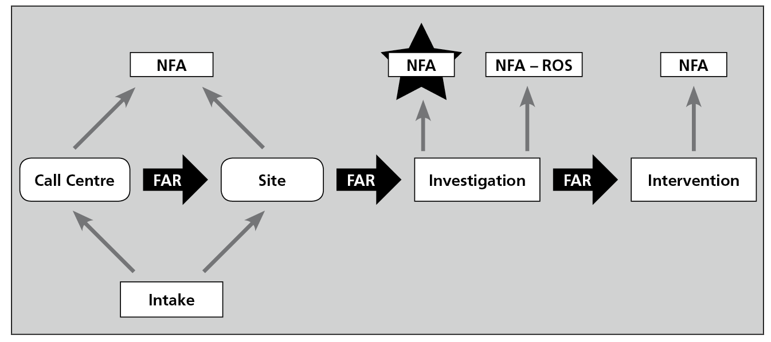
Notes: NFA-ROS = No further action – referred to other service ; FAR = Further action required.

The case note study found that cases closed post-investigation did not represent a waste of effort, in that the majority of cases contained sufficient concern of child maltreatment to warrant an investigation. Social workers were tasked with assessing serious potential harm and identifying cases requiring further statutory intervention, while working with families and other services to provide support and solutions for families to reduce the likelihood of a more intrusive intervention. The researchers found very few examples of cases that had questionable cause for investigation. Furthermore, the closures of cases could be attributed to valid reasons, including situations where families had resolved issues themselves. The data also indicated that in many cases where social workers were working with families, their support and advice had provided the tools for change to take place. Family hui (meetings) and informal family/whānau agreements, referrals to services (particularly parenting and anger management courses) and placements (particularly whānau placements) were prevalent in the records for the children and their families.

This study illustrated that although the investigation of these cases had found it unnecessary to invoke a formal, recorded, statutory intervention, a large portion of the cases needed some form of service to assist the family with the stressors and risks that could otherwise compromise the wellbeing of their children and youth. These risks and stressors were evident from the statistical data in the CYRAS database, which indicated that 30% of the children and youth in the NFA cases had a formally substantiated finding of maltreatment. The data that emerged from this study of case notes suggested nearly double that proportion of children and youth experienced harm, neglect and behaviour/relationship difficulties.

By coding the issues presented in the CYRAS case notes, researchers were able to build a body of evidence to indicate the population of children and young people in the NFA cases who experienced a range of risks, including domestic violence, caregivers’ mental health issues, socioeconomic hardship, caregivers’ problems coping with difficult behaviour, and substance misuse. Researchers were able to identify other issues for children and youth, including truancy, mental health issues and disabilities.

The research showed a prevalence of children who presented with multiple issues of suspected neglect, emotional abuse and behaviour/relationship difficulties, many of which were identified in the case notes. The care and protection concerns surrounding these difficulties are acknowledged in other research as being hard to formally substantiate and treat (Drake and Jonson-Reid 2007). Children at the centre of these cases are likely to present several times to a child protection agency before a circumstance warranting further intervention is identified. The obstacles to identifying need in these cases can lead to repeated presentations to care and protection agencies. The research into these issues indicates that children who suffer neglect and emotional abuse are particularly vulnerable to flying beneath the radar of formal intervention by child protection agencies. Because these forms of maltreatment tend to be difficult for child welfare agents to identify and substantiate, children in these circumstances may spend extended periods of their developmental years unnoticed yet exposed to an extremely detrimental environment, which provides poor life experiences and cumulatively leads to poor life outcomes (HMSO 1995, DFPS 2001, CWIG 2006).

Issues of emotional abuse and neglect seemed particularly prevalent in this population. We concluded that the approach of attending to the needs of children, young people and families who present to CYF’s front door would require a strategy that provides as wide a platform as possible for the delivery of various types of child and family services to achieve the best outcomes for those concerned.

Already contributing to that platform are the CYF and community-based initiatives of collaborative working and differential response models, designed to actuate safe and effective referrals to appropriate agencies. In addition, there are Ministry of Social Development initiatives aimed at improving service co-ordination and service reach, and the Children’s Commissioner’s “Ten Year Vision” aims to ensure, via assessments at key transitions, that families are supported within their communities to help children thrive in physical, emotional, cognitive and social development (Kiro 2006). However, until such capacity is built and working relationships are functioning, the statutory agency remains the de facto organisation for dealing with broad areas of need among the families and children referred.

Methodology

The project undertook to research a sample of cases from July 2003 to June 2004 that proceeded to an investigation phase in the CYF system and were subsequently closed. The approach of the study was to conduct a content analysis of all case notes recorded within the intake and investigation phases of the sample population. The year of the sample was chosen to allow sufficient time to lapse up to the 2006 research to determine whether the child and family had subsequently returned to CYF.

A stratified random sample of 988 cases was selected from the 19,713 individual cases that were closed post-investigation over the period of the 2003/04 financial year. The aim of stratifying the population was to get samples of sufficient size in each of the “criticality statuses” CYF assigns to its cases. The criticality status dictates how rapidly social workers are expected to attend to the case. There are four statuses of response: critical, very urgent, urgent, and low urgent. The sampling frame provided a population sufficient to obtain a 90% confidence interval and a 5% standard error for each of the four criticalities. Figure 2 illustrates the stratification of the sample population across the four criticalities for the purposes of this research, and contrasts this with the proportion of the four criticalities in the population of interest for the 2003/04 year.

Figure 2 Criticality status of notifications
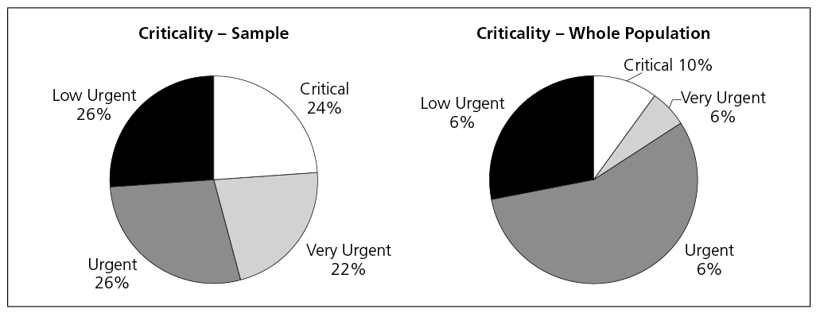

Content analysis was done on the client’s records and assessments associated with the intake and investigation period. Based on discussion and previous CYF research (Wells 2002), the researchers selected a range of factors to include in the content analysis of records and assessments for the sample of cases. These factors can be described as components of risk to the care, safety and protection of the child or youth. The researchers did not attempt to identify and capture protective factors considered likely to mitigate concerns.

The content analysis schedule was developed by several people, including those with social work backgrounds. To achieve a level of confidence about the inter-coder reliability across the analysis of the case notes, a subset of 50 cases were coded at a pilot phase by the researchers. The test demonstrated a high degree of inter-reliability across the coding of case note data.

Three layers of child maltreatment concerns were coded: suspected issues (largely those issues the child presented with, which alerted the social worker to progress the case to an investigation), issues found in case notes, and issues formally recorded in the structured fields of the CYRAS database. Content analysis also covered case note information on the responses to allegations of maltreatment and the involvement of other services. The characteristics of the children and families were also analysed.

Limitations

Clearly CYF’s intake and investigation work is complex and dynamic. The case notes study was not a quality assurance exercise and, while a range of social work practices was found, it was not the aim of this research to assess whether those practices were effective. The researchers acknowledge the limitations of a study that is based on an analysis of social workers’ case notes. The study was subject to a degree of variability in the quality of the data recorded across cases. A range of factors created variability, including site culture and recording practices, staff turnover, the social worker’s experience, differing intensity of note-taking, and variable lengths of the investigations.

Influence of Time Frames

During the time frame examined, several environmental factors affected CYF’s ability to maintain a consistent profile of diligence and quality in its activities. The nature of CYF’s work ensures it is inevitably under continual public scrutiny, but during 2003/04 it faced increased levels of negative press (CYF 2004). In September 2003 a UNICEF publication ranked New Zealand as one of the worst OECD countries for responding to child deaths (UNICEF 2003). At the same time, the death of six-year-old Coral Burrows prompted an inquiry into CYF’s lack of involvement with her family. That report and the reports of four other high-profile child deaths were released during 2003/04 (Mansell 2006). Demand for CYF services escalated and notifications increased by over 30% in 2003/04, which was the beginning of a continuing upward trend. During the course of the year, CYF’s record of allocating cases was criticised. Although several targets and initiatives were implemented, the unallocated case queue continued to be long and the media accused CYF of reducing waiting lists by inappropriately closing cases.

Further upheaval came in October 2003 with recommendations from the Baseline Review (CYF 2003) for significant organisational reform. Newly established outcome measures aimed to reduce staff turnover, increase recruitment, improve staff qualifications and improve compliance with the use of the Risk Estimation System (RES). New senior management structure and governance frameworks were also introduced. Despite increased caseloads, budget pressures, changing work environments and weakening morale, by the end of 2003/04 CYF sites managed to improve efficiency and set the path for later improvements.

analysis of formally structured cyf data

Demographics

The quantitative data taken from the formally structured CYRAS fields was largely demographic (see Figure 3). The sample had slightly more female than male children, and nearly equal numbers of Māori and Pākehā, who made up more than three-quarters of the sample. Māori and Pākehā clients were more likely to have multiple episodes of CYF involvement than other ethnicities.

The Northern region had the highest number of cases overall, followed by the Central and Southern regions. The variables of region, gender and ethnicity did not appear to have a significant correlation with subsequent findings, with just a few statistically significant exceptions. Girls seemed more likely to have findings of sexual abuse and self-harm/suicide (85% or 11 of 13), consistent with international literature (Ministry of Health 2006, Finkelhor 1990, Hopper 1997). Pākehā clients were over-represented in cases with findings of behaviour/relationship difficulties (49%) and custody issues (66%), and Māori clients were over-represented in cases with findings of educational neglect (56% or five of nine), domestic violence (46%) and caregiver’s substance abuse (48%). Pasifika clients were over-represented in cases with findings of neglect (20%).

Figure3 Demographic Profile of Study Sample
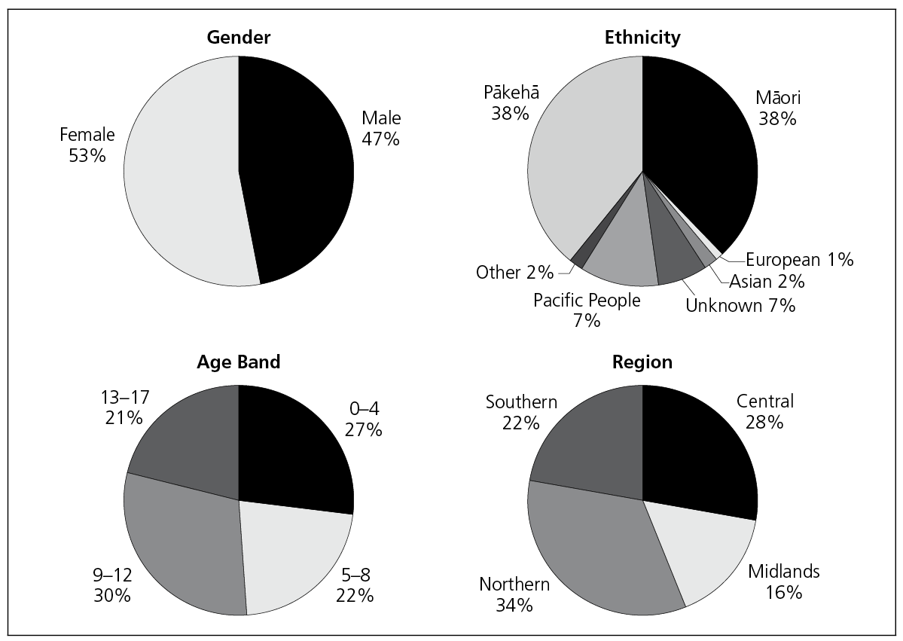

The age of the client appeared to correspond with some significant differences of findings (discussed in more detail later). Curiously, young boys and older girls appeared to be over-represented in the investigation phase. The differences in age of the client were apparent when the data were analysed by the four criticality statuses (critical, veryurgent, urgent and low urgent) (see Figure 4). The data indicated 13–17-year-olds were most likely to have critical status, 9–12-year-olds and 0–4-year-olds were most likely to have very urgent status and 5–8-year-olds were most likely to have urgent status.

Figure 4 Age by Criticality
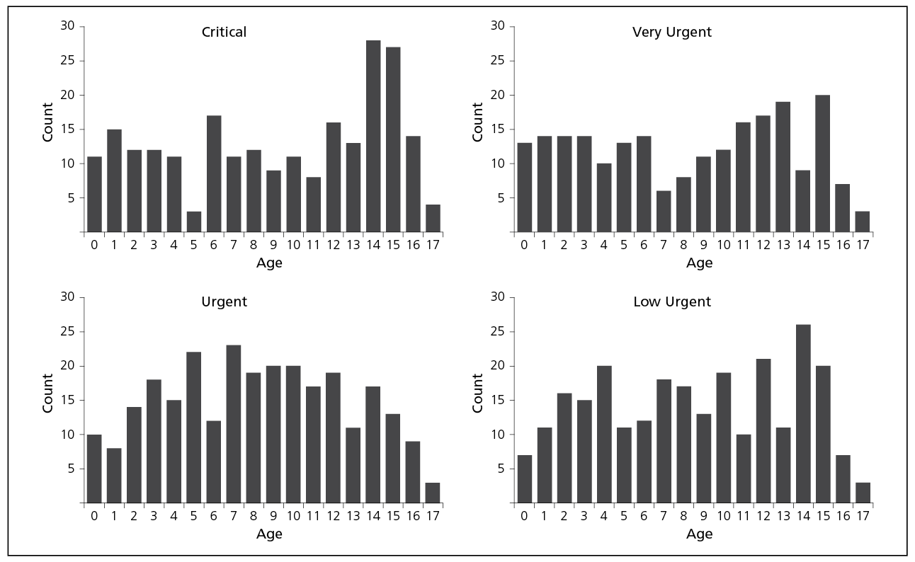

Notifiers

The most common notifiers were police, family, education and health professionals (see Figure 5). This was true for the study as well as for CYF as a whole. When groups of notifiers were collapsed into three categories of professional, citizen and other, it revealed that notifications from professionals were more likely to have a formal finding and more likely to have a “critical” status. This could suggest a number of factors; for example, notifications from professionals are descriptive and specific enough to warrant a critical case status, or the presenting issues have been sufficiently significant to attract the attention of an individual acting in a professional capacity.

Notifiers from particular professions also appeared to notify different age groups; for instance, health professionals notified more children aged 0–4 years and educational professionals notified more children aged 5–12 years. Within the sample population, police notifications were over-represented in cases where there was a formal finding of emotional or sexual abuse, supervisory neglect and behaviour difficulties.

Figure 5 Notifier Types
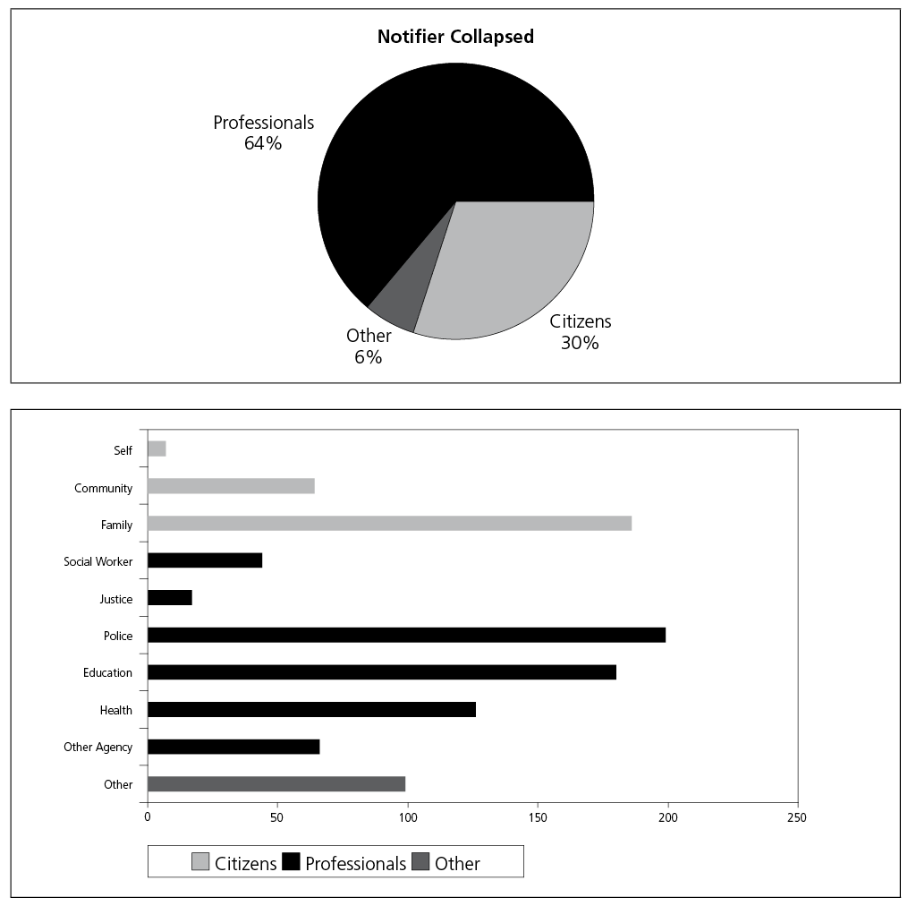

Response Status

This study stratified cases by the four criticalities CYF assigns to a case prior to an investigation process. Cases classified as needing the quickest response time (i.e. critical and very urgent cases) were more likely to have a formal finding. This could suggest the process of allocating a criticality status to a case is a relatively accurate assessment by CYF of a child presenting with a care and protection concern. On the other hand, because these cases have a quick response time there is also a greater likelihood that the timeliness of the investigation can draw on current and readily identifiable evidence that a care and protection concern is present. Supporting the latter hypothesis (that timeliness aids identification), the researchers in this project found some cases among the sample population that allocated a less urgent investigation status and which had been open for a long time (in some cases several years), yet had little evidence that a comprehensive inquiry had occurred. A high status of criticality was also correlated with caregivers having or being suspected of having substance misuse issues. Domestic violence was suspected or evident particularly in those cases allocated the second most critical status of very urgent.

The researchers also noted that children in different age groups had different levels of criticality status. For instance, the highest criticality occurred more commonly among 15- and 16-year-olds. One explanation for the high incidence among this age group is the use police make of a provision under section 48 of the Children, Young Persons, and Their Families Act 1989, to apprehend Youths and refer them to CYF.

Family Re-Engagement

Overall, 74% of the sample population had multiple family engagements with CYF before, during and/or after the 2003/04 investigation examined by the researchers. Specifically, the data indicated that 62% of cases involved families with a previous family engagement, 56% of cases had a subsequent family engagement and 9% of children had concurrent engagements with CYF during 2003/04 (see Figure 6). Of the 56% of families who had a subsequent engagement, 63% included the same child whose file we were analysing. Importantly, for 79% of those children the subsequent investigation resulted in social workers making a formal finding (see Figure 7). Notably, among those subsequent findings was the high prevalence (60%) of emotional abuse or neglect, and of behaviour difficulties.

Figure 6 Multiple Family Engagements
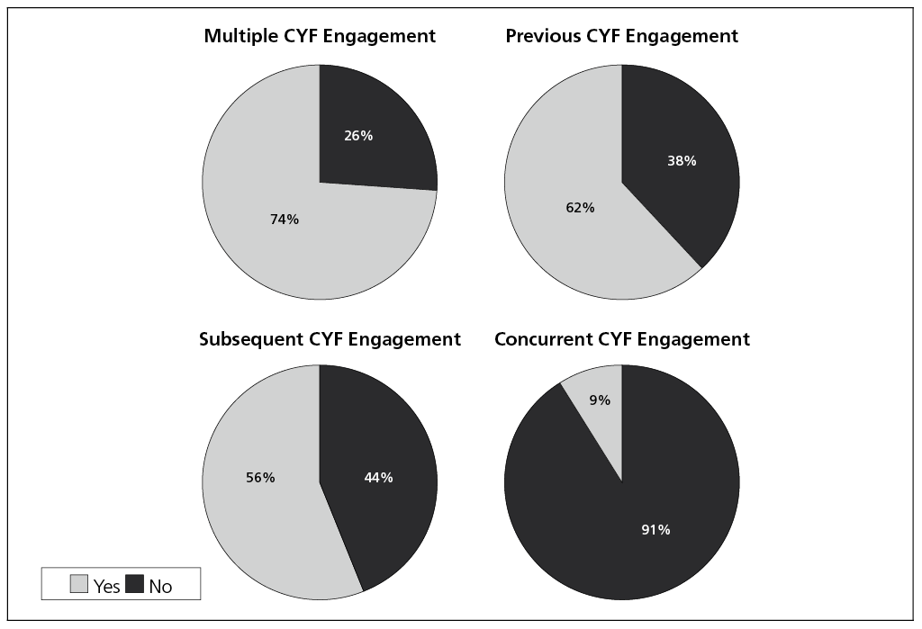

Figure 7 Post-Investigation CYF Engagement for Client
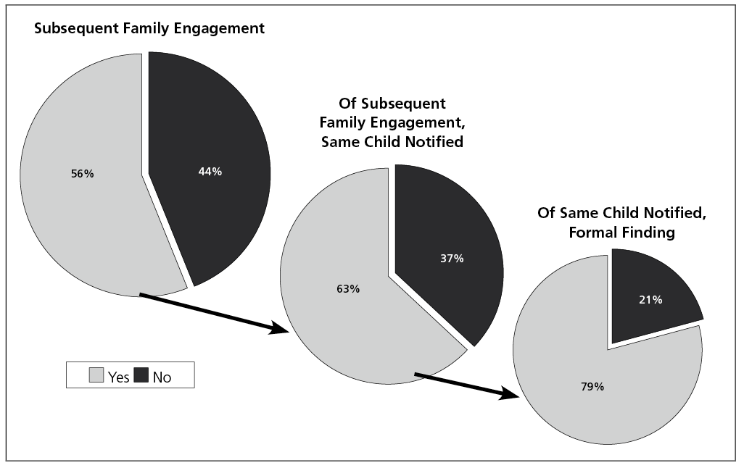

Reinterpreting Data

While, the study revealed a number of features of the CYF intake and investigation process that provide further explanation for the high numbers of cases closed post-investigation, they do not significantly impact on findings. For example, CYF is mandated to include siblings in the notification of any individual child. In the study a significant portion of cases pertained to siblings, and these were duly closed after an investigation showed no maltreatment issues (11%). Also contributing to the large number of cases closed post-investigation were those concerning a child that had multiple simultaneous intakes, investigations or interventions. In the interests of efficiency, social workers appeared to be closing cases or collapsing them into other open investigations or interventions within CYRAS (9%). When these records are removed the percentages of findings do not alter greatly.

analysis of case notes

Social Workers’ Case Note Findings

CYRAS provides a historical repository of qualitative and quantitative information about children and their families. It is necessary to read the case notes entered by social workers to understand the breadth and depth of the work they do, the range of issues facing the children and families who are their clients, and the decisions made. This section examines the kinds of assessments made in the sample cases. The analysis uses a three-fold framework: a formal finding is an officially documented finding in CYRAS (entered in a structured data field), a substantiated finding is evidence identified by researchers of a care and protection issue within case notes but not entered as a formal finding, and no finding is no or insufficient evidence of a care and protection issue in case records.

There was a formal finding of abuse, neglect or behaviour/relationship difficulties in 30% of cases and no formal finding in 70% of cases. The most common formal finding was behaviour/relationship difficulties (12%), followed by physical abuse (7%), emotional abuse (5%), neglect (5%), sexual abuse (3%) and suicide/self-harm (less than 1%). The most commonly found “active” participant in the issue of concern was the mother (11%), followed by the father (10%) and then the child (7%). There was a positive correlation between an abuse or neglect finding and domestic violence.
Where behaviour/relationship difficulties were formally found, there was an increased likelihood the family had multiple engagements with CYF. As previously mentioned, more child maltreatment was found than was reported in formal findings (see Figure 8).

Figure 8 Three Layers of Findings
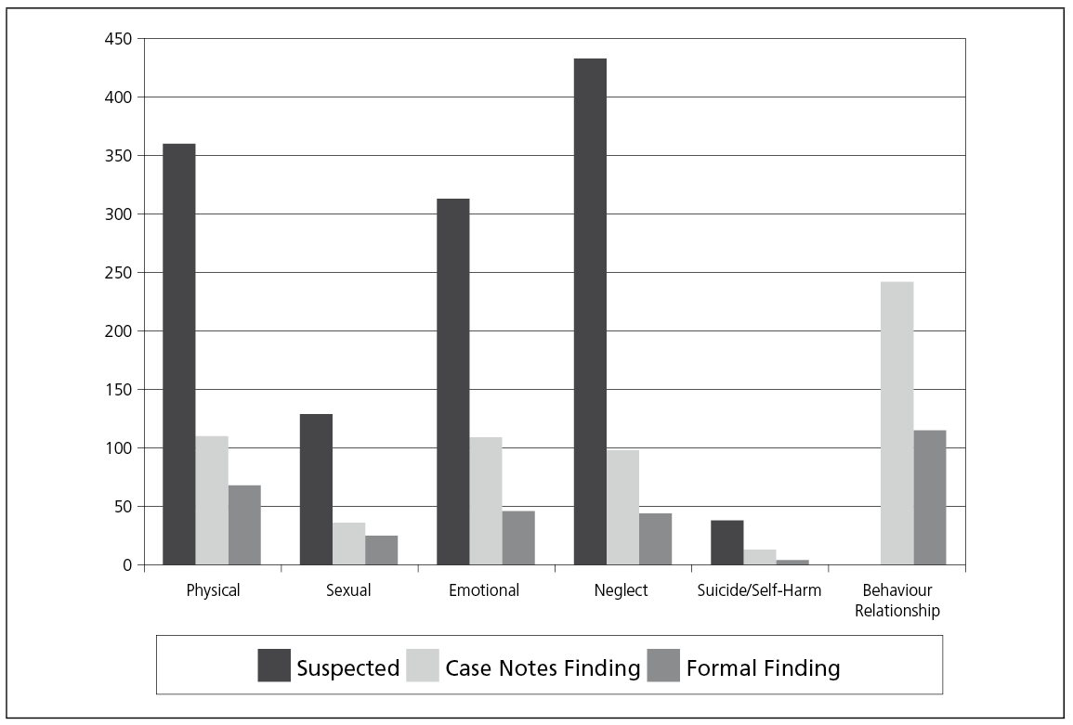

Neglect was suspected for 433 clients (44%) in the study sample. A close examination of those cases with suspected neglect indicated neglect could be substantiated in 95 cases (10%), and of those substantiated findings 44 clients (5% of the entire sample) had an outcome of a formal finding. Given there were four types of neglect explored (supervisory, physical, medical and educational), some clients had multiple types of neglect found or suspected. In total there were 568 instances of neglect presented in the 433 cases, and 122 instances of neglect substantiated in the 95 cases. Supervisory neglect was the most common form of neglect found (n = 64). Where neglect was suspected as a concern for the child, the caregiver was more likely to be suspected of having substance abuse issues or mental health concerns. Neglect was more commonly found for children aged 0–4 (n = 20 of 44) and 9–12 years. Where neglect was substantiated or formally found, 81% of families had more than one engagement with CYF.

Emotional abuse was suspected in 311 cases (32%), substantiated via case note records in 106 cases (11% of the entire sample) and was a formal finding in 44 cases (5%). The older the child, the less likely emotional abuse was to be found. The overwhelming issue correlated with emotional abuse was domestic violence (85%), but emotional abuse also correlated with substance abuse, family breakdown, caregiver’s violent behaviour and parental mental health issues. The father was by far the most common perpetrator in cases concerning emotional abuse.

Where there were multiple findings (in case notes and formal findings), there was a positive correlation between neglect and emotional abuse. When combined, emotional abuse and neglect constituted the most commonly found and suspected category of maltreatment. When combined, at least one instance of either emotional abuse or neglect were evident in 18% of the cases.

Physical abuse was suspected in 360 cases (36%), the abuse could be substantiated via case records for 109 cases (11%) and was a formal finding in 68 cases (7%). Physical abuse was both suspected and found most commonly for children and youth aged 13–17 and 5–8 years, and these cases were more likely to be allocated a critical status. Where physical abuse was found, there was an over-representation of cases where the caregiver was found to be violent and domestic violence was present in the family.

Evidence of suicide and self-harm in case notes were significantly under-reported as formal findings. Sexual abuse was suspected in 129 cases (13%), could be substantiated via case records in 36 cases (4%), of which 25 (3%) had a formal finding. Sexual abuse was most commonly found for female children aged 9–12 years (47%). Where there was a formal finding, the most common perpetrator of the abuse was identified as “other” (48% or 12 of 25) (for example, a boarder), followed by “other” family (16% or 4 of 25).

Self-harm (including suicidal tendencies) was suspected in 38 cases, found in 13 cases and had a formal finding in four cases. Although the numbers were small, girls were over-represented (85% or 11 of 13). Self-harm was exclusive to clients over 12 years old, and nearly half of clients (55% or 6 of 13) were 14 years old at the time of investigation.

Of the cases with formal findings (30% of the sample), over one-third (12% of the sample) fell into the category of behaviour/relationship difficulties. This category was difficult to define because it covered a broad spectrum of concerning issues. The researchers did not attempt to extract information from case notes to identify factors about the relationship difficulties; however, behaviour issues were evident in 25% of cases. The age group that presented with the highest rate of behaviour difficulties was youth aged 13–17 years, and Pākehā were over-represented. Where the child or youth had a formal finding of difficult behaviour, 81% of their families had multiple CYF engagements. Across the cases where behaviour difficulties were an issue, nearly two-thirds (65%) of the children or young people were involved with another service, and their caregivers were involved to a much lesser extent (29%) with other services.

Several other issues were captured in the case notes. Truancy was recorded in 6% of cases, most commonly with youth aged 13–17 years. Special education requirements, disability and mental health issues were each discussed in less than 5% of cases.

Most of the information in case notes pertained to caregivers and their ability to provide their children with adequate care and protection. This was particularly so in cases concerning abuse and neglect. Over one-third of the sample demonstrated issues of domestic violence (36%) and caregiver’s violent behaviour (33%). One-third of those cases had evidence in notes sufficient for the researchers to consider that the issues of concern were substantiated. Caregiver’s substance abuse was suspected in 23% of cases, of which one-quarter were substantiated in case notes. The degree of financial hardship families were experiencing was not specifically captured, but nearly one-quarter of case notes mentioned families who were on benefits. “Other” domestic and caregiver issues, such as exposure to criminal behaviour and a detrimental environment, were suspected in one-fifth of cases, of which one-quarter could be substantiated on the basis of the social workers’ records. Caregivers’ mental health issues were suspected in 13% of cases and diagnosed by health professionals for a quarter of those caregivers. These were most commonly cases of post-natal depression. Custody disputes appeared as a significant issue in 7% of case investigations, but this factor was not necessarily captured in all cases and might be under-reported in case notes. Caregivers’ sexually inappropriate behaviour was mentioned in 7% of cases. Other issues found in case notes included caregiver’s inability to cope, inappropriate child supervision, inappropriate discipline and general household stress.

Closing Cases

Cases were closed for assorted reasons, including, as previously mentioned, cases concerning a sibling or those with a parallel investigation. During 2003/04 it was evident that some cases had been open for extended periods and there was a drive in CYF to reduce these (CYF 2006b). As a result, some cases were routinely closed whereno further work was needed. This research suggests other cases were closed for the following reasons:
- the perpetrator’s access to the client was severed or the issue was resolved
- the incident was seen as a “one-off”
- no care and protection issue was found
- adequate support existed
- the notification was malicious
- the presenting injury was accidental or medical
- the maltreatment was not corroborated
- the issue was historical or the family could not be located.

In some instances the rationale for case closure was poorly recorded.

Researchers noted that the level of cooperation the social worker had from a caregiver during an investigation affected the outcome. This manifested itself in cases being closed both because caregivers were cooperative and, conversely, because they were uncooperative. For instance, cooperative caregivers displayed a willingness to modify their behaviour, which appeared to provide social workers with sufficient confidence that the risk to the child had dissipated. In other cases parents were uncooperative and refused to work alongside the social workers. However, in the opinion of the social worker, these parents did not pose sufficient risk to their child to invoke a statutory intervention. This finding illustrates recognition that an alternative approach, which engaged families voluntarily, may lead to more positive and sustainable outcomes.

Researchers also noted that some investigations were presented with issues of children facing possible abuse or neglect, but that these issues became lost in the progress of the investigation. This mainly occurred where it emerged that the young person had behaviour or relationship issues and these were regarded as the concerns of importance, appearing to supersede inquiry into abuse or neglect. In these instances it was evident that the initial concern that prompted notification was the caregiver’s behaviour, but over the duration of the investigation the focus shifted to the behaviour of the young person at the centre of the case.

Where other services were involved with the family, analysis of the case notes indicated that social workers had a sound rationale for not progressing the case beyond the investigation phase. This finding is consistent with CYF’s position that its further involvement is not deemed necessary where other services may provide adequate support systems to the family (Connolly 2001). It also certainly reveals a willingness among both families and service providers to engage. However, the high rate of re-engagement with CYF indicates that more work is needed to focus service provision for better effect.

Case Vignettes

The following vignettes were created from three of the 988 cases in this study. They provide a qualitative narrative to summarise the diversity of the data that can be extracted from case notes, an overview of three individual cases and how they were closed.

Case 1

A female disclosed to the notifier that she was emotionally abused, neglected, regularly witnessed domestic violence in her home and was the victim of her stepfather’s physical assault. Both the girl and her mother substantiated the concerns during the CYF investigation. Initially a temporary placement was arranged and the mother ended her relationship with the stepfather, ceasing contact. The case was not closed because additional issues emerged, including the girl’s self-harming behaviour and the mother’s serious illness. The young female was given support for her substance use, depression and suicidal ideation and was referred to appropriate services. Subsequently she had a separate incident, which led to a youth justice intervention. This case was open for two years, and a formal finding of behaviour/relationship difficulty was made. This young female had two subsequent CYF engagements, one of which found neglect and led to intervention.

Case 2

The older step-sibling disclosed to school personnel that she believed her brother had been sexually abusing her sister for some time. The social worker interviewed the sister and father and completed a risk assessment using the RES. The sister denied she was “sexually abused” but stated the stepbrother had repeatedly asked her to perform fellatio, to which she never agreed. The stepbrother was sent to a community-based residential sexual intervention programme for male youth and the family ceased his contact with the stepsister. The girl appeared fine and felt safe in the family, so the father decided not to pursue intervention. The case was closed. No finding was made and the family had no other CYF engagement.

Case 3

Police were called to a family home where a loud and violent argument was heard. The police subsequently notified CYF because children were in the home. The social worker assessed the client as safe, but the mother suggested she was in need of support. The family was under stress, she was suffering post-natal depression, felt unsupported by her partner and was unable to cope with the children’s behaviour on her own. The social worker referred her to the appropriate service, as well as offering support and advice on managing stress and the children’s behaviour. The social worker also talked with the woman about how domestic disputes affect children. This was a brief investigation and there was no finding, but this was the family’s third notification and they were subsequently renotified four times for similar issues (where emotional abuse was found by both parents).

Other Service Involvement

Researchers lifted from the case notes the name of the service(s) a child or caregiver was engaged with or referred to as a proxy measure of connectedness to forms of social support. Fifteen types of services were identified, including primary health, secondary/tertiary health, early childhood education, drug and alcohol services, domestic violence intervention, community support, iwi services, police, government-assisted benefit, the courts and legal services. We use the term “service” loosely to include interventions that were pursued voluntarily and those that were mandatory (such as the police or courts), as well as social networks that were not formal services but provided support, such as churches and whānau in the case of kin care. It was not possible to definitively measure the frequency and types of service used, nor whether the service was previously engaged or emerged as a result of the investigation, because the case notes did not always contain that information. The study was not tasked with identifying service gaps, but it did give insight into the range of services CYF’s clients interact with and presented possible signposts for better meeting clients’ needs.

Overall, the data indicated that 61% of families (42% of clients and 36% of caregivers) in the sample population were involved with one or more forms of services either prior to or after CYF involvement. In total, there were 623 instances of service use mentioned for caregivers and 678 instances of service use mentioned for children and young people.

Of the 42% of children who had other service involvement, the majority (62%) had accessed a service despite there being no formal finding. The caregiver population were involved to a lesser extent (36%), and two-thirds (68%) of them accessed services despite there being no formal finding. Of children with formal findings, those with a finding of emotional abuse and neglect were the least likely to access a service (67% did not access a service), followed by those subjected to physical abuse (47%). Interestingly, 34% of children with a formal sexual abuse finding did not access a service, and neither did one of the two young people recorded with a formal finding of attempted suicide. It is fair to speculate that the children in these cases might have required assistance to cope with the issues they faced and for which they were notified to CYF.

The rate of service use by caregivers (n = 358) was less than that of the children (n = 419), but they were involved more frequently with social support services. This may be because caregivers are better able to access services through self-referral than children, or that providing services to caregivers indirectly transmits benefits to their children.

The highest use of services by caregivers was recorded for Support/Community Service (n = 111) followed by Behaviour/Therapy (n = 93) and then Police (n = 81). Combining Police with Court/Legal pushes this “legal” category into the second-highest frequency. Domestic Violence/Safety Interventions (n = 98) were also used at a high frequency by caregivers.

Overall the highest use of services by young people was recorded for Law/Order (n = 110), followed by Primary Health (n = 106) and Education (n = 101). Youth in the age band 13–17 years were the most likely to access services, and this age group most frequently used Law/order interventions (n = 63), followed by Behaviour/Therapy (n = 41) and Childcare (n = 28). Children in the age band 0–4 years were the second most frequent group to have services mentioned (n = 131), followed by children aged 9–12 years (n = 124).

Some caution must be exercised when interpreting these statistics. The fact that a service was accessed by a child or caregiver with a formal finding does not necessarily mean the service was aligned to rehabilitation or treatment of the issues of maltreatment, merely that the service was used. What is clear is that a large potion of this population is engaged with services simultaneous to their period of repeat engagement with CYF. It is fair to suggest by inference that this finding indicates support services are less than optimally effective at targeting families whose behaviour compromises the care and protection of children.

Discussion and Recommendations

Practice Considerations

This study underlines the complexity frontline workers face when working with some families within the care and protection system. In many instances, contrary to the evidence of abuse or neglect in case notes, a decision was made to close a case with an outcome of no formal finding. By definition, a CYF investigation outcome is a binary decision that indicates either a true or false occurrence in the New Zealand care and protection system. There are currently two prime decisions a social worker records in structured files in CYRAS: a) whether there is a finding, and b) whether statutory intervention is required. The two are sometimes conflated. This double-binary decision represents a complex set of judgements made by social workers on intricate and dynamic family interrelationships and functions. Drake and Jonson-Reid (2007:251) describe a growing body of literature supporting the notion that substantiated and unsubstantiated cases are “more similar than different”, and that a “range of other factors” influence social workers’ decisions to substantiate some cases rather than others.

Some discrepancy in the binary records uncovered in this study may highlight two related tensions between practice and recording mandates. First, there is tension between the requirement of the CYPF Act 1989 and the wording of CYRAS. The Act specifies that any social worker who “believes, after inquiry, that any child or young person is in need of care or protection … shall forthwith report the matter to a Care and Protection Co-ordinator” (section 18(1)). The implication of believing there is a need for care and protection assumes a complicated analysis of both the current and future risk of harm. Conversely, recording in CYRAS asks whether abuse, neglect and/or behaviour/relationship difficulties were found or not found, indicating a past occurrence.

The second tension between practice and recording reflects the way social work training and practice precariously balance strengths-based and deficiency- or risk-based models (Staniforth and Larkin 2006). This is most problematic where no standardised taxonomy exists; for instance, with the term “substantiation”. Condensing a complex set of risk and strength assessments, including the adequacy of coping mechanisms and support networks, into a binary decision is a difficult task. The under-reporting of cases where maltreatment exists may be social workers’ best option for reconciling the lack of fit between models of previous and future risk of harm and models of risk and strength. Cases were closed when families and children were deemed to have adequate coping mechanisms and were considered safe despite either a substantiated or formal finding. Gandar and Naden (2005) argue that social workers have been left alone to “form a belief” of abuse or neglect, but suggest possible ways forward under CYF’s Differential Response Model (DRM), currently being piloted. DRM supports and consolidates social worker judgement and offers a more systematic and collaborative approach to screening and referral, while also offering more opportunities for recording categories of data, including a provision for recording the rationale for closing a case.

Responding More Effectively to Need

It has long been suspected that a large percentage of children and families in need are not getting the help they require (Attride-Stirling 2000). The case notes study has provided evidence that the relatively high number of cases closed post-investigation are not a waste of effort, as might be surmised. In most instances, in addition to investigative work social workers undertook a range of fruitful activities to support families through crisis situations during the investigation period, such as arranging informal placements, offering support, making referrals and organising family/whānau hui. Within the analysed records there were signposts that while CYF was not necessarily the most appropriate agency of support for the child and family in that instance, some form of intervention was nonetheless warranted. The research identified a broad range of needs among these clients, despite the fact that they did not meet the threshold for a statutory intervention. A more coordinated response from non-statutory agencies with an interest in preventative work may lead to interventions that are more effective and less intrusive, thus reducing the need to spend money on multiple investigations. However, until capacity is built, CYF remains – de facto – the organisation confronted by this need.

This research provided further evidence for CYF that repeat notifications of particular children and families create a substantial demand on services (Cabinet Expenditure and Administration Committee Review of the care and protection system “Whole of Government Responses to Demand” [EXG Min (06) 5/6 refers]). Clearly, an area for sector development is reducing the likelihood of repeat notifications. In particular, children with behaviour difficulty and circumstances of neglect tend to engage with CYF repeatedly. The threshold for escalating issues of neglect into care and protection poses challenges for the system (Dickens 2007). Attachment, resiliency and connectedness theories agree that deprivation of love, nurture and emotional wellbeing lead to significantly reduced outcomes (Whitfield 2002, HMSO 1995), giving impetus to intervene. However, the state has a particularly poor record at providing “love”, “nurture” and relationship management (HMSO 1995), as these ideals are expected to be met within families. Nevertheless, in instances where families cannot provide these life experiences to their children, the strategic pathways of the state need to include programmes of early intervention, and medium- and long-term investment. Currently, services to address issues of neglect and behaviour difficulties are predominantly short-term and resource-intensive (USDHHS 1993). A stocktake of available services and sector strengths is needed, as well as a renewed commitment to working alongside families.

Achieving better outcomes involves tackling endemic long-term and societal issues, such as family violence, substance misuse and neglect. Hamlin et al. (2003) undertook a study of client needs that uncovered similarly high rates of mental health and substance use issues in caregivers, which led to long-term involvement with statutory services. Their research also highlighted the lack of recognition of, and services for, substance and mental health issues for children and young people.

For those families who presented with behaviour difficulties, this study highlighted the potential gap in services for caregivers, particularly those with children aged 8–12 years. Where these issues were present in families, caregivers were much less likely than children to be involved with a service. New Zealand supports whole-family approaches to the behaviour/relationship difficulties that occur in families, and Strengthening Families is one example of this approach. At the most serious end of the treatment continuum, many of our youth justice initiatives are currently using a multi-systemic approach that includes services for both the youth and their family to treat serious behaviour and relationship difficulties. It could be that the whole-family approach is also pertinent in the cases of behaviour/relationship difficulties found in this study, because over time some of these young people are likely to develop chronic symptoms that necessitate treatment.

Although a statutory intervention was found not to be the most appropriate intervention for the broad range of needs found in this group, the probability is that in some cases there were few other agencies that could effectively intervene, and those that could were not necessarily involved. Unfortunately, in the absence of alternative services or connections to appropriate services, these clients will continue to present to CYF. The EXG Demand Review (CYF 2006a) made recommendations for a range of new and continued approaches to augment the Ministry of Social Development collaborations and partnerships within and outside government. DRM is piloting a mechanism aimed at quickly and safely identifying cases that do not need statutory investigation but do require referrals to services within the family support sector.

In addition to this work, there is a need for a framework that supports local case collaboration and provides flexible funding arrangements to improve accountability, performance feedback and service provision from this broader group of support agencies in the family sector. The progressive implementation of a differential response allows CYF to identify non-government organisation partners and service clusters that are able to work collaboratively to meet those needs. However, this study indicates that there is substantial demand for further support services to address need in this population. Although there are fiscal ramifications for the Ministry of Social Development and other government and non-government agencies to augment and develop the family support network infrastructure, this study shows that CYF is already bearing the costs of not developing the wider system.

Research and evaluation that support better understanding of what promotes good outcomes for children, young people and their families is one key to the success of future initiatives. So, too, is the facilitation of a joined-up approach between CYF and the family support sector to facilitate the identification and timely referral of families and children to services that can mitigate their need for intervention at the acute end of the care and protection continuum.

References

Adam, N., D. Zosky and Y. Unrau (2004) “Improving the research climate in social work curricula: Clarifying learning expectations across BSW and MSW research courses” Journal of Teaching Social Work, 24(3/4):1–18.
Attride-Stirling, J. (2000) “ ‘Someone to talk to who’ll listen’: Addressing the psychosocial needs of children and families” Journal of Community and Applied Social Psychology, (11):179–191.
Burton, T. (2006) Study of Children in Care 2001, Ministry of Social Development, Wellington.
Connolly, M. (2001) “Child care and protection services in child welfare” in M. Connolly (ed.) New Zealand Social Work: Contexts and Practice, Oxford University Press, Auckland.
CWIG (2006) Long Term Consequences of Child Abuse and Neglect, Child Welfare Information Gateway, www.childwelfare.gov/pubs/factsheets/long_term_consequences.pdf.
CYF (2003) Report of the Department of Child, Youth and Family Services First Principles Baseline Review, www.cyf.govt.nz/documents/baselineReview.pdf.
CYF (2004) “The nature and impact of the September 2004 surge in notifications” PAR Information Analysis Bulletin, 1(4).
CYF (2005) Blueprint Investment Strategy: Research into Unmet Needs of CYF Clients [draft at 13 July 2005], Child, Youth and Family, Wellington.
CYF (2006a) EXG Review: Sustainability of the Care and Protection System: Whole of Government Responses to Demand, Child, Youth and Family, Wellington.
CYF (2006b) SENSE Project: 2003/4 Outcome and Process Indicators, unpublished report.
DFPS (2001) Texas State-wide Assessment, Texas Department of Family and Protective Services (DFPS), Texas.
DHHS (1993) Child Neglect: A Guide for Intervention User Manual Series, US Department of Health and Human Services, Gaudin.
Dickens, J. (2007) “Child neglect and the law: Catapults, thresholds and delay” Child Abuse Review, 16:77–92.
Drake, B. and M. Jonson-Reid (2007) “A response to Melton based on the available data” Child Abuse & Neglect, 31:343–360.
Finkelhor, D. (1990) “Early and long-term effects of child sexual abuse: An update” Professional Psychology: Research and Practice, 21(5):325–330.
Gandar, P. and R. Naden (2005) Supporting Social Work Judgement, www.synergia.co.nz/files/Synergia_Think_Piece_050720_Social_Work_Judgement.PDF.
Hamlin, C., J. Horwood and P. Wells (2003) “Access of mental health services by CYF clients” paper given at Strengthening our Foundations: Service User Roles in the Mental Health Workforce, March 2006, Mental Health Commission, Wellington.
Helfner, M.E., R.S. Kempe and R.D. Krugman (1968) The Battered Child, University of Chicago Press, Chicago.
HMSO (1995) “Child protection: Messages from research” in Studies in Child Protection, HMSO, London.
Hopper, J. (1997) Child Abuse: Statistics, Research, and Resources, www.jimhopper.com/abstats.
Kiro, C. (2006) Children’s Commissioner presentation to Barnardos AGM, www.occ.org.nz/childcomm/media_and_speeches/presentations/children_s_commissioner_presents_at_barnados_agm_26th_october_2006.
Leschied, A.W., P.C. Whitehead, D. Hurley and D. Chiodo (2003) Protecting Children is Everybody’s Business: Investigating Demand for Service at The Children’s Aid Society of London and Middlesex, University of Western Ontario, London, Ontario, Canada.
Mansell, J. (2006) “The underlying instability in statutory child protection: Under-standing the system dynamics driving risk assurance levels” Social Policy Journal of New Zealand, 28:97–132.
Ministry of Health (2006) Suicide Facts: Provisional 2003 All-Ages Statistics: Monitoring Report No. 1, Ministry of Health, Wellington.
Office of the Children’s Commissioner (2006) Te Ara Tukutuku Nga Whanaungatanga o Nga Tamariki: Weaving Pathways to Wellbeing – An integrated framework for children and their families, www.occ.org.nz/home_page_highlight_right/overview_of_integrated_framework?eZSESSIDchildcomm=798ca4c31df6fa4cec6efa24cd149da5.
Pfohl, S.J. (1977) “The “discovery” of child abuse” Social Problems, 24(3):310–323.
Schön, D. (1983) The Reflective Practitioner, Temple Smith, London.
Staniforth, B. and R. Larkin (2006) “Documentation in social work: Remembering our ABCs” Social Work Review, xviii(3):13–20.
UNICEF (2003) The League Table of Child Maltreatment Deaths in Rich Countries, UNICEF, Florence, Italy.
USDHHS (1993) Child Neglect: A Guide for Intervention User Manual Series, US Department of Health and Human Services, Gaudin.
Wells, P. (2002) Criticality Review – Low Urgency Work, Child, Youth and Family, Wellington.
Whitfield, R. (2002) “Becoming and staying connected” paper presented at the Youth Development Strategy Aotearoa Seminar, 12 February, Wellington.

Acknowledgements We would like to acknowledge several people who contributed to the data analysis or research design, including John O’Leary, Fiona Coy, Shanti Patel, Fiona Moorhead, Bronwyn Hutcheson, Stu Mitchell and Sue Nelson.
“Reflective practice involves thoughtfully considering one’s own experiences in applying knowledge to practice while being coached by professionals in the discipline” (Wikipedia definition based on Schön 1983).
CYRAS is the CYF case recording system used by all CYF social workers.
Such as Differential Response Model pilots and the Family Violence Management Strategy.
Such as Strengthening Families, Heartland Services, Pathways to Partnership and Early Years Service Hubs.
The findings reported in this paper reflect the actual unweighted sample.
Note that this did not significantly skew other demographic characteristics of the sample.
Neglect, abuse, child’s behaviour, physical or mental health issues, education issues, caregiver’s domestic issues (court orders, other interventions, drug and alcohol issues, domestic violence, other issues), caregiver’s behaviour (sexual, violent, mental health issues, other), custody dispute, family in receipt of benefits (where mentioned), childcare issues, sibling was primary client, previous and post episodes of engagement, other service involvement for the client and caregiver, parallel investigation, case closed because young person turned 17 and file was misfiled.
The inquiry focused on a telephone call Mr Burrows had made to the call centre earlier in the year seeking CYF support.
Tamati Pokaia, Kelly Gush, Saliel Aplin and Olympia Jetson.
As suggested by a review of monthly reports and some literature (CYF 2003, CYF 2004, Mansell 2006).
The authors recognise that self-harm and suicidal ideation sometimes overlap, but are also quite distinct. They are dealt with together in this study because they represented a small proportion of the population and because case notes were not always clear on whether the issue was suicidal ideation, parasuicidal acts, self-mutilation or self-injury. There were no instances of successful suicide for the clients in the sample population. It should be noted that researchers were conservative in their substantiation of suicide or self-harm, for instance, when it led to hospitalisation. The last two points support the gender difference, although boys have a higher rate of successful suicide and girls tend to have a higher rate of self-harm and suicide attempts.
There were multiple types of police notifications, including family violence. In 2003/04 there were few police family violence notifications. This has increased exponentially.
Analysis of all notifier groups between 1998 and 2006 shows that the most common notifiers are police, family, education and health.
Unaccompanied children and young people who are brought into the custody of the police and notified by the police.
“Active” refers to the person who is recorded in CYRAS as the instigating party of the occurrence. For instance, in cases of abuse and neglect the “active” participant is the perpetrator, but in cases pertaining to the child’s behaviour it is the child.
Where behaviour/relationship issues were found, the individual identified as the cause for concern was frequently the child.
Some of the more common behaviour issues for the client included (in order of occurrence) violent behaviour, truancy, suicidal ideation, self-harm, being sexually active, running away, illegal activities, ADHD and alcohol or drug use.
This appears to be consistent with other CYF data for all notifications with a finding of behaviour/relationship difficulty.
Although this was an underestimate as it was inconsistently recorded.
See http://www.cyf.govt.nz/2275.htm for more information about DRM.
Multi-Systemic Therapy New Zealand (see www.mstnz.co.nz).

