The material wellbeing of New Zealand households: trends and relativities using non-income measures, with international comparisons

Prepared by Bryan Perry

Ministry of Social Development
Wellington

November 2019

ISBN 978-1-98-854191-4 (Print)

ISBN 978-1-98-854190-7 (Online)

Changes since last report

- Updates in Sections F, G and H using 2017-18 HES data (including time series trends).

- New material on the role that liquid assets play in producing different material hardship rates for households with similar incomes.

- The 2020 report is expected to have a range of new material, including more up to date information on where New Zealand ranks internationally on material hardship (using the EU’s official 13-item index), more on child material hardship using child-specific indicators which are available again in the 2018-19 HES, and a section on food security / insecurity.

Companion Household Incomes report

- This NIMs report is a companion report to the Household Incomes Report. They are intended to be used together, but are kept separate for ease of access for users.

- The 50-page Overview and Key Findings document brings together the key definitions and concepts, the key findings and overall story from both reports.

Next report

- The next NIMs report is scheduled for mid 2020, and is expected to contain new analysis as well as updates using the 2019 HES data.

Availability on MSD website

- Both reports and the Overview are available on the MSD website
https://www.msd.govt.nz/about-msd-and-our-work/publications-resources/index.html

Updates since publication on Thursday 7 November 2019

- Nil

Introduction

This report uses non-income measures (NIMs) to examine the material wellbeing of New Zealand families and households. Non-income measures are sometimes referred to as non-monetary indicators (NMIs). They refer to the same items and measures.

NIMs focus on the actual day-to-day living conditions of households in terms of the basics of food, clothing, accommodation, heating, and transport, and more widely in terms of their ability to maintain or replace broken household appliances, purchase desirable non-essentials, cope with unexpected demands on the household budget, and so on. They allow a ranking of households using a more direct measurement approach compared with the indirect and partial approach using household income.

The NIMs report sits alongside the Household Incomes Report: together they give a comprehensive account of the relativities between different groups and of trends over time.

The report also shows where New Zealand ranks internationally using material hardship or deprivation measures, a more robust approach to international comparisons of low material wellbeing than using household incomes.

Each NIM can provide valuable information in its own right, and the report includes information on some individual items, but the focus of the report is on the use of selected NIMs used together in two types of index:
- material hardship or deprivation indices – one from the EU (EU-13) and one from MSD’s own work (DEP-17)
- the material wellbeing index (the MWI) which allows comparisons across the spectrum from low to high material living standards, rather than just focussing on the low end.

The MWI is a revised version of the prototype ELSI (Economic Living Standards Index) measure developed by the Ministry of Social Development (MSD) in 2002.

The analysis in the report uses data from MSD’s 2008 Living Standards Survey (LSS) and Stats NZ’s Household Economic Survey (HES) which has included a suite of NIMs since 2006-07. There is some limited use of analysis based on Stats NZ’s longitudinal Survey of Family, Income and Employment (SoFIE), and their General Social Survey (GSS).

Though most of the survey data itself is from Stats NZ, the analysis and findings are the work and responsibility of MSD.

As with the Household Incomes Report, the plan for this NIMs report is to not only update the findings each year but also to add new analysis as time and data availability allow.

The key findings and key messages from both the Incomes Report and the NIMs report are brought together and summarised in the ‘Overview and Key Findings’ document which is available on MSD’s website at:

http://www.msd.govt.nz/about-msd-and-our-work/publications-resources/monitoring/household-incomes/index.html

Outline of Contents

Section A The income-wealth-consumption-material-wellbeing framework ………….. 7
outlines the income-wealth-consumption-material-wellbeing framework that is used in both the Household Incomes Report and in this companion report using non-income measures (NIMs), and discusses how poverty and material hardship (unacceptably low material wellbeing) are conceptualised and defined in the reports.

Section B Data sources and Indices ………………………………………………………….. 15
gives an overview of the deprivation and material wellbeing indices used in this report and in other MSD research, and of the NZiDEP measure used in SoFIE and elsewhere. It also notes the main data sources available for NIMs in New Zealand.

Section C International comparisons of material hardship using EU-13 .…………….. 21
compares New Zealand’s hardship rates for the whole population, children and older New Zealanders with those in other countries through the use of the EU’s 13-item deprivation index (EU-13) which we can closely replicate for New Zealand. Previous MSD research on international hardship comparisons used a 9-item EU index. Hardship rates for New Zealand are very similar on both indices and country rankings are reasonably similar. EU-13 is however a more robust and reliable index than EU-9. The section also shows why it is unwise and misleading to use relative low-income figures as the basis for rankings in international league tables.
Sections D and E describe the DEP-17 and MWI indices and establish their credentials in the main using data from the 2008 Living Standards Survey (LSS).

Section D DEP-17, a material hardship or deprivation index ..…………………………… 29
introduces MSD’s 17-item material deprivation index (DEP-17) and establishes its credentials. It identifies a plausible range of hardship thresholds (from less to more severe) by examining the lived experience of hardship for children using a set of child-specific deprivation items.

Section E MWI, measuring material wellbeing across the spectrum from low to high .. 41
shifts the focus from the hardship end of the spectrum to looking at the wider distribution of material wellbeing from low to high. It gives a detailed account of the 24-item Material Wellbeing Index (the MWI), the upgraded version of the prototype Economic Living Standards Index (ELSI) developed by MSD in 2002. It also shows how the MWI works as a material hardship measure at its lower end, mimicking DEP-17, and why we need all three indices (EU-13, DEP-17 and the MWI). The section finishes with a description of MWI-9, a 9-item short-form of the MWI, which can be used in surveys where there is a need to produce analysis only by broad material wellbeing groupings, and space is limited in the survey.

Sections F and G use the MWI and ELSI indices with data from the Household Economic Surveys (2006-07 to 2017-18) to examine the relationship between household income and material hardship, and to report material hardship trends from 2007 to 2018.

Section F Low income and material hardship ……………………………………………….. 61
returns to the framework outlined in Section A which drew attention to the fact that while household income is an important factor in determining household material wellbeing, other factors are matter too – it describes the degree of overlap between households reporting low income and those reporting material hardship.

Section G Trends in material hardship, 2007 to 2018, using HES data ……………….. 69
reports on trends in material hardship rates for different depths of hardship and different ages (HES 2007 to 2018). It also reports on more severe hardship conceptualised as experiencing both low income and material hardship.

Sections H and I report on individual items

Section H Findings based on individual items rather than indices …………………… 77
reports on selected individual items for self-assessed income adequacy, housing quality, contents insurance trends, and many more

Section I Child-specific deprivation items …………………………………………………….. 89

References …….…………………………………………………………………………………. 93

Appendix 1 The value and the limitations of the HES for the purposes of the reports …. 99

Appendix 2 Comparison of the item lists for EU-13 and EU-9 …………………………… 106

Appendix 3 A brief outline of the changes of items and conceptualisation when moving from ELSI to the MWI ……….…………………………………………… 107

Appendix 4 Is a HES-based material hardship time series feasible given the change
in the item set between the 2011-12 and 2012-13 surveys? ………………… 110

Appendix 5 Overlaps using the three currently available primary measures in the Child Poverty Reduction (CPR) Bill …….………. …………………………..………… 112

Appendix 6 Challenges for both the incomes and the non-incomes approaches to measuring material wellbeing …...….…………………………………………… 113

Appendix 7 Causes and drivers of child poverty and material hardship: a high-level schema …....………………………….…………………………………………… 115

Section A
Income, wealth, consumption and material wellbeing:
a framework for the two reports

Household income is often used as an indicator of household material wellbeing. Household income is a very important factor in determining a household’s level of material wellbeing – especially for those with a minimal stock of basic household goods and appliances and low or zero cash reserves – but it is not the only factor.

The diagram below provides a framework for thinking through the relationship between household income, financial and physical assets, other factors and material wellbeing or living standards.

- Household income and financial and physical assets together largely determine the economic resources available to most households to support their consumption of goods and services and therefore their material standard of living.
- To measure material wellbeing more directly the NIMs report uses both MSD’s material wellbeing index (MWI) which covers the whole spectrum from low to high material living standards, and its deprivation index (DEP-17) which focuses on the low living standards end of the spectrum. The MWI and DEP-17 rank households in almost exactly the same order for the lower 20% of the population.
- Households with resources that are not adequate for supporting consumption that meets basic needs (those experiencing poverty or material hardship) are of special public policy interest.
- The framework recognises that factors other than incomes and assets can also impact on material wellbeing. These factors are especially relevant for low-income / low-asset households, and can make the difference between “poverty/hardship” and “just getting by”.

Financial and physical assets
Basic needs / essentials
Discretionary spend / desirable non-essentials
Material wellbeing or living standards
Resources available for consumption
Household income
DEP-17
MWI

Other factors
eg assistance from outside the household (family, community, state), housing costs, high or unexpected health or debt servicing costs, lifestyle choices and ability to convert given resources into valuable consumption, ability to access available resources

- The framework provides a high-level explanation for the observation that not all households with low incomes are in hardship, and not all in hardship have low incomes. The overlap between similar-sized groups of those identified as in material hardship and those with low incomes is typically only 40 to 50%, not 100%, as there are many factors in addition to income that determine a household’s level of material wellbeing (living standards).
- The level of liquid financial assets held by a household is one such factor, as shown in the chart and table below for HES 2017-18. For households with similar incomes, lower levels of liquid financial assets mean higher levels of material hardship.

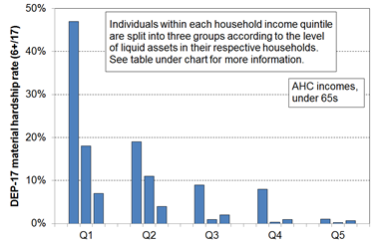

HES 2017-18 | Q1 |  |  | Q2 |  |  | Q3
median liquid assets ($) | 0 | 400 | 8,000 | 100 | 1,200 | 12,000 | 500 | 3,600 | 19,300
can pay an unexpected + essential $500 bill within a month without borrowing | 24% | 43% | 67% | 51% | 71% | 79% | 69% | 84% | 85%
material hardship rate (6+/17, DEP-17) | 47% | 18% | 7% | 19% | 11% | 4% | 9% | 1% | 2%
avg AHC household income (equivalised) | 11,000 | 11,000 | 10,000 | 21,000 | 21,000 | 22,000 | 30,000 | 31,000 | 31,000

- For low-income households that have very limited or no financial assets their income is the main in-house resource available to generate their standard of living. Such households not only struggle in varying degrees to meet basic needs, but are also very vulnerable to the negative impacts of ‘shocks’ such as even a small drop in income or an unexpected expense.

The framework and government policy to address poverty and material hardship

The income-wealth-consumption-material-wellbeing framework, together with its elaboration in Appendix 8 in relation to child poverty and material hardship, provide a high-level check-list for discussion, debate and policy development for addressing poverty and hardship.

For example, thinking about poverty alleviation from the perspective of a household, and how that intersects with government policy, the framework points to the following as pathways for addressing or alleviating poverty:
- increasing household income (whether it be from higher total earnings or increased government cash assistance or reduced tax)
- having the demands on the core household budget reduced (for example, through government services and government subsidies such as those for free doctor’s visits for under 13s, reduced fees for Community Services Card holders, child care subsidies, the SuperGold Card for seniors, KickStart Breakfast in schools programme; and through the work of various NGOs (including foodbanks))
- assisting with addressing toxic debt through services such as those offered by the Community Finance Initiative and the Microfinance Network more generally
- having some financial savings to help deal with shocks to the budget (for example, loss or reduction in paid employment, unexpected health issues that incur costs or reduce earning capacity, unexpected large bill for the car)
- getting better at using a given income to meet basic needs (for example, through improved budgeting, healthy family functioning (tension and chaos reduce efficiency), improving life skills, better access to government and community services, and so on)
- having a streamlined user-friendly interface with government agencies and others for clients to access available assistance
- having improved neighbourhood amenities, including public transport services.

The framework makes it clear that improving the day-to-day living standards of households is about more than income, though income remains a very important factor.

When the focus is on raising incomes for households with children the framework points to three factors that impact on child poverty rates and on the proportion of poor children who come from various subgroups (that is, on the composition of the poor):
- the economy and the labour market (impacting for example on employment and unemployment rates, wage rates, benefit numbers (including numbers of sole-parent families), and interest rates)
- demographic shifts and changing cultural norms (eg the number of sole-parent families, whether sole-parent families live in households on their own or with other adults, the proportion of dual-earner two-parent households)
- policy changes that have a direct impact on income (eg policy changes around benefit rates, income-related rent subsidies, the Accommodation Supplement and Working for Families settings all have clear impacts on the child poverty rates for children from both working and workless households, and on the relativities between the two groups).

Three ways of measuring material wellbeing and ranking households

The reports use three different measures of material wellbeing to rank households from high to low. Both income measures adjust for household size and composition to enable more realistic comparisons between different household types.
- BHC income (income before deducting housing costs):
Household income from all household members from all sources after paying income tax gives an indication of the different levels of financial resources available to different households, all else being equal.
But all else is not equal, as the diagram on the previous page makes clear. There are many factors other than current income that make a difference to the actual day-to-day living standards of households. For example, the largest item on the household budget for many households is accommodation costs, and yet for others in mortgage-free homes these costs are much lower. Accommodation costs cannot usually be changed in the short-term. To better compare the material wellbeing of households when using incomes the Incomes Report also uses household income after deducting housing costs (AHC incomes).
- AHC income (income after deducting housing costs):
AHC income (ie BHC income after deducting housing costs) is a very useful measure for understanding the real-life differences in consumption possibilities for households when looking at income alone. AHC income is sometimes called ‘residual income’.
There are other factors (in addition to income and housing costs) that also contribute to a household’s material wellbeing. The combined impact of all these factors on a household’s material wellbeing can be captured by examining more directly the actual living conditions and consumption possibilities that households experience. The MWI does this.
- MWI (Material Wellbeing Index)
The MWI is made up of 24 items that each give direct information on the day-to-day actual living conditions that households experience. They are about the basics such as food, clothes, accommodation, electricity, transport, keeping warm, maintaining household appliances in working order, and so on, and also about the freedoms households report to purchase and consume non-essentials that are commonly aspired to. See Table B.4 for a list of the MWI items, and Section E for more detail about the index.
Differences in MWI scores reflect the differing impact on living standards of the income, assets and other factors in the framework on page 7. The MWI rankings reflect the different levels of consumption for different households in a way that gets around the need to carry out the very demanding analysis required to create a dollar value for each household’s consumption. The tables in Section E give a picture of the different living standards profiles at different MWI levels, using both MWI items and several not in the MWI.
MSD also uses two deprivation / material hardship indices which focus only on the low end of the spectrum:
- DEP-17: this gives the same results as the MWI when looking at the bottom quintile (20%), but the scoring is more intuitive (eg a score of 6+/17 simply means ‘missing 6 or more basics from the list of 17’) – see Section D
- EU-13: this 13-item index is used in Europe and we use it monitor how New Zealand ranks internationally – it ranks households much the same as DEP-17 does. See Section C.

Where do you and your household rank?

- Appendices One and Two in the Overview and Key Findings document show how to calculate where your household ranks.
The different measures can show different pictures of who is in the higher and lower material wellbeing levels

Different pictures can emerge depending on which measure of material wellbeing is used. This is most clearly illustrated when looking at how different age groups rate relative to each other on the three measures.
- The charts below show how the bottom quintile (bottom 20%) becomes “younger” when the ranking measure changes from BHC to AHC to the MWI – that is, the proportion of older New Zealanders in the bottom quintile decreases (25% to 9% to 5%) and the proportion of children increases (28% to 34% to 38%).
- The differences arise in part because mortgage-free home ownership is very high among older New Zealanders (ie housing costs are very low for most), so when moving from BHC to AHC incomes a large re-ranking happens with many older New Zealanders moving up and many families with children moving down relative to each other. The two circled figures at the left of the table below shows the result of the movement from Q1 (BHC) to Q2 (AHC) for many older New Zealanders.

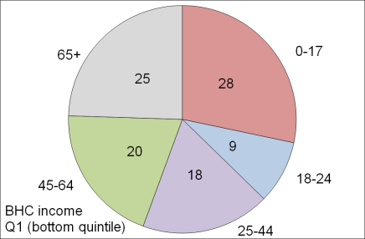
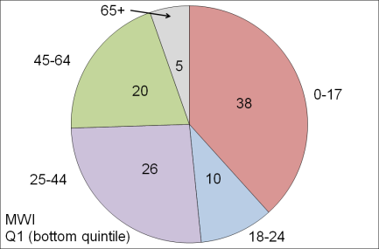
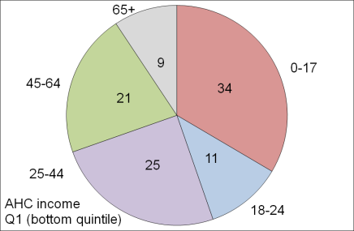
The make-up of the bottom quintile (20%) for the three measures, by age groups (HES 2015)

- The differences in the make-up of the bottom quintile on the three measures are also a reflection of the life-cycle fact that in addition to a mortgage-free home many aged 65+ have all the household appliances and furniture they need and many have other financial reserves they can call on. This explains the large change for older New Zealanders when comparing their numbers in Q5 (see table below which covers all five quintiles): using the MWI, 44% of older New Zealanders are in this higher living standards group, whereas for AHC only 20% are.
- The table also shows that around one in three older New Zealanders (35%) have BHC incomes that place them in the bottom BHC income quintile, but only one in fourteen (7%) are in the lowest MWI quintile.

Where older New Zealanders are found across all quintiles (%), three measures (HES 2015)
 | Q1 | Q2 | Q3 | Q4 | Q5 | TOTAL
BHC | 35 | 18 | 16 | 14 | 16 | 100
AHC | 13 | 32 | 18 | 16 | 20 | 100
MWI | 7 | 10 | 15 | 24 | 44 | 100

Low material wellbeing: what is meant by “poverty” and “material hardship”?

In the more economically developed countries (MEDCs) poverty is generally understood as exclusion from a minimum acceptable way of life (standard of living) in one’s own society because of inadequate financial and material resources. A household is considered ‘poor’ when its resources are not adequate to meet its consumption needs for the basics or necessities.

While it is not an absolute subsistence notion (‘third world starvation’), neither is it ‘just relative’. Poverty is not just about having ‘less than’, it is about ‘not having enough’. There will always be debate about where to set the threshold and even about the use of the ‘poverty’ word itself, but most would agree that there are people in New Zealand today whose actual day-to-day living standards are below a minimum acceptable level. It is not just that these people have less than others who are better off, it is that they are going without too many of the things that the bulk of New Zealand society considers that all should have and none should be without.

There is a particular public policy interest in children whose material wellbeing is below a minimum acceptable level – those identified as living in significant material hardship or deprivation. The concept of material hardship used in this report can be illustrated in the case of children using child-specific items, as below.

Figure A.2 shows how different life is for children in households with low living standards. Children are ranked by their households’ material wellbeing (living standards) from high to low using MSD’s material wellbeing index (MWI). The children are grouped into deciles (ten equal groups). Then, for each child in each household, the number of enforced lacks of basics is counted out of a list made up of 12 child-specific items and 8 general household items that relate to household deprivation.

The day-to-day life experiences of children from families experiencing material hardship are typically very different from those of the vast bulk of the children (eg the top 75 to 80%), whose families report virtually no deprivations at all from the list.

Figure A.2
Life for children in families with low living standards is very different than for the vast majority of children: % with 6+ and 8+ deprivations out of a set of 20 (8 general household, 12 child-specific), children aged 6-17 yrs
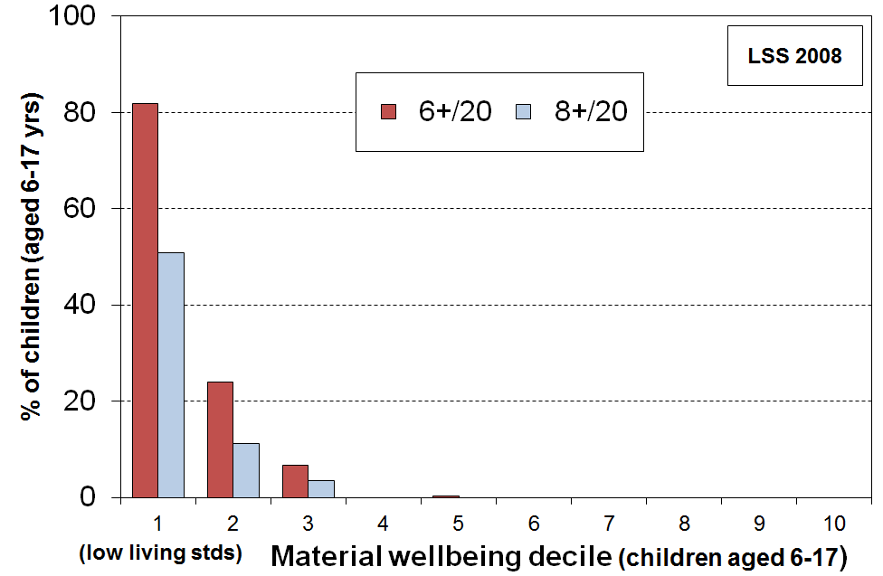

The 20 items used in the calibration list for Figure A.2 are specified in Tables D.9.
- Examples of the 12 child specific items: no waterproof coat, no warm winter clothes, no separate bed, incomplete school uniform, unable to have friends to birthday party, participation in sport restricted “a lot” (because of lack of money or the need to use available money for other basics).
- Examples of the 8 general household deprivations: inability to keep main rooms warm, dampness and mould a major problem, received help with food / clothes from a food bank or community group more than once in last 12 months (same reasons as for child items).

Note that even in the bottom MWI decile (ie even for the 10% of children in most severe hardship) it is not the case that all these children suffer all or even most of the deprivations listed. It is rather (a) that society expects that no child should lack any one of the specified items / all children should have them all, and (b) that this group on average experiences a good number of these lacks, whereas the vast majority of children do not experience any of them at all.

While the use of material deprivation or hardship indices in addition to income measures is a welcome advance, there are some fundamental aspects of the notion of ‘poverty’ that mean that it will always be an awkward term. For example:

- Judgement calls are needed to decide where to draw the lines to identify the (income) poor or those in material hardship. Different judgements lead to different reported levels of hardship or poverty, though the range of plausible thresholds is in practice relatively narrow once all the evidence is considered. This ambiguity and difference in value judgements can be dealt with in part by accepting that poverty and hardship exist on a spectrum from more to less severe, and by regularly and as a matter of course using a range of measures to track progress. This is further discussed in Section D, where the report sets out its approach to setting hardship thresholds.

- Whatever else poverty is understood to be, it is in its essence an unacceptable state-of-affairs – it carries with it the implication that something should be done about it. How best to address poverty, especially child poverty, is a vigorously contested area where empirical evidence, social norms, personal values, views on inter-generational equity, political philosophy and pragmatic compromise all play legitimate parts. Different judgements on these matters lead to different ‘solutions’.

- Yet, just as with the question of where to set low-income or material hardship thresholds, there is in practice a fairly limited range of options for governments when it comes to seeking to reduce child poverty. All richer countries have adopted a multi-pronged approach, reflecting the range of causes of poverty. The difference from one government to another and one state to another reflects to a large degree the different understandings of the relative size of the impact of different causes, decisions on trade-offs with other priorities, and the consequent different weightings given to the different interventions.

Factors behind the rise in the use of
non-monetary indicators (NMIs) or non-income measures (NIMs)

There is increasing acceptance internationally that in addition to income-based measures, non-monetary indicators (NMIs) / non-income measures (NIMs) are needed to provide a more comprehensive and accurate picture of the material wellbeing of households. Income-based measures can be seen as indicators of “command over resources” or as proxies for the “inputs” into material wellbeing.

The impetus for pursuing this other perspective comes from several factors:
- an interest in developing a better understanding of the actual material circumstances of households with low incomes
- an increasing awareness of the limitations of relying on income-based measures alone for assessing household material wellbeing and hardship (as shown in the diagram on p7), and especially so in periods of economic upheaval (cf Whelan and colleagues, 2016)
- a growing unease about the robustness of international comparisons using income-based measures
- a growing understanding of the multi-dimensional nature of poverty and material hardship and the need to identify these and the relationships between them
- the availability of richer datasets in many more countries and a maturing of the relevant methodologies for analysis of data based on NIMs.

The value of a multi-measure perspective

Figure A.3 shows the differing trends for Ireland in recent years using moving and anchored line income poverty measures and a material hardship measure (based on non-monetary indicators). The fully relative income poverty measure only just picked up the impact of the GFC downturn because the median was falling, masking the increasing numbers whose real incomes were falling. This latter was picked up by the anchored line income poverty measure (green). The material hardship measure also picked up the impact on households of the downturn. Both the hardship measure and the anchored line income measure have shown improving trends in the recovery, but the fully relative line has not, remaining flat.
Figure A.3
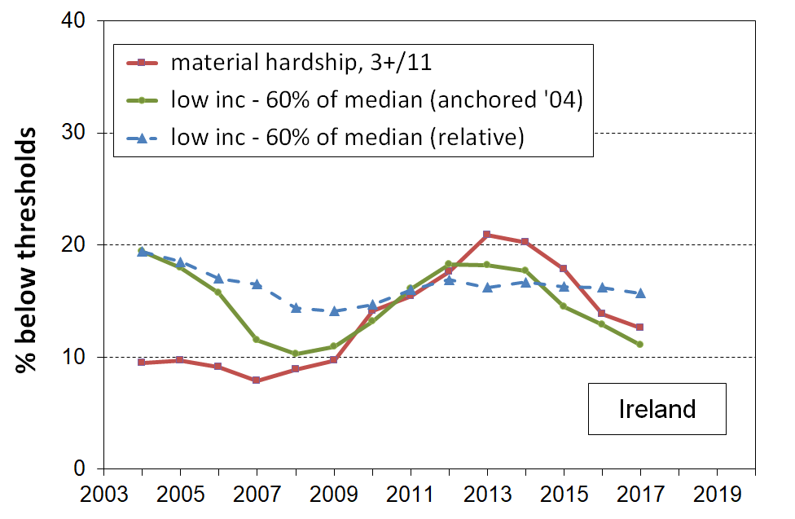
Low income and material hardship in Ireland
The chart for Ireland also shows how material hardship measures can show greater percentage point changes compared with what is shown for even anchored line income poverty measures over the same period. This does not mean, for example, that material hardship in Ireland became ‘really bad’ whereas income poverty just became ‘a little worse’. It simply reflects two features of the use of material deprivation indices for time series: (a) by their construction they are more sensitive than income measures to changing household circumstances, when looking at percentage point changes, and (b) many households live in an ‘only-just-getting-by’ mode and even a small loss in income can easily lead to them moving below a hardship threshold.

The similar chart for Spain (Figure A.4) even more clearly shows the differing low-income trends using fully relative and anchored line BHC measures. The anchored line measure picks up the impact of rising real incomes before the GFC and the downturn during and after the GFC. Reported anchored line ‘poverty’ rates first fell as incomes improved, then rose as many households saw their incomes fall. On the other hand, the fully relative measure remained steady, giving no indication of the increasing financial difficulties experienced by many households in Spain. The flat trend reflects the fact that, on the fully relative measure, a falling median means a falling poverty line. The material hardship measure also picked up the downturn, though not as well as in Ireland as the index used is inferior to Ireland’s, having only 9 items and not being well specified (the researchers had to use what existed at the time – the EU index is now much higher quality but the data is available only from 2014 on).
Figure A.4
Low income and material hardship in Spain
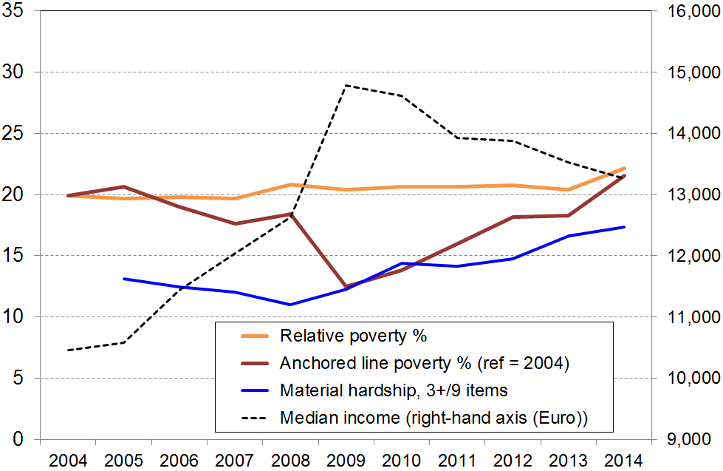
Including causes, consequences and correlates: a wider use of “poverty”

Sometimes ‘poverty’ is used very widely to cover an extended range of aspects of social and material disadvantage, including some of the mooted causes and consequences of low income and material hardship. It then becomes a catchall term for a long list of social and material bads which is not helpful for clear and productive discussion.

The MSD reports encourage the practice of keeping a clear distinction between the core experiences of low income and material hardship on the one hand, and their causes and consequences and other associated disadvantage on the other. To have a more complete understanding it is of course important to monitor trends and levels in all these aspects.

Section B
Data sources and Indices

This section:
- notes the main New Zealand data sources that include non-income measures (NIMs) / non-monetary indicators (NMIs)
- lists the indices used in this report and in other MSD research
- provides the item lists for the EU-13, DEP-17 and MWI indices.
- notes the value and limitations of the HES for the purposes of the reports.

There are three types of NIMs that are of relevance to this report:
- general household items (eg being able to keep the house warm);
- individual adult respondent items (eg having a set of clothes for important or special occasions);
- child-specific items (eg two sets of warm winter clothes for each child, a separate bed for each child).

The following should be read in conjunction with Table B.1 on the next page

- MSD’s Living Standards Surveys (2004, 2008) have a large number of items of each type.

- Stats NZ’s Household Economic Survey (HES) includes a set of 25 items of the general household and adult respondent types from 2006-07 to 2011-12, then a revised set of 29 items from 2012-13 to 2014-15. The 29-item set uses 12 of the earlier 25 items. HES 2016 to HES 2018 include 6 new household / respondent items (eg access to a car or van for private use). A suite of 21 child-specific items was included in HES 2016 and is scheduled to be included each three years.

- Stats NZ’s General Social Survey (GSS) has the same 25 items as the HES in 2008, 2010 and 2012, then a smaller 9-item set in 2014, 2016 and 2018.

- Stats NZ’s longitudinal Survey of Family, Income and Employment (SoFIE) has an 8 item set of the general household and adult respondent types (NZiDep).
Table B.1
Indices and data sources
Index | Description | Data sources
EU-9 | A 9 item material deprivation index used officially by the EU. | LSS 2008
EU-13 | A 13 item material and social deprivation index used by European researchers for some time and recently (May 2017) formally adopted by the EU to replace EU-9. | LSS 2008  HES 2016 and later
DEP-17 | A 17 item deprivation index developed and used by MSD (sometimes referred to as ‘MSD’s material deprivation index’). | LSS 2008  HES 2013 and later
ELSI  ELSI-SF | ELSI is MSD’s prototype full-spectrum index using 40 NIMs to cover the range from low to high material living standards. The short-form (SF) version uses 25 items. The ELSI has been replaced by the MWI. | LSS 2000, 2004 and 2008  HES 2007 to 2012 have the 25 ELSI-SF items  GSS 2008, 2010 and 2012 have the 25 ELSI-SF items
MWI  MWI-9 | MSD’s Material Wellbeing Index (MWI) is a 24 item index covering the full spectrum of material wellbeing from low to high. It was developed as a ‘mark 2 ELSI’, incorporating what was learnt from using the prototype. The short-form version has 9 items. | LSS 2008  HES 2013 and later  GSS 2014 to 2018 (MWI-9 only)
NZiDep | NZiDep is an 8 item deprivation index developed by Wellington School of Medicine researchers. | SoFIE (and the 2006-07 and 2013-14 NZ Health Surveys)
NZDep | Unlike all the indices above, NZDep is not a household- or family-based index. It is based on information from households within a small area, using Census items such as income, benefit status, home ownership, car ownership and so on. NZDep uses the average score from all households in the area, then ranks the small areas using a decile system. There is naturally some variation of material wellbeing across households in a given small area, even though they all have the same NZDep score. | Census
IMD | Auckland University’s New Zealand Index of Multiple Deprivation | Census, admin data, IDI

Three types of child material hardship indices

In broad terms, there are three types of child material hardship indices.
- Those that use only child-specific items (based on information from the household respondent). An example of this is the MODA measure used in UNICEF’s 2017 Report Card #14 (Multidimensional Overlapping Deprivation Analysis tool). A limitation of this approach is that it does not take account of a wide range of general household items that are very relevant to the material wellbeing of children of the household (eg keeping home warm, no dampness or mould, access to private vehicle, getting appliances repaired or replaced, and so on). It also cannot be used to compare children with other age-groups and households.
- Those that use both child-specific and general household items. An example of this is the new Child Material and Social Deprivation Index recently developed by UK and European researchers. This addresses the first issue noted above, but still cannot be used to compare children with others.
- Those that use only general household items and items that relate to the adult respondent. This approach addresses both the issues above, but leaves hanging the question as to whether a general household index reasonably reflects the situation of the children in the household. For the purposes of ranking countries in league tables the second and third approaches give very similar results.
This report uses the third approach as cross-group comparisons are priority outputs. It uses the second approach to assist with scale calibration – see Figures D.3 and D.4. The report does not use the first one at all, but reports on individual child-specific items and how their lack is distributed across household income or material well-being deciles.
No items are available that have information based on the responses of children themselves.

Table B.2
Composition of EU-13
Seven household deprivations (enforced lacks)
ability to face unexpected expenses of NZD1500
have one week’s annual holiday away from home
avoid arrears in mortgage or rent, utility bills or HP instalments
have a meal with meat, fish or chicken every second day
keep the home adequately warm
have access to a car / van for personal use
replace worn-out furniture
Six personal deprivations (enforced lacks)
replace worn-out clothes by some new ones
have two pairs of properly fitting shoes
spend a small amount of money each week on oneself
have regular leisure activities
have a get together with friends/family for a drink/meal at least monthly
have both a computer and an internet connection

Table B.3
Composition of DEP-17
Enforced lack of essentials (for respondent or household as a whole)
meal with meat, fish or chicken (or vegetarian equivalent) at least each 2nd day
two pairs of shoes in good repair and suitable for everyday use
suitable clothes for important or special occasions
presents for family and friends on special occasions
home contents insurance
Economised, cut back or delayed purchases ‘a lot’ because money was needed for other essentials (not just to be thrifty or to save for a trip or other non-essential)
went without or cut back on fresh fruit and vegetables
bought cheaper cuts of meat or bought less than wanted
put up with feeling cold to save on heating costs
postponed visits to the doctor
postponed visits to the dentist
did without or cut back on trips to the shops or other local places
delayed repairing or replacing broken or damaged appliances
In arrears more than once in last 12 months (because of shortage of cash at the time, not through forgetting)
rates, electricity, water
vehicle registration, insurance or warrant of fitness
Financial stress and vulnerability
borrowed money from family or friends more than once in the last 12 months to cover everyday living costs
feel ‘very limited’ by the money available when thinking about purchase of clothes or shoes for self (options were: not at all, a little, quite limited, and very limited)
could not pay an unexpected and unavoidable bill of $500 within a month without borrowing
Note: an enforced lack is an item that is wanted but not possessed because of the cost.
Table B.4
The composition of the MWI and DEP-17, and how each item is scored for the two indices
(the table lists all 29 items in the HES from HES 2012 to HES 2015 – see next page for new items in HES 2016)
Item description |  | MWI | DEP-17
Ownership or participation (have/do, don’t have/do and enforced lack (EL))
For DEP-17, score an EL as 1, otherwise 0
For MWI, score an EL as a 0, otherwise 1
1 | Two pairs of shoes in a good condition and suitable for daily activities | ✓ | ✓
2 | Suitable clothes for important or special occasions | ✓ | ✓
3 | Contents insurance | ✓ | ✓
4 | A meal with meat, fish or chicken (or vegetarian equivalent) at least each 2nd day | ✓ | ✓
5 | A good bed | ✓ | -
6 | Presents for family/friends on special occasions | ✓ | ✓
7 | Holiday away from home at least once every year | ✓ | -
8 | Overseas holiday at least once every three years | ✓ | -
Economising (not at all, a little, a lot) – to keep down costs to help in paying for (other) basic items (not just to be thrifty or to save for a trip or other non-essential)
For DEP-17, score ‘a lot’ as 1, otherwise 0
For MWI, score ‘not at all as 2, ‘a little’ as 1, and ‘a lot’ as 0
9 | Gone without or cut back on fresh fruit and vegetables | ✓ | ✓
10 | Buy cheaper cuts of meat or bought less meat than you would like | ✓ | ✓
11 | Continued wearing worn out clothes | ✓ | -
12 | Put up with feeling cold | ✓ | ✓
13 | Do without or cut back on trips to the shops or other local places | ✓ | ✓
14 | Delay replacing or repairing broken or damaged appliances | ✓ | ✓
15 | Spent less on hobbies or other special interests than you would like | ✓ | -
16 | Postponed visits to the doctor | ✓ | ✓
17 | Postponed visits to the dentist | ✓ | ✓
Housing problems (no problem, minor problem, major problem … in the last 12 months)
For MWI, score as 2, 1 and 0 respectively.
18 | Dampness or mould | ✓ | -
19 | Heating or keeping it warm in winter | ✓ | -
Freedoms/Restrictions
20 | When buying, or thinking about buying, clothes or shoes for yourself, how much do you usually feel limited by the money available? (4 point response options: ‘not at all limited, a little limited, quite limited, very limited)  For DEP-17, score ‘very limited’ as 1, otherwise 0.  For MWI, score as 3, 2, 1 and 0 respectively. | ✓ | ✓
21 | $300 spot purchase for an ’extra’, not a necessity – how limited do you feel about buying it? (5 point response options: not at all limited, a little limited, quite limited, very limited, couldn’t buy it)  For MWI, score as 4, 3, 2, 1 and 0 respectively. | ✓ | -
22 | $500 unexpected unavoidable expense on an essential – can you pay in a month without borrowing? (yes/no)  For DEP-17, score ‘no’ as 1, and ‘yes’ as 0  For MWI, score ‘yes’ as 2 and ‘no’ as 0 | ✓ | ✓
Financial strain (in last 12 months) (not at all, once, more than once)
For DEP-17, score ‘more than once’ as 1, otherwise 0
For MWI, score ‘not at all’ as 2, ‘once’ as 1, ‘more than once’ as 0
23 | Behind on rates or utilities | ✓ | ✓
24 | Behind on car registration, wof or insurance | ✓ | ✓
25 | Behind on rent or mortgage | - | -
26 | Borrowed from family or friends to meet everyday living costs | - | ✓
27 | Received help in the form of food, clothes or money from a welfare or community organisation such as a church or food bank | - | -
Global self-ratings
28 | Adequacy of income to cover basics of accommodation, food, clothing, etc | - | -
29 | Satisfaction with life | - | -
Six new items in the HES 2016 and later

Ownership or participation (3)
- Access to car or van for personal use
- Access to both a computer and internet connection at home
- Have a get together with friends or extended family for a drink or meal at least once a month

Economising (1)
- Delay replacing or repairing broken or worn out furniture

Financial strain or freedoms (2)
- $1500 unexpected unavoidable expense on an essential – can you pay in a month without borrowing? (yes/no)
- About how much money, on average, do you have each week for spending on things for yourself without consulting anyone else? (under $10, 10-25, 26-50, >50)

Section C
International comparisons of material hardship using EU-13

GDP per capita and similar measures are commonly used as indicators of economic performance and social progress. Such measures have a range of well-known limitations for these purposes. One of particular relevance for this report is that while, at best, they can give an indication of trends in average living standards, they do not give any information on the distribution of living standards across households within countries.

International comparisons of the distribution of living standards or material wellbeing at the household level are traditionally done by using household incomes. When the focus is on financial hardship, “poverty lines” are often set at 50% or 60% of the median household income. International league tables which rank countries on their income poverty (low-income) rates are now commonly created and published. There is however growing unease about the robustness of the household income approach for international comparisons of material wellbeing, and especially for “poverty” comparisons. These concerns arise from both theoretical-conceptual and empirical considerations. For example:
- The income-wealth-material wellbeing framework used in this report and elsewhere (see Figure A.1 above) draws attention to the fact that there are several key factors other than income that determine a household’s material wellbeing or living standards. Thus, household income can only be a rough proxy for material wellbeing.
- When the relative low-income measures are used in international comparisons they are best understood as measures of inequality in the lower half of the distribution.
- The income approach can produce incongruous results for “poverty” rates in richer countries. For example, on this approach the Czech Republic has a poverty rate of 9% in 2012, lower than the rates for Denmark and Finland (12%), and Germany (16%), yet the poverty lines in each of the latter three countries were all above the median household income level for the Czech Republic.
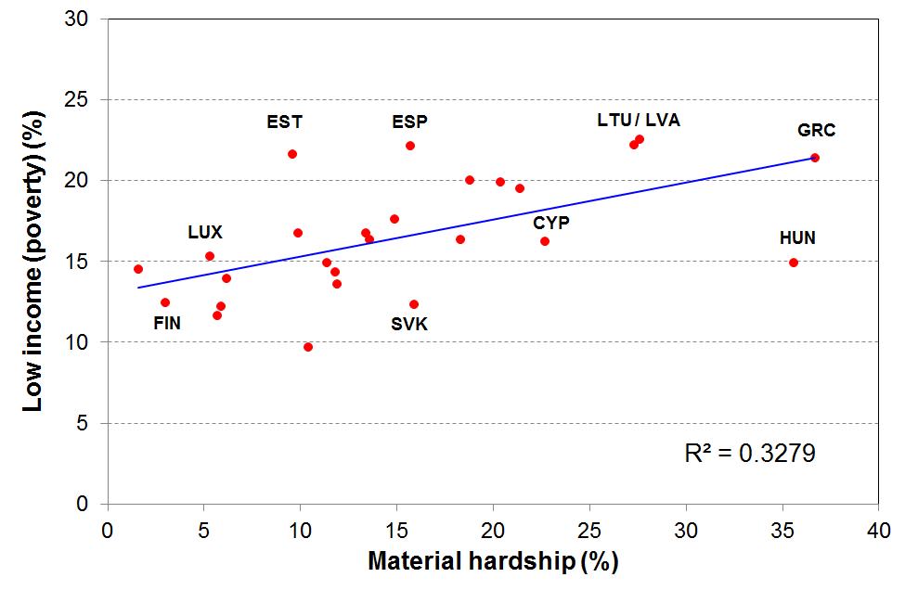
- The chart below uses 2015 EU data and shows that countries with very similar “poverty” rates can have quite different deprivation rates. For example, Luxembourg and Hungary both have 15% low-income (poverty) rates, but very different deprivation rates.
Sources: Low income rates are from http://ec.europa.eu/eurostat/data/database , and the hardship rates from https://www.liser.lu/?type=news&id=1426
Partly in response to these concerns, the EU developed and in 2009 adopted a 9-item deprivation index based on non-income items / deprivations as one of its primary social inclusion indicators. At the time there was a limited pool of items in the source data from the EU-SILC (Survey of Income and Living Conditions). The pool was enlarged in 2009 and EU researchers developed a new 13-item index based on this expanded dataset. The EU adopted this new index in May 2017 as its official measure, renaming it the ‘material and social deprivation index’.

In developing the 2008 Living Standards Survey (2008 LSS), the EU’s plans for their 9-item index (EU-9) and their 2009 EU-SILC enlargement were monitored and MSD included the relevant questions in the 2008 LSS. Deprivation scores for New Zealand have been created for EU-9, with comparative international findings published in Perry (2009).

The new and improved EU index (EU-13) is made up of the thirteen items listed in Table C.1 below. The items are scored as “enforced lacks” – that is, the items were not possessed because of the cost rather than for some other reason. EU researchers using the EU-13 and 2009 data used a threshold of 5 or more enforced lacks to identify those experiencing “standard” material deprivation, and those with 7 or more as in “severe” material deprivation. When the measure became official, the 5+/13 threshold was selected as the “standard” measure and no “severe” threshold was specified.

Table C.1
Composition of EU-13
Seven household deprivations (enforced lacks)
ability to face unexpected expenses of NZD1500
have one week’s annual holiday away from home
avoid arrears in mortgage or rent, utility bills or HP instalments
have a meal with meat, fish or chicken every second day
keep the home adequately warm
have access to a car / van for personal use
replace worn-out furniture
Six personal deprivations (enforced lacks)
replace worn-out clothes by some new ones
have two pairs of properly fitting shoes
spend a small amount of money each week on oneself
have regular leisure activities
have a get together with friends/family for a drink/meal at least monthly
have both a computer and an internet connection

MSD’s 2008 LSS data enabled the creation of EU-13 for New Zealand to give reasonable (albeit, not perfect) international comparisons, reported in earlier reports. The new items in the 2016 HES enable the creation of the EU-13 once again for New Zealand, but the uncertainties with the 2016 and 2017 material hardship items especially means that there are no new EU-13 findings.

A feature of EU-13 and many other similar indices is that they use a mix of items that tap into or reflect different depths of material deprivation. For example, there is a strong consensus that “keeping the home adequately warm” is a necessity on any standard, whereas “having a week’s holiday away from home” is not necessary for survival, but is considered a necessity by around 50% (in the EU) for having a “minimum acceptable standard of living”. Rather than being a weakness of the index, the use of a range of items is a strength as it allows for the fact that there is some variation among those less well-off as to precisely what they cut back on to try to make ends meet. An index with an almost total focus on the very bottom end could not reflect these nuances in its rankings.

When using material deprivation indices such as EU-13 it is important to recognise what they are and what they are not:
- They are designed as instruments to rank households by their differing degrees of material hardship, using a mix of items that tap into differing levels of hardship and which are reasonably equally applicable to people in different age groups and household types.
- They do not purport to use the (13) most important or most serious deprivations – the selection process for such an approach would be fraught and would not be likely to command widespread support.

In the international comparisons that follow, the graphs use 20 European countries (19 EU countries plus Norway), and the tables use 27 (all the EU countries at the time of the survey (27) less Bulgaria and Romania, plus Norway and Iceland).

At the time of the 2009 EU-SILC survey the EU had 27 member states (Table C.2) – the 15 “old” member states from western and southern Europe, the 10 “new” member states added in 2004 (Malta, Cyprus and eight eastern European countries), plus Bulgaria and Romania added in 2007. Bulgaria and Romania are omitted from the graphs and tables that follow as their general standard of living is much lower than New Zealand’s. Malta and Cyprus are very small and are also omitted from the graphs. There is no tradition of comparing New Zealand with Hungary, Poland, Latvia and Lithuania, so they too are omitted from the graphs. Estonia, Slovenia, Slovakia and the Czech Republic are included as their rankings are now often in the same ballpark as New Zealand and some of the “old” EU-15. Norway is not a member of the EU, but data is generally available for Norway as it participates in EU-SILC. The international comparisons that follow therefore use 20 European countries for the graphs (27-2-6+1), though a fuller suite is reported on in the tables.

Table C.2
EU countries
“Old” Member States |  | “New” Member States
Belgium | BE | 2004 Enlargement
Denmark | DK | Czech Republic | CZ
Germany | DE | Estonia | EE
Ireland | IE | Cyprus | CY
Greece | EL | Latvia | LV
Spain | ES | Lithuania | LT
France | FR | Hungary | HU
Italy | IT | Malta | MT
Luxembourg | LU | Poland | PL
Netherlands | NL | Slovenia | SI
Austria | AT | Slovakia | SK
Portugal | PT
Finland | FI | 2007 Enlargement
Sweden | SE | Bulgaria | BG
United Kingdom | UK | Romania | RO

Material hardship comparisons with OECD countries not in the EU (eg Japan, USA, Australia and Canada) are not possible as there are as yet no national surveys in these countries with all the relevant items in them.
Comparisons for the whole population (2008-09)

Using the EU-13 index, 11% of the New Zealand population had 5 or more enforced lacks, ranking New Zealand alongside Austria, Spain, the UK, Belgium and Ireland, at the median for the 20 selected European countries and a little below the median for the full 27 EU members (12%). Many of the newer EU countries had much higher rates of deprivation, as did Portugal and Greece. See Figure C.1 and Table C.3.

Using the EU’s “severe” material deprivation measure (7+/13), country rankings were very similar to those using the 5+/13 measure (correlation =0.98). New Zealand’s “severe deprivation” rate of 4% was a little below the EU’s median “severe” rate of just under 6%.

Figure C.1
Material deprivation rates (% with 5+ and 7+ enforced lacks), EU-13, whole population
20 European countries + NZ, ranked on % with 5+, (EU-SILC 2009, NZ LSS 2008)
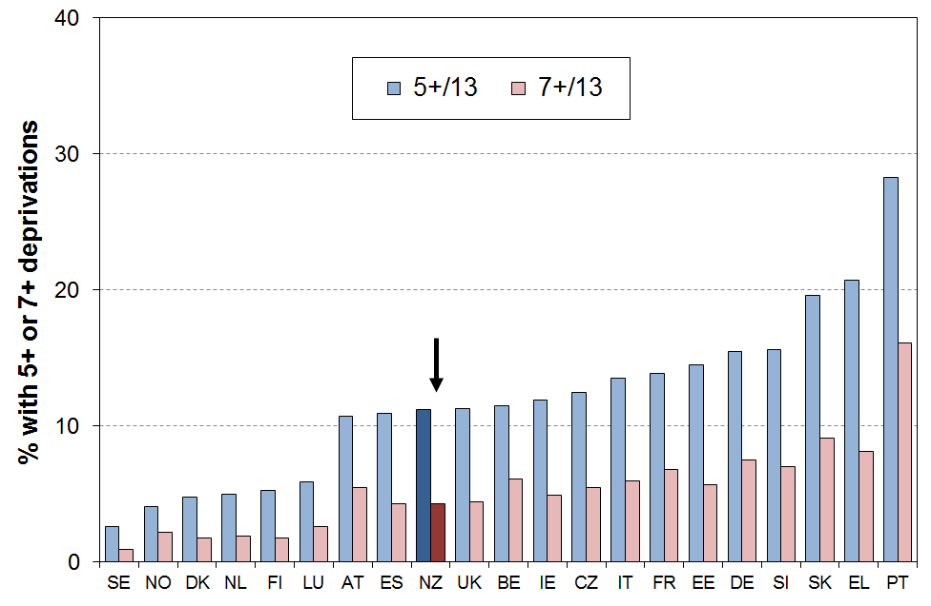

Table C.3
Material deprivation rates (% with 5+ and 7+ enforced lacks), EU-13, whole population
EU-25 + NO + IS + NZ, ranked on % with 5+, (EU-SILC 2009, NZ LSS 2008)
 |  | % with 5+/13  “standard” MD | % with 7+ /13  “severe” MD |  |  | % with 5+/13  “standard” MD | % with 7+ /13  “severe” MD
Sweden | SE | 3 | 1 | Czech Republic | CZ | 13 | 6
Iceland | IS | 3 | 2* | Italy | IT | 14 | 6
Norway | NO | 4 | 3* | France | FR | 14 | 7
Denmark | DK | 5 | 2 | Estonia | EE | 15 | 6
Netherlands | NL | 5 | 2 | Germany | DE | 16 | 8
Finland | FI | 5 | 2 | Slovenia | SI | 16 | 7
Luxembourg | LU | 6 | 3 | Malta | MT | 19 | 7
Austria | AT | 11 | 6 | Slovakia | SK | 20 | 9
Spain | ES | 11 | 4 | Greece | EL | 21 | 8
New Zealand | NZ | 11 | 4 | Poland | PL | 26 | 14
United Kingdom | UK | 11 | 4 | Portugal | PT | 28 | 16
Belgium | BE | 11 | 6 | Lithuania | LT | 31 | 18
Ireland | IE | 12 | 5 | Latvia | LV | 43 | 26
Cyprus | CY | 12 | 4 | Hungary | HU | 44 | 26

* Estimated by author.

Using the 2017-18 HES data (= ‘2017’ in EU notation), the population rate for the ‘standard’ threshold was 9%. NZ’s ranking is similar to what it was in 2008 and 2009. A full update is planned for the next report using the larger HES 2018-19 dataset.
Comparisons for those aged 65+ (2008-09)

Older New Zealanders have a much lower material deprivation rate (3%) than their counterparts in almost all European countries (Figure C.2 and Table C.4). New Zealand ranks alongside Norway, Sweden, Denmark and the Netherlands for having very low material deprivation rates for those aged 65+, using the 5+ threshold with the EU-13 index. Using the “severe deprivation” threshold of 7+/13, New Zealand still ranks at the top of the chart. Even richer western European countries such as Germany (10%) and France (11%) have much higher rates than New Zealand. Many of the newer eastern European EU members have very high rates (eg Hungary at 36%), with Portugal only a little better at 32%.

Figure C.2
Material deprivation rates (% with 5+ and 7+ enforced lacks), EU-13, those aged 65+
20 European countries + NZ, ranked on % with 5+, (EU-SILC 2009, NZ LSS 2008)
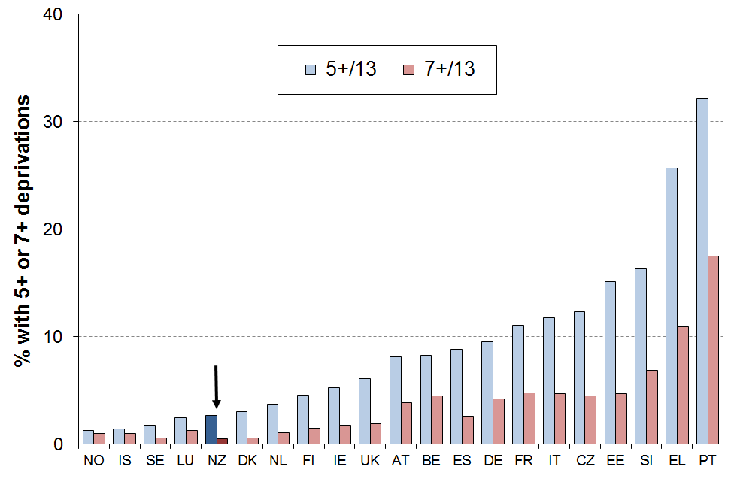

Table C.4
Material deprivation rates (% with 5+ and 7+ enforced lacks), EU-13, those aged 65+
EU-25 + NO + IS + NZ, ranked on % with 5+, (EU-SILC 2009, NZ LSS 2008)
 |  | % with 5+/13  “standard” MD | % with 7+ /13  “severe” MD |  |  | % with 5+/13  “standard” MD | % with 7+ /13  “severe” MD
Norway | NO | 1 | <1* | France | FR | 11 | 5
Iceland | IS | 1 | <1* | Italy | IT | 12 | 5
Sweden | SE | 2 | 1 | Czech Republic | CZ | 12 | 5
Luxembourg | LU | 3 | 1 | Estonia | EE | 15 | 5
New Zealand | NZ | 3 | 1 | Cyprus | CY | 16 | 5
Denmark | DK | 3 | 1 | Malta | MT | 16 | 6
Netherlands | NL | 4 | 1 | Slovenia | SI | 16 | 7
Finland | FI | 5 | 2 | Slovakia | SK | 23 | 10
Ireland | IE | 5 | 2 | Greece | EL | 26 | 11
United Kingdom | UK | 6 | 2 | Poland | PL | 29 | 13
Austria | AT | 8 | 4 | Portugal | PT | 32 | 18
Belgium | BE | 8 | 5 | Hungary | HU | 36 | 19
Spain | ES | 9 | 3 | Lithuania | LT | 36 | 21
Germany | DE | 10 | 4 | Latvia | LV | 47 | 25

* Estimated by author.

Using the 2017-18 HES data (= ‘2017’ in EU notation), the 65+ hardship rate for the ‘standard’ threshold was 3%. NZ’s ranking is similar to what it was in 2008 and 2009. A full update is planned for the next report using the larger HES 2018-19 dataset.
Comparisons for children (aged 0-17 years) (2008-09)

New Zealand children have a material hardship rate of 18% on the EU-13 measure (5+/13 threshold). This ranks New Zealand at the ‘low’ (ie higher hardship rates) end of the old EU for hardship rates for children, similar to Italy, Ireland and France (17%), and the UK (16%), and better than Germany (21%) and Greece (22%). In contrast to the comparisons for those aged 65+, New Zealand’s child deprivation rates are much higher than countries like Sweden, Denmark, Norway, Finland and the Netherlands (3-6%). See Figure C.3 and Table C.5.

Using the “severe” deprivation threshold (7+/13), New Zealand’s rate for children is 8%. This is a little higher than the median, similar to Belgium, Italy and France. There is however no evidence of any greater depth of hardship for New Zealand children when compared with countries with similar “standard” EU hardship rates (ie the ratio of the more “severe” hardship rate to the “standard” rate is in the middle of the bunch).

Figure C.3
Material deprivation rates (% with 5+ and 7+ enforced lacks), EU-13, those aged 0-17 years
20 European countries + NZ, ranked on % with 5+, (EU-SILC 2009, NZ LSS 2008)
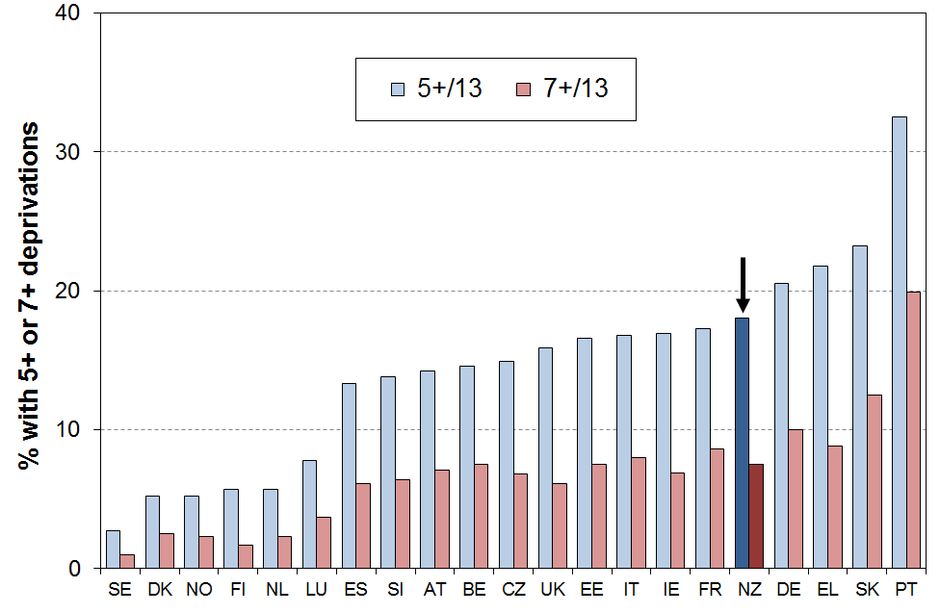

Table C.5
Material deprivation rates (% with 5+ and 7+ enforced lacks), EU-13, 0-17 yrs
EU-25 + NO + IS + NZ, ranked on % with 5+, (EU-SILC 2009, NZ LSS 2008)
 |  | % with 5+/13  “standard” MD | % with 7+ /13  “severe” MD |  |  | % with 5+/13  “standard” MD | % with 7+ /13  “severe” MD
Sweden | SE | 3 | 1 | Estonia | EE | 17 | 8
Iceland | IS | 4 | 2 | Italy | IT | 17 | 8
Denmark | DK | 5 | 2 | Ireland | IE | 17 | 7
Norway | NO | 5 | 2 | France | FR | 17 | 9
Finland | FI | 6 | 2 | New Zealand | NZ | 18 | 8
Netherlands | NL | 6 | 2 | Germany | DE | 21 | 10
Luxembourg | LU | 8 | 4 | Greece | EL | 22 | 9
Cyprus | CY | 10 | 4 | Malta | MT | 23 | 9
Spain | ES | 13 | 6 | Slovakia | SK | 23 | 13
Slovenia | SI | 14 | 6 | Poland | PL | 27 | 15
Austria | AT | 14 | 7 | Lithuania | LT | 30 | 19
Belgium | BE | 15 | 8 | Portugal | PT | 33 | 20
Czech Republic | CZ | 16 | 7 | Latvia | LV | 45 | 30
United Kingdom | UK | 16 | 6 | Hungary | HU | 52 | 33

* Estimated by author.

Using the 2017-18 HES data (= ‘2017’ in EU notation), the hardship rate for children for the ‘standard’ threshold was 15%. NZ’s ranking is similar to what it was in 2008 and 2009. A full update is planned for the next report using the larger HES 2018-19 dataset.
Another aspect to be considered in assessing how children in New Zealand are faring relative to their counterparts in other countries is to compare the child deprivation rate with that for the population as a whole. The ratio of these two figures is called the risk ratio (see Box below).

Figure C.4 shows that for most countries the risk ratio is greater the 1.0, meaning that for most countries children are over-represented in hardship figures (the median is 1.2).

The child hardship risk ratio for New Zealand is 1.6, higher than for any of the 20 European countries in the comparison.

When the other EU countries (except for Bulgaria and Romania) are added to the comparison, the median risk ratio drops a little below 1.2 as more of the extra countries have ratios below 1.2 (eg Poland and Cyprus) than above 1.2 (eg Iceland and Malta). New Zealand’s relative position remains unchanged when these other countries are included.

Using the original 9-item index, the ratio for New Zealand is 1.4, higher than all the other countries except the UK (1.5). The median ratio was 1.2 using the EU-9 index.

The deprivation rate for children (18% on this measure) is just above the EU median of 17%. The reason that the risk ratio is so high is that the very low deprivation rate for older New Zealanders pulls down the population rate more than for other countries, thus making the denominator (bottom line) in the calculation of the ratio relatively smaller.

Figure C.4
Deprivation rates for children (0-17 yrs) relative to overall population deprivation rate
(% with 5+ enforced lacks using the EU-13 index)
20 European countries + NZ, (EU-SILC 2009, NZ LSS 2008)
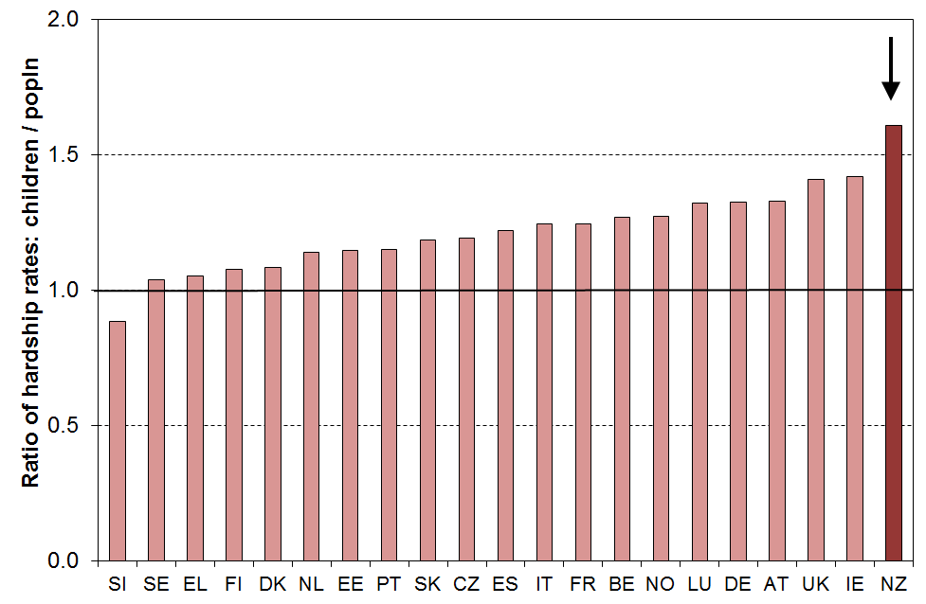

Risk ratio

The risk ratio is a very useful statistic that can be used to succinctly summarise the over- or under-representation of a population subgroup in a hardship category.

The risk ratio can most easily be understood as the ratio of the subgroup’s hardship rate to that for the population as a whole.

An example illustrates the idea. If children have a hardship rate of 20% on a particular measure and the population hardship rate is 10%, then the risk ratio for children is 2 (20/10).

It also means that if children made up 25% of the population overall, then they would make up 50% (2 x 25%) of those in hardship.

Both aspects – the actual deprivation rates and the risk ratios – are important for assessing differences across countries. Figure C.5 combines information from Figures C.3 and C.4 on the one graph.

The countries in the bottom left quadrant (eg Denmark, Netherlands, Finland and Sweden) have below median child deprivation rates and below median risk ratios for children.

In contrast, countries in the top right quadrant (eg the UK, Ireland, Germany and New Zealand) have both above median child deprivation rates and above median risk ratios.

Figure C.5
Deprivation rates for children relative to overall population deprivation rate
(% with 5+ enforced lacks using the EU-13 index)
20 European countries + NZ (EU-SILC 2009, NZLSS 2008)
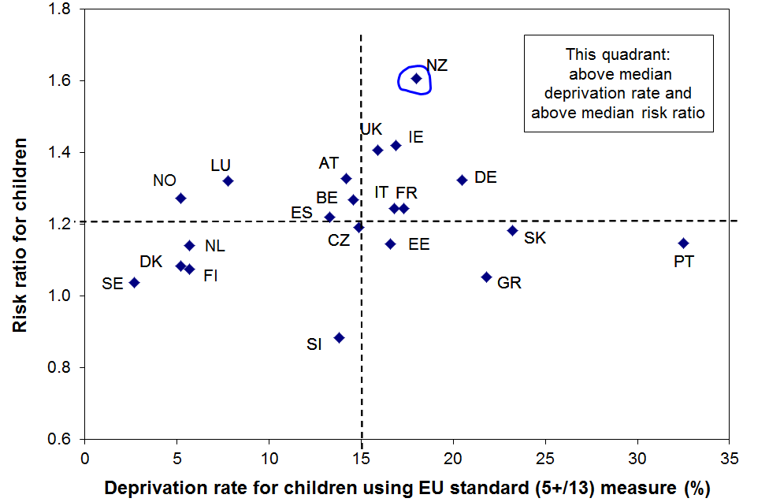

This chart and others in this section will be updated as soon as the EU publishes updated child deprivation rates using the EU-13.
Section D
DEP-17: a deprivation index for
measuring material hardship in New Zealand

The Section:
- defines DEP-17, a 17-item material deprivation index for measuring material hardship in New Zealand
- establishes DEP-17’s credentials
- addresses the question of where to set a reasonable material hardship threshold (cf “the poverty line” for income measures)
- compares selected findings for DEP-17 and EU-13.

This Section in the main uses data from the 2008 Living Standards Survey to illustrate and establish the above, supplemented by analysis using HES data.

The composition of DEP-17

The 17 items are shown in Table D.1 below. The DEP-17 score for each respondent (one per household) is simply the sum of all reported enforced lacks or deprivations. This score is attributed to the respondent and to each other person in the respondent’s household, where there are any. This is the same approach as is taken with household income.

The right-hand columns in Table D.1 show respectively the proportion of all individuals and of children who live in households where the respondent indicated a deprivation of the particular item. Note that five cells are left blank for children to avoid the potential confusion that can arise from the figures there looking as if they are giving information on those specifics for children.

Table D.1
Composition of DEP-17 (LSS 2008),
and the % of people in households for which the respondent reported various deprivations
Item |  | ALL | 0-17 yrs
Enforced lack of essentials (for respondent or household as a whole)
 | meal with meat, fish or chicken (or vegetarian equivalent) at least each 2nd day | 2 | -
 | two pairs of shoes in good repair and suitable for everyday use | 5 | -
 | suitable clothes for important or special occasions | 7 | -
 | presents for family and friends on special occasions | 6 | 7
 | home contents insurance | 12 | 16
Economised, cut back or delayed purchases ‘a lot’ because money was needed for other essentials (not just to be thrifty or to save for a trip or other non-essential)
 | went without or cut back on fresh fruit and vegetables | 10 | 14
 | bought cheaper cuts of meat or bought less than wanted | 27 | 37
 | put up with feeling cold to save on heating costs | 10 | 14
 | postponed visits to the doctor | 11 | -
 | postponed visits to the dentist | 26 | -
 | did without or cut back on trips to the shops or other local places | 15 | 21
 | delayed repairing or replacing broken or damaged appliances | 12 | 19
In arrears more than once in last 12 months (because of shortage of cash at the time, not through forgetting)
 | rates, electricity, water | 11 | 18
 | vehicle registration, insurance or warrant of fitness | 9 | 15
Financial stress and vulnerability
 | borrowed money from family or friends more than once in the last 12 months to cover everyday living costs | 13 | 19
 | feel ‘very limited’ by the money available when thinking about purchase of clothes or shoes for self (options were: not at all, a little, quite limited, and very limited) | 19 | 29
 | could not pay an unexpected and unavoidable bill of $500 within a month without borrowing | 19 | 25
Reading note for table:
The figures in Table D.1 are based on the information provided by the household’s respondent. For example, in the fresh fruit and vegetables row, 10% of the population were in households where the respondent said they (or their partner) went without or cut back “a lot” (rather than “a little” or “not at all”), and 14% of children (aged 0-17yrs) were in such households. Whether all these children (ie 14%) went without fresh fruit and vegetables depends on the arrangements within the household
The distribution of DEP-17 scores across the population

Tables D.2 and D.3 and Figure D.1 below show the distribution of DEP-17 scores for the population and for children (aged 0-17 yrs) using the 2008 LSS data.

The bulk of the population (71%) lives in households reporting two or fewer deprivations from the list of 17, and 6% report 9 or more out of the 17.

Table D.2
Distribution of the DEP-17 scores (% individuals), LSS 2008
Score | 0 | 1 | 2 | 3 | 4 | 5 | 6 | 7 | 8 | 9 | 10 | 11+
ALL (%) | 46 | 15 | 10 | 7 | 5 | 4 | 3 | 3 | 2 | 1 | 1 | 3
0-17 yrs (%) | 33 | 14 | 11 | 10 | 6 | 6 | 4 | 4 | 4 | 2 | 2 | 6

Table D.3
Cumulative distribution of the DEP-17 scores (% individuals), LSS 2008
Score | 0+ | 1+ | 2+ | 3+ | 4+ | 5+ | 6+ | 7+ | 8+ | 9+ | 10+ | 11+
ALL (%) | 100 | 54 | 40 | 30 | 23 | 18 | 14 | 11 | 8 | 6 | 4 | 3
0-17 yrs (%) | 100 | 67 | 53 | 42 | 32 | 26 | 21 | 17 | 13 | 10 | 8 | 6

Figure D.1
Cumulative distribution of the DEP-17 scores for the population and for those aged 0-17 yrs
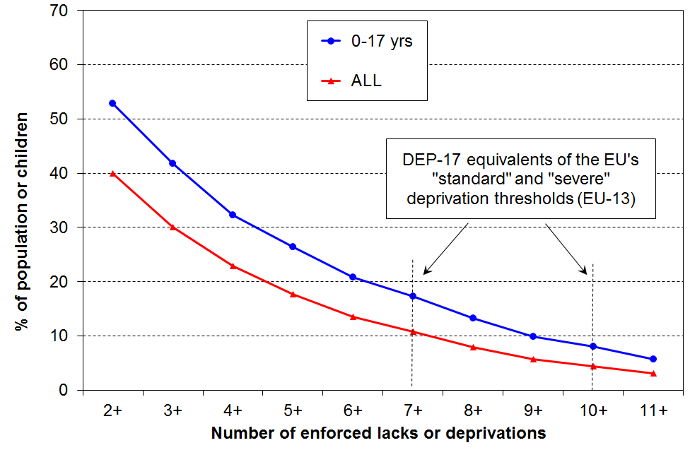

Note: Where the table reports, for example, that 17% of children have a DEP-17 score of 7+/17, it means that 17% of children live in households with a DEP-17 score of 7+/17. This is the same approach as the Incomes Report takes for household income. A “poor” child is one that lives in a household with a household income below a selected threshold.

The different items discriminate at different parts of the material hardship spectrum

Figure D.2 uses selected items from DEP-17 to illustrate how the different component items discriminate across different parts of the DEP-17 spectrum. For example, the “meal with meat” item is focussed on the severe hardship end, whereas the “putting up with being cold” item applies to some households above the hardship zone, while still being very predominant among those with higher DEP-17 scores (high deprivation). Being unable to cope with “an unexpected $500 bill” is something reported by a good number of households above the hardship zone, but still has very high relevance for identifying the more seriously deprived. Table D.4 has all items.

Figure D.2
Reported deprivations by DEP-17 score: different items discriminate at different parts of the spectrum
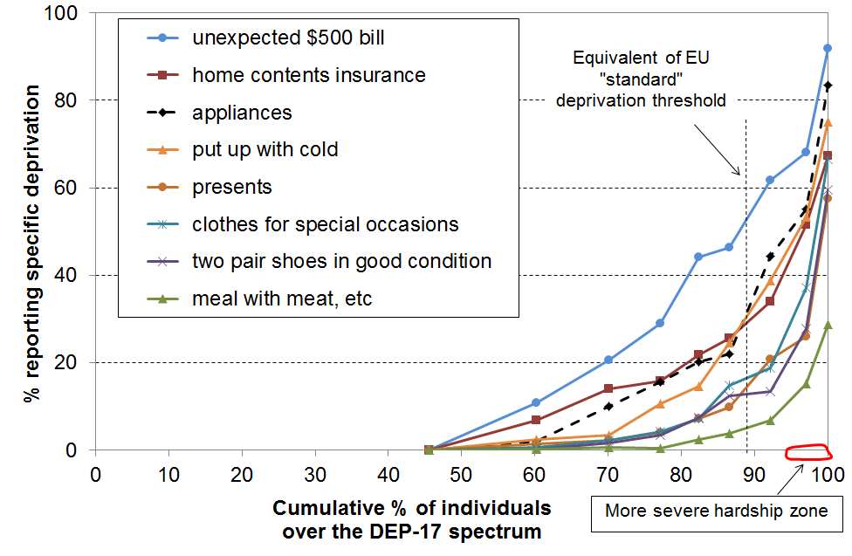

Table D.4
Proportion of population in households whose respondent reported an enforced lack of component items for DEP-17, by DEP-17 score (LSS 2008)
 | ALL | 0 | 1 | 2 | 3 | 4 | 5-6 | 7-8 | 9-10 | 11+
Population % with a given DEP-17 score ➔ | ALL | 46 | 15 | 10 | 7 | 5 | 7 | 5 | 3 | 3
Component items (see Table D.1 above for full descriptions)
meal with meat, fish, chicken, etc | 2 | 0 | 0 | 0 | 0 | 2 | 4 | 9 | 20 | 29
two pair of shoes | 5 | 0 | 0 | 2 | 4 | 8 | 13 | 17 | 31 | 60
presents | 6 | 0 | 2 | 2 | 4 | 7 | 13 | 23 | 28 | 58
clothes for special occasions | 7 | 0 | 0 | 2 | 4 | 7 | 16 | 23 | 47 | 67
arrears in vehicle bills (reg or WoF) | 9 | 0 | 2 | 5 | 8 | 18 | 28 | 34 | 47 | 73
fruit and vegetables | 10 | 0 | 0 | 6 | 11 | 17 | 25 | 49 | 51 | 78
put up with feeling cold | 10 | 0 | 3 | 3 | 11 | 15 | 27 | 47 | 57 | 75
doctor postponed | 11 | 0 | 2 | 8 | 12 | 20 | 28 | 41 | 53 | 75
arrears in electricity / water | 11 | 0 | 3 | 7 | 16 | 25 | 25 | 44 | 53 | 76
home contents insurance | 12 | 0 | 7 | 14 | 16 | 22 | 30 | 37 | 58 | 67
appliances – repair / replace | 12 | 0 | 0 | 10 | 16 | 20 | 28 | 48 | 64 | 84
borrowed from family or friends | 13 | 0 | 4 | 11 | 22 | 23 | 36 | 44 | 60 | 76
local trips | 15 | 0 | 8 | 19 | 21 | 29 | 38 | 48 | 65 | 77
“very limited” re purchase of clothes or shoes | 19 | 0 | 8 | 20 | 25 | 36 | 55 | 74 | 79 | 94
cannot pay unexpected $500 bill | 19 | 0 | 11 | 21 | 29 | 44 | 51 | 63 | 73 | 92
dentist postponed | 26 | 0 | 26 | 35 | 58 | 58 | 58 | 65 | 69 | 92
cheaper/less meat | 27 | 0 | 23 | 35 | 44 | 52 | 66 | 82 | 89 | 94
Note: ‘0’ means <1.5% in this table.

When using deprivation indices such as DEP-17 (and EU-13) it is important to recognise what they are and what they are not:
- They do not purport to use the 17 (or 13) most important or most serious deprivations – the selection process for such an approach would be fraught and would not be likely to command widespread support.
- Rather they are designed as instruments to rank households by their differing degrees of material hardship, using a balanced set of indicators that cover a range of domains and degrees of depth of deprivation, reflect the same underlying concept (or “latent variable”), and which apply reasonably well to people in different age groups and household types.
- Not every conceivable deprivation item has to be used to create a valid and useful index. What is needed is a judiciously selected set of items which tap into the same underlying latent variable. Those lacking these basics are more often than not without other potential index items. That is why EU-13 and DEP-17 give similar results. There is good evidence of a relatively widespread consensus on what basic needs etc are.

Selection of items and the validity and reliability of DEP-17

Validity is about the index measuring what it claims it measures (material hardship). There is no single test to establish validity – it is built up from a range of evidence.

Figure D.2 and Table D.4 provide some of that evidence. Table D.5 uses items from LSS 2008 that are not DEP-17 items, but which are very likely to be strongly associated with material hardship. The information in the table both fills out the profile for living conditions for the various DEP-17 scores and also provides evidence to support the validity of DEP-17 as measuring what it claims to measure, at least at this clumped level.

The figures in the columns in the body of the table are percentages of those with a given DEP-17 score who report the respective deprivations, financial stress, housing problems, and so on.

The gradients are clear and strong in each case, all showing the expected much greater hardship for those with higher DEP-17 scores, and much lower for those with lower DEP-17 scores. This gives good support not only for the validity of DEP-17 (“concurrent validity”), but also shows that there are clear distinctions in living conditions for those with the higher DEP-17 scores.

Table D.5
Proportion of population in households whose respondent reported an enforced lack of selected non-component items for DEP-17, by DEP-17 score (LSS 2008)
DEP-17 score ➔ | 0 | 1 | 2 | 3 | 4 | 5-6 | 7-8 | 9-10 | 11+ | ALL
Population % with a given DEP-17 score ➔ | 46 | 15 | 10 | 7 | 5 | 7 | 5 | 3 | 3 | ALL
good bed for respondent(enforced lack) | 0 | 2 | 3 | 9 | 8 | 11 | 13 | 27 | 44 | 5
attend funeral / tangi (enforced lack) | 0 | 1 | 2 | 7 | 10 | 13 | 21 | 23 | 45 | 21
hairdresser once every three months (enforced lack) | 1 | 4 | 9 | 14 | 19 | 32 | 39 | 58 | 61 | 12
a night out at least once a fortnight (enforced lack) | 4 | 14 | 23 | 25 | 32 | 40 | 46 | 52 | 67 | 18
used food bank or other community assistance (more than once in previous 12 mnths) | 0 | 1 | 1 | 3 | 8 | 11 | 19 | 23 | 38 | 4
pawned goods to get cash for necessities (more than once in previous 12 mnths) | 1 | 2 | 5 | 6 | 7 | 11 | 22 | 32 | 40 | 6
small amt of money for self each week (up to $10)? (no) | 6 | 15 | 20 | 22 | 22 | 29 | 48 | 54 | 67 | 17
major problem with draughts in accommodation | 3 | 8 | 10 | 13 | 16 | 19 | 26 | 41 | 48 | 11
major problem with damp and mould in accommodation | 3 | 7 | 12 | 16 | 20 | 28 | 41 | 33 | 54 | 12
house too small | 3 | 6 | 8 | 8 | 15 | 16 | 24 | 27 | 32 | 8
self-rated physical quality of house – poor or very poor | 1 | 3 | 5 | 6 | 7 | 8 | 20 | 20 | 35 | 5
crime/vandalism in area (major problem) | 4 | 6 | 8 | 10 | 14 | 15 | 18 | 25 | 31 | 8
self-rated material standard of living (low / very low) | 1 | 4 | 7 | 9 | 16 | 23 | 35 | 47 | 44 | 9
self-rated health, poor or fair (<65) | 8 | 11 | 15 | 18 | 24 | 30 | 43 | 45 | 62 | 17
dissatisfied / very dissatisfied with life (from HES) | 3 | 5 | 6 | 10 | 21 | 13 | 22 | 39 | 49 | 9

The strong gradients in Table D.4 raise the question – “if these items show the gradients so clearly why are they not in DEP-17?”

The simplest response is that an index with a large number of items becomes unwieldy and very unattractive to use in surveys, crowding out other items given a fixed time budget for survey length. There has to be some rationing of items, so some good items are inevitably left out.

The more substantial rationale has to do with maintaining the integrity and validity of the index. For example, while the items in Table D.4 show clear gradients at the clumped level of each DEP-17 score, they may not meet the required criteria at the household level. Also, an item may not be appropriate or relevant for all sub-groups (eg hair cut for those without hair), an item may not be wanted by the vast majority (eg 32% of respondents either did not want a night out each fortnight, or had a reason other than cost for not doing so), or the item may not pass the factor analysis test for being sufficiently correlated with the rest of the items (eg house has a major problem with draughts).

The concurrent validity can be examined another way. The conceptual opposite of an enforced lack or of a forced economising (“a lot”) is a “freedom to consume”.

Table D.6 shows the gradient for cumulative freedoms out of a list of 13:
- having a holiday away from home each year for at least a week
- having an overseas holiday every three years
- never having to economise or spend less than desired on meat, fresh fruit and vegetables, hobbies, repairing/replacing furniture, repairing/replacing appliances, local trips to shops etc, visiting family or friends (7 items)
- no restriction when considering purchase of new clothes or shoes for self
- no restriction when considering a spot purchase of a non-essential $250 item;
- can easily find $2000 for an unexpected bill
- self-rating of standard of living is “high” on five point scale from low to high.

The gradients are not only in the expected direction but are quite steep which is what is wanted for a deprivation index (ie a useful and persuasive deprivation index should show that those with moderate to high deprivation scores do not report too many “freedoms to consume”).

Table D.6
Proportion of population in households whose respondent reported multiple “freedoms to consume”,
by DEP-17 score (LSS 2008)
DEP-17 score ➔ | 0 | 1 | 2 | 3 | 4 | 5-6 | 7-8 | 9-10 | 11+ | ALL
Population % with a given DEP-17 score ➔ | 46 | 15 | 10 | 7 | 5 | 7 | 5 | 3 | 3 | ALL
4+ ‘freedoms’ from a list of 13 | 97 | 82 | 69 | 53 | 46 | 26 | 13 | 6 | 0 | 72
6+ ‘freedoms’ from a list of 13 | 87 | 58 | 35 | 21 | 12 | 9 | 2 | 0 | 0 | 54
8+ ‘freedoms’ from a list of 13 | 68 | 27 | 11 | 5 | 3 | 0 | 0 | 0 | 0 | 36

As with any evidence for validity, this does not prove it for DEP-17, but it does add strong support to the case.

Reliability

DEP-17 shows a more than satisfactory level of reliability (internal consistency), using Cronbach’s alpha. For indices of this sort a Cronbach’s alpha of 0.7 to 0.8 is considered respectable, and 0.8 to 0.9 is very good. DEP-17 has an alpha of 0.87, with very good scores for sub-groups as well. The EU-13 scores are given for comparison.

Table D.7
Cronbach’s alpha for DEP-17 and EU-13 (LSS 2008)
 | DEP-17 | EU-13
Whole population | 0.87 | 0.78
0-17 yrs | 0.84 | 0.76
65+ yrs | 0.84 | 0.74
Maori | 0.86 | 0.76
Rural | 0.87 | 0.76

Choosing a hardship threshold for DEP-17 ?

The tables and graph above invite the question – where should the line be drawn so that we can say how many are in hardship and how many are not?

The challenge here is much the same as the one faced when using household income as the indicator of material wellbeing – what low-income threshold or thresholds should be used to identify those in “income poverty” and those “not in poverty”? Material hardship, like income poverty, comes in degrees. There is no clear delineation between those “in hardship” and those “not in hardship” that science can identify independent of judgment. This is not to say that any threshold will do nor that all are equally open to challenge. Some thresholds are clearly much more plausible and defensible than others.

This report uses DEP-17 thresholds in the range of 6+ to 11+ / 17 to examine the characteristics of households with low living standards. It makes no attempt to set “the” threshold, but works within a framework of material hardship existing on a spectrum from less to more severe. The more severe hardship zone is taken as 9+ or more and there would be few who would consider such households to not be in hardship at all (ie not experiencing unacceptably low living standards). There is more room for debate as to where the ‘less severe hardship’ zone should start and finish. For the 2008 LSS data this report uses 7+ as the start of the less severe hardship zone. It also reports using 6+ for sensitivity analysis. The more detailed analysis of the data for children in the next sub-section provides support for this judgment call.

For the purposes of reporting on the composition of those at different depths of hardship and for tracking hardship rates over time for different hardship levels, the approach adopted here is pragmatic, defensible, and produces findings useful for public debate and policy development.

For the purposes of being able to say ‘New Zealand’s material deprivation rate is Y%’, or ‘there are X thousand children in hardship in New Zealand’, this approach does not deliver. That is a consequence of the position taken above in the second paragraph. It is in fact the same position as is taken in the Household Incomes Report for ‘income poverty, and in the Child Poverty reduction Act (2018). It means that the focus can be on understanding what is happening at different depths of hardship, avoiding what are often sterile debates about exactly how many are deemed to be ‘in hardship’, a debate based on the erroneous assumption that such a simple binary division can be robustly made. Using the approach adopted in this report, it could be argued that ‘success’ would be for trend lines at all levels (7+ to 11+) to fall over the medium term. This is a demanding standard.

Table D.8 shows the hardship rates for the whole population and for children using different depths of hardship (in the 7+ to 11+ range), together with the 6+ rates for sensitivity analysis. For children it also shows the number of children and numbers of households with children under the different thresholds.

Table D.8
Cumulative distribution for higher DEP-17 scores (% individuals), LSS 2008
DEP-17 score | 6+ | 7+ | 8+ | 9+ | 10+ | 11+
ALL (%) | 14 | 11 | 8 | 6 | 4 | 3
0-17 yrs (%) | 21 | 17 | 13 | 10 | 8 | 6
# of children | 220k | 180k | 140k | 100k | 80k | 60k
# of households with children | 110k | 90k | 70k | 50k | 40k | 30k

Calibrating DEP-17: rationale for the report’s choice of the 7+ to 11+ range for its monitoring and analysis of child material hardship

DEP-17 is a good ranking instrument for households with low living standards, but there is no straightforward way of just looking at the DEP-17 item list and concluding that a household is experiencing material hardship (ie unacceptably low living standards) if it has, say, 4+ or 8+ or some other count of the 17 deprivation items. This is in part because DEP-17 includes a few items that some would say are not “absolute essentials” for a minimum acceptable standard of living in New Zealand (in 2008), as discussed above. This makes it difficult to use the internal logic of the index by itself to set a range of defensible thresholds that would command widespread support.

To provide support for the report’s choice of the particular range of thresholds (7+ to 11+ out of 17, with 6+ used for further sensitivity analysis), the analysis which follows makes use of 18 child-specific items that are also in the 2008 LSS dataset. There is a very good case for considering them to be essentials for children, items that no child should have to go without. The 18 child-specific items are listed in Table D.9. None of them are used in DEP-17.

Table D.9
18 child-specific items used for calibrating DEP-17 for school-aged children (aged 6-17 yrs)
Enforced lack of essentials |  | Economised, cut back or delayed purchases ‘a lot’ because money was needed for other essentials (not just to be thrifty or to save for a trip or other non-essential)
 | Two pairs of shoes in a good condition that are suitable for daily activities (for each child) | Child(ren) continued wearing shoes or clothes that were worn out or the wrong size
 | Two sets of warm winter clothes for each child | Postponed child’s visit to the dentist
 | A waterproof coat for each child | Postponed child’s visit to the doctor
 | Fresh fruit and vegetables daily | Did not pick up child’s prescription
 | A meal with meat, fish or chicken (or vegetarian equivalent) each day | Unable to pay for a child to go on a school trip or other school event
 | A separate bed for each child | Child(ren) went without music, dance, kapa haka, art, swimming or other special interest lessons
 | Enough bedrooms so that children aged over 10 of the opposite sex are not sharing a room | Had to limit your child(ren)’s involvement in sport
 | Have children’s friends around to play and eat from time to time | Made do with very limited space for children to study or play
 | Have children’s friends to a birthday party
 | All the school uniform required by the school(s) for each child

Figure D.3 shows that children in families with scores of 7+ on DEP-17 have a significantly higher chance of missing out on 4 or more of these child-specific items that most would consider essentials for all school-aged children, and which the vast majority of children have or do.

Figure D.3: Multiple deprivation for children aged 6-17, using child-specific items (LSS 2008)
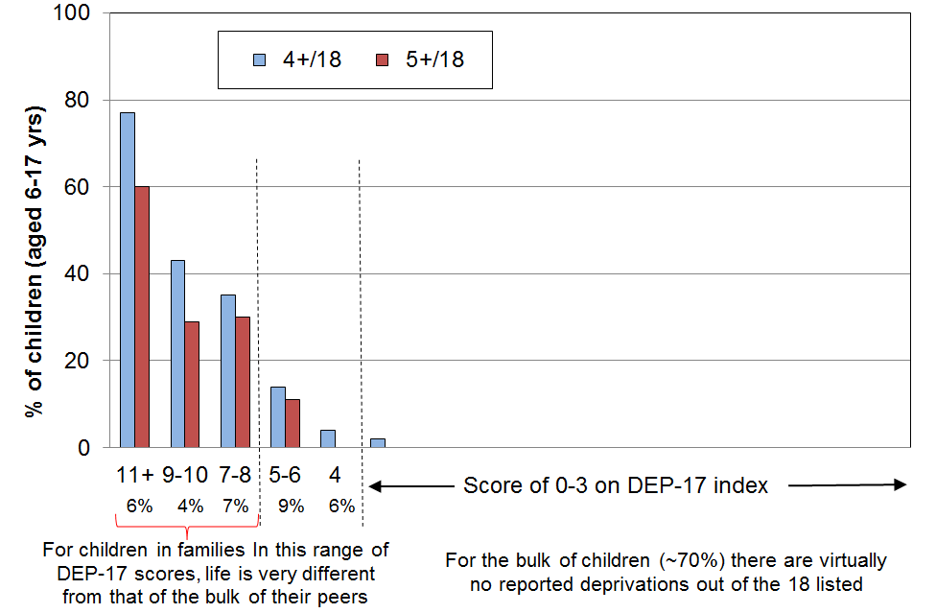
Using a mix of child-specific and general household items to calibrate DEP-17

Children live in households. The more general household items that some households do not possess or the financial stress some households live with also have an impact on children. Using a mix of child-specific and general household deprivation items can give a broader-based and more comprehensive calibration.

In what follows, 20 items are used that relate specifically to school-aged children or to their households. All the items are at the more severe end of the spectrum. Only four of the 20 items are in DEP-17 itself (see Table D.10 below). The children are ranked by the DEP-17 score of their respective households, then the number of deprivations from the list of 20 is calculated for each school-aged child.

Table D.10
20 items used for calibrating DEP-17 for school-aged children (aged 6-17 yrs)
Child-specific items | General household items
- warm winter clothes for each child  - two pairs good shoes for each child  - waterproof coat for each child  - children continued wearing worn out clothes and shoes  - separate bed for each child  - separate bedroom for older and opposite sex children  - able to have friends to birthday party  - each child has all school uniform required by school(s)  - able to pay for school trips for each child  - able to attend music, dance, art and swimming lessons  - sport participation  postponed doctor for children | - could not keep main rooms warm  - cut back or went without fresh fruit and vegetables “a lot”  - delayed repair or replacement of appliances (“a lot”)  - late payment of vehicle wof /reg (more than once in last year)  - late payment of electricity / water / gas (more than once)  - received help from food bank or other community group (more than once)  - dampness or mould in dwelling (major problem)  - crime/vandalism in the area (major problem)
Note: the 4 shaded items are also in DEP-17

Figure D.4 and the associated Table D.11 (next page) show again how different life is for those children in lower living standards households. In particular, they show the significant rise in the numbers missing out on the basics for DEP-17 scores of around 7+/17.

Figure D.4
Multiple deprivation for children aged 6-17: using a mix of child-specific and general household items (LSS 2008)
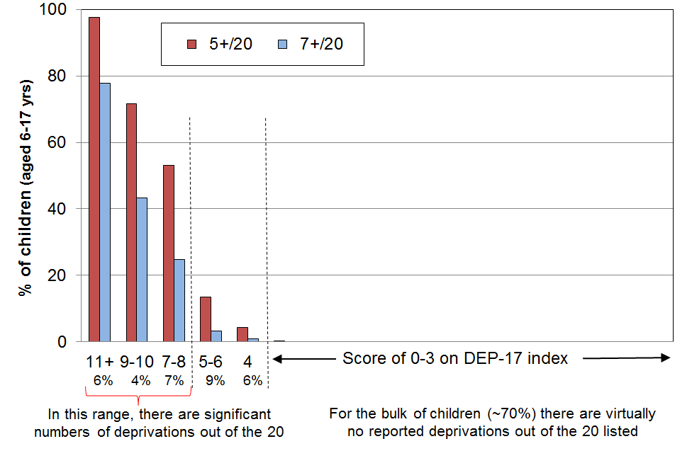

Table D.11
Multiple deprivation for children aged 6-17 years, using 20 items listed in Table D.6 (LSS 2008):
% of the 12 child specific and 8 general household basics missing
Distribution of children (6-17yrs) across DEP-17 (%) | 0-1 | 2 | 3 | 4 | 5-6 | 7-8 | 9-10 | 11+ | All
Distribution of children (6-17yrs) across DEP-17 (%) | 47 | 11 | 10 | 6 | 9 | 7 | 4 | 6 | 100
5+ out of 20 | 0 | 0 | 0 | 4 | 13 | 53 | 72 | 98 | 14
6+ out of 20 | 0 | 0 | 0 | 4 | 8 | 35 | 60 | 95 | 11
7+ out of 20 | 0 | 0 | 0 | 0 | 3 | 25 | 43 | 78 | 8
8+ out of 20 | 0 | 0 | 0 | 0 | 2 | 18 | 24 | 70 | 7
avg number of deprivations out of 20 | 0 | 0 | 0 | 2 | 3 | 5 | 6 | 10 | 1.9
Note: any cell with under 1.5% is reported as”0”.

Comparison of hardship rates for selected population groups using EU-13 and DEP-17

Table D.12 shows that the hardship figures produced by the “standard” EU threshold (5+/13) are almost identical to those produced by the 7+ threshold using DEP-17 for the population as a whole and for sub-groups. The EU’s “more severe” deprivation threshold (7+/13) gives figures that lie in the “more severe” range for DEP-17. This does not prove that this report’s selection of a threshold range is correct, but it does provide strong independent support for it.

Table D.12
Comparisons of hardship rates for different sub-groups
using different indices (EU-13 and DEP-17) and two thresholds
LSS 2008 | “Standard” EU hardship |  | “More severe” EU hardship
 | EU-13 (5+) | DEP-17 (7+) | EU-13 (7+) | DEP-17 (10+)
ALL | 11 | 11 | 4 | 4
0-17 | 18 | 17 | 8 | 8
65+ | 3 | 2 | ~1 | ~1
2P <65 | 11 | 9 | 4 | 3
SP <65 | 35 | 38 | 17 | 22
Couple <65 | 5 | 5 | 2 | 1
European (total) | 8 | 8 | 3 | 3
Maori (total) | 24 | 25 | 9 | 11
Children (market) | 11 | 10 | 4 | 4
Children (benefit) | 51 | 51 | 24 | 28
Reading note: for the purposes of this comparison, the ‘more severe’ threshold for DEP-17 was selected to make the DEP-17 population hardship rates equal to or very close to the same as the EU rates (4%).

Provided care is taken over item choice, quite different sets of items (ie indices) rank households in very similar ways

EU-13 and DEP-17 have only three items in common and two others that are broadly similar. The bulk of the items in one are therefore not in the other.

One of the general findings about the use of non-income measures of material wellbeing and of deprivation indicators in particular is that material hardship indices with quite different sets of component items rank households in similar ways, provided that the indices are constructed following careful protocols for item selection.

Section E
The Material Wellbeing Index (MWI):
material wellbeing across the spectrum (from low to high)

Material hardship or deprivation indices such as EU-13 and DEP-17 do a good job in discriminating between households in differing depths of hardship, and also in identifying those in ‘near hardship’. While they provide valuable information on the lower 20-30% or so of the material wellbeing distribution, such indices are unable to make meaningful distinctions for the remaining 70-80% of households.

The development of the Material Wellbeing Index (MWI), building off the earlier work on the Economic Living Standards Index (ELSI), enables usable distinctions between households across the bulk of material wellbeing spectrum, albeit the discriminating ability decreases as the level of material wellbeing increases. The stylised diagram in Figure E.1 shows the difference in the distributions of DEP-17 and MWI scores. While still itself functioning as a deprivation index at its lower end, the MWI enables distinctions to be made within the 70-80% of the population who have very low scores on deprivation indices such as DEP-17 (ie have living standards above the hardship zone.
Figure E.1
Moving from a deprivation index to a full material wellbeing index
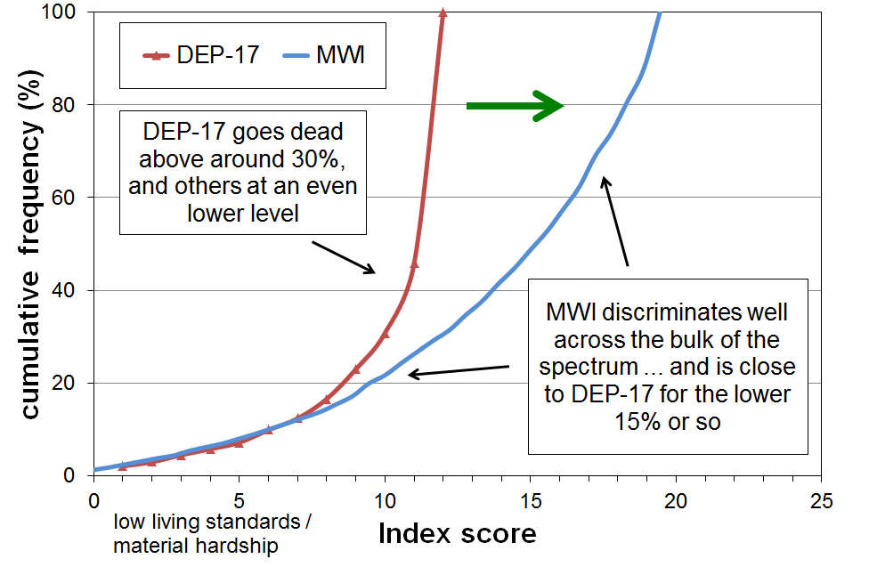
Reading note for Fig E.1: the stylised comparison was constructed by deducting the DEP-17 scores from 12 (thus reversing the scale), and re-scaling the MWI scores.
This section:
- outlines the rationale for the way the MWI is constructed
- lists the MWI’s component items and how they are scored to give the overall index score
- establishes the credentials of the MWI as a valid instrument for ranking households by their material wellbeing through:
  - showing the internal coherence between the index items and the scoring structure on the one hand and the underlying notion of material wellbeing on the other
  - demonstrating the strong correlation between the MWI and items that are not in the index but which could be expected to reflect variation in material wellbeing
- provides information to help calibrate the index (ie give practical meaning to the scores at different levels)
- discusses and defines the MWI hardship thresholds used in the report
- shows in detail the relationship between DEP-17 scores and MWI scores, and how MWI is equivalent to a deprivation index at low MWI scores
- introduces the MWI-9, a 9-item short-form of the MWI, which has potential use in surveys that wish to produce information for analysis by broad material wellbeing groupings.
.
Starting with the 2012-13 survey, Statistics New Zealand’s Household Economic Survey (HES) has all the MWI items in it. See Section F for more detailed MWI analysis and findings based on both the HES and LSS data.
The Material Wellbeing Index (MWI)

When developing the MWI, building off the prototype Economic Living Standards Index (ELSI), several criteria were used to guide item selection:
- Like ELSI, the revised index (MWI) needs an item set that decompresses the distribution that is typically produced by material hardship indices such as DEP-17 (see Figure E.1 above), so that there is good discrimination for the 60-70% of households above the hardship and near hardship zones …
- … while ensuring that tastes and preferences that impact on consumption choices for many aspects of higher living standards do not invalidate the index.
- The items and the index need to be built on a conceptualisation of material wellbeing and living standards that is credible and measureable: it needs to be in accord with the commonplace notion of higher living standards being about having the basics and in addition having more freedom to participate in a wider range of activities and to consume a wider range of goods and services of choice.
- The item set should cover a range of domains such as food, accommodation (and therefore implicitly, clean water on tap and sanitation / flushing toilets), heating, clothing, transport, household goods, leisure pursuits, access to health care, and the ability to cope with modest shocks to the household budget, and some desirable non-essentials to assist with identifying households with higher living standards.
- The item set must reflect goods and services and activities that are commonly aspired to, thus giving assurance that the resulting index will apply reasonably well to a good range of ages and household types.
- The index must satisfy reasonable statistical evidence of internal coherence and of the items reflecting a common latent variable.
- The items and the index need to be able to pick up changes in material wellbeing per se over time. This means, for example, that the item set should not include items which are in the midst of rapidly changing levels of ownership (eg home computers in the early 2000s).
- The index should perform well as a deprivation index at its lower end.

The greatest challenge to the satisfactory development of an index which delivers a usable ranking of households across the full spectrum from lower to higher material wellbeing, rather than just having a focus on the lower 20-30% as with DEP-17, is the differing tastes and preferences that individuals and households have for the consumption of non-necessities. This means that the ‘enforced lack’ approach cannot simply be extended to a list including non-necessities as a “don’t have or do” response could either be because of constraints or because of tastes and preferences. An index would lack credibility and validity if the rankings were impacted by differing preferences.

To illustrate – while items such as “not having a decent meal at least once a day” or “having to put up with being cold” are almost always a matter of financial constraint rather than personal preference and are appropriate for deprivation indices, the enforced lack of items such as “dines out at a good quality restaurant at least once a week” or “has an extensive range of tools and workshop equipment for DIY activities” or “has a sauna“ or “has two cars” are of no use for developing a broader index of wellbeing as there is not a sufficiently widespread common aspiration to possess these, even among the better-off. While possessing these sorts of items do for some reflect higher living standards, too many respondents would state that the reason they do not have the item is not lack of money, but because they simply do not want them. Their non-possession does not necessarily indicate low living standards. Other well-off individuals or households may have tastes and preferences that lead them instead to possessing high quality vehicles, or very well-appointed homes with high quality furniture and appliances, or private health insurance, and so on.

There are some intermediate items which are neither “necessities” nor “luxuries or near luxuries”, but which can be characterised as desirable non-essentials that most aspire to (for example, “a holiday away from home for at least a week once a year”), but this sort of item is not easy to find.

The challenge therefore is to find several “non-necessities”, the presence or absence of which reflects differences in levels of material wellbeing rather than in the main being reflections of tastes or preferences. To achieve this, the MWI uses the four approaches outlined in Table E.1. The left-hand column describes the strategies employed and the right-hand column notes the way the strategies are operationalized for the MWI.

Table E.1
MWI items that assist in discriminating between households above the hardship / near hardship zone
Type of survey item that helps produce discrimination between households in the 60-70% above the “hardship” and “near hardship” zones | Application in MWI
no enforced lack for two desirable non-essentials | - a week’s local annual holiday away from home  - an overseas holiday at least once each three years
economising “not at all”  (ie never having to cut back on or put off key purchases or activities such as those listed) | - purchasing fresh fruit or vegetables  - making trips to the shops or other local places  - replacing or repairing broken or damaged appliances  - visiting the doctor or dentist  - spending less on hobbies or other special interests than you would like
financial strain “not at all”  (ie never being in arrears or late on payments because of lack of money) | - for rates and utilities  - for vehicle registration or warrant of fitness
freedom to purchase  (degrees of constraint or freedom indicate different levels of material wellbeing) | - clothes and shoes for self  - spot purchase of a $300 non-necessity  - ability to pay an unexpected and unavoidable $500 bill within a month

The 24 MWI items and the scoring for each are listed in Table E.2 (next page).

The raw MWI scores range from 0 to 43, with higher scores meaning higher material living standards. For convenience, the actual MWI scores are converted to a 0 to 35 range, with any raw scores of 8 or less being classed as “0”. This does not lead to any loss of usable information as there are typically only 1-2% in this latter category.

A 9-item short form (MWI-9) is available and is defined and discussed at the end of this section.

When using the MWI it is important to recognise what it is and what it is not:
- The MWI ranks households and their members from low to high material wellbeing or living standards.
- The ability to discriminate between households at different levels of material wellbeing is strong at the lower end and decreases across the spectrum.
- The MWI cannot reliably discriminate among households in the top, say, 20%, and users are advised to clump this group or a wider group rather than to try to break it down.
- The MWI is an ordinal index, a ranking instrument. A household with an MWI score of 20 does not have a level of material wellbeing that is double that of a household with a score of 10, it just has a higher level of material wellbeing. (Similarly, a household with double the income of another is not considered to have a standard of living that is double the other’s.
- The items that make up the MWI do not purport to be “the” list of necessities or “the” list of freedoms. Rather they are a balanced set of items that meet the criteria given above on the previous page, reflecting the same underlying notion of material wellbeing.

Table E.2
The 29 non-income items in HES 2013 to HES 2015, the composition of the MWI and DEP-17,
and the scoring of items for the two indices
Item description |  | MWI | DEP-17
Ownership or participation (have/do, don’t have/do and enforced lack (EL))
For DEP-17, score an EL as 1, otherwise 0
For MWI, score an EL as a 0, otherwise 1
1 | Two pairs of shoes in a good condition and suitable for daily activities | ✓ | ✓
2 | Suitable clothes for important or special occasions | ✓ | ✓
3 | Contents insurance | ✓ | ✓
4 | A meal with meat, fish or chicken (or vegetarian equivalent) at least each 2nd day | ✓ | ✓
5 | A good bed | ✓ | -
6 | Presents for family/friends on special occasions | ✓ | ✓
7 | Holiday away from home at least once every year | ✓ | -
8 | Overseas holiday at least once every three years | ✓ | -
Economising (not at all, a little, a lot) – to keep down costs to help in paying for (other) basic items
For DEP-17, score ‘a lot’ as 1, otherwise 0
For MWI, score ‘not at all as 2, ‘a little’ as 1, and ‘a lot’ as 0
9 | Gone without or cut back on fresh fruit and vegetables | ✓ | ✓
10 | Buy cheaper cuts of meat or bought less meat than you would like | ✓ | ✓
11 | Continued wearing worn out clothes | ✓ | -
12 | Put up with feeling cold | ✓ | ✓
13 | Do without or cut back on trips to the shops or other local places | ✓ | ✓
14 | Delay replacing or repairing broken or damaged appliances | ✓ | ✓
15 | Spent less on hobbies or other special interests than you would like | ✓ | -
16 | Postponed visits to the doctor | ✓ | ✓
17 | Postponed visits to the dentist | ✓ | ✓
Housing problems (no problem, minor problem, major problem)
For MWI, score as 2, 1 and 0 respectively.
18 | Dampness or mould | ✓ | -
19 | Heating or keeping it warm in winter | ✓ | -
Freedoms/Restrictions
20 | When buying, or thinking about buying, clothes or shoes for yourself, how much do you usually feel limited by the money available? (4 point response from ‘not limited … very limited)  For DEP-17, score ‘very limited’ as 1, otherwise 0.  For MWI, score as 3, 2, 1 and 0 respectively. | ✓ | ✓
21 | $300 spot purchase for an ’extra’ – how restricted? (5 point response from ‘ not restricted … couldn’t purchase’)  For MWI, score as 4, 3, 2, 1 and 0 respectively. | ✓ | -
22 | $500 unexpected unavoidable expense on an essential – can you pay in a month without borrowing? (yes/no)  For DEP-17, score no’ as 1, and ‘yes’ as 0  For MWI, score ‘yes’ as 2 and ‘no’ as 0 | ✓ | ✓
Financial strain (in last 12 months) (not at all, once, more than once)
For DEP-17, score ‘more than once’ as 1, otherwise 0
For MWI, score ‘not at all’ as 2, ‘once’ as 1, ‘more than once’ as 0
23 | Behind on rates or utilities | ✓ | ✓
24 | Behind on car registration, wof or insurance | ✓ | ✓
25 | Behind on rent or mortgage | - | -
26 | Borrowed from family or friends to meet everyday living costs | - | ✓
27 | Received help in the form of food, clothes or money from a welfare or community organisation such as a church or food bank | - | -
Global self-ratings
28 | Adequacy of income to cover basics of accommodation, food, clothing, etc | - | -
29 | Satisfaction with life | - | -
Notes: An EL is an enforced lack – an item that is wanted but not possessed because of the cost
Starting in 2015-16 the HES has all the above 29 items plus six new ones. See Section B for details.

The underlying conceptualisation of material wellbeing or living standards in the MWI

To create the MWI scores, the component items are scored from two different perspectives:
- From an enforced lack perspective in which respondents report not having essential items or necessities because of the cost, or having to severely cut back on the purchase or consumption of such items because the money is needed for other essentials: for example, being unable to have regular good meals, two pairs of shoes in good repair for everyday activities, or visit the doctor; or having to put up with the cold, and so on because money is needed for other basics.
- From the perspective of the degree of restriction or freedom reported for having or purchasing desirable non-essentials (while having the essentials) – a freedoms enjoyed perspective, for short: for example, having all the essentials on the list, and in addition not having to cut back on local trips, not having to put off replacing broken or damaged appliances, being able to take an overseas holiday every three years or so if desired, not having any great restrictions on purchasing clothing, and being able to spend on hobbies and special interests as desired, and so on.

Material hardship (unacceptably low material wellbeing) is characterised by having many enforced lacks of essentials and few or no freedoms. Higher living standards are characterised by having all the essentials (no enforced lacks of essentials), and also having many or all the freedoms and few or none of the restrictions in relation to the non-essential items that are asked about.

This is in line with the material wellbeing concept in the income-wealth-consumption-material-wellbeing framework discussed in Section A.

Figure E.2 below shows how those in the different MWI deciles fare in terms of both enforced lacks of essentials and also of freedoms enjoyed, using the selected MWI items listed in Tables E.3A and the non-shaded part of Table E.3B on the next page.

Figure E.2
Calibrating the MWI using ‘enforced lacks’ and ‘freedoms/non-essentials enjoyed’ (LSS 2008)
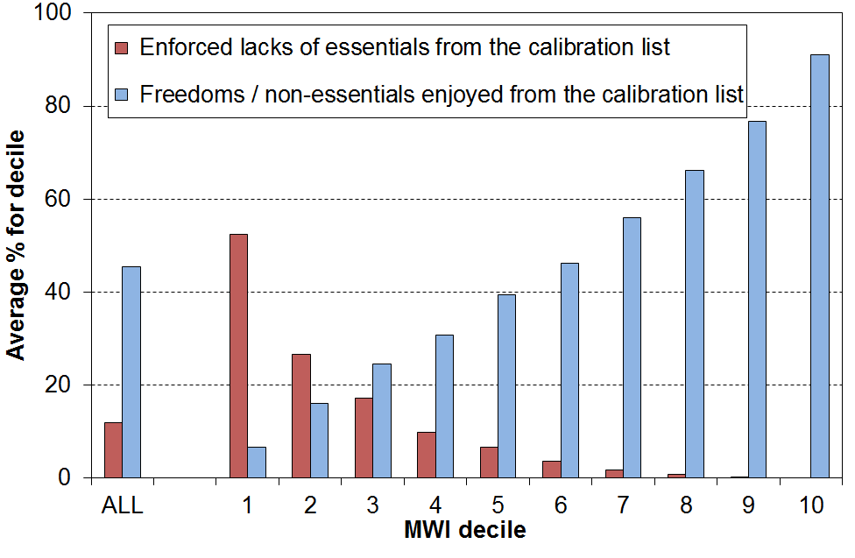

The distributions are in line with the underlying conceptualisation of material wellbeing used in the MWI. For example, those in the lowest material wellbeing decile (decile 1) experience on average just over half the 16 enforced lacks and virtually none of the 9 freedoms, whereas those in the top decile have on average 90% of the freedoms and none of the enforced lacks.

When the extra four freedoms from the shaded cell in Table E.3B are included in the analysis (these items are not in the MWI), the only noticeable difference is that the freedoms average for decile 10 drops a little from 91% to 86%. This reflects the fact that two of the extra freedoms (“high standard of living” and “able to access $2000 within a month without borrowing”) are quite demanding relative to the other 11 freedoms.

Table E.3A
Essentials used in the calibration exercise for Figure E.2
enforced lack of essentials  - meal with meat, fish or chicken (or vegetarian equivalent) at least each 2nd day  - two pairs of shoes in good repair and suitable for everyday use  - suitable clothes for important or special occasions  - a good bed | in arrears more than once in last 12 months (because of shortage of cash at the time, not through forgetting)  - rates and utilities  - vehicle registration, insurance or WoF
economised, cut back or delayed purchases ‘a lot’ because money was needed for other essentials (not just to be thrifty or to save for a trip or other non-essential)  - fresh fruit and vegetables  - meat  - replacing worn out clothes  - put up with being cold  - visits to the doctor  - trips to the shops or other local places  - repairing or replacing broken or damaged appliances | financial stress and vulnerability  - had to borrow from friends or family more than once in last 12 months to cover everyday expenses for basics  - feel ‘very limited’ by the money available when thinking about purchase of clothes or shoes for self (options were: not at all, a little, quite and very limited)  - could not pay an unexpected and unavoidable bill of $500 within a month without borrowing.

Table E.3B
“Freedoms” or non-essentials used in the calibration exercise for Figure E.2
no enforced lacks for holidays  - at least one week away from home each year  - at least once each three years overseas | “not at all restricted”  - when considering buying clothes or shoes for self  - when considering a $250 spot purchase of a non-essential
no economising, cutting back or delaying of purchases because money was needed for other essentials  - fresh fruit and vegetables  - meat  - trips to the shops or other local places  - repair or replace broken or damaged appliances  - hobbies | extras  - self-rated standard of living is “high” (from 5 point scale from low to high)  - never had to borrow from friends or family in last 12 months to cover everyday expenses for basics  - no delay for repairing or replacing worn out or broken furniture due to shortage of money  - could pay an unexpected expense of $2000 within a month without borrowing

Figure E.2 above shows that households with low living standards (eg those in decile one) have few non-essentials compared with those with better living standards, which is not surprising. This does however point to a slight advantage that the MWI has over DEP-17 and the like. Imagine two households in the same street, both with the same DEP-17 score, indicating high deprivation, but with one having more of the non-essentials or freedoms on the list than the other. This household gets a slightly higher MWI score than the other one, reflecting its slightly higher material living standards.

[The above analysis has been repeated for HES 2015 and HES 2018 and the patterns are very similar to those for LSS 2008.]

The different MWI items discriminate at different parts of the material wellbeing spectrum

Figures E.3, E.4 and the associated tables use selected items from the MWI to illustrate how the different component items discriminate across different parts of the MWI spectrum.

For example, in Figure E.3 below the “spot purchase” item discriminates very well in the upper deciles, whereas the item about “not-at-all having to put off visits to the dentist” is a good discriminator across the whole spectrum. “Being able to pay an unexpected but unavoidable $500 bill” is very useful across the lower five deciles.

Figure E.3
MWI Items with a positive association with MWI scores, HES 2014 and 2015 (avg %), by MWI decile
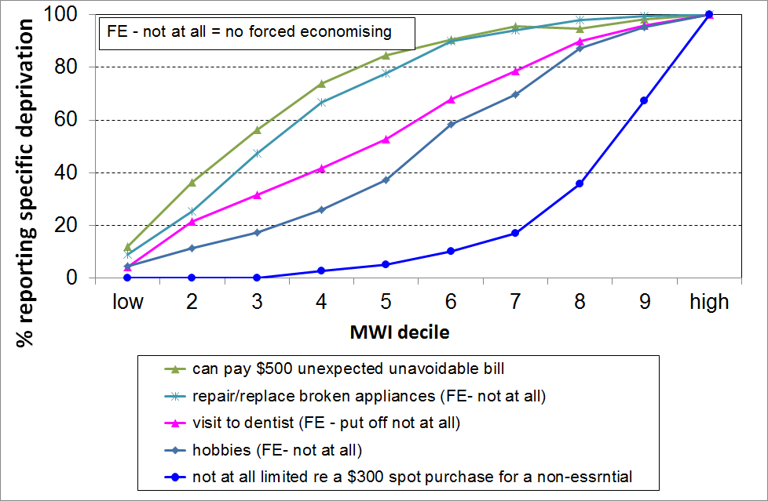

Table E.4
MWI Items with a positive association with MWI scores, HES 2014 and 2015 (avg %), by MWI decile
MWI decile ➔ | 1 | 2 | 3 | 4 | 5 | 6 | 7 | 8 | 9 | 10 | ALL
can pay unexpected unavoidable $500 bill | 12 | 36 | 56 | 74 | 85 | 91 | 96 | 95 | 98 | 100 | 76
delayed replacing or repairing appliances that were not working because of costs [not at all] | 9 | 25 | 47 | 67 | 78 | 90 | 94 | 98 | 99 | 100 | 72
put off going to dentist because of costs [not at all] | 4 | 21 | 31 | 42 | 53 | 68 | 79 | 90 | 96 | 100 | 60
spent less time on hobbies or special interests because of costs [not at all] | 4 | 11 | 17 | 26 | 37 | 59 | 70 | 87 | 95 | 100 | 52
have a holiday overseas at least once every 3 yrs (<65) | 5 | 17 | 25 | 35 | 44 | 51 | 60 | 67 | 69 | 80 | 43
not limited in $300 spot purchase of a non-essential | 0 | 0 | 0 | 3 | 5 | 10 | 17 | 36 | 67 | 100 | 24

The same applies in Figure E.4 below, except that the focus is on items with a negative association with MWI scores.

For example, the lower four lines are for items that are very serious deprivations, or in the case of receiving help from food banks or other community groups shows the extreme measures that households have to go to sometimes to survive. They all discriminate well at the very low end.

On the other hand, the contents insurance item discriminates well across the lower four deciles.

Figure E.4
MWI Items with a negative association with MWI scores, HES 2014 and 2015 (avg %), by MWI decile
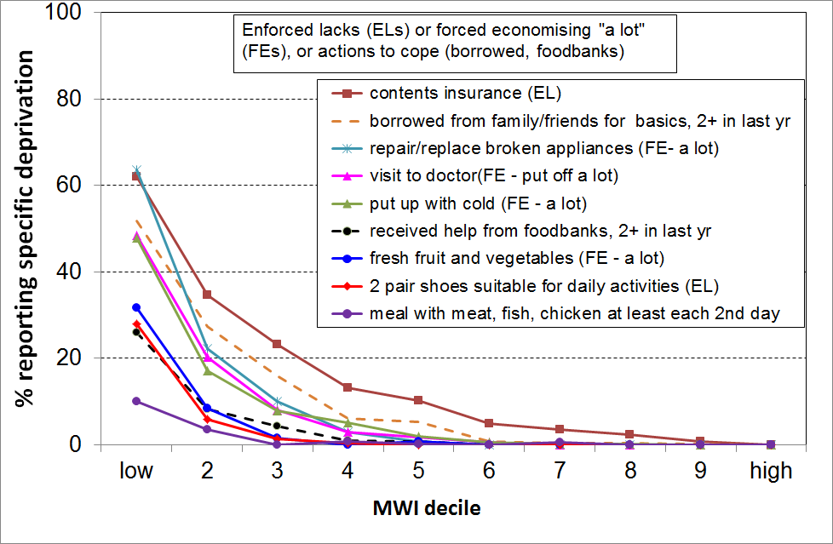

Table E.5
MWI Items with a negative association with MWI scores, HES 2014 and 2015 (avg %), by MWI decile
MWI decile ➔ | 1 | 2 | 3 | 4 | 5 | 6 | 7 | 8 | 9 | 10 | ALL
contents insurance [EL] | 62 | 35 | 23 | 13 | 10 | 5 | 4 | 2 | 1 | 0 | 14
put up with feeling cold [a lot] | 56 | 22 | 13 | 5 | 4 | 1 | 1 | 0 | 0 | 0 | 10
put off repairing or replacing broken appliances [a lot] | 64 | 22 | 10 | 3 | 1 | 0 | 0 | 0 | 0 | 0 | 9
put off doctor’s visits [a lot] | 48 | 20 | 8 | 3 | 2 | 1 | 0 | 0 | 0 | 0 | 7
went without fresh fruit and vegetables [a lot] | 32 | 8 | 1 | 0 | 1 | 0 | 0 | 0 | 0 | 0 | 4
clothes for special or important occasions [EL] | 28 | 8 | 1 | 0 | 0 | 0 | 0 | 0 | 0 | 0 | 3
2 pair of shoes in good condition for everyday activities [EL] | 28 | 6 | 1 | 0 | 0 | 0 | 0 | 0 | 0 | 0 | 3
meal with meat, fish or chicken (or vegetarian equivalent) at least each second day [EL] | 10 | 4 | 0 | 0 | 0 | 0 | 0 | 0 | 0 | 0 | 1
borrowed from family or friends to meet everyday living costs [more than once in last 12 months] | 54 | 29 | 21 | 10 | 9 | 4 | 2 | 2 | 0 | 0 | 13
The ‘food banks” item below is not in MWI, but is included here for illustrative purposes
received help from food banks or other community groups [more than once in last 12 months] | 26 | 8 | 4 | 1 | 1 | 0 | 0 | 0 | 0 | 0 | 4

EL = ‘enforced lack’

The MWI and other indicators of material wellbeing: evidence in support of the MWI’s validity as a material wellbeing index

Figure E.2 above shows that there is an internal coherence between the MWI scores and the underlying conceptualisation of material wellbeing that the index is built on. Figures E.3 and E.4 underline that.

Another aspect of testing and establishing the validity of the index is to examine how the index correlates with items that are not MWI items, but which are very likely to be positively correlated with material wellbeing or living standards as commonly understood and as used for the MWI.

This analysis is shown in Table E.6. The figures in the columns in the body of the table are the percentages of those in a given MWI decile whose household respondent reported the various freedoms to consume, the ability face unexpected bills, and so on. The gradients are clear and strong in each case, all showing the expected higher proportions of reported freedoms for those with higher MWI scores. This gives good support for the validity of the MWI (“concurrent validity”) – there is good evidence that it measures what it claims it measure, material wellbeing or material living standards.

The MWI is also designed to function as a deprivation index across its lower scores. Table E.7 uses items from LSS 2008 that are not MWI items, but which reflect aspects of material hardship or deprivation. The gradients are again clear and strong in each case, with the more severe items (eg use of food banks) applying only to those in the very low end of the MWI scale. This supports the validity of MWI’s use for measuring material hardship.

The strong gradients in Tables E.6 and E.7 raise the question – “if these items show the gradients so clearly why are they not in the MWI?”

The simplest response is that an index with too large a number of items becomes unwieldy and very unattractive to use in surveys (crowding out of other items given a fixed time budget for survey length). There has to be some rationing of items, so some good items are inevitably left out.

The more substantial rationale has to do with maintaining the integrity and validity of the index. For example, while the non-MWI items in the tables show clear gradients at the clumped level of each decile, they may not meet the required criteria at the household level. An example of this is the “quality of kitchen” item. Also, an item may not be appropriate or relevant for all sub-groups (eg hair cut for those without hair), or an item may not be wanted by the vast majority (eg 32% of respondents either did not want a night out each fortnight, or had a reason other than cost for not doing so).

Table E.6
Non-MWI Items with a positive association with MWI scores (LSS 2008),
plus the distribution across MWI deciles for three “freedom” items used in the index (%)
MWI decile ➔ | 1 | 2 | 3 | 4 | 5 | 6 | 7 | 8 | 9 | 10 | ALL
Items not in the MWI
have private health insurance | 14 | 18 | 27 | 40 | 44 | 48 | 51 | 52 | 52 | 62 | 41
have employed a cleaner on a regular basis in last 12 months | 2 | 2 | 3 | 4 | 7 | 9 | 7 | 11 | 18 | 18 | 7
quality of car / motor vehicle for <65 [‘top of the range’ or ‘good quality’ on a 4 point scale with other options being ‘mid-range’ or ‘budget or lower’] | 19 | 29 | 31 | 36 | 40 | 46 | 53 | 49 | 63 | 69 | 42
quality of kitchen appliances, layout, storage etc [‘top of the range’ or ‘good quality’ on a 4 point scale with other options being ‘mid-range’ or ‘budget or lower’] | 11 | 23 | 31 | 31 | 34 | 46 | 46 | 53 | 61 | 70 | 41
overall physical condition of accommodation [‘very good’ on a 5 point scale through to ‘very poor’] | 9 | 17 | 23 | 24 | 30 | 38 | 41 | 44 | 51 | 64 | 34
could pay unexpected expense of $2000 within a month without borrowing | 14 | 35 | 44 | 63 | 72 | 83 | 87 | 88 | 97 | 98 | 68
enough or more than enough money to meet essentials of food, accommodation, and so on | 4 | 10 | 18 | 36 | 42 | 53 | 64 | 75 | 82 | 91 | 48
money for self each week [more than $50] | 7 | 8 | 14 | 23 | 32 | 42 | 48 | 62 | 66 | 80 | 38

Subjective wellbeing (‘very satisfied with life’) - average of HES 12/13 & 13/14
Ranked by MWI | 3 | 9 | 16 | 20 | 23 | 28 | 33 | 40 | 46 | 55 | 28
Ranked by AHC household incomes | 15 | 13 | 20 | 25 | 26 | 24 | 29 | 31 | 40 | 51 | 28
Ranked by BHC household incomes | 16 | 22 | 17 | 25 | 21 | 27 | 28 | 33 | 39 | 49 | 28
Note: The subjective wellbeing rows show that the MWI rankings are likely to be much more highly correlated with subjective wellbeing rankings than are the BHC or AHC income rankings. Using the decile approach is a fairly crude analysis as (a) deciles 2, 3 and 4 are very bunched for incomes, and (b) standard practice is to take the logarithm of incomes in recognition of the fact that a $1000 gain for high income households means less than does an extra $1000 to low income households. Nevertheless, the simple point is illustrated – there is likely to be a higher correlation between MWI rankings and subjective wellbeing rankings.

Table E.7
Non-MWI Items with a negative association with MWI scores (LSS 2008),
plus the distribution across MWI deciles for three “enforced lack” items used in the index (%)
MWI decile ➔ | 1 | 2 | 3 | 4 | 5 | 6 | 7 | 8 | 9 | 10 | ALL
Items not in the MWI
used food bank or other community assistance (more than once in previous 12 months) | 24 | 12 | 4 | 3 | 0 | 0 | 0 | 0 | 0 | 0 | 4
pawned goods to get cash for necessities (more than once in previous 12 months) | 28 | 14 | 7 | 3 | 2 | 2 | 1 | 0 | 0 | 0 | 6
keep main rooms warm [EL] | 35 | 14 | 7 | 4 | 2 | 1 | 1 | 0 | 0 | 0 | 7
house too small [major problem] | 29 | 17 | 11 | 7 | 8 | 3 | 3 | 1 | 2 | 0 | 8
overall physical condition of accommodation [poor or very poor on 5 point scale] | 25 | 9 | 7 | 4 | 3 | 1 | 1 | 0 | 0 | 0 | 5
crime or vandalism in the area [major problem] | 24 | 15 | 11 | 7 | 7 | 6 | 5 | 4 | 4 | 2 | 8
hairdresser once every three months [EL] | 51 | 29 | 18 | 8 | 5 | 2 | 2 | 1 | 0 | 0 | 12
a night out at least once a fortnight [EL] | 56 | 41 | 31 | 21 | 15 | 10 | 5 | 2 | 1 | 0 | 18
self-rated health, poor or fair (<65) | 50 | 30 | 19 | 11 | 13 | 10 | 10 | 6 | 7 | 10 | 17

EL = ‘enforced lack’

Calibration of the MWI when the focus is on the lower end of the spectrum – that is, when the MWI is being used as a material hardship index

For an index like the MWI to be used for measuring and monitoring material wellbeing it needs to be calibrated so as to give some tangible meaning to the different scores. There is no purely objective way of doing this as there is no external natural or consensus-based standard to calibrate against. This is a similar challenge to that faced when using a deprivation index, but in this case the challenge covers the whole spectrum of material wellbeing from low to high, not just the lower end. This section first outlines how the MWI hardship thresholds are set, then looks at the wider calibration question across the full range of scores.

Choosing hardship thresholds for the MWI, and the relationship between DEP-17 and MWI scores

Choosing hardship thresholds for the MWI is a subset of the fuller calibration exercise.

The challenge here, as it was for DEP-17 in Section D, is much the same as the one faced when using household income as the indicator of material wellbeing – what low-income threshold or thresholds should be used to identify those in “income poverty” and those “not in poverty”? Material hardship, like income poverty, comes in degrees. There is no clear delineation between those “in hardship” and those “not in hardship” that science can identify independent of judgment. This is not to say that any threshold will do nor that all are equally open to challenge. Some thresholds are however much more plausible and defensible than others.

This report uses MWI scores for the hardship zone that are consistent with the decisions made on the DEP-17 hardship zone. See Tables E.8A and 8B on the next page for conversions between MWI and DEP-17 scores for low living standards.

MWI scores of 9 or less are used to examine the characteristics of households with low living standards. This gives numbers that are virtually the same as when using a DEP-17 score of 7 or more out of 17. This section makes no attempt to set “the” threshold, but works within a framework of material hardship existing on a spectrum from less to more severe. The more severe hardship zone is taken as an MWI score of 5 or less. This is equivalent to a DEP-17 score of 9 or more out of 17. It also reports using an MWI score of 11 or less (DEP-17 score of 6+) for sensitivity analysis, and to align with the Government Statistician’s selection of a 6+/17 DEP-17 score for the main material hardship measure for the Child Poverty Reduction Act (2018).

For the purposes of reporting on the composition of those at different depths of hardship and for tracking hardship rates over time for different hardship levels, the approach adopted here is pragmatic, defensible, and produces findings useful for public debate and policy development.

For the purposes of being able to say ‘New Zealand’s material deprivation rate is Y%’, or ‘there are X thousand children in hardship in New Zealand’, this approach does not deliver. That is a consequence of the position taken above in the first paragraph of this calibration section. It is in fact the same position as is taken in the Household Incomes Report for ‘income poverty’. It means that the focus can be on understanding what is happening at different depths of hardship, avoiding what are often sterile debates about exactly how many are deemed to be “in hardship”, a debate based on the erroneous assumption that such a simple binary division can be robustly made. Using the approach adopted in this report, it could be argued that ‘success’ would be for trend lines at all hardship levels to fall over the medium term (ie using MWI thresholds of 11 or less, 9 or less and 5 or less. This is a demanding standard.

Table E.8A
Comparisons of MWI and DEP-17 for LSS 2008 and five HES years, using a range of thresholds:
whole population
 | MWI |  |  |  |  |  | DEP-17
MWI | LSS 2008 | HES 2013 | HES 2014 | HES 2015 | HES 2017 | HES 2018 | LSS 2008 | HES 2013 | HES 2014 | HES 2015 | HES 2017 | HES 2018 | DEP-17
13 - | 17 | 16 | 13 | 14 | 11 | 10 | 18 | 15 | 13 | 14 | 11 | 10 | 5+
12 - | 15 | 14 | 12 | 12 | 10 | 9
11 - | 13 | 12 | 10 | 11 | 9 | 8 | 13 | 12 | 10 | 11 | 8 | 8 | 6+
10 - | 12 | 11 | 9 | 10 | 8 | 7
9 - | 10 | 9 | 8 | 8 | 7 | 6 | 11 | 9 | 7 | 9 | 6 | 6 | 7+
8 - | 9 | 8 | 7 | 7 | 6 | 5
7 - | 7 | 7 | 6 | 6 | 5 | 5 | 8 | 6 | 6 | 7 | 5 | 4 | 8+
6 - | 7 | 6 | 6 | 5 | 4 | 4
5 - | 6 | 5 | 5 | 5 | 3 | 3 | 6 | 5 | 5 | 5 | 4 | 3 | 9+
4 - | 5 | 4 | 4 | 4 | 3 | 3
3 - | 4 | 3 | 3 | 3 | 2 | 2 | 4 | 3 | 3 | 4 | 2 | 3 | 10+

Table E.8B
Comparisons of MWI and DEP-17 for LSS 2008 and four HES years, using a range of thresholds:
0-17 years
 | MWI |  |  |  |  | DEP-17
MWI | LSS 2008 | HES 2013 | HES 2014 | HES 2015 | HES 2018 | LSS 2008 | HES 2013 | HES 2014 | HES 2015 | HES 2018 | DEP-17
13 - | 26 | 23 | 20 | 22 | 17 | 26 | 23 | 20 | 22 | 16 | 5+
12 - | 24 | 21 | 19 | 19 | 15
11 - | 21 | 19 | 17 | 18 | 13 | 21 | 18 | 16 | 18 | 13 | 6+
10 - | 18 | 17 | 16 | 16 | 12
9 - | 16 | 15 | 14 | 14 | 11 | 17 | 15 | 12 | 15 | 10 | 7+
8 - | 14 | 13 | 12 | 12 | 9
7 - | 13 | 12 | 11 | 10 | 8 | 13 | 10 | 10 | 12 | 8 | 8+
6 - | 12 | 10 | 10 | 9 | 7
5 - | 10 | 9 | 8 | 8 | 6 | 10 | 8 | 8 | 9 | 6 | 9+
4 - | 8 | 7 | 7 | 6 | 5
3 - | 7 | 6 | 6 | 6 | 4 | 8 | 5 | 5 | 6 | 5 | 10+

Reading note for Tables E.8A and 8B:
- 5+ means 5 or more, and 13- means 13 or less

Comparing the material hardship rankings produced by EU-13, DEP-17 and MSD’s Material Wellbeing Index (MWI)

Even though EU-13 and DEP-17 have only three items in common and two others that are broadly similar they rank households and sub-groups in very similar ways. Similarly, the MWI at the lower end of its range ranks households in a very similar way to both EU-13 and DEP-17. For example:
- When using DEP-17 and the MWI to rank households, there is a 97% overlap for the lower 20% on each and a 95% overlap for the lower 11%. (11% was chosen to tie in with Table E.7 below.)
- The degree of concordance is further illustrated in Table E.9 where the material hardship rates for selected sub-groups are compared across the three indices. The three indices produce very similar hardship rates for the different population groups and for two hardship thresholds.

Table E.9
Comparisons of hardship rates for different sub-groups
using different indices (EU-13, DEP-17 and the MWI), and two thresholds, LSS 2008
 | “Standard” EU hardship |  |  | “More severe” EU hardship
 | EU-13 (5+) | DEP-17 (7+) | MWI (9-) | EU-13 (7+) | DEP-17 (10+) | MWI  (3-/4- avg)
ALL | 11 | 11 | 10 | 4 | 4 | 4
0-17 | 18 | 17 | 18 | 8 | 8 | 8
65+ | 3 | 2 | 2 | <1 | <1 | <1
2P <65 | 11 | 9 | 10 | 4 | 3 | 3
SP <65 | 35 | 38 | 38 | 17 | 22 | 20
Couple <65 | 5 | 5 | 6 | 2 | 1 | 2
European (total) | 8 | 8 | 9 | 3 | 3 | 3
Maori (total) | 24 | 25 | 27 | 9 | 11 | 11
Children (market) | 11 | 10 | 11 | 4 | 4 | 4
Children (benefit) | 51 | 51 | 51 | 24 | 28 | 26
Reading note:
For the purposes of illustrating the fact that the three indices rank households in much the same way, thresholds for DEP-17 and the MWI were selected to make the DEP-17 and MWI population hardship rates equal to or very close to the same as the two EU rates (11% and 4%). For the “more severe” threshold for the MWI figures, the average of the rates for two close thresholds was used to ensure a rate as close to 4% as possible.

This is an illustration of one of the more general findings about the use of non-income measures of material wellbeing and of deprivation indicators in particular which is that indices with quite different sets of component items rank households at the lower end in similar ways, provided that the indices are constructed following careful protocols for item selection. Four important protocols are that:
- items need to cover a range of domains and a range of hardship depths;
- items need to be applicable to all age groups and to both market income and state income households;
- the index needs to have around 10 or more items;
- there needs to be good indications from some sort of factor analysis which shows that the same underlying notion is being reasonably well reflected by the selected items.

This all raises the question – why have three indices? why not keep it simple and just have one index?

Why have three indices (EU-13, DEP-17 and MWI) ? Why not just one?

The short answer is given in Table E.10 below – to meet the goals or criteria in the left-hand column, all three are needed as no one measure can do it all.

Table E.10
The MWI, DEP-17 and EU-13 assessed against high-level criteria
 | MWI | DEP-17 | EU-13
adequately ranks on material hardship? |  |  | 
can do from low to high material wellbeing? |  | x | x
international comparisons? | x | x | 
is a time series available? |   (with ELSI from 2006-07 to 2011-12, then MWI) | (only from HES 12-13 on) | x
communication – meaning of scores? | not as easy as for DEP-17 and EU-13, but not impossible |  | 

Why do we need DEP-17 – why not just use EU-13?

Given that the EU-13 has good credentials in the EU, allows New Zealand to be located relative to other higher income nations, and produces rankings very similar to DEP-17, why not keep things simpler by just having one deprivation index, EU-13?

The basic answer is straightforward. First, it wasn’t clear until mid 2017 that the EU was going to make the EU-13 the official measure. Second, there was an issue of data availability. The survey items needed for EU-13 are available for New Zealand in the 2008 LSS, but nowhere else until the 2016 HES. On the other hand DEP-17 was able to be constructed from both LSS 2008 and from the refreshed HES dataset, starting with the 2012-13 HES.

In the 2016 HES, some extra items were added to enable EU-13 to be constructed, but uncertainties about the material hardship data for the 2015-16 survey precluded their use.

The other rationale is that DEP-17 has some differences from EU-13 which make it a more robust instrument and one that can give a more fine-grained (less “clunky”) analysis at the lower end.
- As discussed above, DEP-17, like the EU-13 and many other similar indices, uses a mix of items that tap into or reflect different depths of material deprivation. For example, not being able to have a good meal each day would generally be considered to be a more serious deprivation than having to delay repairing or replacing broken appliances, and having to repeatedly put up with feeling cold to save on heating costs more serious than not being able to afford contents insurance. There is a good argument to be made that all four are however needed for a household to be able to sustain a minimum acceptable and independent standard of living in a country like New Zealand.
- DEP-17 differs from EU-13 in that it has a larger proportion of items covering the more severe end of the hardship spectrum and a smaller proportion of items covering the less severe end of the hardship spectrum. For example, DEP-17 does not use the “one week’s holiday away from home” item nor the “leisure activities” item, and its question on emergency savings is set at $500 rather than the $1500 figure in EU-13. DEP-17 also covers a wider range of domains in which material deprivation can be revealed.
- DEP-17 nevertheless still uses a range of items reflecting differing degrees of hardship. Rather than being a weakness of the index, the use of this range of items is a strength as it allows for the fact that there is some variation among those less well-off as to what they cut back on to try to make ends meet. An index with an almost total focus on the severe hardship end could not reflect these nuances in its rankings.

DEP-17 also has a slightly better level of reliability (internal consistency) than EU-13, 0.87 compared with 0.78 using Cronbach’s alpha (see Table D.7 above).
Why have DEP-17 – why not just use the lower end of MWI?

MSD’s Material Wellbeing Index (MWI) covers the full spectrum of material living standards from low to high. At its lower end the MWI performs very well as a deprivation index, and produces rankings very similar to DEP-17. As noted above there is a 97% overlap for the lower 20% on each index, and the hardship rates for a range of subgroups are very close on both measures (see Table E.8 above).

The concordance between DEP-17 rankings and MWI rankings at the lower end of the MWI scale is further illustrated in Tables E.11 and E.12 below which examine child-focussed deprivation using the two indices. Table E.11 uses DEP-17 to rank households, and Table E.12 uses the MWI. The numbers in both tables are very close, showing that DEP-17 and the low end of the MWI ranking give an almost identical picture for school-age children.

Table E.11
Using DEP-17 to rank households
Multiple deprivation for children aged 6-17 years, LSS 2008
Multiple deprivation – using 20 items: 12 child-specific items and 8 general household items
DEP-17 score | 0-1 | 2 | 3 | 4 | 5-6 | 7-8 | 9-10 | 11+ | All
Distribution of children (6-17yrs) across DEP-17 (%) | 47 | 11 | 10 | 6 | 9 | 7 | 4 | 6 | 100
5+ out of 20 | 0 | 0 | 0 | 4 | 13 | 53 | 72 | 98 | 14
6+ out of 20 | 0 | 0 | 0 | 4 | 8 | 35 | 60 | 95 | 11
7+ out of 20 | 0 | 0 | 0 | 0 | 3 | 25 | 43 | 78 | 8
8+ out of 20 | 0 | 0 | 0 | 0 | 2 | 18 | 24 | 70 | 7
9+ out of 20 | 0 | 0 | 0 | 0 | 0 | 8 | 10 | 56 | 4
10+ out of 20 | 0 | 0 | 0 | 0 | 0 | 6 | 5 | 47 | 3
avg number of deprivations out of 20 | 0 | 0 | 0 | 2 | 3 | 5 | 6 | 10 | 1.9
Reading note: any cell with under 1.5% is reported as zero.

Table E.12
Using the MWI to rank households
Multiple deprivation for children aged 6-17 years, LSS 2008
Multiple deprivation – using 20 items: 12 child-specific items and 8 general household items
DEP-17 score | 0 | 1 | 2 | 3 | 4 | 5-6 | 7-8 | 9-10 | 11+ | All
MWI score |  |  |  |  |  | 14-11 | 10-6 | 5-3 | 2-
Distribution of all children (0-17 yrs) across DEP-17 (%) | MWI and DEP-17 do not mimic each other for these “well-above-hardship” scores … as DEP-17 is a deprivation index, not a full-spectrum index |  |  |  |  | 11 | 8 | 4 | 6 | 100
Distribution of children (6-17yrs) across DEP-17 (%) |  |  |  |  |  | 10 | 8 | 4 | 6 | 100
5+ out of 20 | - | - | - | - | - | 11 | 42 | 72 | 94 | 14
6+ out of 20 | - | - | - | - | - | 7 | 29 | 61 | 91 | 11
7+ out of 20 | - | - | - | - | - | 3 | 21 | 44 | 72 | 8
8+ out of 20 | - | - | - | - | - | 0 | 14 | 31 | 61 | 7
9+ out of 20 | - | - | - | - | - | 0 | 5 | 21 | 49 | 4
avg number of deprivations out of 20 | - | - | - | - | - | 4 | 5 | 6 | 10 | 1.9

Note: the 20 items used in Tables E.9 and E.10 are listed in Table E.11 below.

Table E.13
The 20 items used in Tables E.11 and E.12 above
Child-specific items | General household items
- warm winter clothes for each child  - two pairs good shoes for each child  - waterproof coat for each child  - children continued wearing worn out clothes and shoes  - separate bed for each child  - separate bedroom for older and opposite sex children  - able to have friends to birthday party  - each child has all school uniform required by school(s)  - able to pay for school trips for each child  - able to attend music, dance, art and swimming lessons  - sport participation  postponed doctor for children | - could not keep main rooms warm  - cut back or went without fresh fruit and vegetables “a lot”  - delayed repair or replacement of appliances (“a lot”)  - late payment of vehicle wof /reg (more than once in last year)  - late payment of electricity / water / gas (more than once)  - received help from food bank or other community group (more than once)  - dampness or mould in dwelling (major problem)  - crime/vandalism in the area (major problem)
Note: the 4 shaded items are also in the MWI.

So, why have both MWI and DEP-17? Why not just use the MWI?

It would certainly be simpler to just use the one New Zealand index, the MWI. It covers the full range of material wellbeing as well as acting as a deprivation index at the lower end.

The real value DEP-17 is that it is simpler for readers and users to grasp the meaning of index scores. For example, the meaning of a DEP-17 score of “9+” is very clear – this household reports 9 or more of the 17 deprivation items. On the other hand an MWI score of “9” is a composite score constructed from the number of enforced lacks of essentials (deprivations) that a household reports and the number of non-essentials that are possessed or accessible for use. The direct meaning of an MWI score is not as easy to communicate as that of a DEP-17 score.

Both are therefore needed.

Calibration across the whole spectrum

For communication purposes, the ELSI-based reports divided the ELSI spectrum into seven levels, ranging from two hardship levels through to ‘comfortable’, ‘good’ and ‘very good’ levels. This is illustrated in Figure E.12 for three groups with different main sources of income: government transfers for under 65s, market income for under 65s, and for older New Zealanders, the bulk of whom are heavily reliant on New Zealand Superannuation and little else. The two hardship levels are on the left for each group. The graphs immediately communicate to the reader.

Figure E.12
Distribution of ELSI scores (material wellbeing) by income source and age (2008)
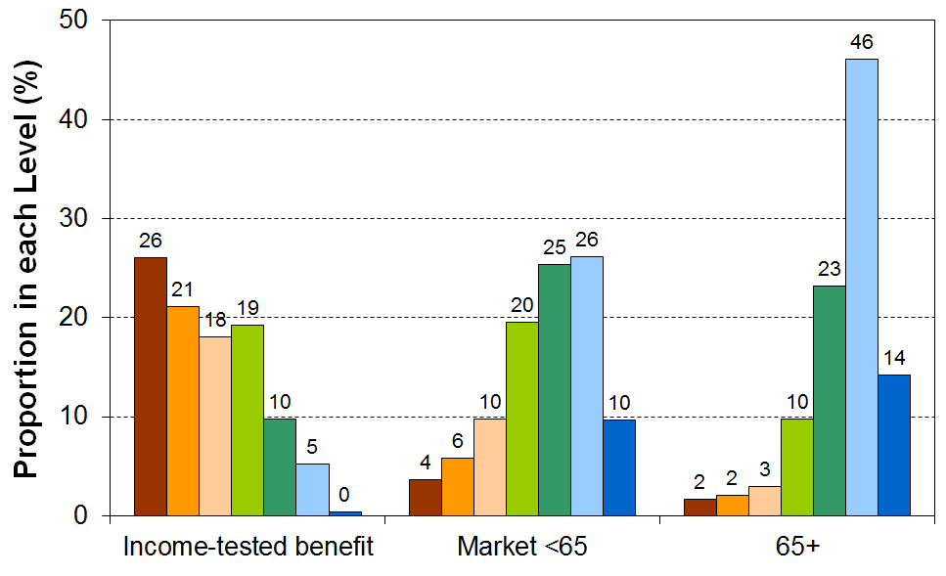

One of the challenges of creating material wellbeing levels and labelling them is that they easily become reified, as if there is such category as “very good” living standards, independent of a judgement call. Findings such as those illustrated in Figure E.12 can be reported or taken to mean that “research has found that 14% of older New Zealanders have very good living standards”, whereas the actual finding is that “research has shown that, using a scale on which 8% of New Zealanders are classed as having “very good” living standards, 14% of older New Zealanders are in that category”.

To avoid or prevent this misinterpretation and many more like it, one strategy is to simply break the spectrum up into deciles or quintiles. This is useful sometimes, but something more like ELSI approach using Levels is needed both for communication purposes and because for some adjacent deciles there is very little difference in living standards.

MWI Levels and their labels are still under development. In the meantime, the decile and quintile approach is being used. Table E.15 below uses a 4-way division for MWI-9.

MWI-9, a short-form of the full MWI

The full 24-item MWI is too long for the time available for such questions in some surveys. The MWI-9 is a short-form that enables users to examine the distribution of other variables across the material wellbeing spectrum. The 2014 GSS and later iterations have the MWI-9 items in them, as does the HES from 2012-13 on (the HES also has the other 15 items that make up the full set of MWI items).

Table E.14 lists the MWI-9 items and the scoring for each item.

Table E.14
The composition of MWI-9, a short-form of the full MWI, and the scoring of items for the index
 | Item | Scoring
 | Economising because of limited money for basics (not at all, a little, a lot) | max = 12
1 | Go without fresh fruit and vegetables | 0 = ‘a lot’  1 = ‘a little’  2 = ‘not at all’
2 | Postpone or put off visits to the doctor | 0 = ‘a lot’  1 = ‘a little’  2 = ‘not at all’
3 | Do without or cut back on trips to the shops or other local places | 0 = ‘a lot’  1 = ‘a little’  2 = ‘not at all’
4 | Spent less on hobbies or other special interests than you would like | 0 = ‘a lot’  1 = ‘a little’  2 = ‘not at all’
5 | Put up with feeling cold | 0 = ‘a lot’  1 = ‘a little’  2 = ‘not at all’
6 | Delay replacing or repairing broken or damaged appliances | 0 = ‘a lot’  1 = ‘a little’  2 = ‘not at all’
 | Freedoms / restrictions | max = 7
7 | When buying, or thinking about buying, clothes or shoes for yourself, how much do you usually feel limited by the money available? (4 point response from ‘not limited … very limited) | 0 = ‘very’  1 = ‘quite’  2 = ‘a little’  3 = ‘not at all’
8 | $300 spot purchase for an ’extra’ – how restricted? (5 point response from ‘ not restricted … couldn’t buy it’) | 0 = ‘couldn’t buy it’  1 = ‘very restricted’  2 = ‘quite’  3 = ‘a little’  4 = ‘not at all’
 | Financial strain (not at all, once, more than once) | max = 2
9 | Behind on rates or utilities in last 12 months? | 0 = ‘more than once’  1 = ‘once  2 = ‘not at all’

The maximum possible raw score on MWI-9 is 21 (12+7+2). To create a 0-20 scale, 1 is deducted from each score, and the possible “-1” is re-set to zero. The higher the score, the higher the level of material wellbeing.

Where there is just one respondent per household, as in the HES and GSS, the respondent’s score can be attributed to all household members to enable each individual to have an MWI-9 score attached to their record, and the population ranked accordingly. This is the same as the approach used with household incomes.

Where there is more than one respondent per household, the average score for all respondents can be attributed to each household member. Alternatively, the distribution of respondent scores can be reported and used, though in that case the range of feasible analysis is more limited analysis as, for example, there are no household scores and no scores for children.

With only 9 items to cover the full spectrum of material well-being, the index is not designed for fine-grained analysis. Even when looking only at material hardship, a 9 item index can be a little clunky (see Section D), so extra care is needed with the MWI-9 across a wider range. The MWI-9 is designed primarily for examining the distribution of other variables across the material wellbeing spectrum at a broad level, rather than for the detailed examination of the distribution of material wellbeing itself. For the broader purpose it is a robust and useful instrument.

Table E.15 suggests a suitable division of the scale into four categories: lower, lower middle, upper middle and higher living standards. The boundaries are set so that the lower category has around 15-20% in it, with the remainder divided reasonably equally across the other three. Table E.15 shows how these boundaries work for data from HES 2012-13, HES 2014-15 and from LSS 2008. For other surveys the boundaries may have to be adjusted a little to create the rough proportions recommended.

Table E.15
Suggested categories for using the MWI-9 to show the gradient for other variables across
material wellbeing levels
MWI-9 Level | 1 | 2 | 3 | 4
MWI scores | 0-7 | 8-13 | 14-17 | 18-20
LSS 2008 (%) | 17 | 30 | 27 | 25
HES 2012-13 (%) | 15 | 28 | 29 | 29
HES 2014-15 (%) | 14 | 25 | 28 | 33
GSS 2014 (%) | 15 | 23 | 31 | 32
Suggested labels | Lower | Lower middle | Upper middle | Higher

Who are the people in the four categories?

Table E.16 shows the composition of each category by individual characteristics (age and ethnicity), and by EFU characteristics (EFU type and Tenure). Read down the columns, not across the rows.

Table E.16
Who are in the categories? LSS 2008
MWI-9 Level | 1 | 2 | 3 | 4
MWI scores | 0-7 | 8-13 | 14-17 | 18-20
% in each category or level | 17 | 30 | 27 | 25
Suggested labels | Lower | Lower middle | Upper middle | Higher
Age (individuals)
16-24 years | 23 | 21 | 20 | 10
25-44 years | 43 | 44 | 34 | 23
45-64 years | 30 | 27 | 29 | 38
65+ years | 4 | 8 | 17 | 29
Ethnicity (individuals)
European | 55 | 66 | 75 | 85
Maori | 23 | 12 | 8 | 6
Pacific | 10 | 7 | 4 | 2
Asian | 7 | 11 | 10 | 5
Other | 5 | 5 | 2 | 3
Family or EFU type
Single < 65 | 43 | 44 | 39 | 30
Single 65+ | 3 | 5 | 11 | 16
Couple <65 | 11 | 15 | 19 | 24
Couple 65+ | 1 | 3 | 8 | 16
SP < 65 | 21 | 9 | 3 | 2
2P < 65 | 20 | 23 | 20 | 13
Tenure (for families/EFUs)
Owned or FT with payments | 29 | 40 | 39 | 30
Owned or FT with NO payments | 7 | 16 | 36 | 52
Private Landlord/Local Authority | 49 | 39 | 23 | 16
Housing NZ | 15 | 5 | 2 | 2
Total | 100 | 100 | 100 | 100

Tracking changes over time

The MWI is designed to be able to pick up changes in material wellbeing or living standards over time for, say, 10-20 years (though the ‘clunkiness’ arising from having only nine items to cover the full range of material wellbeing means that only high-level trends will be robust). Higher scores for the items that focus on the “freedoms” perspective reflect higher living standards per se, irrespective of changes to general levels of living standards and expectations. This is one of the differences between the MWI and ELSI. The ELSI measure is limited in its ability to pick up changes over time in material wellbeing per se, as changes in the scores for its item set reflect to a considerable degree changes in living standards relative to changes in expectations rather than changes in living standards per se. These issues do not impact as strongly on the lower ELSI scores, so for tracking hardship ELSI is still usable.

For a proper account of changes in living standards over longer periods, say from 1950 to 2015, other aspects of household material wellbeing would need to be taken into account – for example, access to / ownership of a range of household appliances and whiteware, hot water on tap from electric or gas heating, indoor flushing toilet, having a telephone, access to leisure goods, and so on.

The MWI and ELSI

In 2002 MSD developed a prototype 40-item Economic Living Standards Index (ELSI) which ranked households from low to high living standards using non-income measures (non-monetary indicators). A short-form of ELSI (ELSI-SF) was subsequently developed and the 25 items needed for it are in the HES from 2006-07 to 2011-12.

The MWI is an update and further development of ELSI. The MWI uses around half of the original ELSI-SF items together with a similar number of new ones. Appendix 2 provides a comparison of the items in each index and a discussion on the key underlying conceptual differences between the MWI and ELSI, as referred to above.

Section F
Low income and material hardship

The income-wealth-consumption-material-wellbeing framework used in this report and in the Incomes Report draws attention to the fact that while household income is an important factor in determining household material wellbeing and in accounting for the differences between the material wellbeing of households, other factors are relevant too.

Discretionary spend / desirable non-essentials
Household income

Resources available for consumption

Basic needs / essentials
Financial and physical assets

Other factors
eg assistance from outside the household (family, community, state), housing costs, high or unexpected health or debt servicing costs, lifestyle choices and ability to convert given resources into valuable consumption, ability to access available resources

Material wellbeing or living standards

The framework shows how households with similar incomes can experience quite different actual day-to-day living standards because of different asset levels or because of different sets of ‘other factors’.

The relationship between low income and material hardship (deprivation)

Income poverty and material hardship approaches are often characterised as complementary ways of measuring ‘poverty’ understood in the wider sense of significant material disadvantage. This perspective is reinforced by the findings that show that both approaches identify the same population groups as being at higher or lower risk (see for example Table F.3 below).

For understanding the relationship between income measures and non-income measures of material well-being, and especially between low household income and high material deprivation, the ‘complementary measures’ view has some validity. However, one of the most fundamental aspects of the relationship between the two is the significant mismatch between those identified as poor (ie income poor) and those identified as in hardship or deprivation. The overlap between the income poor and the materially deprived groups is modest across all EU countries and for New Zealand, typically of the order of 40% to 50% for the population as a whole (when using low income and hardship groups of similar size).

The existence of the mismatch is not surprising. Some low-income households report implausibly low incomes, below core benefit levels. Others report expenditure two to three times their reported income. A household’s standard of living (material wellbeing) is determined by its command over resources relative to its needs. Current income, even when measured and reported accurately and adjusted for household size and composition (equivalised) is only one aspect of the resources available to a household: financial assets, the range and quality of household goods, help in cash and in kind from outside the household are all important too, and vary from household to household. Different households also have different demands on the budget from differing debt servicing requirements, health- and disability-related costs, transport costs for getting to paid employment, expectations to assist others outside their own household, and so on.

The chart and table below for HES 2017-18 shows that for households with similar incomes, lower levels of liquid financial assets mean higher levels of material hardship.

HES 2017-18 | Q1 |  |  | Q2 |  |  | Q3
median liquid assets ($) | 0 | 400 | 8,000 | 100 | 1,200 | 12,000 | 500 | 3,600 | 19,300
can pay an unexpected + essential $500 bill within a month without borrowing | 24% | 43% | 67% | 51% | 71% | 79% | 69% | 84% | 85%
material hardship rate (6+/17, DEP-17) | 47% | 18% | 7% | 19% | 11% | 4% | 9% | 1% | 2%
avg AHC household income (equivalised) | 11,000 | 11,000 | 10,000 | 21,000 | 21,000 | 22,000 | 30,000 | 31,000 | 31,000

None of this means that household income is not a very important driver of living standards. For low-income households an income increase will almost always raise their material wellbeing. What the finding means is that when comparing the material wellbeing of households, income alone is often not a reliable indicator as the ‘other factors’ vary greatly from household to household.

The mismatch between the two measures means that there are six groups to consider:
- the income poor
- the materially deprived
- the income poor who are materially deprived (the both/and group)
- the income poor who are not materially deprived (poor only)
- the materially deprived who are not income poor (deprived only)
- those who are neither.

Table F.1 below shows the proportion of the different groups who report that their household’s income is ‘not enough’ to cover the basics of food, accommodation, clothing, heating and so on from the 2015 HES. The options for the respondent were: not enough, only just enough, enough and more than enough.
Table F.1
Self-assessed income adequacy for the six groups noted above, HES 2015
 | ALL | neither | poor only | poor | deprived only | deprived | both
Whole population
size of groups (% of whole population) | 100 | 76 | 10 | 16 | 8 | 14 | 6
% in HHs with “not enough” for the basics | 14 | 6 | 20 | 36 | 46 | 53 | 63
Children (0-17 yrs)
size of groups (% of all children) | 100 | 67 | 11 | 22 | 11 | 22 | 10
% in HHs with “not enough” for the basics | 18 | 6 | 23 | 42 | 45 | 53 | 62
Note: - the AHC 50% of median measure is used for income poverty
- the DEP-17 measure is used for material deprivation, with the threshold set to give the same proportion as the income poverty measure gives (5+/17 gives 14%).

Figure F.1 examines the overlap from another perspective. It shows that around half those in hardship have incomes below a 60% AHC threshold and one third in hardship have incomes above this but below the median (‘the near poor’).

Figure F.1
The distribution of incomes for those identified as “in hardship”, HES 2012
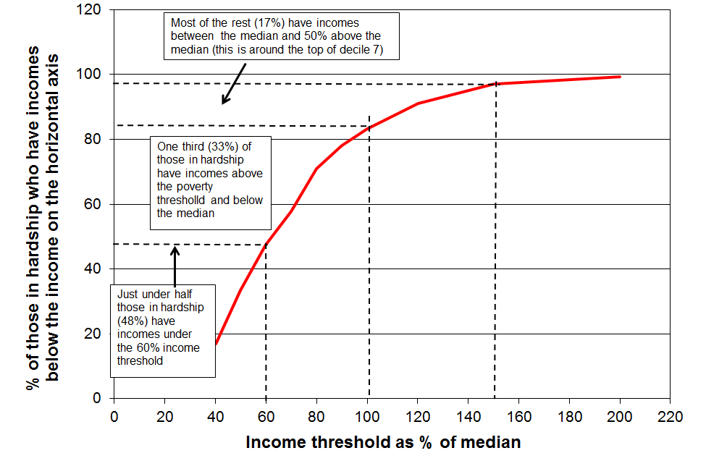
Note: The hardship group is the lower 15% defined using the ELSI-SF measure.
Income is AHC household income.

The same pattern can be shown in a pie chart as in Figure F.2 this time using HES 2015 data. The hardship group is the 8% of the population with MWI scores of 9 or less (the less severe threshold).

At a high level, it shows that around half of those in hardship have incomes above the commonly-used 50% and 60% of median low-income lines.

In more detail, just under half (48%) have incomes below the 50% of median AHC line and a further 8% in the 50% to 60% band; 27% have incomes between the 60% line and the median, and a further 17% have incomes above the median.

Figure F.2
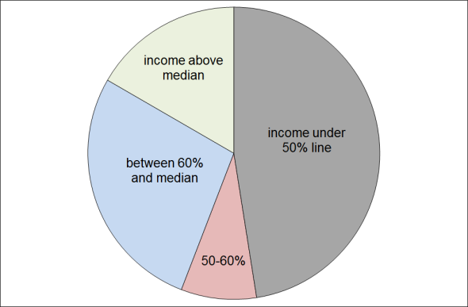
The distribution of incomes for those identified as “in hardship”, HES 2015

The overlap between low-income households and households in hardship is higher for deeper hardship levels

Using data from the 2008 Living Standards Survey (LSS 2008), the right-hand pie chart in Figure F.3 shows that of the 100,000 children in more severe hardship (DEP-17 scores of 9+/17), seven out of ten (69%) are from families with incomes below the 60% of median threshold (after housing costs). This compares with 61% when using a less stringent hardship threshold as in the left-hand diagram (7+/17).

This is hardly a surprising finding, but it useful not only to be able to quantify it but also to have good evidence that the measurement infrastructure delivers what prior considerations predict it should.

Figure F3
Proportion (%) of children in hardship by family income band
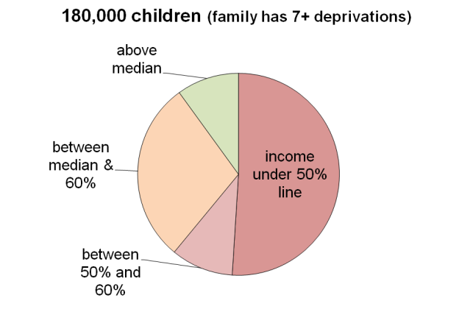
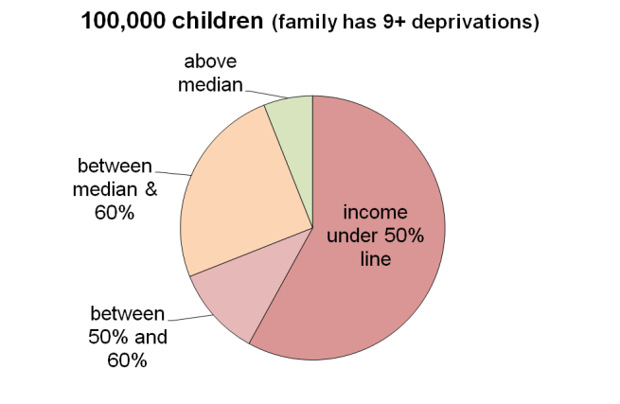
(two hardship thresholds), LSS 2008

Table F.2 shows the data behind the pie charts above, together with further detail.

Table F.2
Proportion (%) of children in hardship by family income band
for five “hardship” thresholds
LSS 2008
# of enforced lacks of basics (deprivations) | 6+ | 7+ | 8+ | 9+ | 11+
 | 21% | 17% | 13% | 10% | 6%
# of children | 220k | 180k | 140k | 100k | 60k
income under a 50% of median AHC line | 47 | 51 | 55 | 58 | 58
income between 50% and 60% lines | 9 | 10 | 10 | 11 | 12
income between 60% line and median | 31 | 29 | 27 | 25 | 24
income above the median | 13 | 10 | 8 | 6 | 6

See Appendix 5 for information on the overlaps using the three currently available primary measures in the Child Poverty Reduction Act (2018).
Comparing the results for the incomes and NIM approaches

Despite the mismatch discussed above, the population subgroups that are identified as being at higher (or lower) risk of being income poor (AHC) are also identified as being at higher (or lower) risk of material hardship or deprivation.

In the 2012 HES, 13% of the population were identified as poor using the 50% AHC (moving line) measure, and 13% were in hardship as measured using the ELSI measure with the threshold set at 6 or more out of 16 essential item. For Table F.3 the thresholds for the FRILS measure and the MWI were adjusted to also give population hardship rates of 12-13%.

Table G.3 reports the poverty and hardship rates for selected subgroups for all four measures. It shows that there is a reasonable similarity in actual proportions identified as ‘income poor’ or ‘in hardship’. In addition it shows that the sub-group relativities are not impacted by the choice of material hardship index that is chosen.

Table F.3
Comparison of hardship rates based on income and non-income measures,
by selected individual and household/family characteristics (2012 HES)
 | Income poverty | Material hardship
 | AHC REL 50 | ELSI | FRILS | MWI
Total population | 13 | 13 | 13 | 12
Age group
0-17 | 20 | 21 | 19 | 19
18-24 | 17 | 14 | 14 | 15
25-44 | 14 | 12 | 12 | 13
45-64 | 9 | 10 | 9 | 9
65+ | 7 | 6 | 8 | 3
Ethnicity (avg over HES 2010, 2011 and 2012)
European | 11 | 10 | 11 | -
Māori/Pacific | 23 | 28 | 31 | -
Family type
SP | 44 | 39 | 34 | 36
2P | 12 | 14 | 14 | 13
Number of children (avg over HES 2010, 2011 and 2012)
One | 19 | 16 | 15 | -
Two | 17 | 15 | 15 | -
Three+ | 27 | 28 | 25 | -
Main source of income for families/households <65
Market | 9 | 10 | 11 | 10
Government | 64 | 43 | 42 | 42

Note: figures for ethnicity and number of children are averages over three surveys to improve the reliability of the estimates, as some of the sub-divisions have relatively low sample numbers.

Household incomes for many in decile one (lowest 10%) are not a reliable guide to the actual financial resources available to these households

While the incomes of most of the households in the bottom decile seem plausible (for example, they are in line with main income support levels or the incomes received by households with workers on the minimum wage), there are always some that report implausibly low incomes, lower than beneficiary incomes or much less then declared spending, or both. A few self-employed report negative incomes. The bottom decile is unique in this regard. For example, while there are households in each income decile that report expenditure more than three times their income (around 2-3% of all households), 70% to 80% of these are found in the bottom income decile.

This means that the average income of the bottom decile cannot be taken as a reasonable estimate of this group’s (relative) material wellbeing.

This assessment is supported by the analysis in Figure F.5 which shows how the MWI score decreases as expected when coming down the income spectrum, except for the bottom income vingtile (5%) whose average MWI score is more like those at the top of the second income decile (4th vingtile). This shows that the incomes of those reporting implausibly low incomes are in general not a reliable indicator of the resources available to those households.

Figure F.5
The MWI score for different income levels, HES 2015 and 2016 combined
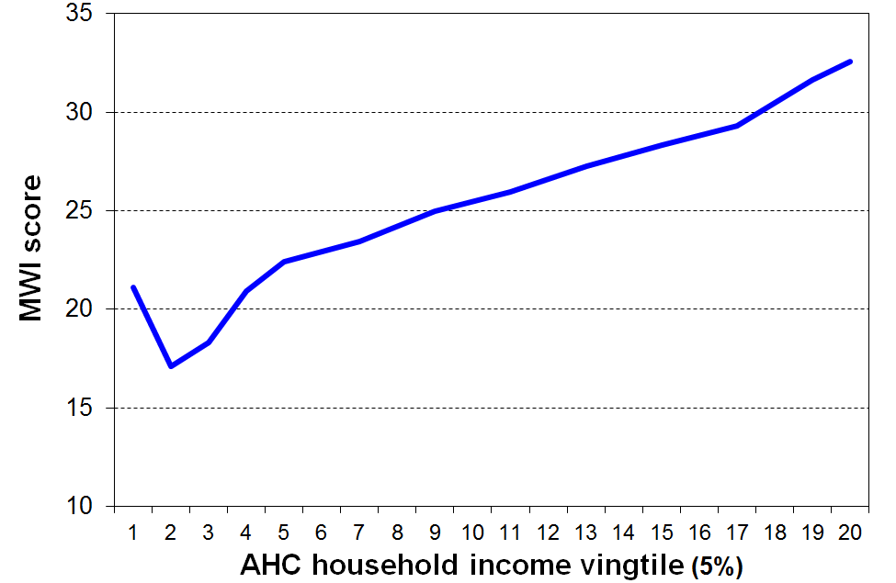

It also means that it is unwise to use very low income thresholds to monitor “severe” poverty as too great a proportion of the households under such thresholds are those with implausibly low reported incomes. The Incomes Report does not go below a 50% of median threshold for BHC incomes and 40% for AHC incomes.

When the low-income-high-expenditure households are removed from the data, the reported low income (poverty) rates are around 1 percentage point lower (using a 50% of median measure), but the overall directions of the trends do not change.

Appendix 8 in the Incomes Report has more information on this issue.

An example of UK research that illustrates the same issue is reported in Brewer at al (2009). Figure F.6 shows that material deprivation is higher for lower income households, as expected. However, for households reporting very low incomes (under around GBP150 per week), material deprivation falls (living standards rise). This is partly explained by the observation that these very low-income households have on average much higher financial assets than their ‘low-income’ counterparts.

Figure F.6
Some very low-income households with children have good financial assets – these enable these households to avoid the low living standards that their income alone suggests they would experience
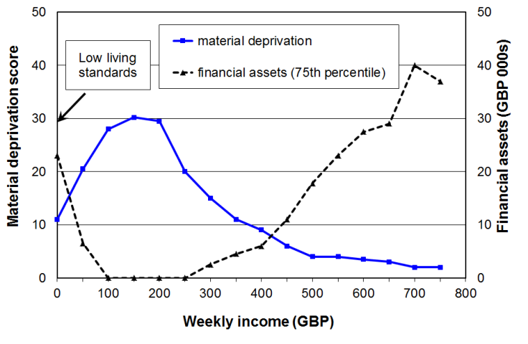
Source: Brewer et al (2009), Tables 5.1 and 5.2

Technical note
poor and deprived
poor but not deprived
deprived but not poor
p+d
poor, not deprived
deprived, not poor
When considering the overlap or mismatch between the two core groups, it is important to make the size of the two groups around the same.

If, for example, the deprived group was relatively small or the income-poor group was relatively large, then it is quite possible for the deprived group to be seen as almost a subset of the income poor group, and to conclude that “the vast majority of the poor are not deprived”, or similar. This would be a mistaken conclusion that is simply a logical consequence of the decision about the relative sizes of the groups, not an empirical finding about the true nature of the relationship itself. Even when the groups are of similar size, 40% to 60% of the income poor are not materially deprived, but when they are very different in size the overlap relative to one core group is likely to be very different from the overlap relative to the other. This asymmetry can lead to mistaken conclusions.

There are times however when the purpose of the analysis requires that different sized groups are used. In that case, the concept of “overlap” needs to be clarified and the overlap both ways reported (eg “30% of those in low income households are in hardship on this measure, and 60% of those in hardship are in low-income households”).

Using longitudinal data: the impact of remaining longer on low income

The longer that households have low income the greater is their risk of (higher) material deprivation

This is not a surprising finding, but it is useful to have it confirmed from analysis of New Zealand longitudinal data from SoFIE (see Figure F.7). It is also worthwhile drawing attention to it, as it is not always to the fore in discussions around poverty and hardship figures.

The relatively flat line for older households reflects the fact that such households often have resources other than current income with which to support consumption for basic needs. This is in line with the income-wealth-consumption-material-wellbeing framework outlined above.

Figure F.7
Increasing material hardship for longer periods on low income
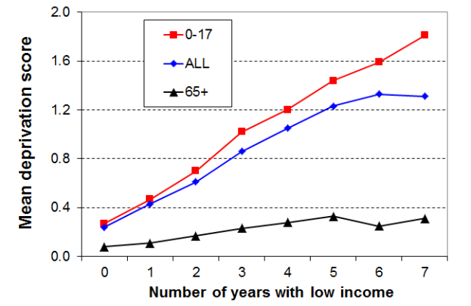
Note: the deprivation index used in this analysis is the 8-item NZiDep – see Section A for more information – and the low-income threshold is 60% of median gross household income (approximately the same as 70% of median disposable income threshold).
Source: Carter and Imlach Gunasekara (2012) via Perry (2015).

The cumulative impact of lower low income leads to higher deprivation

The low-income threshold used in the analysis in Figure F.7 produced poverty rates above the usual cross-sectional ones – that is, it was a relatively generous threshold. When a lower threshold is used, more in line with the 60% BHC cross-sectional threshold, the cumulative impact of on-going lower low income leads to higher reported deprivation, as expected. Figure F.8 shows this for the whole population.

Figure F.8
Higher material hardship for periods on lower low income
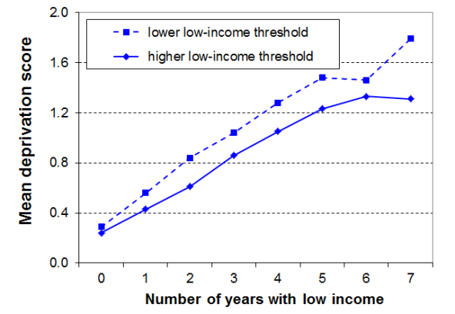
Source: Carter and Imlach Gunasekara (2012) via Perry (2014)
Section G
Material hardship trends from 2007 to 2018 (using HES data)

This section reports on trends in material hardship rates from 2007 to 2018 for the population as a whole, for children aged under 18 years, and for older New Zealanders aged 65+. Several hardship thresholds are used, ranging from more to less severe in line with the approach discussed in earlier sections. The trends in rates for those in ‘near hardship’ are also reported to more fully round out the picture.

Measuring material hardship using non-income measures (NIMs) has been carried out in the UK and Ireland for many years, especially since Townsend’s efforts in the 1960s and 1970s (see, for example, Mack and Lansley (1985, 2015), and Nolan and Whelan (1996, 2013)). John Jensen and David Fergusson in New Zealand used non-income measures in the 1970s to investigate the material wellbeing of older New Zealanders (Department of Social Welfare,1975).

However it is really only in the last ten to fifteen years that governments and their statistical agencies have been gathering information for creating time series with survey data available each year. The EU-SILC series, coordinated and supervised by Eurostat, runs from 2005 for EU countries, plus Iceland and Norway. Australia has financial stress items in HILDA surveys from 2001 to 2009, and a similar set is currently in the Survey of Income and Housing. The 2014 wave of HILDA introduced a new and extensive suite of indicators (Wilkins, 2016), though they do not include the full number of either DEP-17 or EU-13 items. There are no time series data available for the US or Canada using NIMs.

A material hardship time series from 2007 to 2018

The time series in this section use the Economic Living Standards Index (ELSI) up to and including 2012, and after that the Material Wellbeing Index (MWI). The MWI is the revised version of the ELSI prototype – they are discussed in Section E above. These indices are constructed using non-incomes data from Stats NZ’s Household Economic Surveys (HES), from 2007 to 2018:
- twenty-five items were collected from 2007 to 2012 (the ELSI short-form items)
- from 2013 to 2015 the survey collected 29 items from which the MWI and DEP-17 are constructed
- from HES 2016 on, six more items were added, and the previous 29 were retained.

In the change of item sets between the 2012 and 2013 surveys, 13 of the 25 ELSI items were dropped and 17 new ones were added. There can therefore be no on-going ELSI time series and, similarly, the new MWI series can run only from 2013. This means a break between 2012 to 2013 with ELSI before the break and MWI after, which potentially thwarts efforts for a time series across the whole period.

Fortunately nine of the twelve items that are common to both the earlier and later datasets are suitable to create a good-enough index that shows the shape of the trend-lines across the full period, 2007 to 2018, giving a good indication on how to splice the ELSI and MWI series between HES 2012 and HES 2013, the period in which the item sets changed. The details of this analysis are reported in Appendix 4.

Trends in material hardship rates from 2007 to 2018 are shown in Figures G.1 and G.2. The charts use a two-year rolling average which more clearly shows the trends.

Figure G.1
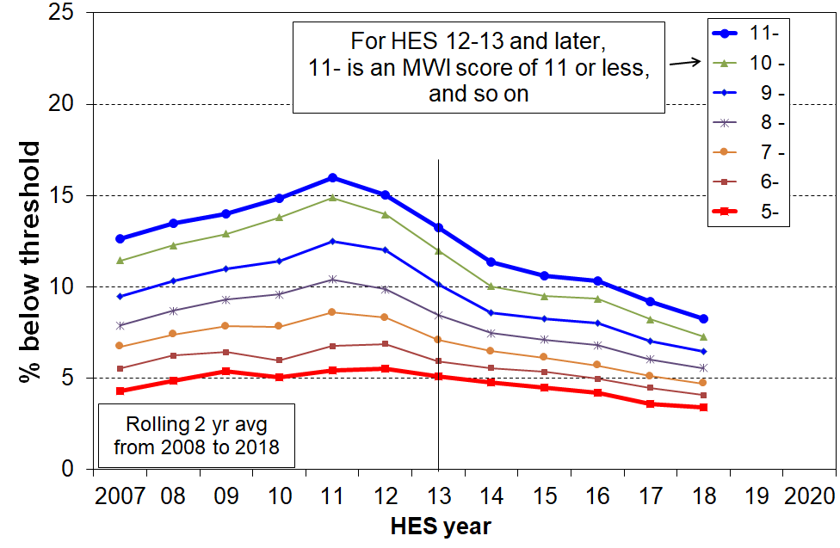
Material hardship trends for different thresholds (whole population)
Note: MWI ≤ 11 ≡ 6+/17 on DEP-17, and MWI ≤ 5 ≡ 9+/17 on DEP-17

Figure G.2
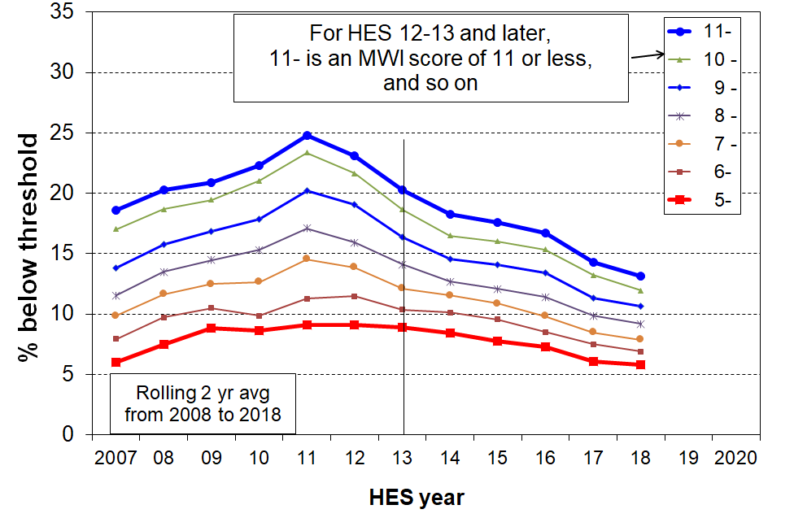
Material hardship trends for different thresholds (0-17yrs)
Note: MWI ≤ 11 ≡ 6+/17 on DEP-17, and MWI ≤ 5 ≡ 9+/17 on DEP-17

Table G.1A and Table G.1B give the unsmoothed and smoothed numbers for the ‘standard’ and ‘more severe’ thresholds.

Table G.2 repeats the hardship rates for children from Table G.1B and provides the corresponding numbers of children.
Table G.1A
Material hardship trends (rate %), 2007 to 2018, using two thresholds (HES)
unsmoothed
 | Less stringent threshold  MWI ≤ 11 (≡ 6+ on DEP-17) |  |  | More stringent threshold  MWI ≤ 5 (≡ 9+ on DEP-17)
 | ALL | 0-17 | 65+ | ALL | 0-17 | 65+
2007 | 13 | 19 | 5 | 4 | 6 | 1
2008 | 14 | 22 | 5 | 6 | 9 | 3
2009 | 14 | 20 | 5 | 5 | 9 | 1
2010 | 16 | 24 | 5 | 5 | 9 | 1
2011 | 16 | 25 | 6 | 6 | 10 | 0
2012 | 14 | 22 | 7 | 5 | 9 | 2
2013 | 12 | 19 | 3 | 5 | 9 | 1
2014 | 10 | 17 | 3 | 5 | 8 | 1
2015 | 11 | 18 | 4 | 5 | 8 | 1
2018 | 8 | 13 | 2 | 3 | 6 | 1

Table G.1B
Material hardship trends (rate %), 2007 to 2018, using two thresholds (HES):
smoothed, using two year rolling averages
 | Less stringent threshold  MWI ≤ 11 (≡ 6+ on DEP-17) |  |  | More severe hardship  MWI ≤ 5 (≡ 9+ on DEP-17)
 | ALL | 0-17 | 65+ | ALL | 0-17 | 65+
2008 | 13 | 20 | 5 | 5 | 8 | 2
2009 | 14 | 21 | 5 | 5 | 9 | 2
2010 | 15 | 22 | 5 | 5 | 9 | 1
2011 | 16 | 25 | 5 | 5 | 9 | 1
2012 | 15 | 24 | 6 | 6 | 9 | 1
2013 | 13 | 20 | 5 | 5 | 9 | 1
2014 | 11 | 18 | 3 | 5 | 8 | 1
2015 | 11 | 18 | 3 | 5 | 8 | 1
2018 | 8 | 13 | 2 | 3 | 6 | 1

Table G.2
Material hardship rates (%) and numbers for children (aged 0-17 yrs):
smoothed, using two year rolling averages
HES year | EU ‘standard’ threshold |  | EU ‘severe’ threshold
 | rate (%) | numbers | rate (%) | numbers
2008 | 20 | 220,000 | 8 | 80,000
2009 | 21 | 225,000 | 9 | 95,000
2010 | 22 | 235,000 | 9 | 95,000
2011 | 25 | 270,000 | 9 | 100,000
2012 | 24 | 255,000 | 9 | 100,000
2013 | 20 | 220,000 | 9 | 95,000
2014 | 18 | 195,000 | 8 | 90,000
2015 | 18 | 190,000 | 8 | 85,000
2018 | 13 | 145,000 | 6 | 65,000

Figure G.3 shows the material hardship trends for younger and older New Zealanders, compared with the overall population trend. The threshold used is the standard one (MWI ≤ 11 (≡ 6+/17 on DEP-17)).
- The overall relativities are clear and well established: older New Zealanders have much lower hardship rates than younger New Zealanders (aged 0-17 yrs), with rates similar to those of couple only ‘working age’ households (~3-5% over many years).
- The rate for sole-parent households rose from around 35% pre-GFC to 45% at its highest and in 2018 was back own to 35%.

Figure G.3
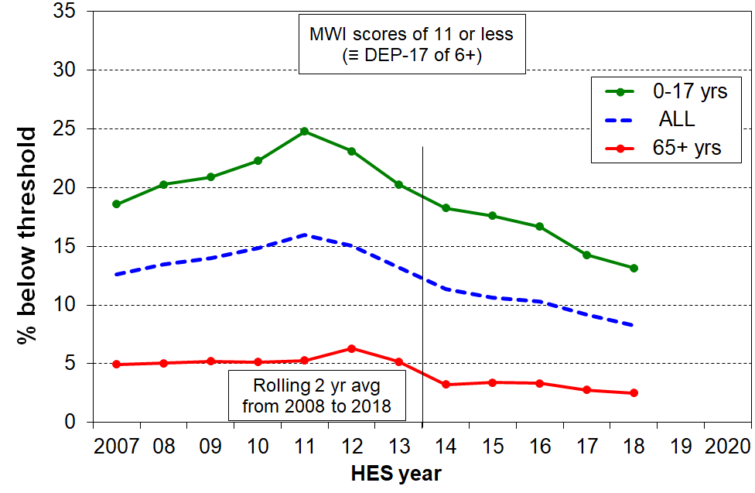
Material hardship trends, 2007 to 2018, older and younger New Zealanders

Using non-income measures (NIMs) and household income together to identify the proportion of those who live in low-income households which are also reporting material hardship

Those in the overlap group are sometimes referred to colloquially as being in ‘severe hardship’ or ‘severe poverty’. This report and the companion Incomes Report note that there are several ways of conceptualising ‘severe hardship’ or ‘severe poverty’:
- higher deprivation scores using the MWI (MWI≤5) or the DEP-17 equivalent (9+/17)
- very low incomes (say, less than 40% of median AHC incomes)
- having both low income and in material hardship, as in this section.

For those households reporting material hardship but with incomes reasonably above a low-income line there are grounds for expecting living standards to improve over time provided their incomes do not decline and that there are no on-going special demands on the budget (eg from high health costs, high debt servicing, and so on). However for those in hardship who also have low incomes, there is very little chance of improvement of living standards until household income rises and stays up (or the household receives outside assistance or a large financial gift).

Figure G.4 and Table G.3 show the trend in the size of the overlap group from 2007 to 2018 for the population as a whole and for children. The impact of the lower GDP per capita from calendar 2007 to calendar 2010 (2007/08 drought and then the GFC) is clear in the rising rates. In HES 2018 rates were a little lower than they were before the downturn.

Figure G.4
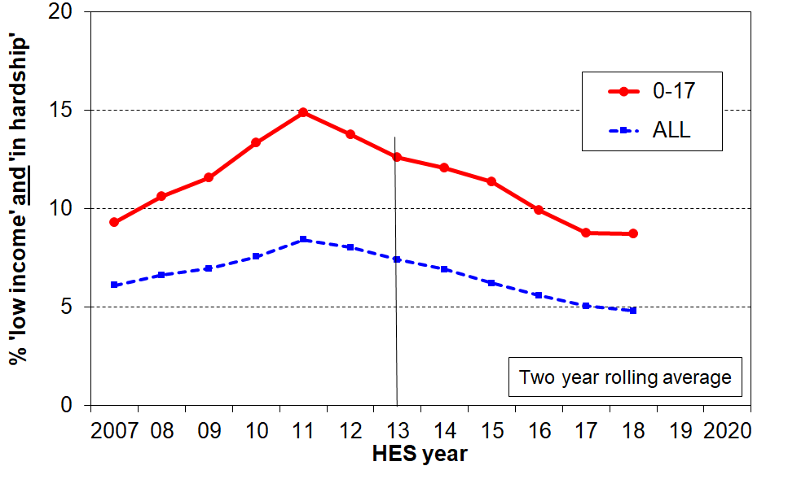
Trends in the proportion of those who are both income poor & materially deprived, 2007 to 2018
Reading note for graph: the overlap analysis here uses the 60% AHC income low-income line and the material hardship line set at MWI ≤ 11 (ie 6+/17 on DEP-17). Using a lower low-income threshold (eg 50% AHC) lowers the lines but the trends are much the same.

Table G.3
Trends in the proportion of those who are both income poor & materially deprived, 2007 to 2018
(rolling two year averages)
 | ALL, % | ALL, 000s | 0-17, % | 0-17, 000s
2008 | 7 | 270 | 11 | 115
2009 | 7 | 285 | 12 | 125
2010 | 8 | 310 | 13 | 140
2011 | 8 | 350 | 15 | 160
2012 | 8 | 340 | 14 | 150
2013 | 7 | 315 | 13 | 135
2014 | 7 | 300 | 12 | 130
2015 | 6 | 270 | 11 | 120
2016 | 6 | 245 | 10 | 105
2017 | 5 | 225 | 9 | 95
2018 | 5 | 220 | 9 | 95

Trends in hardship rates for the “poor” and the “non-poor”

As discussed above and in Section F, one of the features of the relationship between income and material hardship is that although living in a household with an income above a given low-income threshold (“poverty line”) reduces the risk of material hardship, it does not eliminate the risk. Some of the non-poor still experience material hardship (and some of the poor do not).

Tables G.4 and G.5 and the associated graphs on the next page (Figures G.4 and G.5) report the hardship trends for the ‘poor’ and the ‘non-poor’ (broken down into the ‘near poor’ and those with above median incomes).
The ‘non-poor’ have much lower hardship rates than the ‘poor’, as shown in Table G.3. This is not a surprise. There are however many more ‘non-poor’ than there are ‘poor’, and the numbers in hardship in each group are broadly similar for the population as a whole, as shown in Table G.4.

An important finding from this analysis is that around 60% of the reduction in hardship from the peak in 2011-2012 to HES 2015 came from many ‘non-poor’ households moving out of hardship as their incomes improved through greater employment opportunities and wage growth in the recovery post-GFC (50% for children).

It is a reminder that there are households with incomes above even the relatively generous 60% of median AHC low-income line (the ‘near-poor’) whose financial circumstances can best be described as precarious (cf Whelan and colleagues, 2016). Relatively small changes in income or unexpected bills can make a significant difference to their actual day-to-day living conditions.

The analysis uses the 60% AHC low income line for the ‘poor’, and 60% to 100% of median for the ‘near poor’. The material hardship line set at MWI ≤ 11 (ie 6+/17 on DEP-17). ‘The numbers’ in Table G.5 are left unrounded for convenience only and are not intended to imply great precision.

Table G.4
Material hardship rates (%) for the ‘poor’ and the ‘non-poor’, 2007 to 2018
 | Population (%) in hardship |  |  |  |  | 0-17 yrs (%) in hardship
 | ALL | ‘poor’ | 'non-poor' |  |  | ALL | ‘poor’ | 'non-poor'
 | ALL | ‘poor’ | Total | 'near-poor' | above median | ALL | ‘poor’ | Total | 'near-poor' | above median
2008 | 13 | 32 | 9 | 17 | 4 | 20 | 40 | 13 | 23 | 5
2009 | 14 | 33 | 9 | 17 | 4 | 21 | 40 | 13 | 23 | 5
2010 | 15 | 35 | 9 | 17 | 5 | 22 | 44 | 13 | 21 | 5
2011 | 16 | 38 | 10 | 18 | 5 | 25 | 48 | 14 | 24 | 6
2012 | 15 | 37 | 9 | 18 | 4 | 24 | 45 | 14 | 24 | 6
2013 | 13 | 35 | 8 | 15 | 3 | 20 | 42 | 11 | 19 | 4
2014 | 11 | 31 | 6 | 12 | 2 | 18 | 40 | 9 | 15 | 3
2015 | 11 | 28 | 6 | 11 | 3 | 18 | 37 | 9 | 15 | 3
2016 | 10 | 25 | 6 | 12 | 3 | 17 | 33 | 10 | 16 | 4
2017 | 9 | 23 | 5 | 11 | 2 | 14 | 31 | 8 | 14 | 2
2018 | 8 | 22 | 4 | 9 | 2 | 13 | 30 | 6 | 12 | 2

Table G.5
Numbers (000s) of ‘poor’ and ‘non-poor’ who report hardship, 2007 to 2018
 | Population (%) in hardship |  |  |  |  | 0-17 yrs (%) in hardship
 | ALL | ‘poor’ | 'non-poor' |  |  | ALL | ‘poor’ | 'non-poor'
 | ALL | ‘poor’ | Total | 'near-poor' | above median | ALL | ‘poor’ | Total | 'near-poor' | above median
2008 | 550 | 270 | 280 | 201 | 78 | 219 | 114 | 105 | 85 | 20
2009 | 575 | 284 | 291 | 203 | 88 | 223 | 123 | 100 | 82 | 19
2010 | 611 | 311 | 301 | 203 | 98 | 235 | 141 | 94 | 72 | 21
2011 | 670 | 352 | 318 | 213 | 105 | 267 | 161 | 107 | 81 | 26
2012 | 643 | 339 | 304 | 211 | 93 | 254 | 148 | 105 | 82 | 23
2013 | 570 | 315 | 255 | 185 | 70 | 219 | 135 | 83 | 68 | 16
2014 | 491 | 297 | 194 | 143 | 50 | 195 | 130 | 65 | 53 | 12
2015 | 461 | 269 | 192 | 138 | 54 | 189 | 122 | 67 | 54 | 13
2016 | 454 | 245 | 208 | 150 | 58 | 179 | 107 | 72 | 57 | 15
2017 | 411 | 226 | 185 | 138 | 47 | 154 | 94 | 59 | 49 | 10
2018 | 374 | 218 | 156 | 112 | 44 | 143 | 95 | 48 | 41 | 7

Figures G.4 and G.5
Material hardship for those in poor and non-poor households, 2007 to 2018:
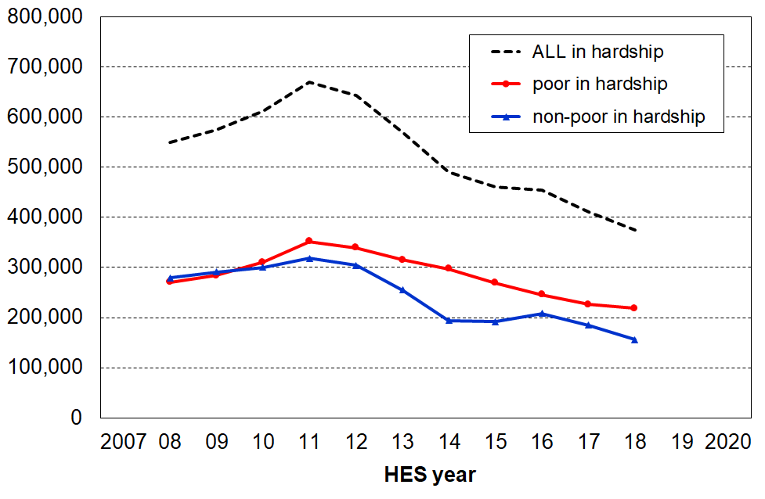
Whole population (left), 0-17 years (right)
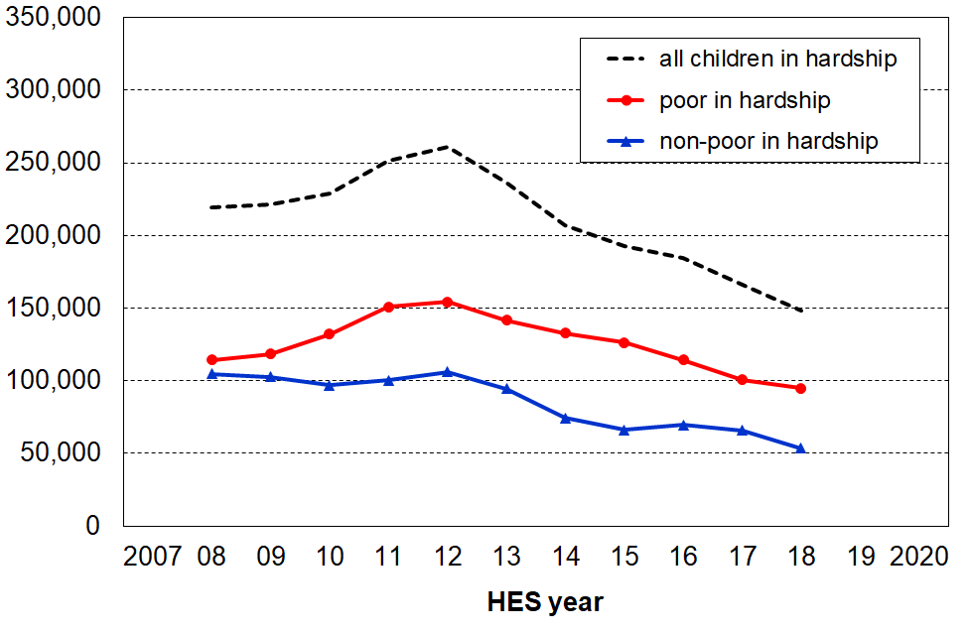
Note for charts: Both charts use a rolling two-year average from 2008 on.
A feature of material hardship trends using non-income measures is that they are quite sensitive to changing household circumstances and can show much higher percentage point changes for rates compared with the corresponding changes in income poverty rates.

This does not mean that in the GFC that material hardship in New Zealand ‘got a lot worse’, whereas income poverty became only ‘a little worse’. It simply reflects two features of the use of material deprivation indices for time series: (a) by their construction they are more sensitive than income measures to changing household circumstances, when looking at percentage point changes, and (b) many households live in an “only-just-getting-by” mode and even a small loss (gain) in income can easily lead to them moving below (above) a hardship threshold.

See the discussion at the end of Section A for more on this point in relation to the trends in Ireland (Figure A.3).

Would using DEP-17 for the time series starting with HES 2013 give different results?

DEP-17 rates will be reported each year, and are expected to track very much the same as the MWI rates. Tables G.6A and G.6B. show a promising start for HES 2013 to HES 2018. The 2016 and 2017 rates (not shown) show the same strong similarity between the two. There is nothing so far to indicate that the DEP-17 and MWI will give different trends.

Section E also gives good evidence as to the equivalence of DEP-17 and MWI for measuring hardship. Tables G.6A and 6B are the same as Tables E.8A and E.8B, except that the LSS 2008 findings are omitted here. Note that these are the unsmoothed numbers..

Table G.6A
Comparisons of MWI and DEP-17 for four HES years, using a range of thresholds:
whole population
 | MWI |  |  |  | DEP-17
MWI | 2013 | 2014 | 2015 | 2018 | 2013 | 2014 | 2015 | 2018 | DEP-17
13 - | 16 | 13 | 14 | 10 | 15 | 13 | 14 | 10 | 5+
12 - | 14 | 12 | 12 | 9
11 - | 12 | 10 | 11 | 8 | 12 | 10 | 11 | 8 | 6+
10 - | 11 | 9 | 10 | 7
9 - | 9 | 8 | 8 | 6 | 9 | 7 | 9 | 6 | 7+
8 - | 8 | 7 | 7 | 5
7 - | 7 | 6 | 6 | 5 | 6 | 6 | 7 | 4 | 8+
6 - | 6 | 6 | 5 | 4
5 - | 5 | 5 | 5 | 3 | 5 | 5 | 5 | 3 | 9+

Table G.6B
Comparisons of MWI and DEP-17 for four HES years, using a range of thresholds:
0-17 years
 | MWI |  |  |  | DEP-17
MWI | 2013 | 2014 | 2015 | 2018 | 2013 | 2014 | 2015 | 2018 | DEP-17
13 - | 23 | 20 | 22 | 17 | 23 | 20 | 22 | 16 | 5+
12 - | 21 | 19 | 19 | 15
11 - | 19 | 17 | 18 | 13 | 18 | 16 | 18 | 13 | 6+
10 - | 17 | 16 | 16 | 12
9 - | 15 | 14 | 14 | 11 | 15 | 12 | 15 | 10 | 7+
8 - | 13 | 12 | 12 | 9
7 - | 12 | 11 | 11 | 8 | 10 | 10 | 12 | 8 | 8+
6 - | 10 | 10 | 9 | 7
5 - | 9 | 8 | 8 | 6 | 8 | 8 | 9 | 6 | 9+
Reading notes for tables above: 5+ means 5 or more, and 13- means 13 or less
Section H
Individual items

The focus so far has been on using groups of non-income measures / non-monetary indicator items together to form indices. Individual items have been used mainly in relation to establishing the validity of the DEP-17 and MWI indices, and to assist with setting material hardship thresholds.

Some individual items are however of interest in their own right, how their absence or presence changes over time and also how they are distributed across the MWI or household income spectra. In this section, three sets of individual items are reported on: self-reported income adequacy, selected deprivation items, and a more detailed look at aspects of housing quality.

Self-reported income adequacy

In the HES there is a question that asks the respondent to think about how well the combined income of the respondent and partner (if any) meets everyday needs for such things as accommodation, food, clothing and other necessities: “Would you say you have not enough money, only just enough money, enough money, or more than enough money?”

The graphs in Figure H.1 below show the responses to the income adequacy question asked in the HES, by household BHC income decile and by decile of MWI score. The graphs use a three-way split for grouping the responses: not enough; only just enough; and enough or more than enough.

Figure H.1
Responses to self-reported income adequacy question,
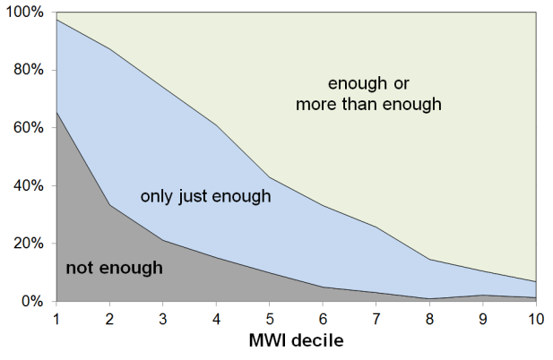
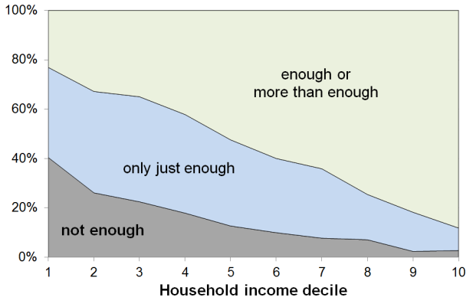
by decile of household income and by decile of MWI score, HES 2013 and HES 2014 (avg)

Table H.1
Responses to self-reported income adequacy question,
by decile of household income and by decile of MWI score, HES 2013 and HES 2014 (avg)
Ranking measure |  | ALL | 1 | 2 | 3 | 4 | 5 | 6 | 7 | 8 | 9 | 10
BHC household income | not enough |  | 40 | 29 | 25 | 19 | 13 | 10 | 7 | 6 | 2 | 2
BHC household income | only just enough |  | 37 | 39 | 40 | 40 | 35 | 30 | 29 | 20 | 18 | 9
BHC household income | enough / more than enough |  | 23 | 32 | 35 | 41 | 52 | 60 | 64 | 74 | 80 | 89
MWI score | not enough |  | 65 | 36 | 23 | 15 | 9 | 5 | 3 | 2 | 2 | 1
MWI score | only just enough |  | 32 | 52 | 52 | 46 | 34 | 30 | 23 | 15 | 9 | 5
MWI score | enough / more than enough |  | 3 | 13 | 26 | 39 | 57 | 65 | 74 | 84 | 89 | 94

The expected gradients from lower to higher material wellbeing are clear on both measures. The “not enough” distribution is however much more tightly bunched at the lower end when the MWI is used for ranking households rather than when household income is used.
In line with the framework outlined on page 7 above, this stronger bunching at the low end when using MWI rankings is highly likely to reflect the fact that respondents are taking as a given both their stock of household goods and appliances, and also the “other” factors that assist or place extra demand on the household budget. In other words, the responses are thoughtful contextualised ones about the adequacy of household income given their particular circumstances. MWI scores reflect the impact on living standards of these other factors as well as that of the household income, whereas household income is a more indirect measure of material wellbeing, a proxy that cannot take account of other key factors.

Looking at the data from the other perspective (how many say “enough” or “more than enough”?), 23% of those in the lowest income decile report having “enough” or “more than enough” income to meet basic needs, but only 3% of those in the lowest MWI decile report that their income is “enough” or “more than enough”.

These findings:
- illustrate the value and importance of the income-wealth-consumption-material wellbeing framework used in the reports
- give some encouraging evidence of the robustness of the responses given to this more subjective self-assessment question
- warn against using the responses to this common question as if they give reliable information on income adequacy per se, leaving other factors aside.

Selected deprivations, with comparisons of their incidence in low-income households and in households with higher deprivation scores (ie lower material wellbeing scores)

In addition to the base information about how many New Zealanders are in households that report the selected deprivations, the tables below also show that:
- not all those in low-income households experience all or even most of the deprivations listed, though their chances of experiencing some are much higher than for most others
- when households are ranked by their MWI scores, the deprivations are more intensely gathered at the low end than the ranking by household income does, even AHC income.

The tables use selected:
- enforced lacks [ELs]
- forced economising “a lot” items
- accommodation quality issues, and
- financial stress items.

The full text for the items can be found in Table E.2. The tables here use abbreviated descriptions.

The figures are averages from analysis using three consecutive HES surveys (2012-13, 2013-14 and 2014-15), and those for HES 2018. The latter are not as robust as the former. The larger 2018-19 survey will bring greater precision in the 2020 report.

Tables H.2A and H.2B are for the population as a whole.

Tables H.3A and H.3B report for households with children, ie what the respondent for the household said about either themselves or the household as a whole, depending on the question.
Table H.2A
Deprivations reported by AHC low-income households (%):
enforced lacks [ELs], or forced economising “a lot”, accommodation quality issues, financial stress,
whole population
 | averages for  HES 2013, 2014, 2015 |  |  | HES 2018
 | Bottom decile | Bottom quintile | ALL | Bottom decile | Bottom quintile | ALL
meal with meat, fish or chicken (or vegetarian equivalent) at least each second day [EL] | 7 | 6 | 2 | 7 | 5 | 2
2 pair of shoes in good condition for everyday activities [EL] | 13 | 9 | 3 | 8 | 7 | 2
clothes for special or important occasions [EL] | 14 | 10 | 3 | 11 | 9 | 3
contents insurance [EL] | 43 | 39 | 15 | 37 | 32 | 13
put up with feeling cold [a lot] | 21 | 19 | 8 | 21 | 18 | 7
put off repairing or replacing broken appliances [a lot] | 25 | 22 | 9 | 24 | 20 | 8
put off doctor’s visits [a lot] | 18 | 15 | 7 | 17 | 16 | 7
went without fresh fruit and vegetables [a lot] | 12 | 10 | 4 | 13 | 12 | 4
damp and mould a major problem | 14 | 15 | 7 | 11 | 10 | 6
heating home or keeping it warm in winter a major problem | 21 | 19 | 9 | 20 | 18 | 8
crowded 1+ (=1 plus 2+) | 11 | 15 | 8 | 17 | 17 | 9
received help from food banks or other community groups [more than once in last 12 months] | 16 | 14 | 4 | 14 | 12 | 3
borrowed from family or friends to meet everyday living costs [more than once in last 12 months] | 30 | 25 | 10 | 25 | 21 | 7
could not pay utilities on time [more than once in 12 months prior to interview] | 24 | 21 | 8 | 17 | 15 | 6

Table H.2B
Deprivations reported by households with low MWI scores (bottom decile and quintile) (%):
enforced lacks [ELs], or forced economising “a lot”, accommodation quality issues, financial stress,
whole population
 | averages for  HES 2013, 2014, 2015 |  |  | HES 2018
 | Bottom decile | Bottom quintile | ALL | Bottom decile | Bottom quintile | ALL
meal with meat, fish or chicken (or vegetarian equivalent) at least each second day [EL] | 10 | 7 | 2 | 12 | 7 | 2
2 pair of shoes in good condition for everyday activities [EL] | 26 | 15 | 3 | 18 | 11 | 2
clothes for special or important occasions [EL] | 26 | 16 | 4 | 25 | 14 | 3
contents insurance [EL] | 60 | 46 | 15 | 58 | 44 | 13
put up with feeling cold [a lot] | 47 | 31 | 8 | 44 | 28 | 7
put off repairing or replacing broken appliances [a lot] | 59 | 40 | 9 | 52 | 35 | 8
put off doctor’s visits [a lot] | 45 | 31 | 7 | 41 | 26 | 7
went without fresh fruit and vegetables [a lot] | 31 | 18 | 4 | 31 | 17 | 4
damp and mould a major problem | 34 | 25 | 7 | 26 | 17 | 6
heating home or keeping it warm in winter a major problem | 47 | 33 | 9 | 39 | 29 | 8
crowded 1+ (=1 plus 2+) | 21 | 19 | 8 | 23 | 20 | 9
received help from food banks or other community groups [more than once in last 12 months] | 25 | 16 | 4 | 26 | 15 | 3
borrowed from family or friends to meet everyday living costs [more than once in last 12 months] | 48 | 37 | 10 | 41 | 29 | 7
could not pay utilities on time [more than once in 12 months prior to interview] | 49 | 34 | 8 | 36 | 24 | 6

Note: Tables H.3A and H.3B show what the respondent reported for the household in which the children lived – the information is not about the children themselves directly. However, the items selected are all about matters that impact on the whole household in which the children live, so they do have an impact on the children. For child specific deprivations, see Section I.

Table H.3A
Deprivations reported by low-income (AHC) households (%):
enforced lacks [ELs], or forced economising “a lot”, accommodation quality issues, financial stress,
children, 0-17 yrs, in households where respondent reports as below
 | averages for  HES 2013, 2014, 2015 |  |  | HES 2018
 | Bottom decile | Bottom quintile | ALL | Bottom decile | Bottom quintile | ALL
contents insurance [EL] | 49 | 44 | 20 | 44 | 39 | 18
respondent reports - put up with feeling cold [a lot] | 23 | 21 | 10 | 20 | 19 | 9
put off repairing or replacing broken appliances [a lot] | 32 | 27 | 15 | 28 | 24 | 11
put off doctor’s visits (respondent) [a lot] | 21 | 18 | 11 | 21 | 21 | 10
respondent reports - went without fresh fruit and vegetables [a lot] | 13 | 10 | 5 | 15 | 14 | 5
damp and mould a major problem | 16 | 18 | 10 | 13 | 12 | 8
heating home or keeping it warm in winter a major problem | 23 | 22 | 13 | 22 | 23 | 12
crowded 1+ (=1 plus 2+) | 17 | 21 | 13 | 24 | 25 | 16
received help from food banks or other community groups [more than once in last 12 months] | 22 | 18 | 7 | 20 | 18 | 7
borrowed from family or friends to meet everyday living costs [more than once in last 12 months] | 37 | 30 | 15 | 31 | 27 | 11
could not pay utilities on time [more than once in 12 months prior to interview] | 33 | 28 | 13 | 23 | 22 | 10
Note: the deciles and quintiles are population deciles and quintiles – 12-13% of children (140,000) are in households in the bottom AHC income decile, and 27-28% (300,000) in the bottom quintile (for HES 13-15).

Table H.3B
Deprivations reported by households with low MWI scores (bottom decile and quintile) (%):
enforced lacks [ELs], or forced economising “a lot”, accommodation quality issues, financial stress,
children, 0-17 yrs, in households where respondent reports as below
 | averages for  HES 2013, 2014, 2015 |  |  | HES 2018
 | Bottom decile | Bottom quintile | ALL | Bottom decile | Bottom quintile | ALL
contents insurance [EL] | 60 | 47 | 20 | 60 | 47 | 18
respondent reports - put up with feeling cold [a lot] | 45 | 30 | 10 | 41 | 26 | 9
put off repairing or replacing broken appliances [a lot] | 62 | 44 | 15 | 51 | 35 | 11
put off doctor’s visits (respondent) [a lot] | 46 | 32 | 10 | 43 | 29 | 10
respondent reports - went without fresh fruit and vegetables [a lot] | 27 | 16 | 5 | 30 | 17 | 5
damp and mould a major problem | 36 | 26 | 10 | 27 | 19 | 8
heating home or keeping it warm in winter a major problem | 49 | 34 | 13 | 42 | 31 | 12
crowded 1+ (=1 plus 2+) | 27 | 24 | 13 | 31 | 28 | 16
received help from food banks or other community groups [more than once in last 12 months] | 28 | 19 | 7 | 31 | 20 | 7
borrowed from family or friends to meet everyday living costs [more than once in last 12 months] | 51 | 39 | 15 | 46 | 33 | 11
could not pay utilities on time [more than once in 12 months prior to interview] | 51 | 37 | 13 | 40 | 29 | 9
Note: the deciles and quintiles are population deciles and quintiles – 12-13% of children (140,000) are in households in the bottom MWI decile, and 27-28% (300,000) in the bottom quintile (for HES 13-15).
Dampness and heating issues for private dwellings

In the HES surveys, starting with 2012-13, respondents are asked whether their accommodation had no problem, a minor problem or a major problem with (i) dampness or mould, and (ii) with heating it / keeping it warm in winter. As noted in the tables above, on average over the three surveys from 2012-13 to 2014-15:
- 7% reported a major problem with dampness or mould
- 9% reported a major problem with heating it / keeping it warm in winter
- for children (aged 0-17 yrs), the figures for their households were:
  - 10% for a major problem with dampness and mould (~110,000 children)
  - 13% for a major problem with heating / keeping it warm in winter (~140,000)
  - 7% reporting both issues (~75,000 children)

Table H.4A shows how these housing quality issues occur across different tenures: owned, private rental and social housing, for the population as a whole and for children (0-17 years). The figures are for individuals, in line with the general pattern for the Incomes and NIMs reports. When the analysis is done by households rather than individuals, very similar results are produced:
- the composition columns show that around 65-70% of those experiencing these two issues are living in rental accommodation (both for the whole population and for children)
- the rate columns show that one in four households in HNZC homes (26%) report having a major problem with damp and mould, and one in three (34%) are hard to heat or keep warm in winter
  - for children, these latter rates rise to 34% for HNZC and 40% for private rentals.

Table H.4A
Major dampness, mould and heating issues: population and 0-17 yrs by tenure
HES 2013 to HES 2015 (avg %)
 | ALL |  | 0-17 yrs
 | Composition | Rate | Composition | Rate
Damp, mould (major problem)
Owned or Family Trust | 30 | 3 | 25 | 4
Private rental | 48 | 12 | 46 | 14
HNZC / Social housing | 21 | 27 | 26 | 34
ALL | 100 | 7 | 100 | 10
Hard to heat in winter
Owned or Family Trust | 31 | 5 | 26 | 6
Private rental | 47 | 15 | 46 | 18
HNZC / Social housing | 19 | 33 | 25 | 40
ALL | 100 | 9 | 100 | 13
Both damp and hard to heat
Owned or Family Trust | 26 | 2 | 23 | 3
Private rental | 45 | 7 | 43 | 9
HNZC / Social housing | 26 | 21 | 32 | 27
ALL | 100 | 4 | 100 | 7
Note: composition columns do not always add to 100 as there is a small group with “other” housing arrangements not included in the table.

Table H.4B on the next page breaks out the private renters into those who receive the Accommodation Supplement and those who do not.

Table H.4B
Major dampness, mould and heating issues: population and 0-17 yrs for renters, with/without AS
HES 2013 to HES 2015 (avg %)
 | ALL |  | 0-17 yrs
 | Composition | Rate | Composition | Rate
Damp, mould (major problem)
Private rental - AS | 34 | 15 | 33 | 17
Private rental - no AS | 14 | 8 | 14 | 10
Private rental - All | 48 | 12 | 46 | 14
Hard to heat in winter
Private rental - AS | 33 | 19 | 34 | 22
Private rental - no AS | 14 | 11 | 13 | 12
Private rental - All | 47 | 15 | 46 | 18
Both damp and hard to heat
Private rental - AS | 34 | 9 | 34 | 11
Private rental - no AS | 11 | 4 | 9 | 5
Private rental - All | 45 | 7 | 43 | 9
Note: composition columns do not always add to 100 as there is a small group with “other” housing arrangements not included in the table.

Statistics New Zealand’s 2014 General Social Survey (GSS) also asked the dampness and mould question and found a similar population proportion reporting a “major problem” (6%). The GSS analysis also found that respondents in rental accommodation were three to four times more likely to report a “major problem” with dampness or mould than were those in owner-occupied dwellings. The HES analysis shows a 16% rate for rental accommodation (private and HNZC), four times the rate for owner-occupied dwellings (4%). This is encouraging confirmation of the reliability of the findings.

Tables H.5 and H.6 show how these housing quality issues are experienced across the AHC incomes spectrum and the material wellbeing index (MWI) spectrum by the whole population and by children (0-17 years). The issues are clearly more prevalent in lower-income households than in middle and higher income households, but are especially concentrated in households with low MWI scores – these are households experiencing multiple deprivation across a range of basics:
- a quarter to a third of these low MWI households (Q1) report “a major problem”
- around 65-70% of those reporting “major problems” are in the lowest material wellbeing quintile (Q1), 75-80% for children (0-17 years).

Table H.5
Major dampness, mould and heating issues: HES 2013 to HES 2015 (%), population
 | Ranking measure | ALL | Q1 | Q2 | Q3 | Q4 | Q5
dampness or mould “a major problem” | AHC incomes | 7 | 15 | 9 | 6 | 4 | 2
dampness or mould “a major problem” | MWI | 7 | 25 | 6 | 3 | 1 | 0
heating home and/or keeping it warm in winter “a major problem” | AHC incomes | 9 | 19 | 11 | 7 | 6 | 3
 | MWI | 9 | 33 | 8 | 3 | 2 | 0
both dampness/mould and heating home a "major problem" | AHC incomes | 4 | 10 | 5 | 3 | 3 | 1
both dampness/mould and heating home a "major problem" | MWI | 4 | 18 | 3 | 1 | 1 | 0

Table H.6
Major dampness, mould and heating issues: HES 2013 to HES 2015 (%), 0-17 yrs
 | Ranking measure | ALL | Q1 | Q2 | Q3 | Q4 | Q5
dampness or mould “a major problem” | AHC incomes | 10 | 18 | 12 | 7 | 4 | 3
dampness or mould “a major problem” | MWI | 10 | 26 | 6 | 3 | 2 | 0
heating home and/or keeping it warm in winter “a major problem” | AHC incomes | 13 | 22 | 15 | 7 | 8 | 4
 | MWI | 13 | 34 | 8 | 2 | 2 | 0
both dampness/mould and heating home a "major problem" | AHC incomes | 7 | 13 | 7 | 3 | 4 | 2
both dampness/mould and heating home a "major problem" | MWI | 7 | 20 | 3 | 1 | 1 | 0

Putting up with feeling cold “because of the cost” [of heating]

In the HES surveys, starting with 2012-13, respondents are asked to what degree they had put up with feeling cold in the last 12 months as a result of being forced to keep costs down to pay for other basics. The response options were “not at all”, “a little”, or “a lot”.

Table H.7A (HES 2015) shows that the proportions reporting being forced to put up with feeling cold “a lot” are in the same ball-park as those reporting a major problem in heating the home or keeping it warm in winter (7% and 9% respectively for the whole population, and 10% and 13% for those in households with children). The proportions reporting this enforced lack are particularly high for sole parent and beneficiary-with-children homes (22% and 30% respectively).

Table H.7A
Forced to put up with feeling cold to keep costs down to pay for other basics, HES 2015 (%)
 | not at all | a little | a lot
All incomes
ALL | 79 | 13 | 7
0-17 | 74 | 16 | 10
65+ | 87 | 9 | 4
Couple < 65 | 88 | 8 | 4
Sole parent | 57 | 22 | 22
Beneficiary with dep children | 46 | 24 | 30
Working with dep children | 81 | 13 | 6
Bottom AHC quintile
Beneficiary with dep children | 46 | 27 | 27
Working with dep children | 63 | 23 | 14
The lower panel of Table H.7A looks only at the lower AHC income quintile, in effect controlling to some degree for income to make the beneficiary / working comparison more robust and realistic. The economising “a lot” rate changes very little for beneficiary families (30% to 27%) as the bulk of beneficiaries are in the bottom quintile. In contrast the rate for working families more than doubles, from 6% to 14%.

In the bottom AHC income quintile there are around 50% more people in working families with children than in beneficiary families with children (a ratio of around 60:40), so the numbers reporting being forced to put up with the cold are fairly similar for each group. This finding, that there is evidence of material hardship for a group of “working poor” that is about the same size as the “beneficiary poor” group, is consistent with similar findings elsewhere in this report and in the Incomes Report.

Table H.7B repeats the analysis for HES 2018. The numbers and relativities are broadly similar to HES 2015.

Table H.7B
Forced to put up with feeling cold to keep costs down to pay for other basics, HES 2018 (%)
 | not at all | a little | a lot
All incomes
ALL | 80 | 13 | 7
0-17 | 76 | 16 | 9
65+ | 89 | 7 | 4
Couple < 65 | 87 | 10 | 3
Sole parent | 61 | 22 | 18
Beneficiary with dep children | 48 | 27 | 24
Working with dep children | 82 | 13 | 5
Bottom AHC quintile
Beneficiary with dep children | 45 | 29 | 26
Working with dep children | 67 | 20 | 13

Table H.8A (HES 2015) shows how being forced to put up with cold a lot is experienced across the AHC incomes spectrum and the material wellbeing index (MWI) spectrum.

The issues are clearly more prevalent in lower-income households than in middle and higher income households, but are especially concentrated in households with low MWI scores – these are households experiencing multiple deprivation across a range of basics:
- one in three in the lowest MWI quintile (Q1) report a major problem
- around four in five (82%) of those reporting major problems are in the lowest MWI quintile (91% for children).

Table H.8A
Forced to put up with feeling cold “a lot” to keep costs down to pay for other basics, HES 2015 (%),
by quintiles using two ranking measures
Ranking measure |  | ALL | Q1 | Q2 | Q3 | Q4 | Q5 | Proportion (%) of the “a lot” group that are in Q1
AHC incomes | ALL | 7 | 18 | 7 | 6 | 4 | 1 | 50
AHC incomes | 0-17 | 10 | 21 | 9 | 6 | 6 | 1 | 56
AHC incomes | 65+ | 4 | 13 | 4 | 4 | 1 | 1 | 40
MWI | ALL | 7 | 30 | 5 | 1 | 0 | 0 | 82
MWI | 0-17 | 10 | 30 | 3 | 1 | 0 | 0 | 91
MWI | 65+ | 4 | 31 | 9 | 1 | 0 | 0 | 63
Note: the quintiles are the whole population quintiles – the two age-groups are put into these quintiles, not their own independent quintiles.

Table H.8B (HES 2018) repeats the analysis for HES 2018. The numbers and relativities are close to those for HES 2015.

Table H.8B
Forced to put up with feeling cold “a lot” to keep costs down to pay for other basics, HES 2018 (%),
by quintiles using two ranking measures
Ranking measure |  | ALL | Q1 | Q2 | Q3 | Q4 | Q5 | Proportion (%) of the “a lot” group that are in Q1
AHC incomes | ALL | 7 | 18 | 7 | 5 | 3 | 3 | 48
AHC incomes | 0-17 | 9 | 19 | 9 | 3 | 2 | 3 | 59
AHC incomes | 65+ | 4 | 13 | 2 | 3 | 2 | 2 | 54
MWI | ALL | 7 | 28 | 5 | 1 | 0 | 0 | 80
MWI | 0-17 | 9 | 26 | 3 | 0 | 1 | 0 | 90
MWI | 65+ | 4 | 31 | 5 | 1 | 0 | 0 | 75
Note: the quintiles are the whole population quintiles – the two age-groups are put into these quintiles, not their own independent quintiles.

Crowding

Living in crowded houses greatly increases the risk of transmission and experience of communicable diseases and respiratory infections. . It also means severely reduced personal space and privacy, more limited space for children to do homework or study, and increases the chances of relational stress.

While there is no internationally agreed measure of household crowding the Canadian Crowding Index is a reasonable one, and is used in the Social Report, by Statistics New Zealand in some of its publications, and by the Ministry of Health in a recent analysis of crowding using Census data (Ministry of Health, 2014). On this definition, a crowded house is one requiring one or more additional bedrooms, when using the following Canadian National Occupancy standard to set the bedroom requirements:
- no more than two people per bedroom
- parents or couples share a bedroom
- children aged under 5 years, either of the same or of the opposite sex, may reasonably share a bedroom
- children aged under 18 years of the same sex may reasonably share a bedroom.
- a child aged 5–17 years should not share a bedroom with a child aged under 5 years of the opposite sex
- single adults 18 years and over and any unpaired children require a separate bedroom.

Trends in more severe crowding can be monitored using a threshold of two or more extra bedrooms needed.

Table H.9 shows from Census data the decline in household crowding for the population as a whole from 1986 to 2001, then the flat trend at around 10% for 2001, 2006 and 2013. HES data can also be used to create the Canadian index. The HES-based crowding rates are all a little lower than the Census rates, 8% rather than 10% for the population, and 12% rather than 16% for children.

Crowding is in the main “a children’s issue” as 75% to 80% of those in crowded or severely crowded households are in households with children:
- ~130,000 children (0-14 yrs) live in crowded households (16%), and 40,000 of these are in severely crowded homes, needing two or more extra bedrooms (5%).

Table H.9
Crowded: Census and HES (1+ needed) (%)
 | Individuals |  |  |  |  |  |  | Households
Census | ALL | European | Maori | Pacific | 0-14 yrs | Rented | Owned or FT | ALL
1986 | 12.8 | 8.2 | 34.9 | 50.4 | - | - | - | -
1991 | 11.8 | 6.9 | 29.7 | 47.0 | - | - | - | -
1996 | 10.9 | 6.0 | 24.5 | 43.6 | - | - | - | -
2001 | 10.1 | 4.7 | 23.0 | 42.1 | - | - | - | -
2006 | 10.4 | 4.5 | 22.3 | 41.7 | 17 | - | - | 5.2
2013 | 10.1 | 4.3 | 19.3 | 38.5 | 16 | 19 | 5 | 5.0
HES – three surveys: 2012-13 to 2014-15 | 8 | - | - | - | 13 | 15 | 4 | -
Note: HES crowding information is useful for giving a sense of the scale of the issue and how it is allocated across tenure and ages, but not robust enough for a time series showing trends in the short to medium term.

Note that the household rate (5%) is much less than individual rate as there are (unsurprisingly) more people per household in crowded households than there are in uncrowded households.

Table H.10 shows crowding across owned and rented accommodation:
- around 70% of those in crowded houses live in rental accommodation
- almost two in five children in HNZC homes (38%) live in crowded accommodation.

Table H.10A
Crowded: population and 0-17 yrs by tenure
HES 2013 to HES 2015 (%)
 | ALL |  | 0-17 yrs
 | Composition | Rate | Composition | Rate
Owned or Family Trust | 30 | 4 | 30 | 7
Private rental | 49 | 13 | 45 | 17
HNZC / Social housing | 20 | 28 | 25 | 39
ALL | 100 | 8 | 100 | 13
Note: the composition columns do not always add to 100 as there is a small group with “other” housing arrangements not included in the table.

Table H.10B
Crowded: population and 0-17 yrs for renters, with / without AS
HES 2013 to HES 2015 (%)
 | ALL |  | 0-17 yrs
 | Composition | Rate | Composition | Rate
Private rental - AS | 35 | 16 | 32 | 20
Private rental - no AS | 14 | 8 | 13 | 12
Private rental - All | 49 | 13 | 45 | 17
Note: the composition columns do not always add to 100 as there is a small group with “other” housing arrangements not included in the table.

Room for the children to study and play

Another aspect of crowding is about whether there is enough room for children to study and play.
Both the 2004 and 2008 Living Standards Surveys (LSS) ask whether the room for the children to study and play is limited because of the need to keep costs down for other basics. The response options were “not at all, a little and a lot”. In the analysis of the LSS 2008 data the “economising a lot” response is taken as equivalent to an enforced lack. This is a conservative approach as some of the “economising a little” responses are likely to be enforced lacks too.

When people are ranked by the MWI score of their households, 10% are in the bottom decile (by definition). This bottom decile holds 16% of all children. In short, the bottom MWI decile for LSS 2008 is a good approximation to the hardship zone, using the less severe threshold described in earlier sections.

The 2008 LSS responses show that:
- 8% of all children and 30% in the bottom MWI decile have this serious restriction regarding space for study and play, and
- 63% of all children facing this space restriction live in households in the bottom MWI decile.

Very similar findings come from the 2004 LSS (9% of children).

In the new suite of child-specific indicators in the 2016 HES a similar though not identical question is asked. When looking at the 20% of children in the bottom MWI quintile (of children, aged 6-17 yrs), 66% of all those who are reported as having a severe restriction on space to study and play are in that lower group. This is a similar finding to the LSS analysis. The 2018-19 HES will provide more robust data for this item.

Contents insurance

Lack of contents insurance significantly reduces the ability for people to bounce back after a fire, flood, earthquake or other misfortune. It increases economic vulnerability.
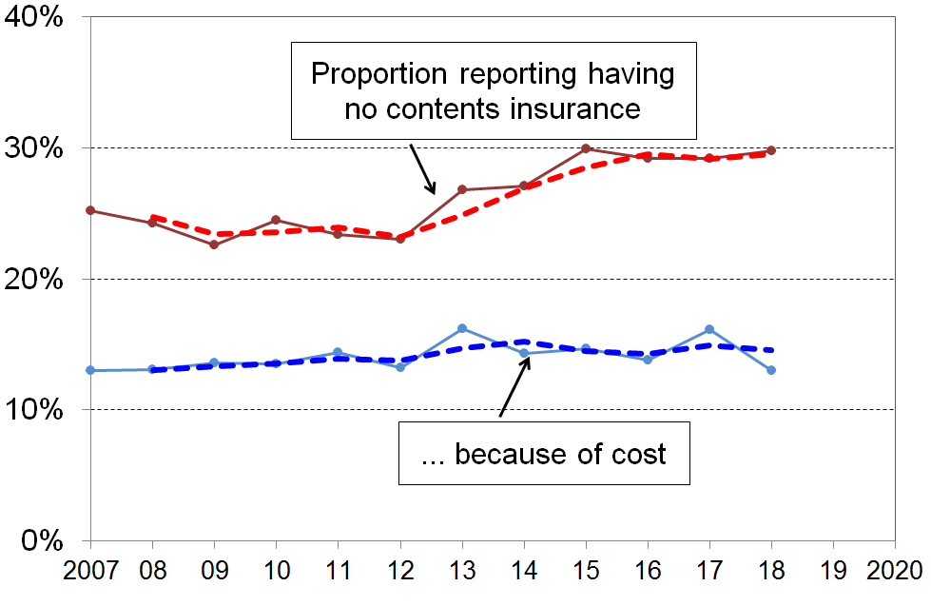
- The top line on the chart shows that the proportion of people in households without contents insurance rose from ~24% in 2007 to 2011 … to a new plateau of close to 30% in 2015 to 2018 (dashed trend-line is the two-year rolling average).

- In low-income households (the bottom AHC quintile (20%)), 51% of those aged under 65 lived in households that had no contents insurance in 2007 & 2008 – this had risen to 56% in 2015 to 2018.

- If the rise in the numbers without contents insurance were simply a temporary response to tighter household budgets for some in the GFC and associated downturn, the next few surveys could be expected to show a decline. However, as the lower line shows, there is an almost flat trend for those who say that they have no contents insurance “because of the cost” and the need to have money for other basics. It is not clear what is behind the rise in the upper line.

- For older New Zealanders (aged 65+), the straight “no-insurance” rate (as in the upper line) has been steady at 14-16% through the period. The change is occurring among those under 65.

Section I
Child-specific items

As noted in Appendix 1, the reported material hardship figures for households with children were surprisingly low in 2016 compared with 2013 to 2015. The figures for the child-specific items in this section should therefore be taken as a lower bound rather than as a reliable point estimate. The section will be updated next time based on data from the 2018-19 HES.

One of the strengths of the non-monetary indicator or non-incomes approach to measuring material hardship is that it can give a real sense of the day-to-day experiences of restriction and deprivation for those identified as poor (low incomes) or in hardship.

The indicators used in DEP-17 and in the MWI are of necessity relevant to all ages and household types. The selection of indicators for the indices is also guided by the need to ensure good discrimination across the full hardship spectrum – this means that the deprivation indicators used for the indices represent varying degrees or levels of material hardship (and for the MWI, there are also other indicators to reflect material wellbeing above the hardship zone).

The 2016 HES includes 20 child-specific items in addition to the more general ones needed for the three indices. They are listed in Table I.1 below. Almost all the child-specific information is about items and experiences that most would agree every child should have and none should be deprived of in New Zealand today. The clear exception is the item about the use / ownership of mobile phones for those aged 11+. Some may want access to a computer and internet at home also considered an exception, though not having this these days is a significant handicap.

Table I.1
The 20 child-specific items in the 2016 HES
Ownership or participation (have/do, don’t have/do and enforced lack (EL))
two pairs good shoes for each child
two sets of warm winter clothes for each child
waterproof coat for each child
all the uniform required by the schools
a separate bed for each child
fresh fruit and vegetables daily
meal with meat, fish or chicken (or vegetarian equivalent) at least each second day
a range of books at home suitable for their ages
a suitable place at home to do school homework
friends around to play and eat from time to time
friends around for a birthday party
good access at home to a computer and internet for homework
mobile phone if aged 11+
Economising (not at all, a little, a lot) – to keep down costs to help in paying for (other) basic items (not just to be thrifty or to save for a trip or other non-essential). Economising “a lot” is taken as a deprivation in this report.
postponed visits to doctor
postponed visits to dentist
unable to pay for school trips / events for each child
had to limit children’s involvement in sport
children had to go without music, dance, kapa haka, art, swimming or other special interest lessons
children continued wearing worn out / wrong size clothes and shoes
made do with very limited space to study or play

These child-specific indicators are not suitable for use in indices such as DEP-17 or the MWI as they do not meet the two criteria noted above (ie they are not suitable for all ages, and do not represent a good range of severity of hardship, only deeper hardship for most of them). They do, however, provide valuable information on the realities of daily life for those children identified as being “in hardship” by the index score of their household. They can be used on their own, or combined with information on more general household conditions that are child-relevant.(See also the box on page 16 in Section B.)

Figure I.1 below shows how multiple material disadvantage for children clusters strongly at the hardship end of the spectrum. The 18 items are those in Table I.2, and further detail is given on Table I.3 on the next page. The children are ranked in deciles by the MWI score of their households. For the most materially deprived 10% of children, 61% experience 4 or more of the 18 deprivations, all of which are about very basic needs. This is the average score for that group. For the most deprived, the proportion experiencing multiple deprivations is much greater.

While there is evidence here and elsewhere of some hardship in the next 10% (decile 2), there is no gradient across all the deciles reflecting what could be called “acceptable inequality”. The analysis shows that for those children in the most materially deprived households (~10% or so), life is undeniably very different from that experienced by the vast majority of New Zealand children. This finding is in line with what was found using similar indicators from the 2008 Living Standards Survey (see Figures D.3 and D.4 above). It illustrates what it means in practice to be “excluded from the minimum acceptable way of life in one’s own society”, the high-level definition of poverty commonly used for richer countries and adopted in MSD reports.

Figure I.1
Multiple deprivation for children aged 6-17,
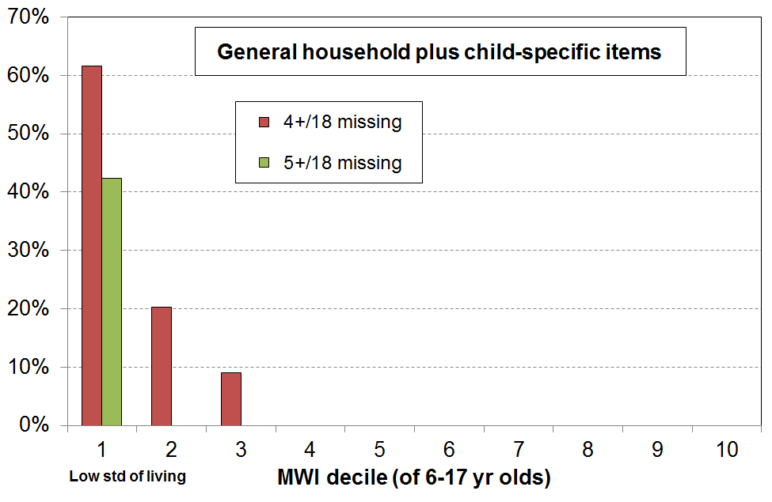
using a mix of child-specific and child-relevant household items, HES 2016
Table I.2
Selected child-specific items (12) | General child-relevant household items (6)
Do not have  - two pairs good shoes for each child  - two sets of warm winter clothes for each child  - waterproof coat for each child (because of cost)  - a separate bed for each child  - fresh fruit and vegetables daily  - meal with meat, fish or chicken (or vegetarian equivalent) at least each second day  - good access at home to a computer and internet for homework  Economised “a lot”  - unable to pay for school trips / events for each child  - had to limit children’s involvement in sport  - children had to go without music, dance, kapa haka, art, swimming or other special interest lessons  - continued wearing worn out / wrong size clothes and shoes  Very limited space to study or play. | - received help from food bank or other community group (more than once in last yr)  - accommodation severely crowded (2+ extra bedrooms needed)  - dampness or mould in dwelling (major problem)  - respondent reports putting up with feeling cold to keep down costs for other basics (a lot)  - delayed repair or replacement of appliances (“a lot”)  - no access to car or van
Table I.3
Children’s restrictions by MWI score of their family (children, 6-17 yrs), HES 2016 (%): grouped by quintiles of children, with the bottom quintile broken out into deciles
 | All | D1 | D2 |  | Q1 | Q2 | Q3 | Q4 | Q5
Distribution of children (6-17yrs) across MWI deciles of children (%) | 100 | 10 | 10 |  | 20 | 20 | 20 | 20 | 20
Don’t have
2 pair of shoes in good condition and suitable for daily activities for each child | 8 | 34 | 10 |  | 23 | 12 | . | . | .
2 sets of warm winter clothes for each child | 2 | . | . |  | . | . | . | . | .
waterproof coat for each child (because of the cost) | 5 | 24 | 8 |  | 17 | 5 | . | . | .
separate bed for each child | 4 | . | . |  | 13 | . | . | . | .
fresh fruit and vegetables daily | 5 | 32 | 9 |  | 21 | 4 | . | . | .
meal with meat, fish or chicken (or vegetarian equiv) at least each second day | 6 | 30 | . |  | 20 | 9. | . | . | .
good access at home to a computer and internet for homework | 12 | 43 | 21 |  | 33 | 15 | 6 | . | .
Economised “a lot” on children’s items to keep down costs to enable other basic things to be paid for (not just to be thrifty or to save for a trip or other non-essential)
had to go without music, dance, kapa haka, art, swimming or other special interest lessons (“a lot”) | 4 | 13 | 6 |  | 10 | 8 | . | . | .
unable to pay for school trip or other school event (“a lot”) | 1 | . | . |  | 6 | . | . | . | .
involvement in sport had to be limited (“a lot”) | 6 | 28 | 11 |  | 20 | 7 | . | . | .
made do with very limited space for children to study or play | 4 | 11 | 10 |  | 10 | 5 | . | . | .
continue to wear shoes or clothes that are worn out or the wrong size (“a lot”) | 3 | 17 | . |  | 11 | . | . | . | .
Multiple restrictions of child-specific items (the 12 above)
2+ out of 12 | 13 | 49 | 34 |  | 42 | 18 | . | . | .
3+ out of 12 | 8 | 41 | 13 |  | 28 | 12 | . | . | .
4+ out of 12 | 5 | 29 | 7 |  | 19 | 6 | . | . | .
Child-relevant general household items
received help (food, clothes, money) from a community organisation more than once in the last 12 months | 5 | 33 | 12 |  | 23 | . | . | . | .
accommodation severely crowded (2+ extra bedrooms needed) | 4 | 14 | 9 |  | 11 | 4 | . | . | .
dampness or mould a “major problem” in the accommodation | 8 | 31 | 19 |  | 25 | 10 | . | . | .
respondent reports putting up with feeling cold to keep down costs for other basics (a lot) | 7 | 34 | 19 |  | 27 | 5 | . | . | .
delayed replacing or repairing broken or damaged appliances to keep down costs for other basics (a lot) | 8 | 54 | 13 |  | 33 | 8 | . | . | .
household has no access to car or van for personal use | 4 | 18 | 10 |  | 14 | 3 | . | . | .
Multiple restrictions out of 12 child-specific and 6 general child-relevant household items (18 in all)
3+ out of 18 | 10 | 72 | 32 |  | 54 | 17 | . | . | .
4+ out of 18 | 6 | 62 | 20 |  | 43 | 4 | . | . | .
5+ out of 18 | 4 | 42 | . |  | 25 | . | . | . | .
Postponed doctor’s visits “a lot” to keep down costs to enable other basic things to be paid for (not just to be thrifty or to save for a trip or other non-essential)
For children (a lot) | . | . | . |  | . | . | . | . | .
For respondent (a lot) | 11 | 58 | 23 |  | 40 | 12 | . | . | .
For children (a little or a lot) | 5 | . | . |  | 15 | 6 | . | . | .
For respondent (a little or a lot) | 27 | 79 | 58 |  | 68 | 47 | 21 | . | .
Respondent reports being dissatisfied or very dissatisfied with life | 8 | 22 | 28 |  | 25 | 7 | . | . | .
Respondent reports being satisfied or very satisfied with life | 76 | 29 | 35 |  | 32 | 75 | 83 | 92 | 96
Reading notes for table:
- The analysis is limited to 6-17 yr olds as some items are not relevant to younger children.
- Any cells with information based on fewer than 5 respondents is reported as “.” For individual items, this mostly corresponds to less than 5% for the quintile cells and less than 10% for the decile cells.
- The lowest MWI decile (decile 1) gives very close to the same numbers as for the DEP-17 hardship zone for children (household score of 7+/17 on that index) – the MWI is used here as it can give a more fine-grained picture across the whole spectrum from low to high living standards.
- The sample numbers for households with children whose respondent parent reports not having or being deprived of the child-specific items are small, and the percentages in the table should be taken as ballpark figures rather than precise estimates. The uncertainty reduces when several items are considered together and the focus is on the hardship end of the spectrum. The numbers allow the bottom quintile to be broken out into the bottom two deciles, but looking at individual items across all deciles is too problematic.
Table I.4 compares the severity of the bunching of multiple material disadvantage in the bottom decile for four ways of ranking children’s households. The MWI and DEP-17 rankings give very similar results across all three columns. Ranking children by the BHC income of their households produces a much less intense clustering for the bottom 10%. This is in line with the findings reported earlier in the report that showed that a good number of households reporting low-income are not in hardship, and many who are in hardship are not in households reporting low income. It is consistent with the framework on page 5.

Table I.4
Severity of bunching of multiple material disadvantage using four different ranking approaches
 | % in bottom decile
Ranked by … | 3+/18 | 4+/18 | 5+/18
MWI | 72 | 62 | 42
DEP-17 | 77 | 67 | 48
BHC incomes | 40 | 29 | 18
AHC incomes | 40 | 20 | 17

The charts below shift the focus from 6-17 year olds in the hardship zone to all 6-17 year olds, and show the proportion who are experiencing various numbers of the 12 selected child-specific deprivations (chart on the left) and these plus the 6 child-relevant household deprivations (chart on the right). As noted above, as valuable as they are, child-specific indicators alone do not give a full picture of day-to-day living conditions for children. Wider child-relevant household items are also needed for this.
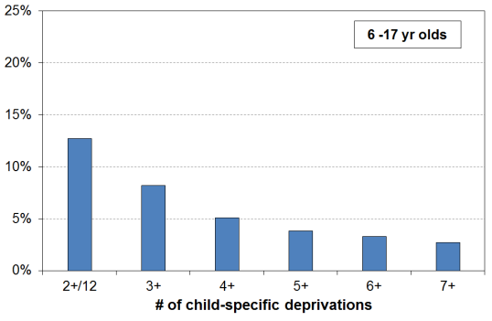
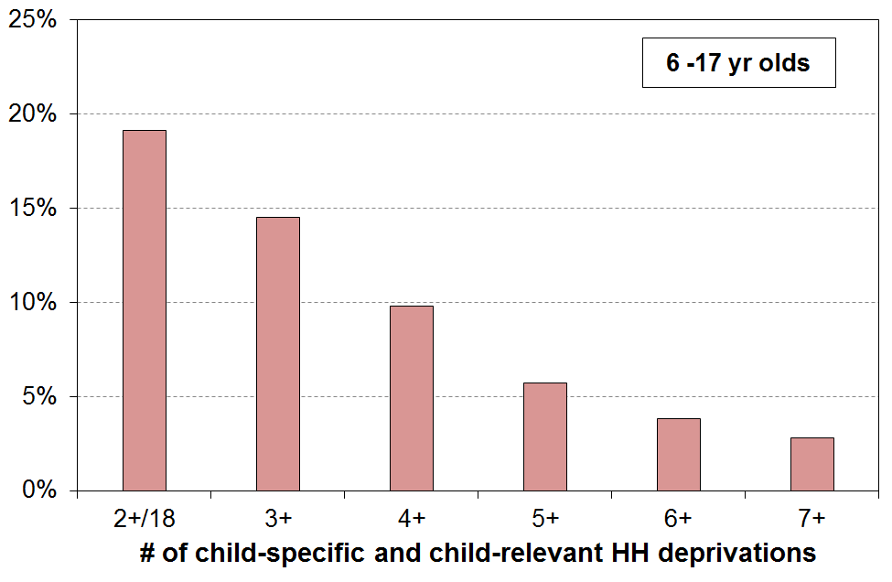

Looking at the clustering of multiple disadvantage is important for our understanding of the depth or severity of hardship for children, but information from individual items is also relevant. Two are reported on here, together with the mobile phone information and life satisfaction self-assessments by the household respondents

Postponement of visits to the doctor for children

- Respondents were asked how often they postponed visits to the doctor for themselves to keep costs down to enable other basics to be purchased, and they were asked the same question about their child(ren), if any. The available responses were “not at all”, “a little”, and “a lot”.
- 10% of respondents said “a lot” for themselves, 39% for those in the lowest MWI decile. In contrast for their children almost none said “a lot”, including for households in the lowest MWI decile.
- For a less demanding response of “a little or a lot”, the adult figures were 28% and 69% respectively, with the overall child figure still very low at around 4-5%.
- There is good UK evidence that many parents in poorer households make sacrifices themselves to protect their children from the most serious aspects of poverty. The figures above are consistent with that research finding, though there are other factors involved. For example, the ‘zero fees GP visits for under-13s‘ policy in force at the time is no doubt also a factor, even though there are other costs involved such as transport and perhaps time off work that make the total cost for children non-zero.

Access at home to a computer and the internet for homework

- 88% of children have good access at home to a computer and the internet for homework.
- For children in households in the lowest MWI decile, only 57% have this access, with around 75% in deciles 2 and 3 and 95%⁺ for the rest.

Mobile phones for children aged 11+
- 73% of children aged 11+ have their own mobile phone.
- 5% do not have a mobile phone because of the cost and 23% for reasons “other than cost”.
- Unlike the “access to a computer and internet at home” item, children (aged 11+) in households in the lowest MWI decile are around average for having a mobile phone (74%). This is a higher rate than for those in the middle deciles (~65%). For this group, the reason for the child not having one is rarely cost – the “other than cost” reason dominates.
- For the top three MWI deciles around 90% have a mobile phone.

Self-assessed life satisfaction for respondents in households with children

- The panel at the bottom of Table I.3 shows a considerably lower self-assessed life satisfaction for respondents in the lower two MWI deciles (bottom quintile).
  - Around one in three (32%) say they are satisfied or very satisfied with life (taking all things into account), compared with 87% for all the rest, and 75% for Q2.
  - One in four (25%) say they are dissatisfied or very dissatisfied with life, compared with next to none for the rest.

References

Alkire, S., Apablaza, M., & Jung, E. (2014). “Multidimensional poverty measurement for EU-SILC countries”. OPHI Research in Progress 36c, Oxford University.
Baker, M., McDonald A, Zhang J, Howden-Chapman, P (2013). Infectious diseases attributable to household crowding in New Zealand: A systematic review and burden of disease estimate. Wellington: He Kainga Oranga/ Housing and Health Research Programme, University of Otago.
Boarini, R., & Mira d'Ercole, M. (2006), 'Measures of material deprivation in OECD countries.' OECD Social, Employment and Migration Working Papers #37, OECD: Paris .
Brewer, M., O’Dea, C., Paull, G. & Sibieta, L. (2009). ‘The Living Standards of Families with Children Reporting Low Incomes’, DWP Research Report no. 577, London: Department for Work and Pensions.
Brewer, M., Etheridge, B. and O’Dea, C. (2016), ‘Why are some households who report the lowest income so well off?’, Economic Journal, forthcoming.

Cappellari, L. & Jenkins, S. (2007), ‘Summarising multiple deprivation indicators’, in J. Micklewright and S. Jenkins (eds) Inequality and Poverty re-examined: Oxford: Oxford University Press.
Carle, A., Baumann, K., & K. Short (2009). ‘Assessing the Measurement and Structure of Material Hardship in the United States’, Social Indicators Research, (92), 35-51.
Carter, K. & Imlach Gunasekara, F. (2012). ‘Dynamics of Income and Deprivation in New Zealand, 2002-2009. A descriptive analysis of the Survey of Family, Income and Employment (SoFIE).’ Public Health Monograph Series No. 24. Wellington: Department of Public Health, University of Otago, Wellington.
Denny, S. and colleagues (2016). ‘The association between socioeconomic deprivation and secondary school students’ health: findings from a latent class analysis of a national adolescent health survey’, International Journal for Equity in Health (15), 109-130
Department of Social Welfare, New Zealand (1975). ‘Survey of Persons Aged 65 Years and Over: Report of Results Relating to Social Security Benefit Rates.’ NZ Government Printer, Wellington.
Deutsch, J., Guio, A.-C., Pomati, M. & Silber, J. (2015). ‘Material deprivation in Europe: Which expenditures are curtailed first?’. Social Indicators Research, (120), 723-740,
Dickes, P., Fusco, A., & Marlier, E. (2010), 'Structure of national perceptions of social needs across EU countries', Social Indicators Research, 95(1), 143-167.
Exeter DJ, Zhao J, Crengle S, Lee A, Browne M (2017.) The New Zealand Indices of Multiple Deprivation (IMD): A new suite of indicators for social and health research in Aotearoa, New Zealand. PLoS ONE 12(8): e0181260. https://doi.org/10.1371/journal.pone.0181260
Gordon et al (2013), ‘The Impoverishment of the UK: PSE first results from the 2012 Living Standards Survey’. PSE Report, available at http://www.poverty.ac.uk/pse-research/pse-uk-reports
Gordon, D. & Nandy, S. (2012). ‘Measuring child poverty and deprivation’. In Minujin, A. and Nandy, S. (Eds) Global child poverty and well-being. Bristol: Policy Press.
Grimes, A. & Hyland, S. (2015). ‘A New Cross-Country Measure of Material Wellbeing and Inequality: Methodology, Construction and Results’. Motu Working Paper 15-09, Motu Economic and Public Policy Research, Wellington.
Guio, A.-C., Gordon, D., & Marlier, E.(2012). ‘Measuring material deprivation in the EU: Indicators for the whole population and child-specific indicators’, Eurostat Methodologies and Working Papers, OPOCE: Luxembourg.
Guio, A.-C, & Marlier, E. (2013). ‘Alternative vs, current measures of material deprivation at EU level: What difference does it make?’ ImPRovE Paper No. 13/07, Antwerp.
Guio, A.-C, Gordon, D., Najera, H. & Pomamti, M. (2017, forthcoming). ‘Revising the EU material deprivation variables’, Eurostat Methodologies and Working Papers, Luxembourg: Publications Office of the European Union.
Helliwell, J., Layard, R. & Sachs, J. (2016). World Happiness Report 2016, Update (Vol. I). New York: Sustainable Development Solutions Network.
Jensen et al (2002), Direct Measurement of Living Standards: The New Zealand ELSI Scale, Wellington: Ministry of Social Development.
Legatum Institute (2015), The Legatum Prosperity Index 2015. The Legatum Institute, London.
Mack, J., & Lansley, S. (1985), Poor Britain, London: Allen and Unwin.
Mack, J., & Lansley, S. (2015), Breadline Britain: The rise of mass poverty, London: One World Publications.
Main, G. & Bradshaw, J. (2014), ‘Child Poverty and Social Exclusion: Final Report of the 2012 PSE Study’, PSE Report, available at http://www.poverty.ac.uk/pse-research/pse-uk-reports
Ministry of Health (2014). ‘Analysis of Household Crowding based on Census 2013 data.’ Wellington: Ministry of Health.
new economic foundation (2012) Happy Planet Index.
new economic foundation (2015) Five Headline Indicators of National Success.
Nolan, B., & Whelan, C. T. (1996), Resources, Deprivation and Poverty, Oxford: Clarendon Press.
Nolan, B., & Whelan, C. T. (2007), ‘On the Multidimensionality of Poverty and Social Exclusion’, in Jenkins, S and Micklewright, J. (eds), Inequality and Poverty Re-examined, Oxford: Oxford University Press.
Nolan, B., & Whelan, C. T. (2011), Poverty and Deprivation in Europe, Oxford: Oxford University Press.
OECD (2016). ‘2016 Ministerial Council Statement: Enhancing Productivity for Inclusive Growth’. OECD C/MIN (2016)8.
Oswald, A. & Wu, S. (2010). ‘Objective confirmation of subjective measures of human well-being: evidence from the USA’. IZA Discussion Papers, No. 4695.
Perry, B. (2007), ‘The Economic Living Standards Index (ELSI): another look at the underlying construct and some of the headline findings in New Zealand Living Standards 2004.’ Working Paper 01/07, Ministry of Social Development, Wellington, available at http://www.msd.govt.nz/about-msd-and-our-work/publications-resources/working-papers/wp-01-07-living-standards-2004.html
Perry, B. (2009), ‘Non-income measures of material wellbeing and hardship: first results from the 2008 New Zealand Living Standards Survey, with international comparisons.’ Working Paper 01/09, Ministry of Social Development, Wellington, available at http://www.msd.govt.nz/about-msd-and-our-work/publications-resources/monitoring/living-standards/living-standards-2008.html
Perry, B. (2013), ‘The material wellbeing of older New Zealanders: Background paper for the Retirement Commissioner’s 2013 review.’ Ministry of Social Development, Wellington, available at
http://www.cffc.org.nz/assets/Documents/RI-Review-2013-Material-wellbeing-of-older-NZers.pdf
Perry, B. (2015). Household Incomes in New Zealand: Trends in Indicators of Inequality and Hardship 1982 to 2015. Ministry of Social Development: Wellington.
Perry, B. (2019). ‘Stats NZ Child Poverty Statistics release, 2 April 2019: MSD Background and Overview’. MSD Working Paper 02/19, available at: https://www.msd.govt.nz/about-msd-and-our-work/publications-resources/working-papers/index.html#WorkingPapers20191
Porter, M. & Stern, S. (2015). The Social Progress Index 2015. The Social Progress Imperative, Washington.
Productivity Commission (2018). Rising inequality? A stocktake of the evidence, Commission Research Paper, Canberra.
Salmond, C., Crampton, P., & Atkinson, J. (2007). NZDep2006 Index of Deprivation.
Salmond, C., King, P., Crampton, P., & Waldegrave, C. (2006), 'NZiDEP: A New Zealand index of socioeconomic deprivation for individuals', Social Science and Medicine, 62(6), 1474-1485.
Shonkoff (2011), “Building a Foundation for Prosperity on the Science of Early Child Development”, Pathways, Stanford University.

Stiglitz, J., Sen, A. & Fitoussi, J. (2009). Report by the Commission on the Measurement of Economic Performance and Social Progress. Commission on the Measurement of Economic and Social Progress. Downloadable at www.stiglitz-sen-fitoussi.fr

Whelan, C. T., Nolan, B. & Maître, B. (2016). ‘Polarisation or “Squeezed Middle” in the Great Recession? A Comparative European Analysis of the Distribution of Economic Stress’. UCD Geary Institute Discussion Paper Series, WP2015/12.

Wilkins, R. (ed). (2016), ‘The Household, Income and Labour Dynamics in Australia Survey: Selected Findings from Waves 1 to 14’. Melbourne Institute of Applied Economic and Social Research, Melbourne.

Appendices

Appendix 1 The value and limitations of the Household Economic Survey for the purposes of the reports

Appendix 2 EU-13 and EU-9

Appendix 3 MWI and ELSI compared

Appendix 4 Is a HES time material hardship series feasible given the change in the item set between the 2011-12 and 2012-13 surveys?

Appendix 5 Overlaps using the three currently available primary measures in the Child Poverty Reduction (Act (2018)

Appendix 6 Challenges for both the incomes and the non-incomes approaches to measuring material wellbeing

Appendix 7 Causes and drivers of child poverty and material hardship: a high-level schema.

Appendix One

The value and limitations of the HES for the purposes of the reports

All sample surveys have statistical uncertainties

- The HES is a random sample survey of around 3500 households (5500 in 2015 and 2018 surveys). When using information from random samples of a population to get estimates of what’s going on in the population itself, we want the samples to be as representative as possible of the population in question. The better the representation the more confidence we have that the estimate based on the sample is close to the true population figure. All else equal, the estimates are more reliable the larger the sample size. The 2018-19 survey, which Stats NZ is using in its next scheduled child poverty report (February 2020), has a much larger achieved sample size of around 20,000 households.

- As the numbers in the Stats NZ releases and in the MSD reports are based on data from sample surveys, there are always statistical uncertainties:
  - Some of the uncertainties arise by chance from the fact that the information is from a sample rather than the whole population (‘sampling error’). This means, for example, that most numbers are expected to bounce around either side of a trend line, especially for population sub-groups and more so for smaller than for larger ones. Sampling error exists even if a 100% response rate is achieved in a perfectly designed and implemented survey.
  - Other uncertainties and ‘noise’ arise from the fact that the response rate to the survey is always less than 100% (typically around 75-80% in recent years for the HES). If those who do not respond are on average quite different from those who do, and if this difference changes from year to year, then further fluctuations can occur that do not represent real-world fluctuations. For example, if it proves more difficult to get responses from households with low incomes or high material hardship than it does to get responses from other households, then the sample is likely to be biased and the bottom end will likely look better off than expected. Non-response bias is a challenge for all sample surveys. It can to some degree be addressed by applying carefully-designed weights to the sample, but some of the bias can remain even after the population weights are applied to the raw sample numbers.
  - Sample bias is an important example of what is referred to as ‘non-sampling error’. Other examples include incorrect information provided by respondents, data input errors or data handling problems, questionnaire design issues, sample design issues. There is no simple control or measurement for such non-sampling errors, although the risk can be minimised through careful application of the appropriate survey techniques from the questionnaire and sample design stages through to analysis of results.

- The use of the terms ‘sampling error’ or ‘sample error’ can suggest that a mistake has been made; however, sample errors are not mistakes. They represent the inevitable difference (that arises by chance) between the estimate and the true value when using a sample rather than interviewing every household in the population. Even a perfectly designed survey with a 100% response rate has sample error. It is an unfortunate term, but it is well-established and widely used internationally.

- Standard statistical theory provides a way of calculating and talking about sampling uncertainties in terms of “sample errors” and “confidence intervals”. A poverty rate of 17% with a sample error of 1 percentage point means that there is a 95% chance that the true rate is between 16% and 18%. This range is called the “confidence interval”. Other confidence levels can be used but Stats NZ, in line with international practice, uses the 95% confidence interval for reporting sample errors for child poverty estimates.

- This all means that surveys like the HES need to be used with care. The HES is very useful and reliable for many of the themes covered by the MSD reports, but for other others it has limitations that need to be recognised.

Using the HES with care for the purposes of this report

- For the purposes of the MSD reports there are many types of findings of public interest or policy relevance for which the HES is well suited and delivers valuable information. For example:
  - the overall picture of household income distribution (and now wealth as well)
  - the overall picture of material wellbeing, including on specific items of material hardship
  - trends in rates of low income, material hardship, inequality, housing costs relative to income, and so on, when the perspective is over many years
  - relativities between different groups on the above themes – even for smaller groups by combining information from several surveys
  - international comparisons.

- However, when the focus is on very short-term changes, especially year-on-year, or when more precision is required in a given year, the HES (to date) is not able to deliver robust results given its relatively small sample size.

- When looking at a change from one survey to the next, the question often arises as to what is driving the change. Is it a ‘real’ change (driven by policy changes or changes in the economy or the rental housing market)? Or is it just the inevitable random fluctuation that happens with sample surveys (‘sampling error’)?

- Many of these questions become more pressing the smaller is the sub-group being looked at. For example, only around a third of the sampled households contain children, so the sample size for this group is down to approximately 1200 (or 1800 in 2015 and 2018).

- MSD’s reports therefore emphasise the need to look at the general trend over many years, and warn against reaching conclusions based on very short-term changes alone, especially year-on-year changes.

Strategies employed to address statistical uncertainties

- The reports use a range of strategies to address the statistical uncertainties and the other challenges. For example:
- rolling two or three year averages for some time series
- reporting actual estimates, but overlaid with a trend-line to summarise
- using the average over several years when reporting on the composition of low-income groups or those experiencing material hardship, thus allowing reasonable estimates for smaller population groups
- reporting sensitivity analysis when applying different modifications to the original dataset to address anomalies (such as the issue of reported incomes being implausibly low)
- by not reporting results when the uncertainties are too great.

Reporting on trends in low-income and material hardship rates for children

In the 2018 Incomes Report and the associated reports using non-income measures, MSD did not publish low-income or material hardship figures for the 2015-16 and 2016-17 HES years.

This decision was made based on a judgement call at the time that there was good reason to believe that the low-income and material hardship figures for households with children for these two years were under-estimates. MSD’s view was that publishing them, even with strong caveats, could easily lead to a premature conclusion that New Zealand had made solid progress in reducing child poverty, when in fact the reported decline mainly reflected either the inevitable uncertainties associated with sample estimates, or some sample bias, or both.

In addition, the Child Poverty Reduction Bill was making its way through the parliamentary process, with a likely consequence being that Stats NZ would be releasing their 2017-18 baseline figures for child poverty in early 2019. If MSD were to publish the 2015-16 and 2016-17 figures, and it turned out that Stats NZ’s 2017-18 figures and the associated back series confirmed MSD’s concerns, then there was the likelihood of distracting confusion over trends in the financial and material wellbeing of households with children.

The detailed case for the ‘pause’ in publishing low-income and material hardship numbers was set out in an MSD report to Minister Sepuloni, released on the MSD website in October 2018, with some further material noted in the recent Working Papers released in association with the Stats NZ child poverty publications on 20 February and 2 April 2019.

MSD’s 2019 reports

MSD has looked carefully at the 2017-18 HES and is satisfied that it is fit for purpose for use across all the charts, tables and other analysis in its 2019 reports, noting the strategies for managing risk for any HES survey as outlined on p6 above. Most of the factors that led to the ‘no publish’ decision no longer apply, though a few remain. The basis for this assessment is elaborated below.

There are two (closely related) datasets available for estimating low-income and material hardship rates for New Zealand.
- The first is the long-running dataset used by MSD for its incomes and other reporting and by Stats NZ for reporting to the OECD’s Income Distribution Database and elsewhere. It has income information from 1982 to 2018, and material hardship information from 2017 to 2018. This is referred to as the HES-TAWA dataset as it contains both HES survey data and essential secondary information produced by the Treasury’s TAWA micro-simulation model (eg TAWA calculates disposable (after tax and transfer) income from the gross income and demographic data available in the survey data). Stats NZ provide standard weights for use with this dataset.
- The second is the special dataset constructed by Stats NZ for its official child poverty release on 2 April 2019 which set the baseline rates required for the implementation of aspects of the Child Poverty Reduction Act (2018). For BHC low income trends, data from the HES and the Household Labour Force Survey (HLFS) are pooled. The income information comes from administrative data, not the surveys themselves. This is referred to in this report as the HES-HLFS dataset. A new set of weights has been calculated for use with this data, based on different benchmarks than the one for the HES-TAWA data. The data in the HES-HLFS dataset is available only from 2007 on.
  - For AHC incomes, administrative data was used for the BHC income component, but as there is no housing cost information in the HLFS, the sample size was limited to that of the HES (5500 in 2017/18). The revised weights are used.
  - For material hardship estimates, the sample was limited to that of the HES (5500 in 2017/18), as the HLFS does not have material hardship information. The revised weights are used.

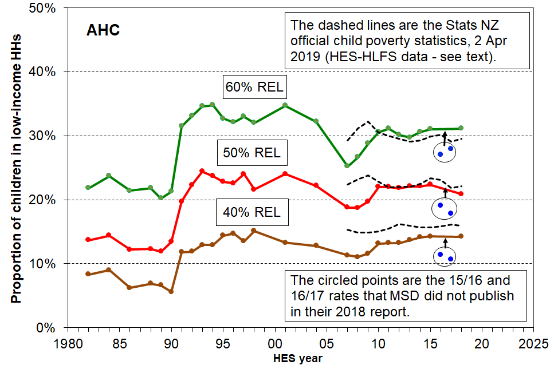
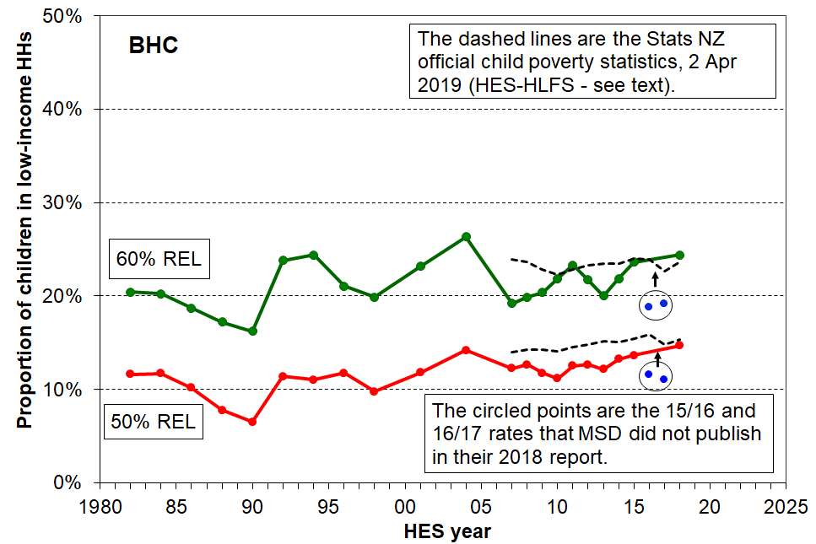
The charts below show the trends for low-income rates for children from 2007 to 2018 using the two data sources noted above. The trend lines use a rolling two-year average from 2008 on.

The main drivers of any differences between the trend lines from the two datasets are not at the level of concept and definition. Any differences that do exist arise in the main from differences in data sources and weights used to convert sample numbers to population estimates:
- The pooling of HES and HLFS samples for BHC incomes reduces sample errors and smoothes the trend line compared with using the HES alone.
- The use of administrative data rather than survey data for income information leads to slightly higher low-income estimates in the Stats NZ 2 April release compared with the MSD numbers, especially for the 40% AHC and 50% BHC measures. Further work is underway to better understand the reasons for the differences.
- The use of revised weights reduces variability as the new weights to some degree better address sample bias in relation to low-income households.

The Stats NZ figures are the official figures.

Key evidence taken into account in the decision to resume publishing child poverty figures

- The trend charts above provide good visual support for both the decision to not publish using 2015-16 and 2016-17 data, and the decision to publish in 2019 using the 2017-18 survey data.

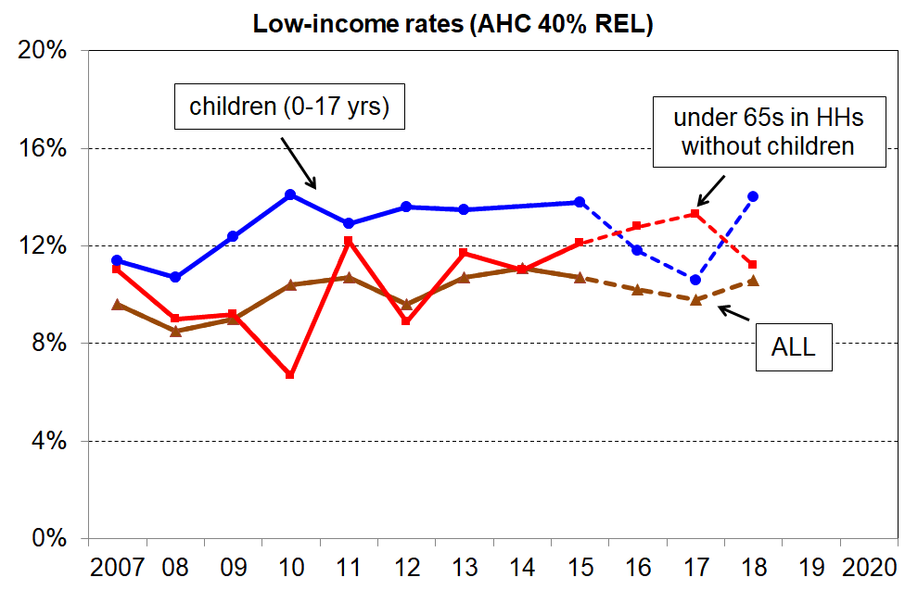
- The AHC relativities for those in households with children and households without children have returned to their expected levels after two years seeming to move in opposite directions without any ready explanation.
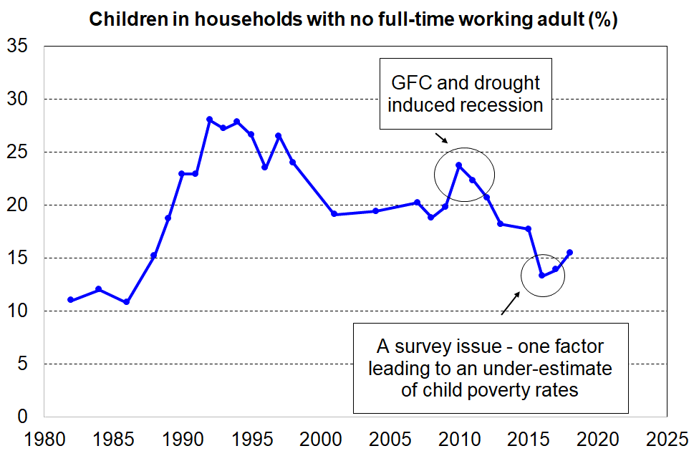
- The trend in the estimated proportion of children living in households with no full-time worker were unusually low in 2015-16 and 2016-17, but in 2017-18 were more like what could be expected.

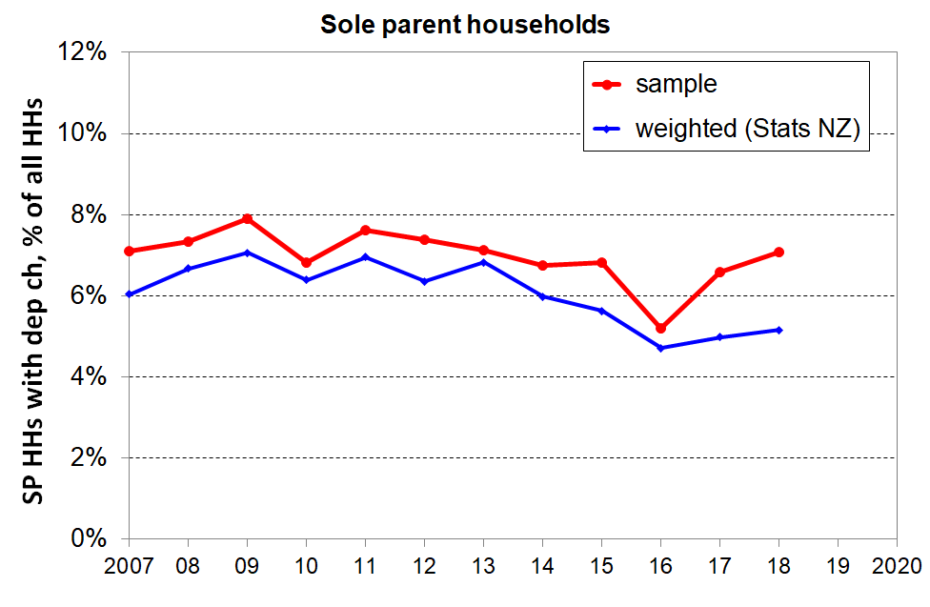
- The sample and population weighted numbers for sole parent households and beneficiary households with children were low in 2015-16, and returned to their expected levels in 2016-17 and 2017-18. There was also a smaller-than-usual proportion of sole-parent households from the bottom NZDep decile in the 2015-16 sample (9% of all households rather than the usual 13-15%).

The trends for several of the non-monetary indicators returned (near) to expected levels in 2017-18. For example, the proportion of HES households with children reporting foodbank usage returned to the steady level seen from 2013 to 2015, after the reported drop in 2016 and 2017. The samples for 2015 and 2018 had good numbers from the lowest NZDep decile area, and the 2018 weights grossed the numbers up to the previous levels after a dip in 2016 and 2017.

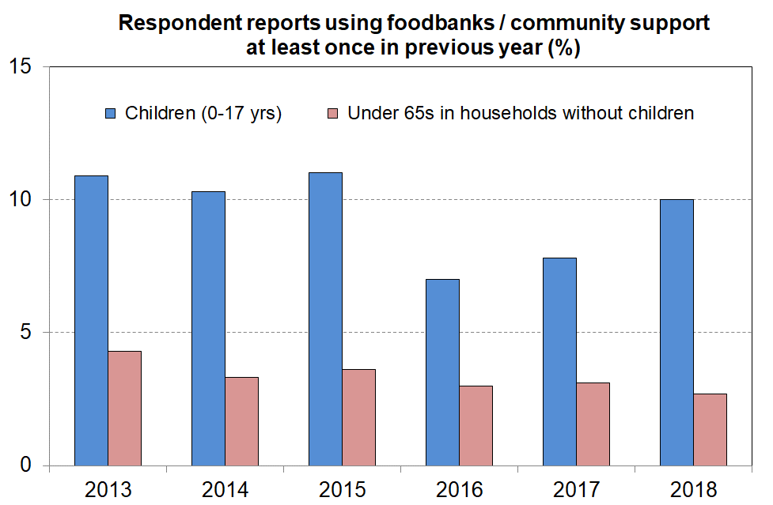
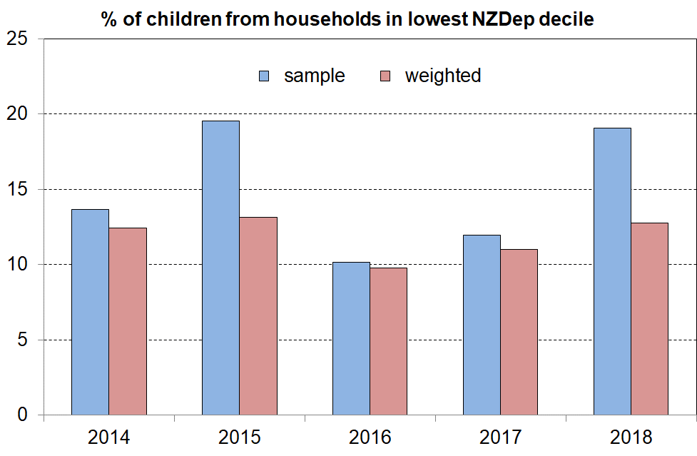

* * * * * * * * * * * * * * * * * * * * *

There remains, however, some evidence of a step-change from 2013-2015 to 2016-2018 for some non-monetary indicators, suggesting some non-response or other bias that the weighting regime was not able to address. For example (as shown in the charts below):
- There was a fall in the proportion of households with children who reported needing to borrow from family and friends to meet basic needs, but for households without children the rate was much the same over the six surveys.
- Reported rates of delaying repairs/replacement of appliances ‘a lot’ for households with children were all lower for 2016 to 2018 than in the previous three years, in contrast to households without children for whom the trend is steady (though 2018 for households with children is more like what would be expected).
- There was a reported fall in the proportion of households with children who were behind on car registration ‘more than once’ in the 12 months prior to interview.
- The self-assessment by working-age beneficiary households that their total income was ‘not enough or only just enough’ was steady at close to 81% in the 2013-2015 period, but only 68% (and steady) in the next three surveys.
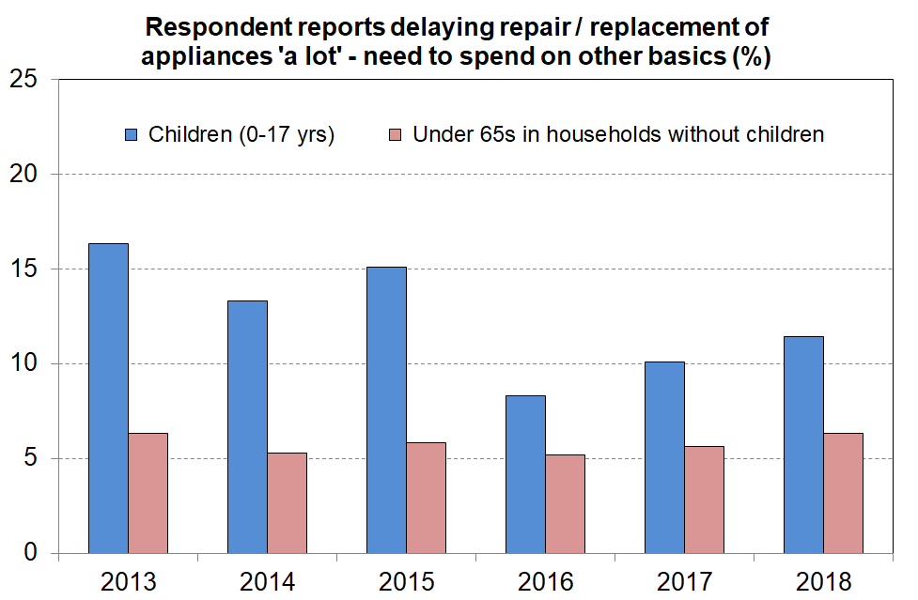
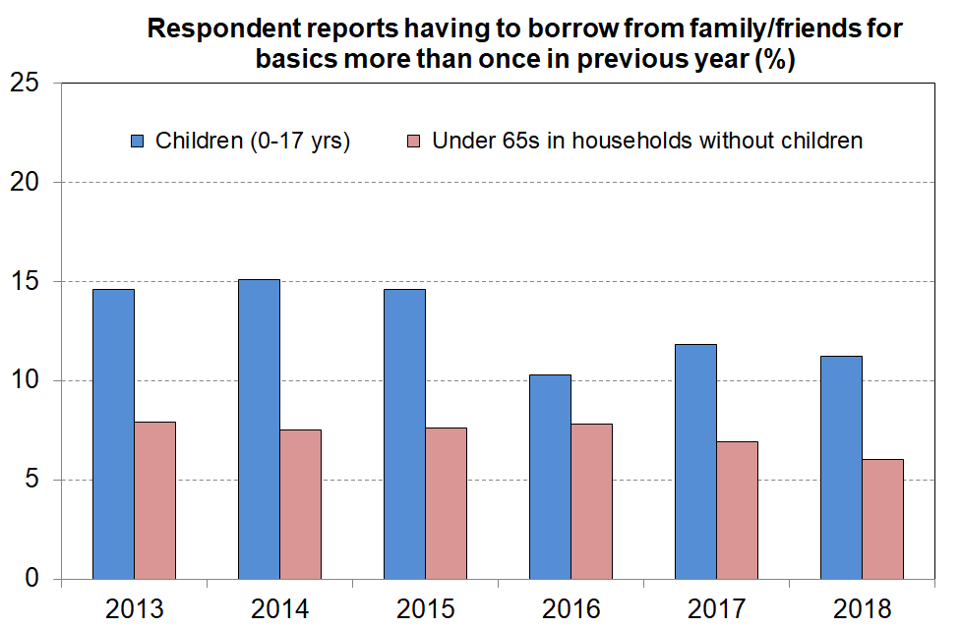

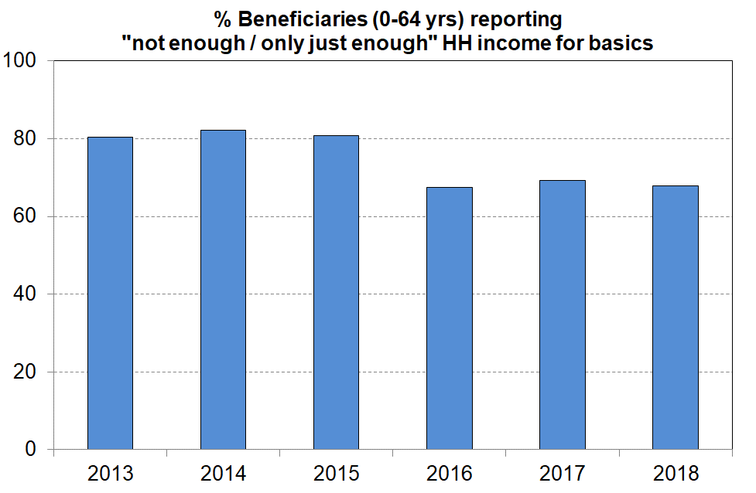
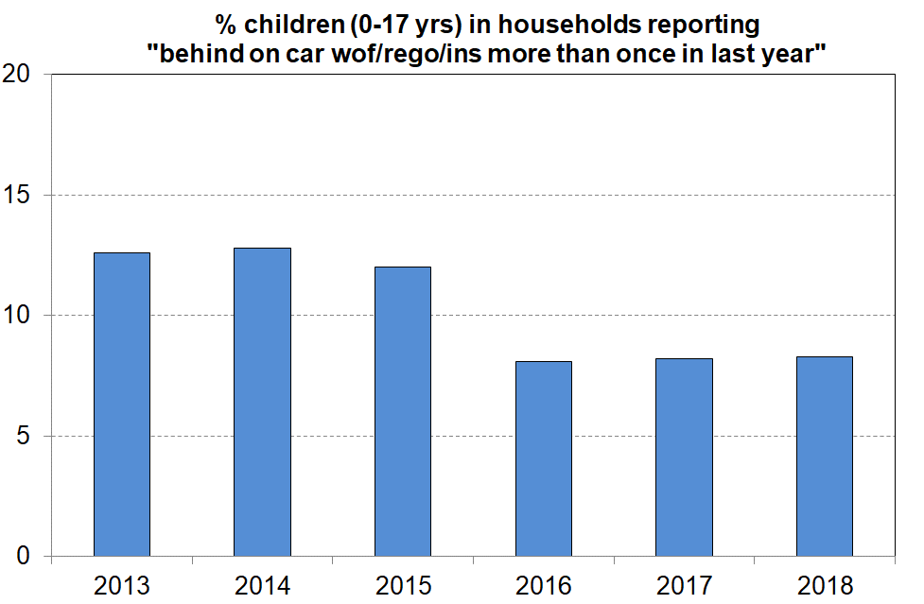

The chart below indicates that compared with 2013 to 2015 there was a sudden large increase in the population of ‘better off’ Māori households in 2016 to 2018: the rate responding ‘more than enough’ to the income adequacy question doubled from 6-8% in 2013 to 2015 to 16-17% in 2016 to 2018. At the same time, the responses of the rest of the population indicate just a small increase for the same time periods.

There is no ready explanation for the large change for Māori in terms of policy, economic, housing market or demographic changes. Median household income for Māori (and the rest) rose in real terms in the period, so some increase in this adequacy indicator could be expected, but the size of the change for Māori points to an explanation involving a change in the profile of the achieved sample for 2016 to 2018.
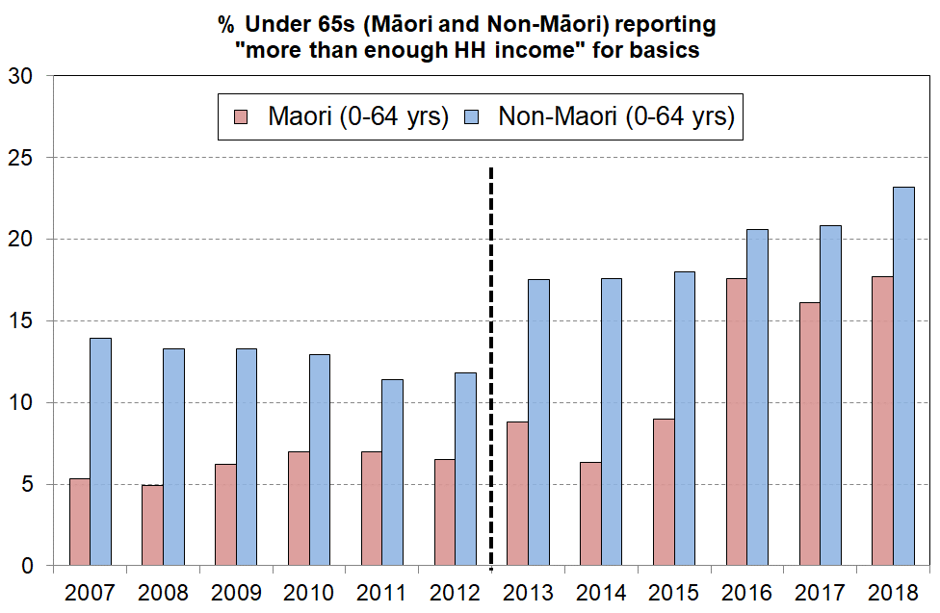
Note: The income adequacy question changed a little in the 2013 HES. The 4 categories changed from ‘not enough / just enough / enough / more than enough’ to ‘not enough / only just enough / enough / more than enough’, but this is unlikely to have changed responses to the ‘more than enough’ option.

The MSD reports will monitor these and similar trends over a longer period and continue to seek to understand the observed changes. The larger sample size for the 2018-19 HES will assist with this.

As for the two previous reports, MSD’s 2019 reports do not use the 2015-16 and 2016-17 numbers for child poverty (low income) reporting in the main body of the report. The trend lines go direct from 2014-15 to 2017-18, leaving out the two intermediate years. This approach is justified by the relatively flat trends reported by Stats NZ in that period (2015 to 2018), using the alternative HES-HLFS dataset and associated weights.

For material hardship trends, the 2019 report does not use 2015-16 HES data as in MSD’s view there is too much cumulative evidence of sample bias. For material hardship time series, the report uses the average of 2014-15 and 2016-17 as the ‘best estimate’ of 2015-16 figures. For other analysis (eg composition of those in households in material hardship), the 2014-15 and 2017-18 data is used, noting the larger sample size for these years (5500 instead of the usual 3500).

Appendix 2

EU-13 and EU-9

Previous MSD research on international hardship comparisons used a 9-item EU index (see Perry, 2009). Hardship rates for New Zealand are very close on both the EU-9 and the new EU-13 indices and country rankings are reasonably similar on both. EU-13 is however a more robust and reliable index. It also allows more reliable comparisons of child hardship rates using both less and more severe hardship thresholds. We can replicate EU-13 for New Zealand to a very good degree from the LSS 2008 data, and will be able to update the comparisons using the enhanced HES datasets starting with HES 2015-16.

Table 1.1
Composition of EU-13 compared with EU-9
EU-13 | EU-9
Items from EU-9 not used in EU-13
x | phone
x | colour TV
x | washing machine
Items in both EU-9 and EU-13
have a meal with meat, fish or chicken every second day | ✓
keep the home adequately warm | ✓
have access to a car / van for personal use | ✓
avoid arrears in mortgage or rent, utility bills or HP instalments | ✓
have one week’s annual holiday away from home | ✓
ability to face unexpected expenses of NZD1500 | ✓
New items in EU-13, but not in EU-9
replace worn-out clothes by some new ones | x
have two pairs of properly fitting shoes | x
replace worn-out furniture | x
spend a small amount of money each week on oneself | x
have both a computer and an internet connection | x
have regular leisure activities | x
have a get together with friends/family for a drink/meal at least monthly | x

Appendix 3
MWI and ELSI compared
Table 2.1
Composition of MWI items (1-24) and ELSI compared
Item description |  | MWI | ELSI-SF
Ownership (have, don’t have and enforced lack)
x | Phone | - | ✓
x | Washing machine | - | ✓
1 | Two pairs of shoes in a good condition and suitable for you daily activities | ✓ | ✓
x | Ability to keep main rooms adequately warm | - | ✓
2 | Suitable clothes for important or special occasions | ✓ | ✓
x | Home computer | - | ✓
3 | Contents insurance | ✓ | ✓
4 | A meal with meat, fish or chicken (or veg equiv) at least each 2nd day | ✓ | -
5 | A good bed | ✓ | -
Social participation (do, don’t do and enforced lack)
6 | Presents for family/friends on special occasions | ✓ | ✓
x | Space for family to stay the night | - | ✓
x | Family/friends over for a meal at least once each few months | - | ✓
x | Visit hairdresser at least once every three months | - | ✓
7 | Holiday away from home at least once every year | ✓ | ✓
x | Night out for entertainment or socialising at least once a fortnight | - | ✓
8 | Overseas holiday at least once every three years | ✓ | ✓
Economising (not at all, a little, a lot) – to keep down costs to help in paying for (other) basic items
x | Not picked up a prescription | - | ✓
x | Stayed in bed to keep warm | - | ✓
9 | Postponed a visit to the doctor | ✓ | ✓
10 | Gone without or cut back on fresh fruit and vegetables | ✓ | ✓
11 | Continued wearing worn out clothes | ✓ | ✓
12 | Spent less on hobbies or other special interests than you would like | ✓ | ✓
13 | Do without or cut back on trips to the shops or other local places | ✓ | ✓
x | Put off buying new clothes as long as possible | - | ✓
14 | Buy cheaper cuts of meat or bought less meat than you would like | ✓ | -
15 | Put up with feeling cold | ✓ | -
16 | Postpone or put off visits to the dentist | ✓ | -
17 | Delay replacing or repairing broken or damaged appliances | ✓ | -
Global self-ratings
x | Adequacy of income to cover basics of accommodation, food, clothing, etc | - | ✓
x | Material standard of living | - | ✓
x | Satisfaction with material standard of living | - | ✓
Freedoms/Restrictions
18 | When buying, or thinking about buying, clothes or shoes for yourself, how much do you usually feel limited by the money available? (4 point response from ‘not limited … very limited) | ✓ | -
19 | $300 spot purchase for an ’extra’ – how restricted? (5 point response from ‘ not restricted … couldn’t purchase’) | ✓ | -
20 | $500 unexpected unavoidable expense on an essential – can you pay in a month without borrowing? (yes/no) | ✓ | -
Financial strain (in last 12 months)
21 | Behind on utilities in last 12 months? (not at all, once, more than once) | ✓ | -
22 | Behind on car registration, wof or insurance in last 12 months? | ✓ | -
Housing problems (no problem, minor problem, major problem)
23 | Dampness or mould | ✓ | -
24 | Heating or keeping it warm in winter | ✓ | -

As discussed in Section E, the greatest challenge to the satisfactory development of both ELSI and the MWI was to find survey items that lie outside the usual lists of “basics” or “necessities”, but for which there is a common aspiration to possess (own, have access to, participate in). In other words, the challenge is to find “non-necessities”, the presence or absence of which in a household reflect differences in levels of material wellbeing rather than being to a large extent reflections of tastes or preferences. A simple extension of the enforced lack approach used in deprivation indices is therefore not a viable approach for constructing a broader index of material wellbeing.

The ELSI measure addressed the issue in three ways:
- It used the “not at all” response in the economising items to indicate higher living standards.
- It used the absence of enforced lacks of some more intermediate items (non-necessities) including:
  - having space for the family to stay for the night
  - having family or friends over for a meal at least once every few months
  - visiting hairdresser at least once every three months
  - having a night out for entertainment or socialising at least once a fortnight
  - a week’s local annual holiday
  - an overseas holiday at least once each three years.
- It used three global self-ratings:
- self-rated adequacy of household income for the basics
- self-rated level of material living standards
- self-rated level of satisfaction with material living standards.

The “not at all” responses in the economising items worked well and the general approach was retained for the MWI, but with some changes to the item selection as indicated in Table 5.1 above.

The use of the intermediate items also assisted in decompressing the distribution above the lower 20-30% in the hardship and near hardship zone. The MWI retained the two holiday items but dropped the other four: the hairdresser and night out items had 27% and 33% of respondents not having them for reasons other than cost, and therefore did not meet the test of widespread aspiration to possess; the space for family and family or friends for a meal items were reasonably widely aspired to or possessed, but they were not relevant to particular groups, though one or both are used in other surveys or indices (eg EU-13), and it was a close call for the MWI.

The use of the three global self-ratings was the main way in which the ELSI development sought to address the compression issue without being compromised by differences in tastes and preferences for non-necessities. They helped greatly with the decompression, especially for the top 40% for whom the other items had almost reached the limit of their effectiveness in discrimination (most in that zone report no enforced lacks and economise “not at all” on the items in ELSI).

The presence of the global self-ratings unfortunately seriously compromised the use of ELSI to monitor changes in material wellbeing over time. The central issue is that it is possible (likely, even) that the self-rating scores for a household will remain unchanged over time even though the household experiences a real improvement in their material wellbeing in that time period. This can happen when the real rise in the household’s material wellbeing is similar to the rise for that household’s reference group. This is not merely a hypothetical wondering. There is good evidence that it happened from 2000 to 2004 and again from 2004 to 2008 (Perry (2007, 2009)).

What this means is that ELSI is highly likely to show little or no change over time even when there is good evidence from other indicators that living standards are improving in real terms. At a technical level this is not an issue for ELSI – in fact, it is entirely consistent with the concept of living standards ELSI seeks to capture, namely, that “[a]n item contributes information about a person’s living standard only when it relates to something the person wants” (Jensen et al (2002:102)). As the standard of living of one’s reference group rises, it is highly likely that one’s own expectations and level of wants also rise. In this sense, ELSI is a fully relative measure of living standards. However, when people say that their standard of living has improved, they do not generally mean that they are now better off relative to others, but that they are better off compared with their own previous situation – more like an “absolute” change.

The ELSI is technically very strong and is an internally coherent index. Unfortunately, except for the more disadvantaged in the lower quintile or so of the distribution it is very limited in its ability to pick up changes over time in living standards per se. The mean ELSI-3 scores were 40.1, 40.0 and 40.3 respectively for the 2000, 2004 and 2008 surveys. Thus, according to the ELSI instrument there was no change in average living standards for New Zealanders from 2000 to 2008. This creates a considerable communication challenge for an instrument which purports to measure ‘economic living standards’, as all the usual indicators of living standards as more commonly understood did improve (eg real household income).

Because of the importance of being able to track living standards over time across a good range from higher to lower, and to do so in a way that accords with the common conception of what an improvement means (more of an “absolute” change relative to one’s previous position), the MWI development took a different path in addressing the central issue of seeking to improve the discrimination for the 60-70% while avoiding being invalidated by the issue of tastes and preferences discussed above.
- it stayed with the economising approach, though with a refreshed and slightly enlarged item set that had more of an emphasis on discrimination above the hardship zone
- it dropped the global self-ratings, and in their place added:
- two financial strain items that have a “not at all” category
- three “freedom to purchase” items that enable good discrimination in the middle to higher range of material wellbeing

The MWI is able to pick up changes in material wellbeing over time over time, but in achieving that it had to trade off a good degree of discrimination at the top end, compared with ELSI, as shown in the chart below. This is not a great loss. In practice, in analysis and reporting, the top 15-20% should be lumped together anyway as the discrimination is weakest here for both MWI and ELSI.

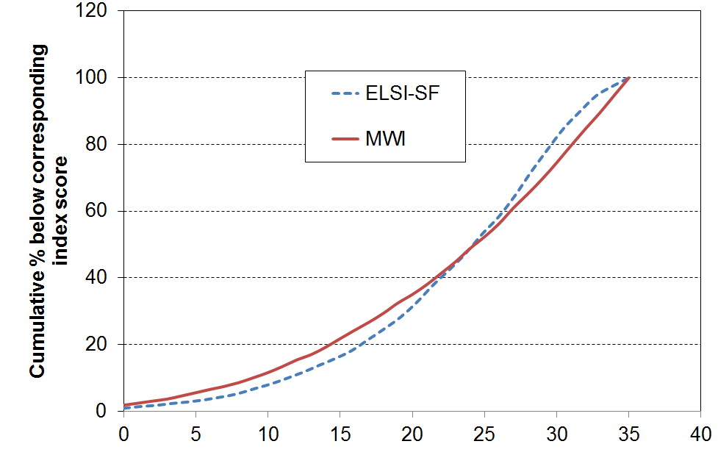

The MWI and the ELSI rank the population in much the same way (correlation of 0.95).

The issue can be addressed in part by being clear about what ELSI measures, especially when looking at changes over time. In other words, consumption and desired consumption (from the ELSI list) rose by similar amounts from 2000 to 2008, which means that ELSI living standards did not change in the period.

Appendix 4

Is a HES time series feasible given the change in the item set between the 2011-12 and 2012-13 surveys?

This Appendix shows that such a time series is feasible. It uses the fact that 9 of the 12 items that are common to both the earlier and later datasets are suitable to be used to create a good-enough index (DEP-COMMON) that shows the shape of the trend lines across the full period, 2007 to 2016, for three thresholds. This information provides a solid guide for how to splice the ELSI and MWI time series between HES 2011 and HES 2012, the period in which the item sets changed.

The 9 common items are listed below. They are of two types:
Enforced lacks
- two pair shoes for daily activities (R)
- suitable clothes for special occasions (R)
- presents for families/friends (R)
- home contents insurance (H)
- holiday away from home for at least a week each year (R)
Economising “a lot” to keep costs down so as able to afford other basic items
- go without fresh fruit and vegetables (H)
- continue wearing worn out clothing (R)
- postpone or put off visits to the doctor (R)
- do without or cut back on trips to the shops or other local places (H)
Note: R= for respondent, and H = for household as a whole.

The 3 items that are in both datasets but which are not used in DEP-COMMON are about hobbies and overseas holidays (not suitable for tracking hardship) and income adequacy. The index score is created simply by adding the number of items that indicate hardship (either an enforced lack or economising “a lot”).

DEP-COMMON has a very good reliability score, with a Cronbach’s alpha of 0.76. The items cover a reasonable range of domains. When it is used to identify the groups with the highest and lowest deprivation rates it gives results similar to DEP-17 and EU-13 (see Table 4.1 below). Its main limitation is that with only 9 items there are relatively large gaps between rates for different thresholds in the typical hardship zones. In other words, DEP-COMMON has a clunky cumulative distribution curve. There are only three thresholds of any great use (3+, 4+, and 5+), and for the whole population the rates are 15%, 9% and 6% respectively using LSS 2008 data. To get a population rate ~11% for DEP-COMMON to allow easy comparisons with EU-13 and DEP-17, the average of the 3+ and 4+ rates is used in the table below.

Table 4.1
Comparisons of hardship rates for different sub-groups
using different indices (EU-13, DEP-17 and DEP-COMMON), LSS 2008
LSS 2008 | EU-13 (5+) | DEP-17 (7+) | DEP-COMMON
ALL | 11 | 11 | 12
0-17 | 18 | 17 | 18
65+ | 3 | 2 | 3
2P <65 | 11 | 9 | 11
SP <65 | 35 | 38 | 37
Couple <65 | 5 | 5 | 6
European (total) | 8 | 8 | 9
Maori (total) | 24 | 25 | 26
Children (market) | 11 | 10 | 11
Children (benefit) | 51 | 51 | 49
Reading note: The thresholds used for the indices were selected to make the population hardship rates similar (11-12%). For DEP-COMMON this required using the average of 3+ and 4+ rates, giving a 12% rate for ALL.
Figure 4.1 below uses the 9-item DEP-COMMON to create a time series from 2008 to 2018. DEP-COMMON has good enough credentials to show the shape of the trend lines for three thresholds across the full period, HES 2007 to HES 2018. This provides a solid guide for how to splice the ELSI / MWI time series between 2012 and 2013, when the item sets changed.

Figure 4.1
Constructing a material hardship time series, 2007 to 2018:
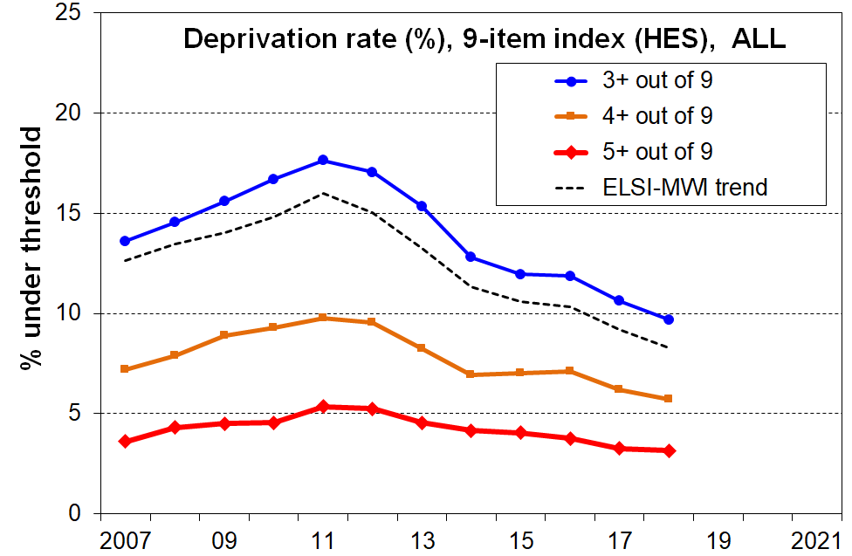
DEP-COMMON (9 items) compared with ELSI-MWI
Note: the trend lines are smoothed using a rolling two year average

MSD also reports on material hardship using the DEP-17 index. This can be constructed from HES 2013 on. It produces a trend and levels for material hardship that are almost identical to that produced by MWI (MWI ≤11 ≡ DEP-17 6+/17).

MSD’s DEP-17 material hardship index is used by Stats NZ for their official child poverty statistics (6+/17 and 9+/17 for the two levels of hardship reported).
Appendix 5

Overlaps using the three currently available primary measures in the Child Poverty Reduction Act (2018).

- The overlap diagram below uses the three cross-sectional primary measures identified in the CPRA, using the HES 2017-18 baseline rates.
- The analysis shows:
  - the degree of overlap between the measures (a visual representation of the observation that ‘not all in hardship come from low-income households and that not all in low-income households are experiencing hardship’)
  - why no single headline low-income measure can capture the full picture of those who are materially disadvantaged
  - how using a multi-measure approach captures a wider range of children in households with low incomes or experiencing material hardship than using any one measure alone.
- In terms of ‘the numbers’:
  - Around 90% of those in households with low BHC incomes also have low AHC incomes.
  - Around 60% of those in households with low AHC incomes also have low BHC incomes (ie 60% of those in the green circle are in the red circle). The rest come from households with incomes higher than the BHC threshold, but whose housing costs are relatively large.
  - Around 60% of those experiencing material hardship are from the low-income AHC group (the black-green overlap). The rest come from households with incomes higher than this. Just over 40% in the hardship group have BHC incomes under the 50% threshold.
- The overlaps mean that if the targets are achieved on these three measures, the reduction in the number of children experiencing poverty or hardship will be significantly more than on any one of the individual measures alone (for instance, more than the targeted 120,000 reduction for the 50% BHC moving line measure, after ten years).

BHC 50% of median moving line income measure
16% (~180,000)
AHC 50% of median fixed line income measure
23% (~250,000)
Material hardship
13% (~150,000)

Appendix 6
Challenges for both the incomes and the non-incomes approaches to measuring material wellbeing

For measuring and monitoring material wellbeing at a household level the more direct approach using deprivation indicators / non-income measures has many advantages over the use of household income. For example: it captures the impact on a household’s material living standards not only of income levels but also of all the other factors that come into play (financial and physical assets, special demands on the family budget, help from outside the household, and so on); it gives a tangible grounded picture of what life is like for those in different degrees of hardship.

The limitations of household income as a measure of household material wellbeing are well-documented and well-understood. These apply even when using income for analysis within a country. For international comparisons, the use of household income is seriously limited, especially when compared with the relative robustness of using the same material deprivation index across countries.

Deprivation or material hardship indices have their challenges too. The most obvious one is the opportunity that exists for respondents to interpret questions differently and therefore to introduce “noise” to the indices. This undoubtedly occurs, but the way that quite different indices (sets of items) produce very similar rankings of households is an encouraging sign. Another challenge, when using “enforced lacks” (items not possessed “because of the cost”), is that there is some evidence of “adaptive preferences” having an impact on responses – for example, some older respondents adapt to their circumstances and say that they do not have an item because they do not want it, rather than for costs reasons. This approach no doubt helps maintain a sense of dignity and being in control of one’s life, even though a more objective assessment of household circumstances may be less optimistic. This issue is addressed in part by also using other types of items that are not as susceptible to this limitation.

There is also a question around the simple “adding up” approach commonly used for calculating index scores (see, for example, Cappellari and Jenkins (2007), chapter 8).

There is noise and limitation in any measurement of this sort (whatever the approach), but there is no evidence to suggest that the key findings in this report are compromised by such matters. Issues arise only when unreasonably definitive claims are made, or when data is pushed too hard in an attempt to yield very detailed analysis or great precision that issues arise.

Appendix 7
Low incomes BHC and AHC
Material hardship
Core benefits
FTC or similar
IWTC or similar
Income tax
Gross accommodation costs
Housing subsidies (AS, IRR)
Household size and composition
- who we live with makes a difference
- difficulty accessing available subsidies and services
- high (net) health and disability costs
- high debt servicing
- high transport costs
- support for others outside the household
- limited life-skills
- poor lifestyle choices
(-)
(+)
- economic growth
- productivity
- suitable range of jobs
- jobs with opportunity for progression
- globalisation
- returns on capital and labour
- relative bargaining powers of employers and employees

- discrimination
- public perceptions of “poverty” and its causes
- cultural norms and values, especially in relation to “individual responsibility” and “social solidarity”

- work tests
- targeted financial incentives
- other expectations and institutional arrangements
- degree of targeting of financial assistance

Some of the causes/drivers of poverty also impact directly on other dimensions of wellbeing
- compulsive and addictive behaviours of parents
- education and skill levels of parent(s) in the household
- physical and mental health of parents
- other personal qualities and lifestyle choices of parents
Material hardship for children: causes/drivers and consequences
- neighbourhood and community social capital – this can impact especially on some of the individual factors
Other outcomes
- other aspects of current wellbeing
- outcomes over the life course / life chances
Labour market
- HH hours worked
- wage rates
- minimum wage

- financial & physical assets (including basic household goods and appliances)
- local amenities and public transport
- support from outside the household from family, friends and NGOs
- government services and subsidies (eg ECE, GP visits, insulation, food-in-schools)
- hardship assistance (eg SNGs)
- personal skills and abilities, including home production, budgeting and ‘stretching the budget’
(Net) child-care costs
A major demand on the budget that can either be a barrier to taking up employment or can lead to in-work material hardship
PPL & PTC
The framework can be used for looking at poverty and hardship, independent of the threshold selected, including:
- poverty and hardship ‘now’, a relatively static perspective (but impacted by dynamic factors)
- poverty and hardship dynamics, including the persistence of low income and material hardship
- life chances – linking poverty and hardship in childhood to other outcomes in childhood and as an adult

Interventions to directly address poor outcomes and/or to mitigate poor outcomes that are consequences of poverty
For some, the ongoing stress of the experience of persistent low income / hardship can impact on their ability to make decisions / plan for beyond the very short-term

Access to the HES data was provided by Statistics New Zealand under conditions designed to meet the confidentiality provisions of the Statistics Act 1975. The results presented in this analysis are the work of the Ministry of Social Development except where otherwise stated.
The 2019 report does not use the 2015-16 HES data for material hardship analysis as in MSD’s view there is too much cumulative evidence of sample bias. For material hardship time series, the report uses the average of 2014-15 and 2016-17 as the ‘best estimate‘ of 2015-16 figures. For other analysis (eg composition of those in households in material hardship), the 2014-15 and 2017-18 data is used, noting the larger sample size for these years (5500 instead of the usual 3500).See Appendix One and Perry (2019) for more detail on this decision.
See also Table E.6 for comparisons of the distribution of subjective wellbeing responses across MWI, AHC and BHC deciles.
Exeter et al (2017).
See Appendix 2 for a comparison of the make-up of EU-13 and EU-9.
For each country, the amount is set at a suitable value close to (±5%) the per month national income poverty line (60% of median) for the one person household. There is no adjustment for household size or composition.
The limitations of GDP, and even the more useful GDP or GNDI per capita, for the measurement of economic performance and social progress have been well-known for a long time. New Zealand’s Social Report, which started in 2001, is an example of an approach that goes beyond GDP and reports progress using a dashboard of indicators covering several domains, and describing the distribution of “goods” and “bads”, not just the average or aggregate values. The momentum of the “beyond GDP” school of thought was greatly strengthened by the Stiglitz-Sen-Fitoussi report in 2009 and the OECD’s “Better Life Initiative” (2011 and ongoing).
See also MSD’s 2016 Household Incomes Report (Section J), and Perry (2009) for more on the limitations of household income measures for international comparisons of poverty rates.
Guio, Gordon and Marlier (2012), Guio and Marlier (2013), and Guio et al (2017, forthcoming) .
See Appendix 1 for a comparison of the make-up of EU-13 and EU-9.
For each country, the amount is set at a suitable value close to (±5%) the per month national income poverty line (60% of median) for the one person household. There is no adjustment for household size or composition.
Dickes et al (2010) for the EU as a whole; Gordon et al (2013), and Mack and Lansley (2015) for the UK.
Using the EU-13 items and other EU-SILC data from 2009, Deutsch et al (2015) show that the order of curtailment of expenditures by individuals / households when facing economic difficulties is much the same across EU countries and across subgroups within each country. This finding supports the use of a mix of items that tap into differing depths of material hardship.
In the 2014 wave of the HILDA survey, Australia started collecting a suite of non-income deprivation measures, but they do not cover all the EU-13 items (Wilkins, 2016).
In 2009, MSD published findings based on the 2008 Living Standards Survey. This included a prototype 14-item deprivation index which was used in the evaluation of the impact of the Working for Families package (Perry, 2009). DEP-17 is a refreshment and further development of the 14-item index using 17 indicators, all of which are now available on a regular basis from the Household Economic Survey (HES), starting in 2012-13.
Information on child-specific deprivations was collected in the 2016 HES and is scheduled for collection each three years. This information is used later in the report, especially in Section H.
See Dickes et al (2010) for the EU as a whole; Gordon et al (2013), and Mack and Lansley (2015) for the UK.
The Child Poverty Reduction Act (2018) requires the Government Statistician (GS) to define a material hardship measure and threshold(s). The GS selected the DEP-17 measure with a threshold of 6+/17 for material hardship and 9+/17 for severe hardship. See https://www.stats.govt.nz/methods/measuring-child-poverty-material-hardship and Perry (2019) for more detailed analysis and discussion.
See Gordon and Nandy (2012) and Main and Bradshaw (2014) for a child deprivation index for the UK using a mixed item approach.
For example: items need to cover a range of domains and a range of hardship depths; items need to be applicable to all age groups and to both market income and state income households; preferably 10 or more items; and some sort of factor analysis to check that the same underlying notion is being reasonably well reflected by the selected items in the indicator set.
See Perry (2019) for more detail and discussion.
See Appendix 3 for more on ELSI and the comparison with the MWI.
See Perry (2002) for a useful, albeit somewhat dated, summary of the international literature and for detailed discussion on the issue, Iceland and Bauman (2007) for a perspective from the US, and Nolan and Whelan (2011), chapter 6, for a comprehensive and more up-to-date analysis based on EU data.
See the technical note on p67.
Very similar patterns are evident in the HES 2015 and 2018 data, using the MWI rather than the ELSI-SF. Next year’s report will have the larger 2018-19 survey data available and the plan is to update the chart then.
Analysis of Australia’s 2014 HILDA survey using BHC incomes and a deprivation index finds even lower overlap between the two groups (Productivity Commission (2018), Figure 6.2)).
See also Brewer et al (2016). MSD is working to be able to replicate Figure F.6 for New Zealand for the 2018 Incomes Report, using 2015 HES income and wealth data.
NIMs are sometimes called NMIs (non-monetary indicators).
See Section B for a list of the items collected in the HES.
The analysis uses the ELSI index from 2007 to 2012 and the MWI from 2013. Using an MWI threshold of ≤ 11 is equivalent to using a DEP-17 threshold of 6+/17, and MWI ≤ 5 is equivalent to 9+/17. The last page in this section shows that the DEP-17 and MWI rates are very close for 2012 to 2018.
“It’s the economy, stupid”.
See also the tables in Sections D and E, especially E.4 and E.5 which use 2014 and 2015 HES data.
eg Baker et al (2013).
Denny (2016) found that for 16 % of high school students in New Zealand, the living room or garage were used as bedrooms and 6% had more than 2 people per bedroom. Much higher for Pacific and Maori and for lower socio-economic areas.
The 6-17 yr old age group is used here as not all the selected child-specific items are relevant for younger children. There are around 730,000 in this age group.
The potential for confusion is exacerbated by the fact that ‘non-sampling errors’ can usually be described as mistakes.
https://www.msd.govt.nz/about-msd-and-our-work/publications-resources/monitoring/household-incomes/index.html
https://www.msd.govt.nz/about-msd-and-our-work/publications-resources/working-papers/index.html#WorkingPapers20191
For each country, the amount is set at a suitable value close to (±5%) the per month national income poverty line (60% of median) for the one person household. There is no adjustment for household size or composition.
See Perry (2007) for more detail on this, especially p25.
The overlap percentages reported here are unchanged from those reported from HES 2015 in last year’s report. There has been very little change in the degree of overlap in recent years (2013 to 2018).

