Key Facts at the end of June 2013

Invalid’s Benefit

Current State

At the end of June 2013, 84,000 working-age people (aged 18–64 years) were receiving an Invalid’s Benefit. Over the year to June 2013, the number of Invalid’s Benefit recipients remained relatively flat, increasing by 100, or 0.2 percent.

Of the Invalid’s Benefit recipients at the end of June 2013:
- three in four (74 percent) were aged 40 years or over, including over one in three (36 percent) who were aged 55 years or over
- 8 percent were aged 18–24 years
- 11 percent had a current earnings declaration for their current spell on benefit. This indicates some participation in paid work (during the last 12 months) while receiving a main benefit.

Characteristics of working-age Invalid’s Benefit recipients (aged 18–64 years), at the end of June 2008 and the end of June 2013
Percentage of recipients who were: | Jun-2008 | Jun-2013
Male | 52.6 | 53.4
Female | 47.4 | 46.6
Māori | 21.3 | 22.9
Pacific people | 4.6 | 5.2
18–24 years | 7.2 | 7.8
25–39 years | 20.4 | 18.0
40–54 years | 37.8 | 37.8
55–64 years | 34.6 | 36.3
Declaring earnings | 14.2 | 11.0
Caring for a dependent child aged under 6 years | 3.1 | 2.4
Number of working-age Invalid’s Benefit recipients (aged 18–64 years) | 82,879 | 83,778
Source: IAP, numbers of working-age Invalid’s Benefit recipients at the end of June.
Note: Numbers receiving an Invalid’s Benefit exclude the partners, spouses and dependents of Invalid’s Benefit
recipients.

Five year trend

The number of clients receiving an Invalid’s Benefit at the end of June increased from 83,000 in 2008 to 85,000 in 2010, then decreased slightly to reach 84,000 in 2013.
The long-term nature of conditions for those on Invalid’s Benefit means that very few people move from an Invalid’s Benefit into paid work or on to another benefit.

Between June 2008 and June 2013, Invalid’s Benefit recipients have become slightly more likely to be aged between 55–64 years.

Changes between 2008 and 2013 which have affected the number of clients receiving an Invalid’s Benefit include an ageing population and increasing movement of people living with long-term incapacities into the community.

Incapacities of people receiving Invalid’s Benefits

Of the clients receiving an Invalid’s Benefit at the end of June 2013:
- almost one in three (31 percent) had psychological or psychiatric conditions
- 13 percent had an intellectual disability.

Main incapacity groups for working-age Invalid’s Benefit recipients (aged 18–64 years), at the end of June 2013
Incapacity group | Proportion of working-age Invalid’s Benefit recipients
Psychological or psychiatric conditions | 31.2
Intellectual disability | 12.7
Musculo-skeletal system disorders | 10.9
Nervous system disorders | 7.6
Cardio-vascular disorders | 7.0
Accidents | 4.4
Cancer and congenital conditions | 7.6
Other disorders and conditions | 18.6
Total | 100.0
Source: IAP, proportion of working-age Invalid’s Benefit recipients at the end of June 2013.

Proportion of the working-age population (aged 18–64 years) receiving an Invalid’s Benefit

The proportion of the working-age population receiving an Invalid’s Benefit at the end of June each year trended upward between 2003 and 2009, remained flat in 2010, trended downward until 2012 and then flattened out in 2013.

Trends in proportion of the working-age population receiving Invalid’s Benefits at the end of June, between 2003 and 2013

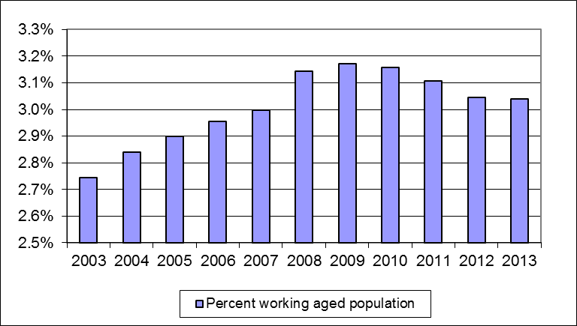

Source: IAP, numbers of working-age Invalid’s Benefit recipients at the end of June.
Statistics New Zealand, population estimates, final resident population aged 18–64 years, as at 31 December. At the publication of this fact sheet, December 2012 was the most recent quarter for which final population estimates were available.

Duration receiving an Invalid’s Benefit

Invalid’s Benefit recipients are more likely than recipients of other main benefits to have been receiving a benefit for a long period. At the end of June 2013, one in three (34 percent) Invalid’s Benefit recipients had received an Invalid’s Benefit continuously for 10 years or more. This reflects the requirement that Invalid’s Benefit recipients have a “permanent and severe” incapacity.

Clients who had received an Invalid’s Benefit for 10 years or more comprised 1.0 percent of the total working-age population at the end of June 2013.

Duration receiving an Invalid’s Benefit as a proportion of working-age Invalid’s Benefit recipients and of the working-age population (aged 18–64 years)
 | Proportion of working-age Invalid’s Benefit recipients | Proportion of working- age population (aged  18–64 years)
Proportion continuously receiving current benefit:
Less than one year | 9.6 | 0.3
Between one and four years | 22.7 | 0.7
Between four and ten years | 33.3 | 1.0
10 years or more | 34.4 | 1.0
Proportion continuously receiving any benefit:
Less than one year | 3.9 | 0.1
Between one and four years | 17.3 | 0.5
Between four and ten years | 29.2 | 0.9
10 years or more | 49.6 | 1.5
Source: IAP, number of working-age Invalid’s Benefit recipients at the end of June 2013.
Statistics New Zealand, population estimates, final resident population aged 18–64 years, at 31 December 2012. At the publication of this fact sheet, this was the most recent quarter for which final population estimates were available.

This fact sheet defines the working-age population as aged 18–64 years to reflect the minimum age of entitlement to most benefits and the age of eligibility for New Zealand Superannuation. All information in this fact sheet refers to working-age recipients of Invalid’s Benefits.
Please note that trends in numbers receiving Invalid’s Benefits are more reliably shown by comparisons between the same quarter 12 months apart than by comparisons between consecutive quarters.

