Key Facts at the end of June 2013

All main benefits

Current state

At the end of June 2013, 310,000 working-age people (aged 18–64 years) were receiving a main benefit. Over the year to June 2013, the number of recipients of a main benefit decreased by 10,000, or 3 percent.

Of the clients receiving a main benefit at the end of June 2013:
- almost one in three (31 percent) were aged 25–39 years, while a similar proportion (32 percent) were aged 40–54 years
- 14 percent had a current earnings declaration for their current spell on benefit. This indicates some participation in paid work (during the last 12 months) while receiving a main benefit
- one in five (21 percent) were caring for a dependent child aged under six years.

Characteristics of working-age recipients of main benefits (aged 18–64 years), at the end of June 2008 and at the end of June 2013
Percentage of recipients who were: | Jun-2008 | Jun-2013
Male | 37.7 | 41.5
Female | 62.3 | 58.5
Māori | 31.5 | 33.8
Pacific people | 7.6 | 7.9
18–24 years | 15.1 | 17.0
25–39 years | 33.3 | 30.8
40–54 years | 31.6 | 32.2
55–64 years | 20.1 | 20.0
Declaring earnings | 15.3 | 13.6
Caring for a dependent child aged under 6 years | 22.1 | 20.6
Number of working-age recipients of main benefits (aged 18–64 years) | 258,317 | 309,782
Source: IAP, numbers of working-age clients receiving a main benefit at the end of June.
Note: Numbers receiving a main benefit exclude the partners, spouses and dependents of recipients of a main benefit.
Five year trend

The number of clients receiving a main benefit at the end of June increased from 258,000 to 333,000 between 2008 and 2010, and then decreased to reach 310,000 in 2013.

Between June 2008 and June 2013, clients receiving a main benefit became slightly more likely to be aged 18–24 years and more likely to be male.

Changes between 2008 and 2013 which have affected the number of clients receiving a main benefit include demographic changes (eg an ageing population, people having children later in life) and changes in economic conditions.

Proportion of the working-age population receiving a main benefit

The proportion of the working-age population who were receiving a main benefit at the end of June decreased between 2003 and 2008, then increased between 2008 and 2011 before decreasing over the last three years. The main driver for this pattern has been change in use of Unemployment Benefits, reflecting changes in economic conditions.

Trends in proportion of the working-age population receiving main benefits at the end of June, between 2003 and 2013

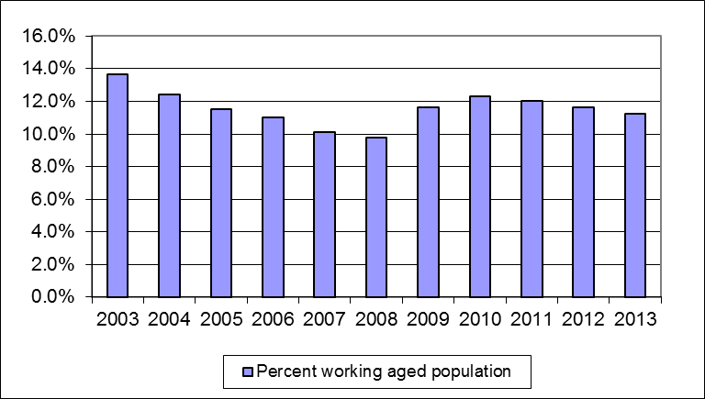
Source: IAP, numbers of working-age clients receiving a main benefit at the end of June.
Statistics New Zealand, final population estimates, resident population aged 18–64 years, at 31 December. At the publication of this fact sheet, December 2012 was the most recent quarter for which final population estimates were available.

Duration receiving main benefits

Of the recipients of main benefits at the end of June 2013:
- one in three (33 percent) had received their current benefit for less than one year, and just under one in three (30 percent) had received their current benefit continuously for between one and four years
- 13 percent had been receiving their current benefit continuously for 10 years or more.

Clients who had received their current benefit continuously for 10 years or more made up 1.5 percent of the working-age population at the end of June 2013.

Duration receiving a main benefit as a proportion of working-age recipients of main benefits and of the working-age population (aged 18–64 years)
 | Proportion of working-age recipients of main benefits | Proportion of working-age population (aged 18–64 years)
Proportion continuously receiving current benefit:
Less than one year | 33.4 | 3.8
Between one and four years | 30.5 | 3.4
Between four and ten years | 22.7 | 2.5
10 years or more | 13.4 | 1.5
Proportion continuously receiving any benefit:
Less than one year | 24.9 | 2.8
Between one and four years | 29.4 | 3.3
Between four and ten years | 24.5 | 2.8
10 years or more | 21.1 | 2.4
Source: IAP, proportion of working-age recipients of a main benefit at the end of June 2013.
Statistics New Zealand, final population estimates, resident population aged 18–64 years, at 31 December 2012. At the publication of this fact sheet, this was the most recent quarter for which final population estimates were available.

This fact sheet defines the working-age population as aged 18–64 years to reflect the minimum age of entitlement to most benefits and the age of eligibility for New Zealand Superannuation. All information in this fact sheet refers to working-age recipients of main benefits.
In this fact sheet, “main benefit” includes Unemployment Benefits, Unemployment Benefits – Hardship (includes Unemployment Benefit – Student Hardship), Independent Youth Benefits, Youth Payments, Young Parent Payments, Domestic Purposes Benefits – Sole Parent, Domestic Purposes Benefits – Care of Sick or Infirm, Domestic Purposes Benefits – Women Alone, Sickness Benefits, Sickness Benefits – Hardship, Emergency Maintenance Allowances, Invalid’s Benefits, Widow’s Benefits, and Emergency Benefits. Youth Payments and Young Parent Payments replaced Independent Youth Benefits from August 2012.
Please note that trends in numbers receiving main benefits are more reliably shown by comparisons between the same quarter 12 months apart than by comparisons between consecutive quarters.

