The Ministry of Social Development

The Statistical Report

for the year ending June 2002

Contents

Section 1: Introduction 3
Introduction to The Statistical Report 3
The Ministry of Social Development 3
The Office for Disability Issues 4
The Office for Senior Citizens 5
Service lines of the Ministry of Social Development 5

Section 2: Assistance Provided by Work and Income 7
Introduction 7
Conventions in this report 7
Benefits, pensions and other financial assistance 8
Employment services 13
Overall trends in use of financial assistance and of employment services 13
Summary information on use of core benefits 15
Trends in core benefit and pension expenditure 20
Distribution of core benefit expenditure among client groups 22
Children dependent on Work and Income clients 24
Other income declared by recipients of core benefits or pensions 27

Section 3: Trends in use of financial assistance and employment
services provided by Work and Income 29
Introduction 29
Unemployment Benefit 29
Domestic Purposes Benefit 38
Sickness Benefit 44
Invalid’s Benefit 48
Unsupported Child’s Benefit and Orphan’s Benefit 51
Widow’s Benefit 54
Employment Services 57
Transitional Retirement Benefit 62
New Zealand Superannuation 65
Veteran’s Pension 69

Section 4: Supplementary benefits and emergency or hardship assistance 72
Introduction 72
Supplementary benefits 72
Accommodation Supplement 72
Tenure Protection Allowance 76
Special Transfer Allowance 77
Childcare Subsidy 78
OSCAR (Out of School Care and Recreation) Subsidy 81
Disability Allowance 84
Child Disability Allowance 87
Training Incentive Allowance 90
Residential Care Subsidies and Residential Support Subsidies 92
Emergency or hardship assistance 94
Special Benefit 94
Emergency or hardship assistance available as lump sums 98

Section 5: Students 106
Assistance available to students 106
Student Allowances 106
Student Loans 111

Section 6: Additional administrative information 114
Community Services Cards 114
Debt Management 117
Benefit Control 120
Social Security Agreements 121

Section 7: Tables of benefit and pension uptake and expenditure
since 1940 127

Appendix 1: Administration of benefits and pensions 130
Income testing 130
Work testing 130

Appendix 2: Differences between officially unemployed and
registered job seekers 131

Section 1 – Introduction

Introduction to The Statistical Report
This report represents a new departure for annual statistical reports produced by the Ministry of Social Development and its predecessor organisations. While still including a range of information about use of financial assistance and employment services provided by the Government, this report places this information into a broader social and population context. We anticipate that the information contained in the report will be of value to anyone working in the social services sector, whether in a policy, research or service delivery capacity.

This report is based on information available in the client databases of the Ministry of Social Development. To ensure consistency in information sources, all detailed information in this report other than expenditure information has been restricted to the period since 1 July 1997. Some of the statistics presented in this report are also available for earlier years, on request from the Decision Support team of the Ministry of Social Development.

All information presented in Sections 2-6 of this report was extracted using the measures and information sources currently used by the Ministry of Social Development in its official reporting. Due to improvements in measurements and changes in the source of information, figures published in earlier reports in this series may not be able to be replicated in this report.

The Ministry of Social Development
The Ministry of Social Development (MSD) was founded on 1 October 2001 as a result of a merger between the Ministry of Social Policy and the Department of Work and Income. MSD was established to lead social development in New Zealand, and works closely with other government organisations as part of achieving this goal.

MSD is responsible for providing the Government with:
- strategic social policy advice and sectoral policy advice in respect of income support, child, youth and family and community policy
- provision of financial support and employment services through its service lines (eg Work and Income, StudyLink)
- a programme of research, programme evaluation, forecasting and modelling which addresses income support and employment issues
- purchasing and monitoring advice to the Minister in respect of employment and income support services, and in respect of the functions of the Department of Child, Youth and Family Services.

MSD is responsible for the delivery of a range of financial and other services through its service lines. These services include:
- the payment of:
– benefits
– pensions (both within New Zealand and overseas)
– student allowances and loans
– some subsidies associated with the Community Services Card
– a range of overseas pensions paid to people currently in New Zealand
- the provision of employment services
- financial means testing for long-stay care subsidies paid by the Ministry of Health.

Through Work and Income (a service of MSD), MSD also works in partnership with communities to help maximise opportunities for employment, self-sufficiency and positive activity.

With more than 5000 staff in 170 different locations throughout the country, MSD is New Zealand’s largest government department. MSD is responsible for $13.9 billion of government spending per annum, through providing financial assistance or employment support to more than one million people.

The Office for Disability Issues
The Office for Disability Issues was established within MSD on 1 July 2002. The Office has three key responsibilities:
- leading the New Zealand Disability Strategy through the promotion and monitoring of its implementation across the state sector
- provision of policy advice on disability issues. The Office leads strategic policy development regarding disability issues across the whole of government, and contributes a disability perspective to policy development led by other government agencies
- supporting the Minister for Disability Issues, through providing information and advice.

The portfolio of the Minister for Disability Issues was created in December 1999. This was the first time that a Minister or Ministry in New Zealand had been given overarching responsibility for disability issues. In 2000, the New Zealand Public Health and Disability Act was passed, and it became effective in January 2001. Part 2, section 8 of that Act requires the preparation of the New Zealand Disability Strategy to provide the framework for the Government’s overall direction for the disability sector and for improving disability services. The first New Zealand Disability Strategy was released in April 2001, after wide consultation with the disability sector.

The New Zealand Disability Strategy (“the Strategy”) presents a long-term plan for changing New Zealand from a society where disabled people face barriers which prevent them from participating in society, into an inclusive society where those barriers are removed. The vision of the Strategy is to develop a society where disabled people can say that they live in “a society that highly values our lives and continually enhances our full participation”.

The Strategy sets out the values that must underpin all of the actions of Government, as well as fifteen objectives to be achieved through detailed action plans developed under the Strategy. All government departments must have an annual implementation plan, which sets out what they will do to implement some or all of the action plans or objectives associated with the Strategy, and must report to the Government on progress against their implementation plan. To obtain a copy of the Strategy, see the website of the Office of Disability Issues (www.odi.govt.nz).

The Office for Senior Citizens
The Senior Citizens Unit was established within the Department of Social Welfare in 1992, and became the Office for Senior Citizens on 1 July 2002. The change in name did not materially affect the functions or output of the agency, but better reflected the nature of work undertaken and the growing importance of the Senior Citizens’ portfolio.

The role of the Office is to:
- provide policy advice relating to the wellbeing of older people to Government, community organisations, advocacy groups and the general public
- promote the New Zealand Positive Ageing Strategy across the private, public and community sectors
- monitor the New Zealand Positive Ageing Strategy, report on achievements against the Strategy, and prepare action plans for each financial year in association with other government departments which contribute to the Strategy
- support community involvement in senior citizens issues
- maintain and expand the network of volunteer community co-ordinators established during the International Year of Older Persons
- advocate for the rights and interests of older people.

The Office for Senior Citizens has also formed partnerships with older people’s organisations and agencies in the policy development process, through consultation and reference group processes.

Positive ageing defines older age as a time for continuing contribution to and participation in society. The New Zealand Positive Ageing Strategy aims to promote positive ageing across a broad range of portfolio areas (health, housing, community development, etc), and thereby to improve opportunities for older people to participate in the community in the ways that they choose to.

The vision of the New Zealand Positive Ageing Strategy is that of a society where people can age positively, where older people are highly valued, and where they are recognised as an integral part of families and communities. New Zealand will be a positive place to age when older people can say that they live in a society that values them, acknowledges their contribution, and encourages their participation.

Service lines of the Ministry of Social Development

Work and Income
Work and Income is the service line of MSD responsible for delivering most financial assistance and employment services to clients. Some financial and in-work assistance delivered by Work and Income is received by working families who are not receiving a core benefit. As part of assisting clients, Work and Income also works with families, employers and communities.

As a service line within MSD, Work and Income takes a social development approach to its work with communities, families and clients. At a local level, Work and Income aims to support three key government and MSD-wide goals:
- to achieve a more unified approach to the delivery of social services in communities, where Work and Income will participate with other agencies in the development of initiatives which respond to local conditions
- to ensure a more integrated approach to the development of social policy, with regional input and knowledge reflected in the policies that are delivered
- to achieve longer-term outcomes for clients with a focus on sustainable employment solutions.

Work and Income uses a range of means to inform people of the range of assistance which may be available to them. These include:
- the internet
- booklets which are available from Work and Income centres or from community groups.

StudyLink
Student Services was established within the Department of Work and Income in 1998, in order to fulfill the responsibility of the Department of Work and Income in delivering Student Allowances from the start of the 1999 academic year. Student Services was renamed StudyLink in April 2002, when StudyLink became a distinct service line within MSD. The name change was made to:
- remove any confusion between StudyLink and similarly named departments operated by educational providers
- more accurately reflect the role of StudyLink in enabling individuals to access and participate in study.

StudyLink’s role reflects the importance that successive governments have placed on:
- the contribution of a more highly educated population to New Zealand’s ability to compete in a global economy
- the removal of financial barriers to participation in education.

StudyLink is responsible for the delivery of Student Allowances (since the 1999 academic year), the administration of advances against student loans (since the 2000 academic year), the payment of Unemployment Benefit – Student – Hardship, and the delivery of other financial assistance to adult students and their families. StudyLink works in co-operation with other service lines of MSD as well as with the Ministry of Education, education providers and student bodies, in order to ensure that students get the finance they are entitled to so they can complete their study.

StudyLink’s National Office is in Palmerston North. It has a Central Processing Centre in Palmerston North, two Contact Centres (in Palmerston North and Lower Hutt) and six Outreach sites (in Auckland, Hamilton, Palmerston North, Wellington, Christchurch and Dunedin). Each year, StudyLink staff deal with around 30,000 Unemployment Benefit Student Hardship applications, 90,000 applications for Student Allowances, and 200,000 applications for drawings against student loans.

Applications for Student Allowances and for drawings against student loans peak between November and March each year, during which time Outreach staff provide on-campus services to all major tertiary education providers. This service extends to regions where StudyLink does not usually have a full-time presence, such as Nelson, Hawkes Bay and the East Coast.

Section 2 – Assistance provided by Work and Income

Introduction
This section summarises information on the use of financial assistance and employment services offered by Work and Income. Sections 3 and 4 outline more detailed information about eligibility for, and use of, employment services and particular types of financial assistance.

Information about work tests and income tests applied to benefits and pensions is outlined in Appendix 1. Information on how registered job seekers differ from the officially unemployed is outlined in Appendix 2.

Conventions in this report
Throughout this report, financial assistance is referred to by either the official name (as at 30 June 2002) of a specific benefit (eg Domestic Purposes Benefit – Sole Parent), or by broad groups of core benefits which are delivered for similar purposes (defined in Section 3). The official names used for financial assistance current at 30 June 2002 have been current since at least 1 July 2001. Where the official name of a financial assistance programme has changed over time (eg Unemployment Benefit to Community Wage – Job Seeker), this is noted within the relevant section of the report.

Trends over time in the numbers of people receiving financial assistance or employment services from MSD service lines are identified from numbers receiving these services at the end of the year ended 30 June. This approach aims to give broad trends in service use over a long period of time in a way which also enables actual numbers of clients receiving services to be shown.

This approach does, however, mean that the trends identified give no information about the numbers of people receiving assistance or services through MSD service lines at other times of the year.

In particular, it should be noted that large numbers of people may be granted services from MSD, and later cease receiving them, without appearing in statistics showing people receiving those services at 30 June. These people will, however, appear in statistics showing services granted, services ceased, and expenditure on services. Because of this, the difference between services granted and services ceased during the financial year will not correspond to the change between the beginning and end of the financial year in the numbers of people receiving services.

In this report, reference is made to SWIFTT and SOLO as sources for the data used in this report. SWIFTT is the system used to record information on financial assistance recipients and on financial assistance being paid, and contains a comprehensive record of information collected since 1995. SOLO is the system used to record information on registered job seekers and on employment services being provided, and contains a comprehensive record of information collected since 1999. Some information is also available for earlier years concerning financial services, employment services and registered job seekers.

Due to improvements in measurements and changes in the source of information, figures published in earlier reports in this series may not be able to be replicated from figures shown in this report.

Expenditure data shown in Section 3 summarises monthly expenditure since 1991/1992 on core benefits and pensions. This data has been adjusted for the number of payments in each month, and then smoothed using a moving average. A three-month moving average has been used for all core benefits and pensions except for Unsupported Child’s Benefits and Orphan’s Benefits, where a two-month moving average is used.

All expenditure data in Section 3:
- includes supplementary benefits payable to recipients of core benefits and pensions
- is shown net of taxation, apart from that for:
– National Superannuation and Veteran’s Pensions, which is shown gross of taxation
– Unsupported Child’s Benefits and Orphan’s Benefits, which are not taxed.

Expenditure data shown in Section 4 summarises monthly expenditure since 1991/1992 on supplementary benefits. This data has been adjusted for the number of payments each month, and then smoothed using a two-month moving average. These benefits are not subject to taxation.

All data on use of core or supplementary benefits (including that used in calculating the proportion of the population receiving Work and Income services) excludes spouses, partners and children of people receiving these benefits. Data on the use of pensions includes non-qualified spouses receiving pensions but excludes any other dependents of the client (eg non-qualified partners or spouses who are not receiving a pension). This data therefore indicates the number of people or the proportion of the population accounted for by numbers officially reported by MSD as receiving core benefits or pensions. This data should not, however, be treated as indicating the number or proportion of the population who are dependent on benefits or pensions.

Numbers of registered job seekers exclude clients registered as seeking employment services who are not registered job seekers (eg vacation workers, people already working full-time but seeking to change jobs). Registered job seeker statistics only include the partners or spouses of job seekers where the partners or spouses are also registered as job seekers. This again means that figures provided match official reports. It does, however, mean that job seeker numbers should not be treated as indicating the total number of people receiving employment services from Work and Income.

Benefits, pensions and other financial assistance

Types of benefits
Benefits are paid to enable people without sufficient income to meet their living costs and to participate in the community. Two types of benefit can be distinguished:
- core benefits
- supplementary benefits.

Core benefits
To be eligible to receive most core benefits, clients must have insufficient income from all sources to support themselves and any dependents. The level of income below which a core benefit can be provided depends on the type of core benefit and on the circumstances of the client. These benefits are income tested, and may also be work tested.

For information on eligibility for particular types of core benefits, see Section 3 of this report. See Appendix 1 for additional general information about income testing and about work testing.

Payment rates for core benefits
The standard weekly rates of core benefits are increased yearly on 1 April, in order to reflect the change in the Consumers Price Index over the previous year. The rates for core benefits current from 1 April 2002 are listed in Table 2.1.

Please note that:
- some clients may receive their core benefit payments fortnightly, at double the amount shown
- these rates are maximum rates unless stated otherwise, and the amount a person actually receives can depend on their income from other sources
- each partner of a married couple receives a half of the core benefit payment.

Table 2.1 – Weekly payment rates for core benefits¹
 |  |  | Children²
Core benefit | Status | None | 1 child | 2 or more
Unemployment | Married, each | $131.13 | $139.35 | $139.35
Benefit | Single, 25+ | $157.37 | $225.40 | $245.91
 | Single 18-24 | $131.13 | $225.40 | $245.91
 | Single 18-19 (Living at Home) | $104.91
Independent  Youth Benefit |  | $131.13
Unemployment | Married, each | $131.13 | $139.35 | $139.35
Benefit – Training | Single 25+ | $157.37 | $225.40 | $245.91
 | Single, 18-24 | $131.13 | $225.40 | $245.91
 | Single, 18-19 (Living at Home) | $104.91
Sickness Benefit | Married, each | $131.13 | $139.35 | $139.35
granted after | Single, 25+ | $157.37 | $225.40 | $245.91
1 July 1998 | Single 18-24 | $131.13 | $225.40 | $245.91
 | Single 18-19 (Living at Home) | $104.91
Sickness Benefit  granted before  1 July 1998³ | Married, each  Single, 25+  Single 18-24 | $139.54  $157.37  $147.34 | $139.54  $225.40  $225.40 | $139.54  $245.91  $245.91
 | Single 18-19 (Living at Home) | na | na | na
Invalid’s Benefit⁴ | Married, each | $163.92 | $163.92 | $163.92
 | Single, 18+ | $196.70 | $258.40 | $277.48
 | Single, 16-17 | $159.18
Domestic Purposes | Sole Parent |  | $225.40 | $245.91
Benefit⁴ | Women Alone | $163.92
Domestic Purposes | Single, 18+ | $196.70
Benefit – Caring for | Single, 16-17 | $159.18
Sick and Infirm^{4,5} | Sole Parent |  | $258.40 | $277.48
 | Half married rate | $163.92
Emergency  Maintenance | Age 16-17 (Living at Home) |  | $104.91 | $104.91
Allowance | Age 16-17 (Away from Home) |  | $225.40 | $245.91
 | 18 or over |  | $225.40 | $245.91
Widow’s Benefit⁴ |  | $163.92 | $225.40 | $245.91
Transitional | Married, each | $163.92 | $163.92 | $163.92
Retirement Benefit⁴ | Single | $196.70 | $258.40 | $277.48
Orphan’s and | Age 14 years or over |  | $109.26
Unsupported Child’s | Age 10-13 years |  | $101.07
Benefit (per child) | Age 5-9 years |  | $92.87
 | Age under 5 years |  | $76.47

Notes:

1 Payments are shown as the net amount set by regulations. Rates shown apply from 1 April 2002. Tax at the “M” rate is calculated retrospectively and paid to Inland Revenue.

2 Rates shown are exclusive of Family Support payments. People on benefit who have children qualify for Family Support, which is funded by Inland Revenue. See Table 2.2 below for rates of Family Support.

3 People who have received a Sickness Benefit since before 1 July 1998 receive the old (higher) Sickness Benefit rates.

4 Some recipients are paid weekly, while others are paid fortnightly at double the indicated rates.

5 Only the caregiver receives payment.

Supplementary benefits
Under the Social Security Act 1964, Work and Income delivers supplementary benefits to people receiving core benefits or pensions, to other people with low incomes and with few assets, and to people with particular needs (eg costs arising from a health issue or a medical condition). Supplementary benefits are available to assist with accommodation, childcare, health-related or medical-related costs, and to meet some other urgent and essential needs.

Many supplementary benefits are paid on a weekly basis, and some supplementary benefits are both income tested and asset tested.

Payment rates for supplementary benefits
Table 2.2 shows maximum weekly rates for a selection of the main supplementary benefits available. In some cases the payment actually made may be less than the amount shown because it is related to the costs incurred or because other income is taken into account.

Table 2.2 – Weekly payment rates for selected supplementary benefits¹
Supplementary Benefit² | Status | Maximum
 |  | Weekly Rate³
Accommodation Supplement (maximum | Living in Auckland  Living in other main provincial centres⁵ | $150.00  $115.00
amounts are subject | Living elsewhere in New Zealand | $100.00
to household circumstances and
income/asset test)⁴
Training Incentive | Maximum weekly rate | $79.81
Allowance | (Maximum per year $3,192.40)
Disability Allowance | Maximum amount | $46.18
Child Disability Allowance | Fixed rate | $34.80
Child Care Subsidy⁶ | Maximum amount | $91.39
Family Support^{7,8} | First child or only child 15 years or under | $47.00
 | Second or subsequent child 0-12 years | $32.00
 | Second or subsequent child 13-15 years | $40.00
 | Child 16 years and over | $60.00

Notes:

1 All rates payable from 1 April 2002.

2 This is a selection of the more common types of supplementary benefits. In general these types of benefit may be received in combination with some core benefit or pension. They may also be available to low-income earners.

3 Weekly amounts are shown.

4 Per family.

5 Includes Wellington, Christchurch, Hamilton, Hastings, Napier, Palmerston North, Rotorua, Tauranga and Nelson.

6 Maximum amount shown is for maximum number of subsidised hours (30) at the highest level of subsidy. Actual rate of subsidy depends on hours subsidised and income.

7 Administered by Inland Revenue, but payments may be made through Work and Income.

8 Payments under this programme are not included in the expenditures reported in this publication.

Pensions
As well as covering the living costs of people without sufficient other income, pensions are also paid as an acknowledgement of the contributions to society which recipients have made, as citizens or as members of the armed forces. Pensions are not asset tested, and pensions received by qualified recipients are not income tested. Clients receiving a pension are eligible to receive supplementary benefits from Work and Income to assist with meeting necessary costs of living. Supplementary benefits paid to people receiving pensions are income tested and asset tested.

Two types of pensions are paid by Work and Income. These are:
- age-related pensions – consists of New Zealand Superannuation. New Zealand Super-annuation is paid as of right to people who have reached a certain age (currently 65 years) and who meet other eligibility criteria (eg residency). People who do not meet these eligibility criteria but who are married to a qualified recipient of New Zealand Superannuation may receive this pension as a “non-qualified spouse”
- pensions related to service with the New Zealand armed forces – comprises Veteran’s Pensions and War Pensions. These pensions may relate to military service by the client, or to military service by a partner/spouse or parent of the client.

For information about eligibility criteria for New Zealand Superannuation and Veteran’s Pension, see Section 3 of this report.

Eligibility for War Pensions, and the rate at which War Pensions are paid, is based on an assessment of the level of disability the client has as a result of military service. This assessment is carried out by a board of assessors who are independent of Work and Income. War Pensions are not income tested or asset tested, and clients may receive them along with any other sources of income, including other benefits, pensions or income from employment.

Payment rates for pensions
The payment rates for New Zealand Superannuation are set by legislation. At the “M” tax rate, the combined after tax amount of New Zealand Superannuation payable to a married couple must be between 65% and 72.5% of the after tax average ordinary time weekly wage.

A single person living alone receives 65% of the rate payable to a married couple, while a single person sharing accommodation receives 60% of the rate payable to a married couple.

Table 2.3 shows rates payable for New Zealand Superannuation and Veteran’s Pension as at 1 April 2002.

Table 2.3 – Payment rates for New Zealand Superannuation and Veteran’s Pension^{1,2}
Status | Tax at “M” Rate |  | Tax at “S” Rate
Married, per person, both qualify | $183.69 | $172.72
Married, per person, only one qualifies³ | $175.14 | $164.17
Married, per person, only one qualifies, | $183.69 | $172.72
and application accepted before 1 October 1991
Single, living alone | $238.80 | $227.83
Single, living with others | $220.43 | $209.46

Notes:

1 All amounts shown are weekly rates, payable from 1 April 2002. New Zealand Superannuation and Veteran’s Pension payments are made fortnightly at double the indicated rates.

2 Rates shown are exclusive of Family Support payments (if any) made by Inland Revenue.

3 Where one partner is under the qualifying age, or does not meet residency requirements, the amount paid is income tested. The qualified spouse can opt to receive the Married rate where only one partner qualifies. All other rates are not income tested.

Emergency or hardship assistance
Work and Income delivers emergency or hardship assistance to people who have insufficient income and assets to meet specified and necessary costs of living from their own resources. People with low income from employment may be eligible to receive this assistance, as well as people receiving benefits or pensions from Work and Income.

Emergency or hardship assistance may be paid as a weekly benefit (the Special Benefit) to people who have insufficient income to meet ongoing and essential expenses, or as lump sums to meet specific essential expenses. Emergency or hardship assistance provided as lump sums may be paid to the client or to another person or organisation who provides goods or services to the client.

Emergency or hardship assistance received as a lump sum may be recoverable, in which case clients are required to repay it to Work and Income.

Employment services
Work and Income provides access to a range of support services and training opportunities to assist clients to obtain ongoing paid employment. These include:
- one-to-one assistance with job search and preparation to enter employment
- employment or training programmes which assist clients in preparing for work, finding a job or entering employment
- referring clients to vacancies which are notified to Work and Income
- subsidies to assist employers with the cost of wages for a specified time
- assistance for the job seeker to set up their own business, including access to business development advice and subsidies to assist with capital or operating costs.

Registered job seekers
To maintain consistency with other MSD publications, this report uses the number of registered job seekers as a measure of the use of employment services provided by Work and Income. All registered job seekers must be:
- working less than 30 hours per week and seeking to work more hours
- available for and actively seeking work.

Since 1999, between 98% and 99% of the clients receiving employment services from Work and Income have been registered job seekers. Some people, however, receive employment services from Work and Income without being registered as job seekers. These people include vacation workers and people already in full-time work who are seeking to change jobs.

The number of registered job seekers is an administrative statistic which differs from, and is usually higher than, the number of officially unemployed. See Appendix 2 for information about the difference between registered job seekers and the officially unemployed.

Overall trends in use of financial assistance and of employment services
The numbers of core benefit recipients has fallen since 1999, while the number of registered job seekers has fallen since 2000 (see Table 2.4). This reflects a number of factors, including:
- improved economic conditions (reflected in falling official unemployment levels)
- changes in Work and Income operational processes, including:
– extending the range of core benefits which are work tested (this process started on 1 April 1997, and was completed on 1 February 1999)
– reviewing the lapsing of job seekers who lose contact with Work and Income (in November 2000)
– placing an increased emphasis on supporting job seekers into paid work
– placing an increased emphasis on ongoing support of clients who have obtained paid work.

Changes over this period in the characteristics of people receiving Work and Income assistance reflect differences in the impact of the above factors on groups of Work and Income clients. In addition, these changes also reflect demographic changes, including an ageing population, people having children later, and increased migration from overseas.

The numbers of people receiving pensions decreased up until 2001, then increased in 2002 (see Table 2.4). This pattern reflects the impact of incremental increases in the age of eligibility for New Zealand Superannuation between 1 April 1993 and 1 April 2001, followed by the fixing of the eligibility age for New Zealand Superannuation at 65 years from 1 April 2001. Incremental increases in eligibility age between 1993 and 2001 kept numbers of New Zealand Superannuation pensions granted below numbers of cessations of New Zealand Superannuation over this period. Once the eligibility age was fixed, however, numbers of New Zealand Superannuation pensions granted outnumbered cessations.

The number of people receiving one or more supplementary benefits has fallen since 2000 (see Table 2.4). This reflects in part the re-introduction of income-related rents for state houses in December 2000 (which significantly reduced the numbers of people receiving an Accommodation Supplement), changes in the numbers of people receiving core benefits, and changes in economic conditions.

Table 2.4 – Trends in the numbers of people receiving government financial assistance and employment services
Type of assistance received  at 30 June | Number of people receiving Government financial assistance or employment services¹
 | 1998 | 1999 | 2000 | 2001 | 2002
 | Number | Number | Number | Number | Number
Core benefits | 381,968 | 386,218 | 379,544 | 370,089 | 359,074
Employment services  (to nearest thousand) | 190,000 | 214,000 | 231,000 | 192,000 | 168,000
Pensions² | 476,584 | 468,471 | 460,649 | 454,131 | 458,022
One or more supplementary benefits and/or weekly Special Benefit | 433,859 | 444,927 | 457,429 | 434,855 | 433,699

Notes:

1 Numbers recorded in SWIFTT or SOLO as receiving assistance at 30 June.

2 All figures for pensions given in this report exclude War Pensions. This is to avoid double counting of people who are receiving both War Pensions and another benefit or pension.

Proportion of the New Zealand population receiving government financial assistance or employment services
Since 1998 (see Figure 2.1):
- the proportion of all 18-59 year olds who are receiving core benefits has fallen slightly from 16% to 14%
- around 16% of all people aged 18 years or over have been receiving one or more supplementary benefits and/or weekly Special Benefit.

The proportion of all 18-59 year olds who are registered as job seekers rose from 9% to 10% between 1999 and 2000, but has fallen to 7% over the last two years (see Figure 2.1).

These changes reflect the economic, operational and demographic factors outlined above.

Figure 2.1 – Trends in the proportion of age groups represented receiving core benefits, work services and supplementary benefits

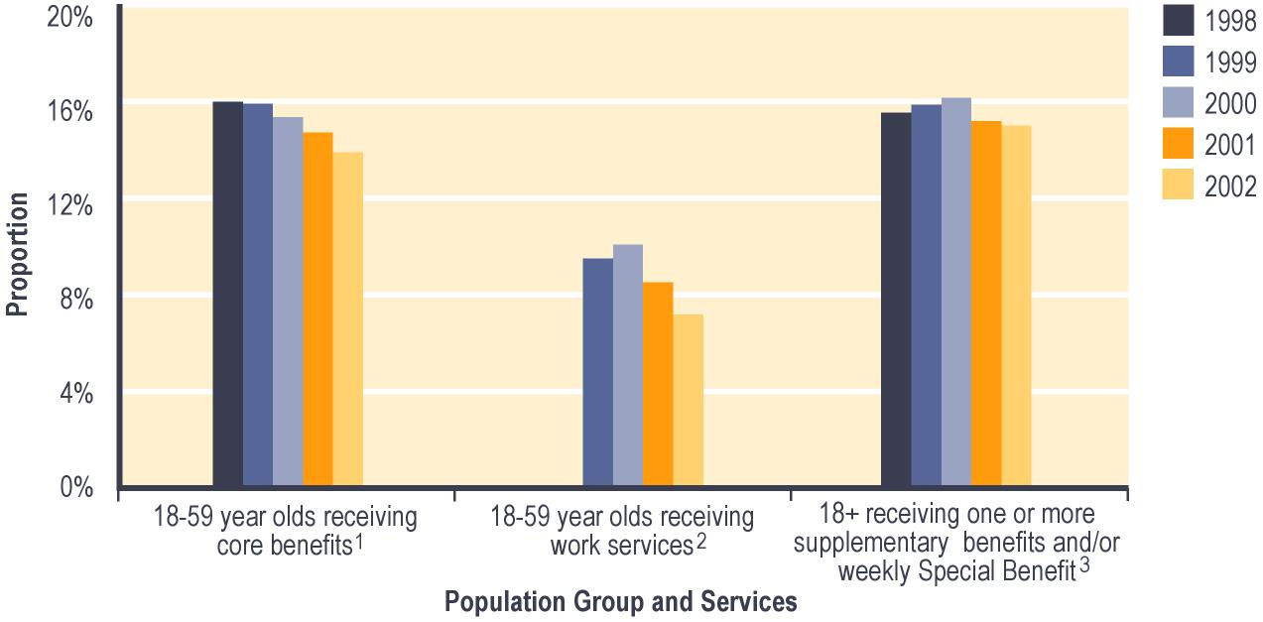
Notes:

1 Proportion shows:
a numbers of 18-59 year olds recorded in SWIFTT as receiving core benefits at 30 June; divided by
b Statistics New Zealand estimate of the total number of 18-59 year olds at 30 June.

2 Proportion shows:
a numbers of 18-59 year olds registered in SOLO as job seekers at 30 June; divided by
b Statistics New Zealand estimate of the total number of 18-59 year olds at 30 June.

3 Proportion shows:
a numbers of people aged 18 years or over who are recorded in SWIFTT as receiving one or more supplementary benefits and/or weekly Special Benefit at 30 June; divided by
b Statistics New Zealand estimate of population aged 18 years or over at 30 June.

Since 1998, around 95% of people aged 65 years or over have been receiving pensions.

Summary information on use of core benefits

Core benefits received
As noted above, the total number of people receiving core benefits increased between 1998 and 1999, but has decreased for the last three years. This at least in part reflects changes in economic conditions. Since 1998, the proportion of core benefit recipients who were receiving an Invalid’s Benefit increased from 13% to 18%, while the proportion receiving an Unemployment Benefit decreased from 42% to 36% (see Table 2.5).

Table 2.5 – Trends in the types of core benefits received
Type of core benefit  received at 30 June | People receiving core benefits¹
 | 1998 | 1999 | 2000 | 2001 | 2002
 | Number | Number | Number | Number | Number
Unemployment Benefit² | 161,279 | 169,203 | 159,160 | 144,849 | 129,932
Domestic Purposes Benefit³ | 113,329 | 109,516 | 108,939 | 107,821 | 108,009
Sickness Benefit⁴ | 35,291 | 33,022 | 32,294 | 33,620 | 36,380
Invalid’s Benefit | 49,468 | 51,173 | 55,392 | 59,812 | 64,529
Widow’s Benefit | 9,372 | 9,178 | 9,104 | 8,900 | 8,774
Unsupported Child’s Benefit/Orphan’s Benefit | 5,078 | 5,383 | 5,799 | 6,075 | 6,332
Transitional Retirement Benefit | 8,151 | 8,743 | 8,856 | 9,012 | 5,118
Total | 381,968 | 386,218 | 379,544 | 370,089 | 359,074

Notes:

1 Numbers of people recorded in SWIFTT as receiving a core benefit at 30 June.

2 Includes Unemployment Benefit, Unemployment Benefit – Hardship, Unemployment Benefit – Hardship – Student, Unemployment Benefit – Training, Unemployment Benefit – Hardship – Training, Emergency Benefit and Independent Youth Benefit.

3 Includes Domestic Purposes Benefit – Sole Parent, Domestic Purposes Benefit – Caring for the Sick and Infirm, Domestic Purposes Benefit – Woman Alone, and Emergency Maintenance Allowance.

4 Includes Sickness Benefit and Sickness Benefit – Hardship.

Since 1998, there have been slight increases in the proportions of core benefit recipients who were aged 60 years or over (from 8% to 12%) and who were aged 40-59 years (from 30% to 34%). Over the same period, there were corresponding decreases in the proportions of core benefit recipients who were aged 16-24 years (from 22% to 19%) and of core benefit recipients who were aged 25-39 years (from 40% to 36%) (see Figure 2.2). This reflects in part the combined impacts of the ageing of the New Zealand population, of incremental increases in the age of eligibility for New Zealand Superannuation, and of people spending longer receiving core benefits.

Figure 2.2 – Trends in the age of people receiving core benefits¹

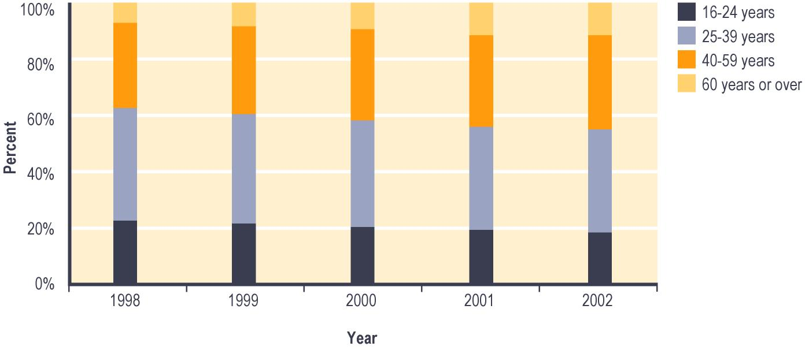
Notes:

1 Percent of people recorded in SWIFTT as receiving core benefits at 30 June.

Since 1998, the proportion of core benefit recipients who had received their core benefit for over four years increased from 23% to 29%. Over the same period, the proportion of core benefit recipients who had received their core benefit for under six months decreased from 27% to 23% and the proportion who had their core benefit for between six months and two years decreased from 33% to 30% (see Figure 2.3).

Figure 2.3 – Trends in people’s length of current spells receiving core benefits¹

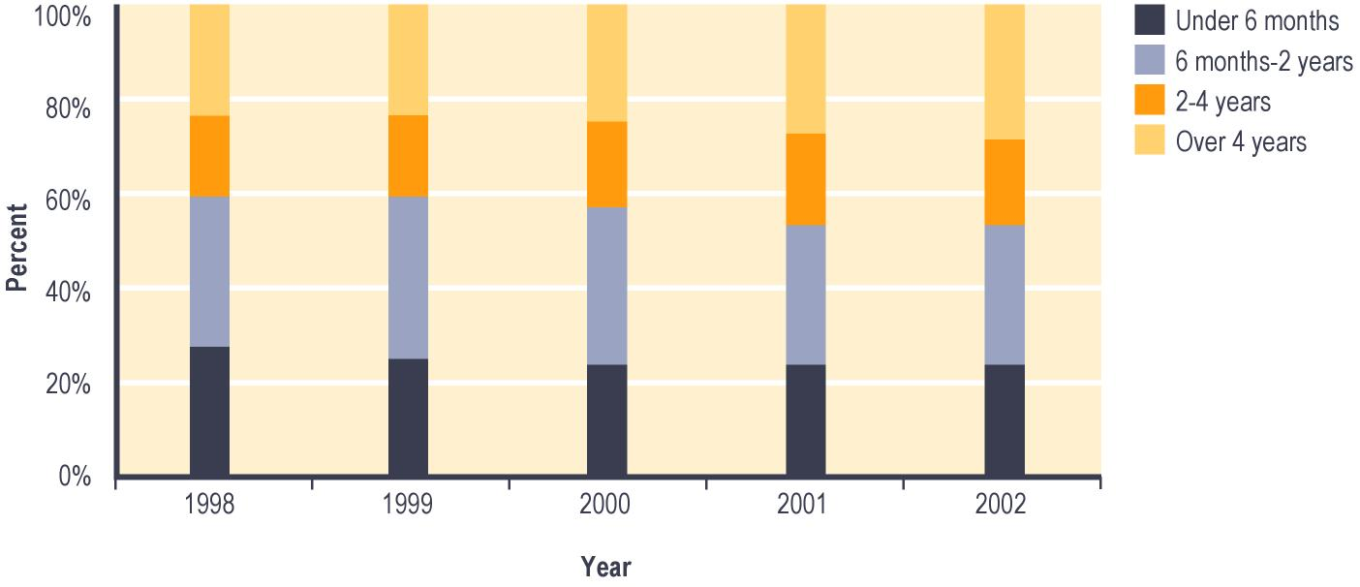
Notes:

1 Percent of people recorded in SWIFTT as receiving core benefits at 30 June.

Trends in core benefits granted
The number of core benefits granted each year has decreased in each of the last four years (see Table 2.6). Since 1998/1999, between 29% and 33% of the core benefits granted each year have been provided to people who have received a core benefit within the previous 12 months, while between 24% and 28% have been provided to people who have not received a core benefit within the previous four years (see Table 2.6).

The proportion of core benefits granted which reflected administrative transfers decreased from 36% to 27% between 1998/1999 and 1999/2000, and has remained relatively stable over the last two years (see Table 2.6). This change reflects at least in part a slowing of administrative transfers between benefits once the impact on benefit eligibility of the policy changes implemented between 1996 and 1998 had passed. These policy changes included the review of eligibility for Sickness Benefits and for Invalid’s Benefits which occurred between 1995 and 1996, and the introduction of the youth income support policy in 1998.

Table 2.6 – Trends in period since clients granted a core benefit had previously received any core benefit
Period since client last received any core benefit | Core benefits granted¹
 | 1997/  1998 | 1998/  1999 | 1999/  2000 | 2000/  2001 | 2001/  2002
 | Number | Number | Number | Number | Number
None (administrative transfers of people continuing to receive some core benefit) | 126,915 | 129,677 | 82,052 | 77,619 | 75,434
Under 6 months | 58,261 | 55,156 | 51,616 | 52,407 | 51,757
6-12 months | 51,464 | 46,318 | 43,411 | 45,362 | 43,644
12-18 months | 14,395 | 13,976 | 13,016 | 12,949 | 12,767
18 months - 2 years | 11,789 | 10,254 | 12,084 | 9,883 | 10,088
2-4 years | 22,859 | 19,593 | 18,957 | 18,981 | 18,377
Never received core benefit in last 4 years | 95,683 | 84,797 | 86,931 | 83,639 | 77,572
Total | 381,366 | 359,771 | 308,067 | 300,840 | 289,639

Notes:

1 Numbers of core benefit applications resulted as successful in SWIFTT during years ended 30 June.

Between 1998/1999 and 1999/2000, the proportion of core benefits granted which were Unemployment Benefits decreased from 74% to 69%, and has fallen only slightly further in the last two years (see Table 2.7). This reflects at least in part a decrease since 1998/1999 in the number of Unemployment Benefits granted through administrative transfers, following the completion of administrative transfers resulting from the introduction of the youth income support policy in January 1998.

Table 2.7 – Trends in types of core benefits granted
Type of core benefit granted | Core benefits granted¹
 | 1997/1998 | 1998/1999 | 1999/2000 | 2000/2001 | 2001/2002
 | Number | Number | Number | Number | Number
Unemployment Benefit² | 277,179 | 267,525 | 212,569 | 203,458 | 190,317
Domestic Purposes Benefit³ | 42,947 | 39,678 | 39,100 | 38,935 | 37,501
Sickness Benefit⁴ | 42,666 | 34,928 | 36,660 | 38,582 | 41,854
Invalid’s Benefit | 9,333 | 8,178 | 10,032 | 10,114 | 11,250
Widow’s Benefit | 2,120 | 2,029 | 2,026 | 2,005 | 2,017
Unsupported Child’s Benefit/ Orphan’s Benefit | 2,674 | 2,912 | 3,227 | 3,290 | 3,123
Transitional Retirement Benefit | 4,447 | 4,521 | 4,453 | 4,456 | 3,577
Total | 381,366 | 359,771 | 308,067 | 300,840 | 289,639

Notes:

1 Numbers of core benefit applications resulted as successful in SWIFTT during years ended 30 June.

2 Includes Unemployment Benefit, Unemployment Benefit – Hardship, Unemployment Benefit – Hardship – Student, Unemployment Benefit – Training, Unemployment Benefit – Hardship – Training, Emergency Benefit and Independent Youth Benefit.

3 Includes Domestic Purposes Benefit – Sole Parent, Domestic Purposes Benefit – Caring for the Sick and Infirm, Domestic Purposes Benefit – Woman Alone, and Emergency Maintenance Allowance.

4 Includes Sickness Benefit and Sickness Benefit – Hardship.

Trends in core benefits ceased
The number of core benefits ceased each year has decreased each year since 1997/1998. Since 1998/1999, the proportion of core benefits ceased each year which were Unemployment Benefits has decreased from 74% to 68% (see Table 2.8).

This reflects a combination of improved economic conditions, operational changes such as an increased emphasis on placing job seekers into paid work, and the slowing of administrative cessations of Unemployment Benefits. The slowing of administrative cessations of Unemployment Benefits followed completion of the administrative changes to benefits which resulted from the introduction of the youth income support policy in January 1998.

Table 2.8 – Trends in types of core benefits ceased
Type of core benefit ceased | Core benefits ceased¹
 | 1997/1998 | 1998/1999 | 1999/2000 | 2000/2001 | 2001/2002
 | Number | Number | Number | Number | Number
Unemployment Benefit² | 275,566 | 268,406 | 229,251 | 225,405 | 212,082
Domestic Purposes Benefit³ | 42,907 | 41,408 | 40,334 | 39,427 | 37,853
Sickness Benefit⁴ | 44,010 | 38,871 | 38,816 | 38,348 | 40,143
Invalid’s Benefit | 7,069 | 7,492 | 7,150 | 6,870 | 7,723
Widow’s Benefit | 2,014 | 2,106 | 2,142 | 2,196 | 2,128
Unsupported Child’s Benefit/ Orphan’s Benefit | 2,424 | 2,576 | 2,810 | 2,968 | 2,860
Transitional Retirement Benefit | 4,350 | 4,053 | 4,414 | 4,429 | 7,593
Total | 378,340 | 364,912 | 324,917 | 319,643 | 310,382

Notes:

1 Numbers of cessations of core benefits actioned in SWIFTT during years ended 30 June.

2 Includes Unemployment Benefit, Unemployment Benefit – Hardship, Unemployment Benefit – Hardship – Student, Unemployment Benefit – Training, Unemployment Benefit – Hardship – Training, Emergency Benefit and Independent Youth Benefit.

3 Includes Domestic Purposes Benefit – Sole Parent, Domestic Purposes Benefit – Caring for the Sick and Infirm, Domestic Purposes Benefit – Woman Alone, and Emergency Maintenance Allowance.

4 Includes Sickness Benefit and Sickness Benefit – Hardship.

Between 1998/1999 and 1999/2000, the proportion of core benefit cessations which reflected clients entering paid work increased from 28% to 34%. This proportion has remained relatively stable over the last two years. The proportion of core benefit cessations reflecting clients transferring to another core benefit showed a corresponding decrease. This reflects a combination of reduced administrative transfers between core benefits, improved economic conditions, and operational factors. Operational factors reflected in this result include increased case management of core benefit recipients following extended work testing of core benefits and an increased focus on placing job seekers into work.

Trends in core benefit and pension expenditure
Total expenditure on core benefits increased significantly between 1997/1998 and 1998/1999, then decreased slightly over 1999/2000 and 2000/2001 but increased slightly in 2001/2002.

Since 1997/1998, Domestic Purposes Benefits have accounted for about 34% of annual core benefit expenditure. Since 1998/1999, the proportion of core benefit expenditure accounted for by Invalid’s Benefits has increased from 14% to 19%, while the proportion accounted for by Unemployment Benefits showed a corresponding decrease (from 37% to 32%) (see Table 2.9). These changes reflect the changes in the types of core benefits used which were indicated earlier.

Since 1997/1998, expenditure on pensions has shown an increase. Over this period, New Zealand Superannuation has accounted for around 98% of total expenditure on pensions (see Table 2.9).

Table 2.9 – Trends in core benefit and pension expenditure by types of core benefits or pensions
Type of core benefit or pension | Expenditure on core benefits and pensions¹
 | 1997/1998 | 1998/1999 | 1999/2000 | 2000/2001 | 2001/2002
 | Amount ($m) | Amount ($m) | Amount ($m) | Amount ($m) | Amount ($m)
Unemployment Benefit^{2,4} | 1,322 | 1,387 | 1,374 | 1,297 | 1,185
Domestic Purposes Benefit^{2,5} | 1,240 | 1,209 | 1,192 | 1,201 | 1,250
Sickness Benefit^{2,6} | 340 | 313 | 294 | 297 | 318
Invalid’s Benefit² | 504 | 532 | 570 | 627 | 698
Widow’s Benefit² | 80 | 79 | 78 | 77 | 77
Unsupported Child’s Benefit/ Orphan’s Benefit² | 30 | 32 | 35 | 38 | 41
Transitional Retirement Benefit² | 94 | 99 | 105 | 107 | 81
Total core benefit expenditure² | 3,609 | 3,650 | 3,649 | 3,645 | 3,652
New Zealand Superannuation³ | 4,168 | 4,195 | 4,199 | 4,358 | 4,531
Veteran’s Pension³ | 67 | 69 | 70 | 75 | 80
Total pensions expenditure³ | 4,235 | 4,264 | 4,269 | 4,433 | 4,611
Total expenditure on core benefits and pensions | 7,844 | 7,914 | 7,918 | 8,078 | 8,263

Notes:

1 Expenditure for years ended 30 June.

2 Expenditure on core benefits excludes tax paid and supplementary benefits provided to clients receiving core benefits.

3 Expenditure on pensions excludes estimated tax at the “M” tax rate, and excludes supplementary benefits provided to people receiving pensions.

4 Includes Unemployment Benefit, Unemployment Benefit – Hardship, Unemployment Benefit – Hardship – Student, Unemployment Benefit – Training, Unemployment Benefit – Hardship – Training, Emergency Benefit and Independent Youth Benefit.

5 Includes Domestic Purposes Benefit – Sole Parent, Domestic Purposes Benefit – Caring for the Sick and Infirm, Domestic Purposes Benefit – Woman Alone, and Emergency Maintenance Allowance.

6 Includes Sickness Benefit and Sickness Benefit – Hardship.

Proportion of Gross Domestic Product accounted for by core benefit and pension expenditure
Between 1997/1998 and 2001/2002, the proportion of Gross Domestic Product accounted for by core benefit and pension expenditure (excluding supplementary benefits) decreased from 8% to 7% (see Table 2.10). This reflects increases in Gross Domestic Product combined with relatively static core benefit expenditure and slow increases in pension expenditure.

Table 2.10 – Proportion of Gross Domestic Product accounted for by core benefit expenditure
Type of expenditure | Expenditure on core benefits¹
 | 1997/1998 | 1998/1999 | 1999/2000 | 2000/2001 | 2001/2002
Total expenditure on core benefits ($m)² | 3,609 | 3,650 | 3,649 | 3,645 | 3,652
Total expenditure on pensions ($m)³ | 4,235 | 4,264 | 4,269 | 4,433 | 4,611
Total expenditure on core benefits and pensions ($m) | 7,844 | 7,914 | 7,918 | 8,078 | 8,263
Percentage of Gross Domestic Product⁴ | 8.0% | 7.9% | 7.5% | 6.5% | 6.7%

Notes:

1 Expenditure on core benefits and pensions for years ended 30 June.

2 Expenditure on core benefits excludes tax paid on core benefits and supplementary benefits provided to clients receiving core benefits.

3 Expenditure on pensions excludes estimated tax at the “M” tax rate, and excludes supplementary benefits provided to people receiving pensions.

4 Total combined core benefit and pension expenditure for year ended 30 June as a percentage of expenditure on Gross Domestic Product in year ended 30 June.

Distribution of core benefit expenditure among client groups
The distribution of core benefit expenditure among gender and ethnic groups reflects a combination of factors including patterns in uptake of and length of spells receiving core benefits, and whether or not core benefit recipients have dependent children.

Since 1997/1998, people aged 25-39 years have accounted for between 39% and 43% of core benefit expenditure, while people aged 40-59 years have accounted for between 30% and 34%. This reflects the predominance of these groups among core benefit recipients. Over this period, the proportion of core benefit expenditure accounted for by people aged 40-59 years increased from 30% to 34%, while the proportion accounted for by people aged 60 years or over increased from 6% to 11%. There were corresponding decreases in the proportions of core benefit expenditure accounted for by people in younger age groups (see Table 2.11). These changes reflect the growth noted earlier in the number of older people receiving core benefits.

Table 2.11 – Trends in distribution of core benefit expenditure by age of recipients
Age group of client | Percent of expenditure on core benefits^{1,2}
 | 1997/1998 | 1998/1999 | 1999/2000 | 2000/2001 | 2001/2002
 | Percent | Percent | Percent | Percent | Percent
16-24 years | 19.8% | 18.3% | 17.6% | 17.0% | 16.6%
25-39 years | 42.8% | 42.3% | 41.0% | 39.7% | 38.8%
40-59 years | 30.4% | 31.5% | 32.2% | 32.9% | 33.6%
60 years or over | 6.2% | 7.0% | 7.9% | 9.2% | 10.5%
Unspecified | 0.0% | 0.0% | 0.0% | 0.0% | 0.0%
Total | 100.0% | 100.0% | 100.0% | 100.0% | 100.0%

Notes:

1 Expenditure on core benefits for years ended 30 June.

2 Excludes tax paid on core benefits and supplementary benefits provided to clients receiving core benefits.

Over the same period, women have accounted for around 62% of core benefit expenditure, while New Zealand Europeans have accounted for around 48% and Mäori accounted for around 30% (see Tables 2.12 and 2.13).

Table 2.12 – Trends in distribution of core benefit expenditure by gender of recipients
Gender of client | Percent of expenditure on core benefits^{1,2}
 | 1997/1998 | 1998/1999 | 1999/2000 | 2000/2001 | 2001/2002
 | Percent | Percent | Percent | Percent | Percent
Female | 61.9% | 61.1% | 61.5% | 61.9% | 62.5%
Male | 38.1% | 38.9% | 38.5% | 38.1% | 37.5%
Unspecified | 0.0% | 0.0% | 0.0% | 0.0% | 0.0%
Total | 100.0% | 100.0% | 100.0% | 100.0% | 100.0%

Notes:

1 Expenditure on core benefits for years ended 30 June.

2 Excludes tax paid on core benefits and supplementary benefits provided to clients receiving core benefits.

Table 2.13 – Trends in distribution of core benefit expenditure by ethnicity of recipients
Ethnic group client identifies with | Percent of expenditure on core benefits^{1,2}
 | 1997/1998 | 1998/1999 | 1999/2000 | 2000/2001 | 2001/2002
 | Percent | Percent | Percent | Percent | Percent
Mäori | 29.7% | 29.8% | 29.9% | 29.9% | 30.1%
Pacific people | 7.4% | 7.5% | 7.5% | 7.6% | 7.7%
Other ethnic group | 12.0% | 12.6% | 13.1% | 13.6% | 14.0%
New Zealand European | 47.5% | 47.9% | 47.8% | 47.6% | 47.5%
Unspecified | 3.2% | 2.4% | 1.8% | 1.3% | 0.9%
Total | 100.0% | 100.0% | 100.0% | 100.0% | 100.0%

Notes:

1 Expenditure on core benefits for years ended 30 June.

2 Excludes tax paid on core benefits and supplementary benefits provided to clients receiving core benefits.

Children dependent on Work and Income clients

Trends in the number of children dependent on core benefit recipients
The total number of children dependent on core benefit recipients has fallen over the last four years. Over the period since 1998, about 32% of children dependent on core benefit recipients have been aged under five years, while between 30% and 32% have been aged between five and nine years. In total, around 88% of children dependent on core benefit recipients since 1998 have been aged 14 years or under (see Table 2.14). By law, children aged under 14 years require supervision at all times.

Table 2.14 – Trends in the ages of children dependent on core benefit recipients
Age of children at 30 June | Children dependent on core benefit recipients¹
 | 1998 | 1999 | 2000 | 2001 | 2002
 | Number | Number | Number | Number | Number
0-4 years | 95,703 | 93,024 | 90,718 | 86,960 | 84,006
5-9 years | 96,353 | 92,481 | 88,780 | 84,245 | 81,115
10-14 years | 74,225 | 75,344 | 76,229 | 75,939 | 74,961
15-17 years | 31,605 | 31,887 | 31,051 | 30,216 | 29,907
18-19 years | 2,800 | 3,132 | 2,679 | 2,378 | 2,293
20 years or over | 4 | 0 | 11 | 7 | 3
Unspecified | 0 | 0 | 0 | 0 | 0
Total | 300,690 | 295,868 | 289,468 | 279,745 | 272,285

Notes:

1 Numbers of children dependent on carers who were recorded in SWIFTT as receiving a core benefit at 30 June.

Trends in the proportion of children dependent on core benefit recipients
Since 1998, between 26% and 29% of all children aged under 18 years have been dependent on core benefit recipients. Over this period, a higher proportion of children aged under 10 years than of older children have been dependent on core benefit recipients (See Figure 2.4).
Since 1998, the proportion of children aged under 18 years who were dependent on core benefit recipients has decreased slightly, with this pattern most evident among children aged under 10 years (see Figure 2.4). This may reflect decreases in the number of people receiving core benefits (in turn reflecting both economic conditions and operational changes), as well as the ageing of children who remain dependent on core benefit recipients.

Figure 2.4 – Trends in the proportion¹ of children aged under 18 years dependent on core benefit recipients, by age

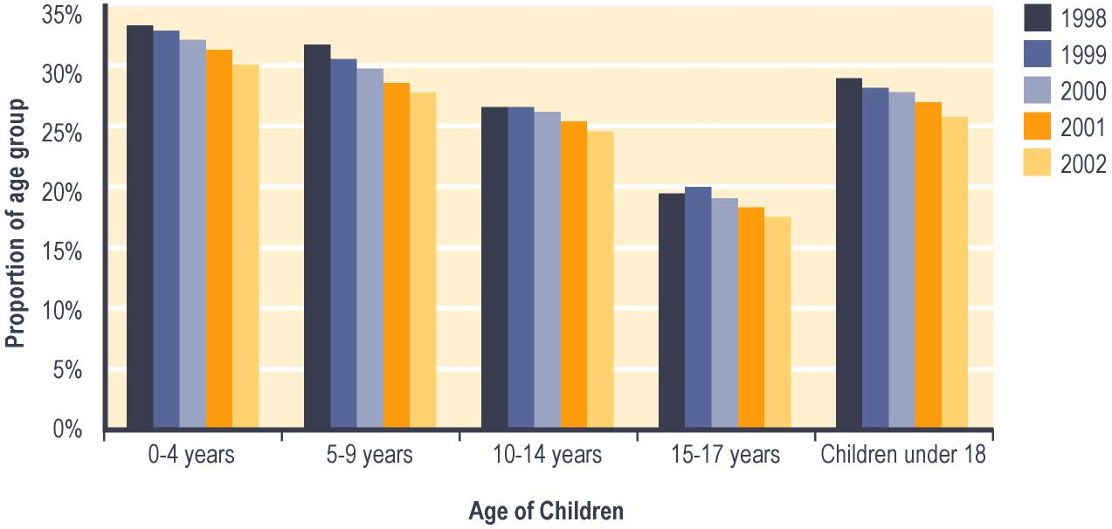

Notes:

1 Proportion shows:

a Numbers of children in age group dependent on people recorded in SWIFTT as receiving core benefits at 30 June; divided by

b Statistics New Zealand estimate of population in age group at 30 June.

Trends in the number of children dependent on registered job seekers
The total number of children dependent on registered job seekers rose between 1999 and 2000, but has decreased over the last two years (see Table 2.15). This is likely to reflect changes in the total number of registered job seekers arising from changes in economic conditions and in operational processes as discussed earlier. Since 1999, about 85% of children dependent on registered job seekers have been aged 14 years or under. By law, children aged under 14 years require supervision at all times.

Since 1999, the proportion of children dependent on registered job seekers who are aged 10-14 years has increased (see Table 2.15). This may reflect in part the increased numbers of children aged 10-14 years in the population as a whole.

Table 2.15 – Trends in the ages of children dependent on registered job seekers
Age of children at  30 June | Children dependent on registered job seekers^{1,2}
 | 1999 | 2000 | 2001 | 2002
 | Number | Number | Number | Number
0-4 years | 23,926 | 28,653 | 22,163 | 19,209
5-9 years | 30,665 | 42,684 | 32,388 | 27,090
10-14 years | 29,159 | 42,931 | 36,140 | 32,426
15-17 years | 13,988 | 17,813 | 15,026 | 13,739
18-19 years | 1,640 | 1,719 | 1,398 | 1,222
20 years or over |  | 7 | 5 | 2
Unspecified | 0 | 0 | 0 | 0
Total | 99,378 | 133,807 | 107,120 | 93,688

Notes:

1 Numbers of children dependent on registered job seekers registered in SOLO at 30 June.

2 Information on numbers and ages of dependent children is only available for job seekers who were also receiving financial assistance from Work and Income. At each of the dates shown, around 95% of registered job seekers were receiving such assistance.

Trends in the proportion of children dependent on registered job seekers
The proportion of children aged under 18 years who were dependent on registered job seekers increased from 9% to 13% between 1999 and 2000, but decreased to 9% over the last two years. Over this period, the proportions of children aged five to nine years and of children aged 10-14 years who were dependent on registered job seekers have both been higher than the proportions of children in other age groups who were dependent on registered job seekers (see Figure 2.5).

The changes in the proportion of children aged under 18 years who were dependent on registered job seekers reflect in part the change in the total number of registered job seekers over this period outlined earlier.

Figure 2.5 – Trends in the proportion¹ of children aged under 18 years who are dependent on registered job seekers, by age

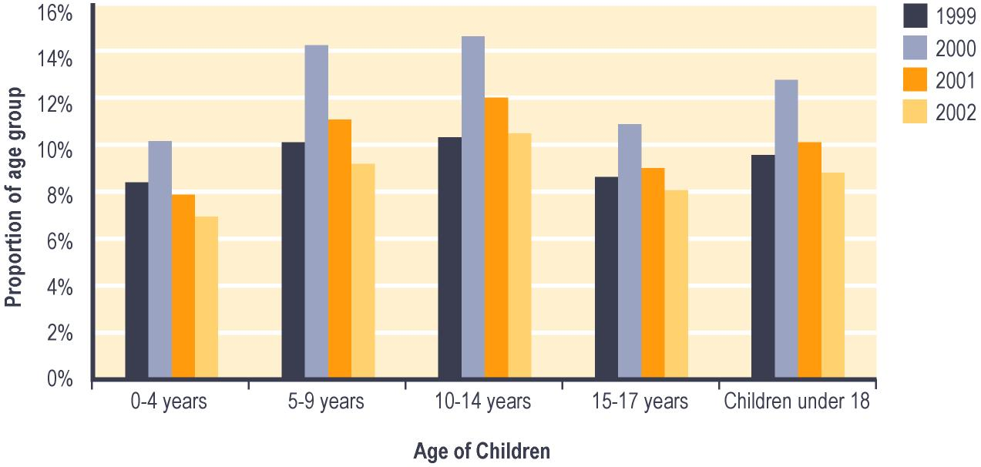

Notes:

1 Proportion shows:

a Numbers of children in age group dependent on job seekers registered in SOLO at 30 June; divided by

b Statistics New Zealand estimate of population in age group at 30 June.

Other income declared by recipients of core benefits or pensions
From 1 July 1996, people receiving core benefits have been able to earn up to $80 per week (before tax) before their core benefit payments are reduced. In addition, income over $80 per week (before tax) results in the core benefit being abated at a lower rate for Domestic Purposes Benefit, for Widow’s Benefit and for Invalid’s Benefit than for Unemployment Benefit or for Sickness Benefit. This aims to give those less able to take up full-time employment an incentive to take up part-time employment.

In addition to the $80 per week (before tax) above:
- People receiving an Invalid’s Benefit can earn an additional $20 per week (before tax) without having their income support payments reduced. Special conditions apply for people receiving an Invalid’s Benefit because of blindness
- people receiving a Widow’s Benefit or a Domestic Purposes Benefit – Sole Parent who are paying for child care can earn an additional $20 per week (before tax) before their income support payments are reduced.
From 1 April 1999, people receiving a Domestic Purposes Benefit or a Widow’s Benefit who have no dependent children or whose dependent children are aged 14 years or over have been subject to a full-time work test. From this date, these clients have had any additional income abated under the same regime as people receiving an Unemployment Benefit.

As long as a non-qualified spouse is not included in their payment, people receiving New Zealand Superannuation or a Veteran’s Pension are not income-tested. This means that these people can earn other income without having their pension abated. Some supplementary benefits (eg Accommodation Supplement) are reduced when people receive other income. This may occur even if the amount earned is too low to affect their core benefit payments, or if they are receiving a pension which is not income tested.

Adjustments in 1996 and 1998 to the rate of tax paid on income earned through secondary employment also contributed to incentives for people receiving core benefits to undertake paid work.

Trends in the number of core benefit recipients declaring other income
The number of core benefit recipients declaring other income increased between 1997/1998 and 1998/1999, but has decreased over the last three years (see Table 2.16). This pattern reflects changes in the total number of people receiving core benefits. Since 1997/1998, about 22% of people receiving income tested core benefits have declared other income during any year.

Since 1997/1998, the proportion of the core benefit recipients declaring other income who declared income of between $1 and $80 per week before tax decreased from 48% to 40%. There were smaller increases in the proportions of core benefit recipients declaring other income who declared income of $80-$180 per week before tax (33% to 37%) and who declared income of over $180 per week before tax (19% to 23%) (see Table 2.16).

Table 2.16 – Trends in levels of other income declared by core benefit recipients
Level of other income declared¹ | Core benefit recipients declaring other income²
 | 1997/1998 | 1998/1999 | 1999/2000 | 2000/2001 | 2001/2002
 | Number | Number | Number | Number | Number
None or under $1 | 295,170 | 298,168 | 291,579 | 283,409 | 276,212
$1-<$40 | 21,870 | 20,905 | 19,145 | 17,748 | 16,134
$40-<$80 | 17,214 | 17,188 | 16,463 | 15,738 | 14,488
$80-<$120 | 15,478 | 16,221 | 16,577 | 16,534 | 15,920
$120-<$160 | 8,247 | 8,698 | 8,904 | 8,874 | 8,665
$160-<$180 | 3,064 | 3,319 | 3,388 | 3,537 | 3,423
$180-<$200 | 2,746 | 3,021 | 3,184 | 3,136 | 3,179
$200 or over | 13,101 | 13,315 | 14,505 | 15,038 | 14,721
Total | 376,890 | 380,835 | 373,745 | 364,014 | 352,742

Notes:

1 Income per week before tax; based on last declaration of the year ended 30 June.

2 Numbers of clients making one or more income declarations in years ended 30 June.

Since 1997/1998, between 32% and 35% of people declaring other income have been receiving a Domestic Purposes Benefit. Between 1998/1999 and 2001/2002, the proportion of core benefit recipients declaring other income who were receiving an Unemployment Benefit decreased from 36% to 30% (see Table 2.17).

Table 2.17 – Trends in core benefits received by people declaring other income
Type of core benefit received at time income declared^{1,2} | Percent of core benefit recipients declaring other income³
 | 1997/1998 | 1998/1999 | 1999/2000 | 2000/2001 | 2001/2002
 | Percent | Percent | Percent | Percent | Percent
Unemployment Benefit⁴ | 35.0% | 35.9% | 34.8% | 31.8% | 30.0%
Domestic Purposes Benefit⁵ | 31.7% | 31.0% | 32.0% | 33.5% | 35.2%
Sickness Benefit⁶ | 7.3% | 6.6% | 6.2% | 6.3% | 6.8%
Invalid’s Benefit | 14.9% | 15.2% | 16.0% | 17.2% | 19.1%
Widow’s Benefit | 5.3% | 5.2% | 5.1% | 5.1% | 5.2%
Transitional Retirement Benefit | 5.8% | 6.0% | 5.9% | 6.1% | 3.7%
Total | 100.0% | 100.0% | 100.0% | 100.0% | 100.0%

Notes:

1 Type of core benefit received at the time when the last income declaration of the year to 30 June was made.

2 Unsupported Child’s Benefits and Orphan’s Benefits are excluded because the child for whom the benefit is paid, rather than the client receiving these benefits, is income tested.

3 Percent of clients making one or more income declarations in years ended 30 June.

4 Includes Unemployment Benefit, Unemployment Benefit – Hardship, Unemployment Benefit – Hardship – Student, Unemployment Benefit – Training, Unemployment Benefit – Hardship – Training, Emergency Benefit and Independent Youth Benefit.

5 Includes Domestic Purposes Benefit – Sole Parent, Domestic Purposes Benefit – Caring for the Sick and Infirm, Domestic Purposes Benefit – Woman Alone, and Emergency Maintenance Allowance.

6 Includes Sickness Benefit and Sickness Benefit – Hardship.

Section 3 – Trends in use of financial assistance and employment services provided by Work and Income

Introduction
This section of the report outlines trends in the use and uptake of financial assistance and employment services provided by Work and Income, and also outlines trends in the cessation of core benefits.

Eligibility criteria are outlined in this section for each core benefit or pension. For information about payment rates for benefits and pensions, see Section 2. Additional information about income and work tests applied to recipients of benefits and pensions is provided in Appendix 1. Information about how registered job seekers differ from the officially unemployed is given in Appendix 2.

Unemployment Benefit
This group of core benefits includes Unemployment Benefits, Unemployment Benefits – Training, Unemployment Benefits – Hardship, Unemployment Benefits – Hardship – Student, Unemployment Benefits – Training – Hardship, Independent Youth Benefits, and Emergency Benefits. Between 1 January 1998 and 30 September 1998, a Young Job Seeker Allowance was available to 18-24 year olds who had been registered as job seekers for less than 13 weeks. After 1 October 1998, the Young Job Seeker Allowance was combined with the Unemployment Benefit as the Community Wage – Job Seeker.

The Unemployment Benefit was known as the Community Wage – Job Seeker between 1 October 1998 and 30 June 2001 but reverted to its former name on 1 July 2001. The Unemployment Benefit – Hardship was known as the Emergency Unemployment Benefit prior to 1 October 1998, and as the Community Wage – Emergency Job Seeker between 1 October 1998 and 30 June 2001. The Unemployment Benefit – Training was known as the Training Benefit prior to 1 October 1998, and as the Community Wage – Training between 1 October 1998 and 30 June 2001. The Unemployment Benefit – Training – Hardship was known as the Community Wage – Emergency – Training between 1 October 1998 and 30 June 2001.

Clients receiving these benefits have historically been subject to a full-time work test, with most being registered as a job seeker. From 1 April 1997, the spouses or partners of clients receiving an Unemployment Benefit who have no dependent children or whose youngest dependent child is aged 14 years or over have also been subject to a full-time work test.

Between 1 April 1997 and 1 February 1999, the spouses or partners of clients who had received an Unemployment Benefit for more than one year and whose youngest dependent child was aged between seven and 13 years were required to attend an annual interview with a Work and Income case manager. This interview was aimed at planning the entry into paid work of the spouse or partner of the Unemployment Benefit recipient. From 1 February 1999, the spouses or partners of Unemployment Benefit recipients whose youngest dependent child was aged between six and 13 years have been subject to a part-time work test.

Types of Unemployment Benefit

Unemployment Benefit
An Unemployment Benefit is available to people who are:
- available for and actively seeking full-time work
- who are not already in full-time employment.

To be eligible to receive an Unemployment Benefit, clients must also be:
- aged 18 years or over or
- aged 16 years or over and living with a spouse or partner and dependent children.

Residency and income tests apply. People aged 55 years or over may apply for an exemption from work testing after receiving an Unemployment Benefit for six months beyond their 55th birthday. Those granted such an exemption continue to receive an Unemployment Benefit and must continue to seek work. They may also choose to register or to remain registered as a job seeker, although they are not obliged to do so.

Unemployment Benefit – Training
The Unemployment Benefit – Training is available to full-time trainees on approved training courses who are:
- aged 18 or over or
- aged 16-17 years and living with a spouse or partner and dependent children.

Income and residency qualifications apply.

People receiving an Unemployment Benefit – Training may continue to receive it over the Christmas break if:
- their course continues after Christmas
- the break over Christmas is no longer than four weeks.

People whose course takes a break for longer than four weeks must enrol for an Unemployment Benefit until their course resumes.

Prior to 1 January 1998, an Unemployment Benefit – Training was available to people 16 years or over undertaking approved employment-related training. Since the introduction of the youth income support policy in January 1998, 16-17 year olds have not been eligible to receive an Unemployment Benefit – Training unless they were living with a spouse or partner and dependent children. This is a major contributor to the fall in the number of young people receiving these benefits over the last four years.

Unemployment Benefit – Training – Hardship
People who do not meet all the criteria for an Unemployment Benefit – Training but who are undertaking training may be eligible to receive an Unemployment Benefit – Training – Hardship. To be eligible for an Unemployment Benefit – Training – Hardship, clients need to have a low income and few assets.

Unemployment Benefit – Hardship
An Unemployment Benefit – Hardship is payable to people who do not meet all the statutory criteria for the Unemployment Benefit but have not been successful in supporting themselves through paid employment or other means.

The most significant group within this category are full-time tertiary students who are unable to secure employment over the summer vacation. These students may be eligible for an Unemployment Benefit – Hardship – Student. To be eligible, students must meet income and asset tests, and:
- have received a Student Allowance during the academic year or
- be entitled to receive a Student Allowance during the next academic year or
- have exceptional circumstances.

Other groups of unemployed people receiving an Unemployment Benefit – Hardship are people who do not meet the two years of residence requirement to receive an Unemployment Benefit.

Emergency Benefit
An Emergency Benefit is available to people who are suffering hardship, who are unable to earn enough income for themselves (and any family), and cannot receive any other benefit.

In considering whether the client is eligible to receive an Emergency Benefit, the following factors are considered:
- why clients cannot receive another benefit (eg age, medical requirements, residency requirements or job search requirements)
- whether the client meets the hardship criteria (ie low cash assets and no income or means of supporting themselves or a family)
- whether the client has contributed to their situation in any way (eg not looking for other work in the off-season from their main employment)
- whether the client could change their position to ease their hardship (eg look for work, change the focus of their business).

Income and asset tests apply.

Independent Youth Benefit
The Independent Youth Benefit is available to 16 or 17 year olds who for some serious reason cannot live with their parents, cannot get financial support from parents or anyone else, and are either:
- actively looking for work or
- a full-time trainee in an approved training course or
- attending secondary school or
- temporarily unable to work through sickness or injury.

Residency and income tests apply. From 1 January 1998, Independent Youth Benefits were no longer available to 16-17 year olds who moved away from home in search of work when no family breakdown had occurred. Over this period, most young people receiving an Independent Youth Benefit have been young job seekers.

From 1 January 1998, Young Job Seeker Allowances were no longer available to 16-17 year olds, so most 16-17 year old job seekers were transferred to Independent Youth Benefits.

Trends in numbers receiving an Unemployment Benefit
The number of people receiving an Unemployment Benefit increased between 1998 and 1999, then decreased over the last three years. The total number of people receiving an Unemployment Benefit – Training decreased between 1998 and 2000, then stabilised in the last two years (see Table 3.1). Changes in the number of people receiving an Unemployment Benefit reflect broader economic trends and patterns in unemployment rates. Changes in the number of people receiving an Unemployment Benefit – Training reflect in part the impact of the youth income support policy introduced in January 1998, which made 16-17 year olds ineligible to receive an Unemployment Benefit – Training.

Table 3.1 – Trends in the number of people receiving an Unemployment Benefit
Unemployment Benefits received at 30 June | Clients receiving an Unemployment Benefit¹
 | 1998 | 1999 | 2000 | 2001 | 2002
 | Number | Number | Number | Number | Number
Unemployment Benefit | 138,855 | 148,575 | 139,042 | 124,561 | 111,990
Unemployment Benefit  – Training | 8,608 | 4,642 | 3,646 | 3,664 | 3,867
Unemployment Benefit  – Hardship | 0 | 2,131 | 2,995 | 3,032 | 2,997
Unemployment Benefit  – Hardship – Training | 0 | 31 | 109 | 102 | 123
Unemployment Benefit  – Hardship Student | 37 | 69 | 95 | 133 | 147
Independent Youth Benefit | 2,867 | 3,481 | 3,566 | 3,635 | 2,998
Emergency Benefit | 10,912 | 10,274 | 9,707 | 9,722 | 7,810
Total | 161,279 | 169,203 | 159,160 | 144,849 | 129,932

Notes:

1 Numbers recorded in SWIFTT as receiving an Unemployment Benefit at 30 June.

Since 1998, the proportion of Unemployment Benefit recipients who were aged 60 years or over has increased from 6% to 12% of all Unemployment Benefit recipients. As for all core benefit recipients, this is likely to reflect in part the ageing of the population and the impact of incremental increases in the age of eligibility of New Zealand Superannuation.

Over the same period, the proportion of Unemployment Benefit recipients who had received their benefit for between two to four years has increased from 10% to 22%, while the proportion who had received their benefit for less than six months has decreased from 43% to 36%. This reflects the lengthening of core benefit spells noted earlier among all core benefit recipients.

Table 7.1 (see Section 7) shows trends since 1940 in the number of people receiving an Unemployment Benefit and trends since 1992 in the number of people receiving an Independent Youth Benefit.

Trends in the proportion of 18-59 year olds receiving an Unemployment Benefit
Since 1998, between 5% and 7% of 18-59 year olds in the New Zealand population have been receiving an Unemployment Benefit. Over this period, the proportion of 18-24 year olds receiving an Unemployment Benefit has been around twice as large as the proportion of people in older age groups who are doing so (see Figure 3.1).

The proportion of 18-59 year olds in the New Zealand population receiving an Unemployment Benefit increased slightly between 1998 and 1999, but decreased between 2000 and 2002 (see Figure 3.1). This broad pattern was evident in all age bands, and may reflect a number of factors including:
- improved economic conditions
- the passing of the peak in job seeker numbers that resulted from expanded work testing of core benefits
- increased emphasis of Work and Income staff on assisting job seekers into work.

Figure 3.1 – Trends in the proportion¹ of 18-59 year olds receiving an Unemployment Benefit, by age

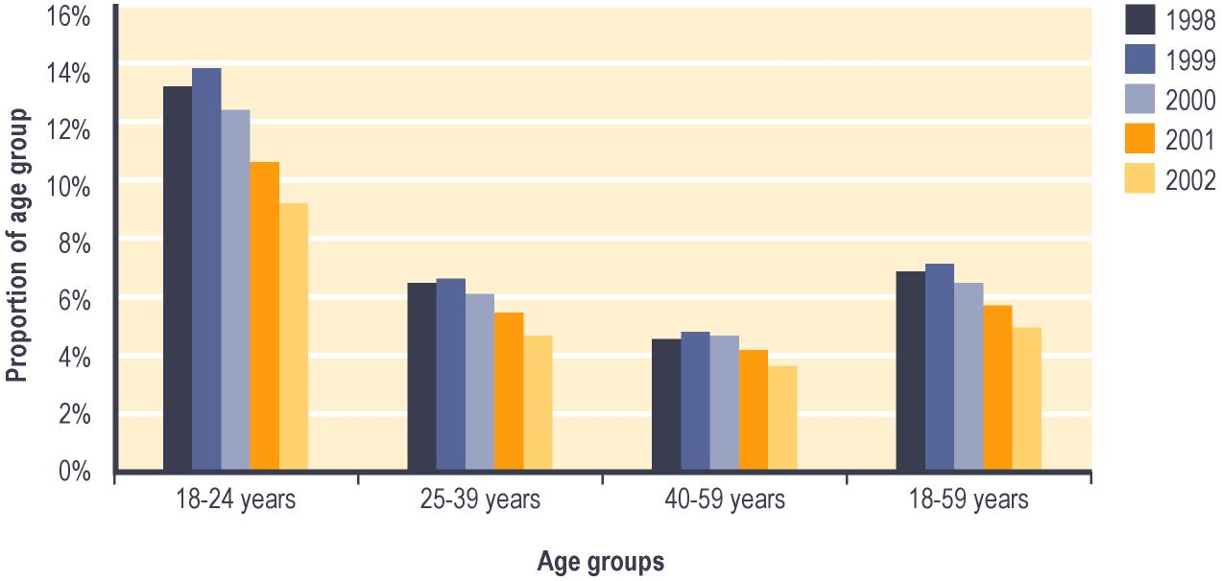

Notes:

1 Proportion shows:

a Number in age group who are recorded in SWIFTT as receiving an Unemployment Benefit at 30 June; divided by

b Statistics New Zealand estimate of population in age group at 30 June.

Trends in the proportion of 16-17 year olds receiving Independent Youth Benefit
Since 1998, about 3% of 16-17 year olds have been receiving an Independent Youth Benefit (see Figure 3.2).

Figure 3.2 – Trends in the proportion¹ of 16-17 year olds receiving an Independent Youth Benefit
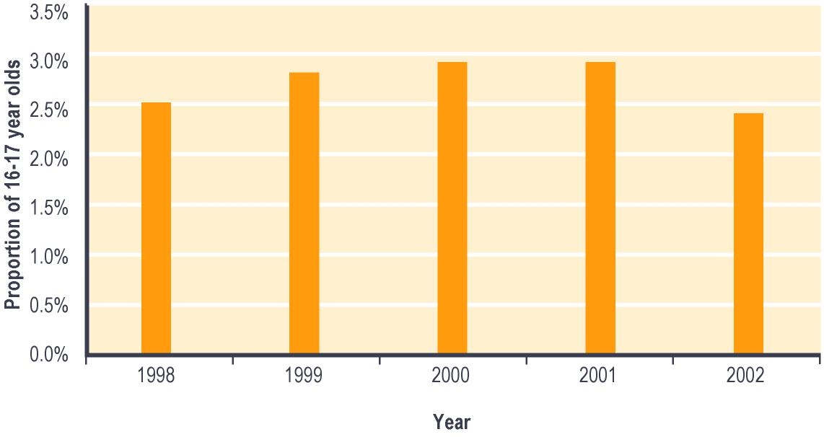

Notes:

1 Proportion shows:

a Number of 16-17 year olds recorded in SWIFTT as receiving an Independent Youth Benefit at 30 June; divided by

b Statistics New Zealand estimate of 16-17 year olds at 30 June.

Trends in Unemployment Benefits granted
The number of Unemployment Benefits granted each year has fallen since 1997/1998. Since 1997/1998, between 31% and 39% of the Unemployment Benefits granted each year have been provided to people who received a core benefit within the previous 12 months. Over the same period, between 23% and 29% of the Unemployment Benefits granted each year were provided to people who had not received a core benefit within the previous four years (see Table 3.2).

There were also larger number of administrative transfers between core benefits between 1997/1998 and 1998/1999 than in subsequent years (see Table 3.2). This reflects transfers between benefits which resulted from the changes implemented in 1998 to the eligibility criteria for Unemployment Benefits – Training and for Independent Youth Benefits.

Table 3.2 – Trends in period since clients granted an Unemployment Benefit last received any core benefit
Period since client last received any core benefit | Unemployment Benefits granted^{1,2}
 | 1997/  1998 | 1998/  1999 | 1999/  2000 | 2000/  2001 | 2001/  2002
 | Number | Number | Number | Number | Number
None (administrative transfer of clients who continue receiving some core benefit) | 81,097 | 92,766 | 44,526 | 40,773 | 37,452
Under 6 months | 45,375 | 42,422 | 39,094 | 38,979 | 37,576
6-12 months | 44,785 | 39,588 | 36,535 | 37,873 | 35,911
12-18 months | 10,619 | 10,460 | 9,107 | 8,979 | 8,629
18 months - 2 years | 8,951 | 7,787 | 9,229 | 6,977 | 7,025
2-4 years | 16,362 | 13,856 | 13,096 | 12,666 | 11,926
Not received a core benefit | 69,990 | 60,646 | 60,982 | 57,211 | 51,798
Total | 277,179 | 267,525 | 212,569 | 203,458 | 190,317

Notes:

1 Numbers of applications for an Unemployment Benefit resulted as successful in SWIFTT during years ended 30 June.

2 Includes Unemployment Benefit, Unemployment Benefit – Hardship, Unemployment Benefit – Hardship – Student, Unemployment Benefit – Training, Unemployment Benefit – Hardship – Training, Emergency Benefit and Independent Youth Benefit.

The number of Unemployment Benefits granted each year was significantly higher in 1997/1998 and in 1998/1999 than in later years. Significant numbers of Unemployment Benefits – Hardship – Students have been granted each year. The numbers of such grants did, however, decrease significantly between 1997/1998 and 1998/1999 (see Table 3.3). The higher numbers of Unemployment Benefits granted in 1997/1998 and in 1998/1999 reflect the benefits granted when clients were transferred between benefits following the changes implemented between 1996 and 1998 to eligibility criteria of these benefits. The decreased numbers of Unemployment Benefits – Hardship – Student granted in the last four years reflect at least in part a policy change effective from 1 July 1998 which restricted student access to the Unemployment Benefit – Hardship – Student.

Table 3.3 – Trends in Unemployment Benefits granted
Unemployment Benefits granted | Unemployment Benefits granted¹
 | 1997/1998 | 1998/1999 | 1999/2000 | 2000/2001 | 2001/2002
 | Number | Number | Number | Number | Number
Unemployment Benefit | 195,824 | 212,475 | 159,776 | 150,282 | 143,327
Unemployment Benefit – Training | 27,732 | 17,514 | 13,148 | 12,097 | 10,290
Unemployment Benefit – Hardship | 0 | 3,178 | 3,635 | 3,030 | 2,688
Unemployment Benefit – Hardship – Training | 0 | 88 | 300 | 308 | 270
Unemployment Benefit – Hardship – Student | 37,049 | 22,164 | 24,904 | 25,136 | 22,994
Independent Youth Benefit | 5,670 | 4,696 | 4,872 | 5,195 | 4,717
Emergency Benefit | 10,904 | 7,410 | 5,934 | 7,410 | 6,031
Total | 277,179 | 267,525 | 212,569 | 203,458 | 190,317

Notes:

1 Numbers of applications for an Unemployment Benefit resulted as successful in SWIFTT during years ended 30 June.

Trends in cessations of Unemployment Benefits
The annual number of cessations of Unemployment Benefits each year has decreased since 1997/1998 (see Table 3.4). The proportion of Unemployment Benefit cessations each year which reflect clients entering paid work increased from 33% to 41% between 1998/1999 and 1999/2000, and has remained relatively stable since, while the proportion reflecting clients transferring to another core benefit showed a corresponding decrease from 31% to 21%. This change reflects in part a combination of changing economic conditions and an increased emphasis on placing job seekers into paid work.

Table 3.4 – Trends in cessations of Unemployment Benefits
Reason for cessations of Unemployment Benefits | Unemployment Benefits ceased^{1,2}
 | 1997/  1998 | 1998/  1999 | 1999/  2000 | 2000/  2001 | 2001/  2002
 | Number | Number | Number | Number | Number
Obtained paid work | 89,112 | 87,766 | 94,417 | 91,604 | 88,207
Transferred to another benefit | 84,881 | 94,870 | 47,781 | 46,382 | 44,517
Other | 101,573 | 85,770 | 87,053 | 87,419 | 79,358
Total | 275,566 | 268,406 | 229,251 | 225,405 | 212,082

Notes:

1 Numbers of cessations of Unemployment Benefits actioned in SWIFTT during years ended 30 June.

2 Includes Unemployment Benefit, Unemployment Benefit – Hardship, Unemployment Benefit – Hardship – Student, Unemployment Benefit – Training, Unemployment Benefit –

Expenditure on Unemployment Benefits
Annual expenditure on Unemployment Benefits has shown a cyclical pattern, with the peaks of the cycle reaching higher levels between 1996/1997 and 2001/2002 than between 1991/1992 and 1995/1996 (see Table 3.5).

Expenditure on Unemployment Benefits tends to change in line with the growth of the economy. Decreased expenditure over the last three years reflects more favourable economic conditions and a consequent decrease in the number of people receiving an Unemployment Benefit.

Table 3.5 – Annual expenditure on Unemployment Benefits
Year ended 30 June | Expenditure on Unemployment Benefits^{1,2,3} ($ million)
1991/1992 | 1,491
1992/1993 | 1,594
1993/1994 | 1,581
1994/1995 | 1,462
1995/1996 | 1,430
1996/1997 | 1,517
1997/1998 | 1,652
1998/1999 | 1,766
1999/2000 | 1,766
2000/2001 | 1,662
2001/2002 | 1,544

Notes:

1 Expenditure on Unemployment Benefits in years ended 30 June.

2 Includes expenditure on Unemployment Benefits, Unemployment Benefits – Hardship, Unemployment Benefits – Hardship – Student, Unemployment Benefits – Training, Unemployment Benefits – Hardship – Training, Emergency Benefits and Independent Youth Benefits.

3 Expenditure shown is net of taxation and includes expenditure on supplementary benefits provided to recipients of Unemployment Benefits.

Monthly expenditure on Unemployment Benefits (shown in Figure 3.3) shows strong seasonal increases over the summer months, which reflects the increase in tertiary students registered as job seekers over the summer vacation. The weaker seasonal increases in monthly expenditure during winter reflects the influx of workers with seasonal jobs (particularly in the agricultural/horticultural and primary processing sectors) registering as job seekers during the off-season.

Figure 3.3 – Trends in monthly expenditure on Unemployment Benefits^{1,2,3}

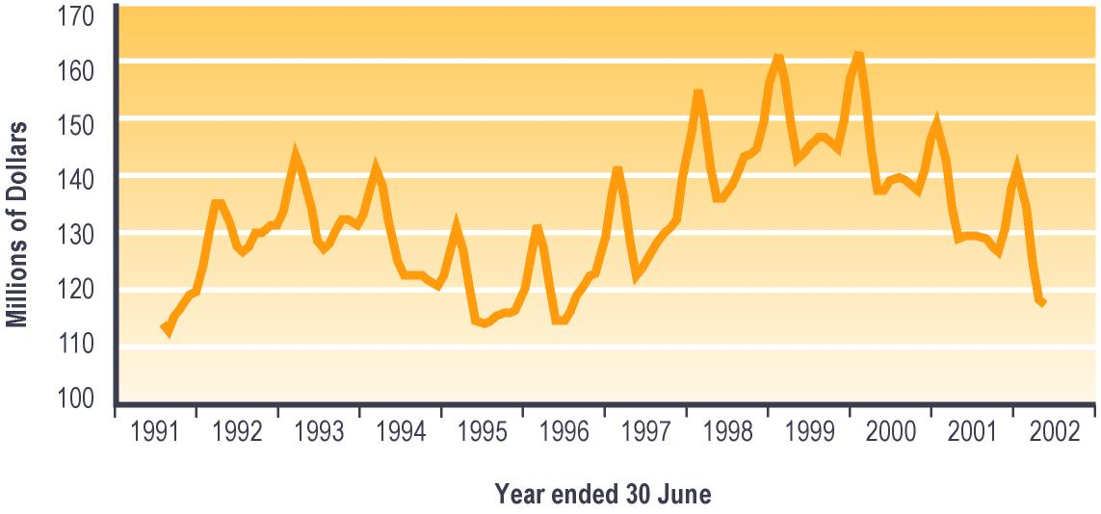

Notes:

1 Includes Unemployment Benefit, Unemployment Benefit – Hardship, Unemployment Benefit – Hardship – Student, Unemployment Benefit – Training, Unemployment Benefit – Hardship – Training, Emergency Benefit and Independent Youth Benefit.

2 Monthly expenditure on Unemployment Benefits and on supplementary benefits paid to Unemployment Benefit recipients.

3 Expenditure shown is net of taxation, adjusted for the number of payments in the month, and smoothed using a three-month moving average.

Table 7.2 (see Section 7) shows trends since 1940 in expenditure on Unemployment Benefits. Please note that core benefit expenditure data in Table 7.2 includes expenditure on supplementary benefits paid to people receiving each core benefit.

Domestic Purposes Benefit
This group of core benefits includes Domestic Purposes Benefits – Sole Parent, Domestic Purposes Benefits – Caring for Sick and Infirm, Domestic Purposes Benefits – Woman Alone, and Emergency Maintenance Allowances.

From November 1996, clients could choose to transfer from fortnightly to weekly payments of the Domestic Purposes Benefit. A large number of clients took up this offer in 1995/1996, followed by a slowing in later years of this movement from fortnightly to weekly payments.

From 1 April 1997, clients receiving a Domestic Purposes Benefit have been subject to a full-time work test if their youngest dependent child was aged 14 years or over, or if they had no dependent children. From 1 February 1999, clients receiving a Domestic Purposes Benefit have been subject to:
- a part-time work test if their youngest dependent child was aged between six and 13 years
- a requirement to attend an annual interview with a Work and Income case manager if their youngest dependent child was aged under six years. The purpose of this interview is to plan how they would enter paid work once their youngest dependent child has reached six years of age.

Types of Domestic Purposes Benefit

Domestic Purposes Benefit – Sole Parent
A Domestic Purposes Benefit – Sole Parent is payable to a single person who:
- is the parent of a dependent child aged under 18 years who lives with them
- is not living with the other parent or with another partner.

To be eligible for a Domestic Purposes Benefit – Sole Parent, clients must also be aged 18 years or over, or be aged 16-17 years and have been legally married. Residency and income qualifications must also be met.

Domestic Purposes Benefit – Caring for the Sick or Infirm
A Domestic Purposes Benefit – Caring for the Sick or Infirm is available to people who are aged over 16 years and caring on a full-time basis for someone (other than a partner) who would otherwise be in hospital.

Residency and income qualifications must also be met.

Domestic Purposes Benefit – Woman Alone
A Domestic Purposes Benefit – Woman Alone is available to unsupported women without dependent children who became alone or lost the support of a partner after turning 50 years of age and after:
- caring for dependent children for at least 15 years or
- caring full-time for a sick or frail relative for at least five years or
- being supported by their partner for at least five years.

Residency and income qualifications must also be met.

Emergency Maintenance Allowance
An Emergency Maintenance Allowance is available to people who do not meet the eligibility criteria for Domestic Purposes Benefit – Sole Parents but are alone, caring for children and unable to support themselves without financial assistance. In some circumstances, an Allowance can also be paid to clients who are experiencing domestic violence but who are still living with their partner or spouse.

Trends in numbers receiving a Domestic Purposes Benefit
The total number of people receiving a Domestic Purposes Benefit declined between 1998 and 2001, then rose slightly in 2002. The number of people receiving a Domestic Purposes Benefit – Caring for the Sick or Infirm has shown a steady increase since 1998. Since 1998, however, between 93% and 95% of Domestic Purposes Benefits being paid have been Domestic Purposes Benefits – Sole Parents (see Table 3.6).

Table 3.6 – Trends in the number of people receiving a Domestic Purposes Benefit
Domestic Purposes Benefit received at 30 June | Clients receiving a Domestic Purposes Benefit¹
 | 1998 | 1999 | 2000 | 2001 | 2002
 | Number | Number | Number | Number | Number
Domestic Purposes Benefit  – Sole Parent | 106,881 | 102,888 | 102,094 | 100,663 | 100,665
Domestic Purposes Benefit  – Caring for Sick or Infirm | 1,925 | 2,172 | 2,399 | 2,717 | 2,936
Domestic Purposes Benefit  – Woman Alone | 2,945 | 2,829 | 2,796 | 2,799 | 2,869
Emergency Maintenance Allowance | 1,578 | 1,627 | 1,650 | 1,642 | 1,539
Total | 113,329 | 109,516 | 108,939 | 107,821 | 108,009

Notes:

1 Numbers recorded in SWIFTT as receiving a Domestic Purposes Benefit at 30 June.

Table 7.1 (see Section 7) shows trends since 1973 in the number of people receiving a Domestic Purposes Benefit.

Proportion of 18-59 year olds receiving a Domestic Purposes Benefit
Since 1998:
- between 4% and 5% of people aged 18-59 years have been receiving a Domestic Purposes Benefit – Sole Parent. A higher proportion of 25-39 year olds than of other age groups have received this benefit, while a lower proportion of people aged between 40-59 years have done so (see Figure 3.4)
- very few people (about 0.1%) aged 18-59 years have been receiving a Domestic Purposes Benefit – Caring for the Sick and Infirm or an Emergency Maintenance Allowance
- a very small number (under 0.5%) of women aged 40-59 years have been receiving a Domestic Purposes Benefit – Woman Alone.

Figure 3.4 – Trends in the proportion¹ of 18-59 year olds receiving a Domestic Purposes Benefit – Sole Parent, by age

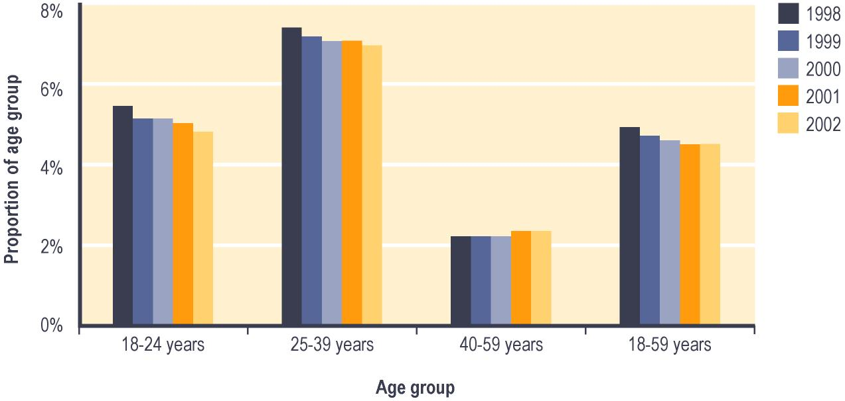

Notes:

1 Proportion shows:

a Number of people in age group recorded in SWIFTT as receiving a Domestic Purposes Benefit – Sole Parent at 30 June; divided by

b Statistics New Zealand estimate of the population in age group at 30 June.

Trends in Domestic Purposes Benefits granted
Since 1997/1998, the number of Domestic Purposes Benefits granted each year has decreased (see Table 3.7).

The proportion of Domestic Purposes Benefits granted each year that were provided to people who had received a core benefit within the previous 12 months increased from 22% to 27% between 1997/1998 and 1998/1999, and has remained relatively stable since. The proportion of Domestic Purposes Benefits granted which reflected administrative transfers showed a corresponding fall from 44% to 38% (see Table 3.7). The decreased use of administrative transfers reflects in large part a slowing of the number of people choosing to transfer from fortnightly to weekly benefit payments.

Table 3.7 – Trends in period since clients granted a Domestic Purposes Benefit last received any core benefit
Period since client last received any core benefit | Domestic Purposes Benefits granted^{1,2}
 | 1997/  1998 | 1998/  1999 | 1999/  2000 | 2000/  2001 | 2001/  2002
 | Number | Number | Number | Number | Number
None (administrative transfers of people who continued to received some core benefit) | 18,737 | 14,876 | 13,558 | 12,644 | 12,157
Under 6 months | 6,243 | 7,101 | 6,834 | 6,979 | 6,873
6-12 months | 3,243 | 3,666 | 3,706 | 3,782 | 3,715
12-18 months | 1,879 | 1,957 | 2,130 | 2,056 | 2,043
18 months - 2 years | 1,360 | 1,231 | 1,512 | 1,563 | 1,471
2-4 years | 3,024 | 2,876 | 3,005 | 3,266 | 3,171
Not received a core benefit in previous four years | 8,461 | 7,971 | 8,355 | 8,645 | 8,071
Total | 42,947 | 39,678 | 39,100 | 38,935 | 37,501

Notes:

1 Numbers of applications for a Domestic Purposes Benefit resulted as successful in SWIFTT during years ended 30 June.

2 Includes Domestic Purposes Benefit – Sole Parent, Domestic Purposes Benefit – Caring for the Sick and Infirm, Domestic Purposes Benefit – Woman Alone, and Emergency Maintenance Allowance.

Trends in cessations of Domestic Purposes Benefits
The number of cessations of Domestic Purposes Benefits has decreased every year since 1997/1998 (see Table 3.8).

Since 1997/1998, around 49% of Domestic Purposes Benefit cessations each year have reflected factors other than clients obtaining paid work or administrative transfers (see Table 3.8), with the most common of these other reasons being a change in marital status (usually from people receiving a Domestic Purposes Benefit – Sole Parent entering another relationship).

Over this period, the proportion of Domestic Purposes Benefit cessations each year that resulted from clients entering paid work has increased from 19% to 29%, while the proportion resulting from clients transferring to another core benefit decreased from 32% to 22% (see Table 3.8). This is likely to reflect a combination of operational changes (increased case management of clients receiving a Domestic Purposes Benefit once they are work tested, and increased Work and Income emphasis on placing job seekers into employment), improved economic conditions, and the impact of abatement and tax changes implemented since 1996.

Table 3.8 – Trends in cessations of Domestic Purposes Benefits
Reasons for cessations of Domestic Purposes Benefits | Domestic Purposes Benefits ceased^{1,2}
 | 1997/1998 | 1998/1999 | 1999/2000 | 2000/2001 | 2001/2002
 | Number | Number | Number | Number | Number
Obtained paid work | 8,118 | 9,662 | 10,783 | 11,077 | 11,069
Transferred to another benefit | 13,541 | 11,095 | 9,705 | 9,014 | 8,435
Other | 21,248 | 20,651 | 19,846 | 19,336 | 18,349
Total | 42,907 | 41,408 | 40,334 | 39,427 | 37,853

Notes:

1 Numbers of cessations of Domestic Purposes Benefits actioned in SWIFTT during years ended 30 June.

2 Includes Domestic Purposes Benefit – Sole Parent, Domestic Purposes Benefit – Caring for the Sick and Infirm, Domestic Purposes Benefit – Woman Alone, and Emergency Maintenance Allowance.

Expenditure on Domestic Purposes Benefits
Annual expenditure on Domestic Purposes Benefits increased between 1991/1992 and 1997/1998 then decreased between 1998/1999 and 2000/2001, but increased again in 2001/2002 (see Table 3.9). This pattern reflects changes in the numbers of people receiving a Domestic Purposes Benefit.

Table 3.9 – Annual expenditure on Domestic Purposes Benefits
Year ended 30 June | Expenditure on Domestic  Purposes Benefits^{1,2,3} ($ million)
1991/1992 | 1,104
1992/1993 | 1,147
1993/1994 | 1,208
1994/1995 | 1,337
1995/1996 | 1,493
1996/1997 | 1,608
1997/1998 | 1,706
1998/1999 | 1,682
1999/2000 | 1,652
2000/2001 | 1,637
2001/2002 | 1,650

Notes:

1 Expenditure on Domestic Purposes Benefits in years ended 30 June.

2 Expenditure shown is net of taxation, and includes expenditure on supplementary benefits provided to recipients of Domestic Purposes Benefits.

3 Includes Domestic Purposes Benefit – Sole Parent, Domestic Purposes Benefit – Caring for the Sick and Infirm, Domestic Purposes Benefit – Woman Alone, and Emergency Maintenance Allowance.

Monthly expenditure on Domestic Purposes Benefits shows a small seasonal peak in the latter part of each fiscal year (see Figure 3.5). This peak results in part from Training Incentive Allowance and benefit advances which are made at the start of the school/academic year to people receiving a Domestic Purposes Benefit.

Figure 3.5 – Trends in monthly expenditure on Domestic Purposes Benefits^{1,2,3}

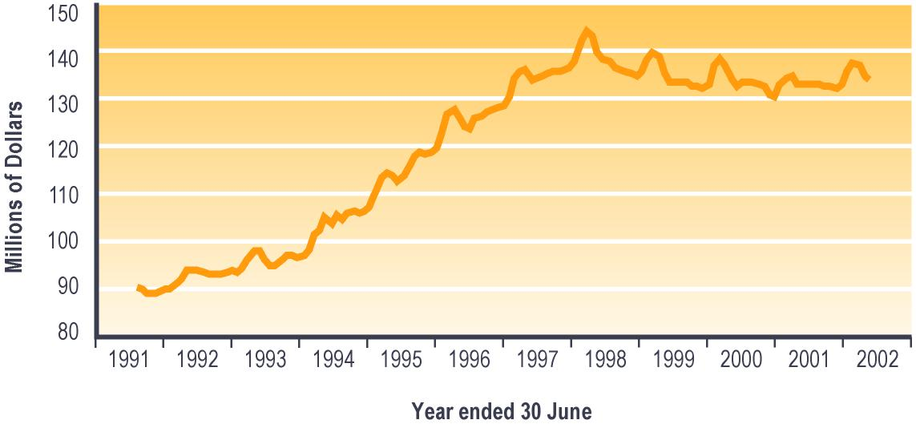

Notes:

1 Includes Domestic Purposes Benefit – Sole Parent, Domestic Purposes Benefit – Caring for the Sick and Infirm, Domestic Purposes Benefit – Woman Alone, and Emergency Maintenance Allowance.

2 Monthly expenditure on Domestic Purposes Benefits and on supplementary benefits paid to Domestic Purposes Benefit recipients.

3 Expenditure shown is net of taxation, adjusted for the number of payments in the month, and smoothed using a three-month moving average.

Table 7.2 (see Section 7) shows trends since 1973 in expenditure on Domestic Purposes Benefits. Please note that core benefit expenditure data in Table 7.2 includes expenditure on supplementary benefits paid to people receiving each core benefit.

Sickness Benefit
Core benefits in this group consist of Sickness Benefits and Sickness Benefits – Hardship.

Sickness Benefits were known as Community Wage – Sickness between 1 October 1998 and 30 June 2001, before reverting to their former name on 1 July 2001. Sickness Benefits – Hardship were known as Emergency Sickness Benefits prior to 1 October 1998, and as Community Wage – Emergency Sickness between 1 October 1998 and 30 June 2001.

From 1 October 1998, the spouses or partners of clients receiving a Sickness Benefit have been eligible to be work tested. If the couple have no dependent children, or their youngest dependent child is aged 14 years or over, the partner or spouse is subject to a full-time work test. If the couple’s youngest dependent child is aged between six and 13 years, the partner or spouse is subject to a part-time work test.

From 1 July 1998, the payment rate of Sickness Benefit has been aligned with the (lower) rate for Unemployment Benefits. People receiving a Sickness Benefit since before 1 July 1998 have continued to receive the old (higher) rate of Sickness Benefit which was paid immediately prior to 1 July 1998.

Types of Sickness Benefit

Sickness Benefit
From 1 October 1998, a Sickness Benefit has been payable to people who are aged 18 or over (or aged 16 or over and living with a partner and dependent child) and:
- are temporarily unable to work full-time through illness, injury or being at least 26 weeks pregnant or
- are in employment but losing earnings through sickness or injury.

Income and residency tests apply.

Prior to 1 October 1998, a Sickness Benefit was payable to persons 18 years or over (16 years or over until 1 January 1998) who were temporarily incapacitated for work and had suffered a loss of earnings.

Sickness Benefit – Hardship
People who do not meet the above criteria but who are temporarily unable to support themselves because of illness or injury (eg people who do not meet residency requirements) may be granted a Sickness Benefit – Hardship. Women aged 16-17 years who are unable to support themselves because of pregnancy may also be eligible for a Sickness Benefit – Hardship.

Applicants prior to 1 October 1998 who did not meet all eligibility requirements may have been granted an Emergency Sickness Benefit because of hardship.

Trends in numbers receiving a Sickness Benefit
The number of people receiving a Sickness Benefit decreased between 1998 and 2000, but has risen over the last two years. Since 1998, Sickness Benefits – Hardship have accounted for between 3% and 5% of the Sickness Benefits being paid (see Table 3.10).

Table 3.10 – Trends in numbers receiving a Sickness Benefit
Sickness Benefit received  at 30 June | Clients receiving a Sickness Benefit¹
 | 1998 | 1999 | 2000 | 2001 | 2002
 | Number | Number | Number | Number | Number
Sickness Benefit | 33,477 | 31,490 | 31,076 | 32,497 | 35,259
Sickness Benefit – Hardship | 1,814 | 1,532 | 1,218 | 1,123 | 1,121
Total | 35,291 | 33,022 | 32,294 | 33,620 | 36,380

Notes:

1 Numbers recorded in SWIFTT as receiving a Sickness Benefit at 30 June.

Table 7.1 (see Section 7) shows trends since 1940 in the number of people receiving a Sickness Benefit.

Trends in the proportion of 18-59 year olds receiving a Sickness Benefit
Since 1998, around 2% of people aged 18-59 years have been receiving a Sickness Benefit. Since 1999, a slightly higher proportion of people aged 40-59 years than of younger people have been receiving a Sickness Benefit.

Trends in Sickness Benefits granted
The number of Sickness Benefits granted each year decreased between 1997/1998 and 1998/1999, but has risen for the last three years. Over this period, between 37% and 41% of Sickness Benefits granted each year were provided to clients who had transferred from another core benefit. Over the same period, between 21% and 24% of Sickness Benefits granted were provided to clients who had received a core benefit in the previous 12 months, and between 24% and 27% were provided to people who had not received a core benefit in the previous four years (see Table 3.11).

Table 3.11 – Trends in period since clients granted a Sickness Benefit received any core benefit
Period since client last received any core benefit | Sickness Benefits granted^{1,2}
 | 1997/  1998 | 1998/  1999 | 1999/  2000 | 2000/  2001 | 2001/  2002
 | Number | Number | Number | Number | Number
None (administrative transfers of clients who continued to receive some core benefit) | 17,443 | 13,413 | 13,943 | 14,443 | 15,589
Under 6 months | 5,943 | 4,911 | 4,910 | 5,493 | 6,331
6-12 months | 3,102 | 2,740 | 2,795 | 3,277 | 3,573
12-18 months | 1,735 | 1,389 | 1,577 | 1,702 | 1,872
18 months - 2 years | 1,344 | 1,106 | 1,201 | 1,185 | 1,419
2-4 years | 3,086 | 2,526 | 2,511 | 2,677 | 2,858
Not received a core benefit in previous four years | 10,013 | 8,843 | 9,723 | 9,805 | 10,212
Total | 42,666 | 34,928 | 36,660 | 38,582 | 41,854

Notes:

1 Numbers of applications for a Sickness Benefit resulted as successful in SWIFTT during years ended 30 June.

2 Includes Sickness Benefit and Sickness Benefit – Hardship.

Sickness Benefits – Hardship have accounted for 5% or less of all Sickness Benefits granted in each year since 1997/1998.

Trends in cessations of Sickness Benefits
The annual number of cessations of Sickness Benefits decreased between 1997/1998 and 1998/1999, remained largely stable between 1998/1999 and 2000/2001, but increased over the last year. The proportion of Sickness Benefit cessations each year which involved clients transferring to another core benefit decreased from 58% to 53% between 1997/1998 and 2001/2002 (see Table 3.12).

Table 3.12 – Trends in reasons for cessations of Sickness Benefits
Reasons for cessation of Sickness Benefits | Sickness Benefits ceased^{1,2}
 | 1997/1998 | 1998/1999 | 1999/2000 | 2000/2001 | 2001/2002
 | Number | Number | Number | Number | Number
Obtained paid work | 4,805 | 4,333 | 4,625 | 4,946 | 5,262
Transferred to another core benefit | 25,369 | 21,745 | 21,642 | 20,693 | 21,203
Other | 13,836 | 12,793 | 12,549 | 12,709 | 13,678
Total | 44,010 | 38,871 | 38,816 | 38,348 | 40,143

Notes:

1 Numbers of cessations of Sickness Benefits actioned in SWIFTT during years ended 30 June.

2 Includes Sickness Benefit and Sickness Benefit – Hardship.

Expenditure on Sickness Benefits
Annual expenditure on Sickness Benefits increased between 1991/1992 and 1997/1998 and decreased between 1998/1999 and 2000/2001, then increased in 2001/2002 (See Table 3.13). Annual expenditure on Sickness Benefits is driven largely by the numbers of Sickness Benefit recipients.

Table 3.13 – Annual expenditure on Sickness Benefits
Year ended 30 June | Expenditure on Sickness Benefits^{1,2,3} ($ million)
1991/1992 | 234
1992/1993 | 273
1993/1994 | 323
1994/1995 | 361
1995/1996 | 394
1996/1997 | 419
1997/1998 | 452
1998/1999 | 429
1999/2000 | 405
2000/2001 | 404
2001/2002 | 432

Notes:

1 Expenditure on Sickness Benefits in years ended 30 June.

2 Includes Sickness Benefit and Sickness Benefit – Hardship.

3 Expenditure shown is net of taxation, and includes expenditure on supplementary benefits provided to recipients of Sickness Benefits.

Monthly Sickness Benefit expenditure shows little seasonal variation, and largely follows trends in the numbers of people receiving a Sickness Benefit (see Figure 3.6).

Figure 3.6 – Trends in monthly expenditure on Sickness Benefits^{1,2,3}

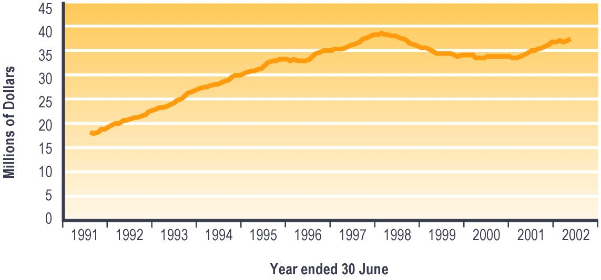

Notes:

1 Includes Sickness Benefit and Sickness Benefit – Hardship.

2 Monthly expenditure on Sickness Benefits and on supplementary benefits paid to Sickness Benefit recipients.

3 Expenditure shown is net of taxation, adjusted for the number of payments in the month, and smoothed using a three-month moving average.

Table 7.2 (see Section 7) shows trends since 1940 in expenditure on Sickness Benefits. Please note that core benefit expenditure data shown in Table 7.2 includes expenditure on supplementary benefits paid to people receiving each core benefit.

Invalid’s Benefit
The Invalid’s Benefit is payable to people who are 16 years or over and are:
- permanently and severely restricted in their capacity for work because of sickness, injury or disability or
- totally blind.

A “permanent and severe” restriction is defined in the Social Security Act 1964 as one which:
- is expected to last at least two years
- means the client cannot regularly work more than 15 hours per week in open employment.

People with a permanent and specified level of restriction of their sight are also eligible to receive an Invalid’s Benefit.

A residential qualification and income test must be met in order to receive an Invalid’s Benefit.

From 1 October 1998, the partners and spouses of people receiving an Invalid’s Benefit have been eligible to be work tested. If the couple have no dependent children, or if their youngest child is aged 14 years or over, the spouse or partner is subject to a full-time work test. If the couple’s youngest dependent child is aged between six and 13 years, the partner or spouse is subject to a part-time work test.

Trends in numbers receiving an Invalid’s Benefit
Since 1998, the number of people receiving an Invalid’s Benefit has increased steadily (see Table 3.14).

Table 3.14 – Trends in numbers receiving an Invalid’s Benefit
Invalid’s Benefit received at 30 June | Clients receiving an Invalid’s Benefit¹
 | 1998 | 1999 | 2000 | 2001 | 2002
 | Number | Number | Number | Number | Number
Total | 49,468 | 51,173 | 55,392 | 59,812 | 64,529

Notes:

1 Numbers recorded in SWIFTT as receiving an Invalid’s Benefit at 30 June.

Since 1998, the proportion of people receiving an Invalid’s Benefit who were aged 60 years or over increased from 11% to 16%, while the proportion aged 25-39 years decreased from 30% to 25%. This reflects at least in part the trend noted earlier toward people receiving all core benefits becoming older.

Table 7.1 (see Section 7) shows trends since 1940 in the number of people receiving an Invalid’s Benefit.

Proportion of 18-59 year olds receiving an Invalid’s Benefit
Since 1998, around 2% of people aged 18-59 years have been receiving an Invalid’s Benefit. Over this period, a larger proportion of 40-59 year olds than of younger people have been receiving an Invalid’s Benefit. The proportion of 18-59 year olds receiving an Invalid’s Benefit increased slightly over the same period, with this increase apparent in all age groups.

Trends in Invalid’s Benefits granted
The number of Invalid’s Benefits granted each year decreased between 1997/1998 and 1998/1999, but has increased over the last three years. Since 1997/1998, between 70% and 75% of Invalid’s Benefits granted each year have reflected administrative transfers between core benefits. Over this period, between 16% and 18% of Invalids Benefits granted were provided to clients who had not received a core benefit in the previous four years (see Table 3.15).

Table 3.15 – Trends in period since clients granted an Invalid’s Benefit last received any core benefits
Period since recipient had last received any core benefit | Invalid’s Benefits granted¹
 | 1997/  1998 | 1998/  1999 | 1999/  2000 | 2000/  2001 | 2001/  2002
 | Number | Number | Number | Number | Number
None (administrative transfer of client who continued to receive some core benefit) | 7,035 | 5,910 | 7,312 | 7,036 | 7,919
Under 6 months | 387 | 409 | 454 | 577 | 649
6-12 months | 159 | 149 | 197 | 233 | 237
12-18 months | 60 | 83 | 94 | 117 | 128
18 months - 2 years | 64 | 60 | 68 | 80 | 97
2-4 years | 165 | 108 | 154 | 169 | 218
Not received a core benefit in previous four years | 1,463 | 1,459 | 1,753 | 1,902 | 2,002
Total | 9,333 | 8,178 | 10,032 | 10,114 | 11,250

Notes:

1 Numbers of applications for an Invalid’s Benefit resulted as successful in SWIFTT during years ended 30 June.

Trends in cessations of Invalid’s Benefits
The annual number of cessations of Invalid’s Benefits fluctuated between 1997/1998 and 2000/2001, then increased over the last year (see Table 3.16).

Table 3.16 – Trends in reasons for cessations of Invalid’s Benefits
Invalid’s Benefits ceased | Invalid’s Benefits ceased¹
 | 1997/1998 | 1998/1999 | 1999/2000 | 2000/2001 | 2001/2002
 | Number | Number | Number | Number | Number
Total | 7,069 | 7,492 | 7,150 | 6,870 | 7,723

Notes:

1 Numbers of cessations of Invalid’s Benefit actioned in SWIFTT in years ended 30 June.

Expenditure on Invalid’s Benefits
Since the 1991/1992 financial year, annual expenditure on Invalid’s Benefits has increased each year (see Table 3.17). In general, annual expenditure on Invalid’s Benefits is related to the number of people receiving an Invalid’s Benefit.

Table 3.17 – Annual expenditure on Invalid’s Benefits
Year ended 30 June | Expenditure on Invalid’s Benefits^{1,2} ($ million)
1991/1992 | 329
1992/1993 | 365
1993/1994 | 414
1994/1995 | 465
1995/1996 | 501
1996/1997 | 556
1997/1998 | 624
1998/1999 | 661
1999/2000 | 703
2000/2001 | 764
2001/2002 | 846

Notes:

1 Expenditure on Invalid’s Benefits in years ended 30 June.

2 Expenditure shown is net of taxation, and includes expenditure on supplementary benefits provided to recipients of Invalid’s Benefits.

Monthly expenditure on Invalid’s Benefits reflects the steadily increasing numbers receiving Invalid’s Benefit with little seasonal change evident (see Figure 3.7). In addition, there was a slight dip in 1995, which corresponded with the transfer of maximised benefit payments to Vote: Health and which may also have been associated with the announcement of the review of the Sickness and Invalid’s Benefits which started later that year. Another slight dip in expenditure on Invalid’s Benefits in 2001 occurred because of a fall in expenditure on Accommodation Supplement received by Invalid’s Benefit recipients following the re-introduction of income-related rents. This permanent fall in Accommodation Supplement expenditure was offset by continued growth in expenditure on Invalid’s Benefits (excluding supplementary benefits).

Figure 3.7 – Trends in monthly expenditure on Invalid’s Benefits^{1,2}

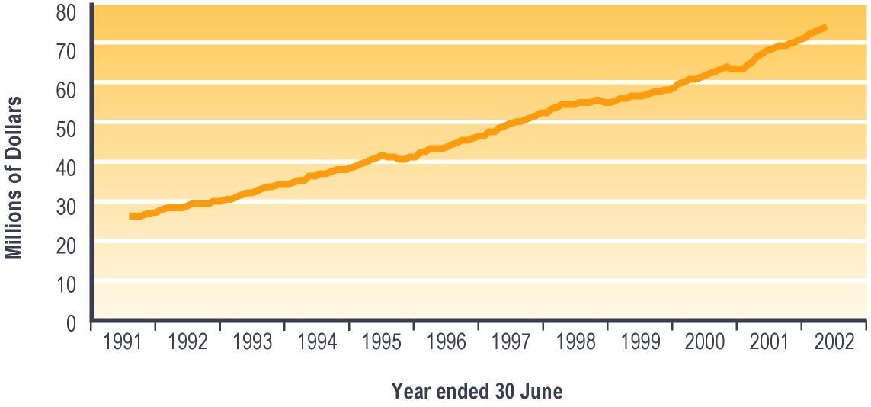

Notes:

1 Monthly expenditure on Invalid’s Benefits and on supplementary benefits paid to Invalid’s Benefit recipients.

2 Expenditure shown is net of taxation, adjusted for the number of payments in the month, and smoothed using a three-month moving average.
Table 7.2 (see Section 7) shows trends since 1940 in expenditure on Invalid’s Benefits. Please note that core benefit expenditure data shown in Table 7.2 includes expenditure on supplementary benefits paid to people receiving each core benefit.

Unsupported Child’s Benefit and Orphan’s Benefit
An Unsupported Child’s Benefit or an Orphan’s Benefit are available to people caring for dependent children who are unable to live with or be supported by their parents.

These benefits are income tested in relation to any income the child receives apart from personal earnings, but are not work tested.

Eligibility for Orphan’s Benefit and for Unsupported Child’s Benefit

Unsupported Child’s Benefit
An Unsupported Child’s Benefit is payable to the principal caregiver of a child whose natural, adoptive, or step parents are, because of a family breakdown, unable to:
- care for the child or
- provide for the child’s support.

Residency tests apply, and the child must be expected to be in the care of the client for at least 12 months.

Orphan’s Benefit
An Orphan’s Benefit is payable to the principal caregiver of a child whose natural or adoptive parents cannot support the child because they:
- are deceased or
- suffer from serious long-term illness or incapacity which means they cannot care for the child or
- cannot be found.

Residency tests apply, and the child must be expected to be in the care of the client for at least 12 months.

Trends in numbers receiving an Unsupported Child’s Benefit or an Orphan’s Benefit
Since 1998, the number of people receiving an Unsupported Child’s Benefit or an Orphan’s Benefit has increased (see Table 3.18). This reflects the increasing numbers of people granted an Unsupported Child’s Benefit or Orphan’s Benefit each year combined with a comparatively stable number of cessations each year. Over this period, Unsupported Child’s Benefits accounted for between 92% and 94% of the core benefits in this group being paid.

Table 3.18 – Trends in the numbers of people receiving an Unsupported Child’s Benefit or an Orphan’s Benefit
Unsupported Child’s Benefits and Orphan’s Benefits received at 30 June | Clients receiving an Unsupported Child’s Benefit or an Orphan’s Benefit¹
 | 1998 | 1999 | 2000 | 2001 | 2002
 | Number | Number | Number | Number | Number
Total | 5,078 | 5,383 | 5,799 | 6,075 | 6,332

Notes:

1 Numbers recorded in SWIFTT as receiving an Unsupported Child’s Benefit or an Orphan’s Benefit at 30 June.

Table 7.1 (see Section 7) shows trends since 1940 in the number of people receiving an Unsupported Child’s Benefit or an Orphan’s Benefit.

Trends in the proportion of 18-59 year olds receiving an Unsupported Child’s Benefit or an Orphan’s Benefit
Since 1998, a very small number (around 0.2%) of people aged 18-59 years have been receiving an Unsupported Child’s Benefit or an Orphan’s Benefit, with the proportion receiving one of these benefits increasing slightly with age.

Trends in Unsupported Child’s Benefits and Orphan’s Benefits granted
The annual number of Unsupported Child’s Benefits and Orphan’s Benefits granted increased between 1997/1998 and 2000/2001, then decreased over the last year (see Table 3.19).

Table 3.19 – Trends in numbers of clients granted Unsupported Child’s Benefits and Orphan’s Benefits
Unsupported Child’s Benefits and Orphan’s Benefits granted | Unsupported Child’s Benefits and Orphan’s Benefits granted¹
 | 1997/  1998 | 1998/  1999 | 1999/  2000 | 2000/  2001 | 2001/  2002
 | Number | Number | Number | Number | Number
Total | 2,674 | 2,912 | 3,227 | 3,290 | 3,123

Notes:

1 Numbers of applications for an Unsupported Child’s Benefit or for an Orphan’s Benefits resulted successful in years ended 30 June.

Trends in cessations of Unsupported Child’s Benefits and Orphan’s Benefits
The annual combined number of cessations of Unsupported Child’s Benefits and of Orphan’s Benefits increased between 1997/1998 and 2000/2001, but decreased over the last year (see Table 3.20). Since 1997/1998, around 98% of cessations of Unsupported Child’s Benefits and Orphan’s Benefits each year have reflected reasons other than clients obtaining paid work or clients transferring to another core benefit. The chief reason for these “other” cessations is that the child or children for whom the benefit is paid has either left the care of the person receiving the benefit or has otherwise become independent.

Table 3.20 – Trends in numbers of cessations of Unsupported Child’s Benefits and Orphan’s Benefits
Reasons for cessations of Unsupported Child’s Benefits and Orphan’s Benefits | Cessations of Unsupported Child’s Benefits or Orphan’s Benefits¹
 | 1997/  1998 | 1998/  1999 | 1999/  2000 | 2000/  2001 | 2001/  2002
 | Number | Number | Number | Number | Number
Obtained work | 13 | 15 | 29 | 22 | 21
Transferred to another benefit | 65 | 52 | 30 | 42 | 41
Other | 2,346 | 2,509 | 2,751 | 2,904 | 2,798
Total | 2,424 | 2,576 | 2,810 | 2,968 | 2,860

Notes:

1 Numbers of cessations of Unsupported Child’s Benefits or Orphan’s Benefits actioned in SWIFTT during years ended 30 June.

Expenditure on Unsupported Child’s Benefits and Orphan’s Benefits
Since the 1991/1992 financial year, combined annual expenditure on Unsupported Child’s Benefits and on Orphan’s Benefits has increased steadily (see Table 3.21). Total expenditure on Unsupported Child’s Benefit and Orphan’s Benefits is largely driven by the numbers of people receiving these benefits.

Table 3.21 – Combined annual expenditure on Unsupported Child’s Benefits and on Orphan’s Benefits
Year ended 30 June | Expenditure on Unsupported Child’s Benefits and Orphan’s Benefits^{1,2} ($ million)
1991/1992 | 14
1992/1993 | 16
1993/1994 | 19
1994/1995 | 21
1995/1996 | 23
1996/1997 | 27
1997/1998 | 30
1998/1999 | 33
1999/2000 | 36
2000/2001 | 39
2001/2002 | 42

Notes:

1 Expenditure on Unsupported Child’s Benefits or Orphan’s Benefits in years ended 30 June.

2 Includes expenditure on supplementary benefits provided to recipients of Unsupported Child’s Benefits and recipients of Orphan’s Benefits. Unsupported Child’s Benefits and Orphan’s Benefits are not subject to taxation.

Monthly combined expenditure on Unsupported Child’s Benefits and Orphan’s Benefits follows trends in the numbers receiving these core benefits, with little seasonal variation (see Figure 3.8). The steeper increase in expenditure in 1996/1997 and 1997/1998 reflects the impact of increases in the core rates of payments of these benefits in July 1996 and July 1997.

Figure 3.8 – Trends in monthly expenditure on Unsupported Child’s Benefits and Orphan’s Benefits^{1,2}

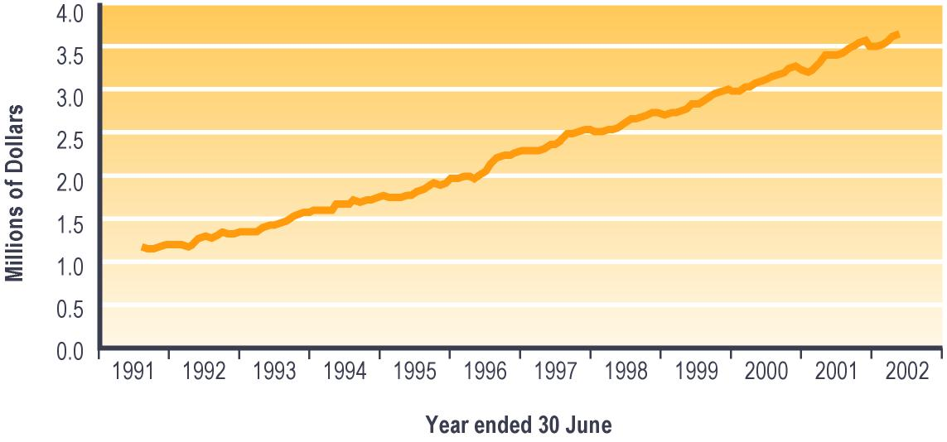

Notes:

1 Monthly expenditure on Orphan’s Benefits and Unsupported Child’s Benefits, and on supplementary benefits paid to recipients of Orphan’s Benefits or Unsupported Child’s Benefits.

2 Expenditure shown is adjusted for the number of payments in the month, and smoothed using a two-month moving average. Unsupported Child’s Benefits and Orphan’s Benefits are not subject to taxation.
Table 7.2 (see Section 7) shows trends since 1940 in combined expenditure on Unsupported Child’s Benefits and on Orphan’s Benefits. Please note that core benefit expenditure data shown in Table 7.2 includes expenditure on supplementary benefits paid to people receiving each core benefit.

Widow’s Benefit
A Widow’s Benefit may be paid to a woman who is aged 16 years or over and living on her own or with dependent children after being widowed. Residency qualifications and income tests apply.

A Widow’s Benefit may be payable to a client who has been widowed and:
- is caring for one or more dependent children or
- was married and subsequently cared for dependent children for 15 years or more or
- had one or more dependent children and was married for a total of 15 years or
- is aged at least 50 years, was married for five years or more, and became a widow after turning 50 years or
- is aged at least 50 years, was married for at least 10 years after marrying for the first time at least 15 years ago, and became a widow after turning 40 years.

From 1 February 1999, women receiving a Widow’s Benefit have been eligible to be work tested. If the client has no dependent children, or her youngest dependent child is aged 14 years or over, the client is subject to a full-time work test. If the client’s youngest dependent child is aged between six and 13 years, the client is subject to a part-time work test. If the child’s youngest dependent child is aged under six years, the client is required to attend an annual interview with a Work and Income case manager. The aim of this interview is to plan how the client will enter paid work once her youngest dependent child is aged six years.

Trends in numbers receiving a Widow’s Benefit
The number of women receiving a Widow’s Benefit has decreased over the last four years. Over this period, the proportion of women receiving a Widow’s Benefit who are aged 60 years or over has increased from 27% to 46%, while the proportion aged 40-59 years has reduced from 66% to 49% (see Table 3.22). This reflects the trend noted earlier towards people receiving core benefits becoming older.

Table 3.22 – Trends in ages of women receiving a Widow’s Benefit
Age at 30 June | Number of women receiving a Widow’s Benefit¹
 | 1998 | 1999 | 2000 | 2001 | 2002
 | Number | Number | Number | Number | Number
16-24 years | 9 | 10 | 11 | 7 | 11
25-39 years | 643 | 552 | 504 | 448 | 417
40-59 years | 6,180 | 5,727 | 5,290 | 4,797 | 4,325
60 years or over | 2,539 | 2,886 | 3,299 | 3,647 | 4,021
Unspecified | 1 | 3 | 0 | 1 | 0
Total | 9,372 | 9,178 | 9,104 | 8,900 | 8,774

Notes:

1 Numbers recorded in SWIFTT as receiving a Widow’s Benefit at 30 June.

Table 7.1 (see Section 7) shows trends since 1940 in the number of people receiving a Widow’s Benefit.

Trends in the proportion of women aged 18-59 years receiving a Widow’s Benefit
Since 1998, a very small number (around 0.5%) of women aged 18-59 years have been receiving a Widow’s Benefit. Over this period, a significantly higher proportion of women aged 40-59 years than of younger women have been receiving a Widow’s Benefit.

Since 1998, the proportion of women aged 18-59 years who are receiving a Widow’s Benefit reduced slightly. This reflects the ageing of women receiving a Widow’s Benefit, as increasing numbers of these women reach 60 years of age or older.

Trends in Widow’s Benefits granted
The number of Widow’s Benefits granted each year decreased between 1997/1998 and 1998/1999, and has fluctuated around the lower level for the last three years (see Table 3.23).

Table 3.23 – Trends in numbers of Widow’s Benefits granted
Widow’s Benefits Granted | Widow’s Benefits granted¹
 | 1997/1998 | 1998/1999 | 1999/2000 | 2000/2001 | 2001/2002
 | Number | Number | Number | Number | Number
Total | 2,120 | 2,029 | 2,026 | 2,005 | 2,017

Notes:

1 Numbers of applications for a Widow’s Benefit resulted as successful in SWIFTT during years ended 30 June.

Trends in cessations of Widow’s Benefits
The annual number of cessations of Widow’s Benefits increased between 1997/1998 and 2000/2001, but decreased over the last year (see Table 3.24).

Table 3.24 – Trends in cessations of Widow’s Benefits
Widow’s Benefits ceased | Widow’s Benefits ceased¹
 | 1997/1998 | 1998/1999 | 1999/2000 | 2000/2001 | 2001/2002
 | Number | Number | Number | Number | Number
Total | 2,014 | 2,106 | 2,142 | 2,196 | 2,128

Notes:

1 Numbers of cessations of Widow’s Benefits actioned in SWIFTT during years ended 30 June.

Expenditure on Widow’s Benefits
Annual expenditure on Widow’s Benefits increased between 1991/1992 and 1993/1994, then fluctuated between 1994/1995 and 1995/1996 following the introduction in 1994 of the Transitional Retirement Benefit. Expenditure on Widow’s Benefits increased between 1995/1996 and 1997/1998, but decreased between 1999/2000 and 2000/2001 and remained stable over the last year (see Table 3.25). These changes largely reflect the numbers of women receiving Widow’s Benefit.

Table 3.25 – Annual expenditure on Widow’s Benefits
Year ended 30 June | Expenditure on Widow’s Benefits^{1,2} ($ million)
1991/1992 | 82
1992/1993 | 84
1993/1994 | 86
1994/1995 | 82
1995/1996 | 86
1996/1997 | 92
1997/1998 | 95
1998/1999 | 95
1999/2000 | 93
2000/2001 | 91
2001/2002 | 91

Notes:

1 Expenditure on Widow’s Benefits in years ended 30 June.

2 Expenditure shown is net of taxation, and includes expenditure on supplementary benefits provided to recipients of Widow’s Benefits.

Monthly expenditure on Widow’s Benefits shows small seasonal peaks in the latter part of each fiscal year (see Figure 3.9). This peak results from the Training Incentive Allowance and benefit advances which are made at the start of the school/academic year to women receiving a Widow’s Benefit.

Figure 3.9 – Trends in monthly expenditure on Widow’s Benefits^{1,2}

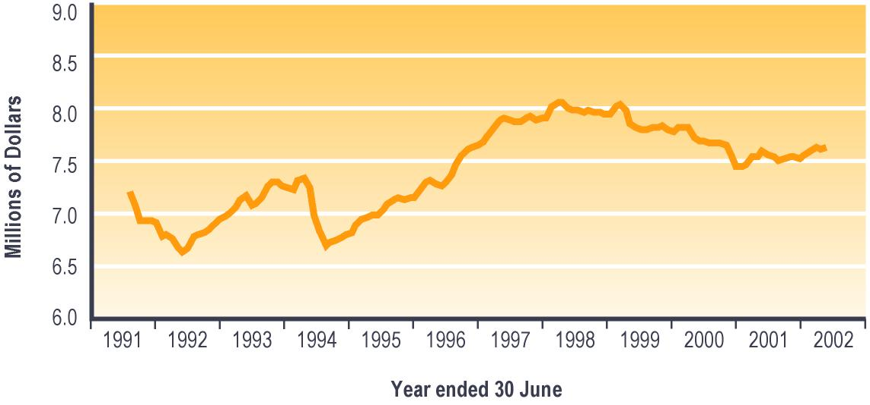

Notes:

1 Monthly expenditure on Widow’s Benefits and on supplementary benefits paid to Widow’s Benefit recipients.

2 Expenditure shown is net of taxation, adjusted for the number of payments in the month, and smoothed using a three-month moving average.

Table 7.2 (see Section 7) shows trends since 1940 in expenditure on Widow’s Benefit. Please note that core benefit expenditure data shown in Table 7.2 includes expenditure on supplementary benefits paid to people receiving each core benefit.

Employment Services
Work and Income provides access to a range of support services and training opportunities to assist clients to obtain ongoing paid employment. These include:
- one-to-one assistance with job search and preparation to enter employment
- employment or training programmes which assist clients in preparing for work, finding a job or entering employment
- referring clients to vacancies which are notified to Work and Income
- subsidies to assist employers with the cost of wages for a specified time
- assistance for the job seeker to set up their own business, including access to business development advice and subsidies to assist with capital or operating costs.

Registered job seekers
All registered job seekers must be:
- working less than 30 hours per week and seeking to work more hours
- available for and actively seeking work.

Registered job seekers comprise:
- people who are required to register as job seekers because they or their partner or spouse are receiving a work-tested benefit
- people who:
– choose to register to receive employment services from Work and Income as part of seeking work
– meet the definition of registered job seekers outlined above.

Clients (or their partners and spouses) receiving a range of benefits are subject to a work test, and may therefore be required to register as job seekers. Work tested benefits are:
- Unemployment Benefits: client and partners/spouses both subject to work test
- Domestic Purposes Benefits: client subject to work test
- Sickness Benefits: partner or spouse subject to work test
- Invalid’s Benefits: partner or spouse subject to work test
- Widow’s Benefits: client subject to work test.

For consistency with other official reports produced by the MSD, this report uses the number of registered job seekers as an indicator of the use of employment services.

Since 1999, between 98% and 99% of the clients receiving employment services from Work and Income have been registered job seekers. A small number of people (vacation workers, people already in full-time work who are seeking to change jobs) do, however, receive employment services from Work and Income without being registered as job seekers.

From 1 July 2001, all registered job seekers receiving a work tested benefit have been required to enter into a Job Seeker Agreement with Work and Income. The Job Seeker Agreement sets out the assistance that Work and Income will provide to assist the job seeker to obtain employment, and the steps that the job seeker will take to find employment or to improve their prospects for doing so. The Job Seeker Agreement must specify the job search activities which will be undertaken, and may include employment or training programmes to be undertaken by the job seeker (eg a period of work experience or of employment-related training).

The number of registered job seekers is an administrative statistic which differs from, and is usually higher than, the number of officially unemployed. See Appendix 2 for information about the difference between registered job seekers and the officially unemployed.

Trends in the number of registered job seekers
The number of registered job seekers increased between 1999 and 2000, but has fallen over the last two years (see Table 3.26). This pattern reflects both changing economic conditions and the impact of operational changes such as extended work testing of core benefits and an increased emphasis on placing job seekers into paid work.

The proportion of job seekers who were receiving a Domestic Purposes Benefit increased from 9% to 16% between 1999 and 2000 and has remained relatively stable over the last two years, while the proportion receiving an Unemployment Benefit showed a corresponding decrease from 67% to 58% (see Table 3.26). These changes reflect the combined impacts of changing economic conditions on the job seeker register and of operational changes such as the extended work testing of core benefits.

Table 3.26 – Trends in types of core benefits or pensions received by registered job seekers
Type of core benefit or pension  received at 30 June | Number of registered job seekers¹
 | 1999 | 2000 | 2001 | 2002
 | Number | Number | Number | Number
Unemployment Benefit² | 142,317 | 133,164 | 115,114 | 100,431
Domestic Purposes Benefit³ | 19,079 | 38,396 | 30,551 | 27,851
Sickness Benefit⁴ | 1,773 | 3,076 | 1,689 | 1,514
Invalid’s Benefit | 504 | 1,398 | 722 | 850
Widow’s Benefit | 1,791 | 2,386 | 1,768 | 1,475
Unsupported Child’s Benefit/  Orphan’s Benefit | 137 | 255 | 192 | 167
Transitional Retirement Benefit | 44 | 70 | 21 | 10
New Zealand Superannuation | 44 | 63 | 37 | 34
Veteran’s Pension | 2 | 2 | 0 | 3
No core benefit or pension | 47,960 | 52,125 | 41,700 | 35,382
Total | 213,651 | 230,935 | 191,794 | 167,717

Notes:

1 Numbers of job seekers registered in SOLO at 30 June.

2 Includes Unemployment Benefit, Unemployment Benefit – Hardship, Unemployment Benefit – Hardship – Student, Unemployment Benefit – Training, Unemployment Benefit – Hardship – Training, Emergency Benefit and Independent Youth Benefit.

3 Includes Domestic Purposes Benefit – Sole Parent, Domestic Purposes Benefit – Caring for the Sick and Infirm, Domestic Purposes Benefit – Woman Alone, and Emergency Maintenance Allowance.

4 Includes Sickness Benefit and Sickness Benefit – Hardship.

Since 1999, the proportion of registered job seekers who had been registered for between two and four years has increased from 12% to 21%, while the proportion who had been registered for over four years has increased from 5% to 10%. Over the same period, the proportion of registered job seekers who had been registered as a job seeker for under six months decreased from 43% to 35%, and the proportion registered for between six months and two years decreased from 41% to 34% (see Figure 3.10). This lengthening of spells registered as a job seeker reflects in part the combined impacts of changing economic conditions on the job seeker register and of expanded work testing of core benefits.

Figure 3.10 – Trends in length of current spell registered as a job seeker¹

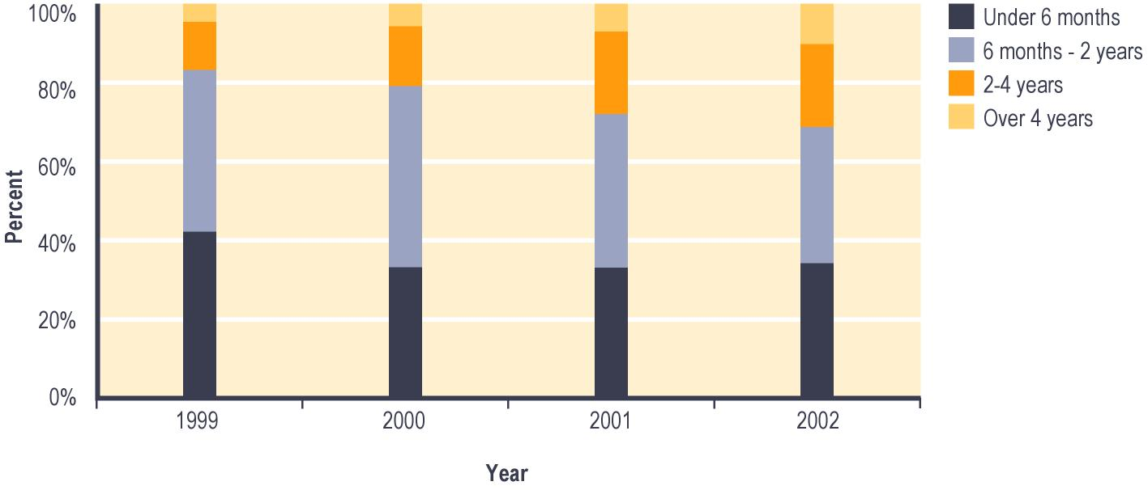

Notes:

1 Percent of job seekers registered in SOLO at 30 June.

Since 1999, the proportion of registered job seekers who were female increased from 41% to 47%, while the proportion who identified as New Zealand Europeans decreased from 53% to 46% (see Figures 3.11 and 3.12). These changes reflect in part the impact of changing economic conditions on the job seeker register and of the extended work testing of core benefits.

Figure 3.11 – Trends in gender of registered job seekers¹

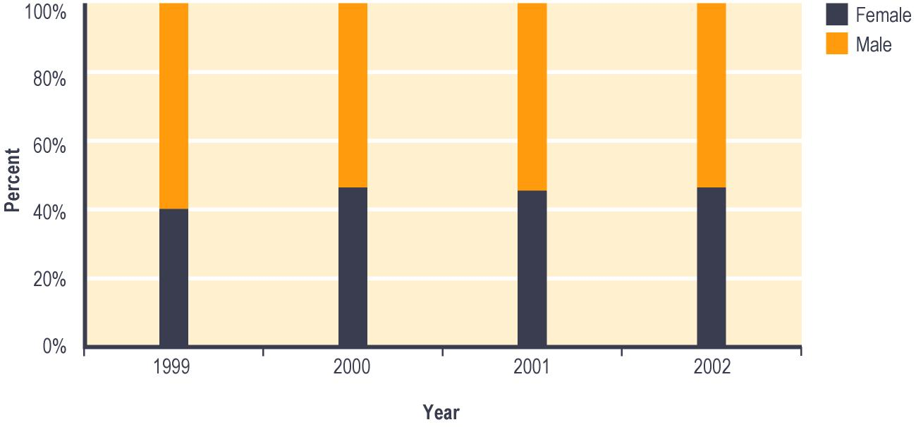

Notes:

1 Percent of job seekers registered in SOLO at 30 June.

Figure 3.12 – Trends in ethnicity of registered job seekers¹

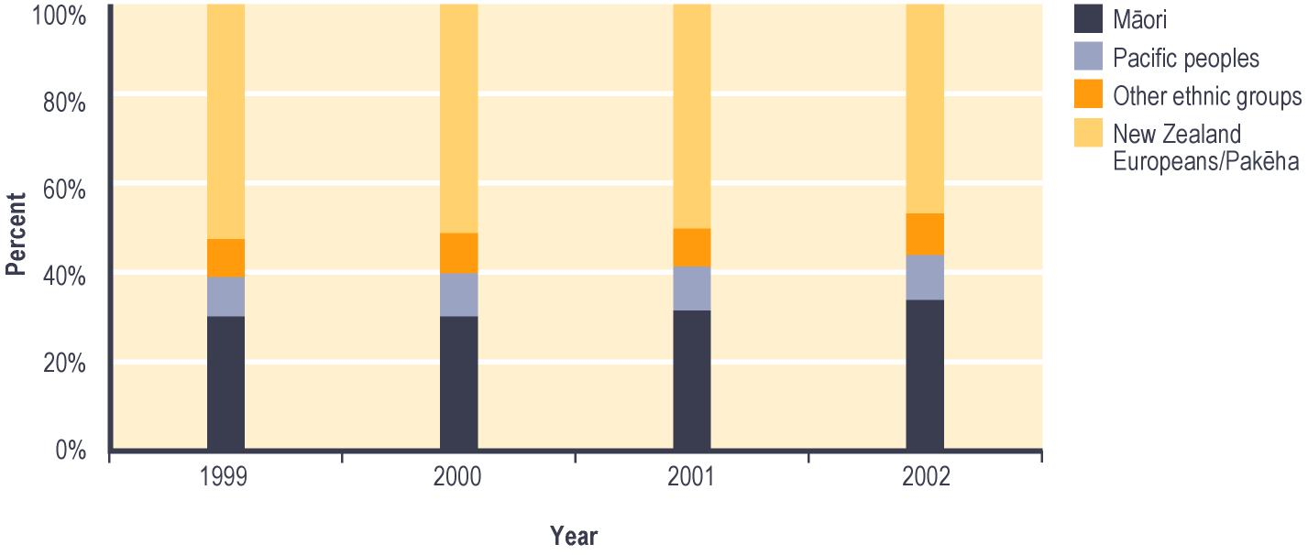

Notes:

1 Percent of job seekers registered in SOLO at 30 June.

Trends in the proportion of 18-59 year olds registered as job seekers
Since 1999, between 7% and 10% of people aged 18-59 years have been registered as job seekers. Compared with the proportion of 18-59 year olds registered as job seekers in this period, a higher proportion of 18-24 year olds and a lower proportion of 40-59 year olds have been registered as job seekers (see Figure 3.13).

The proportion of 18-59 year olds who were registered as job seekers increased slightly between 1999 and 2000, but decreased over the last two years. The proportion of 25-39 year olds registered as job seekers and the proportion of 40-59 year olds registered as job seekers both mirrored this pattern. The proportion of 18-24 year olds registered as job seekers, however, began decreasing a year earlier, in 1999 (see Figure 3.13).

Changes in the proportion of 25-39 year olds registered as job seekers and of 40-59 year olds registered as job seekers reflect in part the combined impacts on the job seeker register of improved economic conditions, the extended work testing of core benefits, and an increased operational focus on assisting job seekers into employment.

Figure 3.13 – Trends in the proportion¹ of people aged 18-59 years registered as job seekers

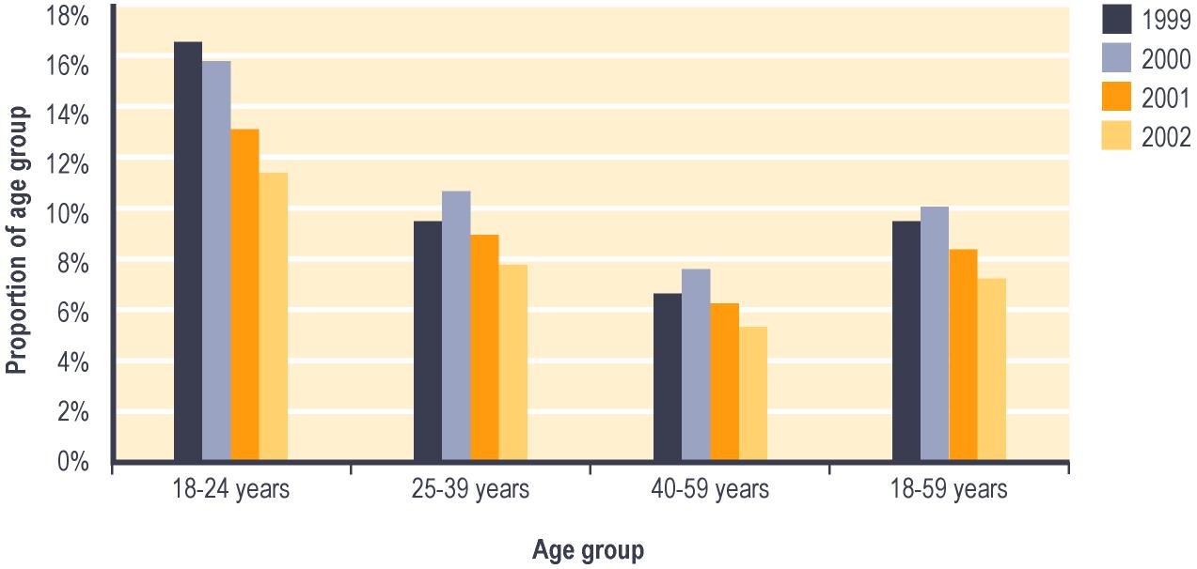

Notes:

1 Proportion shows:

a Number of job seekers registered in SOLO in each age group at 30 June; divided by

b Statistics New Zealand estimate of the total number of people in each age group at 30 June.

Trends in new registrations of job seekers
The total number of new job seeker registrations each year has fallen since 1998/1999. There were higher numbers in 1998/1999 and in 1999/2000 than in later years of new job seekers registrations by people who had never previously registered as a job seeker (see Table 3.27). This reflects both changing economic conditions and the impact of the expanded work testing of core benefits.

In 1998/1999 and over the last two years, between 51% and 53% of new job seeker registrations each year have involved clients who had been registered as job seekers within the previous 12 months, while between 23% and 26% involved clients who had never previously registered as a job seeker (see Table 3.27).

Table 3.27 – Trends in period since newly registered job seekers had last been enrolled as a job seeker

Period since newly registered  job seeker was last enrolled  as a job seeker | New job seeker registrations¹
 | 1998/1999 | 1999/2000 | 2000/2001 | 2001/2002
 | Number | Number | Number | Number
Under 6 months | 131,598 | 114,057 | 113,097 | 108,729
6-12 months | 35,302 | 33,208 | 34,564 | 35,810
12-18 months | 15,903 | 14,934 | 13,932 | 16,634
18 months - 2 years | 11,676 | 11,447 | 9,353 | 10,599
2-4 years | 24,564 | 26,456 | 20,115 | 18,771
At least four years | 22,358 | 28,144 | 22,703 | 19,902
Never previously registered  as a job seeker | 84,517 | 93,532 | 69,743 | 63,765
Total | 325,918 | 321,778 | 283,507 | 274,210

Notes:

1 Numbers of new job seeker registrations actioned in SOLO during years ended 30 June.

Transitional Retirement Benefit
A Transitional Retirement Benefit provides income to people who:
- are retired or have low incomes
- have not yet reached the qualifying age for New Zealand Superannuation.

Transitional Retirement Benefits were introduced on 1 April 1994, to provide financial assistance to older people who are retired or approaching retirement and were affected by the incremental increases in the age of eligibility for New Zealand Superannuation which occurred between 1 April 1993 and 1 April 2001.

The age of eligibility for a Transitional Retirement Benefit was raised concurrently with the age of eligibility for New Zealand Superannuation, rising three months every six months. At 30 June 2000, the qualifying age for a Transitional Retirement Benefit was 63 years, and at 30 June 2002 it was 64 years. Transitional Retirement Benefits will be phased out on 1 April 2004, when the final incremental increase in eligibility age for a Transitional Retirement Benefit raises this eligibility age to 65 years (which is the same as the eligibility age for New Zealand Superannuation).

Transitional Retirement Benefits are not work tested, but are income tested. Residential qualifications must also be met.

Trends in numbers receiving a Transitional Retirement Benefit
The number of people receiving a Transitional Retirement Benefit rose between 1998 and 2001, but fell sharply in the last year (see Table 3.28). The decrease in the number of people receiving a Transitional Retirement Benefit over the last 12 months reflects in large part the combined effect of:
- the age of eligibility for a Transitional Retirement Benefit being raised from 63 years at 1 April 2001 to 64 years on 1 April 2002
- the age of eligibility for New Zealand Superannuation being fixed at 65 years since 1 April 2001.

Table 3.28 – Trends in the number of people receiving a Transitional Retirement Benefit
Transitional Retirement Benefits received | Clients receiving a Transitional Retirement Benefit¹
 | 1998 | 1999 | 2000 | 2001 | 2002
 | Number | Number | Number | Number | Number
Total | 8,151 | 8,743 | 8,856 | 9,012 | 5,118

Notes:

1 Numbers recorded in SWIFTT as receiving a Transitional Retirement Benefit at 30 June.

Since 1998, all the clients receiving a Transitional Retirement Benefit have been aged 60-64 years apart from a very small number (0.3% or less of Transitional Retirement Benefit recipients) who are aged 65 years or over. This reflects the eligibility ages for this core benefit and the fact that virtually all clients cease receiving a Transitional Retirement Benefit when they reach the qualifying age for New Zealand Superannuation.

Between 2000 and 2001, the proportion of Transitional Retirement Benefit recipients who had received the benefit for over two years decreased from 24% to 0.2%. This reflects the shortening of the period between the eligibility age for Transitional Retirement Benefit and the eligibility age for New Zealand Superannuation.

Table 7.1 (see Section 7) shows trends since 1994 in the number of people receiving a Transitional Retirement Benefit.

Trends in the proportion of 60-64 year olds receiving Transitional Retirement Benefits
Between 1998 and 2001, around 6% of people aged 60-64 years were receiving a Transitional Retirement Benefit. In 2002, this fell to 3%, due to the combined effect of increased eligibility age for Transitional Retirement Benefit and static eligibility age for New Zealand Superannuation as outlined above.

Trends in Transitional Retirement Benefits granted
The number of Transitional Retirement Benefits granted each year fluctuated between 1997/1998 and 2000/2001, then decreased sharply in the last year (see Table 3.29).

Table 3.29 – Trends in numbers of Transitional Retirement Benefits granted
Transitional Retirement Benefits granted | Transitional Retirement Benefits granted¹
 | 1997/1998 | 1998/1999 | 1999/2000 | 2000/2001 | 2001/2002
 | Number | Number | Number | Number | Number
Total | 4,447 | 4,521 | 4,453 | 4,456 | 3,577

Notes:

1 Numbers of applications for a Transitional Retirement Benefit resulted as successful in SWIFTT during years ended 30 June.

Expenditure on Transitional Retirement Benefits
Annual expenditure on Transitional Retirement Benefits increased between 1994/1995 and 2000/2001, but decreased sharply in 2001/2002 (see Table 3.30). Expenditure on Transitional Retirement Benefit is driven by the number of people receiving Transitional Retirement Benefits, and the decreased expenditure in 2001/2002 reflects the large decrease in numbers receiving Transitional Retirement Benefits during that year.

Table 3.30 – Annual expenditure on Transitional Retirement Benefits
Year ended 30 June | Expenditure on Transitional Retirement Benefits^{1,2} ($ million)
1994/1995 | 78
1995/1996 | 90
1996/1997 | 96
1997/1998 | 99
1998/1999 | 105
1999/2000 | 112
2000/2001 | 113
2001/2002 | 91

Notes:

1 Expenditure on Transitional Retirement Benefits in years ended 30 June.

2 Expenditure shown is net of taxation, and includes expenditure on supplementary benefits provided to recipients of Transitional Retirement Benefits.

Since 1995/1996 monthly expenditure on Transitional Retirement Benefits has shown seasonal patterns reflecting peaks in applications for Transitional Retirement Benefits in April and October (see Figure 3.14). These peaks occurred as the incremental adjustments of the eligibility age for Transitional Retirement Benefits took effect.

Figure 3.14 – Trends in monthly expenditure on Transitional Retirement Benefits^{1,2}

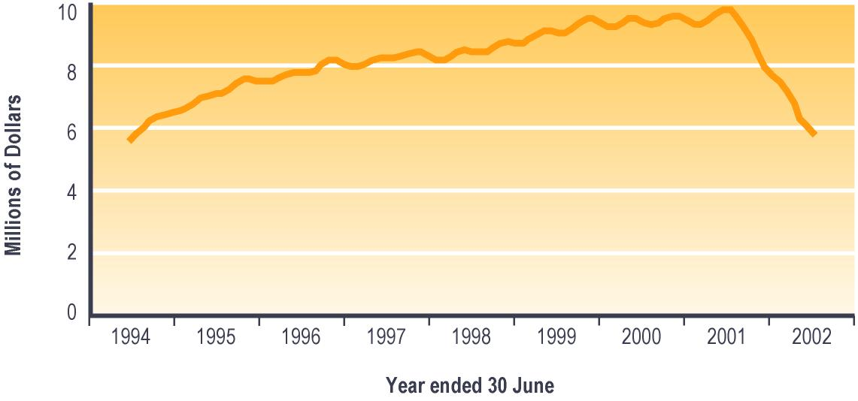

Notes:

1 Monthly expenditure on Transitional Retirement Benefits and on supplementary benefits paid to Transitional Retirement Benefit recipients.

2 Expenditure shown is net of taxation, adjusted for the number of payments in the month, and smoothed using a three-month moving average.

Table 7.2 (see Section 7) shows trends since 1994 in expenditure on Transitional Retirement Benefits. Please note that core benefit expenditure data shown in Table 7.2 includes expenditure on supplementary benefits paid to people receiving each core benefit.

New Zealand Superannuation
New Zealand Superannuation provides a source of income to people who have reached a qualifying age and meet a residency qualification.

On 1 April 1992 the qualifying age was increased from 60 years to 61 years. The qualifying age was increased by three months every six months between 1 April 1993 and 1 April 2001, but has remained fixed at 65 years since 1 April 2001.

The residency requirements for New Zealand Superannuation are that the client has lived in New Zealand for 10 years since they were aged 20 years, and for five years since they were aged 50 years. People who have reached the qualifying age for New Zealand Superannuation but who do not meet these residency requirements may be eligible to receive an Emergency Benefit if hardship exists.

New Zealand Superannuation may be paid to couples in which only one partner personally qualifies for New Zealand Superannuation. In these cases, the partner or spouse who does not qualify for New Zealand Superannuation in their own right is referred to as a “non-qualified spouse”. Where one partner or spouse does not meet the qualifying age or does not qualify for New Zealand Superannuation for some other reason while the other does, there are two options available:
- the qualified spouse only may receive payment at half the married couple rate of the pension or
- both the qualified and the non-qualified spouse may receive the non-qualified spouse rate of the pension, subject to an income test.

Clients may at any time choose to include or exclude their non-qualifying spouse from their pension payment.
New Zealand Superannuation payments are made gross of tax. Recipients pay tax on New Zealand Superannuation depending on their financial circumstances.

Trends in numbers receiving New Zealand Superannuation
The number of people receiving New Zealand Superannuation decreased between 1998 and 2001, then increased slightly in 2002 (see Table 3.31). The decrease between 1998 and 2001 reflects numbers of cessations of New Zealand Superannuation each year which were higher than numbers of New Zealand Superannuation pensions granted in the same year. This occurred because of an ageing population receiving New Zealand Superannuation combined with an incrementally increasing eligibility age. The increase between 2001 and 2002 reflects the combination of a sharp increase in New Zealand Superannuation pensions granted once the eligibility age was fixed on 1 April 2001 and relatively constant cessations of New Zealand Superannuation compared with previous years.

Since 1998, the proportion of people receiving New Zealand Superannuation who were aged 60-64 years has decreased from 10% to 3% (see Table 3.31). This reflects the impact of changes in the eligibility age for New Zealand Superannuation (which reached 65 years on 1 April 2001).

Table 3.31 – Trends in the ages of people receiving New Zealand Superannuation
Age at 30 June | Clients receiving New Zealand Superannuation¹
 | 1998 | 1999 | 2000 | 2001 | 2002
 | Number | Number | Number | Number | Number
Under 60 years² | 8,537 | 7,323 | 6,303 | 5,293 | 5,038
60-64 years² | 48,023 | 36,385 | 25,472 | 14,933 | 14,140
65-69 years | 123,793 | 122,588 | 121,105 | 119,719 | 120,489
70-74 years | 110,317 | 111,370 | 111,812 | 112,963 | 112,741
75-79 years | 82,751 | 86,051 | 87,937 | 89,363 | 90,434
80 years or over | 95,846 | 97,401 | 100,750 | 104,406 | 107,593
Unspecified | 40 | 19 | 22 | 29 | 0
Total | 469,307 | 461,137 | 453,401 | 446,706 | 450,435

Notes:

1 Numbers recorded in SWIFTT as receiving New Zealand Superannuation at 30 June.

2 Clients receiving New Zealand Superannuation while under the qualifying age are non-qualified spouses.

Table 7.1 (see Section 7) shows trends since 1940 in the number of people receiving New Zealand Superannuation.

Proportion of people aged 65 years or over receiving New Zealand Superannuation
Since 1998, around 93% of people in New Zealand aged 65 years or over have received New Zealand Superannuation, with a slightly higher proportion of those aged 80 years or over than of those aged 65-79 years doing so. In the last two years, the proportion of 65-69 year olds receiving New Zealand Superannuation has decreased to slightly below the overall proportion for people aged 65 years or over.

Trends in granting New Zealand Superannuation
The number of New Zealand Superannuation pensions granted each year decreased between 1997/1998 and 1998/1999, but increased over the last three years. There was a particularly sharp increase over 2001/2002 in the number of New Zealand Superannuation pensions granted (see Table 3.32).

Since 1999/2000, the proportion of New Zealand Superannuation pensions granted each year which were provided to clients who were aged 65-69 years increased from 8% to 81%, while the proportion provided to clients aged 60-64 years decreased from 79% to 11% (see Table 3.32). This reflects at least in part the impact of incremental increases in the age of eligibility for New Zealand Superannuation, which reached 65 years on 1 April 2001, combined with the historic predominance of qualified recipients among people granted New Zealand Superannuation.

Table 3.32 – Trends in ages of clients granted New Zealand Superannuation
Age when  New Zealand Superannuation granted | New Zealand Superannuation pensions granted¹
 | 1997/1998 | 1998/1999 | 1999/2000 | 2000/2001 | 2001/2002
 | Number | Number | Number | Number | Number
Under 60 years² | 2,092 | 1,638 | 1,452 | 1,280 | 1,606
60-64 years² | 16,498 | 14,335 | 14,794 | 8,589 | 3,496
65-69 years | 2,128 | 1,393 | 1,469 | 8,387 | 26,388
70-74 years | 719 | 525 | 488 | 478 | 471
75-79 years | 322 | 233 | 257 | 245 | 277
80 years or over | 337 | 227 | 230 | 227 | 256
Unspecified | 20 | 8 | 3 | 0 | 0
Total | 22,116 | 18,359 | 18,693 | 19,206 | 32,494

Notes:

1 Numbers of applications for New Zealand Superannuation resulted as successful in SWIFTT during years ended 30 June.

2 Clients granted New Zealand Superannuation while under the qualifying age are non-qualified spouses.

Expenditure on New Zealand Superannuation
Annual expenditure on New Zealand Superannuation decreased in 1992/1993 and 1993/1994 following the implementation of incremental increases in eligibility age, then rose until 1997/1998 due to increases in the rate of New Zealand Superannuation paid. A decrease in expenditure in 1998/1999 and 1999/2000 resulted from falling numbers receiving New Zealand Superannuation combined with stable payment rates arising from low annual Consumers Price Index adjustments to the payment rate. Expenditure on New Zealand Superannuation has increased over the last two years because of a combination of the married rate for New Zealand Superannuation being raised to 65% of the average wage (from 1 April 2000) and the increase in the number of people receiving New Zealand Superannuation over the last year (see Table 3.33).

Table 3.33 – Annual expenditure on New Zealand Superannuation
Year ended 30 June | Expenditure on New Zealand Superannuation^{1,2} ($ million)
1991/1992 | 5,153
1992/1993 | 5,070
1993/1994 | 5,045
1994/1995 | 5,083
1995/1996 | 5,158
1996/1997 | 5,187
1997/1998 | 5,263
1998/1999 | 5,253
1999/2000 | 5,228
2000/2001 | 5,457
2001/2002 | 5,638

Notes:

1 Expenditure on New Zealand Superannuation in years ended 30 June

2 Includes estimated taxation calculated at the “M” rate, and includes expenditure on supplementary benefits provided to recipients of New Zealand Superannuation.

Monthly expenditure on New Zealand Superannuation shows a strong relationship to the number of people receiving New Zealand Superannuation pensions. In addition, this expenditure showed seasonal peaks in the second and fourth quarter of each financial year between 1992/1993 and 2000/2001 (see Figure 3.15). This reflects the impact on numbers receiving New Zealand Superannuation of a surge of New Zealand Superannuation pensions being granted in April and October each year (as each incremental increase in eligibility age took effect) which briefly outnumbered cessations. Following these peaks of New Zealand Superannuation pensions granted, cessations result in a decrease in the numbers receiving New Zealand Superannuation, and hence in New Zealand Superannuation expenditure, until the next peak. Since the age of eligibility for New Zealand Superannuation has been fixed at 65 years throughout 2001/2002, these peaks are not in evidence over the last year.

Figure 3.15 – Trends in monthly expenditure on New Zealand Superannuation^{1,2}

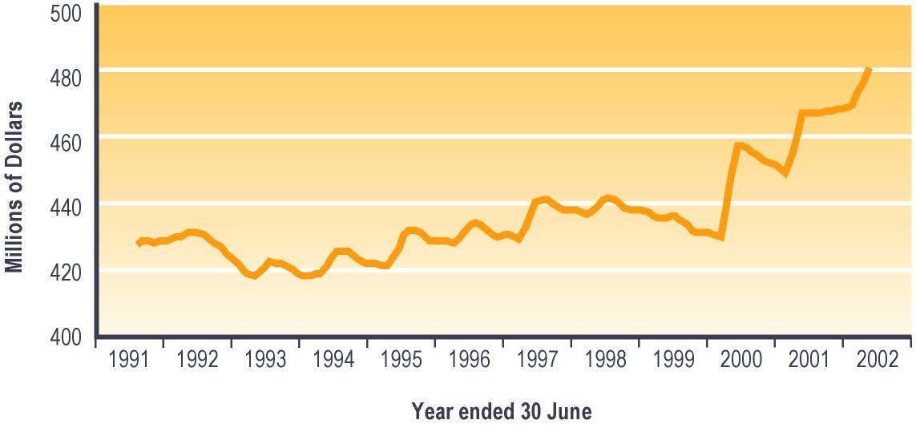

Notes:

1 Monthly expenditure on New Zealand Superannuation and on supplementary benefits paid to New Zealand Superannuation recipients.

2 Expenditure shown includes taxation estimated at the “M” tax rate, is adjusted for the number of payments in the month, and is smoothed using a three-month moving average.

Table 7.2 (see Section 7) shows trends since 1940 in expenditure on New Zealand Superannuation. Please note that pension expenditure data shown in Table 7.2 includes expenditure on supplementary benefits paid to people receiving each pension.

Veteran’s Pension
Veteran’s Pensions were introduced from 1 April 1990 and replaced the former War Veteran’s Allowances, War Service Pensions and Economic Pensions. Veteran’s Pensions are not income tested for qualified recipients, but are taxable. If a non-qualified spouse is receiving a Veteran’s Pension along with their qualified spouse, this is, however, subject to an income test.

The rates of payment are the same as for New Zealand Superannuation. A policy change was introduced in 1992 which allowed veterans receiving New Zealand Superannuation to transfer to a Veteran’s Pension.

Because widows of veterans are entitled to continue to receive a Veteran’s Pension, there are slightly more women than men receiving a Veteran’s Pension. In April 1997, a change in War Pensions criteria was introduced which increased the numbers of people eligible to receive a Veteran’s Pension. From 1 July 1999, the funding of Veteran’s Pensions was transferred from Vote: Work and Income to Vote: Veteran’s Affairs: Work and Income.

To qualify for a Veteran’s Pension, a client must be an ex-service person who served during a war or emergency who either:
- has reached the qualifying age for New Zealand Superannuation and qualifies for a War Disablement Pension of at least 70% or
- has not reached the qualifying age but is unable to work for a substantial period because of a disability from any cause.

Trends in numbers receiving a Veteran’s Pension
Since 1998, the number of people receiving a Veteran’s Pension has increased, with some fluctuations in the upward trend in 1999 and in 2000 (see Table 3.34). Total numbers receiving a Veteran’s Pension have remained relatively small, however.

Since 1998, the proportion of people receiving a Veteran’s Pension who were aged 80 years or over has increased from 32% to 49%, while the proportions aged 70-74 years and aged 75-79 years both decreased (from 20% to 12% for 70-74 year olds, and from 37% to 28% for 75-79 year olds) (see Table 3.34). This change is likely to reflect at least in part the ageing of World War Two veterans and their spouses or partners, who are the largest group of people receiving a Veteran’s Pension.

Table 3.34 – Trends in the ages of people receiving a Veteran’s Pension
Age at 30 June | Clients receiving a Veteran’s Pension¹
 | 1998 | 1999 | 2000 | 2001 | 2002
 | Number | Number | Number | Number | Number
Under 60 years | 201 | 223 | 272 | 325 | 351
60-64 years | 135 | 134 | 149 | 192 | 243
65-69 years | 483 | 451 | 370 | 362 | 395
70-74 years | 1,431 | 1,217 | 1,009 | 893 | 773
75-79 years | 2,706 | 2,621 | 2,459 | 2,316 | 2,114
80 years or over | 2,321 | 2,688 | 2,988 | 3,336 | 3,711
Unspecified | 0 | 0 | 1 | 1 | 0
Total | 7,277 | 7,334 | 7,248 | 7,425 | 7,587

Notes:

1 Numbers recorded in SWIFTT as receiving a Veteran’s Pension at 30 June.

Table 7.1 (see Section 7) shows trends since 1990 in the number of people receiving a Veteran’s Pension.

Trends in the proportion of people aged 65 years or over receiving a Veteran’s Pension
Since 1998, around 2% of people aged 65 years or over have been receiving a Veteran’s Pension. Over this period, the proportion of people aged 80 years or over receiving a Veteran’s Pension has increased. This is likely to again reflect in part the ageing of World War Two veterans and their spouses or partners, who comprise the largest group of people receiving a Veteran’s Pension.

Trends in granting Veteran’s Pension
The number of times Veteran’s Pensions are granted each year decreased between 1997/1998 and 1999/2000, but has increased over the last two years (see Table 3.35). Veteran’s Pensions granted generally reflect assessments of clients as being as 70% disabled or more under War Disablement Pensions criteria. The number of Veteran’s Pensions granted each year therefore reflects at least in part the ageing of veterans, War Disablement Pensions criteria and reviews.

Table 3.35 – Trends in Veteran’s Pensions granted
Veteran’s Pensions granted | Veteran’s Pensions granted¹
 | 1997/1998 | 1998/1999 | 1999/2000 | 2000/2001 | 2001/2002
 | Number | Number | Number | Number | Number
Total | 633 | 598 | 483 | 724 | 816

Notes:

1 Numbers of applications for a Veteran’s Pension resulted successful in SWIFTT in years ended
30 June.

Expenditure on Veteran’s Pensions
Expenditure on Veteran’s Pensions has increased since 1991/1992, with a particularly sharp increase between 1991/1992 and 1992/1993 following the policy change in 1992 which allowed veterans receiving New Zealand Superannuation to transfer to a Veteran’s Pension. A smaller increase between 1996/1997 and 1997/1998 reflects in part the change in War Pensions criteria which made more people eligible to receive a Veteran’s Pension. Strong increases in expenditure over the last two years reflect in part increasing numbers of people receiving Veteran’s Pensions (see Table 3.36).

Table 3.36 – Annual expenditure on Veteran’s Pensions
Year ended 30 June | Expenditure on Veteran’s Pensions^{1,2} ($ million)
1991/1992 | 30
1992/1993 | 47
1993/1994 | 54
1994/1995 | 56
1995/1996 | 59
1996/1997 | 64
1997/1998 | 70
1998/1999 | 72
1999/2000 | 73
2000/2001 | 77
2001/2002 | 83

Notes:

1 Expenditure on Veteran’s Pensions in years ended 30 June.

2 Includes estimated taxation calculated at the “M” tax rate and expenditure on supplementary benefits provided to recipients of Veteran’s Pensions.

Monthly expenditure on Veteran’s Pensions shows relatively little seasonal variation, reflecting mainly the trend to increasing levels of expenditure on Veteran’s Pensions (see Figure 3.16).

Figure 3.16 – Trends in monthly expenditure on Veteran’s Pensions^{1,2}

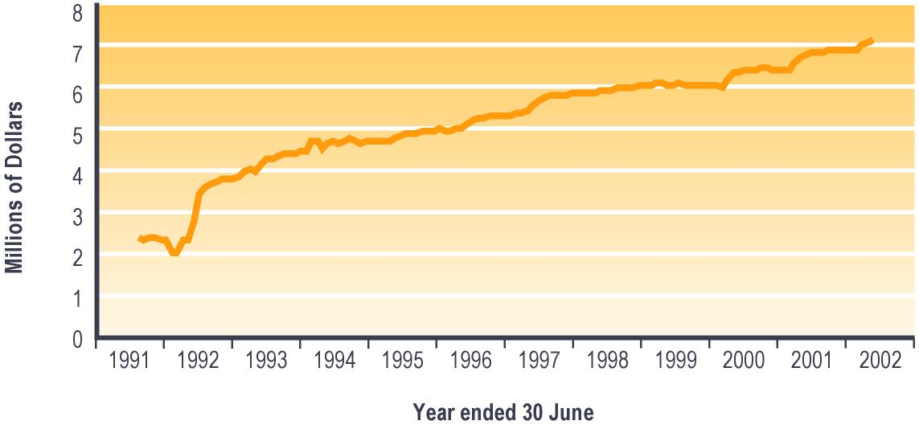

Notes:

1 Monthly expenditure on Veteran’s Pensions and on supplementary benefits paid to Veteran’s Pension recipients.

2 Expenditure shown includes taxation estimated at the “M” tax rate, is adjusted for the number of payments in the month, and is smoothed using a three-month moving average.

Table 7.2 (see Section 7) shows trends since 1990 in expenditure on Veteran’s Pensions. Please note that pension expenditure data shown in Table 7.2 includes expenditure on supplementary benefits paid to people receiving each pension.

Section 4 – Supplementary benefits and emergency or hardship assistance

Introduction
People with low incomes and few assets may be eligible for supplementary benefits and for emergency or hardship assistance. These benefits and forms of assistance are designed to assist clients with meeting urgent and specified living costs which they cannot meet from their own resources.

Supplementary benefits
Most supplementary benefits are paid on an ongoing weekly basis, while some are paid for short periods in response to a specific need (eg childcare costs during school holidays).

People may receive more than one supplementary benefit, because each supplementary benefit is aimed at assisting with specific living costs. In addition, clients may receive payments of some supplementary benefits which cover more than one person (eg payments of Childcare Subsidy which cover more than one child). In these cases, this report shows information on the people covered by payments of the supplementary benefit, not on clients receiving payments of the supplementary benefit which may cover one or more people.

Accommodation Supplement
Accommodation Supplements assist people with limited income and limited cash assets to pay accommodation costs above a threshold. Assistance is available to pay rent, board or costs of home ownership. Accommodation Supplements replaced Accommodation Benefits on 1 July 1993.

Housing costs must be over a stated minimum, and income and asset tests must be met. Accommodation Supplements pay 70% of rent or mortgage costs over an entry threshold, up to a maximum that varies according to region and household size. Sixty-two percent of boarding costs over the relevant entry threshold are covered, up to the regional maximum.

Trends in numbers receiving an Accommodation Supplement
The number of people receiving an Accommodation Supplement increased between 1998 and 2000, but fell sharply in 2001 and showed a smaller fall in 2002 (see Table 4.1). Decreased use of Accommodation Supplements in the last two years reflect in part both a reduction in numbers of people receiving core benefits (assisted by improved economic conditions) and the impact of the re-introduction in December 2000 of income-related rents for state houses.

Since 1998, between 33% and 36% of people receiving an Accommodation Supplement have been receiving an Unemployment Benefit, while between 29% and 31% have been receiving a Domestic Purposes Benefit (see Table 4.1).

Table 4.1 – Trends in types of core benefit or pension received by people receiving an Accommodation Supplement
Type of core benefit or pension received at 30 June | Clients receiving an Accommodation Supplement¹
 | 1998 | 1999 | 2000 | 2001 | 2002
 | Number | Number | Number | Number | Number
Unemployment Benefit² | 109,802 | 117,453 | 112,593 | 94,641 | 84,252
Domestic Purposes Benefit³ | 94,841 | 92,013 | 92,442 | 77,913 | 77,281
Sickness Benefit⁴ | 25,341 | 23,873 | 23,878 | 22,152 | 24,292
Invalid’s Benefit | 26,507 | 27,408 | 30,410 | 27,360 | 29,596
Widow’s Benefit | 3,537 | 3,431 | 3,454 | 2,572 | 2,572
Unsupported Child’s Benefit/ Orphan’s Benefit | 1 | 2 | 0 | 0 | 0
Transitional Retirement Benefit | 1,746 | 1,975 | 2,107 | 1,762 | 938
New Zealand Superannuation | 23,039 | 23,063 | 23,074 | 14,733 | 16,068
Veteran’s Pension | 349 | 350 | 339 | 205 | 245
No core benefit or pension | 20,572 | 23,474 | 27,691 | 24,544 | 22,790
Total | 305,735 | 313,042 | 315,988 | 265,882 | 258,034

Notes:

1 Numbers recorded in SWIFTT as receiving an Accommodation Supplement at 30 June.

2 Includes Unemployment Benefit, Unemployment Benefit – Hardship, Unemployment Benefit – Hardship – Student, Unemployment Benefit – Training, Unemployment Benefit – Hardship – Training, Emergency Benefit and Independent Youth Benefit.

3 Includes Domestic Purposes Benefit – Sole Parent, Domestic Purposes Benefit – Caring for the Sick and Infirm, Domestic Purposes Benefit – Woman Alone, and Emergency Maintenance Allowance.

4 Includes Sickness Benefit and Sickness Benefit – Hardship.

Since 1998, the proportion of Accommodation Supplement recipients who were renting privately has increased from 45% to 56%, while the proportion renting from an organisation other than a private landlord decreased from 17% to 3% (see Figure 4.1). This change reflects in part the impact of the re-introduction of income-related rents for state houses.

Figure 4.1 – Trends in ownership status of people receiving an Accommodation Supplement¹

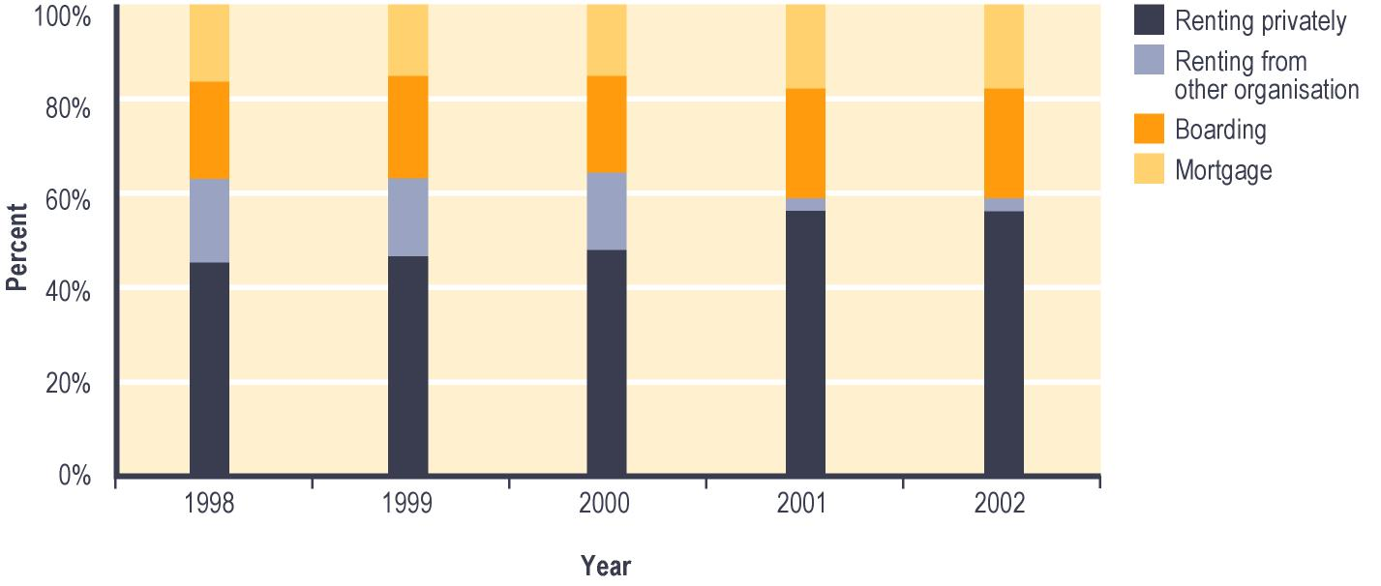

Notes:

1 Percent of clients recorded in SWIFTT as receiving Accommodation Supplement at 30 June.

Trends in proportion of people aged 18 years or over receiving an Accommodation Supplement
Since 1998, between 9% and 11% of people aged 18 years or over have been receiving an Accommodation Supplement. Over this period, a higher proportion of 18-39 year olds than of people aged 40 or over have been receiving an Accommodation Supplement (see Figure 4.2). This reflects (in part) the tendency for older people to be more likely than younger people to own their own home.

The proportion of people aged 18 years or over who were receiving an Accommodation Supplement increased slightly between 1998 and 1999, then decreased over the last two years (see Figure 4.2). This reflects the impacts of changes in the numbers of people receiving core benefits (which in turn reflects in part changing economic conditions) and the re-introduction of income-related rents in December 2000. The re-introduction of income-related rents resulted in a particularly steep decrease between 2000 and 2001 in the number of Accommodation Supplements received.

Figure 4.2 – Trends in the proportion¹ of people aged 18 or over receiving an Accommodation Supplement, by age

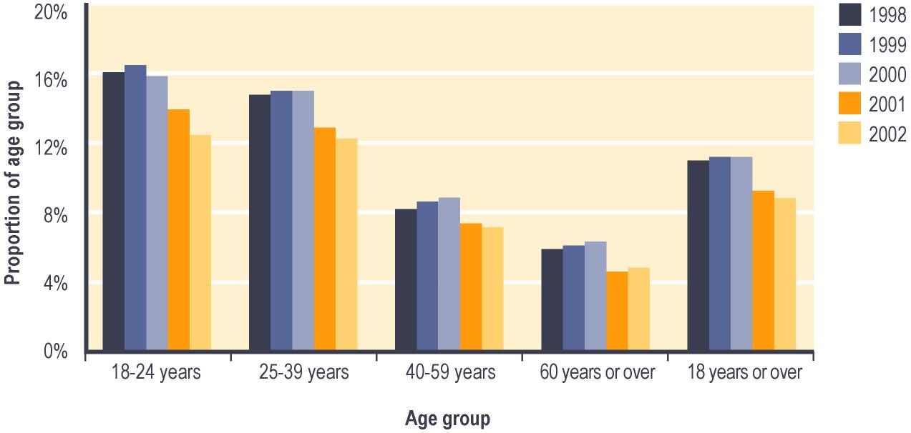

Notes:

1 Proportion shows:

a The number of people in age group recorded in SWIFTT as receiving an Accommodation Supplement at 30 June; divided by

b Statistics New Zealand estimates of the population in age group at 30 June.

Trends in Accommodation Supplements granted
The number of Accommodation Supplements granted each year has fallen for the last four years (see Table 4.2). This is likely to reflect (in part) the combined impact of economic changes (with the associated change in the number of people receiving core benefits), and of the re-introduction of income-related rents for state houses. Since 1997/1998, between 37% and 42% of Accommodation Supplements granted in each year have been provided to people who were aged 16-24 years, while between 38% and 40% have been provided to people aged 25-39 years.

Table 4.2 – Trends in numbers of Accommodation Supplements granted
Age when Accommodation Supplement granted | Number of Accommodation Supplements granted¹
 | 1997/1998 | 1998/1999 | 1999/2000 | 2000/2001 | 2001/2002
 | Number | Number | Number | Number | Number
16-24 years | 163,356 | 124,210 | 101,619 | 98,821 | 91,713
25-39 years | 125,077 | 116,848 | 111,067 | 104,375 | 96,149
40-59 years | 54,246 | 55,071 | 53,016 | 50,946 | 48,980
60 years or over | 9,366 | 11,708 | 9,430 | 9,033 | 10,382
Unspecified | 45 | 52 | 39 | 40 | 11
Total | 325,090 | 307,889 | 275,171 | 263,215 | 247,235

Notes:

1 Numbers of applications for Accommodation Supplement resulted as successful in SWIFTT during years ended 30 June.

Expenditure on Accommodation Supplements
Annual expenditure on Accommodation Supplements increased between 1991/1992 and 1999/2000, but decreased over the last two years (see Table 4.3). Annual expenditure on Accommodation Supplements has been driven strongly by numbers receiving these supplementary benefits, which in turn are significantly affected by economic conditions and by policy related to rents for state houses.

Table 4.3 – Annual expenditure on Accommodation Supplements
Year ended 30 June | Expenditure on Accommodation Supplements¹ ($ million)
1991/1992 | 174
1992/1993 | 206
1993/1994 | 337
1994/1995 | 483
1995/1996 | 551
1996/1997 | 648
1997/1998 | 777
1998/1999 | 831
1999/2000 | 852
2000/2001 | 790
2001/2002 | 711

Notes:

1 Expenditure on Accommodation Supplements in years ended 30 June.

Monthly expenditure on Accommodation Supplements shows small seasonal peaks in summer (see Figure 4.3). These reflect the seasonal peak in core benefit uptake which occurs around this time.

Figure 4.3 – Trends in monthly expenditure on Accommodation Supplement¹

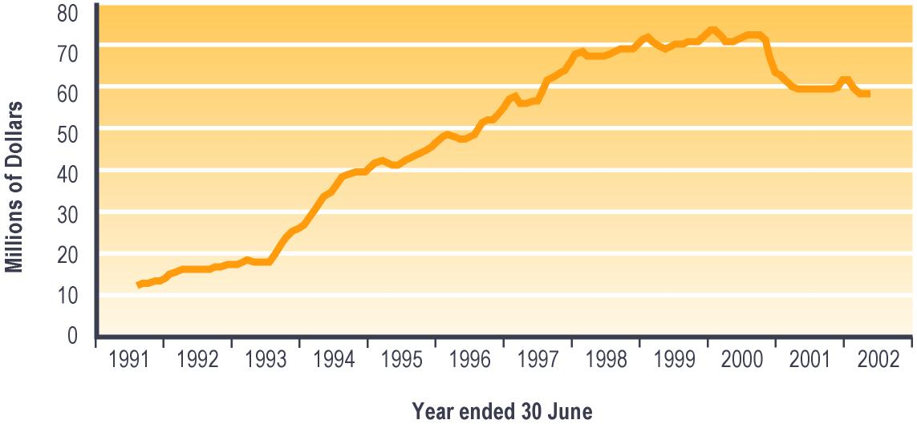

Notes:

1 Expenditure is adjusted for the number of payments per month, and smoothed using a two-month moving average. Accommodation Supplements are not subject to taxation.

Tenure Protection Allowance
Tenure Protection Allowances were paid to selected tenants in Housing New Zealand Corporation or Te Puni Kökiri housing who would face difficulty as a result of market-related rents if they were required to move to other accommodation. Tenure Protection Allowances were set at the difference between:
- the actual market rent payable
- the average rent for a household of the same size in the same region.

In total, about 90% of those who received a Tenure Protection Allowance did so under the special criteria for persons aged 65 years or over set up at 1 October 1992. These criteria allowed people to receive an Allowance in recognition of the fact that it was inappropriate to require these people to move from their home.

Tenure Protection Allowances were a transitional provision for eligible tenants who were residing in state houses on 1 October 1992. It was abolished following the re-introduction of income-related rents for state houses.

Trends in numbers receiving a Tenure Protection Allowance
The number of people receiving a Tenure Protection Allowance decreased from 1997/1998 to 1999/2000 (see Table 4.4). The programme ended during the 1999/2000 financial year. Since 1997/1998, around 92% of the people receiving a Tenure Protection Allowance were aged 60 years or over. This reflects the fact that about 90% of those receiving a Tenure Protection Allowance did so under the special criteria for persons aged 65 years or over set up at 1 October 1992.

Table 4.4 – Trends in the numbers of people receiving a Tenure Protection Allowance
Clients receiving a Tenure Protection Allowance | Clients receiving a Tenure Protection Allowance¹
 | 1998 | 1999 | 2000
 | Number | Number | Number
Total | 5,897 | 5,103 | 4,413

Notes:

1 Numbers recorded in SWIFTT as receiving a Tenure Protection Allowance at 30 June.

Special Transfer Allowance
Special Transfer Allowances were introduced on 1 October 1996 to provide ongoing assistance to those who previously qualified for a Tenure Protection Allowance but who lost that entitlement when they moved from their Housing New Zealand Corporation property. Entitlement to a Tenure Protection Allowance was lost whether tenants moved to another Housing New Zealand Corporation property or to a property rented from another landlord.

Trends in numbers receiving a Special Transfer Allowance
The number of people receiving a Special Transfer Allowance increased between 1998 and 2000 before dropping sharply in 2001, and reducing more slowly in 2002 (see Table 4.5). From December 2000, only those people who rented from a private landlord continued to receive a Special Transfer Allowance.

Since 1998, between 88% and 95% of the clients receiving a Special Transfer Allowance have been aged 60 years or over. This reflects the fact that people receiving a Special Transfer Allowance had previously qualified for a Tenure Protection Allowance. As noted above, over 90% of clients receiving a Tenure Protection Allowance were aged 60 or over.

Table 4.5 – Trends in numbers of people receiving a Special Transfer Allowance
Clients receiving a Special Transfer Allowance | Clients receiving a Special Transfer Allowance¹
 | 1998 | 1999 | 2000 | 2001 | 2002
 | Number | Number | Number | Number | Number
Total | 245 | 308 | 358 | 182 | 152

Notes:

1 Numbers of clients recorded in SWIFTT as receiving a Special Transfer Allowance at 30 June.

Expenditure on Special Transfer Allowance and on Tenure Protection Allowance
Combined annual expenditure on Special Transfer Allowance and on Tenure Protection Allowance has fallen since the 1996/1997 financial year, with a particularly sharp fall in 2000/2001 following the re-introduction of income-related rents and the related abolition of the Tenure Protection Allowance programme (see Table 4.6).

Table 4.6 – Combined annual expenditure on Special Transfer Allowance and on Tenure Protection Allowance

Year ended 30 June | Expenditure on Special Transfer Allowance and on Tenure Protection Allowance¹ ($ million)
1994/1995 | 16
1995/1996 | 17
1996/1997 | 16
1997/1998 | 15
1998/1999 | 13
1999/2000 | 11
2000/2001 | 5
2001/2002 | 0

Notes:

1 Expenditure on Special Transfer Allowance and on Tenure Protection Allowance in years ended 30 June.

Combined monthly expenditure on Tenure Protection Allowance and on Special Transfer Allowance shows little seasonal variation, and largely follows trends in the numbers receiving these supplementary benefits (see Figure 4.4).

Figure 4.4 – Trends in monthly expenditure on Tenure Protection Allowance and Special Transfer Allowance¹

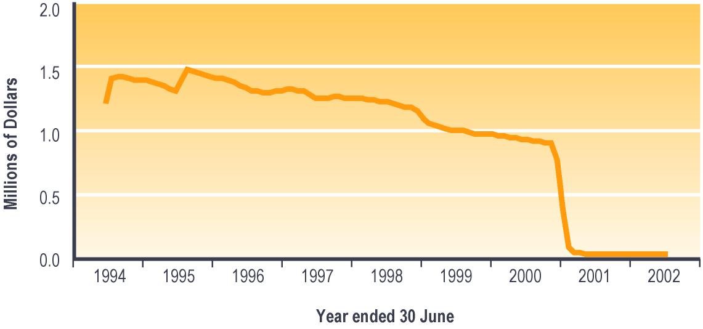

Notes:

1 Expenditure is adjusted for the number of payments per month, and smoothed using a two-month moving average. Tenure Protection Allowance and Special Transfer Allowance are not subject to taxation.

Childcare Subsidy
The Childcare Subsidy programme provides financial assistance to low-income families with dependent children, by assisting with the costs of childcare for children aged under five years (or aged under six years if the caregiver receives a Child Disability Allowance for their child). Childcare Subsidies provide assistance with the cost of licensed childcare, family day care projects and chartered Te Kohanga Reo.

A policy change in July 1993 restricted the Childcare Subsidy for those people not in education, training or employment to a maximum of nine hours per week. This applied to new applicants from that date and was extended to existing recipients from early 1994.

Please note that the count of children covered by a Childcare Subsidy in June 1999 may be affected by volatility in data due to system changes being made at this time. In addition, prior to February 1999, payments were made manually and some children were recorded on the system although no payments were made in respect of them. The numbers of children covered by a Childcare Subsidy reported prior to February 1999 may therefore overestimate the actual number of children for whom payments were being made.

Please note also that information in this section indicates the number of children covered by Childcare Subsidies received and granted. This information may therefore differ from other published information giving the number of clients receiving or granted Childcare Subsidies for one or more children.

Trends in the number of children covered by a Childcare Subsidy
The number of children covered by a Childcare Subsidy fluctuated markedly between 1998 and 2000, and fell in the last two years (see Table 4.7). As noted above, the fluctuation in 1999 may reflect data volatility due to system changes being made during June 1999.

Since 1998, all of the children covered by a Childcare Subsidy have been aged under five years, apart from a very small number (0.3% or less of the children covered by a Childcare Subsidy) who are aged between five and nine years. This reflects the eligibility criteria for a Childcare Subsidy. Over this period, between 53% and 56% of children covered by a Childcare Subsidy have been cared for by a person receiving a Domestic Purposes Benefit, while about 35% have been cared for by a person receiving no core benefit or pension.

Table 4.7 – Trends in numbers of children covered by a Childcare Subsidy
Core benefit or pension received by carer at 30 June² | Number of children covered by a Childcare Subsidy¹
 | 1998 | 1999 | 2000 | 2001 | 2002
 | Number | Number | Number | Number | Number
Unemployment Benefit³ | 2,564 | 1,795 | 2,137 | 1,718 | 1,378
Domestic Purposes Benefit⁴ | 16,726 | 11,704 | 15,349 | 15,210 | 15,064
Sickness Benefit⁵ | 552 | 318 | 412 | 357 | 373
Invalid’s Benefit | 460 | 302 | 493 | 561 | 598
Widow’s Benefit | 135 | 80 | 125 | 114 | 106
Transitional Retirement Benefit | 6 | 5 | 9 | 14 | 8
New Zealand Superannuation | 37 | 30 | 40 | 30 | 35
Veteran’s Pension | 1 | 1 | 0 | 1 | 1
No core benefit or pension | 10,533 | 7,791 | 10,118 | 9,869 | 9,038
Total | 31,014 | 22,026 | 28,683 | 27,874 | 26,601

Notes:

1 Numbers of children recorded in SWIFTT as being covered by a Childcare Subsidy at 30 June.

2 Because Childcare Subsidies are income tested, the carers of children covered by a Childcare Subsidy who are receiving an Unsupported Child’s Benefit or an Orphan’s Benefit will also be receiving another core benefit or low income from employment. To avoid double counting, children covered by a Childcare Subsidy who are cared for by recipients of Unsupported Child’s Benefits or Orphan’s Benefits are shown as:

a) cared for by people receiving no core benefit or pension (if the carer is receiving a low income from employment) or

b) cared for by people receiving one of the benefits or pensions listed (if the carer is receiving another core benefit or pension).

3 Includes Unemployment Benefit, Unemployment Benefit – Hardship, Unemployment Benefit – Hardship – Student, Unemployment Benefit – Training, Unemployment Benefit – Hardship – Training, Emergency Benefit and Independent Youth Benefit.

4 Includes Domestic Purposes Benefit – Sole Parent, Domestic Purposes Benefit – Caring for the Sick and Infirm, Domestic Purposes Benefit – Woman Alone, and Emergency Maintenance Allowance.

5 Includes Sickness Benefit and Sickness Benefit – Hardship.

Trends in the proportion of preschool children covered by a Childcare Subsidy
Since 1998, about 10% of children aged under five years have been covered by a Childcare Subsidy. This proportion reached 7% in 1999, which may reflect data volatility arising from system changes at that time.

Trends in granting Childcare Subsidies
The number of Childcare Subsidies granted each year increased between 1997/1998 and 1999/2000, but has decreased for the last two years (see Table 4.8).

Table 4.8 – Trends in numbers of Childcare Subsidies granted
Childcare Subsidies granted | Childcare Subsidies granted¹
 | 1997/1998 | 1998/1999 | 1999/2000 | 2000/2001 | 2001/2002
 | Number | Number | Number | Number | Number
Total | 39,397 | 41,743 | 53,679 | 45,615 | 42,266

Notes:

1 Numbers of applications for Childcare Subsidies resulted as successful in SWIFTT during years ended 30 June
Since 1997/1998, between 50% and 58% of the Childcare Subsidies granted each year were provided because carers had insufficient income to pay for childcare. Over the same period, between 21% and 24% of the Childcare Subsidies granted each year were provided because carers were in employment, and between 18% and 21% were provided because carers were in training or education.

OSCAR (Out of School Care and Recreation) Subsidy
This subsidy pays for out of school care for children aged between five and 13 years.

The OSCAR Subsidy was introduced in February 1999, and provides assistance with the cost of approved out of school care and holiday programmes.

Please note that the information given below shows the numbers of children covered by OSCAR Subsidies received and OSCAR Subsidies granted. This information may therefore differ from other published information showing the number of clients receiving or granted OSCAR Subsidies for one or more children.

Trends in the number of children covered by OSCAR Subsidy
The number of children covered by an OSCAR Subsidy increased between 1999 and 2001, but decreased in 2002 (see Table 4.9). Since 1999, between 50% and 54% of the children covered by an OSCAR Subsidy have been cared for by people receiving no core benefit or pension, and between 44% and 48% by a person receiving a Domestic Purposes Benefit. Over the same period, between 82% and 84% of children covered by an OSCAR Subsidy were aged between five and nine years.

Table 4.9 – Trends in the ages of children covered by an OSCAR Subsidy
Age of children covered by an OSCAR subsidy at 30 June | Number of children covered by an OSCAR Subsidy¹
 | 1999 | 2000 | 2001 | 2002
 | Number | Number | Number | Number
5-9 years | 500 | 1,428 | 1,631 | 1,534
10-14 years | 94 | 297 | 368 | 347
Total | 594 | 1,725 | 1,999 | 1,881

Notes:

1 Numbers of children recorded in SWIFTT as being covered by an OSCAR Subsidy at 30 June.

Trends in the proportion of children aged between five and 14 years covered by an OSCAR Subsidy
Since 1999, a very small number (0.3% or less) of children aged five to 14 years inclusive have been covered by an OSCAR Subsidy. Over this period, a significantly higher proportion of children aged between five and nine years than of children aged between 10 and 14 years have been covered by an OSCAR Subsidy (see Figure 4.5).

The proportion of children aged five to 14 years who were covered by an OSCAR Subsidy rose slightly between 1999 and 2000, and has remained stable since (see Figure 4.5).

This is likely to reflect increased awareness and uptake of the Subsidy following its introduction.

Figure 4.5 – Trends in the proportion¹ of children aged between five and 14 years covered by a OSCAR Subsidy, by age

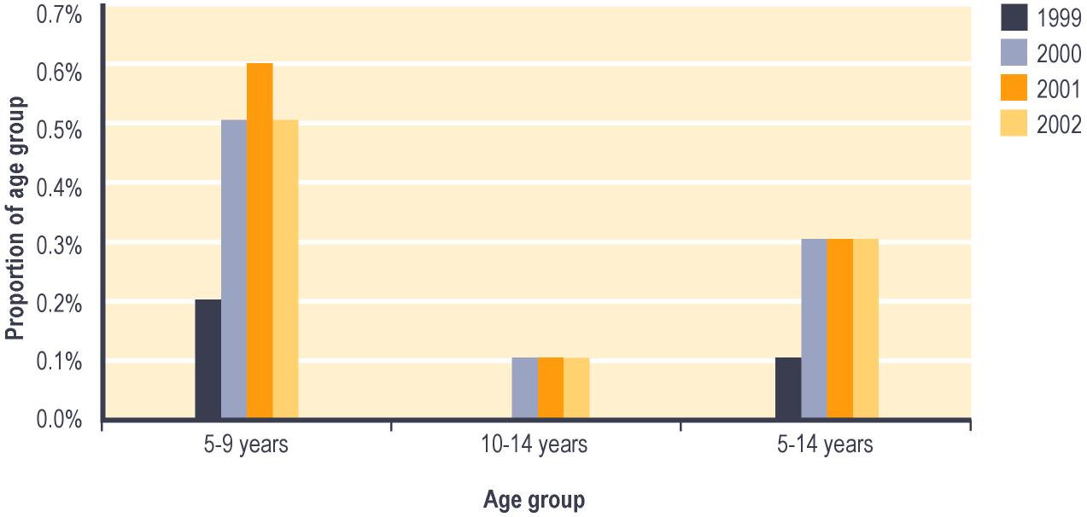

Notes:

1 Proportion shows:

a Numbers of children in age group recorded in SWIFTT as covered by OSCAR Subsidies current at 30 June; divided by

b Statistics New Zealand estimates of population in age group at 30 June.

Trends in OSCAR Subsidies granted
Since the 1998/1999 financial year, the number of times OSCAR Subsidies are granted each year has increased. Over this period, the proportion of OSCAR Subsidies granted each year which covered children aged five to nine years decreased from 83% to 78%, while the proportion covering children aged 10-14 years increased from 16% to 21% (see Table 4.10).

Table 4.10 – Trends in numbers of OSCAR Subsidies granted
Age when OSCAR Subsidy granted | OSCAR Subsidies granted¹
 | 1998/1999 | 1999/2000 | 2000/2001 | 2001/2002
 | Number | Number | Number | Number
0-4 years | 20 | 34 | 22 | 17
5-9 years | 2,471 | 7,228 | 7,951 | 8,057
10-14 years | 456 | 1,667 | 2,107 | 2,207
Total | 2,947 | 8,929 | 10,080 | 10,281

Notes:

1 Numbers of applications for OSCAR Subsidies resulted as successful in SWIFTT during years ended 30 June.

Since 1998/1999, the proportion of OSCAR Subsidies granted which covered children whose carers are in employment increased from 65% to 75%.

Expenditure on Childcare Subsidy and OSCAR Subsidies
Combined annual expenditure on Childcare Subsidies and OSCAR Subsidies increased significantly between 1991/1992 and 1993/1994, then reduced in 1994/1995 before beginning a steady increase which has persisted over the last eight years (see Table 4.11).

The imposition from 1 July 1993 of a maximum of nine hours care per week for people not in education, training or employment reduced costs in 1994/1995 compared to the previous two years. From 1 April 1996, Childcare Subsidy payments have been adjusted by the Consumers Price Index, and these adjustments have contributed to the steady increases in expenditure on Childcare Subsidies since this time. The introduction of OSCAR Subsidy from 1 February 1999 also contributed to expenditure on Childcare and OSCAR Subsidies over the last three years being higher than in earlier years.

Table 4.11 – Combined annual expenditure on Childcare Subsidies and on OSCAR Subsidies
Year ended 30 June | Expenditure on Childcare Subsidies and on OSCAR Subsidies¹  ($ million)
1991/1992 | 15
1992/1993 | 38
1993/1994 | 39
1994/1995 | 31
1995/1996 | 34
1996/1997 | 37
1997/1998 | 40
1998/1999 | 49
1999/2000 | 51
2000/2001 | 52
2001/2002 | 56

Notes:

1 Expenditure on Childcare Subsides and on OSCAR Subsidies in years ended 30 June.

The strong seasonal pattern in monthly expenditure on Childcare and OSCAR Subsidies shown in Figure 4.6 reflects higher demand for this assistance during the school/academic year, and a decrease in demand over the summer vacation period.

Figure 4.6 – Trends in monthly expenditure on Childcare Subsidies and OSCAR Subsidies¹

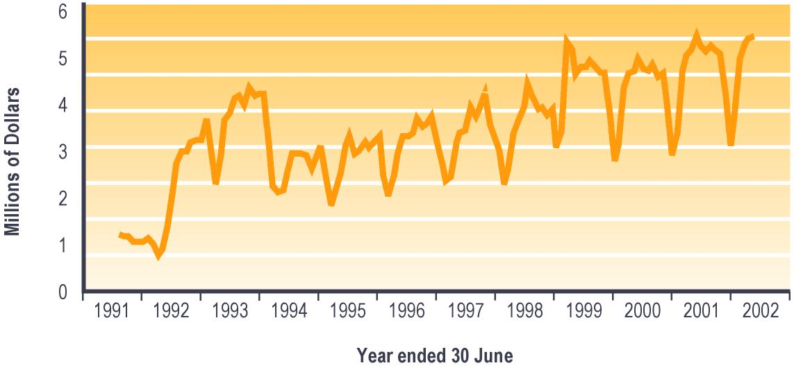

Notes:

1 Expenditure is adjusted for the number of payments per month, and smoothed using a two-month moving average. Childcare Subsidies and OSCAR Subsidies are not subject to taxation.

Disability Allowance
Please note that information reported below for Disability Allowance combines information on Disability Allowance, Disability Allowance – Telephone Support, and Disability Assistance Programmes. Please note also that information on Disability Allowance shows the number of people covered by the Disability Allowances received or granted. This information may therefore differ from other published information which shows the number of clients receiving or granted Disability Allowances which cover one or more people.

Eligibility for Disability Allowance and related programmes

Disability Allowance
A Disability Allowance reimburses people for many types of actual and ongoing regular costs that they incur because they have a disability or a personal health need. In general, it only covers costs which are not funded, subsidised or otherwise covered by other agencies. An income test also applies.

A Disability Allowance is payable to people who have:
- a disability which:
1) means they require ongoing help with normal living tasks or ongoing health care
2) is likely to last at least six months
- extra ongoing costs directly related to their disability.

People receiving ACC support for extra costs related to their disability cannot receive a Disability Allowance for those same costs. Just under half of those receiving a Disability Allowance are also receiving New Zealand Superannuation.

Disability Allowance – Telephone Support
Disability Allowance – Telephone Support (also known as Telephone Costs payment) provides telephone subsidies to people who:
- were in receipt of telephone subsidies as at 31 March 1999 but
- would lose their entitlement to these subsidies if they were assessed under the Disability Allowance criteria effective from 1 April 1999.

Disability Assistance Programme
The Disability Assistance Programme provided assistance to people receiving New Zealand Superannuation or a Veteran’s Pension who failed the income test for a Disability Allowance due to the 1 April 2000 increase in the payment rates for New Zealand Superannuation and for Veteran’s Pension.

This programme preserved the entitlement of these people to assistance equivalent to a Disability Allowance. The programme ceased on 31 March 2001, due to income thresholds for a Disability Allowance being increased from 1 April 2001.

Trends in numbers covered by a Disability Allowance
The number of people covered by a Disability Allowance has increased steadily since 1998, with the increase slowing between 1998 and 1999 but increasing again over the last three years. Over this period, the proportion of people covered by a Disability Allowance who are receiving New Zealand Superannuation has increased from 44% to 48% (see Table 4.12). This change is likely to reflect in part the ageing of the New Zealand population.

Table 4.12 – Trends in types of core benefit or pension received by people covered by Disability Allowance or their carers
Type of core benefit or pension received at 30 June | Number of clients covered by Disability Allowance¹
 | 1998 | 1999 | 2000 | 2001 | 2002
 | Number | Number | Number | Number | Number
Unemployment Benefit² | 8,748 | 9,585 | 9,404 | 9,118 | 8,641
Domestic Purposes Benefit³ | 25,230 | 22,389 | 21,185 | 20,840 | 20,995
Sickness Benefit⁴ | 15,956 | 15,292 | 14,953 | 15,744 | 16,936
Invalid’s Benefit | 36,772 | 37,924 | 41,213 | 45,137 | 49,023
Widow’s Benefit | 2,372 | 2,252 | 2,251 | 2,406 | 2,456
Unsupported Child’s Benefit/ Orphan’s Benefit | 191 | 197 | 206 | 234 | 253
Transitional Retirement Benefit | 2,629 | 3,049 | 3,179 | 3,324 | 1,917
New Zealand Superannuation | 74,708 | 79,407 | 85,454 | 92,002 | 98,191
Veteran’s Pension | 1,703 | 1,866 | 2,030 | 2,319 | 2,546
No core benefit or pension | 3,014 | 3,139 | 3,539 | 4,022 | 4,215
Total | 171,323 | 175,100 | 183,414 | 195,146 | 205,173

Notes:

1 Numbers recorded in SWIFTT as covered by Disability Allowance at 30 June.

2 Includes Unemployment Benefit, Unemployment Benefit – Hardship, Unemployment Benefit – Hardship – Student, Unemployment Benefit – Training, Unemployment Benefit – Hardship – Training, Emergency Benefit and Independent Youth Benefit.

3 Includes Domestic Purposes Benefit – Sole Parent, Domestic Purposes Benefit – Caring for the Sick and Infirm, Domestic Purposes Benefit – Woman Alone, and Emergency Maintenance Allowance.

4 Includes Sickness Benefit and Sickness Benefit – Hardship.

Trends in proportion of New Zealand population covered by a Disability Allowance
Since 1998, between 4% and 5% of the New Zealand population have been covered by a Disability Allowance. Over this period, the proportion of people aged 60 years or over who were covered by a Disability Allowance has been significantly higher than the proportion of younger people covered by a Disability Allowance (see Figure 4.7).

Figure 4.7 – Trends in the proportion¹ of the New Zealand population covered by a Disability Allowance, by age

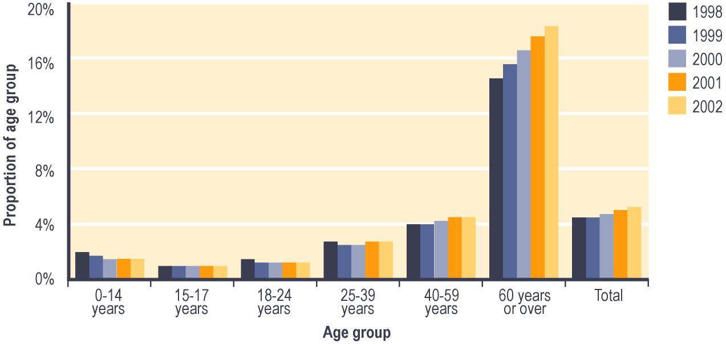

Notes:

1 Proportion shows:

a Number of people in each age group recorded in SWIFTT as being covered by a Disability Allowance at 30 June; divided by

b Statistics New Zealand estimate of population in age group at 30 June.

Trends in granting Disability Allowance
The number of times Disability Allowance is granted each year decreased between 1997/1998 and 1999/2000, but has increased over the last two years. Since 1997/1998, the proportion of Disability Allowances granted each year which have covered people who were aged 60 years or over has increased from 30% to 36%, while the proportion covering people aged under 15 years has shown a corresponding decrease (see Table 4.13).

Table 4.13 – Trends in ages of people covered by Disability Allowances granted
Age when Disability Allowance granted | Number of Disability Allowances granted¹
 | 1997/1998 | 1998/1999 | 1999/2000 | 2000/2001 | 2001/2002
 | Number | Number | Number | Number | Number
0-14 years | 11,088 | 9,307 | 7,773 | 7,196 | 6,821
15-17 years | 643 | 476 | 740 | 942 | 971
18-24 years | 5,943 | 5,234 | 4,417 | 4,776 | 4,903
25-39 years | 15,656 | 14,039 | 13,627 | 14,112 | 14,109
40-59 years | 18,173 | 17,589 | 17,193 | 18,458 | 19,118
60 years or over | 22,541 | 21,885 | 23,337 | 25,081 | 26,200
Unspecified | 1,145 | 689 | 331 | 130 | 26
Total | 75,189 | 69,219 | 67,418 | 70,695 | 72,148

Notes:

1 Numbers of applications for Disability Allowance resulted as successful in SWIFTT during years ended 30 June.

Expenditure on Disability Allowance
Annual expenditure on Disability Allowance has increased steadily since 1991/1992 (see Table 4.14). The general trend to increased expenditure on Disability Allowance reflects at least the increased numbers receiving a Disability Allowance.

Table 4.14 – Annual expenditure on Disability Allowance
Year ended 30 June | Expenditure on Disability Allowance¹ ($ million)
1991/1992 | 66
1992/1993 | 86
1993/1994 | 113
1994/1995 | 128
1995/1996 | 146
1996/1997 | 175
1997/1998 | 195
1998/1999 | 201
1999/2000 | 203
2000/2001 | 217
2001/2002 | 231

Notes:

1 Expenditure on Disability Allowance in years ended 30 June.

Monthly expenditure on Disability Allowance shows no marked seasonal changes, but follows the general pattern of the number of people receiving a Disability Allowance (see Figure 4.8). The slower increase of Disability Allowance expenditure in 1994/1995 was due to revision (effective from 1 July 1994) of the definition of valid reasons for receiving a Disability Allowance.

Figure 4.8 – Trends in monthly expenditure on Disability Allowance¹

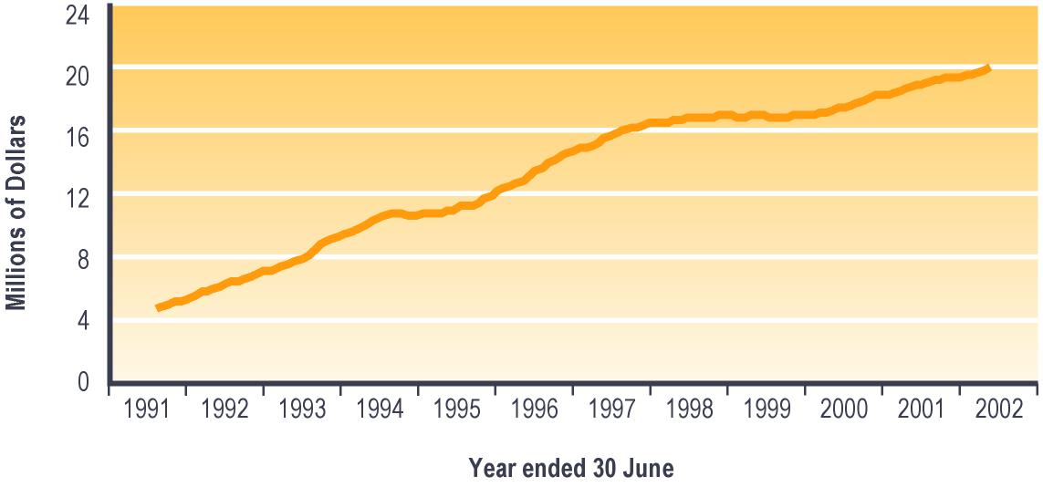

Notes:

1 Expenditure is adjusted for the number of payments per month, and smoothed using a two-month moving average. Disability Allowances are not subject to taxation.

Child Disability Allowance
The Child Disability Allowance is a fortnightly payment that can be made to the parent or guardian of a child with a disability who lives at home and who requires constant care and attention. This allowance is not means tested.

Just under a fifth of the children covered by a Child Disability Allowance are also covered by a Disability Allowance, which covers the direct costs arising from the child’s disability.

Please note that information in this section shows the number of children covered by a Child Disability Allowances received or granted. This information may therefore differ from other published information showing the numbers of clients receiving or granted Child Disability Allowances which cover one or more children.

Trends in number of children covered by a Child Disability Allowance
Since 1998, the number of children covered by a Child Disability Allowance has increased steadily (see Table 4.15).

Table 4.15 – Trends in the numbers of children covered by a Child Disability Allowance
Children covered by Child Disability Allowances | Number of children covered by a Child Disability Allowance¹
 | 1998 | 1999 | 2000 | 2001 | 2002
 | Number | Number | Number | Number | Number
Total | 17,587 | 19,320 | 20,864 | 21,724 | 23,748

Notes:

1 Numbers of children recorded in SWIFTT as being covered by Child Disability Allowance at 30 June.

Since 1998, between 63% and 66% of children covered by a Child Disability Allowance have been cared for by people who are not receiving any core benefit or pension. Over the same period, between 26% and 29% have been cared for by people receiving a Domestic Purposes Benefit.

Trends in the proportion of children aged under 18 years who are covered by a Child Disability Allowance
Since 1998, between 1% and 2% of children aged under 18 years have been covered by a Child Disability Allowance. Over this period, slightly smaller proportions of children aged under five years and of children aged 15-17 years than of children aged between five and 14 years have been covered by a Child Disability Allowance. Since 1998, there has been a slight increase in the proportion of children aged under 18 years who have been covered by Child Disability Allowance (see Figure 4.9).

Figure 4.9 – Trends in the proportion¹ of children aged under 18 covered by Child Disability Allowance, by age

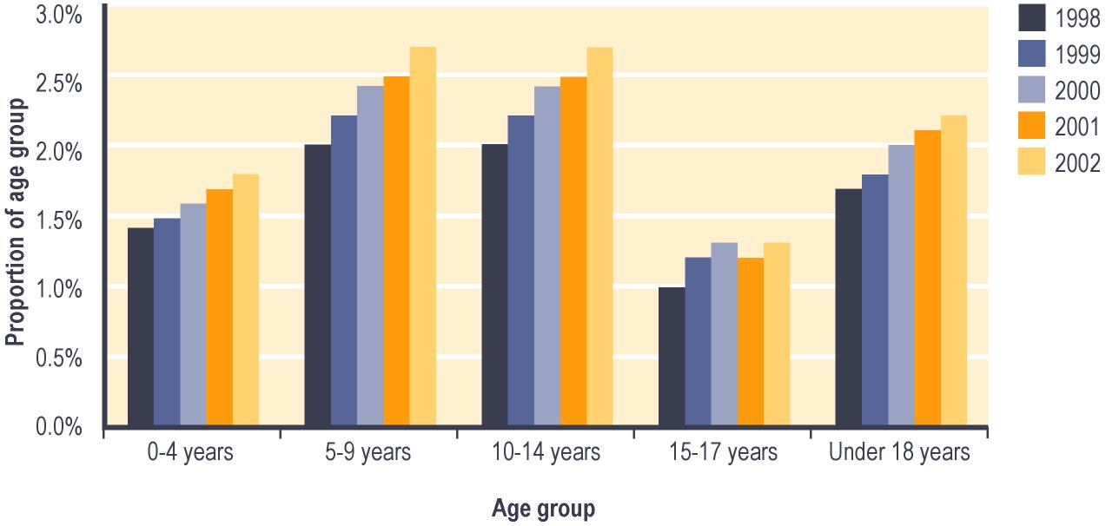

Notes:

1 Proportion shows:

a Number of children in each age group recorded in SWIFTT as being covered at 30 June by Child Disability Allowance paid; divided by

b Statistics New Zealand estimate of population in age group at 30 June.

Trends in Child Disability Allowances granted
Since the 1997/1998 financial year, the number of Child Disability Allowances granted each year has increased (see Table 4.16).

Table 4.16 – Trends in number of Child Disability Allowances granted
Child Disability Allowances granted | Number of Child Disability Allowances granted¹
 | 1997/1998 | 1998/1999 | 1999/2000 | 2000/2001 | 2001/2002
 | Number | Number | Number | Number | Number
Total | 3,708 | 4,070 | 4,743 | 6,205 | 6,341

Notes:

1 Numbers of applications for Child Disability Allowance resulted as successful in SWIFTT during years ended 30 June.

Over this period, between 42% and 45% of Child Disability Allowances granted each year have covered children aged under five years, while about 30% have covered children aged five to nine years.

Expenditure on Child Disability Allowance
Annual expenditure on Child Disability Allowance has increased steadily since 1991/1992, and is driven largely by the number of people receiving the Allowance (see Table 4.17).

Table 4.17 – Annual expenditure on Child Disability Allowance
Year ended 30 June | Expenditure on Child Disability Allowance¹ ($ million)
1991/1992 | 13
1992/1993 | 15
1993/1994 | 17
1994/1995 | 18
1995/1996 | 21
1996/1997 | 25
1997/1998 | 28
1998/1999 | 32
1999/2000 | 35
2000/2001 | 39
2001/2002 | 41

Notes:

1 Expenditure on Child Disability Allowance in years ended 30 June.

Monthly expenditure on Child Disability Allowance shows little seasonal variation, and little change from a steady increase apart from a short halt in late 2000/2001 and early 2001/2002 (see Figure 4.10). This halt in the increase of expenditure on Child Disability Allowances arose from a review of overdue medical reviews, which led to a fall in the number of Child Disability Allowance recipients.

Figure 4.10 – Trends in monthly expenditure on Child Disability Allowance¹

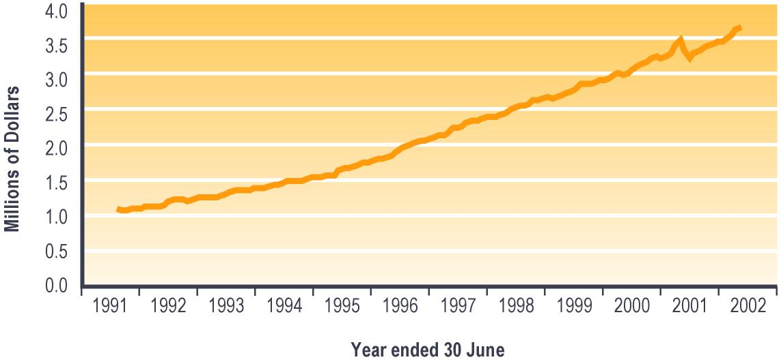

Notes:

1 Expenditure is adjusted for the number of payments per month, and smoothed using a two-month moving average. Child Disability Allowances are not subject to taxation.

Training Incentive Allowance
The Training Incentive Allowance aims to assist people undertaking training or studies that will:
- develop their skills
- improve their prospects of gaining sustainable paid employment.

Training Incentive Allowance is paid to people who are receiving a Domestic Purposes Benefit, a Widow’s Benefit or Invalid’s Benefit.

Training Incentive Allowance contributes toward fees, course costs and associated costs (eg transport, childcare) faced by trainees and students. Training Incentive Allowance may be paid as a lump sum, as an ongoing entitlement, or as a combination of the two.

A number of policy changes were made in the 1998/1999 fiscal year with the intention of targeting expenditure to ensure the greatest benefits for job seekers. These changes included:
- tightening objectives of providing Training Incentive Allowance, particularly a greater focus on training for paid employment
- introduction of co-payment for fees and course costs
- exclusion of people who had completed a degree in the previous five years
- exclusions of Training Opportunities programmes and Work and Income courses
- exclusion of private training establishment courses outside the NZQA accreditation framework.

In the 1999/2000 fiscal year, Training Incentive Allowance was restored to its former level for people undertaking courses subject to the co-payment regime. Other policy changes in 1999/2000 were:
- that the maximum amount of Training Incentive Allowance will be adjusted on 1 April each year to reflect the change in the cost of living over the previous 12 months
- permitting consideration of granting Training Incentive Allowance to people who have completed a degree in the previous five years when they intend to undertake employment-related courses which are less than 12 weeks long.

Please note that information on Training Incentive Allowance granted provided in this section includes weekly Training Incentive Allowance payments only, while expenditure information includes both weekly and lump sum payments.

Trends in numbers of Training Incentive Allowances granted
Clients may commence and cease receiving weekly Training Incentive Allowance at any point during the year, as their courses begin and end. Training Incentive Allowances granted therefore offers a more complete view of use of this assistance than the numbers of people who are receiving Training Incentive Allowance at any one point in time.

The number of Training Incentive Allowances granted each year has trended downward over the last four years (see Table 4.18).

Table 4.18 – Trends in numbers of Training Incentive Allowances granted
Training Incentive Allowances granted | Number of clients granted Training Incentive Allowance¹
 | 1997/1998 | 1998/1999 | 1999/2000 | 2000/2001 | 2001/2002
 | Number | Number | Number | Number | Number
Total | 28,530 | 25,162 | 21,320 | 21,726 | 21,289

Notes:

1 Numbers of applications for Training Incentive Allowance resulted as successful in SWIFTT during years ended 30 June.

Since 1997/1998, between 87% and 89% of Training Incentive Allowances granted each year have been provided to people who were receiving a Domestic Purposes Benefit. Over the same period, between 57% and 61% of Training Incentive Allowance granted each year were provided to people aged 25-39 years, while between 21% and 23% were provided to people aged 40-59 years.

Expenditure on Training Incentive Allowance
Annual expenditure on Training Incentive Allowance increased between 1991/1992 and 1997/1998. This expenditure then decreased in 1998/1999 before rising between 1998/1999 and 2000/2001, but remained stable over the last year (see Table 4.19). The decrease over 1998/1999, and the resumption of the upward trend in more recent years, reflects in part the impact of the successive policy changes referred to above.

Table 4.19 – Annual expenditure on Training Incentive Allowance
Year ended 30 June | Expenditure on Training Incentive Allowance¹ ($ million)
1991/1992 | 9
1992/1993 | 13
1993/1994 | 17
1994/1995 | 21
1995/1996 | 27
1996/1997 | 29
1997/1998 | 34
1998/1999 | 31
1999/2000 | 35
2000/2001 | 36
2001/2002 | 36

Notes:

1 Expenditure on Training Incentive Allowance in years ended 30 June.

The strong seasonal pattern evident in expenditure on Training Incentive Allowance (see Figure 4.11) arises because most Training Incentive Allowance payments are made at the beginning of the school/academic year, in order to cover one-off costs such as tuition fees. This leads to peaks in expenditure on Training Incentive Allowance at this time as shown in Figure 4.11.

Figure 4.11 – Trends in monthly expenditure on Training Incentive Allowance¹

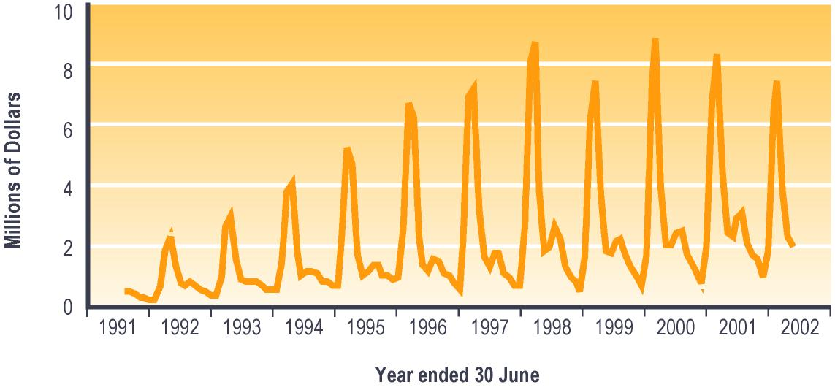

Notes:

1 Expenditure is adjusted for the number of payments per month, and smoothed using a two-month moving average. Training Incentive Allowances are not subject to taxation.

Residential Care Subsidies and Residential Support Subsidies
These subsidies are used to provide financial assistance to clients who have been assessed as requiring long-term residential care but who are unable to pay for the full cost of their care.

Work and Income is responsible for income testing and asset testing clients for these subsidies, and for assessing whether the client can pay for or contribute towards the cost of their care. The Ministry of Health pays these subsidies to the care provider, and to the client’s partner if they continue to live in the community.

When a client in residential care is receiving a core benefit or a pension, they must contribute their core benefit or pension (less a personal allowance) toward the cost of their care.

Eligibility for Residential Care Subsidies and for Residential Support Subsidies

Residential Care Subsidies
Residential Care Subsidies may be payable to people who are:
- aged 65 years or over or
- aged 50-64 years, single with no dependent children, and assessed by the Ministry of Health as being “close in interest” to people aged over 65 years.

Residential Care Subsidies are payable to eligible clients who require residential care disability services indefinitely.

Residential Support Subsidies
Residential Support Subsidies may be payable to people who are aged under 65 years who are assessed as having a need for support due to physical disability, intellectual disability or psychiatric disability (including drug and alcohol rehabilitation). To receive a Residential Support Subsidy, the client must have been assessed as needing to have their need for support met by a residential care facility that has been contracted by the Ministry of Health.

Trends in numbers of people receiving a Residential Care Subsidy or a Residential Support Subsidy
The number of people receiving Residential Care Subsidies or Residential Support Subsidies increased between 1998 and 2001, but declined in 2002 (see Table 4.20).

Table 4.20 – Trends in numbers of people receiving a Residential Care Subsidy or a Residential Support Subsidy
Residential Care Subsidies and Residential Support Subsidies received | Number clients receiving a Residential Care Subsidy or a Residential Support Subsidy¹
 | 1998 | 1999 | 2000 | 2001 | 2002
 | Number | Number | Number | Number | Number
Total | 21,475 | 22,624 | 23,200 | 23,319 | 22,938

Notes:

1 Numbers recorded in SWIFTT as receiving a Residential Support Subsidy or a Residential Care Subsidy at 30 June.

Since 1998, about 69% of people receiving Residential Care Subsidies or Residential Support Subsidies have been aged 60 years or over. Over the same period, between 63% and 65% of these people have been receiving New Zealand Superannuation, while between 30% and 32% have been receiving an Invalid’s Benefit.

Trends in Residential Care Subsidies and Residential Support Subsidies granted
The number of times Residential Care Subsidies or Residential Support Subsidies are granted each year has decreased over the last four years (see Table 4.21).

Table 4.21 – Trends in the total number of Residential Care Subsidies and Residential Support Subsidies granted
Residential Care Subsidies and Residential Support Subsidies granted | Residential Care Subsidies and Residential Support Subsidies granted¹
 | 1997/1998 | 1998/1999 | 1999/2000 | 2000/2001 | 2001/2002
 | Number | Number | Number | Number | Number
Total | 12,669 | 10,794 | 10,337 | 9,097 | 8,742

Notes:

1 Number of applications for Residential Care Subsidies and Residential Support Subsidies resulted as successful in SWIFTT during years ended 30 June.

Emergency or hardship assistance
This consists of:
- Special Benefits, which may be paid as a weekly benefit or as a lump sum
- several other types of assistance paid as lump sums.

Special Benefit
Please note that information in this section only refers to numbers of people receiving or granted an ongoing weekly Special Benefit. This information may therefore differ from other published information which includes both weekly Special Benefits and lump sum payments of Special Benefit.

Special Benefit may be paid to people receiving core benefits or any other low income earners. To receive Special Benefit, clients must:
- have insufficient income to meet ongoing essential expenses
- be in individual circumstances which warrant receiving a Special Benefit.

In July 1995, about 1,900 people receiving maximised Special Benefits to cover institutional boarding costs had their costs transferred to Vote: Health.

Trends in people receiving weekly Special Benefit
The number of people receiving a weekly Special Benefit decreased between 1998 and 2000, then increased sharply over the last two years. Since 1998, between 36% and 45% of people receiving a weekly Special Benefit have been receiving a Domestic Purposes Benefit. Over the same period, the proportion of recipients of weekly Special Benefits who are receiving an Invalid’s Benefit has increased from 17% to 25% (see Table 4.22). This reflects changes among all people receiving core benefits.

Table 4.22 – Trends in core benefits or pensions provided to recipients of a weekly Special Benefit
Core benefit or pension received at 30 June | Clients receiving a weekly Special Benefit¹
 | 1998 | 1999 | 2000 | 2001 | 2002
 | Number | Number | Number | Number | Number
Unemployment Benefit² | 3,393 | 2,304 | 1,764 | 2,071 | 2,190
Domestic Purposes Benefit³ | 8,055 | 4,858 | 3,893 | 4,944 | 6,563
Sickness Benefit⁴ | 2,019 | 1,413 | 1,323 | 1,565 | 1,992
Invalid’s Benefit | 2,950 | 2,559 | 2,822 | 3,238 | 3,993
Widow’s Benefit | 388 | 246 | 185 | 189 | 230
Unsupported Child’s Benefit/ Orphan’s Benefit | 1 | 1 | 0 | 1 | 0
Transitional Retirement Benefit | 75 | 63 | 54 | 47 | 42
New Zealand Superannuation | 368 | 248 | 190 | 199 | 259
Veteran’s Pension | 3 | 3 | 1 | 4 | 6
No core benefit or pension | 631 | 435 | 486 | 789 | 951
Total | 17,883 | 12,130 | 10,718 | 13,047 | 16,226

Notes:

1 Numbers recorded in SWIFTT as receiving a weekly Special Benefit at 30 June.

2 Includes Unemployment Benefit, Unemployment Benefit – Hardship, Unemployment Benefit – Hardship – Student, Unemployment Benefit – Training, Unemployment Benefit – Hardship – Training, Emergency Benefit and Independent Youth Benefit.

3 Includes Domestic Purposes Benefit – Sole Parent, Domestic Purposes Benefit – Caring for the Sick and Infirm, Domestic Purposes Benefit – Woman Alone, and Emergency Maintenance Allowance.

4 Includes Sickness Benefit and Sickness Benefit – Hardship.

Since 1998, between 52% and 61% of people receiving a weekly Special Benefit have been living with at least one dependent child aged under 14 years.

Trends in the proportion of people aged 18 years or over receiving a weekly Special Benefit
Since 1998, about 1% of people aged 18 years or over have received a weekly Special Benefit. Over this period, a higher proportion of 25-59 year olds than of younger or older people have been receiving a weekly Special Benefit (see Figure 4.12), which may reflect the predominance of people with dependent children among those receiving a weekly Special Benefit.

The proportion of people aged 18 years or over who are receiving a weekly Special Benefit decreased between 1998 and 1999, but has risen slightly over the last two years (see Figure 4.12).

Figure 4.12 – Trends in the proportion¹ of people aged 18 years or over receiving a weekly Special Benefit, by age

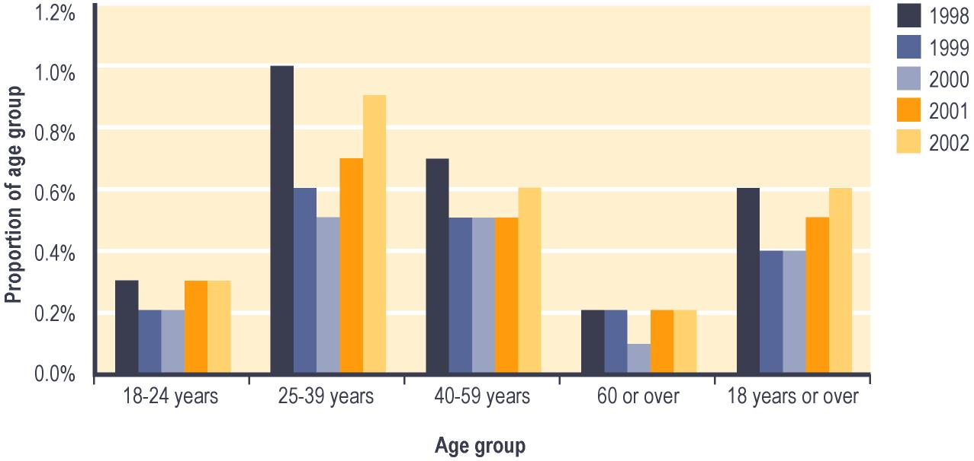

Notes:

1 Proportion shows:

a Number of people in each age group recorded in SWIFTT as receiving a Special Benefit at 30 June; divided by

b Statistics New Zealand estimate of population in age group at 30 June.

Trends in granting weekly Special Benefits
The number of times weekly Special Benefits are granted each year decreased between 1997/1998 and 1999/2000, but increased sharply over the last two years (see Table 4.23).

Since 1997/1998, between 30% and 33% of weekly Special Benefits granted each year have been provided to people receiving a Domestic Purposes Benefit. Between 1998/1999 and 1999/2000, the proportion of weekly Special Benefits granted each year which were provided to people receiving an Unemployment Benefit decreased from 37% to 29%, but has remained relatively stable for the last two years (see Table 4.23).

Table 4.23 – Trends in types of core benefit or pension provided to clients granted a weekly Special Benefit
Type of core benefit or pension received when weekly Special Benefit granted | Weekly Special Benefits granted¹
 | 1997/  1998 | 1998/  1999 | 1999/  2000 | 2000/  2001 | 2001/  2002
 | Number | Number | Number | Number | Number
Unemployment Benefit² | 7,196 | 5,740 | 4,097 | 5,959 | 6,347
Domestic Purposes Benefit³ | 6,950 | 4,680 | 4,364 | 6,831 | 8,306
Sickness Benefit⁴ | 3,199 | 2,401 | 2,491 | 3,467 | 4,224
Invalid’s Benefit | 1,931 | 1,570 | 1,928 | 2,780 | 3,055
Widow’s Benefit | 244 | 163 | 158 | 250 | 260
Unsupported Child’s Benefit/ Orphan’s Benefit | 1 | 1 | 1 | 4 | 0
Transitional Retirement Benefit | 83 | 53 | 52 | 70 | 58
New Zealand Superannuation | 269 | 158 | 162 | 197 | 222
Veteran’s Pension | 2 | 4 | 1 | 7 | 6
No core benefit or pension | 1,232 | 929 | 1,011 | 1,749 | 2,282
Total | 21,107 | 15,699 | 14,265 | 21,314 | 24,760

Notes:

1 Numbers of applications for weekly Special Benefit resulted as successful in SWIFTT during years ended 30 June.

2 Includes Unemployment Benefit, Unemployment Benefit – Hardship, Unemployment Benefit – Hardship – Student, Unemployment Benefit – Training, Unemployment Benefit – Hardship – Training, Emergency Benefit and Independent Youth Benefit.

3 Includes Domestic Purposes Benefit – Sole Parent, Domestic Purposes Benefit – Caring for the Sick and Infirm, Domestic Purposes Benefit – Woman Alone, and Emergency Maintenance Allowance.

4 Includes Sickness Benefit and Sickness Benefit – Hardship.

Expenditure on Special Benefit
Expenditure on Special Benefit increased between 1991/1992 and 1995/1996, decreased between 1996/1997 and 1999/2000, then increased over the last two years (see Table 4.24). The pattern of annual expenditure on Special Benefit largely reflects the numbers of people receiving Special Benefit.

Table 4.24 – Annual expenditure on Special Benefit
Year ended 30 June | Expenditure on Special Benefits¹ ($ million)
1991/1992 | 53
1992/1993 | 62
1993/1994 | 67
1994/1995 | 80
1995/1996 | 87
1996/1997 | 74
1997/1998 | 59
1998/1999 | 44
1999/2000 | 34
2000/2001 | 39
2001/2002 | 48

Notes:

1 Expenditure on Special Benefits in years ended 30 June.

Monthly expenditure on Special Benefits shows little seasonal variation, and tends to follow patterns in the numbers of people receiving Special Benefits (see Figure 4.13). The spike in expenditure on Special Benefit towards the end of 1994/1995 reflects the April 1995 increase in the average rate of Special Benefit, followed by the July 1995 transfer to Vote: Health of “maximised” Special Benefit to cover institutional boarding costs.

Figure 4.13 – Trends in monthly expenditure on Special Benefit¹

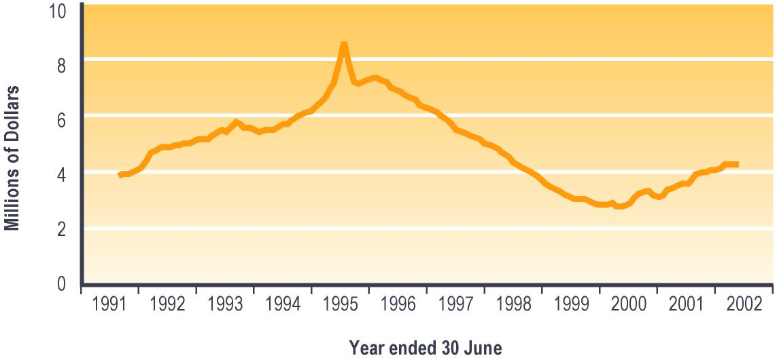

Notes:

1 Expenditure is adjusted for the number of payments per month, and smoothed using a two-month moving average. Special Benefits are not subject to taxation.

Emergency or hardship assistance available as lump sums
A range of emergency or hardship assistance is only available as a lump sum. These are: Special Needs Grants, Recoverable Assistance Programme grants, and benefit advances.

Please note that all information in this section excludes Special Benefit lump sums.

Eligibility for lump sum emergency or hardship assistance

Special Needs Grants
Special Needs Grants are ad hoc payments made to those who have an immediate need or an emergency and have no other way of paying for what they need. Some Special Needs Grants are recoverable (ie they have to be repaid to Work and Income) while others are not.

Special Needs Grants are available to people who are not receiving core benefits as well as to those who are. Residency, income and asset tests apply.

Recoverable Assistance Programme
The Recoverable Assistance Programme was introduced from 1 July 1996, to provide recoverable assistance to low-income earners not receiving core benefits. Any low-income earner may apply for assistance with immediate and essential expenses under the Recoverable Assistance Programme.

This programme was designed to replace most recoverable Special Needs Grants which had previously been available to people who were not receiving benefits.

Residency, income and asset tests apply.

Benefit advances
Advance payments of core benefits are made to enable people receiving a core benefit to meet their immediate and essential needs. The advance is recovered from subsequent payments of the core benefit.

Prior to 9 October 1995, benefit advances were only granted to people who were expected to receive a core benefit for a long time (ie people receiving an Invalid’s Benefit, a Widow’s Benefit, a Domestic Purposes Benefit, an Orphan’s Benefit, and people who had received an Unemployment Benefit for longer than six months). People receiving New Zealand Superannuation or a Veteran’s Pension could be granted advances for a limited range of health-related categories.

Since 9 October 1995, benefit advances of up to six weeks worth of the core benefit received have been available to everyone receiving a core benefit. At the same date, most recoverable Special Needs Grants provided to people receiving a core benefit were reclassified as benefit advances.

Trends in use of lump sum emergency or hardship assistance
The number of payments of lump sum emergency or hardship assistance decreased between 1997/1998 and 1998/1999, but increased over the last three years. Both non-recoverable lump sums and recoverable lump sums in this group showed the same pattern. Since 1997/1998, between 46% and 48% of the lumps sums of emergency or hardship assistance payments provided have been recoverable (see Table 4.25).

Table 4.25 – Trends in types of lump sum emergency or hardship assistance payments
Type of emergency or hardship assistance | Number of emergency or hardship assistance payments¹
 | 1997/1998 | 1998/1999 | 1999/2000 | 2000/2001 | 2001/2002
 | Number | Number | Number | Number | Number
Non-recoverable lump sum emergency or hardship assistance
Special Needs Grants (non-recoverable) | 317,342 | 314,463 | 343,848 | 364,438 | 375,058
Recoverable lump sum emergency or hardship assistance
Special Needs Grants (recoverable) | 11,808 | 11,278 | 14,156 | 14,815 | 12,993
Recoverable Assistance Programme | 3,716 | 3,974 | 6,833 | 9,660 | 12,072
Benefit advances | 271,312 | 250,079 | 259,463 | 285,195 | 299,015
Total recoverable assistance | 286,836 | 265,331 | 280,452 | 309,670 | 324,080
All lump sum emergency or hardship assistance
Total lump sum emergency or assistance | 604,178 | 579,794 | 624,300 | 674,108 | 699,138

Notes:

1 Numbers of emergency or hardship assistance lump sum payments recorded in SWIFTT in years ended 30 June.

Use of Special Needs Grants and benefit advances
The total number of Special Needs Grants and benefit advances paid decreased between 1997/1998 and 1998/1999, then increased over the last three years. Since 1997/1998, between 39% and 43% of Special Needs Grants and benefit advances have been paid to people receiving a Domestic Purposes Benefit, while between 29% and 33% were made to people receiving an Unemployment Benefit (see Table 4.26).

The increased use of Special Needs Grants and of benefit advances over the last three years was reflected across all core benefit types, with the largest increases being among Domestic Purposes Benefit recipients, Invalid’s Benefit recipients, and people receiving no core benefit.

Table 4.26 – Trends in types of core benefit or pension received by people receiving Special Needs Grants and benefit advances
Type of core benefit or pension received when emergency or hardship assistance provided | Number of payments of Special Needs Grants and benefit advances¹
 | 1997/  1998 | 1998/  1999 | 1999/  2000 | 2000/  2001 | 2001/  2002
 | Number | Number | Number | Number | Number
Unemployment Benefit² | 184,821 | 190,581 | 202,666 | 214,386 | 200,620
Domestic Purposes Benefit³ | 259,291 | 234,102 | 239,551 | 254,357 | 266,205
Sickness Benefit⁴ | 60,016 | 53,056 | 54,170 | 59,906 | 67,327
Invalid’s Benefit | 50,565 | 51,270 | 58,508 | 68,320 | 78,814
Widow’s Benefit | 6,207 | 5,644 | 5,711 | 6,077 | 6,072
Unsupported Child’s Benefit/ Orphan’s Benefit | 1,297 | 1,147 | 1,252 | 1,341 | 1,476
Transitional Retirement Benefit | 1,467 | 1,421 | 1,864 | 2,028 | 1,635
New Zealand Superannuation | 13,388 | 12,456 | 13,566 | 14,465 | 15,817
Veteran’s Pension | 124 | 89 | 160 | 170 | 202
No core benefit or pension | 23,286 | 26,054 | 40,019 | 43,398 | 48,898
Total | 600,462 | 575,820 | 617,467 | 664,448 | 687,066

Notes:

1 Numbers of Special Needs Grants and benefit advances recorded in SWIFTT in years ended 30 June.

2 Includes Unemployment Benefit, Unemployment Benefit – Hardship, Unemployment Benefit – Hardship – Student, Unemployment Benefit – Training, Unemployment Benefit – Hardship – Training, Emergency Benefit and Independent Youth Benefit.

3 Includes Domestic Purposes Benefit – Sole Parent, Domestic Purposes Benefit – Caring for the Sick and Infirm, Domestic Purposes Benefit – Woman Alone, and Emergency Maintenance Allowance.

4 Includes Sickness Benefit and Sickness Benefit – Hardship.

Since 1997/1998, people receiving an Unemployment Benefit accounted for between 26% and 30% of expenditure on Special Needs Grants and benefit advances. Over this period, the proportion of expenditure on Special Needs Grants and benefit advances accounted for by people receiving Domestic Purposes Benefits decreased from 46% to 41%.

Over the same period, between 37% and 41% of Special Needs Grants and benefit advances have been provided to pay for food, and about 35% have been provided to assist in “other emergency situations” (see Table 4.27). Over this period, however, assistance for “other emergency situations” has accounted for between 49% and 53% of expenditure on Special Needs Grants and benefit advances, while food has accounted for between 17% and 19% of such expenditure.

Table 4.27 – Purposes of Special Needs Grants and benefit advances
Purpose of Special Needs Grant or benefit advance | Number of Special Needs Grants and benefit advances¹
 | 1997/  1998 | 1998/  1999 | 1999/  2000 | 2000/  2001 | 2001/  2002
 | Number | Number | Number | Number | Number
Advances | 10,491 | 7,603 | 7,323 | 8,011 | 8,559
Civil Defence (Rural) | 546 | 1,695 | 1,045 | 3 | 13
Disabled Civilian Amputee² | 81 | 119 | 144 | 122 | 135
Food | 224,360 | 223,505 | 255,104 | 272,103 | 284,372
Funeral Grants | 12 | 19 | 22 | 13 | 31
Health-related assistance | 8,488 | 7,192 | 7,179 | 8,438 | 9,524
Home help payments² | 15 | 11 | 8 | 4 | 9
Lump sum payment on death² | 1 | 5 | 1 | 0 | 0
Medical and associated costs (SNG) | 71,278 | 72,957 | 77,414 | 82,809 | 86,373
New Employment Transition Grant | 0 | 0 | 540 | 385 | 518
Other emergency situations (SNG) | 210,489 | 195,778 | 208,603 | 231,810 | 242,095
Payments for goods or services (ex DDC) | 8,126 | 5,041 | 3,155 | 2,171 | 1,497
People affected by benefit stand-downs (SNG) | 8,795 | 7,955 | 7,672 | 6,888 | 2,884
Re-establishment accommodation element | 589 | 547 | 630 | 640 | 581
Re-establishment grants (SNG) | 9,578 | 9,284 | 9,951 | 9,914 | 9,862
Rural sector (SNG) | 21 | 49 | 109 | 15 | 18
Sickness Benefit/Invalid’s Benefit assessment travel | 204 | 251 | 252 | 181 | 182
School education costs (SNG) | 32,659 | 29,011 | 27,647 | 31,033 | 31,250
Special Education Service (SNG) | 4,196 | 4,838 | 5,279 | 5,835 | 5,036
Transfer to New Zealand Superannuation (SNG) | 1,578 | 1,234 | 832 | 505 | 681
Urgent house repairs and maintenance | 3,454 | 2,991 | 2,954 | 3,459 | 3,416
Work Start Grants³ | 5,501 | 5,735 | 1,603 | 109 | 30
Total | 600,462 | 575,820 | 617,467 | 664,448 | 687,066

Notes:

1 Numbers of Special Needs Grants and benefit advances recorded in SWIFTT in years ended 30 June.

2 These items have been created as Special Needs Grants but were later transferred to other payment codes. Figure 4.14 below does not include expenditure on these items as Special Needs Grants expenditure.

3 Work Start Grants were paid as Special Needs Grants until 30 September 1998. From 1 October 1998, new Work Start Grants were created using a different payment mechanism, although a small number continued to be recorded as Special Needs Grants.

Expenditure on Special Needs Grants and Benefit Advances
Annual expenditure on recoverable Special Needs Grants fluctuated around an upward trend between 1991/1992 and 1995/1996, then decreased between 1996/1997 and 1997/1998 before increasing slightly over the last four years (see Table 4.28).

The reduction and stabilisation of expenditure on Special Needs Grants between 1995/1996 and 1997/1998 reflects the impact of the extended availability of benefit advances from 9 October 1995 and the introduction of the Recoverable Advances Programme for people not receiving benefits from 1 July 1996. The gradual increases in expenditure on Special Needs Grants over the last four years reflects increased numbers of grants being made. Increases in numbers of grants over this period reflect a number of factors, including grants made to students who were waiting to receive Student Allowances in 1998/1999, and grants made during 1999/2000 to people who required financial assistance after having made provision for possible disruption during the transition to the year 2000.

Please note that Table 4.28 includes expenditure on recoverable Special Needs Grants which were provided to core benefit recipients prior to 9 October 1995 and which were subsequently reclassified as benefit advances.

Table 4.28 – Annual expenditure on recoverable Special Needs Grants
Year ended 30 June | Expenditure on recoverable Special Needs Grants¹ ($ million)
1991/1992 | 16
1992/1993 | 40
1993/1994 | 38
1994/1995 | 44
1995/1996 | 58
1996/1997 | 40
1997/1998 | 39
1998/1999 | 40
1999/2000 | 44
2000/2001 | 46
2001/2002 | 47

Notes:

1 Expenditure on recoverable Special Needs Grants in years ended 30 June.

Monthly expenditure on recoverable Special Needs Grants shows significant variation between months (see Figure 4.14). This reflects variation in the number of recoverable Special Needs Grants made.

Figure 4.14 – Trends in monthly expenditure on Special Needs Grants¹

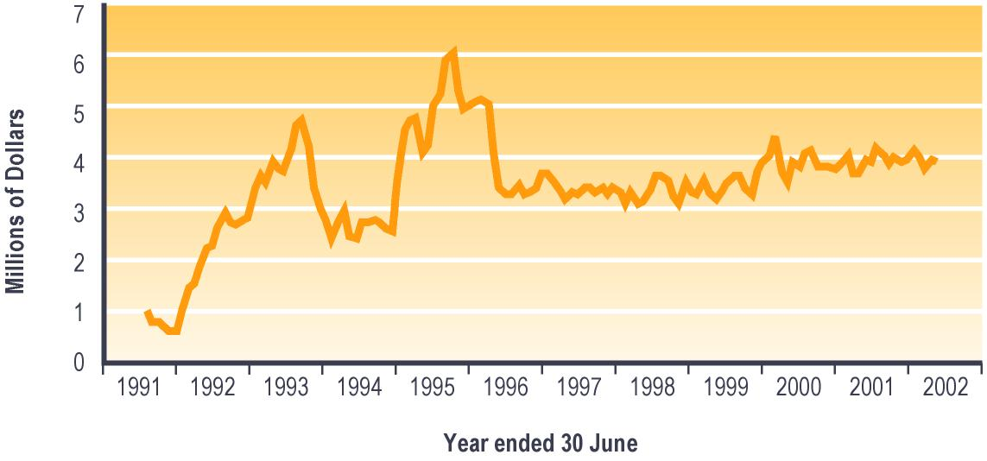

Notes:

1 Expenditure is adjusted for the number of payments per month, and smoothed using a two-month moving average. Special Needs Grants are not subject to taxation.

Annual expenditure on benefit advances fluctuated around similar levels between 1992/1993 and 1994/1995, increased steeply over 1995/1996 and 1996/1997, decreased over 1997/1998 and 1998/1999, and increased over the last three years (see Table 4.29). The higher levels of expenditure on benefit advances from 1995/1996 onward compared with earlier years reflects in part the impact of the expanded availability of benefit advances from 9 October 1995.

Table 4.29 – Annual expenditure on benefit advances
Year ended 30 June | Expenditure on benefit advances¹  ($ million)
1991/1992 | 21
1992/1993 | 50
1993/1994 | 48
1994/1995 | 48
1995/1996 | 82
1996/1997 | 88
1997/1998 | 81
1998/1999 | 75
1999/2000 | 79
2000/2001 | 87
2001/2002 | 91

Notes:

1 Expenditure on benefit advances in years ended 30 June.

Monthly expenditure on benefit advances shows significant variation between months (see Figure 4.15), which reflects variation in the number of benefit advances made.

Figure 4.15 – Trends in monthly expenditure on benefit advances¹

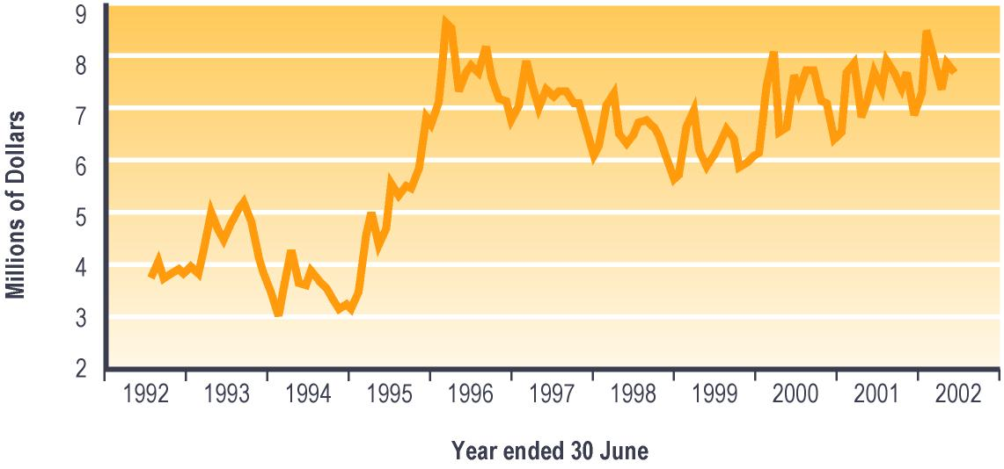

Notes:

1 Expenditure is adjusted for the number of payments per month, and smoothed using a two-month moving average. Benefit advances are not subject to taxation.

Section 5 – Students

Assistance available to students
Assistance from MSD is available to students through StudyLink. The eligibility of students for this assistance depends on the age and circumstances of the student as well as the nature of the course they are undertaking and of the institution they are enrolled at.

The following types of assistance is available to students from MSD:
- Student Allowances
- student loans
- core benefit during vacation periods
- supplementary benefits
- job search assistance during vacation periods.

Student Allowances
The Student Allowances Scheme was introduced in 1989, to provide living support for New Zealand students studying full-time toward recognised tertiary qualifications, and for adults studying full-time at secondary school. The aim of the scheme is to ensure that the need to meet day-to-day living expenses does not act as a barrier to full-time education for adult students (particularly those from low socio-economic groups).

The Department of Work and Income took over responsibility for administering Student Allowances in 1999. This function is now carried out by MSD through its StudyLink service.

Eligibility for Student Allowances
Student Allowances are available to people who are:
- aged 18 years or over, or aged 16-17 if they meet criteria based on their circumstances
- enrolled as a full-time student
- on a recognised programme at an approved institution
- a New Zealand citizen, or a permanent resident of New Zealand who has lived in New Zealand for at least two years and has held permanent residency status for at least two years.

Income tests are applied to the income of the student and of the student’s spouse (if any). An income test is also applied to the income of the parents of most single students aged under 25 years. Tests of academic achievement (to secure continued access to Student Allowance) also apply.

Students who are not studying full-time may be eligible for a Student Allowance if they:
- have an illness, disability or some other sufficient cause beyond their control which stops them studying full-time
- have reduced their course to less than full-time on academic advice or
- are studying more than half of a full-time course and the course is required to complete a recognised programme.
If a student is eligible for Student Allowance and is living away from home, they are entitled to an Accommodation Benefit payable under the Student Allowances Scheme. This is a contribution towards their accommodation costs, up to a maximum of $40 per week.

Bursaries (consisting of A and B Bursaries) are part of the Student Allowances Scheme. These are paid as tax-free lump sums of $200 (for an A Bursary) or $100 (for a B Bursary) once a year.

Payment rates for Student Allowances
Student Allowances are available at different rates depending on the circumstances of the student and on their assumed living costs. For students who are living with one or both parents, Student Allowances are paid at a discounted rate reflecting the fact that these students are likely to face lower living costs than students living away from home.

Table 5.1 shows the weekly rates at which Student Allowances were paid during the 2002 academic year.

Table 5.1 – Payment rates (per week) for Student Allowances issued during 2002 academic year¹
Type of Student Allowance | Status | No children | One child | Two or more children
16-24 years | Away from home | $131.13
16-24 years | At home | $104.91
25+ years | Away from home | $157.37
25+ years | At home | $125.89
Couple allowance – both students, no children | Both eligible (each)  One eligible | $131.13  $157.37
Couple allowance – dependent spouse, no children |  | $262.26
Single student with dependent children |  |  | $225.40 | $245.91
Couples – both students | One eligible |  | $225.40 | $245.91
with dependent children | Both eligible (each) |  | $139.35 | $139.35
Couples – dependent spouses with dependent children |  |  | $278.70 | $278.70
Students in independent circumstances |  | $131.13
Earning spouse – at home |  | $56.85
Earning spouse – away from home |  | $84.69

Notes:

1 Maximum weekly rates payable at 1 April 2002, net of tax.

Trends in the number of students receiving Student Allowances
The number of students receiving Student Allowances increased slowly between 1999 and 2001, but decreased slightly in the last year. Since 1999, about 55% of students receiving Student Allowances have been receiving allowances while living away from home, and about 21% have received allowances while living at home. Over the same period, around 10% of students receiving Student Allowances have been receiving allowances that include dependent children, and a similar number have been receiving allowances for living in independent circumstances (see Table 5.2).

Table 5.2 – Trends in types of Student Allowances received
Type of Student Allowance  received at 31 July | Students receiving Student Allowances¹
 | 1999 | 2000 | 2001 | 2002
 | Number | Number | Number | Number
16-24 years – targeted away from home | 17,093 | 16,935 | 16,405 | 15,377
16-24 years – targeted at home | 8,695 | 9,144 | 8,992 | 8,814
25+ years – away from home | 10,337 | 11,041 | 11,594 | 11,921
25+ years – at home | 1,395 | 1,386 | 1,378 | 1,415
Couple allowance – both students, no children | 849 | 795 | 757 | 777
Couple allowance – dependent spouse, no children | 964 | 930 | 1,003 | 1,048
Single student with dependent children | 812 | 964 | 1,103 | 1,166
Couples – both students with dependent children | 4,095 | 4,014 | 3,936 | 3,752
Couples – dependent spouses with dependent children | 0 | 0 | 0 | 0
Students in independent circumstances | 4,432 | 4,505 | 4,872 | 5,347
Earning spouse – at home | 112 | 141 | 95 | 94
Earning spouse – away from home | 833 | 823 | 848 | 817
Total | 49,617 | 50,678 | 50,983 | 50,528

Notes:

1 Numbers of students recorded as receiving Student Allowances at 31 July.

Of students receiving a Student Allowance since 1999, between 51% and 56% have been attending a university. Between 1999 and 2000, the proportion of students receiving a Student Allowance who were attending a polytechnic decreased from 33% to 26%, and has remained at around 26% over the last two years (see Figure 5.1).

Figure 5.1 – Trends in type of institutions attended by students receiving Student Allowances¹

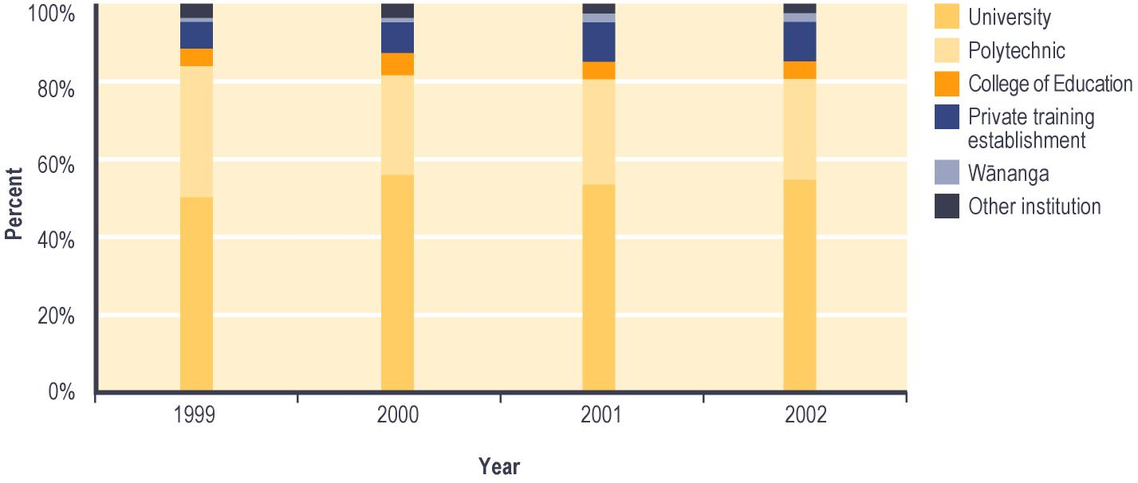

Notes:

1 Percent of students recorded as receiving Student Allowances at 31 July.

Proportion of all tertiary students who were receiving a Student Allowance
Since the 1999 academic year, between 16% and 20% of students enrolled at eligible tertiary institutions have been receiving a Student Allowance. Over this period, higher proportions of students aged 18-29 years than of other students were receiving a Student Allowance (see Figure 5.2).

Figure 5.2 – Trends in the proportion¹ of students at eligible institutions receiving Student Allowances, by age

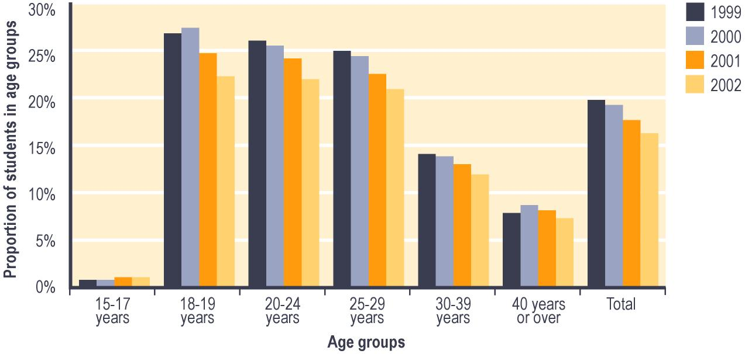

Notes:

1 Proportion shows:

a Number of students enrolled at eligible institutions and in age group recorded as receiving Student Allowances as at 31 July; divided by

b Total number of students enrolled at eligible institutions and in age group at 31 July (source Ministry of Education).

Since 1999, a higher proportion of male students than of female students have been receiving a Student Allowance. The reduction in the proportion of students receiving a Student Allowance noted above has been evident regardless of the gender of students (see Figure 5.3).

Figure 5.3 – Trends in the proportion¹ of students at eligible institutions receiving Student Allowances, by gender

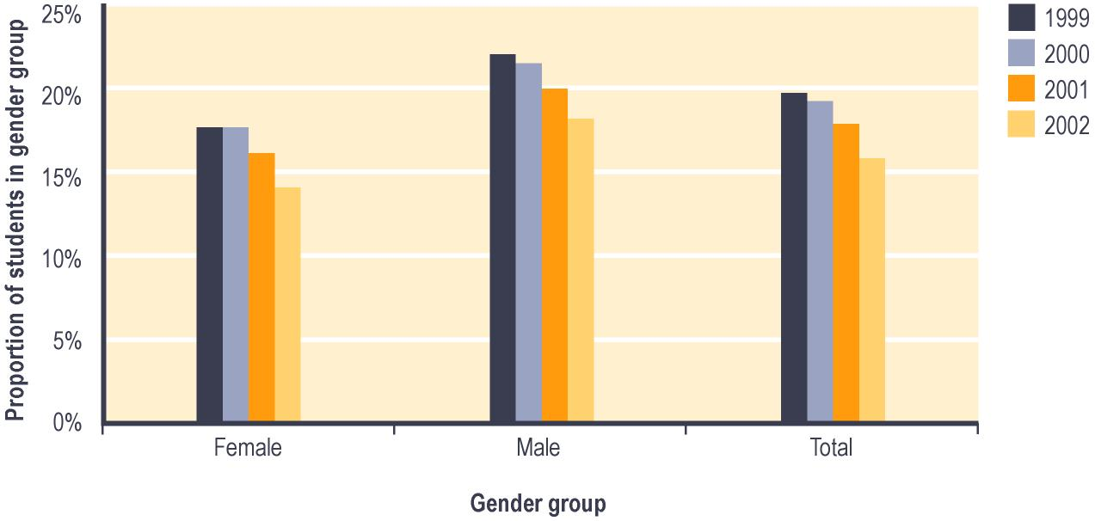

Notes:

1 Proportion shows:

a Number of students enrolled at eligible institutions and in gender group recorded as receiving Student Allowances as at 31 July; divided by

b Total number of students enrolled at eligible institutions and in gender group at 31 July (source Ministry of Education).

Since 1999, a higher proportion of students attending universities or colleges of education than of other students have been receiving a Student Allowance. The decrease noted above in the proportion of students receiving Student Allowances has been more evident among students attending polytechnics or wänanga than among students attending other institutions (see Figure 5.4).

Figure 5.4 – Trends in the proportion¹ of students at eligible institutions receiving Student Allowances, by type of institution

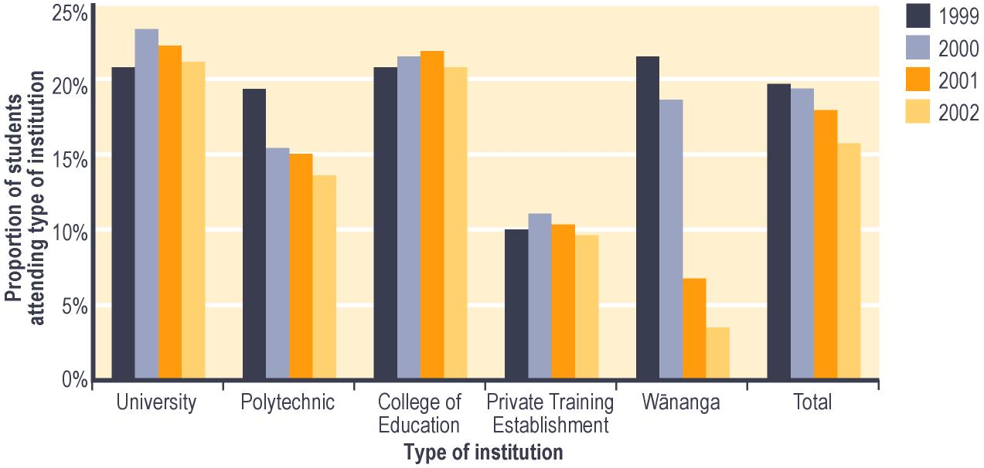

Notes:

1 Proportion shows:

a Number of students enrolled at each type of eligible institution recorded as receiving Student Allowances as at 31 July; divided by

b Total number of students enrolled at each type of eligible institution at 31 July (source Ministry of Education).

Bursaries
Bursaries are payable students aged under 20 years who have passed the bursary examinations and who continue to meet tests of academic achievement.

The number of students enrolled at eligible institutions who are receiving bursaries increased dramatically between 1999 and 2000, but has fluctuated around a similar level over the last two years. This pattern was evident for both types of bursaries (see Table 5.3).

Table 5.3 – Trends in the bursaries received by students enrolled in eligible institutions
Type of Bursary received at 31 July | Number of students enrolled in eligible institutions receiving bursaries¹
 | 1999 | 2000 | 2001 | 2002
 | Number | Number | Number | Number
“A” Bursary | 1,257 | 2,965 | 2,682 | 2,904
“B” Bursary | 629 | 1,618 | 1,326 | 1,709
Total | 1,886 | 4,583 | 4,008 | 4,613

Notes:

1 Numbers of students at eligible institutions recorded as receiving bursaries at 31 July.

Student Loans
The Student Loans Scheme was introduced in 1992 to assist students studying at tertiary level. The purpose of the Scheme is to ensure that the costs of study (including the need to meet day-to-day living expenses for those whose study limits their ability to earn) are not a barrier to students undertaking tertiary study.

The Department of Work and Income took over responsibility for administering student loans at the start of the 2000 academic year. This function is now carried out by MSD through its StudyLink service.

Eligibility for Student Loans
Student loans are available to people who are:
- New Zealand citizens, permanent residents or refugees
- enrolled on a tertiary course approved by the Ministry of Education which is:
– full-time or limited full-time or
– part-time and 32 weeks or longer.

To receive a loan for living costs, students must be enrolled in a full-time or limited full-time course. Students enrolled on courses which are part-time and 32 weeks or longer may receive a loan for fees and course-related costs only. If a student or their partner receives a core benefit, or receives a Student Allowance of $150.00 a week or more after tax, they may only receive loans for compulsory fees and course-related costs.

People who are currently bankrupt or who are on a course already paid for by the Government (such as Training Opportunities) are not eligible to receive a Student Loan. Students attending summer school courses may receive student loans if their course is full-time or part of a full-year programme.

From 1 January 2002, prisoners have been eligible to access student loans for compulsory fees and for course-related costs, subject to the agreement of the prison authority. They are not able to receive loans for living costs unless they are on home detention.

Accessibility of funds through student loans
Cabinet minutes prescribe maximum drawings against student loans which students may make for specific purposes (see Table 5.4). The purpose of establishing these maxima is to curb unnecessary borrowing.

Table 5.4 – Maximum amount of student loan funds available for different purposes (2002 academic year)
Purpose for which funds are accessed | Maximum Amounts available
Course fees (annual)¹ | Total fee cost; maximum of $6,500 for private training institutions
Course-related expenses (annual)² | $1,000.00
Living costs (weekly)³ | $150.00

Notes:

1 Payment of fees is reduced by any Training Incentive Allowance (available to some core benefit recipients) which is provided to pay fees.

2 Payment of course-related expenses is reduced by any Training Incentive Allowance (available to some core benefit recipients) which is provided to pay course-related expenses.

3 Payment of living costs is restricted to periods when the student is studying full-time, and is reduced by any Student Allowance payments received.

Trends in the number of students making drawings against student loans
This section shows information about students making drawings against student loans during the academic year indicated. It excludes information about drawings made against student loans in earlier years, and therefore does not show the total levels of debt which students have accumulated through the Student Loan Scheme.

The number of students making drawings against student loans has increased in every academic year since 2000. Of the students making drawings against student loans in each academic year since 2000, nearly half drew a total of less than $5,000 over the academic year, while just over two-fifths drew between $5,000 and $10,000. Between the 2000 academic year and the 2001 academic year, there was an increase in the proportion of the students who made drawings against student loans in each academic year who drew between $10,000 and $15,000 in an academic year (see Table 5.5). This may reflect the impact of the interest write-off policy concerning student loans which was introduced in 2000.

Table 5.5 – Trends in the amount per student drawn against student loans
Amount drawn against student loan | Students making drawings against student loans¹
 | 2000 | 2001 | 2002
 | Number | Number | Number
Under $5,000 | 61,497 | 67,765 | 70,440
$5,000-<10,000 | 54,660 | 61,514 | 60,758
$10,000-<15,000 | 6,462 | 15,656 | 17,831
$15,000-<20,000 | 363 | 1,295 | 1,573
$20,000-<30,000 | 164 | 217 | 278
$30,000-<40,000 | 72 | 74 | 100
$40,000-<50,000 | 0 | 20 | 80
$50,000 or over | 16 | 73 | 185
Total | 123,234 | 146,614 | 151,245

Notes:

1 Number of students recorded as making drawings against student loans during the academic years indicated.

Between the 2000 academic year and the 2002 academic year, the proportion of the students making drawings against student loans each year who were not receiving a Student Allowance increased from 60% to 66%. Over the same period, students receiving a Student Allowance for living away from home accounted for between 19% and 22% of students making drawings against student loans.

Trends in the number of drawings made against student loans
The number of drawings against student loans in each academic year increased significantly between the 2000 academic year and the 2002 academic year. Of the drawings made against student loans over this period, about 46% were for course fees while between 26% and 29% were for course-related expenses and between 25% and 27% were for living costs (see Table 5.6).

Table 5.6 – Trends in the purpose of drawings made against student loans
Purpose of drawings against student loan | Number of drawings against student loans¹
 | 2000 | 2001 | 2002
 | Number | Number | Number
Course fees | 117,881 | 138,250 | 142,657
Courses costs | 66,868 | 90,086 | 93,007
Living expenses | 68,317 | 79,683 | 79,331
Total | 253,066 | 308,019 | 314,995

Notes:

1 Number of drawings against student loans during the academic year indicated.

Section 6 – Additional administrative information

Community Services Cards

Introduction
The Community Services Card is an entitlement card which people on low to middle incomes or receiving income support may use to obtain higher subsidies on:
- doctors’ fees
- prescriptions.

A new application type for families not claiming Family Support from Inland Revenue was introduced from 1 February 1994. Prior to this, only those families receiving Family Support were able to apply for the Community Services Card. Families not receiving Family Support are indicated as “Families” in the following tables. The income limits for families with dependent children increased on 1 July 1998. New income limits for families with more than six children were introduced. The Community Services Card regulations were amended from 1 February 1999. From this date, families with children receiving Child Disability Allowance could include that child in their application for the Community Services Card. The income limits for the card were increased on 1 April 2000 to match the increase in the rate of New Zealand Superannuation from this date.

People receiving income-tested income support, Veteran’s Pensions and the Residential Care Subsidy automatically receive a card (and subsequent replacement cards), so they do not have to complete application forms. People receiving New Zealand Superannuation must apply for their first card. However, card renewal for more than 80% of people receiving New Zealand Superannuation has been automated since 1 January 1996.

A fault was identified in August 1999 with the information transfer between Inland Revenue and EDS which was supposed to identify people eligible for the card, through their entitlement to Family Support. As a result, there was an increase in the number of applications received under the “Families” category, while the fault was fixed.

Processing of claims for partial reimbursement of health charges under the Community Services Card scheme was centralised to the national Community Services Card Centre on 1 October 1999. Between 1992 and 30 September 1999, claims were processed at Work and Income service centres.

Numbers of Community Services Cards applied for and on issue
Since 1998/1999, the total number of applications for new cards has remained relatively stable, while the total number of applications for renewed cards has trended downwards. Different groups of Community Services Card recipients have shown different patterns in applications for core benefits (see Table 6.1).

Table 6.1 – Applications for and issues of Community Services Cards
Total applications for and issues of new and renewed Community Services Cards | Cards issued¹
 | 1997/  1998 | 1998/  1999 | 1999/  2000 | 2000/  2001 | 2001/  2002
 | Number | Number | Number | Number | Number
New cards
Low-income earners and students | 61,995 | 60, 070 | 61,869 | 60,119 | 63,919
Family Support² | 55,113 | 48,852 | 42,273 | 50,069 | 48,664
New Zealand Superannuation | 14,877 | 12,544 | 12,016 | 12,235 | 11,781
Families | 17,996 | 17,209 | 24,689 | 18,526 | 17,498
Total | 149,981 | 138,675 | 140,847 | 140,949 | 141,862
Renewed cards
Low-income earners and students | 60,107 | 61,337 | 60,311 | 59,326 | 58,076
Family Support² | - | - | - | - | -
New Zealand Superannuation | 14,322 | 14,696 | 14,736 | 11,351 | 12,089
Families | 12,999 | 11,550 | 11,666 | 11,176 | 8,640
Total | 87,428 | 87,583 | 86,713 | 81,853 | 78,805
Total (includes issue of renewed cards) | 237,409 | 226,258 | 227,560 | 222,802 | 220,667
– = Not available

Notes:

1 Applications and issues in years ended 30 June.

2 All cards issued to Family Support recipients (both new cards and renewals) are coded as new cards. Separate counts of renewals of cards held by Family Support recipients are not available.

The number of Community Services Cards on issue increased slightly between 1998 and 1999, but has trended downward for the last three years. Since 1998, between 43% and 46% of people holding a Community Services Card have been receiving a means-tested benefit, while about 29% have been receiving New Zealand Superannuation (see Table 6.2).

Table 6.2 – Number of current Community Services Cards on issue
Group cards are issued to | Cards on issue¹
 | 1998 | 1999 | 2000 | 2001 | 2002
 | Number | Number | Number | Number | Number
Low income earners² | 100,751 | 106,748 | 105,822 | 108,011 | 108,766
Family Support³ | 133,776 | 126,253 | 116,800 | 132,822 | 145,485
War Pension | 5,800 | 5,659 | 5,467 | 5,669 | 5,769
Students² | 3,875 | - | - | - | -
Means tested benefits^{4,5} | 507,270 | 517,863 | 515,799 | 500,424 | 479,691
New Zealand Superannuation⁶ | 327,959 | 323,311 | 317,835 | 329,585 | 326,055
Residential Care Subsidy | 17,800 | 18,981 | 19,775 | 22,730 | 22,807
Families | 34,475 | 33,972 | 39,874 | 29,359 | 26,569
Total | 1,131,706 | 1,132,787 | 1,121,372 | 1,128,600 | 1,115,142
– = Not applicable

Notes:

1 Cards on issue at 30 June

2 From 1 July 1998 “Low income” includes students receiving the Tertiary Living Allowance and Student Allowance who are granted the Community Services Card as low-income earners. Tertiary students do not automatically receive the Community Services Card.

3 “Family Support” includes both Group 1 and Group 2 Family Support recipients, who have both been subsidised at Group 1 Family Support levels since 1 July 1993.

4 “Means-tested benefits” includes students receiving the Unemployment Benefit – Hardship – Student or the Emergency Benefit.

5 The number of people receiving means-tested benefits does not correspond with the numbers of these people issued with a Community Services Card shown above. This is because the above numbers include:

• spouses of people receiving means-tested benefits

• people who ceased receiving means-tested benefits less than 12 months previously. Cards covering the 12 months after a person ceases receiving means-tested benefits are issued automatically.

6 The number of people receiving New Zealand Superannuation does not correspond with the number of New Zealand Superannuation recipients issued with a Community Services Card shown above. This is because income tests for the Community Services Card exclude some people who receive New Zealand Superannuation from receiving a Community Services Card.

Expenditure on Community Services Cards
Claims for partial reimbursement of health charges by cardholders are processed and paid by MSD on behalf of the Ministry of Health. The Ministry of Health then reimburses MSD for the payments made in respect of these claims.

Expenditure on claims for partial reimbursement of health charges under the Community Services Card scheme has fluctuated since 1997/1998 (see Table 6.3).

Table 6.3 – Trends in expenditure on Community Services Cards
Expenditure on Community Services Cards^{1,2}
 | 1997/1998 | 1998/1999 | 1999/2000 | 2000/2001 | 2001/2002
 | Amount | Amount | Amount | Amount | Amount
 | ($000) | ($000) | ($000) | ($000) | ($000)
Total | 308 | 261 | 301 | 330 | 318

Notes:

1 Ministry of Social Development expenditure on partial claims against Community Services Cards in years ended 30 June.

2 Ministry of Social Development expenditure on Community Services Card subsidies is reimbursed by the Ministry of Health.

Debt Management

Background
MSD’s debt management functions are an integral part of the Ministry’s operations, providing services, advice and debt recovery processes.

Debt is managed in two portfolio groups: current benefit debt and non-current debt.

Work and Income is responsible for current benefit debt, where clients with benefit debts are currently in receipt of benefit.

The Debt Management Group is responsible for managing non-current debt. This includes benefit debts owed by clients who are no longer in receipt of a benefit, Student Allowance and fraudulent Student Loan debt, and outstanding debts from programmes such as Liable Parent Contribution and Maintenance. Four Regional Collection Units located in Christchurch, Lower Hutt, Hamilton and Auckland are responsible for the operational management of non-current debt.

New debts are established as a result of:
- data matching
- fraud or abuse
- innocent overpayments
- benefit advances, recoverable grants and loans.

There are a number of methods of repayment. For clients with debts who are on benefit, repayments are predominantly made by way of an offset from the benefit they receive. Clients with debts who are no longer in receipt of benefit may repay their debts by:
- regular or lump sum payment by cash or cheque or
- phone banking or
- automatic payments or
- bank deductions or
- wage deductions.

Any cash or cheque payments are made at New Zealand Post Shops.

Trends in Debt Established and Repaid
During the last 12 months the value of debt collected has increased, particularly recovery from the non-current debt portfolio. An increase in debtor numbers and key performance indicators which ensure that a high proportion of debtors repay their debt have contributed to this result.

The value of outstanding debt has continued to increase as the existing rate of establishment exceeds the ability of MSD ability to recover debt.

New debt established rose between 1997/1998 and 1999/2000, but has maintained lower levels over the last two years. Debt repaid or adjusted on review rose each year between 1997/1998 and 2000/2001, but decreased sharply last year following a reporting correction. This reporting correction also led to an increase in outstanding debt at 30 June 2002, compared with 30 June 2001 (see Table 6.4).

Table 6.4 – Trends in debt established, debt repaid and outstanding debt
Financial year¹ | New debt established ($m) | Debt repaid or adjusted on review ($m) | Outstanding at  30 June ($m)
1997/1998 | 287.8 | 270.6 | 723.0
1998/1999 | 325.8 | 279.3 | 770.6
1999/2000 | 329.7 | 299.2 | 800.4
2000/2001 | 312.6 | 300.4 | 813.8
2001/2002 | 318.4 | 233.1² | 899.1²

Notes:

1 Years to 30 June

2 Both debt adjusted on review and outstanding debt has been impacted by a reporting correction in June 2002. The total value of current benefit debt was previously understated by $72m. The correction of this error has resulted in a decrease in debt adjusted on review and a corresponding increase in outstanding debt.

The number of Work and Income debtors has trended upward each year since 1997/1998. Over the same period, however, the numbers of clients who have debts related to Liable Parent Contributions and who have debts related to Maintenance have each decreased. Clients who have debts related to Student Allowances, who have debts related to fraudulent Student Loans, and who have debts related to work services each form a small part of the total number of debtors (see Table 6.5).

Table 6.5 – Trends in the number of debtors with open debts by category
Financial year¹ | Income support debtors |  | Other debtors |  |  |  | Total debtors²
 | Current Clients³ | Non-Current Clients⁴ | Liable Parent Contri-butions⁵ | Total Maint-enance⁶ | Student Allow-ances⁷ | Work Debt⁸
1997/1998 | 150,170 | 100,697 | 37,979 | 13,743 | 0 | 0 | 302,589
1998/1999 | 152,703 | 104,936 | 34,718 | 11,011 | 3,317 | 570 | 307,255
1999/2000 | 154,241 | 113,591 | 30,861 | 10,508 | 3,066 | 584 | 312,851
2000/2001 | 170,561 | 121,613 | 28,653 | 9,792 | 3,480 | 609 | 334,708
2001/2002 | 173,296 | 127,788 | 26,639 | 8,691 | 3,729 | 624 | 340,767

Notes:

1 Financial years ended 30 June.

2 The total number of debtors may be overstated because of double-counting where a person has more than one type of debt.

3 Debtors who are currently receiving income support from Work and Income and have had advances, grants or overpayments of income support.

4 Debtors who are no longer receiving income support from Work and Income but who have had advances, grants or overpayments of income support.

5 The Liable Parent Contribution scheme ended in 1992. The number represents liable parents with arrears of payments.

6 Administration of Maintenance Orders and registered agreements ended in 1992. The number represents maintenance debtors with arrears of payments.

7 Debtors who have received overpayments of Student Allowance. Prior to 1 January 1999, the Ministry of Education administered Student Allowance debt.

8 Debtors who have received overpayment of employment-related grants and allowances. Prior to October 1998, the New Zealand Employment Service administered work debt.

In total, 71% of all Crown debt is a result of benefit overpayment, benefit advance or grant. Approximately half of this total is current debt and the other half is non-current debt (see Figure 6.1).

Figure 6.1 – Total composition of Crown debt at 30 June 2002

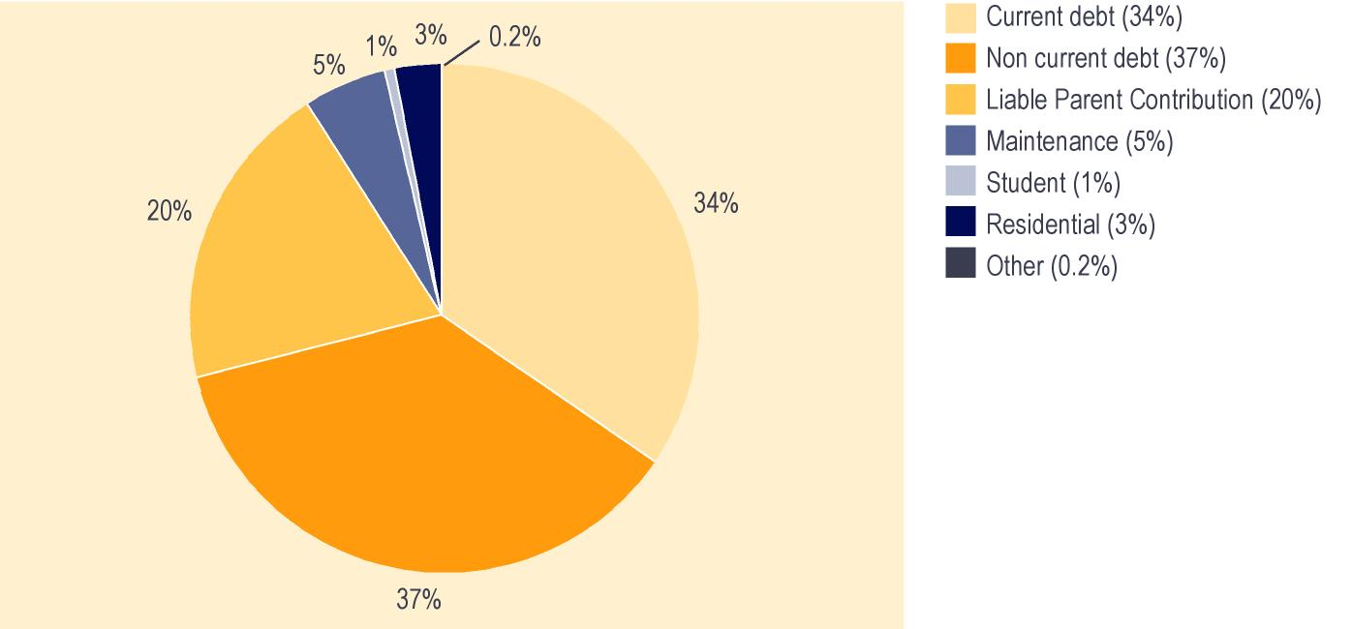

Benefit Control

Background
The Benefit Control Unit covers activities to protect the integrity of the benefit system offered by Work and Income. Activities include:
- prevention of fraud and abuse
- early intervention interviews
- identification of discrepancies through data matching
- investigations of suspected irregularities
- deterrence of abuse of the benefit system
- sanctioning persons involved in abuse of the benefit system.

Data matching is undertaken with Inland Revenue, the Department of Corrections, and the New Zealand Customs Service. The purpose of these matches is to detect clients who are or have been in receipt of benefits or financial assistance to which they may not be entitled.

Trends in cases investigated and overpayments identified
The majority of Benefit Control cases between 1997/1998 and 2000/2001 involved data matching, while a slight majority of the investigations in 2001/2002 involved Area Benefit Control teams. The total amount of overpayments identified trended upward between 1997/1998 and 1998/1999, but has decreased for the last three years (see Table 6.6).

Table 6.6 – Trends in Benefit Control statistics by source of information
Financial year¹ | Number of cases investigated | Overpayments identified
Area Benefit Control teams
1997/1998 | 49,060 |  | $69,557,331
1998/1999² | 52,706 |  | $86,785,211
1999/2000 | 45,181 |  | $76,348,609
2000/2001 | 41,254 |  | $56,288,559
2001/2002 | 47,835 |  | $47,506,880
Data Match
1997/1998 | 56,815 |  | $32,386,485
1998/1999² | 68,641 |  | $33,942,545
1999/2000 | 47,794 |  | $27,872,645
2000/2001 | 52,910 |  | $33,723,772
2001/2002 | 47,169 |  | $33,945,242

Notes:

1 Financial years ended 30 June.

2 The 1998/1999 year includes three months as part of the Department of Social Welfare and nine months as part of the Department of Work and Income.

The total number of Benefit Control cases has increased over the last three years. While the actual dollar returned from Benefit Control activities has decreased over the last three years, it remains significantly above the target dollar returned set in MSD’s Purchase Agreement (see Table 6.7).

Table 6.7 – Trends in cases investigated and dollar returns
Financial year¹ | Total number of cases investigated | Actual dollar returned³ | Target dollar returned³
1997/1998 | 105,875 | $4.54 | $2.50
1998/1999² | 121,347 | $4.99 | $3.25
1999/2000 | 92,975 | $4.34 | $3.25
2000/2001 | 94,168 | $3.89 | $3.25
2001/2002 | 95,004 | $3.32 | $2.50

Notes:

1 Financial years ended 30 June

2 The 1998/1999 year includes three months as part of the Income Support unit of the Department of Social Welfare, and nine months as part of the Department of Work and Income.

3 Target and actual dollar returned includes overheads and is GST exclusive. Target dollar returned is set in the Ministry of Social Development Purchase Agreement with the Minister of Social Services and Employment.

Social Security Agreements
New Zealand currently has social security agreements with Australia, the Netherlands, the United Kingdom, Greece, Canada, the Republic of Ireland, Jersey and Guernsey, and Denmark. There is also a special portability arrangement for the countries of the Pacific. An agreement was signed with Italy in June 1998, but it has not yet been ratified by Italy.

Australia
A new social security agreement between New Zealand and Australia came into effect on 1 July 2002. The agreement covers New Zealand Superannuation, Veteran’s Pension, and Invalid’s Benefits for people with severe disabilities. Under the new agreement, individual pensioners will receive dual payments (one from each government, according to the proportion of the individual’s working life spent in each country). There will be no government-to-government reimbursements as under the current agreement.

People going to Australia can use their periods of residence in New Zealand to help them qualify for an Australian pension covered by the agreement. Conversely, periods of residence in Australia will assist people coming to live in New Zealand to qualify for New Zealand benefits covered by the agreement.

The new agreement provides for New Zealand to continue to reimburse Australia for benefits for which it agreed to reimburse Australia under the old agreement. Reimbursement amounts are set out in the new agreement and should phase out in approximately 2015. The reimbursement for the financial year beginning 1 July 2002 is $AUD104.6 million.

United Kingdom
People going to the United Kingdom can use their periods of residence in New Zealand to help them qualify for a United Kingdom pension and certain other social security payments. People coming from the United Kingdom to New Zealand can use periods of United Kingdom residence to help them qualify for a New Zealand benefit. In addition, United Kingdom pensions are paid to New Zealand residents under United Kingdom domestic law.

There were 35,114 people receiving United Kingdom pensions in New Zealand at 30 June 2002. At the same date, a further 23 Isle of Man pensions were also being paid to New Zealand under the current New Zealand/United Kingdom agreement.

The Netherlands
Since 1 February 1992, people who have lived in New Zealand for more than 10 years may, under the terms of the agreement, qualify for New Zealand Superannuation, Veteran’s Pension, Invalid’s Benefit, Widow’s Benefit or Domestic Purposes Benefit for widowers while they are living in the Netherlands. The rates of payment of these benefits are determined in accordance with the length of residence in New Zealand.

Anyone arriving in New Zealand from the Netherlands may use periods of residence or contributions made in the Netherlands to meet the residence criteria for New Zealand benefits within the scope of the agreement. A person who has limited residence, or who has made a limited number of insurance contributions, in the Netherlands may use New Zealand residence to help them qualify for a pension from the Netherlands.

A new agreement with the Netherlands is scheduled to come into force on 1 October 2003. The new agreement modernises the provisions of the agreement.
At 30 June 2002, there were 1,989 people receiving Netherlands pensions in New Zealand. At the same date, there were 859 people receiving New Zealand income services in the Netherlands.

The Republic of Ireland
This agreement came into force on 1 March 1994. The agreement allows payment of New Zealand Superannuation, Veteran’s Pension, Widow’s Benefit, Invalid’s Benefit, Domestic Purposes Benefit for widowers or Orphan’s Benefit to former New Zealand residents who have lived or intend to live in the Republic of Ireland for more than 26 weeks. The rate of payment is based on whole months of residence in New Zealand since age 20. The agreement also allows payments of analogous Irish benefits to qualifying New Zealand residents.

People coming to live in New Zealand from the Irish Republic may use periods of contributions to Irish insurance to assist them to meet the residence criteria for New Zealand income services.

At 30 June 2002, there were 101 people receiving New Zealand Superannuation, in the Republic of Ireland. At the same date, there were 71 Irish pensions being paid in New Zealand.

Greece (the Hellenic Republic)
This agreement came into force on 1 April 1994. Under the agreement, former New Zealand residents who live or intend to live in Greece may qualify for New Zealand Superannuation, Veteran’s Pension, Widow’s Benefit, Invalid’s Benefit or Domestic Purposes Benefit for widowers. The rate of payment is based on whole years of New Zealand residence since age 20. Orphan’s Benefit and funeral grants are also payable at the full New Zealand rate.

People arriving in New Zealand from Greece will be entitled to use periods of Greek insurance to qualify for New Zealand benefits within the scope of the agreement. Periods of residence in New Zealand will also assist people who have made limited Greek insurance contributions to qualify for a Greek pension.

At 30 June 2002, there were two people receiving an Invalid’s Benefit, and 189 people receiving New Zealand Superannuation, in Greece. At the same date, 17 Greek pensions had been granted to New Zealand residents under the Agreement.

Canada
The agreement with Canada came into force in May 1997. Under the agreement, former New Zealand residents who live or intend to live in Canada may qualify for New Zealand Superannuation, Veteran’s Pension, Widow’s Benefit, Invalid’s Benefit or Domestic Purposes Benefit for widowers. The rate of payment is based on whole months of New Zealand residence since age 20.

Anyone arriving in New Zealand from Canada may use periods of residence or contributions made in Canada to meet the residence criteria for New Zealand income services within the scope of the agreement. Periods of residence in New Zealand will also assist people who have made limited contributions to the Canadian scheme, or who have insufficient periods of Canadian residence, to qualify for a Canadian pension.

At 30 June 2002, there was one person receiving a Widow’s Benefit, and 198 receiving New Zealand Superannuation, in Canada. At the same date, there were 210 Canadian pensions being paid in New Zealand.

Denmark
The agreement with Denmark came into force on 1 October 1997. Under the agreement, former New Zealand residents who live or intend to live in Denmark may qualify for New Zealand Superannuation, Widow’s Benefit, Invalid’s Benefit or Domestic Purposes Benefit for widowers. The rate of payment is based on whole months of New Zealand residence since age 20.

Anyone arriving in New Zealand from Denmark may use periods of residence or contributions made in Denmark to meet the residence criteria for New Zealand income services within the scope of the agreement. Periods of residence in New Zealand will also assist people who have made limited contributions to the Danish scheme, or who have insufficient periods of Danish residence, to qualify for a Danish pension. To qualify for a Danish pension under the agreement a person must be either a Danish or New Zealand citizen.

At 30 June 2002, there were three people receiving Invalid’s Benefit, and 21 people receiving New Zealand Superannuation, in Denmark. At the same date, there were 29 Danish pensions being paid in New Zealand.

Jersey and Guernsey
This agreement came into force on 1 April 1995. Under the agreement, former New Zealand residents who live or intend to live in Jersey or Guernsey may qualify for New Zealand Superannuation, Veteran’s Pensions, Widow’s Benefit, Invalid’s Benefit, or of Domestic Purposes Benefits for widowers. The rate of payment is based on whole years of New Zealand residence since age 20.

People coming to New Zealand who have made contributions to the Jersey or Guernsey social insurance schemes will be able to use those periods of insurance to qualify for New Zealand benefits within the scope of the agreement, which includes Sickness Benefit. Periods of residence in New Zealand will also assist people who have made limited contributions to the Jersey or Guernsey insurance schemes to qualify for pensions available under those schemes.

At 30 June 2002, there was one person receiving a Widow’s Benefit, and 53 people receiving New Zealand Superannuation, in Jersey and Guernsey. At the same date, there were 94 Jersey or Guernsey pensions being paid in New Zealand.

Payments overseas under social security agreements
At 30 June 2002, virtually all of the people receiving New Zealand pensions or income services while residing overseas were receiving New Zealand Superannuation. About two-fifths of the people receiving New Zealand pensions or income services at 30 June 2002 while they were residing overseas were living in the Netherlands.

Recipients in New Zealand
People who have come to New Zealand from overseas may qualify for some New Zealand entitlements under social security agreements because residency or social security contributors from another country are taken into account.

Since 1998, the number of people from overseas who qualified for New Zealand entitlements under social security agreements has risen steadily. Over this period, between 60% and 66% of these people have qualified for New Zealand entitlements under the agreement with the United Kingdom, while about 19% have done so under the agreement with Australia (see Table 6.8).

Table 6.8 – Trends in numbers qualifying for New Zealand entitlements under social security agreements
Country of reciprocity | Number of people receiving New Zealand pensions or income services who qualified by social security agreements¹
 | 1998 | 1999 | 2000 | 2001 | 2002
Australia | 950 | 1,015 | 1,046 | 1,037 | 1,099
Canada | 61 | 96 | 131 | 160 | 197
Denmark | 25 | 42 | 63 | 66 | 73
Greece | 108 | 136 | 137 | 156 | 170
Ireland | 58 | 68 | 83 | 86 | 80
Jersey and Guernsey | 48 | 51 | 63 | 66 | 66
Netherlands | 455 | 545 | 610 | 661 | 705
United Kingdom | 3,240 | 3,374 | 3,424 | 3,394 | 3,524
Total | 4,945 | 5,327 | 5,557 | 5,626 | 5,914

Notes:

1 Numbers recorded as receiving payments at 30 June who qualified through social security agreements.

Some people may be receiving a reduced rate of New Zealand Superannuation or Veteran’s Pension payments because they are also receiving overseas pensions paid into New Zealand under social security agreements.

Since 1998, the number of people receiving reduced New Zealand pensions because they are also receiving overseas pensions paid under social security agreements has increased steadily. Over this period, between 93% and 97% of these people have been receiving a United Kingdom pension.

Other Provisions for Payment of New Zealand Superannuation Overseas

General portability
Under the general portability provision, people eligible to receive New Zealand Superannuation or Veteran’s Pension in their own right may receive 50% of their payment while they are living outside New Zealand, provided that they are not living in a country which has a social security agreement with New Zealand. Applications under this provision must be made while the applicant is resident in New Zealand.

Special portability arrangement for Pacific countries
People leaving New Zealand to reside in a Pacific country can receive a rate of New Zealand Superannuation or Veteran’s Pension which is based on their New Zealand residence since the age of 20 years. People with 10 years New Zealand residence since the age of 20 years receive 50% of New Zealand Superannuation or Veteran’s Pension. People with between 10 and 20 years New Zealand residence since the age of 20 years are entitled to an additional 5% of New Zealand Superannuation or Veteran’s Pension for each year of residence over 10 years. At the date of application, they must be both resident and present in New Zealand, and intending to live in a participating Pacific country for 52 weeks or more.

Pacific countries covered by the arrangement are: American Samoa, the Cook Islands, the Federated States of Micronesia, Fiji, French Polynesia, Guam, Kiribati, Marshall Islands, Nauru, New Caledonia, Niue, Northern Mariana Islands, Palau, Papua New Guinea, Pitcairn Island, Samoa, Solomon Islands, Tokelau, Tonga, Tuvalu, Vanuatu, and Wallis and Futuna.

At 30 June 2002, New Zealand was paying 349 people under the special portability arrangements.

The takeup of the Payment Overseas programme has largely been from single people returning from New Zealand to the country of their birth. The principal destinations are Europe and North America.

Trends in total payments to New Zealanders living overseas
New Zealanders living overseas may be eligible to receive New Zealand Superannuation or a Veteran’s Pension under the special and general portability provisions of the Payment Overseas programme and under social security agreements. Since 1998, a small number of New Zealanders living overseas have been doing so, with all but a very small number (under 0.1%) of these people receiving New Zealand Superannuation. This reflects the predominance of New Zealand Superannuation (rather than Veteran’s Pension) among pensions paid to New Zealanders who are eligible for pensions.

Section 7 – Tables of benefit and pension uptake and expenditure since 1940

Table 7.1 over the page shows numbers receiving core benefits and pensions since 1940. Table 7.2 following shows expenditure on core benefits and pensions since 1940. Please note that expenditure figures given in Table 7.2 include expenditure on supplementary benefits received by people who are receiving the core benefits, while core benefit and pension expenditure data published in some other sources does not. This may lead to differences between expenditure information in Table 7.2 and core benefit and pension expenditure information published in other sources.

Table 7.1 – Historical summary – numbers of people receiving core benefits and pensions 1940 – 2002^{1,2}
Year³ | Unempl-oyment Benefit⁴ | Inde-pendent Youth Benefit | Unempl-oyment Benefit – Training | Sick-ness Benefit | Invalid’s Benefit | Miner’s Benefit | Domestic Purposes Benefit | Widow’s Benefit | Orphan’s & Unsupported Child’s Benefit | Family Benefit⁵ | Transitional Retirement Benefit⁶ | NZ Superann-uation⁷ | Veteran’s Pensions⁸
1940 | 4,053 |  |  | 2,565 | 11,811 | 988 |  | 10,174 | 330 | 11,053 |  | 93,262
1945 | 198 |  |  | 4,233 | 12,205 | 783 |  | 10,965 | 421 | 24,251 |  | 158,332
1950 | 12 |  |  | 4,931 | 9,476 | 636 |  | 14,198 | 366 | 254,920⁵ |  | 186,512
1955 | 19 |  |  | 4,277 | 8,110 | 481 |  | 12,197 | 300 | 298,370 |  | 199,236
1960 | 312 |  |  | 4,064 | 8,024 | 353 |  | 13,049 | 277 | 343,193 |  | 204,036
1965 | 208 |  |  | 4,681 | 7,951 | 184 |  | 14,529 | 316 | 376,824 |  | 214,659
1970 | 983 |  |  | 5,876 | 8,342 | 98 |  | 15,663 | 315 | 408,397 |  | 241,772
1975 | 2,894 |  |  | 7,830 | 9,414 | 45 | 17,231 | 16,738 | 376 | 452,389 |  | 289,348
1980 | 20,850 |  |  | 7,504 | 15,647 | 21 | 37,040 | 16,120 | 413 | 460,897 |  | 405,834
1981 | 35,666 |  |  | 7,104 | 16,961 | 16 | 39,412 | 15,416 | 388 | 461,211 |  | 418,901
1982 | 32,596 |  |  | 7,177 | 17,891 | 16 | 43,447 | 14,737 | 365 | 459,994 |  | 430,175
1983 | 50,744 |  |  | 7,669 | 18,757 | 16 | 48,121 | 14,125 | 362 | 460,798 |  | 441,789
1984 | 50,136 |  |  | 9,452 | 20,187 | 13 | 53,144 | 13,921 | 384 | 460,382 |  | 451,128
1985 | 38,419 |  |  | 9,627 | 21,464 | 11 | 56,548 | 13,557 | 365 | 455,961 |  | 459,813
1986 | 42,405 |  |  | 9,517 | 21,993 | 10 | 62,570 | 13,304 | 364 | 455,330 |  | 465,079
1987 | 63,922 |  |  | 11,116 | 23,087 | 10 | 69,146 | 13,019 | 496 | 450,072 |  | 473,401
1988 | 86,782 |  |  | 13,132 | 24,379 | 9 | 74,862 | 12,862 | 1,537 | 436,066 |  | 479,985
1989 | 123,565 |  |  | 16,021 | 26,260 | 7 | 85,615 | 13,026 | 2,993 | 437,287 |  | 485,962
1990 | 139,625 |  | 9,453 | 19,511 | 27,824 | 6 | 94,823 | 12,676 | 5,239 | 446,373 |  | 495,500 | 3,428
1991 | 150,721 | 2,538 | 7,483 | 20,147 | 30,746 | 3 | 97,000 | 10,989 | 2,931 |  |  | 506,047 | 3,130
1992 | 166,685 | 3,682 | 7,857 | 24,093 | 31,831 | 1 | 96,722 | 9,873 | 3,135 |  |  | 504,561 | 5,393
1993 | 165,975 | 4,364 | 10,897 | 28,729 | 34,957 |  | 96,335 | 10,259 | 3,539 |  |  | 488,893 | 6,117
1994 | 153,869 | 3,313 | 12,834 | 31,535 | 37,030 |  | 100,256 | 9,012 | 4,093 |  | 6,540 | 477,400 | 6,278
1995 | 136,496 | 2,891 | 11,665 | 34,037 | 39,686 |  | 104,027 | 9,007 | 4,280 |  | 7,327 | 469,239 | 6,380
1996 | 131,288 | 2,845 | 11,389 | 33,386 | 42,423 |  | 108,790 | 9,043 | 4,655 |  | 7,832 | 481,565 | 6,887
1997 | 138,074 | 2,554 | 11,567 | 34,371 | 46,174 |  | 112,289 | 9,151 | 4,833 |  | 7,967 | 474,488 | 7,182
1998 | 151,897 | 2,877 | 7,915 | 35,172 | 49,468 |  | 113,329 | 9,372 | 5,078 |  | 8,151 | 469,307 | 7,277
1999 | 161,049 | 3,481 | 4,673 | 33,022 | 51,173 |  | 109,516 | 9,178 | 5,383 |  | 8,743 | 461,137 | 7,334
2000 | 151,839 | 3,566 | 3,755 | 32,294 | 55,392 |  | 108,939 | 9,104 | 5,799 |  | 8,856 | 453,401 | 7,248
2001 | 137,448 | 3,635 | 3,766 | 33,620 | 59,812 |  | 107,821 | 8,900 | 6,075 |  | 9,012 | 446,706 | 7,425
2002 | 122,944 | 2,998 | 3,990 | 36,380 | 64,529 |  | 108,009 | 8,774 | 6,332 |  | 5,118 | 450,435 | 7,587

Notes:

1 An historical summary of the number of people receiving core benefits or pensions prior to 1940 is included in the 1990 Official Year Book, page 210. Since 1975, the number of people receiving emergency benefits or receiving benefits granted because of hardship has been included in the numbers receiving core benefits or pensions in the group concerned.

2 All figures given exclude spouses and partners who receive a share of the core benefits paid to their partner or spouse.

3 Prior to 1990, the year ended 31 March; from 1990 onwards, the year ended 30 June.

4 Excludes people receiving an Independent Youth Benefit. Includes persons aged 55 or over. From 1991 includes Job Search Allowance. From 1998 includes Young Job Seekers Allowance and Emergency Benefit. From 1 October 1998 until 30 June 2001, the main benefit in this group was known as Community Wage – Job Seeker, and from 1 July 2001, it was known as Unemployment Benefit.

5 Family Benefit was paid without a means test from 1 April 1946 and was abolished from 1 April 1991. Ongoing problems with data and programs used to extract the statistics relating to Family Benefit has meant that these statistics are of uncertain accuracy.

6 Transitional Retirement Benefit was introduced on 1 April 1994.

7 Up to 1975, superannuation and age-related pensions are combined. From 1976, Superannuation and age-related pensions were replaced by National Superannuation. For the period 1 April 1990 to 31 March 1992 this pension was called Guaranteed Retirement Income. Between 1 April 1992 and 31 March 1994 it was known as National Superannuation, and from 1 April 1994 onward it has been known as New Zealand Superannuation. The age of eligibility was raised to 61 on 1 April 1992, and was raised progressively to reach 65 years on 1 April 2001. This table excludes non-qualified spouses.

8 From 1 July 1999, Veteran’s Pensions and War Pensions are funded from Vote: Veteran’s Affairs – Work and Income.

Table 7.2 – Historical summary – expenditure on core benefits and pensions
^{1940 – 2002 ($000)}1,2
Year³ | Unempl-oyment  Benefit⁴ | Inde-pendent  Youth  Benefit | Unempl-oyment  Benefit – Training | Sick-ness Benefit | Invalid’s Benefit | Miner’s Benefit | Domestic Purposes Benefit | Widow’s Benefit | Orphan’s & Unsupported Child’s Benefit | Family Benefit⁵ | Transitional Retirement Benefit⁶ | NZ Superann- uation⁷ | Veteran’s Pensions⁸
1940 | 869 |  |  | 418 | 1,884 | 185 |  | 1,572 | 30 | 505 |  | 13,036
1945 | 56 |  |  | 704 | 2,145 | 149 |  | 1,971 | 47 | 2,810 |  | 18,974
1950 | 21 |  |  | 2,017 | 2,795 | 240 |  | 4,320 | 62 | 29,702 |  | 34,627
1955 | 11 |  |  | 2,554 | 3,233 | 257 |  | 5,329 | 58 | 36,358 |  | 58,002
1960 | 380 |  |  | 3,439 | 4,237 | 226 |  | 7,832 | 79 | 63,584 |  | 85,502
1965 | 197 |  |  | 3,914 | 4,830 | 153 |  | 10,215 | 110 | 65,925 |  | 110,314
1970 | 1,465 |  |  | 6,073 | 6,093 | 99 |  | 13,742 | 150 | 73,318 |  | 155,822
1975 | 5,155 |  |  | 15,887 | 13,665 | 84 | 30,156 | 27,967 | 381 | 153,175 |  | 365,803
1980 | 66,077 |  |  | 33,236 | 40,924 | 76 | 169,449 | 53,342 | 778 | 220,854 |  | 1,334,115
1981 | 118,757 |  |  | 38,553 | 49,580 | 68 | 198,053 | 57,815 | 865 | 306,773 |  | 1,556,518
1982 | 156,429 |  |  | 43,529 | 60,454 | 72 | 252,654 | 62,164 | 943 | 297,705 |  | 1,895,845
1983 | 195,218 |  |  | 52,355 | 79,074 | 95 | 333,617 | 73,954 | 1,114 | 293,044 |  | 2,418,930
1984 | 315,849 |  |  | 62,212 | 87,410 | 78 | 380,836 | 71,295 | 1,186 | 289,689 |  | 2,526,031
1985 | 274,689 |  |  | 72,550 | 105,724 | 72 | 460,385 | 78,495 | 1,004 | 284,167 |  | 2,743,512
1986 | 290,462 |  |  | 91,762 | 133,287 | 76 | 603,878 | 89,338 | 1,281 | 281,957 |  | 3,341,211
1987 | 459,685 |  |  | 124,292 | 159,823 | 74 | 709,568 | 94,732 | 1,700 | 273,248 |  | 3,650,165
1988 | 672,694 |  |  | 159,850 | 196,051 | 69 | 808,787 | 104,170 | 6,174 | 290,556 |  | 3,986,544
1989 | 987,275 |  |  | 197,745 | 226,304 | 72 | 962,871 | 106,062 | 14,074 | 258,445 |  | 4,314,259
1990 | 1,235,056 |  | 56,460 | 229,568 | 260,751 | 68 | 1,136,718 | 114,888 | 24,742 | 284,444 |  | 4,774,676 | 1,147
1991 | 1,401,628 |  | 81,696 | 248,672 | 289,212 | 39 | 1,207,856 | 106,070 | 20,697 | 222,996 |  | 5,173,859 | 29,639
1992 | 1,445,248 | 25,605 | 74,546 | 239,415 | 348,810 | 14 | 1,161,191 | 85,468 | 15,080 |  |  | 5,514,482 | 33,331
1993 | 1,560,669 | 28,640 | 78,236 | 284,597 | 372,786 |  | 1,159,737 | 84,977 | 16,473 |  |  | 5,315,899 | 47,793
1994 | 1,498,545 | 26,263 | 92,502 | 329,995 | 422,324 |  | 1,228,054 | 86,665 | 19,185 |  | 17,385 | 5,102,551 | 54,660
1995 | 1,313,682 | 21,547 | 93,584 | 352,167 | 463,598 |  | 1,300,173 | 81,258 | 20,557 |  | 79,167 | 5,083,119 | 57,217
1996 | 1,276,540 | 21,552 | 96,973 | 378,850 | 494,849 |  | 1,440,122 | 85,008 | 22,929 |  | 90,698 | 5,170,506 | 60,612
1997 | 1,370,772 | 20,739 | 97,406 | 406,164 | 555,200 |  | 1,563,488 | 91,249 | 26,870 |  | 96,819 | 5,239,129 | 64,963
1998 | 1,496,627 | 20,764 | 97,264 | 434,956 | 622,157 |  | 1,654,035 | 93,931 | 29,831 |  | 99875 | 5,259,198 | 70,414
1999 | 1,620,031 | 26,610 | 68,035 | 403,708 | 654,432 |  | 1,610,910 | 93,235 | 32,152 |  | 105,412 | 5,221,501 | 72,645
2000 | 1,634,523 | 29,229 | 45,021 | 384,680 | 700,385 |  | 1,590,813 | 91,592 | 35,413 |  | 112,384 | 5,227,598 | 73,801
2001 | 1,536,340 | 31,532 | 40,575 | 385,680 | 761,656 |  | 1,575,974 | 89,008 | 38,567 |  | 114,108 | 5,422,012 | 78,354
2002 | 1,423,509 | 29,782 | 32,687 | 415,683 | 843,535 |  | 1,588,381 | 88,958 | 41,953 |  | 86,586 | 5,600,488 | 83,605

Notes:

1 Expenditure figures shown are on a cash basis until 30 June 1994, and on an accrual basis thereafter. Accrual figures exclude repayable amounts such as recoverable Special Needs Grants or benefit advances which are recorded as capital contributions. Accrual figures are also net of debts recovered. Expenditure figures include expenditure on Accommodation Supplement, Disability Allowance, Disability Allowance – Telephone Assistance, Disability Assistance Programme, Tenure Protection Allowance, Special Transfer Allowance, Training Incentive Allowance, Special Benefit, and non-recoverable Special Needs Grants.

2 A historical summary of expenditure on income support prior to 1940 is included in the 1990 Official Year Book, page 210. Since 1975 expenditure on emergency benefits or on benefits paid on grounds of hardship has been included in expenditure on the related main income support.

3 Prior to 1990, the year ended 31 March; from 1990 onwards, the year ended 30 June.

4 Includes expenditure on Independent Youth Benefit. Includes people aged 55 or over who were receiving these benefits. From 1991 includes Job Search Allowance. From 1998 includes Young Job Seekers Allowance and Emergency Benefit. From 1 October 1998, the main core benefit in this group was known as Community Wage – Job Seeker, and from 1 July 2001 it was known as the Unemployment Benefit. Independent Youth Benefit began in December 1990, and expenditure is included in expenditure on Unemployment Benefit. Expenditure on Independent Youth Benefit has also been separated out as far as possible.

5 Family Benefit was paid without a means test from 1 April 1946, and was abolished from 1 April 1991. Ongoing problems with data and programmes used to extract the statistics related to Family Benefit has meant that these figures are of uncertain accuracy.

6 Transitional Retirement Benefit was introduced on 1 April 1994.

7 Up to 1975, superannuation and age-related pensions were combined. From 1976, Superannuation and age-related pensions were replaced by National Superannuation. For the period 1 April 1990 to 31 March 1992 this pension was called Guaranteed Retirement Income. From 1 April 1992 – 31 March 1994 it was known as National Superannuation, and from 1 April 1994 it has been known as New Zealand Superannuation. The age of eligibility was raised to 61 on 1 April 1992, and was raised progressively to reach 65 years on 1 April 2001.

8 From 1 July 1999, Veteran’s Pensions and War Pensions are funded from Vote: Veteran’s Affairs – Work and Income.

Appendix 1 – Administration of benefits and pensions

Income testing
Core benefits apart from Unsupported Child’s Benefit and Orphan’s Benefits are income tested, as are supplementary benefits apart from Child Disability Allowance. Income testing involves both:
- the assessment of income over the previous 12 months when a person applies for an income tested benefit
- ongoing monitoring of income received in addition to an income-tested benefit.

Income is defined in section 3 of the Social Security Act 1964 as any money received (before income tax) which is not a one-off capital payment. It includes wages, salary, commission, and Parental Leave payments, and the value of any interest (before income tax) acquired which is not a one-off capital payment. Whether or not income is taxed is irrelevant to identifying it as income.

As well as interest received from savings and investments, interest can refer to the value in money’s worth rather than money itself. For example, where another person is meeting expenses such as rent for the client, this can be considered as income. The value of free board or free rent is also considered as income.

Clients are required to declare other income received while they are in receipt of an income-tested benefit. Receipt of other income over a certain level (generally $80 per week before tax) leads to abatement of the income-tested core benefit received. Supplementary benefits may be abated due to receipt of other income even when the level of income received is too low to affect the client’s core benefit.

New Zealand Superannuation and Veteran’s Pensions are not income tested.

Work testing
Clients receiving a work tested core benefit may, depending on their circumstances, be subject to:
- a full-time work test or
- a part-time work test or
- a requirement to meet Work and Income case managers to plan their entry into paid work.

Clients may be exempted from the work test on a range of grounds, including age, health issues, and caring responsibilities.

For many clients who were not exempted from the work test and who had no dependent children aged under six years, fulfilling their work test requirements involved registering as job seekers.

For clients not exempted from a work test, any work or training being undertaken (whether this began before or after they became subject to a work test) may be counted toward fulfilling their obligations under the work test.

Appendix 2 – Differences between officially unemployed and registered job seekers

There are a number of differences between registered job seekers and people counted as officially unemployed which contribute to these measures of unemployment being incompatible. It should be noted that the count of registered job seekers used in this report is an administrative measure only, and should not be treated as an official measure of unemployment.

The key differences between registered job seekers and the officially unemployed concern:
- whether and how much people can work before being counted as unemployed. Registered job seekers may be working up to 29 hours per week, as long as they are seeking to increase their hours of work. The officially unemployed, however, must have worked less than one hour during the week for which their employment status is measured
- what job search activities the unemployed must be undertaking. There are no specific job search criteria for registered job seekers. The officially unemployed, however, must have actively sought work (ie done more than looking at job advertisements in the newspaper) within four weeks of having their employment status measured
- availability for work. Most registered job seekers are expected to be available for work, but at any time some (eg those caring for a sick child) may not be immediately available. All of the officially unemployed, however, must either have been available to start work during the week their employment status was measured or have had a job to start in the next four weeks.

The number of officially unemployed is measured by the Household Labour Force Survey (HLFS) conducted quarterly by Statistics New Zealand.

